# MERISE:

## Data dictionary:

* **SuperAdmin:**

|  |  |  |  |  |
| --- | --- | --- | --- | --- |
| Attribute | Meaning | Observation | Length | Constraint |
| ID | Admin id | *Integer* |  | *Primary key* |
| FullName | Full name | *Nvarchar* | 255 | *Not null* |
| Email | Email | *Varchar* | 255 | *Not null* |
| Phone | Phone | *Varchar* | 255 | *Not null* |
| Password | Password | *Varchar* | 255 | *Not null* |
| UpdateBy | Last update by which admin | *Integer* |  | *Foreign key* |

* **VehicleType:**

|  |  |  |  |  |
| --- | --- | --- | --- | --- |
| Attribute | Meaning | Observation | Length | Constraint |
| ID | Vehicle type id | *Integer* |  | *Primary key* |
| Name | Name | *Nvarchar* | 255 | *Not null* |
| UpdateBy | Last update by which admin | *Integer* |  | *Foreign key* |

* **Vehicle:**

|  |  |  |  |  |
| --- | --- | --- | --- | --- |
| Attribute | Meaning | Observation | Length | Constraint |
| ID | Vehicle id | *Integer* |  | *Primary key* |
| Name | name | *Nvarchar* | 255 | *Not null* |
| VehicleTypeID | Vehicle type | *Integer* |  | *Foreign key* |
| Price | Price | *Float* |  | *Not null* |
| Color | Color | *Varchar* | 255 | *Not null* |
| Weight | Weight | *Float* |  | *Not null* |
| Cylinder | Cylinder | *Float* |  |  |
| DoorNumber | Number of doors | *Integer* |  |  |
| Length | Length | *Float* |  |  |
| UpdateBy | Last update by which admin | *Integer* |  | *Foreign key* |

* **User:**

|  |  |  |  |  |
| --- | --- | --- | --- | --- |
| Attribute | Meaning | Observation | Length | Constraint |
| ID | User id | *Integer* |  | *Primary key* |
| FullName | Full name | *Nvarchar* | 255 | *Not null* |
| Email | Email | *Varchar* | 255 | *Not null* |
| Phone | Phone | *Nvarchar* | 255 | *Not null* |
| Role | Role | *Varchar* | 255 | *Not null* |
| UpdateBy | Last update by which admin | *Integer* |  | *Foreign key* |

* **Reservation :**

|  |  |  |  |  |
| --- | --- | --- | --- | --- |
| Attribute | Meaning | Observation | Length | Constraint |
| ID | Reservation id | *Integer* |  | *Primary key* |
| UserID | User id | *Integer* |  | Foreign Key |
| VehicleID | Vehicle id | *Integer* |  | Foreign Key |
| StartDate | Start date | *Date* |  | *Not null* |
| ReturnDate | Return date | *Date* |  | *Not null* |
| TotalPrice | Total price | *Float* |  | *Not null* |
| UpdateBy | Last update by which admin | *Integer* |  | *Foreign key* |

* **Comment :**

|  |  |  |  |  |
| --- | --- | --- | --- | --- |
| Attribute | Meaning | Observation | Length | Constraint |
| ID | Comment id | *Integer* |  | *Primary key* |
| UserID | User id | *Integer* |  | Foreign Key |
| VehicleID | Vehicle id | *Integer* |  | Foreign Key |
| Content | Content | *Nvarchar* | 255 | *Not null* |
| CommentDate | Date | Date |  | *Not null* |
| UpdateBy | Last update by which admin | *Integer* |  | *Foreign key* |

## Determation of objects :

**Admin:**

* Admin (**ID**, Full_Name, Email, Phone, Last_Update_Date, Last_Update_By)

**VehicleType:**

* VehicleType (**ID**, Name, Last_Update_Date, Last_Update_By)

**Vehicle:**

* Vehicle (**ID**, Name, Vehicle_Type_ID, Price, Color, Weight, Cylinder, Door_Number, Length, Last_Update_Date, Last_Update_By)

**User:**

* User (**ID**, Full_Name, Email, Phone, Role, Last_Update_Date, Last_Update_By)

**Reservation:**

* Reservation (**ID,** User_ID, Vehicle_ID, Start_Date, Return_Date, Total_Price, Last_Update_Date, Last_Update_By)

**Comment:**

* Comment (**Comment_ID**, User_ID, Vehicle_ID, Content, Comment_Date, Last_Update_Date, Last_Update_By)

## Relationship Determinations:

* **User to Comment:**
  + One user can make many comments.
  + One comment is made by only one user.
  + Relationship: One-to-Many (1 User - Makes - Many Comments)
* **Reservation to User:**
  + One reservation is made by one user.
  + One user can conduct many reservations.
  + Relationship: One-to-Many (1 Reservation - Conducted by - 1 User)
* **Vehicle to Comment:**
  + One vehicle can have many comments.
  + One comment is associated with only one vehicle.
  + Relationship: One-to-Many (1 Vehicle - Has - Many Comments)
* **VehicleType to Vehicle:**
  + One vehicle type can have many vehicles.
  + One vehicle is associated with only one vehicle type.
  + Relationship: One-to-Many (1 VehicleType - Has - Many Vehicles)
* **Vehicle to Reservation:**
  + One vehicle can be in many reservations.
  + One reservation is associated with only one vehicle.
  + Relationship: One-to-Many (1 Vehicle - In - Many Reservations)

• **Admin to VehicleType (Last_Update_By):**

* Each vehicle type has a last update done by an admin.
* Each admin can update many vehicle types.
* Relationship: One-to-Many (1 Admin - Updates - Many Vehicle types)

• **Admin to Vehicle (Last_Update_By):**

* Each vehicle has a last update done by an admin.
* Each admin can update many vehicles.
* Relationship: One-to-Many (1 Admin - Updates - Many Vehicles)

• **Admin to User (Last_Update_By):**

* Each user’s information is last updated by an admin.
* Each admin can update information for many users.
* Relationship: One-to-Many (1 Admin - Updates - Many Users)

• **Admin to Reservation (Last_Update_By):**

* Each reservation’s information is last updated by an admin.
* Each admin can update information for many reservations.
* Relationship: One-to-Many (1 Admin - Updates - Many Reservations)

• **Admin to Comment (Last_Update_By):**

* Each comment is last updated by an admin.
* Each admin can update many comments.
* Relationship: One-to-Many (1 Admin - Updates - Many Comments)

## Conceptual data model

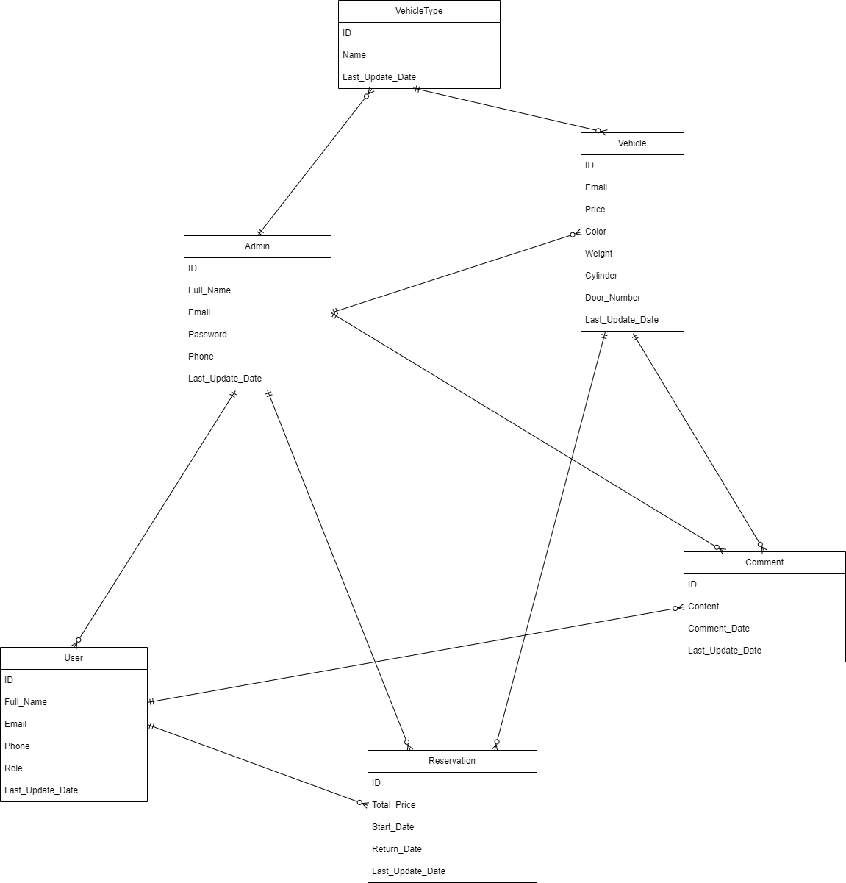

## Logical data model

