1. **Client:** LibrarianCan Tho University
2. **Function Requirement:**

|  |  |
| --- | --- |
| Login Function (01) | |
| Request name | Login. |
| Purpose | Help login to the application |
| Objects of use | Reader, Labrarian, Manager. |
| Conditions of use | Users are given an account by the administrator based on a user code (e.g. ReaderID). |
| Usage | 1: Open the application  2: Choose login function  3: Enter the account provided by admin  4: Authenticate the correct login information, allowing users to use the features of the application.  5: record the user object, notify the successful login to the system. |
| Result | The user successfully logs into the system and is allowed to use the system's features according to the user object. |
| Note | Each login object will use different functions depending on the object group. (Reader, Librarian, Manager.) |

|  |  |
| --- | --- |
| Logout Function(02) | |
| Request name | Log out. |
| Purpose | Help logout the application. |
| Objects of use | Reader, Labrarian, Manager. |
| Conditions of use | The user is logged in to the application. |
| Usage | 1: select sign out.  2: logout confirmation message.  3: user confirm logout.  4: the system logs the user out of the application. |
| Result | The user logs out of the application successfully. |
| Note | If the user does not confirm the logout do nothing. |

|  |  |
| --- | --- |
| Change Password(03) | |
| Request name | Change Password. |
| Purpose | Help change user password. |
| Objects of use | Reader, Labrarian, Manager. |
| Conditions of use | The user has an application account. |
| Usage | 1: User selects “Change password”.  2: Show password reset form.  3: The user enters the account name (id) then press "continue".  4: Display from enter new password.  5: Confirm password changed successfully.  6: Send a notification the password has been changed successfully. |
| Result | The user has changed the new password. |
| Note | If the user chooses to cancel, the password change will stop.  If the verification code is wrong, the confirmation code is not correct. |

|  |  |
| --- | --- |
| Book Search Function(04) | |
| Request name | Find books. |
| Requrest name | Support to find books easier for users. |
| Objects of use | Reader. |
| Conditions of use | The user has logged into the system. |
| Usage | 1: Select "Book Catalog".  2: Enter the title of the book you are looking for.  3: The system displays detailed book information if any. |
| Result | Display information about the book the user needs to find. |
| Note | If the user enters the wrong book title, is missing, or there is no book in the system, the user will be notified to stop re-entering. |

|  |  |
| --- | --- |
| Borrowed Documents Function (05) | |
| Request name | Borrowed Documents |
| Purpose | View currently borrowed documents |
| Objects of use | Reader. |
| Conditions of use | The user has logged into the system |
| Usage | 1: Select "Borrowed Documents"  2: Display information about books that the user is borrowing  3: Allow extension of documents.  4: If a book is renewed, update its status. |
| Result | Information about books being borrowed & Renewed |
| Note |  |

|  |  |
| --- | --- |
| Renewal Document Function (06) | |
| Request name | Renewal Document. |
| Purpose | Show renewed book information. |
| Objects of use | Reader. |
| Conditions of use | The user has logged into the system |
| Usage | 1: Select "Renewal Document"  2: Show renewal document information |
| Result | Renewal document information |
| Note |  |

|  |  |
| --- | --- |
| Borrow a Discussion Room (07) | |
| Request name | Borrow a discussion room |
| Purpose | Support to register to borrow a discussion room. |
| Objects of use | Reader. |
| Conditions of use | The user has logged into the system |
| Usage | 1: Select "Borrow discussion room"  2: Choose the time and date to borrow.  3: The system displays a list of available rooms that can be borrowed.  4: Select the room to borrow.  5: Loan registration is successful |
| Result | Room loan registration successful. |
| Note | If the user signs up, the loan message is successful. |

|  |  |
| --- | --- |
| Feedback Function (08) | |
| Request name | Feedback. |
| Purpose | Support users to submit comments to the system. |
| Objects of use | Reader. |
| Conditions of use | The user has logged into the system |
| Usage | 1: Select “Feedback”  2: Display and enter feedback form.  3: Tap send feedback.  4: Notification of successful response submission. |
| Result | User submitted a successful contribution feedback. |
| Note | If the user presses cancel then nothing is done. |

|  |  |
| --- | --- |
| Reader Management Function (09) | |
| Request name | Reader management |
| Purpose | Support librarians to manage readers who are members of the library. |
| Objects of use | Librarian. |
| Conditions of use | The user has logged into the system. |
| Usage | 1: Select “Manage reader”.  2: Display the form to be filled out and a list of users if any.  3: Optional can add, delete, update the information you read.  4: Change confirmation message (add, delete, update).  5: Change successful. |
| Result | Display the list of readers' information and add/ update/ edit/delete successfully |
| Note | Every successful/fail operation shows a notification dialog to the user |

|  |  |
| --- | --- |
| Discussion Room Management Function (10) | |
| Request name | Discussion room management. (8.1) |
| Purpose | Support the librarian to manage the list of registrations to borrow the discussion room. |
| Objects of use | Librarian. |
| Conditions of use | The user is logged on to the librarian with role system. |
| Usage | 1: Select “Manage discussion room”  2: Load from the database to display the form about the borrower,  3: Display the list of room to borrow, the date and time of the loan. (can be searched by the code you read) |
| Result | Displays the list of registrations to borrow and the list to borrow rooms. (date and time borrowed). |
| Note |  |

|  |  |
| --- | --- |
| Discussion Room Management Function (11) | |
| Request name | Search the discussion room (8.2). |
| Purpose | Assist librarians in finding rooms in case they need to check. |
| Objects of use | Librarian. |
| Conditions of use | The user has logged into the system as librarian. |
| Usage | 1: Select “Manage discussion room”  2: Select the search box and enter the room code you want to find.  3: Show the room search form (room code, room name, date and time of borrowing and returning). |
| Result | Displays a list of rooms to rent. (date and time borrowed). |
| Note | Search by room code to know the date and time and the person who borrowed the room. |

|  |  |
| --- | --- |
| Book Loan Management Function (11) | |
| Request name | Book loan manager.(9.1) |
| Purpose | Support librarians to manage book borrowers. |
| Objects of use | Librarian. |
| Conditions of use | The user has logged into the system |
| Usage | 1: Select "manage borrowing books"  2: Display a list of people who have registered to borrow books.  3: Confirm for readers to borrow books.  4: Update the list of readers to borrow books  5: Display a list of books borrowed by readers, borrowed date, return date. |
| Result | Display a list of readers coming to borrow books. |
| Note |  |

|  |  |
| --- | --- |
| Book Loan Management Function (12) | |
| Request name | Search for the book loan code. (9.2) |
| Purpose | Support to find the code to borrow books. |
| Objects of use | Librarian. |
| Conditions of use | The user has logged into the system. |
| Usage | 1: Select " Book loan management ".  2: Click the search box.  3: Enter the loan code/ date you want to find.  4: The system displays the search form. |
| Result | Displays the user's search request. Display the search form (borrower code, borrower name, book title, borrowed date and time). |
| Note | The reader code must be entered correctly if nothing is displayed or an error which system must sent a re-entry message. |

|  |  |
| --- | --- |
| Book Return Management Function (13) | |
| Request name | Book return management. (10.1) |
| Purpose | Support librarian to manage whether the borrower has paid book or not. |
| Objects of use | Librarian. |
| Conditions of use | The user has logged into the system. |
| Usage | 1: select “book return management”  2: Display the form for the list of people who have returned the book. |
| Result | Display information of readers who have returned books |
| Note |  |

|  |  |
| --- | --- |
| Book Return Management Function (14) | |
| Request name | Search by reader code/ date (10.2) |
| Purpose | Support librarians to manage details of date, time, and return information. |
| Objects of use | Librarian. |
| Conditions of use | The user has logged into the system. |
| Usage | 1: Select “Book return management”  2: Select the search box.  3: Enter code reader/date.  4: Show details of the time/ information the person returned the book and the book. |
| Result | Display the name of the returnee, the title of the book, the date and time of the return |
| Note | The return list is taken from the loan list after updating the status to paid |

|  |  |
| --- | --- |
| Catalog and Books Management Function (15) | |
| Request name | Book management (11.1) |
| Purpose | Support to manage books in the library. |
| Objects of use | Manager. |
| Conditions of use | The user has logged into the system. |
| Usage | 1: Select “manage books”  2: Select “add/update/delete books”.  3: Display the book form to be updated.  4: Confirm add/update/delete books |
| Result | Add/update/delete books successfully. |
| Note |  |

|  |  |
| --- | --- |
| Catalog and Books Management Function (16) | |
| Request name | Catalog Management (11.2) |
| Purpose | Support managing the list of books in the library. |
| Objects of use | Manager. |
| Conditions of use | The user has logged into the system. |
| Usage | 1: Select “manage book list”  2: Select “add/update/delete list of books.  3: Display the book list form.  4: Confirm to add/update/delete book categories |
| Result | Add/update/delete book list successfully. |
| Note |  |

|  |  |
| --- | --- |
| Catalog and Books Management Function (17) | |
| Request name | Find catalog (11.3) |
| Purpose | Support to find the list of books in the library and the titles of books in that category. |
| Objects of use | Manager. |
| Conditions of use | The user has logged into the system. |
| Usage | 1: Select “manage book list”  2: Select “Find category”.  3: Enter the name of the category to search.  4: Display a list of available categories. |
| Result | Displays the list of books to search and the books in that category. |
| Note | Need to enter keywords to search by category name. |

|  |  |
| --- | --- |
| Catalog and Books Management Function (18) | |
| Request name | Find the book catalog location (11.4) |
| Purpose | Support to find the catalog where the list is located on the second shelf in the library. |
| Objects of use | Manager. |
| Conditions of use | The user has logged into the system. |
| Usage | 1: Select “manage book catalog”.  2: Select “find catalog location”.  3: Enter the name of the category to search.  4: Show the position of the catalog to look for (what number of shelves?). |
| Result | Find out where that directory is located |
| Note | The purpose of finding the location of the list of books to easily manage and arrange books |

|  |  |
| --- | --- |
| Bookshelf Management Function (19) | |
| Request name | Bookshelf Management (12.1) |
| Purpose | Support adding/updating/deleting bookshelves in the library. |
| Objects of use | Manager. |
| Conditions of use | The user has logged into the system. |
| Usage | 1: Select “manage bookshelf”  2: Select “add/ update/ delete bookshelf”.  3: Display the add/ update/ delete form and the bookshelf position.  4: Confirm shelf and shelf position.  5: Notification of successful add/ update/ delete. |
| Result | Add/update/delete bookshelves and change their position. |
| Note |  |

|  |  |
| --- | --- |
| Employee Management Function (20) | |
| Request name | Employee Management |
| Purpose | Support management of library staff. |
| Objects of use | Manager. |
| Conditions of use | The user has logged into the system. |
| Usage | 1: select “employee management”  2: Display the list of staff including (empID, name, age, gender, qualifications, position, salary, ..). |
| Result | List of employee. |
| Note | Only some members have permissions in the system. Account given by admin. |

|  |  |
| --- | --- |
| Statistics Function (21) | |
| Request name | Statistics by Category/Book/Employee/Reader (13.1) |
| Purpose | Support the management of the library's operating state |
| Objects of use | Manager. |
| Conditions of use | The user has logged into the system. |
| Usage | 1: Click on “Statistics”  2: Select “Category/Book/Employee/Reader”.  3: Display the list of data to find |
| Result | Output the data form in the library according to each request |
| Note |  |

**3. Overview of Processes involved in the system**

* Below is a flowchart showing an overview of the processes in the application.

Figure 1.1 displays the flowchart for Library Management Application.

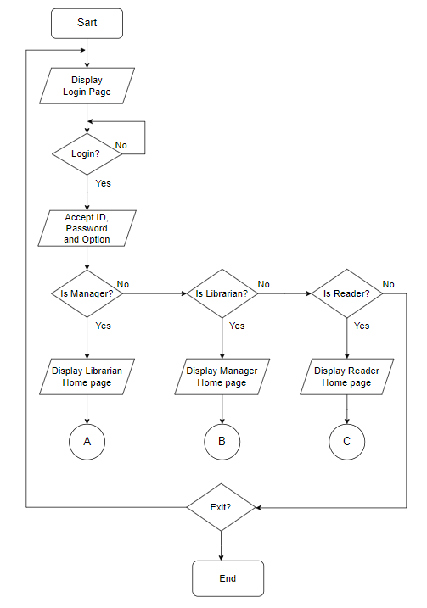**Figure 1.1: Flowchart for Library Management Application**

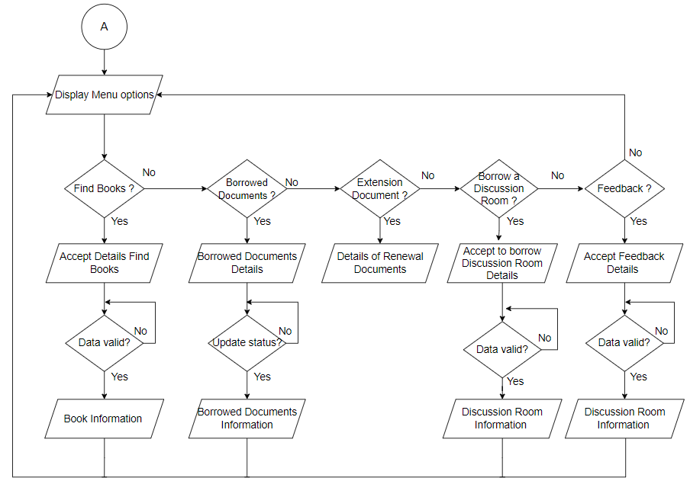Figure 1.2 displays the flowchart for Reader Activities in System.

**Figure 1.2: Flowchart for Reader Activities in System**

Figure 1.3 display the flowchart for Librarian Activies in System.

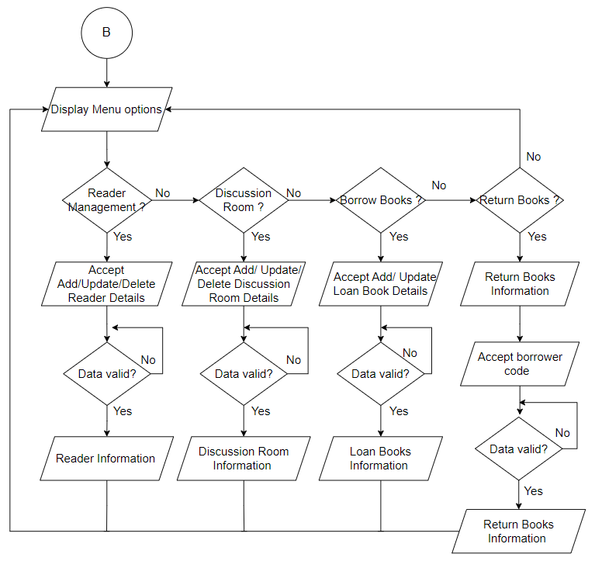

**Figure 1.3: Flowchart for Librarian activities in the System**

Figure 1.4 display the flowchart for Manager Activies in the System.

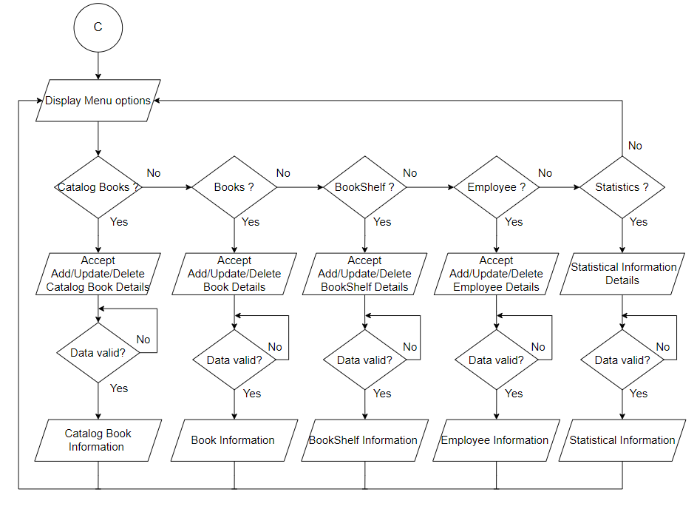

**Figure 1.4: Flowchart for Librarian activities in the System**

**4. Hardware and Software required for implementing the project**

* **Hardware:**
* **CPU:** Intel Core i5-10400F 2.9 Ghz or higher.
* **Memory:** 8GB of RAM or higher.
* **HDD:** 20GB or higher.
* **Software:**
* **Operating system**: Windows 7 or higher.
* Java SE 18 or higher.
* JDK 18.0.2.1 or higher.
* MS SQL Server 2018 or higher.

**5. Customer’s Acceptance Criteria**

The acceptance criteria could be the following:

|  |  |
| --- | --- |
| **No.** | **Customer’s Acceptance Criteria** |
| 1 | Librarians/ Reader/ Manager log into the system with the provided account |
| 2 | Reader can find books in the system |
| 3 | Readers can view borrowed and renewed books |
| 4 | Readers can see the books they are borrowing / renewing. Submit feedback form |
| 5 | Librarians can register reading cards for users |
| 6 | Librarians can register to lend/return books |
| 7 | Librarians can display information about the discussion room |
| 8 | Manager can add/edit/delete/update catalogs & books/Bookshelf/ Employee |
| 9 | Manager can perform catalog books & books/ Reader/ Employee statistics |
| 10 | The application should be user-friendly |
| 11 | The application must have an intelligent User Interface (UI) |
| 12 | The application must be highly secure |