1. **[Conceptual data model](https://en.wikipedia.org/wiki/Conceptual_data_model).**

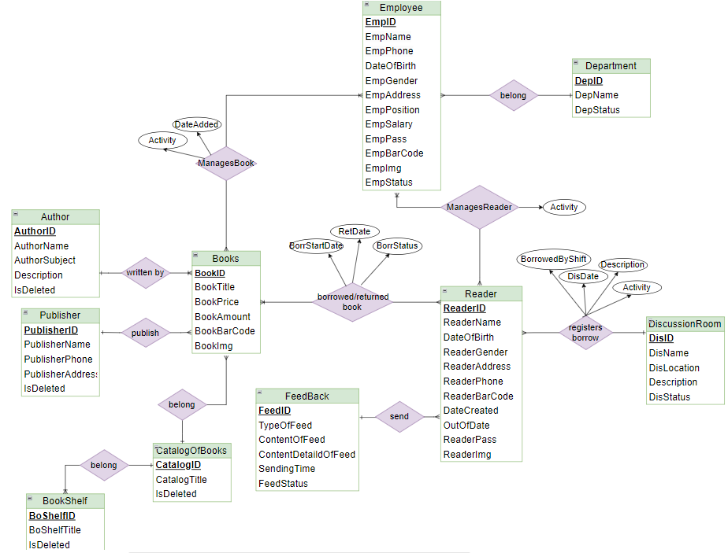

**Figure 1.1: Conceptual data model**

1. [**Logical data model**](https://en.wikipedia.org/wiki/Logical_data_model)

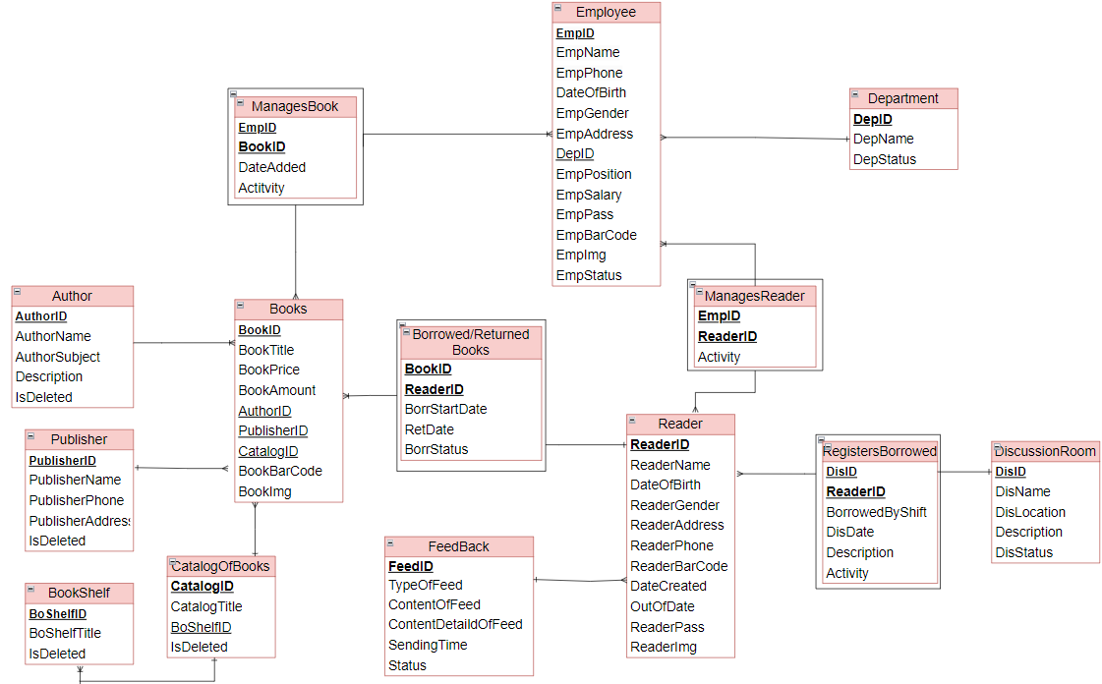

**Figure 1.2: Logical Data Model**

1. [**Physical data model**](https://en.wikipedia.org/wiki/Physical_data_model)

**Author:**

|  |  |  |  |
| --- | --- | --- | --- |
| **Fields name** | **Data Type** | **Key** | **Description** |
| AuthorID | Varchar(8) | PK | Storing the author id of the author |
| AuthorName | Varchar(50) |  | Storing the author name of the author |
| AuthorSubject | Varchar(80) |  | Storing author subject of the author |
| Description | Varchar(150) |  | Storing the description of the author |
| IsDeleted | INT |  | Storing deleted activity of the author |

**Publisher: (Table Name: Publisher) –Storing**

|  |  |  |  |
| --- | --- | --- | --- |
| **Fields name** | **Data Type** | **Key** | **Description** |
| PublisherID | Varchar(8) | PK | Storing the publisher id of the publisher |
| PublisherName | Varchar (80) |  | Storing the publisher name of the publisher |
| PublisherPhone | Varchar (20) |  | Storing the phone of the publisher |
| PublisherAddress | Varchar (150) |  | Storing the address of the publisher |
| IsDeleted | INT |  | Storing deleted activity of the publisher |

**BookShelf**:

|  |  |  |  |
| --- | --- | --- | --- |
| **Fields name** | **Data Type** | **Key** | **Description** |
| BoShelfID | Varchar (8) | PK | Storing the bookshelf id of the bookshelf |
| BoShelfTitle | Varchar (10) |  | Storing the title of the bookshelf |
| IsDeleted | INT |  | Storing deleted activity of the bookshelf |

**CatalogOfBooks**:

|  |  |  |  |
| --- | --- | --- | --- |
| **Fields name** | **Data Type** | **Key** | **Description** |
| CatalogID | Varchar (8) | PK | Storing the id of the book catalog |
| CatalogTitle | Varchar (80) |  | Storing the title of the book catalog |
| BoShelfID | Varchar(8) | PK-FK | Storing the bookshelf id of the bookshelf |
| IsDeleted | INT |  | Storing deleted activity of the book catalog |

**Books:**

|  |  |  |  |
| --- | --- | --- | --- |
| **Fields name** | **Data Type** | **Key** | **Description** |
| BookID | Varchar (8) | PK | Storing the id of the book catalog |
| AuthorID | Varchar (8) | FK | Storing the author id of the author |
| PublisherID | Varchar (8) | FK | Storing the publisher id of the publisher |
| CatalogID | Varchar (8) | FK | Sotres the catalog id of the book catalog |
| BookTitle | Varchar (100) |  | Storing the book title of the books |
| BookPrice | Varchar(25) |  | Storing the book price of the books |
| BookAmount | INT |  | Storing the book amount of the books |
| BookBarCode | Varchar(12) |  | Storing the bar code of the books |
| BookImg | Varchar(500) |  | Storing the book imgage of the books |

**Employee:**

|  |  |  |  |
| --- | --- | --- | --- |
| **Fields name** | **Data Type** | **Key** | **Description** |
| EmpID | Varchar (8) | PK | Storing the id of the employee |
| EmpName | Varchar (50) |  | Storing the name of the employee |
| EmpPhone | Varchar(20) |  | Storing the phone of the employee |
| DateOfBirth | Date |  | Storing the birthday date of the employee |
| EmpGender | Varchar(6) |  | Storing the gender of the eployee |
| EmpAddress | Varchar(150) |  | Storing the address of the enployee |
| DepID | Varchar(8) | FK | Storing the id of the department |
| EmpPosition | Varchar(25) |  | Storing the position of the enployee |
| EmpSalary | Varchar(15) |  | Storing the salary of the enployee |
| EmpPass | Varchar(255) |  | Storing the password of the enployee |
| EmpBarCode | Varchar(12) |  | Storing the barcode of the enployee |
| EmpImg | Varchar(500) |  | Storing the image of the enployee |
| EmpStatus | Varchar(25) |  | Storing the status of the employee: Active, On Leave, Resigned, Terminated, Retired, Suspended, Absent Without Leave, Probation, Trainning |

**ManagesBook:**

|  |  |  |  |
| --- | --- | --- | --- |
| **Fields name** | **Data Type** | **Key** | **Description** |
| EmpID | Varchar(8) | PK-FK | Storing the id of the employee |
| BookID | Varchar(8) | PK-FK | Storing the id of the books |
| DateAdded | Varchar(8) |  | Storing date added book |
| Activity | Varchar(25) |  | Storing activity of book management: Available, Borrowed, Overdue, Lost, Damanged, Withdrawn |

**Department:**

|  |  |  |  |
| --- | --- | --- | --- |
| **Fields name** | **Data Type** | **Key** | **Description** |
| DepID | Varchar(8) | PK | Storing the department id of the department |
| DepName | Varchar(80) |  | Storing the name of the department |
| DepStatus | Varchar(25) |  | Storing status of the department: active, inactive, merged, deleted, pending |

**Reader:**

|  |  |  |  |
| --- | --- | --- | --- |
| **Fields name** | **Data Type** | **Key** | **Description** |
| ReaderID | Varchar (8) | PK | Storing the bookshelf id of the bookshelf |
| ReaderName | Varchar (50) |  | Storing the title of the bookshelf |
| DateOfBirth | Date |  | Storing deleted activity of the bookshelf |
| ReaderGender | Varchar(6) |  | Storing the gender of the reader |
| ReaderAddress | Varchar(150) |  | Storing the address of the reader |
| ReaderPhone | Varchar(20) |  | Storing the phone of the reader |
| ReaderBarCode | Varchar(12) |  | Storing the bar code of the reader |
| DateCreated | Date |  | Storing date created of the reader |
| OutOfDate | Date |  | Storing the expiration date of the reader |
| ReaderPass | Varchar(255) |  | Storing password of the reader when reader login system |
| ReaderImg | Varchar(500) |  | Storing the image of the reader |

**ManagesReader:**

|  |  |  |  |
| --- | --- | --- | --- |
| **Fields name** | **Data Type** | **Key** | **Description** |
| EmpID | Varchar (8) | PK-FK | Storing the employee id of the employee |
| ReaderID | Varchar (8) | PK-FK | Storing the reader id of the reader |
| Activity | Varchar(25) |  | Storing activity of the reader: Active, Inactive, Expried, Closed, Banned |

**BorrowedAndReturnedBook:**

|  |  |  |  |
| --- | --- | --- | --- |
| **Fields name** | **Data Type** | **Key** | **Description** |
| BookID | Varchar (8) | PK-FK | Storing the bookshelf id of the bookshelf |
| ReaderID | Varchar (8) | PK-FK | Storing the title of the bookshelf |
| BorrStartDate | Date |  | Storing the start date of borrowing books |
| RetDate | Date |  | Storing the expiration date of returning books |
| BorrStatus | Varchar(25) |  | Storing the state of the loan activity: Borrowed, Returned, Overdue, Renewal |

**DiscussionRoom:**

|  |  |  |  |
| --- | --- | --- | --- |
| **Fields name** | **Data Type** | **Key** | **Description** |
| DisID | Varchar (8) | PK | Storing the id of the discussion room |
| DisName | Varchar (80) |  | Storing the name of the discussion room |
| DisLocation | Varchar(50) |  | Storing the location of the discussion room |
| Description | Varchar(500) |  | Storing description of the discussion room |
| DisStatus | Varchar(25) |  | Storing status of the discussion room: Active, Closed, Restricted, Pending |

**RegistersBorrowed**:

|  |  |  |  |
| --- | --- | --- | --- |
| **Fields name** | **Data Type** | **Key** | **Description** |
| DisID | Varchar (8) | PK-FK | Storing the id of the discussion room |
| ReaderID | Varchar (8) | PK-FK | Storing the id of the reader |
| BorrowedByShift | Varchar(150) |  | Storing the rotating time frames to borrow rooms from shifts 1 - 6 |
| DisDate | Date |  | Storing date borrwed the discussion room |
| Description | Varchar(500) |  | Storing description of the discussion room |
| Activity | Varchar(20) |  | Storing activity of the discussion room: Processed, Returned, Cancelled |

**FeedBack:**

|  |  |  |  |
| --- | --- | --- | --- |
| **Fields name** | **Data Type** | **Key** | **Description** |
| FeedID | Varchar (8) | PK | Storing the id of the feedback |
| ReaderID | Varchar (8) | FK | Storing the id of the reader |
| TypeOfFeeed | Varchar(20) |  | Storing type of feedback |
| ContentOfFeed | Varchar(500) |  | Response content storage |
| ContentDetaildOfFeed | Varchar(500) |  | Storing content details of feedback |
| SendingTime | Time |  | Storing the date and time of sending feedback |
| FeedStatus | Varchar(25) |  | Storing stauts of feedback: Pending, Processed, Closed |