**Introduction:**

Helm charts are one of the [best practices for building efficient clusters in Kubernetes.](https://phoenixnap.com/kb/kubernetes-best-practices) It is a form of packaging that uses a collection of Kubernetes resources. Helm charts use those resources to define an application.

Helm charts use a template approach to deploy applications. Templates give structure to projects and are suitable for any type of application.

**This article provides step-by-step instructions to create and deploy a Helm chart.**

**Prerequisites**

* Access to a CLI
* Minikube cluster installed and configured. (For assistance, follow our guides [How to Install Minikube on Ubuntu](https://phoenixnap.com/kb/install-minikube-on-ubuntu) and [How to Install Minikube on CentOS](https://phoenixnap.com/kb/install-minikube-on-centos).)
* [Helm installed](https://phoenixnap.com/kb/install-helm) and configured.

**Note:** To confirm Helm installed properly, run **which helm** in the terminal. The output should return a path to Helm.

**Create Helm Chart**

Creating a Helm chart involves creating the chart itself, configuring the image pull policy, and specifying additional details in the *values.yaml* file.

### Step 1: Create a New Helm Chart

1. To create a new Helm chart, use:

helm create <chart name>

### Step 2: Configure Helm Chart Image Pull Policy

For example:

helm create phoenixnap

2. Using the [ls command](https://phoenixnap.com/kb/linux-ls-commands), list the chart structure:

The Helm chart directory contains:

* **Directory *charts*** – Used for adding dependent charts. Empty by default.
* **Directory *templates***– Configuration files that deploy in the cluster.
* [YAML](https://phoenixnap.com/blog/what-is-yaml-with-examples) **file** – Outline of the Helm chart structure.
* ***YAML*file**– Formatting information for configuring the chart.

1. Open the *values.yaml*file in a [text editor](https://phoenixnap.com/kb/best-linux-text-editors-for-coding). Locate the *image* values:

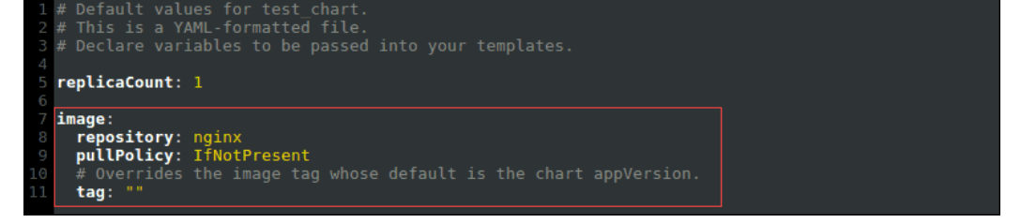

There are three possible values for the *pullPolicy*:

* **IfNotPresent**– Downloads a new version of the image if one does not exist in the cluster.
* **Always** – Pulls the image on every restart or deployment.
* **Latest** – Pulls the most up-to-date version available.

2. Change the image *pullPolicy* from **IfNotPresent** to **Always**:

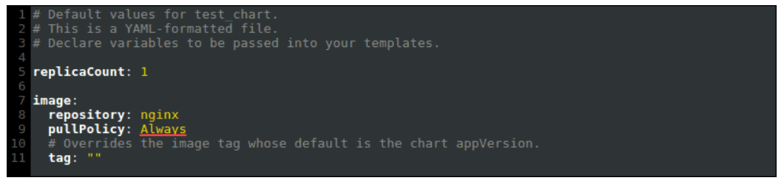

### Step 3: Helm Chart Name Override

To override the chart name in the values.yaml file, add values to the nameOverride and fullnameOverride:

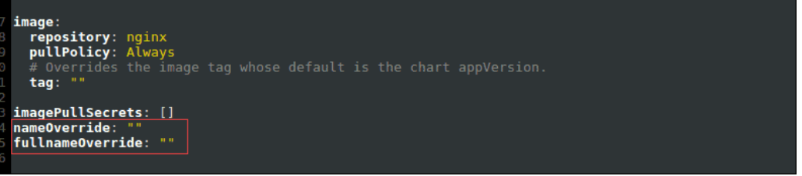

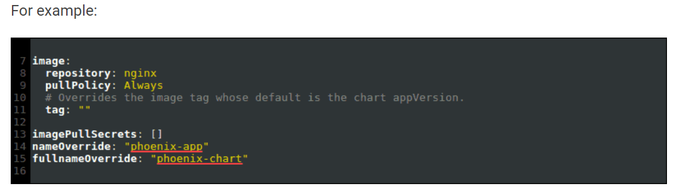

Overriding the Helm chart name ensures configuration files also change.

### Step 4: Specify Service Account Name

The service account name for the Helm chart generates when you run the cluster. However, it is good practice to set it manually.

The service account name makes sure the application is directly associated with a controlled user in the chart.

1. Locate the serviceAccount value in the values.yaml file:

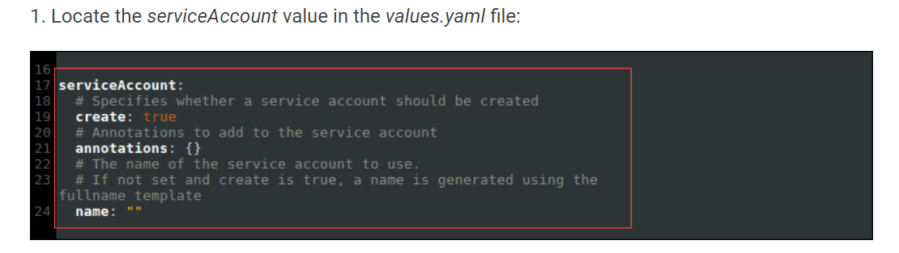

2. Specify the name of the service account:

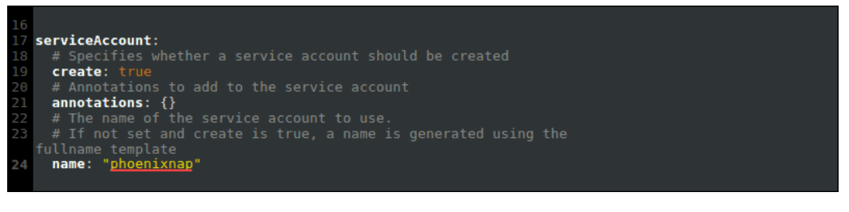

### Step 5: Change Networking Service Type

The recommended networking service type for Minikube is **NodePort**.

1. To change the networking service type, locate the service value:

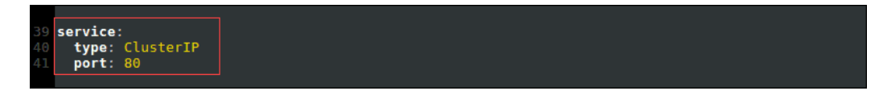

2. Change the type from **ClusterIP** to **NodePort**:

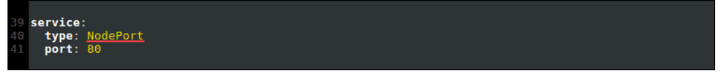

## Deploy Helm Chart

After configuring the values.yaml file, check the status of your Minikube cluster and deploy the application using [Helm commands](https://phoenixnap.com/kb/helm-commands-cheat-sheet).

### Step 1: Check minikube Status

If Minikube isn’t running, the install Helm chart step returns an error.

1. Check Minikube status with:

minikube status

The status shows up as Running.

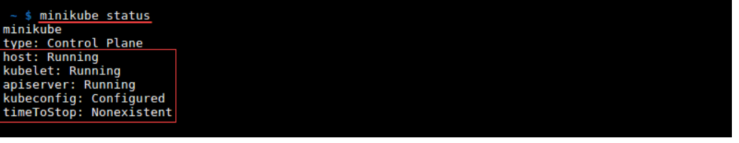

2. If the status shows Stopped, run:

minikube start

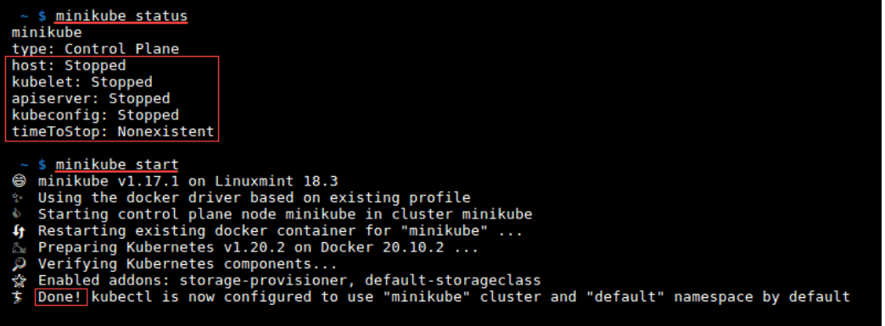

The output shows Done and the status changes to Running.

### Step 2: Install the Helm Chart

Install the Helm chart using the **helm install** command:

helm install <full name override> <chart name>/ --values <chart name>/values.yaml

For example:

helm install phoenix-chart phoenixnap/ --values phoenixnap/values.yaml

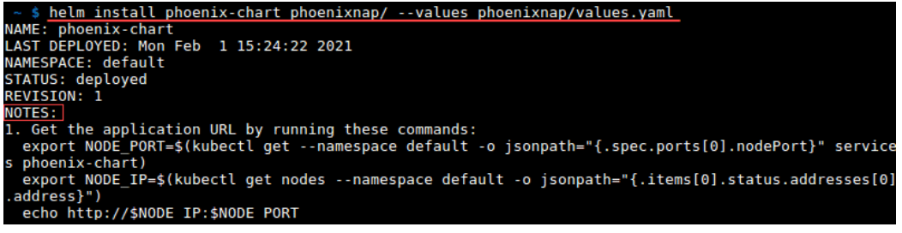

The **helm install** command deploys the app. The next steps are printed in the NOTES section of the output.

### Step 3: Export the Pod Node Port and IP Address

1. Copy the two **export** commands from the **helm install** output.

2. Run the commands to get the Pod node port and IP address:

