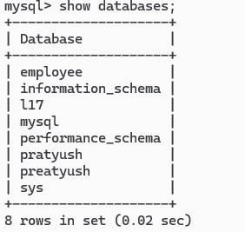

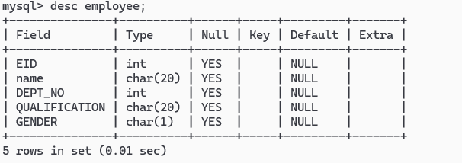

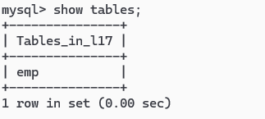

LAB – 17

Aim: MySQL Set 1, DDL commands 1

COMMANDS:

#MySQL commands to create a database and a table in the database  
create database if not exists L17;  
show databases;  
use L17;  
create table employee(EID int, name char(20), DEPT_NO int, QUALIFICATION char(20), GENDER  
char(1));

#MySQL commands to display the table description and rename it  
desc employee;  
alter table employee rename emp;

#MySQL commands to show the tables in the database L17   
show tables;

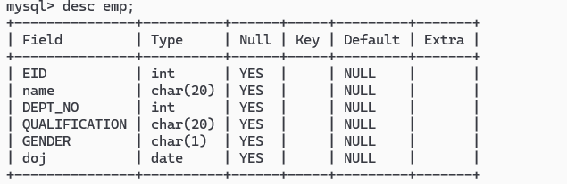

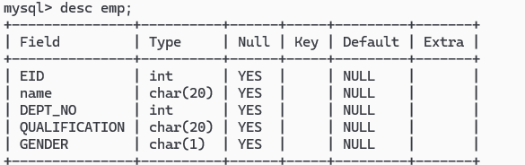

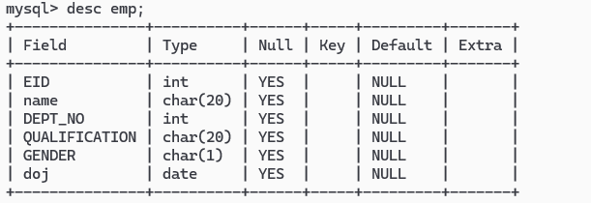

LAB – 18

AIM: MySQL Set 1, DDL Commands 2

ALTER COMMANDS:

1. # To add a new column doj type – date  
   alter table emp add column doj date;  
   desc emp;
2. # Drop columns doj  
   alter table emp drop column doj;  
   desc emp;
3. # Add column and change the data type  
   alter table emp add column doj char(20);  
   alter table emp modify doj date;  
   desc emp;
4. # Change column name of qualification to qual  
   alter table emp rename column QUALIFICATION to qual;  
   desc emp;
5. # Add not null constraint  
   alter table emp modify name varchar(20) not null;  
   desc emp;
6. # Add default constraint to qual  
   alter table emp modify column qual set default ‘BA’;  
   desc emp;
7. #Add a unique key to dept_no  
   alter table emp modify DEPT_NO int unique;  
   desc emp;
8. #Remove unique key  
   alter table emp drop index DEPT_NO;  
   desc emp;

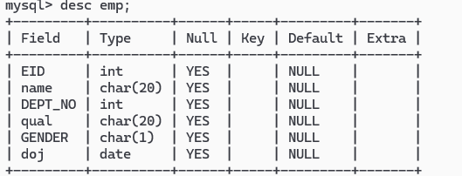

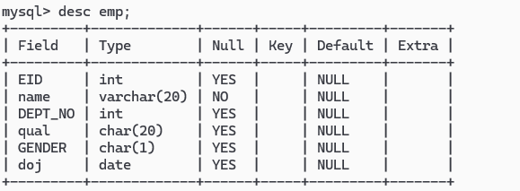

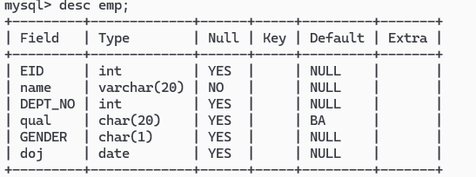

1. # Add primary key to Employee ID  
   alter table emp add primary key(EID);  
   desc emp;
2. # Create unique constraint for EID and name using constraint name  
   alter table emp add constraint con unique(EID,name);  
   desc emp;

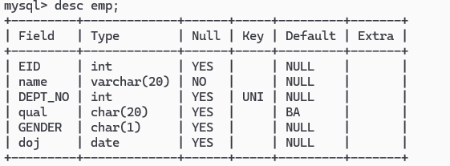 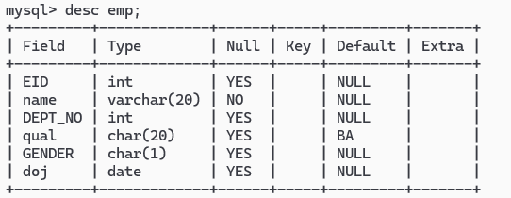 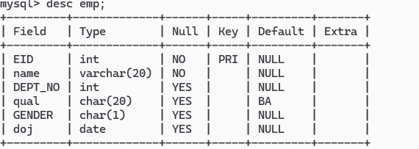 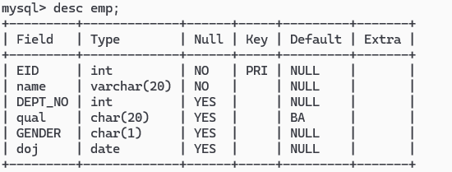

4. Display all employees who have joined between 2000 and 2018.
5. To display the different departments