Use Cases for TEC Control for Energy Management in Microgrid Systems

|  |  |
| --- | --- |
| 1 Join Market | 2 |
| 2​ Accept Power | 4 |
| ​3​ Provide Power | 6 |
| 4​ Provide Meter Data | 8 |
| 5​ Tender Tender | 10 |
| ​6​ Accept Transaction | 12 |
| 7​ Determine Price | 14 |
| ​8​ Provide Report | 16 |
| 9​ Observe | 18 |
| 10​ Diagrams | 20 |

# 1 Join Market

**Characteristic Information**

The following defines information that pertains to this particular use case. Each piece of information is important in understanding the purpose behind the Use Case.

|  |  |
| --- | --- |
| **Goal In Context:** | To authenticate user for participation in the market |
| **Pre-Condition:** | User has credentials, contracts, fulfilled bonding requirements |
| **Success End Condition:** | Market Participant receives acknowledgement from the market facilitator that login was successful |
| **Primary Actor:** | Market Participant |
| **Trigger Event:** | Initiated by market participant |

**Main Success Scenario**

This Scenario describes the steps that are taken from trigger event to goal completion when everything works without failure. It also describes any required cleanup that is done after the goal has been reached. The steps are listed below:

|  |  |  |
| --- | --- | --- |
| **Step** | **Actor** | **Action Description** |
| 1 | Market Participant | Sends credentials to the Market Facilitator |
| 2 | Market Facilitator | Validates Market Participant’s credentials |
| 3 | Market Participant | Receive success notification from Market Facilitator |

**Scenario Variations**

This is a listing of how each step in the Main Success Scenario can be extended. Another way to think of this is how can things go wrong. The extensions are followed until either the Main Success Scenario is rejoined or the Failed End Condition is met. The Step refers to the Failed Step in the Main Success Scenario and has a letter associated with it. I.E if Step 3 fails the Extension Step is 3a.

|  |  |  |
| --- | --- | --- |
| **Step** | **Condition** | **Action Description** |
| 1a | Credentials fail | Market Facilitator sends a notification to the Market Participant. |

# 2​ Accept Power

**Characteristic Information**

The following defines information that pertains to this particular use case. Each piece of information is important in understanding the purpose behind the Use Case.

|  |  |
| --- | --- |
| **Goal In Context:** | Market Participant consumes transacted power |
| **Pre-Condition:** | Transaction was created |
| **Success End Condition:** | Transacted power was consumed for transacted time period |
| **Primary Actor:** | Market Participant |
| **Trigger Event:** | Transaction start time |

**Main Success Scenario**

This Scenario describes the steps that are taken from trigger event to goal completion when everything works without failure. It also describes any required cleanup that is done after the goal has been reached. The steps are listed below:

|  |  |  |
| --- | --- | --- |
| **Step** | **Actor** | **Action Description** |
| 1 | Market Participant | Market Participant engages loads to consume the amount of energy transacted |

**Scenario Variations**

This is a listing of how each step in the Main Success Scenario can be extended. Another way to think of this is how can things go wrong. The extensions are followed until either the Main Success Scenario is rejoined or the Failed End Condition is met. The Step refers to the Failed Step in the Main Success Scenario and has a letter associated with it. I.E if Step 3 fails the Extension Step is 3a.

|  |  |  |
| --- | --- | --- |
| **Step** | **Condition** | **Action Description** |
| 1a | Market Participant does not consume all transacted power | Market facilitator creates spot transaction in arrears to sell excess power on spot market, market rules may prescribe additional consequences |
| 1b | Market participant consumes more power than transacted | Market facilitator creates spot transaction in arrears to buy excess power on spot market, market rules may prescribe additional consequences |
| 1c | Transport was not provided | Market Participant is not able to fulfill transaction and disengages load |

# ​3​ Provide Power

**Characteristic Information**

The following defines information that pertains to this particular use case. Each piece of information is important in understanding the purpose behind the Use Case.

|  |  |
| --- | --- |
| **Goal In Context:** | Market Participant provides transacted power |
| **Pre-Condition:** | Transaction was created |
| **Success End Condition:** | Transacted power was provided for transacted time period |
| **Primary Actor:** | Market Participant |
| **Trigger Event:** | Transaction start time |

**Main Success Scenario**

This Scenario describes the steps that are taken from trigger event to goal completion when everything works without failure. It also describes any required cleanup that is done after the goal has been reached. The steps are listed below:

|  |  |  |
| --- | --- | --- |
| **Step** | **Actor** | **Action Description** |
| 1 | Market Participant | Market Participant produces power or sheds loads to meet energy transacted |

**Scenario Variations**

This is a listing of how each step in the Main Success Scenario can be extended. Another way to think of this is how can things go wrong. The extensions are followed until either the Main Success Scenario is rejoined or the Failed End Condition is met. The Step refers to the Failed Step in the Main Success Scenario and has a letter associated with it. I.E if Step 3 fails the Extension Step is 3a.

|  |  |  |
| --- | --- | --- |
| **Step** | **Condition** | **Action Description** |
| 1a | Market Participant does not produce all transacted power | Market facilitator creates spot transaction in arrears to buy additional power on spot market, market rules may prescribe additional consequences |
| 1b | Market participant produces more power than transacted | Market facilitator creates spot transaction in arrears to sell excess power on spot market, market rules may prescribe additional consequences |
| 1c | Transport was not provided | Market Participant curtails generation, engages loads, utilizes storage capacity or utilizes a load bank to consume power. |

# 4​ Provide Meter Data

**Characteristic Information**

The following defines information that pertains to this particular use case. Each piece of information is important in understanding the purpose behind the Use Case.

|  |  |
| --- | --- |
| **Goal In Context:** | To provide meter data for the market facilitator to settle the transaction |
| **Pre-Condition:** | Transaction is complete |
| **Success End Condition:** | Market Participant receives acknowledgement from the market facilitator that meter data was received |
| **Primary Actor:** | Market Participant |
| **Trigger Event:** | Completion of transaction  Voluntary interval reporting  Upon request for a specified time period |

**Main Success Scenario**

This Scenario describes the steps that are taken from trigger event to goal completion when everything works without failure. It also describes any required cleanup that is done after the goal has been reached. The steps are listed below:

|  |  |  |
| --- | --- | --- |
| **Step** | **Actor** | **Action Description** |
| 1 | Market Participant | Query entity for power usage |
| 2 | Market Participant | Send meter data to Market Facilitator |
| 3 | Market Participant | Receive success notification from Market Facilitator |

**Scenario Variations**

This is a listing of how each step in the Main Success Scenario can be extended. Another way to think of this is how can things go wrong. The extensions are followed until either the Main Success Scenario is rejoined or the Failed End Condition is met. The Step refers to the Failed Step in the Main Success Scenario and has a letter associated with it. I.E if Step 3 fails the Extension Step is 3a.

|  |  |  |
| --- | --- | --- |
| **Step** | **Condition** | **Action Description** |
| 1a | Telemetry fails | Market Participant produces and sends a notification to the Market Facilitator. |
| 1b | Telemetry fails | Market Facilitator tags out the Market Participant until telemetry issue is resolved. |
| 2a | Success indication not received | Market Participant re-attempts to transmit meter data |

# 5​ Tender Tender

**Characteristic Information**

The following defines information that pertains to this particular use case. Each piece of information is important in understanding the purpose behind the Use Case.

|  |  |
| --- | --- |
| **Goal In Context:** | Market Participants provide a buy or sell tender containing an amount of power at a specific time and location |
| **Pre-Condition:** | Market Participant has forecasted supply or demand |
| **Success End Condition:** | Market Facilitator indicates that tender is received from Market Participant |
| **Primary Actor:** | Market Participant |
| **Trigger Event:** | A change in current or forecasted consumption or generation |

**Main Success Scenario**

This Scenario describes the steps that are taken from trigger event to goal completion when everything works without failure. It also describes any required cleanup that is done after the goal has been reached. The steps are listed below:

|  |  |  |
| --- | --- | --- |
| **Step** | **Actor** | **Action Description** |
| 1 | Market Participant | Produces forecast |
| 2 | Market Participant | Produces a tender containing quantity, price, location and time |
| 3 | Market Participant | Transmits the tender to Market Participant(s) |

**Scenario Variations**

This is a listing of how each step in the Main Success Scenario can be extended. Another way to think of this is how can things go wrong. The extensions are followed until either the Main Success Scenario is rejoined or the Failed End Condition is met. The Step refers to the Failed Step in the Main Success Scenario and has a letter associated with it. I.E if Step 3 fails the Extension Step is 3a.

|  |  |  |
| --- | --- | --- |
| **Step** | **Condition** | **Action Description** |
| 2a | No response | Market Facilitator cleared market |
| 3a | Transmitting tender fails | Market Participant must satisfy local load requirements if in an islanded state |

# ​6​ Accept Transaction

**Characteristic Information**

The following defines information that pertains to this particular use case. Each piece of information is important in understanding the purpose behind the Use Case.

|  |  |
| --- | --- |
| **Goal In Context:** | Market Participant accepts binding tender |
| **Pre-Condition:** | A valid tender was received by the Market Participant |
| **Success End Condition:** | Market Facilitator records transaction |
| **Primary Actor:** | Market Participant |
| **Trigger Event:** | Binding tender received |

**Main Success Scenario**

This Scenario describes the steps that are taken from trigger event to goal completion when everything works without failure. It also describes any required cleanup that is done after the goal has been reached. The steps are listed below:

|  |  |  |
| --- | --- | --- |
| **Step** | **Actor** | **Action Description** |
| Step # | Name The Actor | Give A Description Of What The Actor Is Doing |
| 1 | Market Participant | Accepts tender and sends acknowledgement |
| 2 | Market Facilitator | Records binding transaction |
| 3 | Market Participant | Updates local forecast with new supply and demand data |

**Scenario Variations**

This is a listing of how each step in the Main Success Scenario can be extended. Another way to think of this is how can things go wrong. The extensions are followed until either the Main Success Scenario is rejoined or the Failed End Condition is met. The Step refers to the Failed Step in the Main Success Scenario and has a letter associated with it. I.E if Step 3 fails the Extension Step is 3a.

|  |  |  |
| --- | --- | --- |
| **Step** | **Condition** | **Action Description** |
| Step # | What Caused The Branch To Occur | Description Of The Action To Be Performed or the name of a Sub Use Case |
| 1a | Tender rejected | Market participant sends rejection |
|  |  |  |

# 7​ Determine Price

**Characteristic Information**

The following defines information that pertains to this particular use case. Each piece of information is important in understanding the purpose behind the Use Case.

|  |  |
| --- | --- |
| **Goal In Context:** | Determine the price at which agents (market Participant) tender the product |
| **Pre-Condition:** | Product (I.e quantity of power and interval are established)  Market Participants have explicit or implicit cost (production) or value (consumption) function of the product  Initial bids |
| **Success End Condition:** | Minimized difference in negotiated price for a specified product. Zero difference in negotiated price indicates buy price and sell price are equal for all agents |
| **Primary Actor:** | Market Participant, Market facilitator |
| **Trigger Event:** | Time triggered |

**Main Success Scenario**

This Scenario describes the steps that are taken from trigger event to goal completion when everything works without failure. It also describes any required cleanup that is done after the goal has been reached. The steps are listed below:

Come back to

|  |  |  |
| --- | --- | --- |
| **Step** | **Actor** | **Action Description** |
| 1 | Market Participant | Transmit bid (to Market facilitator)* |
| 2* | Market facilitator | Collect bids and check network feasibility conditions, update price offers and transmit to Market parties. If offers and bids have converged (i.e. not changing from previous iterations), clear the market |
| 3 | Market Participant | Receive updated price. Update bid based on latest price |

**Scenario Variations**

This is a listing of how each step in the Main Success Scenario can be extended. Another way to think of this is how can things go wrong. The extensions are followed until either the Main Success Scenario is rejoined or the Failed End Condition is met. The Step refers to the Failed Step in the Main Success Scenario and has a letter associated with it. I.E if Step 3 fails the Extension Step is 3a.

|  |  |  |
| --- | --- | --- |
| **Step** | **Condition** | **Action Description** |
| 1.a | Fail to transmit bid | Latest successfully transmitted bid is used |
| 2.a | No market Facilitator | Market Participant receives bid, checks feasibility, and updates offer locally |
| 2.b | No convergence of price at market period end | Clear at latest price |
| 3.a | Fail to receive bid | Assume latest known price |

# ​8​ Provide Report

**Characteristic Information**

The following defines information that pertains to this particular use case. Each piece of information is important in understanding the purpose behind the Use Case.

|  |  |
| --- | --- |
| **Goal In Context:** | Market Facilitator provides tender settlements |
| **Pre-Condition:** | What Must Be True Before The Use Case Is Started. Also describes What Must Be Avoided. |
| **Success End Condition:** | What Must Be True After The Use Case Is Completed |
| **Primary Actor:** | Role Name: Description Of The Actor that is interacting with the system, an actor can be anything with behavior |
| **Trigger Event:** | Action or Time event that starts the Use Case, often this is step 1 |

**Main Success Scenario**

This Scenario describes the steps that are taken from trigger event to goal completion when everything works without failure. It also describes any required cleanup that is done after the goal has been reached. The steps are listed below:

|  |  |  |
| --- | --- | --- |
| **Step** | **Actor** | **Action Description** |
| Step # | Name The Actor | Give A Description Of What The Actor Is Doing |
|  |  |  |
|  |  |  |
|  |  |  |

**Scenario Variations**

This is a listing of how each step in the Main Success Scenario can be extended. Another way to think of this is how can things go wrong. The extensions are followed until either the Main Success Scenario is rejoined or the Failed End Condition is met. The Step refers to the Failed Step in the Main Success Scenario and has a letter associated with it. I.E if Step 3 fails the Extension Step is 3a.

|  |  |  |
| --- | --- | --- |
| **Step** | **Condition** | **Action Description** |
| Step # | What Caused The Branch To Occur | Description Of The Action To Be Performed or the name of a Sub Use Case |
|  |  |  |
|  |  |  |

# 10​ Diagrams

Use Cases

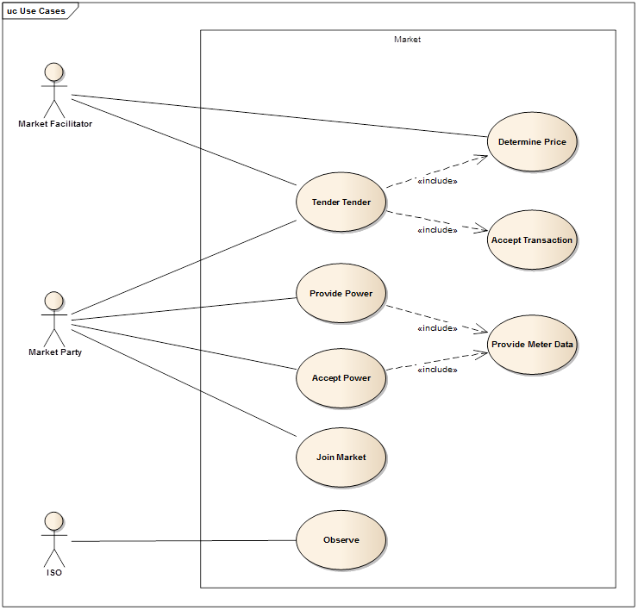

Class View

