Referee expertise:
Referee #1: Neuroimaging & Psychiatry; ML
Referee #2: Neuroimaging & Psychiatry; ML
Referee #3: Psychiatric Genomics
NOTE ON FILE NAMING CONVENTIONS: Files prefixed with "Updated_" contain tracked changes showing modifications before and after revision. Files prefixed with "Updated_" contain the final clean versions with all changes incorporated.
Reviewers' comments:
Reviewer #1 (Remarks to the Author):
This study aims to develop and validate a deep learning framework that integrates polygenic risk scores (PGS) with diffusion MRI-derived white matter features to predict the onset and developmental trajectory of depression. The authors utilized a large multi-ethnic youth cohort from the ABCD study (N=4,741) and an independent Korean cohort (N=108), applying PGS to pretrain the model and subsequently fine-tuning it on white matter imaging data for depression classification and prediction. Additionally, the model identified key white matter tracts associated with depression. The study demonstrates certain strengths in methodological design, sample size, cross-population validation, and biological interpretability. However, the methodological descriptions lack sufficient detail, and several analytical approaches, result interpretations, and writing aspects need improvement to enhance the rigor and clarity of the paper. Moreover, given the existence of numerous high-performing multimodal fusion approaches, the lack of comparison with such methods reduces the methodological novelty of this study. In conclusion, the current version lacks critical implementation details, raising concerns about the reliability and reproducibility of the reported findings.
1. Major Strengths
(1) The innovative use of PGS (including both depression PGS and composite PGS) for pretraining the white matter imaging model leverages potential gene-brain structural associations to improve downstream depression prediction; (2) Identification of depression-associated white matter tracts, contributing to biological interpretability; (3) Use of a large ABCD dataset and validation on an independent Korean cohort, as well as longitudinal evaluation of predictive performance; (4) Comprehensive experimental design, but insufficient detail in implementation limits reproducibility.
2. Major Concerns
The methodology and experimental details require substantial clarification and supplementation. While the authors conducted multiple experiments to demonstrate the method's effectiveness from different angles, it is strongly recommended that each experiment be briefly introduced with its purpose and procedure before presenting results, to help readers better follow the research flow. To further enhance clarity, a comprehensive schematic diagram of the entire pipeline (including data partitioning, model training, validation, and evaluation) is strongly encouraged, rather than limiting to the analytical process shown in Figure 1. Importantly, without sufficient methodological transparency, the credibility of the findings is significantly compromised.
Specific points requiring clarification include:
(1) How were the "10 matched subsets with diverse controls" generated (line 121)? Table S1 does not provide demographic details for each of the three stages of data usage. Please elaborate on the population characteristics used in each stage and provide brief explanations for the variables in the demographic table rather than simply listing them without context. Also, please clarify whether the pretraining set (N=4,741) is completely independent of the fine-tuning/testing set to avoid data leakage. In Figure S1, a total of 5,248 ABCD participants were included in the study, yet the sum of samples used in the three stages (4,741 + 266 + 236) does not match this number, please explain the discrepancy.
-> We sincerely thank the reviewer for this comment. We confirm that there is no overlap between participants in the pretraining, fine-tuning, and prediction sets, and we have carefully verified this throughout our analysis. However, we acknowledge that this critical information was not sufficiently detailed in the original manuscript. We have now updated both the main text and Supplementary Materials to provide complete transparency. The detailed participant flow is as follows:
- Starting cohort: 11,875 participants from the ABCD study
- Step 1 - Initial data screening: Removed 16 participants with missing critical data across 555,888 data points → 11,859 participants
- Step 2 - Basic eligibility criteria: Excluded 20 participants who were:
- Non-native English speakers
- Reported history of severe traumatic brain injury
- Had documented abnormal neuroimaging findings → 11,839 participants
- Step 3 - Twin/sibling selection: Randomly selected one individual from each twin/sibling pair, excluding 872 participants → 10,967 participants
- Step 4 - Diffusion MRI quality control: Excluded 2,477 participants due to:
- Missing diffusion MRI acquisition
- Failed eddy current QC
- Problems in structural connectivity generation → 8,490 participants
- Step 5 - Track-weighted imaging quality control: Excluded 836 participants with issues in track-weighted FA or tractography generation → 7,654 participants
- Step 6 - Complete data requirements: Excluded 2,007 participants lacking KSADS data, CBCL data and genetic data → 5,647 participants
The detailed elaboration of ABCD subset division process is as follows:
1) Fine-tuning Set: Cross-sectional MDD Classification (N=266 per fold, 10 folds)
- MDD group: 133 participants meeting baseline MDD criteria
- KSADS lifetime MDD diagnosis = 1 (from child or parent report)
- No other developmental disorders
- Healthy Control (HC) group: Selected from 1,269 participants who remained healthy at both baseline and 2-year follow-up
- 10-fold cross-validation strategy:
- Each of the 133 MDD participants was divided into 10 stratified folds
- Each fold served as the test set exactly once
- For each fold, train:validation:test ratios were approximately 7:2:1
- HC participants were matched via propensity score matching (age, sex, study site) for each fold
- Specific sample sizes per fold (train:val:test):
  - Fold 1: 180:48:38
  - Fold 2: 200:44:22
  - Fold 3: 186:54:26
  - Fold 4: 178:60:28
  - Fold 5: 184:56:26
  - Fold 6: 174:66:26
  - Fold 7: 190:48:28
  - Fold 8: 184:52:30
  - Fold 9: 198:50:18
  - Fold 10: 188:54:24
- Each fold contains 266 participants (133 MDD + 133 HC), but the specific individuals in train/val/test sets vary across folds.
- Total unique individuals used in fine-tuning: 634 (133 MDD + 501 HC across all folds)
2) 2-Year Follow-up Prediction Set: Zero-shot Evaluation
- Initial 2y follow-up MDD group: 154 participants who developed MDD at 2-year follow-up
- Critical exclusion for zero-shot evaluation: Participants with MDD at BOTH baseline AND 2-year follow-up were excluded to prevent data leakage and ensure unbiased prediction (these participants were already in the fine-tuning set).
- Final prediction cohorts:
- MDD without suicidality: 118 participants (new-onset MDD at 2-year)
- MDD with suicidal active ideation: 58 participants
- MDD with suicide attempt: 15 participants
- HC participants were matched via propensity score matching (age, sex, study site) for each prediction cohort. Since it was zero-shot prediction task, we did not split into train/val/test set.
- Total unique individuals used in 2-year prediction: 251 (including both MDD and matched HC)
3) Pretraining Set (N=4,741)
- The pretraining set included all remaining participants not used in either the fine-tuning set (634 participants) or the 2-year prediction set (251 participants) or participants who developed MDD symptoms in 2years later but who was not in prediction set (21 participants). This includes:
- HC participants not selected for matching in fine-tuning or prediction sets
- Participants with varying levels of depressive symptoms but not meeting full MDD criteria at baseline or 2-year follow-up
- Participants without psychological/psychiatric outcomes
- Complete independence verified: No participant appears in multiple sets (pretraining, fine-tuning, or prediction).
- Total cohort = 4741+634+251+21 = 5,647
Also, the reviewer correctly noted that 4,741 + 266 + 236 = 5,243, which differs from the reported participants. This discrepancy occurred due to an error in our initial exclusion accounting:
- During Step 4 (diffusion MRI QC), we excluded participants with structural connectivity issues
- During Step 5 (track-weighted imaging QC), we performed additional QC that identified some participants with overlapping issues
- 399 participants were double-counted in the exclusion flowchart (excluded in both steps)
We apologize for the lack of clarity in the original manuscript's flowchart and sample descriptions. We have now provided the exact participant flow and emphatically confirm that all analyses presented were performed on these three, strictly independent, and mutually exclusive datasets (Pretraining N=4,741; total unique Fine-tuning N=634; and total unique Prediction N=251). This rigorous partitioning, which was correctly implemented in our original analysis, ensures that no data leakage occurred.
To ensure complete transparency, we have:
- Updated Supplementary Figure S1 with a clear flowchart showing exact numbers at each exclusion step & inclusion/ exclusion criteria.
- Updated the “Participants’ section of the Supplementary text, specifically adding the second and third paragraphs detailing the dataset partitioning and the demographic characteristics of each group
  - Participants underwent systematic quality control and exclusion procedures. After removing 16 participants with missing critical data, 20 participants were excluded for not being fluent in English, having a history of severe traumatic brain injury, or having documented abnormal neuroimaging findings. For multiple births (twins/triplets/sibling), only one sibling was randomly selected, resulting in exclusion of 872 participants. Subsequently, 2,477 participants were excluded due to missing diffusion MRI acquisition, failed eddy current QC, or problems in structural connectivity generation. An additional 836 participants were excluded for issues in track-weighted FA or tractography generation during track-weighted imaging quality control. Finally, 2,007 participants lacking genetic data, KSADS, CBCL data were excluded.
The remaining 5,647 participants were partitioned into three completely non-overlapping sets to ensure unbiased evaluation. The fine-tuning set consisted of 133 participants meeting baseline MDD criteria (KSADS lifetime MDD diagnosis from child or parent report, with no other developmental disorders) and 501 healthy controls were selected from 1,269 participants who remained healthy at both baseline and 2-year follow-up, matched via propensity score matching (age, sex, study site) across 10-fold cross-validation. The 2-year follow-up prediction set included 118 participants with new-onset MDD (excluding those with MDD at both baseline and 2-year to prevent data leakage), 58 with suicidal active ideation, and 15 with suicide attempts, along with their propensity score-matched controls. The pretraining set comprised 4,741 remaining participants, including those not used in fine-tuning or prediction sets, and 21 participants who developed MDD symptoms at 2-year follow-up but were not included in the prediction set. Ultimately, a total of 5,647 participants were included in our analysis (Fig S1.A), with complete independence verified across all three sets.
- We have also updated Supplementary Table S1 to include comprehensive demographic characteristics (age, sex, ABCD site, genetic ancestry) for each of the three stages (pretraining, fine-tuning, and 2-year prediction), along with brief explanations of each variable.
We hope this comprehensive clarification addresses the reviewer's concerns regarding data partitioning and sample size discrepancies.
(2) How were the "multimodal models trained without pretraining" implemented? Was it simply concatenation of multimodal features? Please specify the model construction in more detail. It is also recommended to compare the proposed method with established multimodal fusion approaches.
-> We appreciate the reviewer for this comment, which highlighted the need for clearer methodological description.
Yes. The reviewer is correct that our ‘multimodal models trained without pretraining’ employed feature concatenation. Specifically, the 3DCNN+MLP model extracts features from TW-FA images via 3DCNN, concatenates these features with PGS values, and passes them through an MLP for classification. The only difference between our PGS-pretrained and from-scratch models is the initialization of 3DCNN weights (pretrained vs random). This was described in Methods (lines 497-498), but we recognized this placement can cause confusion. We have now moved whole ‘Methods’ section in front of ‘Result’ section for immediate clarity.
We appreciate the reviewer's suggestion to compare against established multimodal fusion approaches. We deliberately chose our simpler, concatenation-based architecture for two principled reasons that directly align with our core research question and the constraints of our specialized dataset.
1. Sample size constraints in pediatric neuroimaging: Our small size of fine-tuning dataset (N=266) reflects a common challenge in pediatric psychiatric neuroimaging research. Sample sizes in this field typically range from 15-200 per diagnostic group [1]. Modern multimodal fusion methods often employ attention-based mechanisms that are widely recognized as being 'data-hungry' and require substantial training data for adequate performance. When trained from small-mid size datasets, Vision Transformer (ViT), a typical model which is based on attention mechanisms, underperform CNNs even in unimodal approach [2]. Furthermore, training deep architectures with complex fusion mechanisms such as cross-modal attention has been shown to be computationally intensive and prone to overfitting when applied to small multimodal datasets [3,4].
Therefore, we adopted a parameter-efficient approach: (1) a relatively efficient 3DCNN backbone, and (2) concatenation-based fusion, which follows the ‘joint fusion’ strategy described by Huang et al. (2020). This approach offers key advantages: it models interactions between multimodal features, learns compatible representations from each modality, and avoids the need to train multiple separate models, all while maintaining parameter efficiency suitable for smaller datasets [5].
2. Research question specificity: Our primary research question was not to optimize multimodal fusion per se, but rather to address the challenge of youth depression prediction in small samples by leveraging prior knowledge about gene-brain associations. This consideration was critical because when the domain gap between pre-training and target datasets is substantial, even sophisticated fusion architectures may not overcome the fundamental challenge of limited target-domain data [6]. Our approach specifically tested whether pretraining on the well-established association between genetic risk and white matter integrity could improve depression prediction in limited data regimes.
This required a targeted comparison: pretrained vs. from-scratch models with identical architectures, isolating the effect of PGS-guided pretraining. Introducing more complex fusion methods (e.g., cross-modal attention) would confound interpretation, performance differences could arise from either the pretraining strategy or the fusion mechanism, obscuring our core research question.
We agree that systematic comparison with advanced fusion architectures represents an important future direction. We have added this to the Discussion (lines 536-540) [Updated Main Text], emphasizing that such approaches may provide additional benefits as larger pediatric depression datasets with multimodal data become available.
Fourth, our study employed a 'joint fusion' strategy rather than more complex, state-of-the-art fusion models. This was a deliberate methodological choice, prioritizing a parameter-efficient model suitable for our modest sample size of finetune set (N=266). However, we acknowledge that this represents a trade-off, and future work with larger, dedicated datasets should explore whether advanced fusion mechanisms could yield further improvements in predictive accuracy.
References
- Schnack & Kahn (2016). Detecting Neuroimaging Biomarkers for Psychiatric Disorders: Sample Size Matters. Front Psychiatry, 7:50.
- Dosovitskiy et al. (2021). An Image is Worth 16x16 Words: Transformers for Image Recognition at Scale. ICLR.
- Dhawan, M., Sharma, S., Kadam, A. et al. Game-on: graph attention network based multimodal fusion for fake news detection. Soc. Netw. Anal. Min. 14, 114 (2024). https://doi.org/10.1007/s13278-024-01271-4
- C. Sun, A. Shrivastava, S. Singh, and A. Gupta, “Revisiting unreasonable effectiveness of data in deep learning era,” in Proc. IEEE Int. Conf. Comput. Vis. (ICCV), Oct. 2017, pp. 843–852.
- Huang, S.C., et al. (2020). Fusion of medical imaging and electronic health records using deep learning. npj Digital Medicine, 3:136.
- Z. Wang, Z. Dai, B. Poczos, and J. Carbonell, “Characterizing and avoiding negative transfer,” in Proc. IEEE/CVF Conf. Comput. Vis. Pattern Recognit. (CVPR), Jun. 2019, pp. 11285–11294.
(3) Line 146 claims that the pretrained 3DCNN outperformed traditional machine learning models. Please clarify whether the training data, features, and evaluation protocols were consistent across the comparisons, otherwise, the comparison lacks validity.
-> We thank the reviewer for this crucial point, which allows us to clarify the consistency of our experimental design.
We confirm that all models were compared fairly, using identical source data and most importantly, identical 10-fold cross validation splits. This ensures that the exact same participants were used for training, validation and testing across all experiments, providing a valid basis for comparison. This was stated in the Methods section: "All experiments were conducted using 10-fold cross-validation, ensuring that the same training, validation, and test folds were used consistently across all experiments" (lines 497-498). However, we recognize that the placement of Methods after Results may have obscured this critical detail. For conventional ML models, we used flattened FA-weighted structural connectivity + PGS. Models like SVM and XGBoost cannot take raw 3D images as direct input. Therefore, we extracted a 1D feature vector (the flattened connectivity matrix) and concatenated it with PGS. For deep learning models, we used the 3D TW-FA images and PGS. This (a 3D white matter imaging) is the optimal input for 3DCNN and later concatenated with PGS as it is mentioned in Methods.
To improve transparency, we have made the following changes:
- We moved entire ‘Methods’ section to appear before ‘Results section
- The following sentence has been added to the Result section (lines 267; Updated Main Text):
  - All experiments including comparison models were conducted using identical splits.
- We added comprehensive details for the traditional machine learning models (SVC linear, SVC rbf, XGBOOST) including all hyperparameter settings to the Updated Supplementary Materials, ensuring full reproducibility
  - Comparison with Conventional Machine Learning Models
All ML models were implemented in Python (scikit-learn, xgboost) and evaluated using the identical 10-fold cross-validation splits as our deep learning models to ensure a fair comparison. For each fold, we first fit a StandardScaler on the train set and used this scaler to transform the validation and test sets. We then performed a grid search to find the optimal hyperparameters by training on the train set and evaluating performance on the validation set. The best model was then evaluated on the held-out test set. The hyperparameter grids searched were: SVC (Linear and RBF): C ([0.1, 1, 10, 100]), kernel (either ['linear'] or ['rbf']), and random_state ([1234]); XGBoost: n_estimators ([100, 200, 300]), max_depth ([3, 4, 5]), learning_rate ([0.01, 0.1, 0.2]), reg_alpha ([0.1, 0.5, 1.0, 1.5, 2.0]), and random_state ([1234]).

(4) The performance difference between depression PGS and composite PGS models (e.g., AUROC 0.597 vs. 0.62 in Table 1) is not discussed. Please provide possible explanations or cite relevant supporting literature.
-> We appreciate the reviewer's insightful observation regarding the performance metrics in Table 1. We have expanded the manuscript to clarify the rationale behind the Composite PGS and to discuss the performance nuances between the two PGS models.
As detailed in the Methods, our Composite PGS was constructed using a data-driven Elastic Net approach, which identified Depression, BMI, and Alcohol Dependence as the optimal combination for predicting baseline depressive symptoms. This empirical finding aligns with established literature documenting the shared genetic architecture among these traits (Wray et al., 2018; Zhou et al., 2017). The slight numerical advantage of the Composite PGS in cross-sectional analysis (AUROC 0.62 vs. 0.597) likely reflects its ability to capture a broader range of genetic liabilities associated with current symptom severity.
While composite PGS showed numerically higher cross-sectional performance compared to depression-specific PGS (AUROC 0.62 vs. 0.597), this difference was not statistically significant (p=0.089). Interestingly, in zero-shot 2-year prediction, depression-specific PGS significantly outperformed composite PGS (0.619 vs. 0.61, p=0.006). This reversal may reflect that composite weights, optimized on baseline symptoms, align well with concurrent phenotypes but generalize less effectively to longitudinal outcomes where symptom trajectories may diverge from baseline presentations. However, this explanation remains speculative and requires validation in independent longitudinal datasets.
Most importantly, regardless of the PGS type used, our results consistently demonstrate that integrating polygenic risk with white matter imaging via our pretraining framework yields substantial improvements over unimodal or non-pretrained baselines. This confirms that the core contribution of our work lies in the methodology of gene-brain integration rather than the superiority of a specific polygenic score. We have added this discussion to the Discussion section of the updated manuscript.
Discussion (Lines 424-430; Updated Main text)
Our composite PGS, which integrated Depression, BMI, and Alcohol Dependence selected via data-driven Elastic Net optimization, showed similar cross-sectional performance to depression-specific PGS (AUROC 0.62 vs. 0.597), while depression-specific PGS showed better performance in zero-shot 2-year prediction (0.619 vs. 0.61). Importantly, both approaches demonstrated substantial improvements when integrated with white matter imaging through pretraining compared to unimodal and non-pretrained multimodal baselines, indicating that the primary value lies in the polygenic-informed white matter representational learning framework.

References
- Wray, N. R., Ripke, S., Mattheisen, M., et al. (2018). Genome-wide association analyses identify 44 risk variants and refine the genetic architecture of major depression. Nature Genetics, 50(5), 668-681.
- Zhou, H., Polimanti, R., Yang, B. Z., et al. (2017). Genetic risk variants associated with comorbid alcohol dependence and major depression. JAMA Psychiatry, 74(12), 1234-1241.
(5) In the Decision Curve Analysis section, please explain the basis for threshold selection and the clinical interpretation of net benefit values.
-> We appreciate the reviewer’s opportunity to clarify our Decision Curve Analysis (DCA). We have updated the manuscript to explicitly describe the rationale behind the threshold selection and the clinical interpretation of the net benefit, specifically within the context of our balanced test sets.
The DCA was performed using our test sets which was balanced (1:1 matching), resulting in a prevalence of approximately 50Consequently, the 'Treat All' strategy shows positive net benefit up to a threshold probability of nearly 0.5, after which it rapidly declines. This makes the threshold range around 0.4-0.6 particularly important for evaluating the model's clinical utility, as these represent the decision points where distinguishing true cases from controls becomes most critical. As shown in Supplementary Figure 7, our model maintains a high net benefit in this range, whereas the net benefit of the ‘Treat All’ strategy decreases rapidly and crosses zero. This demonstrates that our model provides robust clinical utility specifically at these decision thresholds, which are most relevant for distinguishing cases from controls in a balanced risk scenario.
Regarding the clinical interpretation of net benefit, we have clarified this in the Discussion section following Vickers et al. (2021). For example, in the 2-year follow-up model (Fig. S7B), at a threshold probability of 0.5, the model achieves a net benefit of approximately 0.1, indicating that using our model is equivalent to correctly identifying 10 additional MDD cases per 100 patients without increasing false positives, compared to the 'Treat None' strategy.
To improve transparency, we have made the following changes:
Methods (Lines 240-256; Updated Main Text)
Decision Curve Analysis
To assess the clinical utility of our model, we conducted Decision Curve Analysis (DCA) by computing net benefit across a range of clinically relevant threshold probabilities [59]. Net benefit quantifies the balance between true positives and false positives, incorporating the relative harm of unnecessary interventions. It is calculated as:
Net Benefit=(True Positives - False Positives × p_t/(1-p_t ) )/N
where 𝑝 is the threshold probability, and 𝑁 is the sample size. The threshold probability is defined as the minimum probability of disease at which a clinician would opt for an intervention. Mathematically, this threshold serves as the relative weight between the benefit of true positives and the harm of false positives (unnecessary interventions). We compared our best-performing models against two baseline strategies: ‘Treat All’ (assuming all individuals are at risk and should receive intervention) and ‘Treat None’ (assuming no individuals require intervention). Given the balanced nature of our dataset (approximate prevalence of 50%), we evaluated net benefit across threshold probabilities with emphasis on the 0.40–0.60 range where model discrimination is particularly informative given the balanced prevalence. A higher net benefit across threshold probabilities indicates superior clinical applicability by improving the identification of at-risk individuals while minimizing unnecessary interventions.
Results (Lines 322-331; Updated Main Text)
Decision Curve Analysis (DCA) Results for Clinical Utility
To evaluate the potential clinical utility of our pretrained models, we conducted a Decision Curve Analysis (DCA) comparing the default strategies including, “Treat All” and “Treat None” with our best-performing PGS-pretrained 3DCNN. In the clinically relevant threshold probability range of 0.4-0.6, where the decision boundaries are most critical given the balanced nature of the dataset, our model consistently yielded higher net benefit values compared to both comparison strategies (Figure. S3 A, B). Specifically, at a threshold probability of 0.50, the model achieved a net benefit of approximately 0.10, whereas the net benefit of the "Treat All" strategy decreased markedly. This indicates superior performance in identifying children who would progress to MDD while minimizing unnecessary interventions.
Discussions (Lines 468-477; Updated Main Text)
While our model’s AUROCs in the 0.61-0.66 range fall within the moderate performance band, they consistently surpassed unimodal and conventional machine learning baselines. In the context of low-prevalence, high-stakes conditions such as youth depression [7], even modest improvements in future outcome prediction can provides incremental predictive value. Decision curve analysis (DCA) [74] further demonstrated that our models offer higher net benefit over default strategies such as “treat-all” or “treat-none” approaches, particularly in the threshold range of 0.4-0.6. To interpret this clinically, a net benefit of 0.1 at a threshold of 0.5 is equivalent to identifying 10 additional true positive cases per 100 patients without increasing the number of false positives [74]. These findings support the clinical utility of biologically informed prediction models, not as stand-alone diagnostics, but as components of multi-tiered screening frameworks.
(6) The calculation and biological implications of PGS and composite PGS lack detailed explanation. Please supplement this information to ensure reproducibility.
-> We appreciate the reviewer’s concern regarding reproducibility and have substantially expanded the Methods section to provide comprehensive technical details on PGS calculation and composite PGS construction.
1) Detailed PGS calculation Methodology
All PGS used in this study were calculated following the methodology established and validated in Joo et al., (2024) [1]. We have added comprehensive section to our Updated Supplementary Materials (Genetic Data Preprocessing Section) as below:
Genotype Quality Control and Preprocessing
The ABCD study collected saliva samples from participants, which were genotyped at Rutgers University Cell and DNA Repository using the Affymetrix SmokeScreen Array consisting of 733,293 single nucleotide polymorphisms (SNPs). We applied standard quality control filters using PLINK version 1.9, removing variants with genotype call rates below 95%, samples with call rates below 95%, and variants with minor allele frequency (MAF) less than 1%. Following these initial filters, genotypes were imputed using the Michigan Imputation Server with the 1000 Genomes Phase 3 reference panel, yielding a total of 12,046,090 SNPs. The imputed data were phased using Eagle v2.4. After imputation, we applied additional stringent quality control measures, removing SNPs with imputation quality scores (INFO) below 0.4, genotype call rates below 95%, Hardy-Weinberg Equilibrium p-values less than 1×10⁻²⁰ (appropriate for diverse ethnic populations), sample missingness greater than 5%, MAF below 0.5%, and variants showing extreme heterozygosity (defined as exceeding three standard deviations from the population mean). These comprehensive filters resulted in a final set of 11,221,810 high-quality variants for PGS construction.
Addressing Population Structure and Genetic Relatedness
Given the multi-ethnic composition of the ABCD cohort, we implemented rigorous procedures to address potential population stratification due to genetic relatedness and ancestry admixture. We employed the PC-Air algorithm implemented in the SNPRelate R package to identify genetically unrelated individuals and compute ancestrally informative principal components robust to familial or cryptic relatedness. This process involved two rounds of principal component analysis. In the first round, we obtained initial pairwise kinship coefficient estimates using the KING-robust algorithm on a pruned set of independent genetic variants (linkage disequilibrium threshold r²<0.1). We identified genetically related individuals with kinship coefficients indicating closer than third-degree relatives (kinship threshold = 2⁻⁹/², approximately equivalent to first cousins), retaining only one individual per related pair for the main analysis while setting aside excluded individuals as an independent validation set (n=1,814). The PC-Air algorithm identified an unrelated set of 8,845 individuals based on these pairwise kinship estimates and systematically computed principal components of their genotype data. Subsequently, PC-Relate was applied to compute refined kinship estimates adjusting for ancestry, providing estimates robust to population structure and admixture. The second round of PC-Air then computed accurate principal components using this refined unrelated set. We further excluded 88 participants whose projected principal components had Mahalanobis distances greater than 6 standard deviations from the population mean. This comprehensive process resulted in a final analytic sample of 8,620 unrelated individuals. The 1,814 individuals initially excluded from relatedness analysis were further assessed for third-degree relatedness, yielding a final independent validation set of 1,579 unrelated individuals used for PGS hyperparameter optimization.
PGS Construction Using PRS-CSx
To estimate individual-specific polygenic liability for complex traits, we employed PRS-CSx, a state-of-the-art Bayesian polygenic modeling technique designed for cross-population prediction. PRS-CSx implements an effective posterior inference algorithm that explicitly accounts for population-specific allele frequencies and linkage disequilibrium (LD) patterns by adopting a shared continuous shrinkage prior across ancestries. This approach is particularly appropriate for multi-ethnic cohorts as it leverages information from multiple ancestry groups to improve prediction accuracy. For PGS construction, we utilized LD reference panels for European-ancestry (EUR) and Admixed Americans (AMR) from the 1000 Genomes Project Phase 3, selected in accordance with the discovery GWAS samples. Although PRS-CSx can automatically estimate the global shrinkage hyperparameter (φ), we conducted a small-scale grid search across φ values of 1×10⁻⁶, 1×10⁻⁴, 1×10⁻², and 1 for traits where corresponding phenotypes were available in the ABCD dataset, selecting the φ value that maximized explained variance to optimize predictive performance.
Multi-Ancestry PGS Integration
For five complex traits—BMI, PTSD, depression, schizophrenia, and alcohol dependence—GWAS summary statistics were available from both European-ancestry and non-European-ancestry populations. For these traits, we constructed multi-ethnic PGS by combining ancestry-specific GWAS summary statistics through learning the optimal linear combination of ancestry-specific PGS. This approach explicitly models the contribution of each ancestry-specific genetic architecture to trait variation in our admixed population. For example, in constructing multi-ancestry depression PGS, if the optimal φ value for the European-ancestry-based PGS was 1 and for the Admixed-American-based PGS was 1×10⁻², the regression model would be: depression outcome = (GPS_depression_EUR × β₁) + (GPS_depression_AMR × β₂) + (sex × β₃) + (top 10 genetic PCs × β₄...₁₃) + (genetic ancestry × β₁₄) + ε. The β coefficients representing the optimal weighting of each ancestry-specific PGS were estimated through this regression framework to maximize predictive accuracy in our multi-ethnic sample.
PGS Validation and Optimization
After constructing the initial PGS, we validated and optimized them using available phenotypes in the ABCD dataset. For traits with corresponding measures in ABCD, we tuned the global shrinkage hyperparameter by examining the effect size (β coefficient) and significance of the PGS in linear regression models across the grid-searched φ values, selecting the φ that maximized both effect size and model R². This optimization was conducted in the independent validation set of 1,579 unrelated participants who were excluded during the relatedness quality control process, ensuring unbiased hyperparameter selection. Final optimized PGS were then assessed for validity in the full analytic sample of 8,620 participants, with regression models adjusting for sex, age, study site, and genetic ancestry. For 15 GWAS traits that lacked corresponding target phenotypes in the ABCD study, we employed PRS-CS-auto, which automatically selects the hyperparameter φ from data using a fully Bayesian approach, providing pseudo-validation for these traits.
We also updated the main manuscript to reflect this change. The Main Text manuscript refers to this new, detailed information by stating (line 144-145; Updated Main Text):
Full details on genotype preprocessing and the complete PGS calculation methodology are provided in the Supplementary Materials.
2) Composite PGS construction
Among the 29 traits in Joo et al. (2024) [1], only five PGS, BMI, PTSD, depression, schizophrenia, and alcohol dependence, were constructed as multi-ethnic PGS using both European-ancestry and non-European-ancestry GWAS summary statistics. We selected these five as candidate predictors for our composite PGS because they were the only traits with multi-ancestry GWAS data available, ensuring applicability across the diverse ethnic composition of our ABCD cohort and planned Korean validation sample as it was mentioned above.
From these five candidates, we employed Elastic Net regularization to identify the optimal weighted combination. The target outcome for optimization was a depressive symptom score derived from KSADS-COMP in the pretraining set (n=4,741). We used symptom scores rather than diagnostic status because the pretraining set deliberately excluded all participants with lifetime MDD diagnosis, this exclusion was necessary to maximize the sample size available for the subsequent fine-tuning set where MDD classification was performed. The Elastic Net model was fitted to maximize explained variance (R²) while minimizing the number of independent variables through stepwise elimination across 5,000 resampled train-validation-test splits. This iterative data-driven approach consistently identified three PGS, Depression, BMI, and Alcohol Dependence, as providing optimal predictive performance. PTSD and Schizophrenia PGS did not improve explained variance beyond these three and were therefore excluded. The final composite PGS was computed as: Composite PGS = (β_Depression × GPS_Depression) + (β_BMI × GPS_BMI) + (β_Alcohol × GPS_Alcohol Dependence), where the β coefficients represent the optimal weights from the best-performing Elastic Net model.
We updated the Methods Section (lines 154-172) in Updated Main Text manuscript under the subsection (‘Genetic Data Preprocessing’)
We included composite PGS in our analysis, guided by prior research, that demonstrated the increased predictive power of composite PGS in enhancing risk stratification [53, 54]. Among the 29 traits in Joo et al. (2024), five PGS, BMI, PTSD, depression, schizophrenia, and alcohol dependence, were constructed as multi-ethnic PGS by combining GWAS summary statistics from both European-ancestry and non-European-ancestry populations (detailed in Supplementary Materials). From these five multi-ancestry candidate PGS, we employed Elastic Net regularization, which is robust in multicollinearity, to identify the optimal weighted combination that maximized prediction of depressive symptoms in our pretraining set. Because the pretraining set (n=4,741) excluded participants with lifetime MDD diagnosis to maximize the sample size for the fine-tuning set, we used a depressive symptom score derived from KSADS-COMP as the target outcome for composite PGS optimization. The Elastic Net model was fitted to maximize explained variance (R²) while minimizing the number of independent variables through a stepwise elimination process across 5,000 resampled train-validation-test splits within the pretraining set. This iterative optimization consistently identified three PGS—Depression, BMI, and Alcohol Dependence—as providing the best predictive performance. The final composite PGS was computed as a weighted sum of these three selected PGS, each weighted by its corresponding beta coefficient from the best-performing model. PTSD and Schizophrenia PGS were excluded during the regularization process as they did not improve explained variance beyond the contribution of the three retained PGS.
Reference
1. Joo, Y.Y., et al., Polygenic architecture of brain structure and function, behaviors, and psychopathologies in children. bioRxiv, 2024: p. 2024.05.22.595444.
(7) Please review the over 100 references cited in the manuscript to ensure their relevance and avoid excessive or redundant citations.
->We thank the reviewer for this important suggestion to streamline our reference list. We conducted a comprehensive review of all citations and reduced the total number of references from 103 to 84, removing 19 citations that were redundant or less directly relevant to our core findings.
Our review followed several principles: First, we removed redundant citations where multiple papers conveyed the same point, retaining the most authoritative sources (e.g., meta-analyses, large consortium studies) while removing single-site or overlapping studies. Second, we eliminated citations that were tangential to our main narrative, focusing on papers that directly inform our methodological approach, findings, or interpretation rather than general background context. Third, we addressed duplicate citations where the same paper appeared multiple times across sections, retaining each citation only in its most relevant context. Fourth, we consolidated citations where one comprehensive paper adequately covered the point, avoiding unnecessary citation clusters.
The remaining 84 references represent essential citations that directly support our study's rationale, methodology, findings, or interpretation. We believe this revision has substantially improved the manuscript's focus while ensuring all remaining citations are directly relevant and non-redundant.
(8) Furthermore, making the used data and reproducible code publicly available (subject to ethical and legal constraints) would greatly strengthen the transparency, credibility, and broader impact of this study.
-> We greatly appreciate the reviewer’s emphasis on transparency and reproducibility. The ABCD data are publicly accessible through the NIMH Data Archive (https://abcdstudy.org/scientists_data_sharing.html). The Korean cohort data are subject to IRB restrictions but can be shared with qualified researchers upon request. Our code used for the analysis (3DCNN, 3DCNN + MLP) is now publicly available at https://github.com/mieuxmin/PGSTWFA-3DCNN to facilitate reproducibility. Also, we have now added a dedicated “Data and Code Availability” section to the Updated Main Text manuscript (lines 583-590) to address this important point.
Data and Code Availability
The ABCD Study data are publicly available through the NIMH Data Archive (https://abcdstudy.org/scientists_data_sharing.html). The Korean cohort data are subject to IRB restrictions protecting participant privacy but may be shared with qualified researchers upon reasonable requests to the corresponding author, following institutional review and completion of appropriate data use agreements. The 3DCNN and 3DCNN+MLP model implementations used in this study are publicly available at https://github.com/mieuxmin/PGSTWFA-3DCNN with documentation to support reproducibility.
3. Minor Issues
(1) Carefully check the use of abbreviations: full terms should be provided upon first appearance, and brief explanations added when necessary to improve readability. Also, all abbreviations in figures and tables should be defined and explained. For instance, in Figure S1, the meaning of “SC data” should be clearly stated.
-> We thank the reviewer for the detailed comments. We checked the manuscript to ensure that all key abbreviations (e.g., PGS, MDD, dMRI, FA, TW-FA, 3DCNN, KSADS-COMP, ABCD) are clearly defined upon their first appearance. We also appreciate the comment on the ambiguity in Figure S1. 'SC data' stood for 'structural connectivity data,' and this has been clarified in the updated figure.
(2) Improve the quality of all figures, especially Figure 2C where axis labels are unclear, consider enlarging or bolding the font.
-> We appreciate this suggestion. We have updated all figures to improve the resolution quality and readability, specifically enlarging and bolding the axis labels in Figure 2C as recommended.
(3) Revise formatting issues throughout the manuscript, such as extra spaces, missing punctuation, etc..
-> We appreciate the meticulous review. We have checked and corrected the formatting issues you pointed out (such as extra spaces, missing punctuation, etc.) throughout the manuscript.")
Reviewer #2 (Remarks to the Author):
This study proposes a novel deep learning method that integrates brain white matter features with polygenic scores to enhance prediction performance for major depressive disorders in youth. The authors utilized a large dataset to fine-tune the model and demonstrated the scalability of their methodology across both sectional and ethnic groups. The manuscript requires significant clarification to be ready for publication. Additionally, several trivial writing and figure issues need to be addressed to improve readability.
Major Comments:
Clarification of Prior Literature (Line 35 vs. Line 42):
At line 35, the authors state that “studies have identified significant genetic correlations between measures of diffusion tensor imaging and depression-related traits.” However, this lacks specific details on how these correlations were determined. Moreover, this appears to contradict the statement at line 42 that “most studies have examined genetic and neuroimaging factors in isolation, failing to capture their complex interplay.” The authors should reconcile these two points and clearly specify what previous studies have done regarding genetic-neuroimaging associations.
-> We thank the reviewer for identifying this important ambiguity in our Introduction. We agree that the relationship between lines 35 and 42 requires clarification.
To address this, we have updated the Introduction to clearly distinguish between two types of prior research: (1) population-level genetic correlation studies that have identified shared genetic liability between white matter integrity and depression (line 35), and (2) individual-level predictive modeling studies, which have predominantly used genetic or neuroimaging features in isolation rather than integrating them (line 42).
Specifically, the studies referenced at line 35 [23, 36] employed genetic correlation methods to demonstrate shared genetic architecture at the population level, which is, genetic variants associated with white matter measures overlap with those associated with depression risk. However, these correlational findings have not been widely translated into individual-level prediction models that integrate both modalities. The studies cited at line 42 [32, 37-39] represent neuroimaging prediction studies that used either genetic data or brain imaging data, but not both simultaneously, to predict depression outcomes in individuals.
We updated the Introduction to make this distinction explicit as below.
Introduction (Lines 33-45; Updated Main Text)
The interplay between genetic predispositions and white matter integrity is critical for understanding the biological basis of depression. Supporting this, population-level genetic correlation studies have identified shared genetic liability between diffusion tensor imaging measures and depression-related traits [19, 28]. Additionally, forebrain white matter-related dMRI measures have been associated with single nucleotide polymorphisms in genes, encoding proteins involved in extracellular matrix and epidermal growth factor signaling, which are critical for myelin repair and synaptic plasticity and closely linked to MDD [16]. These findings suggest shared genetic mechanisms influencing both white matter integrity and depression susceptibility.
Despite these correlational findings at the population level, critical gaps remain intranslating genetic-neuroimaging associations into individual-level prediction of youth depression. Most studies have examined genetic and neuroimaging factors in isolation, failing to capture their complex interplay [24, 29, 30].

We believe these revisions clarify the gap our study addresses: while genetic correlations between brain structure and depression have been established at the population level, integrating these modalities for individual-level risk prediction remains underexplored.
Model Training and Validation Strategy (Line 67):
The manuscript lacks sufficient detail on how the 10-fold cross-validation was implemented. Specifically, it is unclear how the "Finetune" dataset (N=266) was used in the context of model training and evaluation. If the Finetune dataset was used both for tuning hyperparameters and reporting final performance metrics, this could lead to data leakage and inflated performance estimates (“double-dipping”). The authors should adopt standard machine learning nomenclature (e.g., training, validation, and test sets) and clarify the role each subset played in model development and evaluation.
-> We thank the reviewer for this important comment regarding our training and validation strategy. We acknowledge that the original manuscript lacked sufficient detail about our cross-validation implementation and data partitioning strategy. We have now substantially clarified these procedures in the Methods section to address concerns about potential data leakage.
Our study employed three completely separate datasets with distinct roles:
- Pretraining Set (N=4,714): Used exclusively for PGS-based pretraining with genetic prediction targets. This set was partitioned into train/validation/test (7:2:1 ratio) using 10-fold iterative stratification. Hyperparameter selection was performed using validation set performance, and pretraining was completed before any exposure to the finetuning dataset.
- Finetuning Set (N=266): Used exclusively for cross-sectional MDD classification. Critically, this set was completely held out from the pretraining phase and shares no participants with the pretraining set. We implemented proper cross-validation as follows:
  - The dataset was partitioned into 10 folds using iterative stratification
  - For each iteration, one fold served as the test set (ensuring every participant appears in a test set exactly once)
  - The remaining 9 folds were split 7:2 into training and validation sets
  - Hyperparameter tuning (learning rate, weight decay) was performed using only the validation set
  - Final model selection was based on validation performance
  - The selected model was then evaluated on the held-out test set
  - Reported performance metrics represent the average across all 10 test sets, with no test set data used for model selection or hyperparameter tuning
- 2-Year Follow-up Set (N=236 for MDD; N=116 for MDD+suicidal ideation; N=30 for MDD+suicide attempt): Completely separate from both pretraining and finetuning sets, used exclusively for zero-shot longitudinal prediction. No training or hyperparameter tuning occurred on this dataset.To address class imbalance, we created 10 balanced datasets by fixing case numbers and randomly sampling controls, with reported 2-year performance metrics representing the average across these 10 iterations.
We have substantially updated the Methods section (lines 198-205) in Updated Main Text of manuscript as below:
We employed three non-overlapping datasets: pretraining, finetuning, and 2-year follow-up prediction set. For cross-sectional MDD classification, we implemented nested 10-fold cross-validation with 7:2:1 train/validation/test splits. Hyperparameter tuning was performed exclusively on validation sets, and model evaluation was conducted solely on held-out test sets, ensuring no data leakage. Each participant appeared in exactly one test set. Reported performance metrics represent averages across all 10 test sets. For 2-year predictions, zero-shot inference was conducted without additional training, with metrics averaged across 10 matched iterations.
Reporting of F1 Scores (Figure 2):
Figure 2 presents multiple F1 scores for each model, but it is not clear how these scores were obtained. Were they derived through nested cross-validation, or are they from repeated runs on held-out sets? Ideally, model comparisons should be based on performance on an independent test set. The authors should clarify their methodology and justify their approach.
-> We thank the reviewer for this important clarification request. We acknowledge that the original manuscript did not clearly explain how the reported F1 scores were derived.
The F1 scores presented in Figure 2 and other performance metrics reported in Table 1-2 were derived through our 10-fold cross-validation strategy, where each score represents performance on an independent test set that was completely held out from model training and hyperparameter tuning. Specifically:
  - The dataset was partitioned into 10 folds using iterative stratification
  - For each iteration, one fold served as the test set (ensuring every participant appears in a test set exactly once)
  - The remaining 9 folds were split 7:2 into training and validation sets
  - Hyperparameter tuning (learning rate, weight decay) was performed using only the validation set
  - Final model selection was based on validation performance
  - The selected model was then evaluated on the held-out test set
  - Reported performance metrics represent the average across all 10 test sets, with no test set data used for model selection or hyperparameter tuning
This methodology aligns with the reviewer's recommendation for model comparisons based on independent test set performance. Each of the 10 F1 scores was computed on data that the model had never seen during training or validation, providing an unbiased estimate of generalization performance.
We have substantially updated the Methods section (lines 198-205) in Updated Main Text of manuscript as below:
We employed three non-overlapping datasets: pretraining, finetuning, and 2-year follow-up prediction set. For cross-sectional MDD classification, we implemented nested 10-fold cross-validation with 7:2:1 train/validation/test splits. Hyperparameter tuning was performed exclusively on validation sets, and model evaluation was conducted solely on held-out test sets, ensuring no data leakage. Each participant appeared in exactly one test set. Reported performance metrics represent averages across all 10 test sets. For 2-year predictions, zero-shot inference was conducted without additional training, with metrics averaged across 10 matched iterations.
Statistical Analysis of F1 Scores:
The manuscript lacks details on the statistical test on the F1 scores. It is mentioned in the supplementary maters that Wilcoxon rank sum test was used. As there are multiple models, it is better to first run a Kruskal-Wallis H test and run post-hoc test with multiple comparison correction.
-> We appreciate the reviewer's constructive suggestion regarding statistical testing. While our primary research question focuses on whether PGS-pretraining improves upon each specific baseline approach (PGS-only, brain-only, and from-scratch multimodal models), we agree that an omnibus test provides additional rigor. Therefore, we have complemented our pairwise Wilcoxon rank-sum tests with Kruskal-Wallis H tests to assess overall differences across all models.
The Kruskal-Wallis H tests confirmed statistically significant differences across models for all prediction tasks. For cross-sectional MDD classification, we observed significant overall differences for both depression PGS models (H = 11.12, p = 0.025) and composite PGS models (H = 15.00, p = 0.005). Two-year follow-up MDD prediction showed even stronger effects with depression PGS models (H = 43.85, p < 0.001) and composite PGS models (H = 45.10, p < 0.001). Similarly, prediction of MDD with suicidal active ideation demonstrated highly significant differences for depression PGS models (H = 44.22, p < 0.001) and composite PGS models (H = 46.61, p < 0.001). Finally, prediction of MDD with suicide attempts also showed significant overall differences for both depression PGS models (H = 33.38, p < 0.001) and composite PGS models (H = 33.77, p < 0.001).
These omnibus tests confirm that significant performance differences exist across the model architectures. Our subsequent pairwise comparisons (Dunn’s test) with false discovery rate correction(FDR_BH) then specifically identify which baseline models are outperformed by our PGS-pretrained approach, directly addressing our primary research hypothesis. We have added these Kruskal-Wallis H test results to Supplementary Figure 8. Now this section is updated as below.
Figure-S8– Kruskal-Wallis H Tests and Post-hoc Dunn’s Test for Overall Model Comparisons
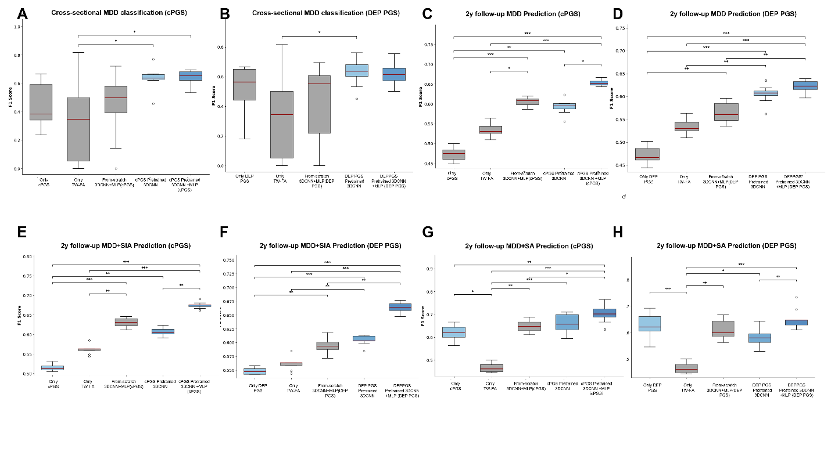
Supplementary figure 8.
Box plots displaying F1 score distributions across all model architectures for each prediction task. (A-B) Cross-sectional MDD classification using composite PGS and depression PGS. (C-D) Two-year follow-up MDD prediction using composite PGS and depression PGS. (E-F) Two-year follow-up MDD with suicidal active ideation prediction using composite PGS and depression PGS. (G-H) Two-year follow-up MDD with suicide attempt prediction using composite PGS and depression PGS. Box plots show median (red line), interquartile range (box), and full range excluding outliers (whiskers). Kruskal-Wallis H test p-values indicate overall significant differences across models for all tasks. Pairwise post-hoc comparisons were performed using Dunn's test with FDR_BH. Significance levels: * p < 0.05, ** p < 0.01, *** p < 0.001. Gray boxes represent baseline models (PGS-only MLP, brain-only 3DCNN, from-scratch multimodal 3DCNN), while blue boxes indicate PGS-pretrained models.
To complement our pairwise statistical comparisons, we performed Kruskal-Wallis H tests to assess overall differences across all model architectures within each prediction task. These omnibus tests examined F1 scores across five models: PGS-only MLP, brain-only 3DCNN, from-scratch multimodal 3DCNN, PGS-pretrained 3DCNN, and PGS-pretrained 3DCNN with additional PGS input.
For cross-sectional MDD classification using depression PGS, the Kruskal-Wallis H test revealed significant differences across models (H = 11.1183, p = 0.025266). When using composite PGS, the effect was stronger (H = 14.9979, p = 0.004706). Two-year follow-up MDD prediction demonstrated highly significant overall differences for both depression PGS models (H = 43.8522, p < 0.000001) and composite PGS models (H = 45.1047, p < 0.000001). Prediction of MDD with suicidal active ideation at two-year follow-up showed similarly robust effects with depression PGS (H = 44.2186, p < 0.000001) and composite PGS (H = 46.6063, p < 0.000001). Finally, prediction of MDD with suicide attempts demonstrated significant overall model differences for depression PGS (H = 33.3833, p = 0.000001) and composite PGS (H = 33.7719, p = 0.000001). And the post-hoc analysis (Dunn’s Test) result is on Supplementary Figure 8.
Ambiguity in Table 1 Descriptions:
In Table 1, the entry “Only TW-FA with feature TW-FA” appears to be duplicated and lacks clarity. Additionally, the terminology conflates model types with input features. The table should indicate what machine learning models were used (e.g., SVM, XGBoost, or CNN), not just the features. A consistent and clear presentation of model type and input features is necessary.
-> We sincerely thank the reviewer for their careful observation and for catching this error. The reviewer is correct. This was typographical error in the table labeling, which created unnecessary confusion. The model in question is the ‘from-scratch 3DCNN model using only TW-FA as input’, which serves as our unimodal (brain-only) comparison model. We have now corrected this error in the Table2 [Updated Main Text]. The table now clearly lists this model as from scratch 3DCNN, to avoid ambiguity.
Model Specificity for Depression Prediction:
The manuscript would benefit from a discussion of the specificity of the proposed model to major depressive disorder (MDD). Is the model specifically trained and validated for MDD, or could it be identifying general psychiatric risk? This has important implications for both clinical utility and interpretation.
-> We thank the reviewer for this important comment regarding the diagnostic specificity of our MDD prediction models. This is indeed a critical question with significant implications for clinical interpretation and utility. To directly address this concern, we have conducted comprehensive cross-diagnostic validation analyses at both baseline and 2-year follow-up, which we have now included in the updated manuscript.
We systematically evaluated whether our MDD-trained models discriminate: (1) the target disorder (MDD), (2) other internalizing disorders (anxiety disorders), and (3) externalizing disorders (conduct disorder) using KSADS-5 diagnostic criteria. We selected anxiety disorders as representative of the broader internalizing spectrum and conduct disorder as representative of externalizing psychopathology. These analyses were performed for both our Composite PGS-pretrained and DEP PGS-pretrained 3DCNN models at baseline (training cohort, test set) and 2-year follow-up (zero-shot prediction with sensitivity analyses across 10 balanced iterations).
In the 9-10y (cross-sectional) baseline, the Composite PGS-pretrained 3DCNN model (our best-performing baseline model) demonstrated MDD-specific discrimination, showing significant differentiation for MDD diagnosis (p=0.0081) but not for anxiety disorders (p=0.0992) or conduct disorder (p=0.97) (Supplementary Figure S10). This pattern indicates that the model learned MDD-specific neurobiological features rather than capturing general psychopathology or internalizing distress. The DEP PGS-pretrained 3DCNN model showed broader internalizing sensitivity, with significant discrimination for both MDD (p=0.0083) and anxiety disorders (p=0.0066), but not conduct disorder (p=0.3066) (Supplementary Figure S9). This suggests that DEP PGS pretraining captures shared neurobiological substrates across internalizing disorders.
Sensitivity analyses across 10 iterations at 2-year follow-up revealed distinct patterns of diagnostic specificity between the two pretraining approaches. The Composite PGS-pretrained 3DCNN model maintained robust MDD-specific prediction, showing significant discrimination in all 10 iterations (100%) for MDD, inconsistent discrimination for anxiety disorders (4/10 iterations, 40%), and minimal discrimination for conduct disorder (1/10 iterations, 10%). Adding MLP layers to the Composite PGS model (3DCNN+MLP) preserved this MDD-centered pattern while improving anxiety discrimination (MDD: 10/10 iterations, 100%; anxiety: 8/10 iterations, 80%; conduct disorder: 1/10 iterations, 10%).
In contrast, the DEP PGS-pretrained models demonstrated a different specificity profile. The DEP PGS 3DCNN showed highly consistent MDD discrimination (9/10 iterations, 90%) but limited discrimination for anxiety disorders (1/10 iterations, 10%) and no discrimination for conduct disorder (0/10 iterations, 0%). However, adding MLP layers substantially enhanced the model's internalizing sensitivity, achieving perfect MDD discrimination (10/10 iterations, 100%) and near-perfect anxiety discrimination (9/10 iterations, 90%), while maintaining no significant discrimination for conduct disorder (0/10 iterations, 0%).
Across both pretraining approaches and architectures, the consistent discrimination of MDD across iterations, contrasted with minimal or absent discrimination of conduct disorder, confirms that these models capture internalizing-specific rather than general psychopathology patterns. The differential patterns between Composite and DEP PGS pretraining, with Composite showing more MDD-specific discrimination and DEP+MLP showing broader internalizing sensitivity, suggest that the choice of genetic pretraining influences the specificity-breadth trade-off in learned neurobiological representations.
We have substantially updated the manuscript to incorporate these findings:
- Added Supplementary Figure S9-S12 as below.
- Added Supplementary Table S34-S45 for statistics of specificity analyses in 2y followup 10 iterations
Figure-S9– Diagnostic specificity of cross-sectional MDD classification models (DEP PGS)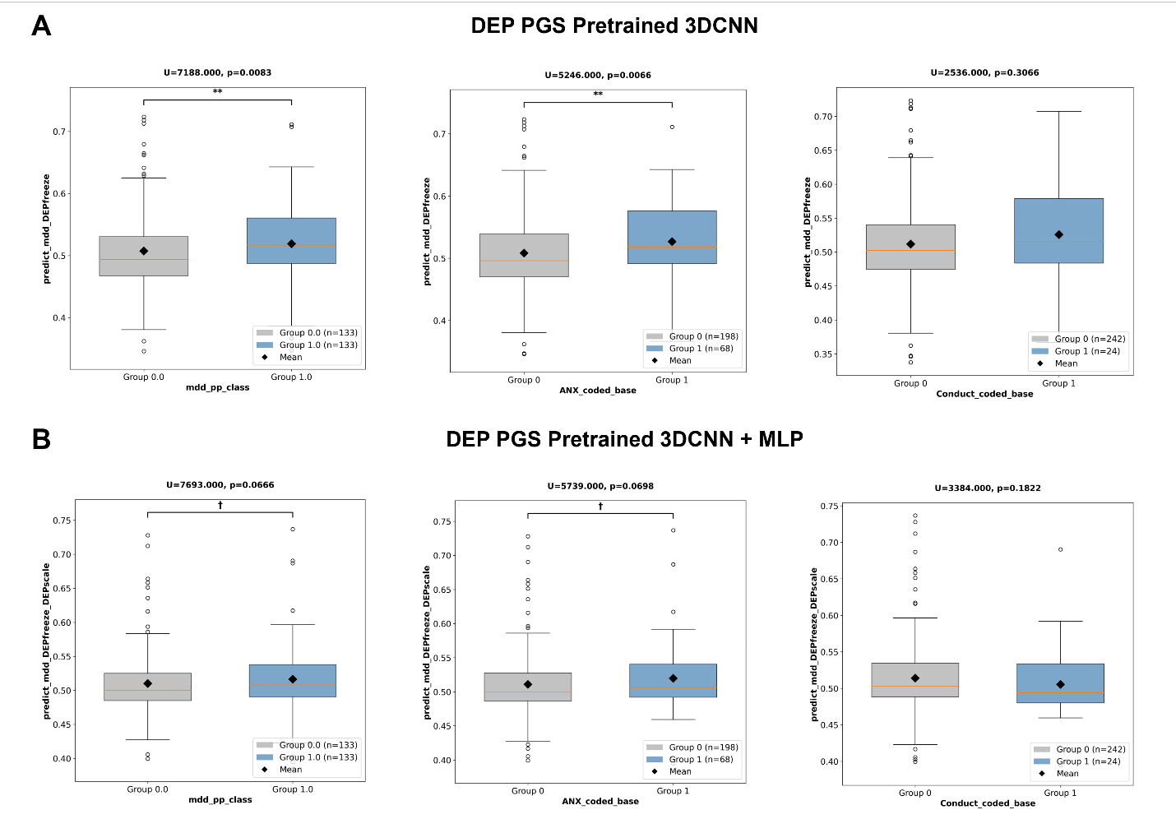
Supplementary figure 9.
Diagnostic specificity of cross-sectional MDD classification models. (A) DEP PGS-pretrained 3DCNN showed significant discrimination for both MDD (p=0.0083**) and anxiety (p=0.0066**), but not conduct disorder (p=0.3066, n.s.), indicating broader internalizing sensitivity than the Composite PGS model. (B) 3DCNN+MLP showed reduced effects with marginal discrimination for MDD (p=0.0666†) and anxiety (p=0.0698†), but not conduct disorder (p=0.1822, n.s.). Mann-Whitney U tests. **p<0.01, †p<0.10. Gray=no disorder, blue=disorder present, diamonds=means.
Figure-S10– Diagnostic specificity of cross-sectional MDD classification models (Composite PGS)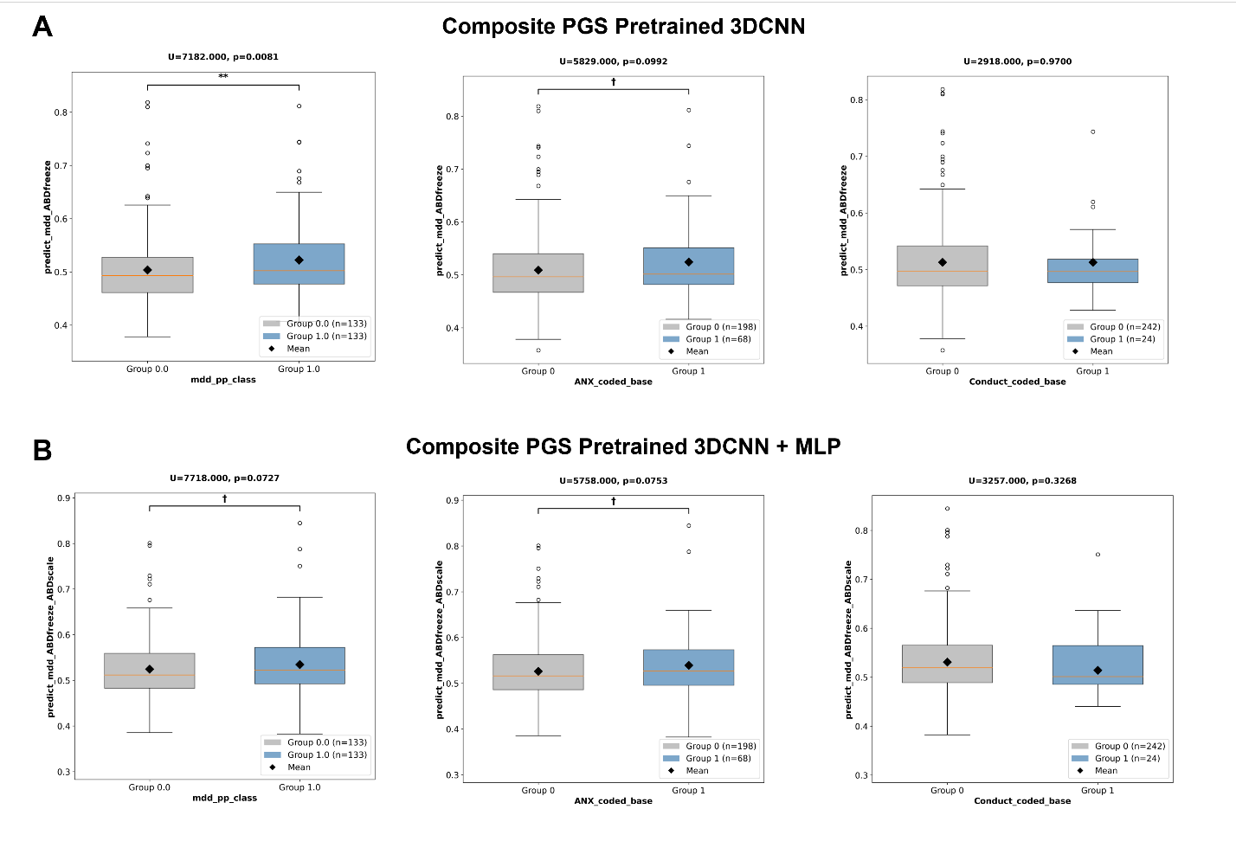
Supplementary figure 10.
Diagnostic specificity of cross-sectional MDD classification models. (A) Composite PGS-pretrained 3DCNN (baseline best model) showed significant discrimination only for target disorder MDD (p=0.0081**), not for anxiety (p=0.0992†) or conduct disorder (p=0.9700, n.s.), demonstrating diagnostic specificity. (B) 3DCNN+MLP model showed reduced specificity with only marginal effects for MDD (p=0.0727†) and anxiety (p=0.0753†), and no effect for conduct disorder (p=0.3268, n.s.). The 3DCNN model's selective discrimination for MDD indicates target-specific learning rather than general psychopathology detection. Mann-Whitney U tests. **p<0.01, †p<0.10. Gray=no disorder, blue=disorder present, diamonds=means.

Figure-S11– P-value distributions across 10 iteration sensitivity iterations. (DEP PGS) 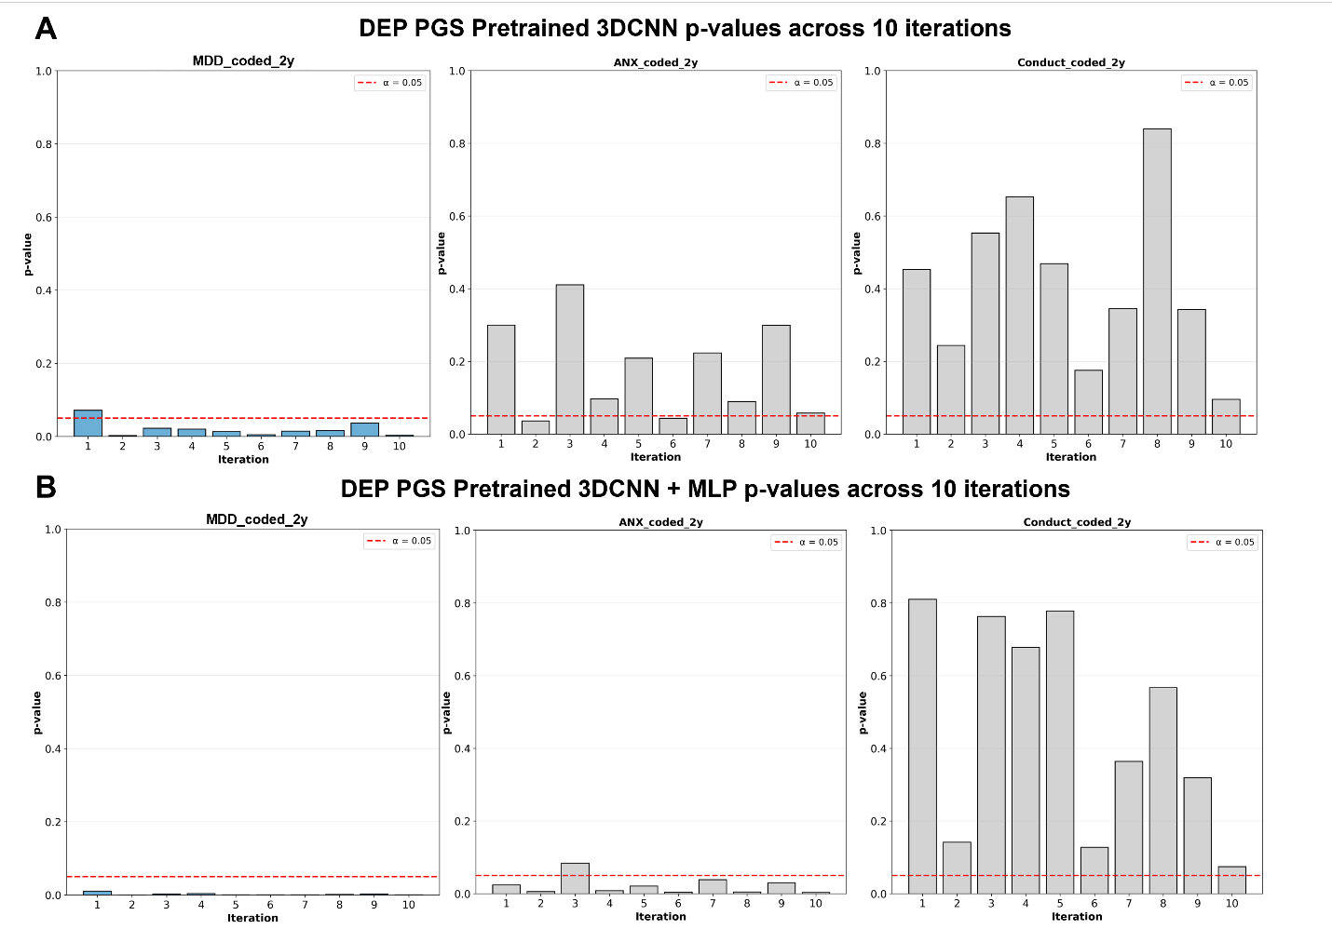
Supplementary figure 11.
P-value distributions across 10 iteration sensitivity iterations. (A) DEP PGS 3DCNN showed consistent MDD discrimination (9/10 p<0.05) with limited anxiety discrimination (1/10 p<0.05) and no conduct discrimination (0/10 p<0.05). (B) 3DCNN+MLP achieved complete MDD discrimination (10/10 p<0.05) and near-complete anxiety discrimination (9/10 p<0.05) and no conduct discrimination (0/10 p<0.05) Red line=α=0.05.

Figure-S12– P-value distributions across 10 iteration sensitivity iterations. (Composite PGS)
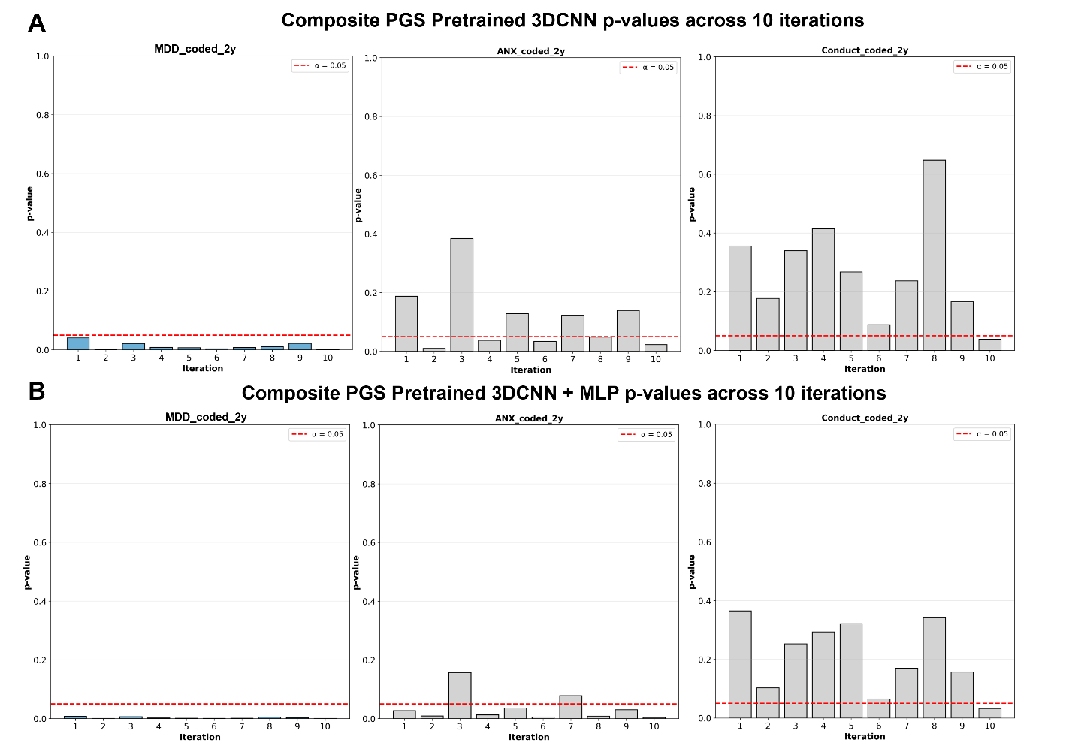
Supplementary figure 12.
P-value distributions across 10 iteration sensitivity iterations. (A) Composite PGS 3DCNN showed consistent MDD discrimination (10/10 iterations p<0.05), inconsistent anxiety discrimination (4/10 p<0.05), and no conduct disorder discrimination (1/10 p<0.05). (B) 3DCNN+MLP showed similar pattern: MDD (10/10 p<0.05), anxiety (8/10 p<0.05), conduct disorder (1/10 p<0.05). Consistent significance across all MDD iterations versus sporadic or absent significance for other disorders demonstrates robust target-specific zero-shot prediction. Red line=α=0.05.

Minor Comments:
Terminology Consistency (Tables 1 and 2):
The terms “composite PGS” and “cPGS” appear to refer to the same feature but are used inconsistently. Please standardize terminology throughout the manuscript for clarity.
-> We appreciate the reviewer’s comment on pointing out this inconsistency of using cPGS and composite PGS while referring to the same feature. To improve clarity and reduce the number of abbreviations, we have standardized the terminology to "composite PGS" throughout the entire manuscript (Main text and Supplementary Materials), including all tables and figures.
Identical Results (Table 2):
In Table 2, the models “from-scratch 3DCNN TW-FA” and “Only TW-FA TW-FA” report identical results. Please verify whether this is accurate or a copy-paste error.
-> We sincerely thank the reviewer for their careful observation and for catching this error. The reviewer is correct. These two entries refer to the exact same model. This was typographical error in the table labeling, which created unnecessary confusion. The model in question is the ‘from-scratch 3DCNN model using only TW-FA as input’, which serves as our unimodal (brain-only) comparison model. We have now corrected this error in the Table2 [Updated Main Text]. The table now clearly lists this model as from scratch 3DCNN, to avoid ambiguity.
Table Formatting:
The headers in Tables 1 and 2 are repeated. Consider either removing redundant headers or presenting each section as a separate table to improve readability.
->We appreciate the helpful suggestion on improving the readability of our tables. We understand that the repeated headers, which we originally included to show the parallel results for both 'composite PGS' and 'Depression PGS', made the tables dense and difficult to read. To address this, we have streamlined the main text as you suggested. We have kept the primary results table (for 'composite PGS') in the main manuscript as most of the figures are also based on composite PGS results. We moved the corresponding results for 'Depression PGS' to the Supplementary Materials (now Table S3, S4; Updated Supplementary Materials). This makes the main text clearer while ensuring all results remain accessible.
Figure Readability:
The font size used in the figures is too small and may be difficult to read, especially for visually impaired or older readers. Please increase the font size and ensure all labels are clearly legible.
-> We are grateful for the reviewer’s helpful suggestion regarding figure readability. All figures have been updated to enhance legibility, including an increase in font size as recommended.
Typographical Error (Line 826):
There is a typo at line 826: “Intendent” should likely be “Intended.”
-> We thank the reviewer for catching this typographical error. The word ‘Intendent’ should have been ‘Independent’, referring to the independent Korean cohort as mentioned in Table3. This has been corrected in the updated main text manuscript.
Age Group Clarification (Line 795):
The phrase “Fine-tuned model evaluates 9–10y depression classification” is unclear. Does this refer to predicting depression diagnosis in participants aged 9–10 years? Please rephrase for clarity.
-> We thank the reviewer for pointing out this lack of clarity. In our effort to be concise, the figure caption became ambiguous. The reviewer’s interpretation is correct. This refers to a cross-sectional classification task. We use brain images from participants at baseline (age 9-10) to predict their concurrent depression diagnosis (also at age 9-10), which is based on the KSADS.
We also want to clarify a critical point that the caption failed to convey. This cross-sectional (age 9-10) task is the only step where fine-tuning occurs. The subsequent 2-year follow-up prediction (which uses the same baseline age 9-10 images to predict future symptoms) is a zero-shot evaluation, meaning the fine-tuned model is applied directly without any additional training. To make this entire flow clear, we have updated the Figure 1 caption as follows:
Figure 1. Analysis Flows. This study integrates Track-Weighted FA and PGS to enhance youth depression prediction. The model is pretrained on white matter imaging and depression-related PGS using a 3D convolutional neural network. The model is then fine-tuned for cross-sectional classification (using TW-FA taken at age 9-10 to predict concurrent depression at age 9-10). This fine-tuned model is subsequently utilized in two ways: (1) as a zero-shot prediction of 2-year follow-up depression (using TW-FA taken at age 9-10 to predict future outcomes), and (2) for generalizability in an independent Korean cohort.

Reviewer #3 (Remarks to the Author):
Comments for Author
Manuscript Review for Communications Medicine July 2025
Manuscript Title: Polygenic Risk-Informed White Matter Integrity Improves Deep Learning-Based Prediction of Youth Depression
General Feedback:
In this paper Min et al. address the issue of early detection of youth depression and present a model incorporating both genetic risk and neuroimaging to improve prediction of depression and suicidality in at-risk youths. Early detection of psychiatric disorders offers significant benefits, including improved treatment outcomes, reduced severity of symptoms, and prevention of secondary complications. This is particularly true for early-onset disorders, which tend to have more detrimental outcomes.
The over-all study design is good: the ABCD cohort is an excellent choice for this study; the results show good replication in an independent Korean cohort; and the 2-year follow-up prediction is good (better than other unimodal and machine learning models), though still below clinical AUROC threshold of 0.80. However, this manuscript is lacking crucial details for the design and implementation of the model, specifically for the PGS component of this study. Referring the reader to a second paper (Joo et al., BioRxiv, 2024) for all details of this central part of the project is insufficient (see detailed comment below). Moreover as the Results report that the model does not perform as well as the symptom-based model (retaining 80-90% predictive accuracy of the symptom-based model) it is unclear what clinical benefit this model provides in comparison to existing behavioural and symptomatic assessments. A better explanation of how an at-risk (pre-symptomatic) cohort would benefit from this approach (or be selected for MRI/genomic assessment) is required to support the benefit and usefulness of this approach in a clinical setting (“particularly when for-casting longer-term psychiatric outcomes”). That would counter the better performance of the symptom-based model. These points and the points outlined below need to be addressed before this manuscript is ready for publication.
Major:
1. Results:
“Further details on PGS calculations are provided in the methods Genetic Data Preprocessing”. The section of the methods referred to in this quoted text recommends readers to refer to a separate paper by Joo et al. (BioRxiv, 2024) to get “a detailed description of the method”. However, the paper by Joo et al. uses a number of PGS scores (35 GWAS summary statistics for 29 traits, including two depression, one MDD and one cross-disorder GWAS) and it is not clear how these scores have been incorporated in the current study. For example, what depression PGS is used as the “DEP PGS” in this model? Joo et al. present multiple Depression GWAS summary statistics and it is not clear which one (or multiple?) was used by the authors. Similarly it is unclear what traits/PGS were included in the composite PGS. If a subset of the data from Joo et al. was used there are no details given of which PGS were included or an explanation for why that subset was selected.
The PGS used for both the Depression PRS and composite PRS need to be clarified and the selection criteria need to be justified.
-> We appreciate the reviewer for this valuable feedback and apologize for the lack of details regarding the PGS methodology. We have now substantially expanded the Methods section to include all critical technical details directly in the manuscript, eliminating the need to consult external references for reproducibility.
1) Detailed PGS calculation Methodology
All PGS used in this study were calculated following the methodology established and validated in Joo et al., (2024) [1]. We have added comprehensive section to our Updated Supplementary Materials (Genetic Data Preprocessing Section) as below:
Genotype Quality Control and Preprocessing
The ABCD study collected saliva samples from participants, which were genotyped at Rutgers University Cell and DNA Repository using the Affymetrix SmokeScreen Array consisting of 733,293 single nucleotide polymorphisms (SNPs). We applied standard quality control filters using PLINK version 1.9, removing variants with genotype call rates below 95%, samples with call rates below 95%, and variants with minor allele frequency (MAF) less than 1%. Following these initial filters, genotypes were imputed using the Michigan Imputation Server with the 1000 Genomes Phase 3 reference panel, yielding a total of 12,046,090 SNPs. The imputed data were phased using Eagle v2.4. After imputation, we applied additional stringent quality control measures, removing SNPs with imputation quality scores (INFO) below 0.4, genotype call rates below 95%, Hardy-Weinberg Equilibrium p-values less than 1×10⁻²⁰ (appropriate for diverse ethnic populations), sample missingness greater than 5%, MAF below 0.5%, and variants showing extreme heterozygosity (defined as exceeding three standard deviations from the population mean). These comprehensive filters resulted in a final set of 11,221,810 high-quality variants for PGS construction.
Addressing Population Structure and Genetic Relatedness
Given the multi-ethnic composition of the ABCD cohort, we implemented rigorous procedures to address potential population stratification due to genetic relatedness and ancestry admixture. We employed the PC-Air algorithm implemented in the SNPRelate R package to identify genetically unrelated individuals and compute ancestrally informative principal components robust to familial or cryptic relatedness. This process involved two rounds of principal component analysis. In the first round, we obtained initial pairwise kinship coefficient estimates using the KING-robust algorithm on a pruned set of independent genetic variants (linkage disequilibrium threshold r²<0.1). We identified genetically related individuals with kinship coefficients indicating closer than third-degree relatives (kinship threshold = 2⁻⁹/², approximately equivalent to first cousins), retaining only one individual per related pair for the main analysis while setting aside excluded individuals as an independent validation set (n=1,814). The PC-Air algorithm identified an unrelated set of 8,845 individuals based on these pairwise kinship estimates and systematically computed principal components of their genotype data. Subsequently, PC-Relate was applied to compute refined kinship estimates adjusting for ancestry, providing estimates robust to population structure and admixture. The second round of PC-Air then computed accurate principal components using this refined unrelated set. We further excluded 88 participants whose projected principal components had Mahalanobis distances greater than 6 standard deviations from the population mean. This comprehensive process resulted in a final analytic sample of 8,620 unrelated individuals. The 1,814 individuals initially excluded from relatedness analysis were further assessed for third-degree relatedness, yielding a final independent validation set of 1,579 unrelated individuals used for PGS hyperparameter optimization.
PGS Construction Using PRS-CSx
To estimate individual-specific polygenic liability for complex traits, we employed PRS-CSx, a state-of-the-art Bayesian polygenic modeling technique designed for cross-population prediction. PRS-CSx implements an effective posterior inference algorithm that explicitly accounts for population-specific allele frequencies and linkage disequilibrium (LD) patterns by adopting a shared continuous shrinkage prior across ancestries. This approach is particularly appropriate for multi-ethnic cohorts as it leverages information from multiple ancestry groups to improve prediction accuracy. For PGS construction, we utilized LD reference panels for European-ancestry (EUR) and Admixed Americans (AMR) from the 1000 Genomes Project Phase 3, selected in accordance with the discovery GWAS samples. Although PRS-CSx can automatically estimate the global shrinkage hyperparameter (φ), we conducted a small-scale grid search across φ values of 1×10⁻⁶, 1×10⁻⁴, 1×10⁻², and 1 for traits where corresponding phenotypes were available in the ABCD dataset, selecting the φ value that maximized explained variance to optimize predictive performance.
Multi-Ancestry PGS Integration
For five complex traits—BMI, PTSD, depression, schizophrenia, and alcohol dependence—GWAS summary statistics were available from both European-ancestry and non-European-ancestry populations. For these traits, we constructed multi-ethnic PGS by combining ancestry-specific GWAS summary statistics through learning the optimal linear combination of ancestry-specific PGS. This approach explicitly models the contribution of each ancestry-specific genetic architecture to trait variation in our admixed population. For example, in constructing multi-ancestry depression PGS, if the optimal φ value for the European-ancestry-based PGS was 1 and for the Admixed-American-based PGS was 1×10⁻², the regression model would be: depression outcome = (GPS_depression_EUR × β₁) + (GPS_depression_AMR × β₂) + (sex × β₃) + (top 10 genetic PCs × β₄...₁₃) + (genetic ancestry × β₁₄) + ε. The β coefficients representing the optimal weighting of each ancestry-specific PGS were estimated through this regression framework to maximize predictive accuracy in our multi-ethnic sample.
PGS Validation and Optimization
After constructing the initial PGS, we validated and optimized them using available phenotypes in the ABCD dataset. For traits with corresponding measures in ABCD, we tuned the global shrinkage hyperparameter by examining the effect size (β coefficient) and significance of the PGS in linear regression models across the grid-searched φ values, selecting the φ that maximized both effect size and model R². This optimization was conducted in the independent validation set of 1,579 unrelated participants who were excluded during the relatedness quality control process, ensuring unbiased hyperparameter selection. Final optimized PGS were then assessed for validity in the full analytic sample of 8,620 participants, with regression models adjusting for sex, age, study site, and genetic ancestry. For 15 GWAS traits that lacked corresponding target phenotypes in the ABCD study, we employed PRS-CS-auto, which automatically selects the hyperparameter φ from data using a fully Bayesian approach, providing pseudo-validation for these traits.
We also updated the main manuscript to reflect this change. The Updated Main Text manuscript refers to this new, detailed information by stating (line 144-145; Updated Main Text):
Full details on genotype preprocessing and the complete PGS calculation methodology are provided in the Supplementary Materials.
2) Depression PGS (DEP PGS) Specification
Among the 29 complex traits for which polygenic scores were constructed in Joo et al. (2024) [1], depression was one of five traits with multi-ancestry GWAS summary statistics available. Our study specifically utilized this multi-ancestry depression PGS for two key reasons: to ensure applicability across the diverse ethnic composition of the ABCD cohort, and because our PGS-pretrained white matter model was designed for subsequent transfer learning to an independent Korean cohort, requiring PGS derived from multi-ancestry GWAS to ensure that the learned gene-brain representations would generalize across populations.
3) Composite PGS construction
Among the 29 traits in Joo et al. (2024) [1], only five PGS, BMI, PTSD, depression, schizophrenia, and alcohol dependence, were constructed as multi-ethnic PGS using both European-ancestry and non-European-ancestry GWAS summary statistics. We selected these five as candidate predictors for our composite PGS because they were the only traits with multi-ancestry GWAS data available, ensuring applicability across the diverse ethnic composition of our ABCD cohort and planned Korean validation sample as it was mentioned above.
From these five candidates, we employed Elastic Net regularization to identify the optimal weighted combination. The target outcome for optimization was a depressive symptom score derived from KSADS-COMP in the pretraining set (n=4,741). We used symptom scores rather than diagnostic status because the pretraining set deliberately excluded all participants with lifetime MDD diagnosis, this exclusion was necessary to maximize the sample size available for the subsequent fine-tuning set where MDD classification was performed. The Elastic Net model was fitted to maximize explained variance (R²) while minimizing the number of independent variables through stepwise elimination across 5,000 resampled train-validation-test splits. This iterative data-driven approach consistently identified three PGS, Depression, BMI, and Alcohol Dependence, as providing optimal predictive performance. PTSD and Schizophrenia PGS did not improve explained variance beyond these three and were therefore excluded. The final composite PGS was computed as: Composite PGS = (β_Depression × GPS_Depression) + (β_BMI × GPS_BMI) + (β_Alcohol × GPS_Alcohol Dependence), where the β coefficients represent the optimal weights from the best-performing Elastic Net model.
We updated the Methods Section (lines 154-172) in Updated Main Text manuscript under the subsection (‘Genetic Data Preprocessing’)
We included composite PGS in our analysis, guided by prior research, that demonstrated the increased predictive power of composite PGS in enhancing risk stratification [53, 54]. Among the 29 traits in Joo et al. (2024), five PGS, BMI, PTSD, depression, schizophrenia, and alcohol dependence, were constructed as multi-ethnic PGS by combining GWAS summary statistics from both European-ancestry and non-European-ancestry populations (detailed in Supplementary Materials). From these five multi-ancestry candidate PGS, we employed Elastic Net regularization, which is robust in multicollinearity, to identify the optimal weighted combination that maximized prediction of depressive symptoms in our pretraining set. Because the pretraining set (n=4,741) excluded participants with lifetime MDD diagnosis to maximize the sample size for the fine-tuning set, we used a depressive symptom score derived from KSADS-COMP as the target outcome for composite PGS optimization. The Elastic Net model was fitted to maximize explained variance (R²) while minimizing the number of independent variables through a stepwise elimination process across 5,000 resampled train-validation-test splits within the pretraining set. This iterative optimization consistently identified three PGS—Depression, BMI, and Alcohol Dependence—as providing the best predictive performance. The final composite PGS was computed as a weighted sum of these three selected PGS, each weighted by its corresponding beta coefficient from the best-performing model. PTSD and Schizophrenia PGS were excluded during the regularization process as they did not improve explained variance beyond the contribution of the three retained PGS.
Reference
1. Joo, Y.Y., et al., Polygenic architecture of brain structure and function, behaviors, and psychopathologies in children. bioRxiv, 2024: p. 2024.05.22.595444.
2. Genotyping and QC of the Korean youth cohort:
There is a section describing genetic variant pre-processing for the ABCD cohort but not for the Korean cohort (no details of the genotyping or QC of variants used to generate PGS). These data should be included so the reader can understand how the Korean PGS compares to the ABCD PGS and the cross-population applicability of the model.
-> We thank the reviewer for raising this important point, as it gives us the opportunity to clarify our methodological approach. We acknowledge that our original manuscript did not clearly explain that genetic data were not used in the Korean cohort. The Korean validation dataset utilized only track-weighted FA (TW-FA) neuroimaging data, not polygenic scores.
Our transfer learning approach proceeded as follows: (1) The 3DCNN model was pretrained on the ABCD pretraining set using TW-FA as input and PGS (depression PGS or composite PGS) as the outcome to learn gene-brain associations. (2) This pretrained model was then fine-tuned on the ABCD 9-10y MDD dataset for depression classification. (3) Finally, this fine-tuned model was transferred to the Korean cohort using only TW-FA imaging data. This explains why the PGS calculation methodology in both the main text and Supplementary Materials describes only the ABCD cohort procedures.
We have now clarified this critical distinction in both the main text and Supplementary Materials to prevent confusion:
Main Text (Methods – Deep Neural Network Training Section, lines 192-197; Updated main text)
In the pretraining set in ABCD cohort, the 3DCNN model was trained with TW-FA as input and depression PGS or composite PGS as the outcome to learn gene-brain associations. The pretrained model weights were then used in the fine-tune set for MDD classification. Subsequently, this PGS-pretrained MDD classifier trained on ABCD data was transferred to the Korean cohort using only TW-FA (3DCNN models), without requiring genetic data from Korean participants. Detailed procedures for transfer learning are provided in the Supplementary Materials.
Supplementary Materials (Transfer Learning to Independent Dataset section)
Transfer Learning to Independent Dataset
Participants of Korean datasets were also partitioned through 10-fold iterative stratification to ensure there was no significant difference in distribution of biological sex, age (month) and the prediction target outcome. Train, validation, and test were divided in a ratio of 7:2:1. We conducted PSM to match the participants in the folds using same covariate variables. Hyperparameter tuning was performed within the following ranges: learning rate (lr) = {0.01, 0.001, 0.0001, 0.00001}, weight decay (wd) = {0.01, 0.001}, dropout = {0.1, 0.2} and compared validation performance metric to select the best model. All the metrics are reported in average value of all repeated settings. After generating TW-FA neuroimaging data for the Korean dataset, we performed transfer learning using the depression PGS-pretrained or composite PGS-pretrained 3DCNN models that had been fine-tuned on ABCD MDD classification. Thus, only the 3DCNN architecture was used for Korean cohort validation, as the 3DCNN+MLP model requires PGS input which was not available for Korean participants. Considering the ethnic difference between the two datasets, we chose to unfreeze the ABCD MDD classifier model's parameters.
We thank the reviewer again for highlighting this important clarification.
3. 2y follow-up MDD/MDD + suicide predictions:
Does the ABCD cohort have symptom data for multiple time points? If so, what time-point was used for the symptom-based model (the symptoms from the initial screen or the follow-up screen)? I would imagine symptoms recorded at these two time-points would give different results, therefore this needs to be clarified.
-> We thank the reviewer for the important clarification request. The symptom-based benchmark model used CBCL internalizing scores collected at age 9-10 years, along with age and biological sex as predictors. We used 1st visit (baseline) symptoms for both cross-sectional MDD classification and 2-year follow-up prediction.
The rationale for using baseline symptoms consistently across tasks is as follows: Our proposed model aims to demonstrate the predictive value of biological data (neuroimaging and polygenic risk scores) in the absence of symptom information. The symptom-based model serves as an upper-bound benchmark representing the current standard approach to depression screening in clinical practice, where symptom assessments are the primary diagnostic tool. By comparing our biological model against this symptom-based benchmark, we aimed to evaluate how much predictive information can be captured from biological risk markers alone.
Since our neuroimaging data (TW-FA) and polygenic scores were collected at baseline (age 9-10 years) and used to predict both cross-sectional and future outcomes, we used CBCL scores from the same timepoint to ensure temporal consistency across all predictor modalities. Using follow-up symptom scores would introduce temporal asymmetry, as baseline biological data would be compared against future symptom data, which would not reflect a fair comparison of predictive utility at the same measurement timepoint.
We have clarified this in the Updated Main Text Results section (line 283-285) by specifying:
The benchmark for psychiatric risk prediction was established using symptom-based model that incorporated behavior (CBCL internalizing problems at age 9-10 years), age, and biological sex, achieving an AUROC of 0.767±0.07.
4. Use of MRI for screening:
The Discussion states that the proposed model could be used to identify at-risk children before symptom onset (sentence in last paragraph: “(identifying) at-risk youth before symptom on-set”.) I agree that the proposed model could be very useful in this context, but how to identify these “at-risk youth” to assess in the first place is not clear. Are they selected based on family history first or is this considered a screening program? How would using MRI in a screening program be feasible considering the cost of MRI? “for youth flagged by clinical or genomic indicators” is a vague statement, particularly when the clinical indicators are likely to include symptom/behavioural data, which has been shown to be a better predictor than this model.
-> We thank the reviewer for this important question about clinical implementation. We have substantially updated our Discussion to clarify the clinical rationale, target population, and practical limitations of our approach.
1) Clinical Rational for why biological vulnerability markers matter
We respectfully acknowledge that our symptom-based benchmark model outperformed our biological model for 2-year prediction (AUROC 0.767-0.815 vs. 0.61-0.67). However, we emphasize several critical considerations.
First, the critical window for intervention. Once youth develop a clinical first episode of depression, they enter a high-risk trajectory characterized by substantial recurrence (46-50%), treatment resistance (~40%), chronicity (18% remain persistently unwell into adulthood), and elevated comorbidity. Early-onset depression is "particularly malignant and recalcitrant," being "more chronic and debilitating than depression beginning in adulthood." Recent reviews emphasize that "identifying young people at risk for recurring or chronic depression is critical," with optimal identification occurring before first clinical episode onset. [ref needed]
Second, the timing and nature of symptom-based prediction. Our symptom-based model utilized baseline behavioral symptoms (CBCL internalizing problems at ages 9-10) to predict clinical depression diagnosis at ages 11-12. While effective for this near-term prediction, subclinical symptoms in early childhood show mixed results for predicting outcomes in the more distant future. For example, symptoms reported at age 5 had "very limited accuracy" in predicting depression at ages 14 and 21 [1]. This temporal limitation is particularly relevant for preventive interventions, which ideally target individuals years before clinical episode onset.
2) Target Population and Implementation Strategy
We clarify that our model is not intended for universal screening but as a second-tier assessment for asymptomatic youth already identified as high-risk through more accessible first-tier methods.
Tier 1 (accessible screening): Family history of depression, polygenic risk scores, environmental risk factors
Tier 2 (targeted neuroimaging): For high-risk youth without current clinical symptoms (asymptomatic), our model provides enhanced risk stratification (8.5-24% improvement over PGS-only models)
This tiered approach mirrors established medical practice where costly imaging is reserved for genetically vulnerable individuals. We acknowledge that both PGS calculation and neuroimaging involve costs; however, these must be weighed against the substantial lifetime burden of early-onset depression.
3) Current Limitations and Future Directions
We recognize important limitations. Our model predicts from biological vulnerability (genetics + brain) without information about environmental stressors that trigger depression onset. Depression emerges from gene-environment interactions; our model captures only the vulnerability component. Notably, the ABCD dataset lacks detailed assessment of life stressors between baseline and follow-up, precisely when environmental can trigger likely precipitated depression in affected youth.
Despite this limitation, our model retained 80-88% of symptom-based model performance using only biological vulnerability markers. We position this as proof-of-concept that multimodal biological integration enhances prediction beyond unimodal approaches. Future research integrating environmental stressor assessments alongside genetic and neuroimaging data may enable pre-symptomatic prediction approaching symptom-based performance while retaining applicability before first episode onset, the critical window for primary prevention.
We have substantially updated our Discussion to tone down clinical utility claims while clarifying these limitations and future directions.
Discussion (lines 494-509; Updated Main Text)
Our model retained 80-88% of symptom-based model performance using only genetic and neuroimaging data, demonstrating the utility of biological vulnerability markers. While the symptom-based model utilizing baseline behavioral symptoms (CBCL internalizing problems) achieved superior 2-year prediction (AUROC 0.767-0.815), several considerations support the value of biological vulnerability assessment. First, the long-term predictive utility of subclinical symptoms in early childhood is questionable. For instance, childhood depressive symptoms have been reported to have ‘very limited accuracy’ for predicting depression occurring 9-16 years later [78]. Second, once youth develop a first clinical episode, they enter a high-risk trajectory characterized by substantial recurrence (46-50%) [5], treatment resistance (~40%) [79] and chronicity (18% remain persistently unwell)[5]. Early-onset depression is "particularly malignant and recalcitrant" [80], being "more chronic and debilitating than depression beginning in adulthood"[3], with optimal identification occurring before first clinical episode. Our approach captures biological vulnerability through genetic predisposition and brain structure, markers independent of current symptom state that provide stable indices of underlying risk, which may be particularly valuable for identifying pre-symptomatic youth years before clinical episode onset, when primary prevention remains possible.
Discussion (lines 515- 522; Updated Main Text)
Our model is not intended for universal screening but as a second-tier assessment for asymptomatic youth already identified as high-risk through family history or genetic screening. This targeted strategy mirrors established practices in other medical domains where costly imaging is reserved for genetically vulnerable individuals. For such high-risk but pre-symptomatic youth, integrating genetic and neuroimaging data improves prediction beyond genetic information alone (8.5-24% improvement over PGS-only models). While neuroimaging involves costs, these must be weighed against the substantial lifetime burden of early-onset depression [4].
Discussion (lines 523-527; Updated Main Text)
While this study provides valuable insights into youth depression, several limitations remain. First, our framework does not incorporate environmental factors like early stress and socio-economic status. Future research integrating environmental stressor assessments alongside genetic and neuroimaging data may enable pre-symptomatic prediction approaching symptom-based performance while retaining applicability before first episode onset.
Same paragraph lines 540-543
Finally, the practical implementation of a tiered screening approach requires validation in real-world clinical settings, assessment of cost-effectiveness, and development of standardized protocols for identifying and monitoring high-risk youth. This represents important directions for future work.
Minor:
Results
Line 116: The N for the various datasets should include case and control numbers.
-> We thank the reviewer for the helpful suggestion. We agree that specifying the case and control numbers improves clarity. We have updated the sentence to include this information in Updated Main Text (lines 259-260).
The updated sentence now reads:
The dataset was divided into three groups: Pretrain (N=4,741), Finetune (N=266 [Case N=133/Control N=133]), and 2-Year Follow-up Prediction (N=236 [Case N=118/Control N=118]) sets with additional subsets for suicidality analyses (Figure. S1)
Line 316: provide not provides
-> We thank the reviewer for catching this grammatical error. We have corrected the sentence as follow (lines 469-470; Updated Main Text):
In the context of low-prevalence, high-stakes conditions such as youth depression [5], even modest improvements in future outcome prediction can provide incremental predictive value.
Lines 324, 325, 329 and 331: consistency in capitalisation of “Cohen’s D”. Current text includes use of Cohen and cohen, D, d, and d.
-> We thank the reviewer for their attention to detail. We have corrected these inconsistencies and standardized the capitalization to 'Cohen's d' throughout the manuscript."
Methods
Line 376: “inclusion/exclusion criteria are provided in Supp at Table S1” actually in Fig S1.
-> We thank the reviewer for catching this incorrect reference. As the reviewer correctly noted, the inclusion/exclusion criteria are detailed in Figure S1, not Table S1. We have corrected this reference in the Updated Main Text manuscript (Methods Participants, line 72).
The updated sentence now reads: 'Detailed demographics and full inclusion/exclusion criteria are provided in Supplementary Materials (Figure. S1).
Line 425: “sampled from participants”. Delete “from”
-> We thank the reviewer for this grammatical correction. We have deleted the redundant from as suggested. The corrected sentence now reads (Methods, Demographic and Behavioral Variables, line 120):
In addition, to statistically evaluate the 2-year follow-up zero-shot prediction performance, we utilized individuals with MDD diagnosis at the 2-year follow-up and matched them with randomly sampled participants not included in either the pretrained or finetune sets (control: 118).
General comment on Figures and Tables (main and supplementary):
• highly pixelated and difficult to read. Labels are very small
• Figures don’t print properly as they go beyond page boundaries.
• SIA and SA are not defined anywhere in figures or text. Assume SA is suicide attempt and SIA is Suicide active ideation?
• Figure 1: Composite PGS: give max PGS # included (e.g. PGS 1,2,3… 29).
• Figure 2: Labels are very small and as image is pixelated they are not possible to read.
• Tables 1-3 would benefit from inclusion of legends/descriptions.
-> We thank the reviewer for this comprehensive and valuable feedback regarding the presentation of our figures and tables. We have made the following revisions to address each point:
1. Overall Figure Quality (Point 1,2,5): We acknowledge that the figures were not clear. We have re-exported all figures (including Figure 2) at a higher resolution (e.g., 300 DPI) to resolve the pixelation. We have also significantly increased the font size of all labels and legends and adjusted the scaling to ensure all figures are legible and print correctly within the page boundaries.
2. Abbreviations (SIA/SA) (Point 3): The reviewer's assumption is correct: SIA is 'Suicidal Ideation Active' and SA is 'Suicide Attempt'. We apologize for this oversight. We have now clearly defined these abbreviations upon their first use in the main text and in the captions of all relevant figures and tables to prevent any confusion.
3. Table Descriptions (Point 6): As suggested, we have added detailed descriptive captions to Tables 1, 2, and 3. These captions now clarify the contents of each table, the cohorts being compared, and the specific metrics reported.
4. Figure 1 (composite PGS) (Point 4): We have updated the Figure 1 caption to clarify this point. We began with 5 candidate PGSs (Depression, BMI, PTSD, Alcohol Dependence, Schizophrenia), all derived from multi-ancestry GWAS. Through data-driven Elastic Net regularization (5,000 iterations), we identified the optimal Composite PGS comprising 3 PGSs (Depression, BMI, Alcohol Dependence), each weighted by beta coefficients that maximized explained variance in depressive symptoms from KSADS symptoms assessment.

