NiDB Administrator Guide

May 2015

Greg Book - [gregory.book@hhchealth.org](mailto:gregory.book@hhchealth.org)

Table of Contents

2 Installation 3

2.1 Get NiDB source code 3

2.2 Software Pre-requisites 3

2.3 System Configurations 4

2.3.1 DICOM receiver 4

2.4 Other Installations 5

2.5 NiDB Configuration 5

# Installation

## Get NiDB source code

NiDB is stored on github: http://github.com/gbook/nidb. Download the source code by clicking the Download ZIP button on the lower right of the github page. Place this .zip file on your Linux install and unzip. Place the contents of the subdirectories into the following places (you can certainly change these paths, but make sure to note the changes as there are many places in the code where path references occur).

|  |  |
| --- | --- |
| Directory | Final path |
| programs | /nidb/programs |
| Web | /var/www/html |

## Operating System Installation

### CentOS 7

Choose default install for most options.Except under the Software Selection, choose “Server with GUI”, and select

* FTP Server
* Hardware Monitoring Utilities
* MariaDB Database Server
* Development Tools

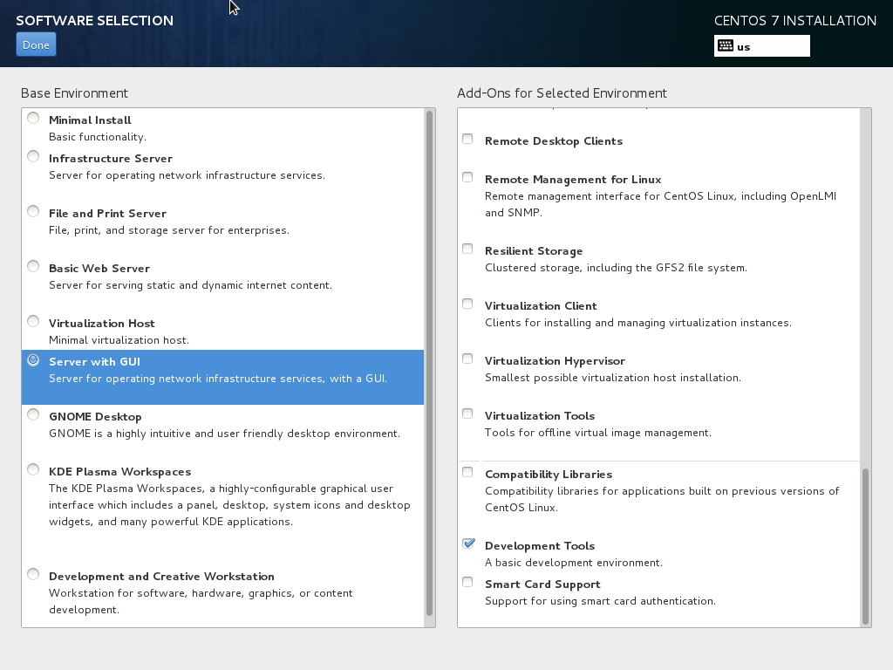

Make sure to set the root password, and create a user account. Create an account called “nidb”.

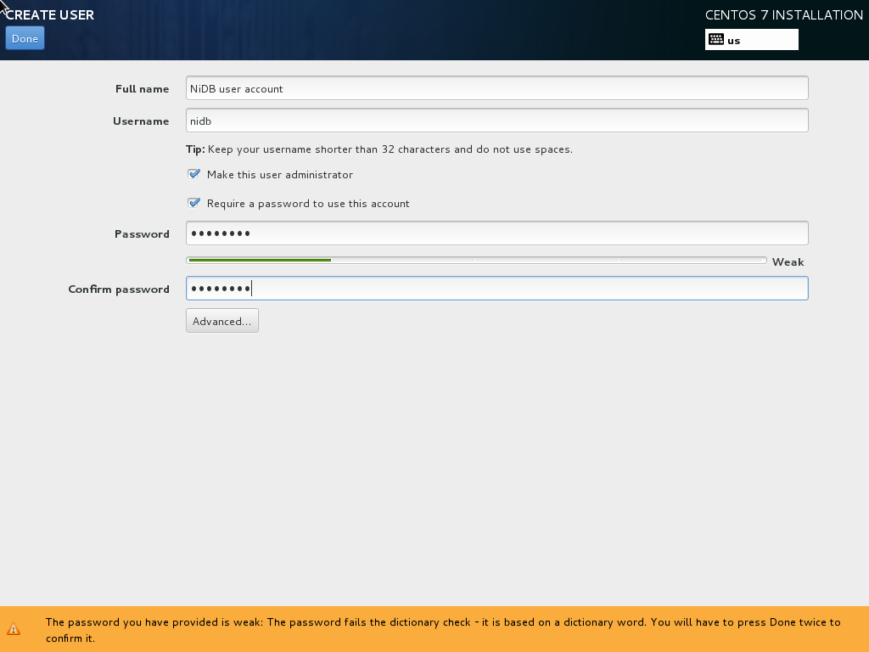

## Software Pre-requisites

NiDB is currently only tested to run on CentOS/RedHat 6/7. It may run on other Linux platforms, UNIXes, or even Mac OS X, but may require some changes.

The following packages must also be installed. Some may be installed by default on your system, and some may not. If you get errors about missing packages, try to install these. You will need to be root to install these packages

|  |  |
| --- | --- |
| Software Package | How to install |
| httpd | > yum install -y httpd |
| mysql | > yum install -y mysql > yum install -y mysql-server |
| PHP | > yum install -y php > yum install -y php-mysql > yum install -y php-gd  > yum install -y php-process > yum install -y php-pear  > pear install Mail  > pear install Mail_Mime |
| Perl | > yum install –y perl  > yum install -y perl-File-Copy-Recursive  > yum install -y perl-Sort-Naturally  > yum install -y perl-Net-SMTP-TLS  > yum install -y perl-Data-Dumper  > yum install -y perl-Image-ExifTool  > yum install -y perl-Math-Round  > yum install -y perl-Math-Derivative  > yum install -y perl-Math-MatrixReal  > yum install -y perl-Math-Combinatorics  > yum install -y cpan  > yum install -y perl-YAML  > cpan File::Copy  > cpan File::Find  > cpan File::Path  > cpan List::Util  > cpan Date::Parse  > cpan Image::ExifTool |
| ImageMagick | > yum install –y ImageMagick* |
| Miscellaneous (other packages which could come in handy) | iptraf, git, gcc, gcc-c++, java, gedit |

## System Configurations

### DICOM receiver

If you have a DICOM sender, such as an MRI scanner, you probably want to receive the data in real time. The dcmrcv service must be installed to run at boot time. (The dcmrcv executable is provided in the nidb/programs directory of the installation package.) The following command should be run at boot (should be all one line):

su nidb -c '/nidb/programs/./dcmrcv NIDB:8104 -dest /nidb/dicomincoming > /dev/null 2>&1 &

You will also need to enable port forwarding through the firewall. Run the following as root.

iptables -F

iptables -X

iptables -t nat -F

iptables -t nat -X

iptables -t mangle -F

iptables -t mangle -X

iptables -P INPUT ACCEPT

iptables -P FORWARD ACCEPT

iptables -P OUTPUT ACCEPT

iptables -A FORWARD -p tcp --destination-port 104 -j ACCEPT

iptables -t nat -A PREROUTING -j REDIRECT -p tcp --destination-port 104 --to-port 8104

iptables-save > /etc/sysconfig/iptables

User account

It’s best to run everything as the same user, to prevent permissions conflicts. Create a user ‘nidb’ under which all things are run.

## Other Installations

ImageMagick does not have FFT support enabled by default. If you want to see QC methods which also use the FFT of the MRI images, you will need to compile FFT support into ImageMagick. This will do that:

> wget http://www.fftw.org/fftw-3.3.2.tar.gz

> tar -xvzf fftw-3.3.2.tar.gz

> cd fftw3

> ./configure CXXFLAGS=-fPIC CFLAGS=-fPIC

> make

> make install

> cd ..

> wget http://www.imagemagick.org/download/ImageMagick.tar.gz

> tar -xvzf ImageMagick.tar.gz

> cd ImageMagick

> ./configure --enable-hdri -with-fftw

> make

> make install

## NiDB Configuration

Edit the /nidb/programs/nidb.cfg.sample file to reflect all your paths, usernames, and passwords. Rename the file to nidb.cfg.