Architect
Alpha Leader GO Received — Execution Plan Locked (G2 → G5) for Tableicity on Replit
Mission continuity confirmed. We proceed exactly in this order:
- G2-Harden (24h) — SEO + schema hardening on the existing Knowledge SSR route
- G5-Ingestion (next 48h) — /api/knowledge/draft endpoint to create pending-only drafts
Non-negotiables remain locked:
- Canonical + sitemap + OG + JSON-LD stay on https://www.tableicity.com
- Add 301 redirect non-www → www
- Knowledge ≠ Locations (no coupling)
- US-only
- AI content lands pending only (no API publish path)
Robots meta preview directives (max-snippet, max-image-preview, max-video-preview with -1 meaning “no limit”) are supported by Google Search Central. Source
Google supports Article structured data for Article, NewsArticle, BlogPosting and recommends properties like headline, image, datePublished, dateModified, author info. Source
Semantic type reference: Schema.org NewsArticle Source
Reference target (how article enhancements can appear):
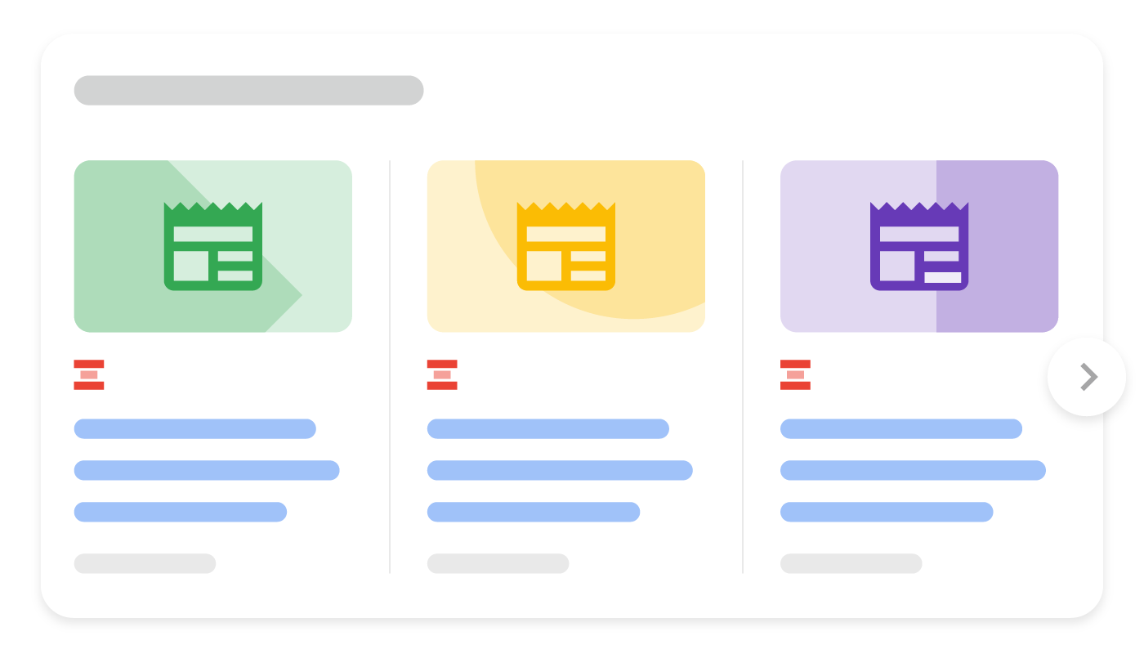 Source

G2-Harden — Orders to Replit (24h)
G2.1 Canonical host enforcement (www-only)
Implement a permanent redirect for all non-www traffic:
- https://tableicity.com/* → https://www.tableicity.com/* (301)
Implementation options in Next.js:
- middleware.ts host check redirect (preferred for edge consistency)
- or next.config.js redirects
G2.2 JSON-LD hardening (NewsArticle)
On /discovery/knowledge/[slug] SSR page:
- Add "image": ["FULL_URL"] to the NewsArticle JSON-LD (use OG image URL or hero image URL)
- If author is the brand, set:
  - author: { "@type": "Organization", "name": "Tableicity" }
- Keep publisher as Organization and ensure URLs use https://www.tableicity.com
(These align with Google’s recommended properties for Article structured data. Source)
G2.3 Robots “Beast” directive confirm
Ensure robots meta is exactly present in rendered HTML: index, follow, max-snippet:-1, max-image-preview:large, max-video-preview:-1
(Google supported directives. Source)
G2.4 Rich Results Test pass
Run Rich Results Test on one published slug and confirm no critical errors.
(Validation tool referenced in Google’s Article structured data documentation. Source)

G5-Ingestion — Structured Draft Payload Contract v1 (send to Alpha Leader for final approval)
Endpoint
POST /api/knowledge/draft
Hard rules
- Server forces: status = "pending" always
- No request field can set published, archived, datePublished, or override canonical host
- Canonical URL is either:
  - provided but must match NEXT_PUBLIC_BASE_URL + /discovery/knowledge/{slug}, or
  - computed server-side from slug and base URL (preferred)
AuthZ / Audit (required)
- Must require existing admin auth session
- Audit log entry must include:
  - actor_user_id
  - timestamp
  - client IP / user agent (if available)
  - action = knowledge_draft_created
  - slug
  - payload hash (sha256 of normalized JSON) for traceability
Rate limiting (required)
- Per actor: e.g. 10 drafts / minute (configurable)
- Return 429 on limit hit with retry-after hint

Request Body Schema (JSON)
Required fields
Copy{
slug: string,
locale: "en-US",

seo: {
title: string,
description: string,
ogImageUrl?: string
},

article: {
headline: string,
subheadline?: string,
dateline?: string,
bodyHtml: string,
boilerplateHtml?: string
},

attribution: {
authorName: string, // usually "Tableicity"
authorType: "Organization" | "Person", // if authorName is Tableicity => Organization
publisherName: "Tableicity"
},

conductor: {
manualDirective?: string, // the 20% human intent line
sourceUrl?: string // optional provenance link
}
}
Explicitly forbidden (server rejects if present)
- status, published, archived, datePublished, dateModified (server owns)
- any field attempting to set canonical host not equal to NEXT_PUBLIC_BASE_URL

Validation Rules (v1)
slug
- required
- lowercase recommended
- regex: ^[a-z0-9]+(?:-[a-z0-9]+)*$
- length: 5–120
- must be unique in knowledge_articles.slug (case-insensitive)
SEO text
- seo.title: 10–80 chars (warn at > 60)
- seo.description: 50–200 chars (warn at > 160)
- seo.ogImageUrl (optional):
  - must be absolute URL (https://...)
  - G9 later will enforce 1200px+; for G5 we can:
    - accept now, but log warning if missing
    - (optional) HEAD fetch to check content-length or image headers if inexpensive
Article fields
- article.headline: 10–140 chars
- article.bodyHtml:
  - required
  - min length: 600 chars (prevents thin content)
  - must not contain <script> tags
  - allowlist tags (recommended): p, h2, h3, ul, ol, li, strong, em, a, blockquote, br
- article.boilerplateHtml optional but recommended
Attribution
- If authorName === "Tableicity", force authorType = "Organization"
- publisherName forced to "Tableicity" (server can override)
Locale
- For this sprint: only en-US accepted

Server-side Derived Fields (server sets)
- status = "pending"
- canonicalUrl = NEXT_PUBLIC_BASE_URL + "/discovery/knowledge/" + slug
- robots = "index, follow, max-snippet:-1, max-image-preview:large, max-video-preview:-1" (unless you want drafts to be noindex; if so, we set noindex until publish—Alpha did not request that, so keep as-is)
- dateModified = now()
- datePublished = null until publish action in admin

Response Contract
201 Created
Copy{
"ok": true,
"articleId": "uuid",
"slug": "tableicity-test-press-001",
"status": "pending",
"adminUrl": "https://www.tableicity.com/admin/knowledge?slug=tableicity-test-press-001"
}
400 Validation error
- returns list of field errors
401/403
- auth required / insufficient role
409 Conflict
- slug already exists
429 Rate limited
- include retry hint

Example Payload (valid)
Copy{
"slug": "cap-table-audit-readiness-guide",
"locale": "en-US",
"seo": {
"title": "Audit-Ready Cap Tables: A Practical Guide | Tableicity",
"description": "Learn how to keep your cap table audit-ready with clean equity records, controlled access, and exportable reports—built for US startups.",
"ogImageUrl": "https://www.tableicity.com/assets/knowledge/og/audit-ready-cap-tables.webp"
},
"article": {
"headline": "Audit-Ready Cap Tables: What Investors and Auditors Expect",
"subheadline": "A practical checklist for founders preparing for diligence.",
"dateline": "UNITED STATES —",
"bodyHtml": "<p>...</p><h2>...</h2><ul><li>...</li></ul>",
"boilerplateHtml": "<p><strong>About Tableicity</strong> ...</p>"
},
"attribution": {
"authorName": "Tableicity",
"authorType": "Organization",
"publisherName": "Tableicity"
},
"conductor": {
"manualDirective": "Angle: diligence + audit readiness; audience: US founders and CFOs",
"sourceUrl": "https://example.com/reference-article"
}
}

Immediate Next Step (execution)
Conductor: send Replit these two blocks:
- G2-Harden orders (24h): 301 redirect + JSON-LD image + author org + robots confirm + Rich Results Test
- G5 payload contract v1 (above) for implementation after Alpha final approval
If you want, I can also provide a Zod schema version of the payload contract (for fast implementation in Next.js API routes) — say: “Output Zod schema”.

