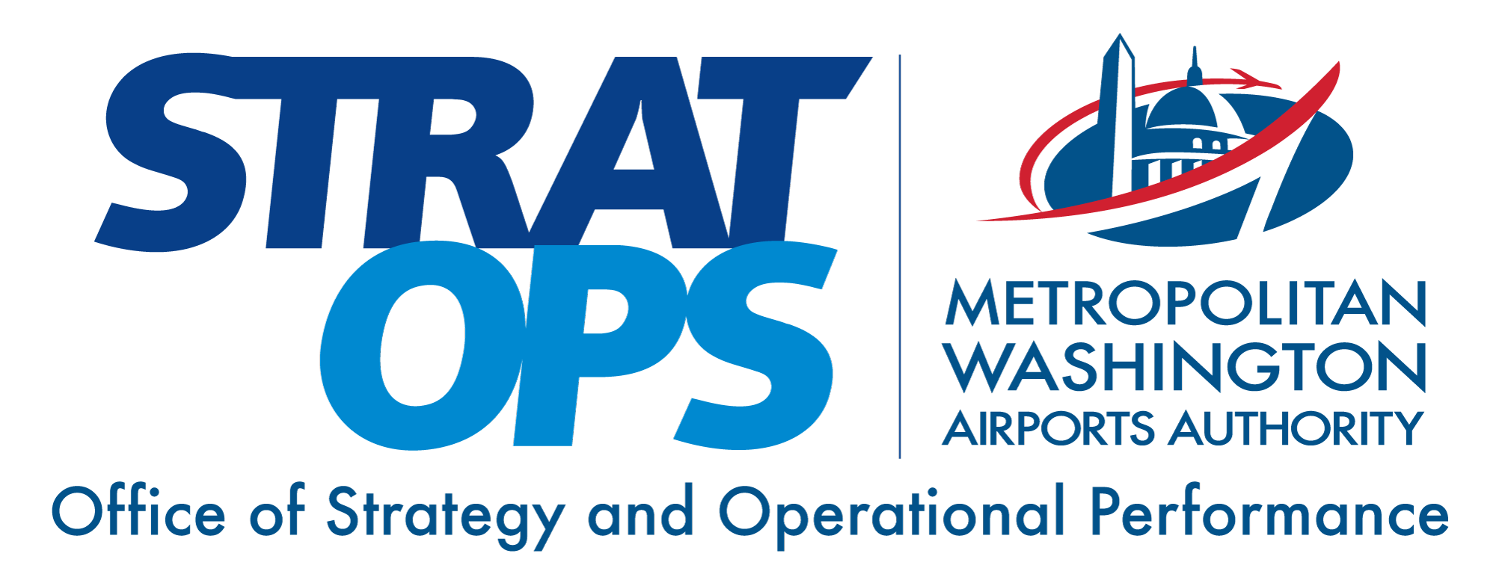
Quiet-by-Design Standards for MWAA Terminals
August 2026 • Transform Airports AI Research Council • Decision brief
This decision-support document was generated with assistance from a multi-model AI research system. A named human decision owner remains responsible for verifying the evidence, judging local applicability, and approving any action.

Executive decision brief
BOTTOM LINE
Decision-critical unknown: the run prompt specifies no requested decision. The verified draft frames the choice as whether MWAA adds a tiered communications-integrity standard to the Design Manual this capital cycle — mandatory intelligibility, accessibility, and governance floors at both airports, context-dependent tiers by terminal — before the committed ~$9B AUL capital program and the provisional $20B+ Dulles transformation pass through design.
DECISION OWNERSHIP AND EXECUTION
Decision owner | Decision-critical unknown: the run prompt names no accountable executive. The verified draft identifies the MWAA Office of Engineering as the issuing authority under its delegated Design Manual standards-setting role, with Board visibility; the delegation's exact scope was not verified from primary MWAA governance documents in this research pass.
Approval route | Decision-critical unknown: the run prompt specifies no approval path. The verified draft proposes: Office of Engineering issues the Design Manual amendment under delegated standards-setting authority; taken to the MWAA Board as an information item; escalated to a Board resolution only if airline consultation surfaces material objection. Tenant-audio reach is contingent on verification of the 2025 Airline Use and Lease Agreement's majority-in-interest provisions, which no agent read in primary text.
First 90-day action | Direct the Office of Engineering to (1) verify the current Design Manual's acoustic, PA-zoning, and STI content and the 2025 AUL's majority-in-interest and cost-recovery provisions from primary text, and (2) commission the IAD Concourse E intelligibility and ambient baseline — STI measured per IEC 60268-16:2020 under representative traffic, not empty-building conditions — at the fall 2026 opening, establishing the reference number every future MWAA facility is measured against.
Success measures | - Acceptance: Concourse E commissioning baseline achieves STI >= 0.45 (CIS >= 0.65) at >= 90% of measurement locations within each acoustically distinguishable space, average STI >= 0.50 (CIS >= 0.70), measured per IEC 60268-16:2020 under representative traffic — the NFPA 72 emergency-voice floor applied as the facility acceptance test.  - Within 90 days, primary-text verification of the Design Manual's current acoustic/PA content and the 2025 AUL majority-in-interest provisions is complete and documented; stop condition: if the Manual already contains equivalent tiers, re-scope the amendment to gap-fill only; if MII review shows tenant-audio reach requires airline consent, escalate to Board resolution rather than issue as an information item.  - Every new or substantially renovated terminal design package after amendment issuance includes an acoustically-distinguishable-space map as a milestone design deliverable, with commissioning verification under representative traffic treated as verification-with-cure-period, not an occupancy condition.  - Announcement governance operational within the first amended project: audit-logged broadcasts, templated multi-language delivery, and a named Airport Duty Manager IROPS override with post-event reconciliation of every deviation.
WHY THIS MATTERS NOW
- MWAA holds a committed capital construction program of approximately $6.99 billion at IAD and $2.39 billion at DCA — roughly $9 billion together — under the fifteen-year Airline Use and Lease Agreement effective January 1, 2025.¹ On July 29, 2026, the President, the U.S.
- Keep "quiet-by-design" internal; externally, say "communications-integrity standard." After the January 29, 2025 midair collision and the NTSB's final report, no board member should sign a policy paraphrasable as "reduced safety broadcasts."⁵
EVIDENCE THAT SHOULD DRIVE THE DECISION
- Three propositions carry the case. Acoustic treatment specified at design time costs a fraction of retrofit treatment at commercial benchmarks.⁹
RECOMMENDED ACTION
Priority | Action
1 | a tiered communications-integrity standard added to the Design Manual this capital cycle, issued by the Office of Engineering under its delegated standards-setting authority, taken to the Board as an information item, and escalated to a resolution only if airline consultation surfaces material objection.
2 | Reference application, subject to phase verification: the DCA Terminal 1 concourse replacement.
3 | Concourse E, opening this fall, carries the first commissioned intelligibility and ambient baseline under representative traffic.⁴
DECISION-BRIEF NOTES
⁴ MWAA, Concourse E project disclosures (flydulles.com): approximately 435,000 square feet, 14 gates, initial phase opening fall 2026. Verified against the project page August 11, 2026. | ¹ MWAA, "Metropolitan Washington Airports Authority Completes Negotiations for New Use and Lease Agreement with Airlines" (2024), mwaa.com: 15-year agreement effective January 1, 2025; capital construction program of approximately $6.99 billion at IAD and $2.39 billion at DCA — approximately $9 billion together; airline-funded debt-service coverage to at least a 140-percent target ratio. Majority-in-interest thresholds and cost-recovery categorization not verified from primary agreement text.
⁵ National Transportation Safety Board, Aircraft Accident Report NTSB/AIR-26/02, Midair Collision over the Potomac River — PSA Airlines Flight 5342 (final, 2026, ntsb.gov). The January 29, 2025 collision and its 67 fatalities were documented in contemporaneous coverage: CNN, "DCA midair collision first responders, others remembered by victims' families as heroes" (cnn.com). | ⁹ Commercial pricing guides: new-construction acoustic ceiling installation $5–$15 per square foot (designtransitionstudio.com, "Acoustical Ceiling Cost Per Square Foot: Price Guide 2026," which also quotes lower typical bands and premium tiers to $22); retrofit acoustic panel treatment $18–$45 per square foot (acousticmod.com, "Acoustic Retrofit vs. New Construction: Cost & Time Guide," as captured in research; page since relocated). Non-airport, medium-confidence directional benchmarks; airside premiums would raise both ranges.

