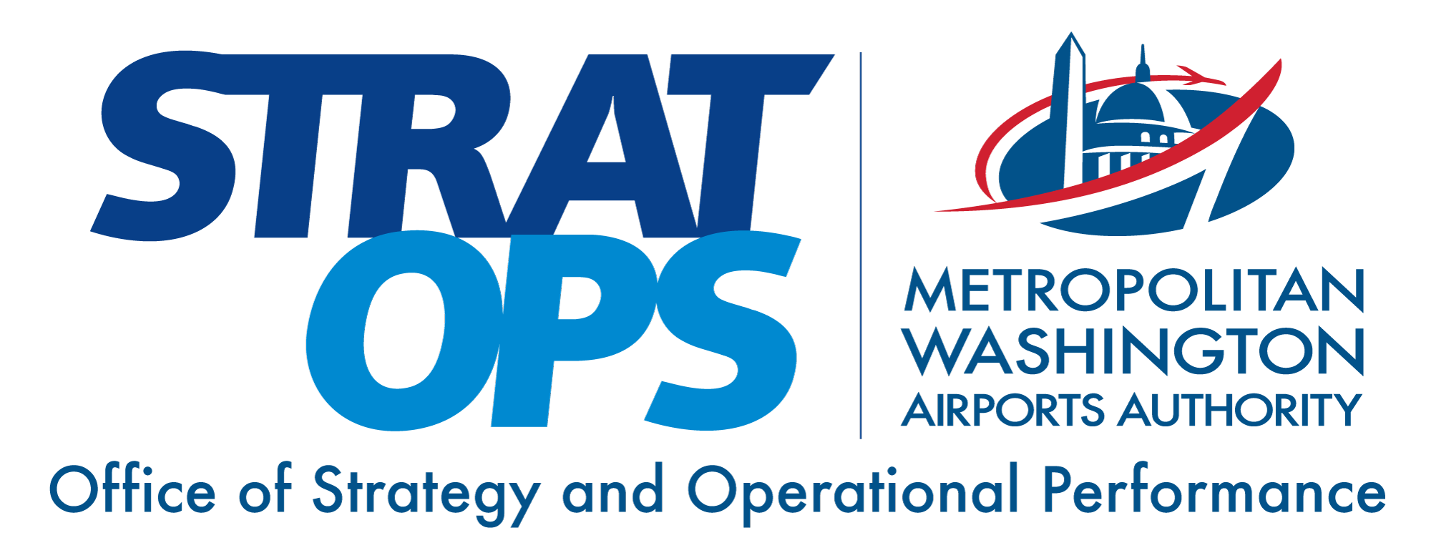
Designing for 2043: What Terminal F Should Absorb Before the Concrete Cures
August 2026 • Transform Airports AI Research Council • Decision brief
This decision-support document was generated with assistance from a multi-model AI research system. A named human decision owner remains responsible for verifying the evidence, judging local applicability, and approving any action.

Executive decision brief
BOTTOM LINE
Not specified in run prompt. The verified draft frames the implied decision as: adopt the six-decision program (D0–D5) that establishes a module-by-module reversibility register before the fabrication-release window closes in 2030 — beginning with D0, confirming the Innovation Next+ JV procurement path for owner-directed template changes at repeat-part cost.
DECISION OWNERSHIP AND EXECUTION
Decision owner | Decision-critical unknown; the run prompt names no accountable executive. The verified draft assigns D0 to the Chief Procurement Officer, D2 (the register) to the Vice President Terminal Development, with the CEO's office signing any unwind; board-level ownership must be established from verified authority before release.
Approval route | Decision-critical unknown; the run prompt names no approval path. Verified constraints that any path must respect: register briefings route through the Operations, Safety & Security Committee; the Finance & Audit Committee sets the forward-CPE ceiling the aggregate register premium must live inside; and further new-money debt authorization beyond the 70th Supplemental Bond Ordinance's $3.0 billion (through February 2026) requires both Dallas and Fort Worth city-council approval [quantitative-analyst::ev-c214ece13d4d].
First 90-day action | Execute Decision D0 and D2 phase 1: the Chief Procurement Officer obtains written confirmation of whether the Innovation Next+ JV design-build contract permits owner-directed template changes at repeat-part cost within the current change-order envelope, and the VP Terminal Development obtains the per-module release-for-fabrication schedule from the JV as contract disclosure — so the board can see which Terminal F decisions are still live and which have quietly closed.
Success measures | - Measurable acceptance condition: 100% of Terminal F module fabrication releases are preceded by a written register finding (item, cost order of magnitude, funding source, federal dependency), reported quarterly to the Operations, Safety & Security Committee.  - Aggregate register premium remains inside the Finance & Audit Committee's forward-CPE ceiling every cycle; any breach triggers unwind review.  - Written TSA and CBP concurrence on checkpoint and FIS geometry obtained before any affected module's fabrication release (D4).  - Stop condition: American announces a formal Flagship-tier build-out at Terminal F on a published schedule — a specific fit-out program replaces the register.  - Stop condition: AA connecting share falls below a connecting-majority floor across two consecutive annual cycles — the connecting-heavy sizing assumption softens and affected geometry is re-tested.  - Stop condition: any Side Letter shell uncountersigned by American after two fabrication cycles is dropped from the register.
WHY THIS MATTERS NOW
- The deadline in the title is misleading. The reversibility clock at Terminal F is set by release-for-fabrication, per module, weeks to months before any concrete cures. For the six modules placed in August 2025,¹ it has already passed.
- Post-release modular is more change-hostile than stick-built. Multiple independent analyses, working from different starting points, arrived at the same reading: once a module clears release-for-fabrication, scope changes propagate across the fabrication line rather than being absorbed within a single trade.
EVIDENCE THAT SHOULD DRIVE THE DECISION
- The tenant's announced posture is a strong signal, not a settled Use-and-Lease instruction. American has placed a 37,000-square-foot Admirals Club — its largest anywhere — in Terminal C near the Skylink station, a Flagship Check-In in Terminal D, and a scaled-down Provisions by Admirals Club grab-and-go in Terminal F.²
- American is expanding the connecting bank, not softening it — and the sizing debate is genuine. The December 2025 restructure moved DFW from 9 daily banks to 13, effective April 2026.⁴ One reading sees bank contiguity amplifying gate concurrency at peaks; another sees a flatter, mid-day-loaded operation.
- The historical record on purpose-built hub terminals is mixed, and the mixed cases matter. Six times since deregulation, a US airport has built a purpose-designed hub terminal on a long single-carrier commitment. Four were dehubbed a decade to fifteen years after opening — Pittsburgh (1992, dehubbed 2004),⁶
- The pour-locked decisions with the largest cost of being wrong are geometric, not aesthetic. MARS-capable stands at a defined minority of positions,¹³ a Federal Inspection Services floor plate sized to CBP's roughly 100 passengers per hour per double primary booth with 50–75 foot queue depth,¹⁴ checkpoint rooms dimensioned for next-generation CT throughput,¹⁵
RECOMMENDED ACTION
Priority | Action
1 | The most valuable governance artifact this run can produce is a written module-by-module reversibility register, executed inside real contract instruments. Not a "flexibility strategy." A short, priced list of options bought before each module's fabrication release — each with a named VP-level owner, an order-of-magnitude cost, a named funding source, named federal dependencies, and, where the space serves American, a Terminal F Reversibility Side Letter to the 2025 U&L amendment carrying a schedule of pre-priced options.²⁰
RISKS AND CONDITIONS
- The strongest reader in the room will not concede any of this without a fight. Four objections.
- American signed to 2043.[^20] Designing for American's departure is bad faith toward the tenant funding the building. The 2025 lease extension gave DFW eighteen years of scheduling certainty²⁰ and made the $4 billion debt stack politically survivable.
DECISION-BRIEF NOTES
²⁰ DFW Airport newsroom and American Airlines joint release, "DFW Airport and American Airlines announce acceleration and expansion," May 2025: Terminal F expanded from 15 gates (~$1.6 billion) to 31 gates (~$4 billion); Use and Lease Agreement extended through 2043; American sole occupant. | ¹ Walsh Group / Archer Western–Turner–Phillips May–H.J. Russell (Innovation Next+ JV) release on Terminal F module set, completed August 8, 2025 (date verified against the DFW newsroom and contemporaneous trade coverage, 2026-08-20): six mega-modules placed via self-propelled modular transporter across a closed taxiway over an approximately two-week overnight window; largest module 278 ft × 136 ft at 3,320 tons, set to ~¾-inch survey tolerance. Module dimensions and weight confirmed by Dallas Innovates, "DFW Airport's Terminal F rises with record-setting modular construction and a scaled-up $4B plan to meet global demand," 2025. The ¾-inch survey tolerance corroborated by International Airport Review, August 2026.
² American Airlines newsroom, "American unveils premium experience at DFW featuring Admirals Club lounge and Flagship services," July 2026. Terminal C Admirals Club at approximately 37,000 square feet, described by American as its largest ever; Flagship Check-In near D30 checkpoint in Terminal D; Provisions by Admirals Club grab-and-go planned for Terminal F. Corroborated by Dallas Morning News, July 2026, and View from the Wing coverage. Whether the Provisions designation is a long-term U&L commitment or a placeholder for a later Flagship-tier build is flagged as unsettled and is the subject of Decision D1. | ⁴ American Airlines newsroom, "Doubling down on DFW: American further strengthens its Flagship hub," December 2025; restructure from 9 to 13 daily banks at DFW effective April 2026.
⁶ Cranky Flier, "Across the Aisle from Pittsburgh Airport Executive Director on Pittsburgh's Rise and Fall as a Hub (Part 1)," 2012: US Airways dehubbed 2004 over a fee dispute; CPE was roughly $6 when the dehub was announced and rose to approximately $14.97 in 2011 — nearly doubling from the post-dehub nadir. Midfield Terminal opened 1992 at approximately $1 billion. | ¹³ Multi-Aircraft Ramp System (MARS): ACI-NA, "Enhancing Airport Operations: The Power of MARS Gates," September 2024 — confirmed: a single wide-body stand can accommodate two narrowbody aircraft. Engineering geometry for apron, dual loading bridges, dual 400 Hz/PCA, and hydrant fuel per FAA AC 150/5300-13B (Airport Design, Change 1). ORD Terminal 5 MARS deployment per ADB SAFEGATE vendor publication.
¹⁴ PARAS 0052, "Planning Considerations International Arrivals Facilities," 2024; CBP Airport Technical Design Standard (2021 edition): approximately 100 passengers per hour per double primary booth; 50–75 foot primary queue depth. | ¹⁵ DHS Science and Technology Directorate, "300 People Per Hour Per Lane" (dhs.gov/science-and-technology/300-people-hour-lane): DHS target of 300 passengers per hour per CT-based checkpoint lane. The DHS webpage was inaccessible at time of remediation-pass verification (403 Forbidden); the URL and program name are confirmed. Figures retained from evidence ledger records at high confidence for the DHS target.

