**New Topical Treatment for Atopic Dermatitis**

José Miguel Ingelmo Calvo1, José Ruiz Cobo2, and Mohamed Farouk Allam3*

**Running Title:** Topical Treatment for Atopic Dermatitis

1Department of Plastic Surgery, Hospital HM Malaga, Spain.

2Distrito Sanitario Costa del Sol, SUAP Torremolinos, Spain.

3Department of Family Medicine, Faculty of Medicine, Ain Shams University, Egypt.

\***Corresponding Author:** E-mail: [farouk.allam@med.asu.edu.eg](mailto:farouk.allam@med.asu.edu.eg)

**Abstract**

The primary approach for managing atopic dermatitis (AD) involves the use of topical corticosteroids as the first-line treatment. While high-potency topical corticosteroids have shown to be effective, they come with an increased risk of local and, rarely, systemic adverse effects. Additionally, patients often experience a relapsing and remitting course. A revolutionary topical treatment for psoriasis and AD has recently received patent approval from the Spanish Ministry of Industry, Trade, and Tourism. This innovative treatment, presented in the form of a lotion, includes a combination of clobetasol, papaverine hydrochloride, spironolactone, a milk-peptide complex, and propylene glycol. An 18-year-old female presented with AD on the back of her neck and scalp. The patient had no significant past medical history and primarily complained of intense pruritus in the AD lesions. The patient received guidance to apply our recently patented lotion, *Psorisbye*, once a day for 5 days. In total, 50ml of *Psorisbye* was utilized over 4 days. On the 5th day, the patient underwent an examination at the outpatient clinic. The patient reported a significant improvement in pruritus sensations and observed a reduction in scaled lesions. Upon evaluating our patient, a comparison of the lesions before and after applying the topical treatment for 4 days revealed a notable improvement in the SCORAD index, decreasing from 49.95 to 0. While the results of *Psorisbye* in this case show promise, it is crucial to conduct further studies with larger sample sizes and extended follow-up periods to validate the findings presented in our case report.

**Keywords:** Atopic dermatitis, Topical treatment, SCORAD, SCORing Atopic Dermatitis, Malaga.

1. **Introduction**

Atopic dermatitis (AD) stands as the prevalent chronic inflammatory skin ailment, impacting approximately 230 million individuals globally. In developed nations, its prevalence varies, with rates ranging from 10% to 25% in children and 7-10% in adults [1].

Clinically, AD is identified by severe itching, dry skin, and eczematous lesions, primarily affecting flexures, of the head, neck, and hands [1,2].  Furthermore, disruptions in attention and low sleep quality, likely associated with itching, can manifest, impacting both academic and professional performance [2].

The primary approach for managing AD involves the use of topical corticosteroids as the first-line treatment [3]. As per a recent comprehensive review and meta-analysis, the treatments found to be most effective for AD comprise pimecrolimus, tacrolimus, and topical corticosteroids with moderate potency [4]. While high-potency topical corticosteroids are more effective, they come with an increased risk of local and, rarely, systemic adverse effects. Additionally, patients often experience a relapsing and remitting course [5].

The Spanish Ministry of Industry, Trade, and Tourism has recently granted patent approval (Invention patent reference number 202030824) for a ground-breaking topical treatment designed for psoriasis and AD. This innovative treatment, presented in the form of a lotion, includes a combination of clobetasol, papaverine hydrochloride, spironolactone, a milk-peptide complex, and propylene glycol.

We showcase a case of AD that was treated using our newly patented lotion, *Psorisbye*.

1. **Case Report**

An 18-year-old female presented with AD on the back of her neck. The patient had no significant past medical history and primarily complained of intense pruritus in the AD lesions.

During the examination, a red rash on swollen skin, accompanied by crusting and scaling, was observed on the back of the neck and scalp. Additionally, a few abrasions from scratching were identified, primarily located on the back of the neck.

She received the diagnosis during infancy and has undergone treatment involving a combination of corticosteroid creams and moisturizers to address dry skin.

The patient received guidance to apply our recently patented lotion, *Psorisbye*, once a day for 5 days. In total, 50 ml of *Psorisbye* was utilized over 4 days. Throughout this duration, the patient did not undergo antihistamine treatment in conjunction with the application of the lotion.

On the fifth day, the patient underwent an examination at the outpatient clinic. The patient reported a significant improvement in pruritus sensations and observed a remission of the scaled lesions.

The gold standard for assessing AD is the SCORing Atopic Dermatitis Index (SCORAD). SCORAD incorporates both objective symptoms (extent and intensity) and subjective criteria (daytime pruritus and sleep loss). Clinical features considered for evaluating disease severity encompass erythema, swelling, oozing/crusting, scratch marks, skin thickening, and dryness. Each characteristic is assigned a severity rating of 0, 1, 2, or 3. The extent of the disease is estimated by the percentage of affected skin with eczema. SCORAD assesses subjective symptoms, such as itch intensity and sleep disturbance, on a scale from 0 (no symptoms) to 10 (maximum), reflecting the preceding three days. Numerical data for all three aspects are tabulated and summed, with a maximum score of 103 [6].

Upon evaluating our patient, a comparison of the lesions before and after applying the topical treatment for 4 days revealed a notable improvement in the SCORAD index, decreasing from 49.95 to 0 (**Figure 1**).

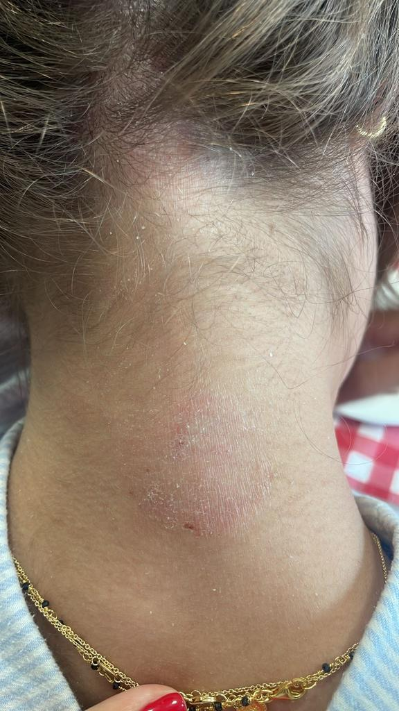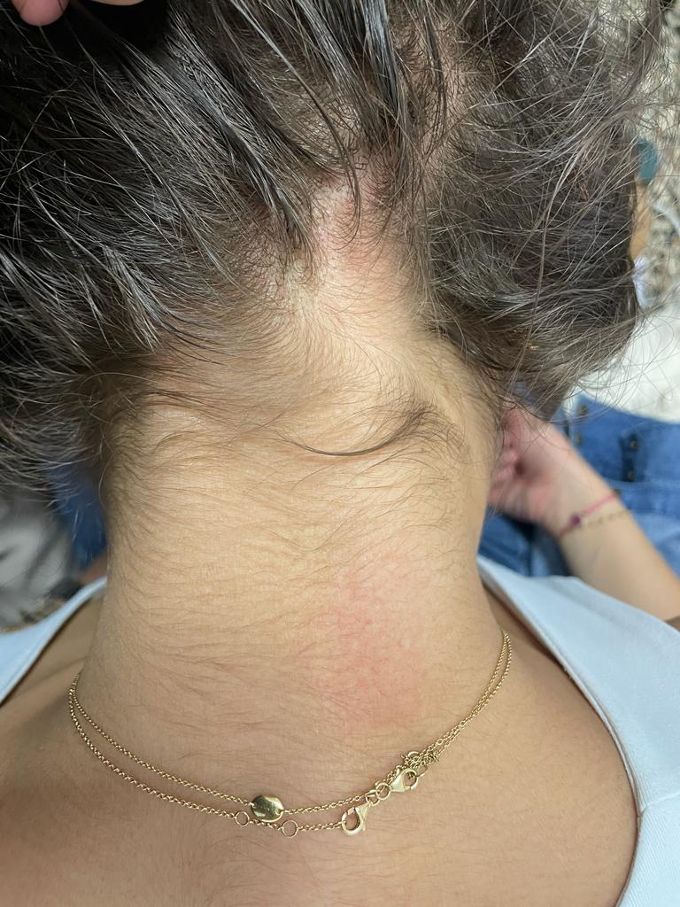

a

b

**Figure 1** illustrates the back of the patient's neck before (a) and after (b) the application of *Psorisbye*, with a 5-day interval between the images.

1. **Discussion**

We have herein showcased a case of AD successfully treated with our innovative lotion. Notably, substantial improvement was evident after only 5 days of topical application of *Psorisbye*.

The outstanding outcomes observed in this case can be attributed to the synergistic effects and well-balanced dosages of the medications incorporated in *Psorisbye*:

* Clobetasol, a corticosteroid widely utilized in the management of these types of lesions, functions by effectively reducing the proliferation of keratinocytes, the skin cells involved in the lesion, and concurrently address the characteristic crust formation, thereby contributing to an overall therapeutic effect.
* *Papaverine hydrochloride*: Operating as a vasodilator, papaverine hydrochloride plays a pivotal role in augmenting blood flow to the lesion, a mechanism that not only fosters enhanced circulation but also contributes to the facilitation of superior penetration and accessibility to the dermal lesion, thereby potentially optimizing therapeutic outcomes.
* Spironolactone recognized as a diuretic, mitigates the occurrence of skin atrophy resulting from the application of topical corticosteroids.
* *The milk-peptide complex*: Through its intricate mechanism, the milk-peptide complex serves as a catalyst for the reactivation of skin cells, initiating a dynamic process that stimulates the production of essential components such as collagen, hyaluronic acid, and fibronectin. This orchestrated synthesis not only contributes to an augmentation in these vital structural elements but also plays a pivotal role in the comprehensive enhancement and softening of the skin's underlying framework.
* *Propylene glycol*: In its capacity as an alcohol, propylene glycol plays a pivotal role in optimizing skin moisture dynamics by actively aiding in the more efficient absorption of moisture. This concerted action not only fosters heightened hydration levels but also serves as a proactive agent in the cultivation and maintenance of skin suppleness, resulting in an overall improvement in the skin's tactile and visual qualities.
* Excipients encompass a hydroalcoholic solution carefully formulated in precisely measured proportions, a strategic composition designed to achieve the utmost solubility and stability of the formula.

In our case report, we did not observe any adverse reactions or interactions among the different molecules in the new topical treatment.

Our previously published case reports on *Psorisbye* have recently demonstrated the efficacy of the new foaming lotion in addressing moderate psoriasis in the short term [7,8].

1. **Conclusions**

The effectiveness of the new topical treatment was evident in the significant improvement noted, demonstrated by the disappearance of the pruritus sensations and a notable difference in the pre- and post-SCORAD index assessment.

While the preliminary results exhibited by Psorisbye in the context of this specific case are indeed promising, the imperative to establish its efficacy and reliability necessitates the initiation of further investigations characterized by more expansive sample sizes and prolonged follow-up periods. Conducting such comprehensive studies will not only serve to validate the preliminary findings articulated in our current case report but also contribute to a more robust understanding of the potential long-term effectiveness and safety profile of the aforementioned topical treatment.

Author Contributions

The study design was conducted by José Miguel Ingelmo Calvo, José Ruiz Cobo, and Mohamed Farouk Allam. Analysis and interpretation of data were performed by José Miguel Ingelmo Calvo and José Ruiz Cobo. Manuscript writing was carried out by José Ruiz Cobo and Mohamed Farouk Allam. The collection of data was managed by José Miguel Ingelmo Calvo and José Ruiz Cobo. Critical revision was conducted by José Ruiz Cobo and Mohamed Farouk Allam.

**Abbreviations**

SCORAD: SCORingAtopic Dermatitis

**Ethical Statement**

Written informed consent was obtained for the patient, treatment, and publication of this case report and the accompanying image.

**References**

1. Weidinger S, Beck LA, Bieber T, Kabashima K, Irvine AD. Atopic dermatitis. Nat Rev Dis Primers 2018;4:1. doi: 10.1038/s41572-018-0001-z.

2. Birdi G, Cooke R, Knibb RC. Impact of atopic dermatitis on quality of life in adults: A systematic review and meta-analysis. Int J Dermatol 2020;59:e75-e91. doi: 10.1111/ijd.14763.

3. Butala S, Paller AS. Optimizing topical management of atopic dermatitis. Ann Allergy Asthma Immunol 2022;128(5):488-504. doi: 10.1016/j.anai.2022.03.004.

4. Chu DK, Chu AWL, Rayner DG, Guyatt GH, Yepes-Nuñez JJ, Gomez-Escobar L, *et al.* Topical treatments for atopic dermatitis (eczema): Systematic review and network meta-analysis of randomized trials. J Allergy Clin Immunol 2023;152(6):1493-519. doi: 10.1016/j.jaci.2023.08.030.

5. Johnson BB, Franco AI, Beck LA, Prezzano JC. Treatment-resistant atopic dermatitis: challenges and solutions. Clin Cosmet Investig Dermatol 2019;12:181-92. doi: 10.2147/CCID.S163814.

6. Kunz B, Oranje AP, Labrèze L, Stalder JF, Ring J, Taïeb A. Clinical Validation and Guidelines for the SCORAD Index: Consensus Report of the European Task Force on Atopic Dermatitis. Dermatology 1997;195:10-9. doi: 10.1159/000245677.

7. Calvo JMI, Cobo JR, Allam MF. New Topical Treatment for Psoriasis. J Explor Res Pharmacol 2023;8(3):264-6. doi: 10.14218/JERP.2023.00015.

8. Calvo JMI, Cobo JR, Allam MF. A Report of Three Cases with Moderate Psoriasis Treated with New Topical Treatment. Glob J Med Clin Case Rep 2023;3(1):16-20.