**Blood flow modeling in constricted arteries under body acceleration and**

**wall slip using two-layered Bingham Plastic fluid**

Dr. Mokshed Ali, Asst. Professor, Department of Mathematics

Barkhetri college, Narayanpur Mukalmua, Nalbari (Assam)

E-mail: mokshed.ali7@gmail.com

**Abstract:** Analysis is done on a two-layered Bingham Plastic model of restricted, thin arteries with periodic body acceleration. The model essentially consists of a centre layer with a core of suspended red blood cells and an outer layer with a peripheral plasma layer. It has been assumed that the rheology of blood in the core region has been classified as a Newtonian fluid with the PPL and a non-Newtonian fluid obeying the law of Bingham plastic model. This model has been used to investigate how blood flow in stenotic arteries is affected by body acceleration, the non-Newtonian character of blood, and a velocity slip at the wall. Analytical equations for axial velocity, flow rate, wall shear stress, and apparent viscosity are produced by using the perturbation method, and their variations with respect to various parameters are shown in the figures and explained in this article. Due to a wall slip, it is seen that while velocity and flow rate rise, effective viscosity falls. The impact of body acceleration significantly increases flow rates and speed. The physiological effects of this theoretical modelling for blood flow conditions are also briefly looked at.

***Key words***: Stenosed artery, shear stress, Bingham plastic, flow resistance, and body acceleration

**Introduction**

The majority of fatal cases are known to be caused by circulatory diseases, and stenosis or arterioscleriosis is one such worrying instance ( Guyton 1970, Bayd 1960). The term "stenosis" refers to an abnormal growth that narrows the diameter of an artery. It is one of the most common diseases and can cause major circulatory disorders by restricting or obstructing the blood flow to various body organs and tissues. The existence of a core area of suspension containing nearly all the erythrocytes and a layer of cell-poor plasma (Newtonian fluid) for blood flowing through small arteries has been empirically demonstrated by Bugliarello and Sevilla (1970) and Cokelet (1972). In a two-layered model of blood flow in tiny diameter tubes, Bugliarello and Sevilla (1970) presupposed that the core and periphery fluids were Newtonian fluids with varying viscosities. Several researchers have noted that under specific flow conditions, blood has a finite yield stress [Fung (1981); Kapur et al. (1982)]. One intriguing and unique example of a material having yield stress is referred to as Bingham plastic, which exhibits a straight line consistency curve or flow behaviour [Fung(1981); Kapur et al. (1982)]. Until the yield stress is reached, this specific material deforms elastically. Nevertheless, after this stress is exceeded, it flows like a Newtonian fluid, with shear stress being linearly proportional to share rate of shear strain [Schlichting(1968)]. Hence, it appears plausible to think of blood acting as a Bingham plastic in the core region of a restricted artery.

As a muscular pump, the human heart creates a pressure difference between its systolic and diastolic states, commonly referred to as the pressure pulse, which doctors measure at the wrist. Pulsatile flow is the term used to describe the blood flow caused by this pressure pulse [Chaturani and Samy (1985); Guyton and Hall (2006)]. The human body may also experience accelerations in unusual conditions (or variations). In everyday life, acclerative disruptions are fairly common, for instance when driving, flying, or boarding an aircraft or spacecraft. The human body may unintentionally experience external accelerations in such circumstances. Such entire body accelerations have an impact on the subject's blood flow through the arteries [Sud and Sekhon (1985, 1987)]. Although the human body is adaptable, long-term exposure to these acclerative disturbances can cause health issues like headache, abdominal pain, eyesight loss, and elevated heart rate. A mathematical model of blood flow in a single artery subject to pulsatile pressure gradient and body acceleration was presented by Sud and Sekhon in 1985. A theoretical model of pulsatile blood flow in a stenosed artery under the influence of periodic body accleration, with blood acting as a Casson fluid, was provided by Nagarani and Sarojamma (2008). By assuming a velocity slip condition at the constricted wall, Biswas and Chakraborty (2009a, 2009b, 2010) constructed mathematical models for blood flow in stenosed arterial segments. So, it appears that taking a velocity slip at the stenosed vessel wall into account in blood flow modelling will be rather logical.

A 2-layered model of Bingham plastic flow through an asymmetrically constricted vessel with velocity slip at the interface has been attempted to investigate the effects of slip (at the asymmetric stenosis) and the influence of body acceleration on the flow variables (wall shear stress, velocity, flow rate, pressure gradient, and apparent viscosity). It is assumed that the flow is steady and laminar.

1. **Mathematical Formulation:**

Blood flow through a constricted artery with an axially non-symmetrical but radially symmetrical stenosis is taken into consideration. The artery is assumed to be incompressible in the axial (Z) direction. The arterial constriction happens in the artery's lumen and is characterised by gradual alterations. In this inquiry, the stenosis's morphology is regarded as asymmetrical. In order to ignore the entrance and exit special wall effects, it is assumed that the artery length is sufficiently large compared to its radius. The centre of the sculpture is made up of a suspension of red blood cells. Two plasma layers—a central plasma layer and a peripheral plasma layer—are present in the outermost layer (as shown in Fig.1). The rheology of blood in the core region has been categorised as a Newtonian fluid with varying viscosities and a non-Newtonian fluid that follows the Bingham fluid model, respectively. 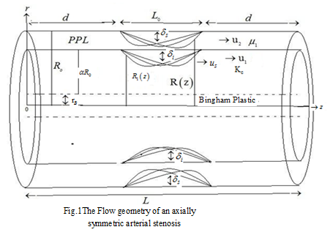

Mathematically, the geometry of the stenosis that develops in the artery wall asymmetrically is modelled as  (Ponalagusamy, 1968).

For PPL

 (1)

=1, Otherwise

For the core region

 (2)

=, otherwise

Where R(z) is the radius of the tube with stenosis, Ro is the constant radius of the tube, R1(z) is the radius of the artery in the core region such that, L0 is the length of the stenosis, L is the length of the tube, d is the stenosis location, and are the maximum height of the stenosis in the PPL and the core region respectively at such that the ratio of the stenotic height to the radius of the artery is very much less than unity i.e.  ,  where  is a parameter determining the shape of the stenosis. It is of interest to note that an increase in the value of m [eads to the change of stenosis shape. When m=2, the geometry of the stenosis becomes symmetrical at  and 

**Governing equations and boundary conditions**

It has been stated that for a low Reynolds number flow in a narrow tube with minor stenosis, the radial velocity is negligibly tiny and can be overlooked. The blood flow in the axial and radial directions is governed by momentum equations developed by D.S. Shankar and A.I.M. (2009) as

 (3)

 (4)

In the core and peripheral regions respectively where and are the fluid velocities in the core region and peripheral region respectively; are the shear stresses for Bingham fluid and Newtonian fluid respectively;  are the densities for Pulsatile fluid and Newtonian fluid;  the pressure and  is the body acceleration.

The constitutive equations of Bingham fluid and Newtonian fluid are respectively given by



 (5)

And  (6)

where  is radius of the plug core region. The periodic body acceleration in the axial direction is given by

 (7)

where A0 is its amplitude,   is its frequency in Hz,  is the lead of  w.r.t the heart action. The frequency of body acceleration is assumed to be small so that wave effect can be neglected.

The pressure gradient at any and  may be represented as follows

 (8)

Where A0 is the steady component of the pressure gradient, A1 is amplitude of the fluctuating component and  where  is the pulse frequency. Both A0 and A1 are functions of 

We introduce the non dimensional variables



 (9)

Where are the pulsatile Reynolds number for Bingham plastic fluid and Newtonian fluid respectively.

Using non-dimensional variables, equations (1) and (2) become

Flow geometry: For PPL

 (10)

=1, otherwise

**For the core region**:

 (11)

**Boundary Conditions**

The non-dimensional form's of boundary conditions are provided by

1.  is finite at r=0 (12)
2.  at r= R(z) (13)
3.  (14)

The non-dimensional form of the governing equations of motion provided by equations (3) and (4) is (15)

 (16)

Equations (5) and (6) are reduced by using non-dimensional variables as follows

 (18)

 (19)

 (20)

The dimensionaless volumetric flow rate is given by

 (21)

Where , is the volumetric flow rate.

The effective viscosity defined as

 (22)

Can be expressed in dimensionless form as

 (23)

**Method of Solution**

It is important to expand equations (15), (16), and (18)–(20) in perturbation series about  and  since ,  are time dependent, we expand uB, Rp, and uN as follows:

 (24)

 (25)



Equating powers of , the resulting equations of the core region can be obtained as

 (27)

Similarly using the perturbation series expansions in equations (16) and (20) and equating powers of , the resulting equations of the peripheral region can be obtained as

 (28)

Using the perturbation series expansions in equations (12) - (14) and equating constant terms and terms containing  and , we get

 are finite at r=0,

 (29)

On solving equations (27) and (28) for unknowns  using equation (29), we can obtain

 (30)

 (31)

 (32)

 (33)

 (34)

 (35)

 (36)

 (37)

 (38)

Where 

Neglecting the terms of and higher powers of  in equation (25), the first approximation plug core radius R0p can be obtained as

 (39)

Using equations (31), (32), (36) and (37) the expressions for axial velocities in the core and peripheral regions are obtained as

 (40)

 (41)

The expression for plug-core velocity can also be easily calculated using equations (24), (33) and (38) in a similar manner.

The expression for wall shear stress can be obtained by

 (42)

 (43)

From equations (21), (40) and (41) the volumetric flow rate is given by



 (44)

Where R=R(z), R1 =R1(z). The expression for effective viscosity  can be obtained from equations (23) and (44)

The second approximation plug core radius R1p can be obtained by neglecting terms of  and higher powers of  in equation (28) as



 (45)

From equations (25), (39) and (45), the expression for plug core radius can be obtained as

 (46)

The flow system represented by equations (40)–(44) reduces to a one-layered Newtonian flow system with body accleration as the lack of yield stress, i.e.  and a peripheral plasma layer (i.e 

 (47)

 (48)

 (49)

 (50)

* 1. **Results and Discussions**
  2. In order to study the combined effects of body acceleration, stenosis, and velocity slip on the flow variables—axial velocity, flow rate, shear stress, and effective viscosity of blood—flowing in an artery with a modest constriction, the current model has been created. Using a perturbation analysis with very small Womersley frequency parameters (αB = αN = 0.5 ˂1), the equations governing the aforementioned flow are integrated. The lead angleɸ is taken to be 0.2 and the height of the stenosis δp in the peripheral region is taken to be in the range of 0-0.5. It is assumed that the body acceleration parameter B is in the range of 0-2, and that the pressure gradient parameter e is in the range of 0-5. The central core radius to the normal radius of the artery is assumed to be 0.8, the yield stress is assumed to be 0 and 0.1, and the value of z is assumed to be between -4 and 4. The axial velocity slip is estimated to be between 0 and 0.1.
  3. Figure 2 illustrates the relationship between axial velocity and radial distance using equations (40) and (41) for constant values of peripheral stenosis heightδp, pressure gradient e, time duration t, and for various values of slip velocity us and body acceleration parameter B.
  4. It is noted from the picture that axial velocity is maximum at r = 0 , where from it gradually drops with the rise in radius of the artery r and attains a minimum value at the stenotic wall (r = R ( z )) for any value of body acceleration parameter B . Yet, using slip at the wall causes the axial velocity to increase. Axial velocity is further enhanced by an increase in body acceleration. Figure 3 shows the variation in volumetric flow rate with respect to the pressure gradient parameter e for constant values of peripheral stenosis height δp, time t, and for various values of slip velocity us, yield stress, and body acceleration parameter B. For any value of B and, it has been found that flow rate gradually rises as the pressure gradient parameter e increases. Yet, the flow rate is greater in the absence of yield stress ( ) than it is when yield stress is present. Further observation reveals that using body acceleration enhances flow rate. Figures 4 and 5, which show the variation of wall shear stress with axial distance z and time t, respectively. As seen in the figures, wall shear stress ζw  increases from its approached magnitude (i.e. at z =- 4) in the upstream of the throat with the axial distance and reaches its maximum at the throat of the stenosis. From there, it decreases in the downstream and attains a lower magnitude at the end of the constriction profile (i.e. at z = 4). The magnitude of wall shear stress  in a uniform tube (δp= 0) is less than that of an artery with stenosis (δp > 0) increases noticeably for any value of the body acceleration parameter B with the height of the peripheral stenosis δp. For any value of the body acceleration parameter B, it is also seen that the wall shear stress , progressively declines over time until it achieves its minimum at time t = 1800, after which it gradually increases over time until it reaches its peak magnitude at time t = 3600. Figures 6 and 7 shows visual representations of the variations in effective viscosity (µa) with axial distance (z) and peripheral stenosis height (δp), respectively. Effective viscosity rises with axial distance z from the beginning of a stenosis (i.e., at z=- 4) to the throat (i.e., at z= 0), where it reaches its greatest value, before gradually falling to its original value at the stenosis' termination (i.e., at z= 4). Additionally, the findings show that for both no-slip and slip at wall scenarios, effective viscosity  rises with the height of peripheral stenosis. Yet, for any value of the body acceleration parameter B, using an axial slip velocity at the wall reduces the effective viscosity in both the presence and absence of yield stress. Given fixed values of B and us , effective viscosity increases with yield stress, body acceleration decreases wall shear stress in both uniform (δp= 0) and stenosed( δp>0) arteries.
  5. **Conclusions:**
  6. The two-layered pulsatile blood flow through an artery (Fig. 1) embedded with an axi-symmetric moderate stenosis is the subject of the current analysis, and an axial velocity slip is used at the constricted wall. Blood is modelled as Bingham Plastic in the core region and is believed to behave as a Newtonian fluid in the periphery plasma layer. A perturbation method is used to integrate the motion equations that control the flow. It is possible to obtain analytical formulas for flow variables, and their variations with various flow parameters are graphically displayed. As anticipated, it is seen that wall slip causes a drop in effective viscosity while increasing axial velocity and flow rate.Also wall shear stress and effective viscosity decrease but velocity and flow rate increase with the body acceleration parameter *B* .Effective viscosity µ*e* increases as µ *p* increases. However, µB is lowered for both the uniform tube ( δs =0) and stenosed artery (δp>0) as a result of wall slip. Since this study takes care of pulsatibility of the flow and also it incorporates the characteristics of non-Newtonian nature of blood,so it is well mentioned that the present model could play a pivotal role to study the flow of blood. From the analysis, it may also be concluded that with slip, the damages to the vessel wall could be lowered. This type of decrease in wall shear stress and effective viscosity may be used to improve the health and performance of diseased arterial systems. So, one may search for medications or equipment that causes slip and use it to treat peripheral arterial illnesses. The permeability of the blood vessels could be taken into account to further enhance the model.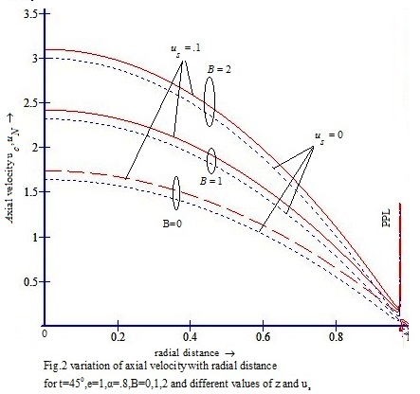
  7. 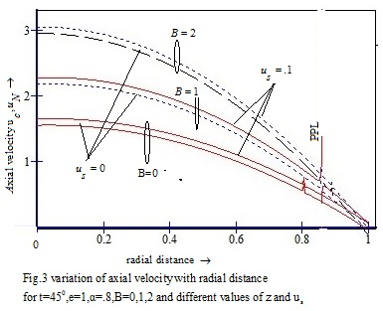

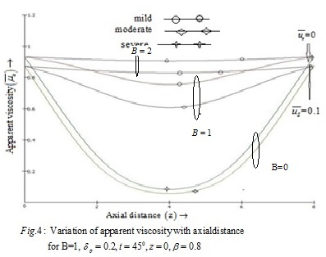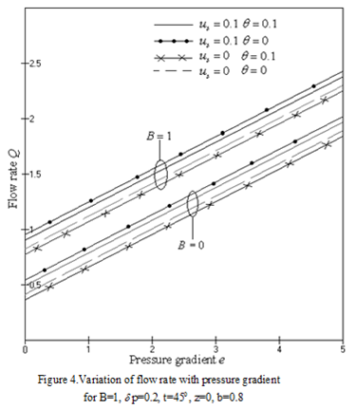

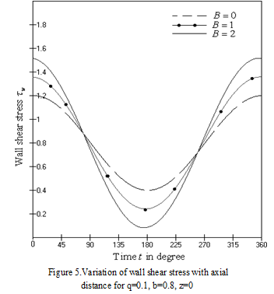

* **References**
* Biswas, D and Chakraborty, U.S. (2010): A brief review on blood flow modeling in arteries, Assam University, Journal of Science and Technology, Silchar, India, Vol.6, pp. 10-15
* Biswas, D. (2000).Blood Flow Models: A comparative study , Mittal Publications, New Delhi, India.
* Biswas, D.; Chakraborty, U.S. (2009). Steady Flow of Blood through a Catheterized Tapered Aborty, U.Srakrtery with stenosis. A Theoretical Model .Assam University Journal of Science and Technology. 4(2): 7-16
* Biswas, D. and Paul, M. (2013) Study of Blood flow inside an Inclined non-uniform stenosed artery, International Journal of Mathematical Archive-4(5), 1-10
* Chaturani, P. and Biswas, D (1983), Effects of slip in Flow Through stenosed tube, Physiological Fluid Dynamics: Proc. Of 1st  international Conf. on Physiological Fluid Dynamics ,September 5-7,pp. 75-80,IIT-Madras
* Chakraborty, U.S., Biswas, D and Paul, M (2011) Suspension model blood flow through an inclined tube with an axially non-symmetrical stenosis, Korea- Australia Rheology, Vol-23, no. 1, pp. 25-32.
* Chaturani, P. and D. Biswas, (1983).A theoretical study of blood flow through stenosed arteries with velocity slip at the wall. Proc. First International Symposium on Physiological fluid Dynamics,IIT Madras, India, pp: 23-26
* Schlichting, H., (1968) Boundary Layer Theory, Mc Graw-Hill Book Company, New York
* Fung, Y.C. (1981) Biomechanics: Mechanical properties of Living Tissues, Springer-Verlag, New York Inc.
* Mac Donald, D.A. (1979). On steady flow through modeled vascular stenosis. J. Biomech. 12:13-20
* Mac Donald, D.A. (1974). Blood Flow in Arteries, Edward Arnold (Second Edition) London
* Mac Donald, M.A. (1986): Pulsatile Flow in a Catheterized Artery. J. Biomech. 19: 239-249
* Sankar, D.S.and Ismail, A.I. Md. (2009) Two-fluid mathematical models for blood flow in stenosed artery: A Comparative study. Boundary Value Problems 2009, 1-15
* Dash, R.K; Jayaraman, G.; Mehta, K.N. (1995): “Estimation of Increased wall shear stress during Coronary Angioplasty- A Theoretical Model”. Proc.23rd Nat. conf. on Fluid Mechanics and Fluid Power, India, 522-533
* Jayaraman and Tewari, (1995): Flow in Catheterized curved Artery. Medical and Biological Engineering and Computing (IFBME). 33: 1-6
* Nagarani, P. ; Sarojamma, G. (2008). Effect of Body Acceleration on Pulsatile Flow of Casson Fluid through a mild stenosed Artery. Korea Australia Rheology Journal. 20(4): 189-196