CityBrain Product Consolidation
Product picture, architecture, PM view, gaps, parked work and component plug-in map
Generated 2026-07-07 from Codex exports, conversation summaries and source docs
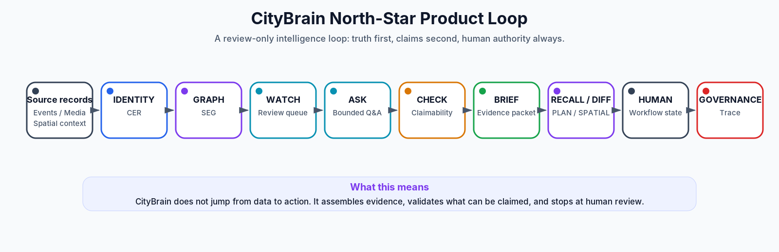
CityBrain is a governed review-only city intelligence cockpit that turns fragmented city records, events, media candidates and spatial context into evidence-backed human-review packets.

1. Executive picture
CityBrain is not a dashboard, chatbot, CCTV detector, graph demo or Omniverse scene. It is a governed city intelligence platform that helps people understand, validate, brief, review and eventually approve city workflows under explicit authority.

What can be safely said today
- Ingest and retain city/source records.
- Organize records into evidence-backed entities and context.
- Show source-backed records and review packets.
- Answer bounded ASK-style questions from sealed packets.
- Surface WATCH/review prompts in local/replay contexts.
- Generate briefs and evidence/context packets.
- Support review-only option sets and planning context.
- Connect candidate perception observations to review workflows.
- Show spatial/Omniverse/WebRTC proof paths.
- Run governed traces, ledgers, hash manifests and claim-boundary audits.
- Materialize labels and run one offline experimental forecast under explicit authority.

What cannot be safely claimed yet
- Production live operations.
- Public API / SLA.
- Certified citywide digital twin.
- Autonomous monitoring or dispatch.
- Enforcement/legal/certified finding.
- Official ticket/case/work-order creation.
- Product forecast surface.
- Live Watch consumption of a forecast model.
- Cross-city learned transfer.
- Trained ranking in operator surfaces.
- Production-grade execution adapters.

2. Product management view
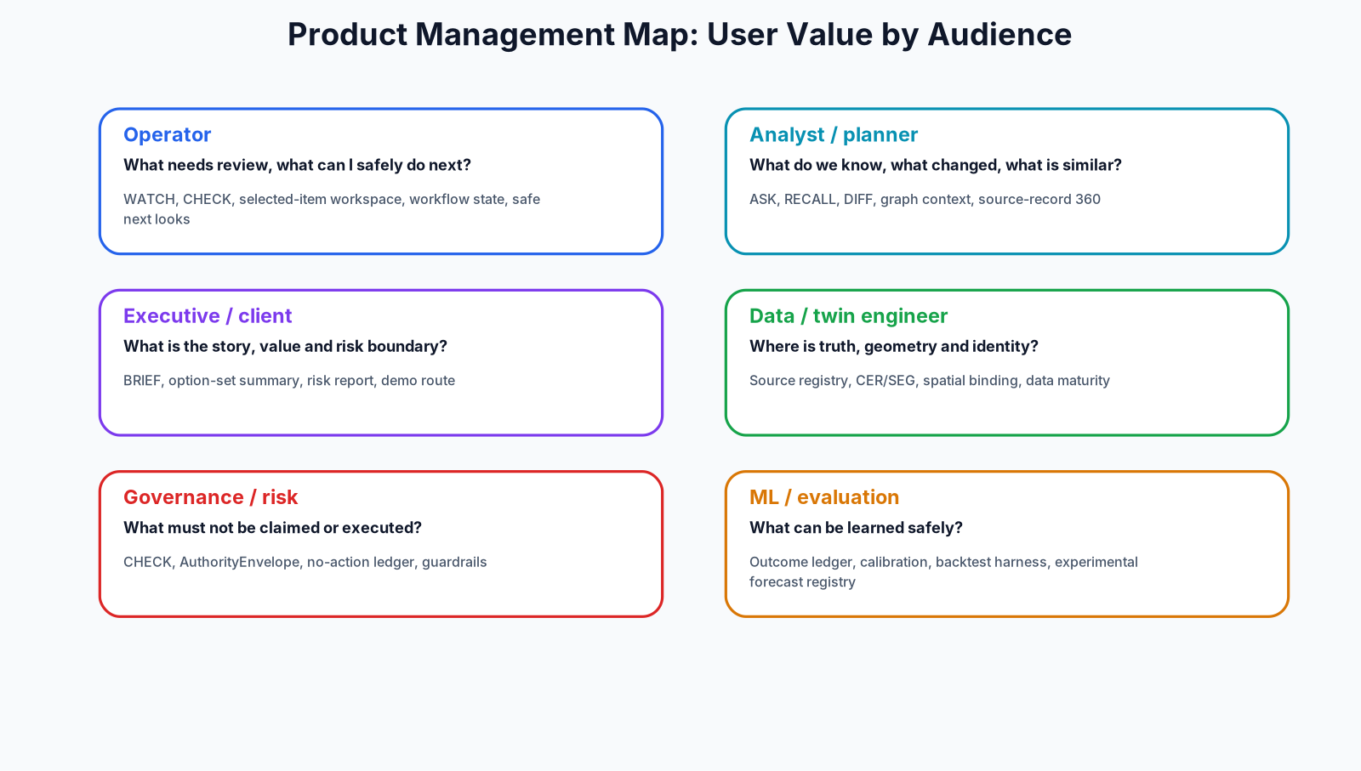

Product modes and PM rules

Operator-facing modes
- WATCH: candidate review queue.
- ASK: bounded cited question answering.
- CHECK: evidence sufficiency / claimability validation.
- BRIEF: evidence packet generation.
- RECALL and DIFF: precedent memory and change review.
- PLAN / SCHEDULE / SPATIAL / WORKFLOW: review-only options, sequencing, spatial selection and local review state.

System and platform modes
- IDENTITY and GRAPH: entity resolution and relationship traversal.
- EVENT and PERCEPTION: event state and candidate observations.
- SIMULATE and OPTIMIZE: scenario modeling and constrained option generation.
- GOVERN: boundary, refusal and claim audit.
- QUALITY/MATURITY, FEDERATION, SYNTHETIC and PERSONA: commercial/platform expansion modes.
PM rule: the product unit is not a UI widget. It is a packet: canonical entity identity + graph context + evidence + CHECK report + authority envelope + workflow state.

3. Architecture blueprint
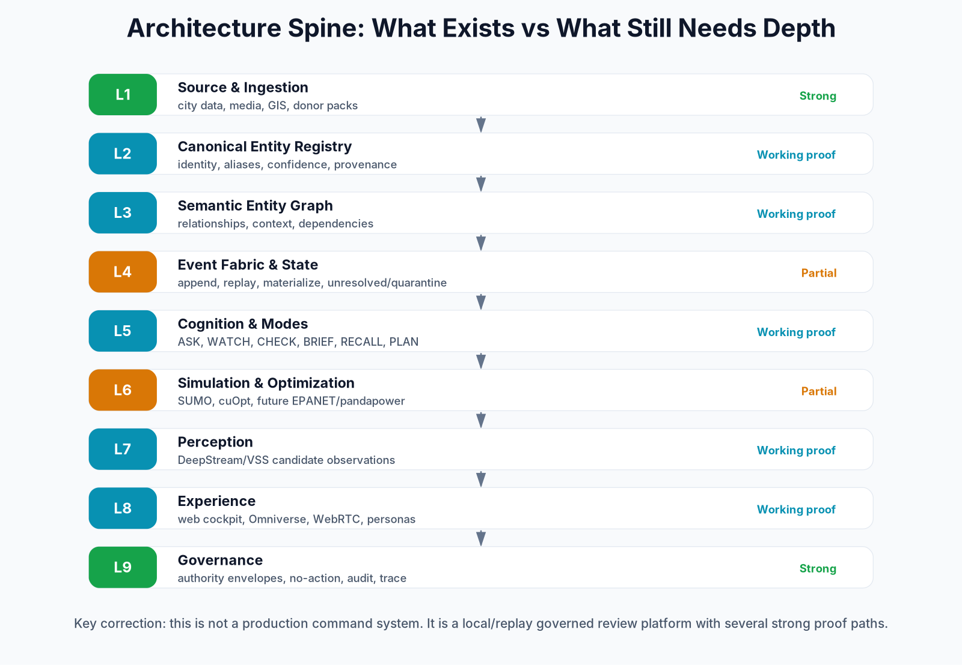
The hard architecture spine is: Canonical Entity Registry first, Semantic Entity Graph on top, Evidence/CHECK/Authority Envelope, review-only modes, human workflow state and governance trace.

Why CER before graph
The core problem is identity under ambiguity: mismatched IDs, inconsistent names, partial geometries, duplicates, stale records and unreliable source keys. The registry owns identity; the graph projects relationship intelligence only after identity contracts are stable.

4. Capability maturity map
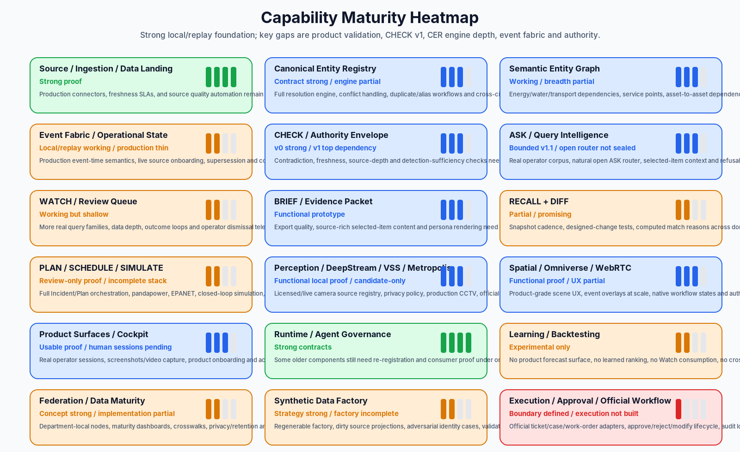

Maturity summary table
Capability | Maturity | Main gap | Next move
Source / Ingestion / Data Landing | Strong proof | Production connectors, freshness SLAs, and source quality automation remain incomplete. | Normalize ingestion manifests into one SourceRegistry v1.
Canonical Entity Registry | Contract strong / engine partial | Full resolution engine, conflict handling, duplicate/alias workflows and cross-city identity semantics are not complete. | Build CER Engine R1 with canonical_entities, source_entities, assertions, match_candidates and review queue.
Semantic Entity Graph | Working / breadth partial | Energy/water/transport dependencies, service points, asset-to-asset dependencies and temporal edge semantics remain thin. | Graph v2 over CER assertions with edge confidence, review_state and temporal validity.
Event Fabric / Operational State | Local/replay working / production thin | Production event-time semantics, live source onboarding, supersession and continuous monitoring not complete. | Event Fabric v1: append, replay, resolve, preserve, quarantine, materialize, query, trace.
CHECK / Authority Envelope | v0 strong / v1 top dependency | Contradiction, freshness, source-depth and detection-sufficiency checks need product-grade v1. | CHECK v1 with claim-to-evidence mapping and cannot-claim downgrade logic.
ASK / Query Intelligence | Bounded v1.1 / open router not sealed | Real operator corpus, natural open ASK router, selected-item context and refusal taxonomy still need validation. | Staged ASK router R1: boundary -> intent family -> target -> answer lens -> selected context.
WATCH / Review Queue | Working but shallow | More real query families, data depth, outcome loops and operator dismissal telemetry needed. | WATCH v1 family library tied to domain packs and CHECK v1.
BRIEF / Evidence Packet | Functional prototype | Export quality, source-rich selected-item content and persona rendering need hardening. | BRIEF v3 templates with operator/planner/executive/persona policies.
RECALL + DIFF | Partial / promising | Snapshot cadence, designed-change tests, computed match reasons across domains and precedent datasets need expansion. | Recall/DIFF R2 on real snapshots with source-level change classifier.
PLAN / SCHEDULE / SIMULATE | Review-only proof / incomplete stack | Full Incident/Plan orchestration, pandapower, EPANET, closed-loop simulation, uncertainty and calibration not complete. | One simulator end-to-end, starting with SUMO then pandapower/EPANET.
Perception / DeepStream / VSS / Metropolis | Functional local proof / candidate-only | Licensed/live camera source registry, privacy policy, production CCTV, official-finding path not built. | Perception candidate schema + source registry + evidence clip retention policy.
Spatial / Omniverse / WebRTC | Functional proof / UX partial | Product-grade scene UX, event overlays at scale, native workflow states and authoring pipeline still need polish. | Hero-neighbourhood twin with event overlay and evidence card click-through.
Product Surfaces / Cockpit | Usable proof / human sessions pending | Real operator sessions, screenshots/video capture, product onboarding and accessibility not finished. | Epoch 4 review pilot: 5-10 real sessions, task success, confusion logs, export feedback.
Runtime / Agent Governance | Strong contracts | Some older components still need re-registration and consumer proof under one runtime contract. | Runtime recertification: no component closes without registered consumer and replay fixture.
Learning / Backtesting | Experimental only | No product forecast surface, no learned ranking, no Watch consumption, no cross-city learned transfer. | Keep offline until enough operator labels and CHECK calibration exist.
Federation / Data Maturity | Concept strong / implementation partial | Department-local nodes, maturity dashboards, crosswalks, privacy/retention and federation contracts need more depth. | Data Quality & Maturity R1 with identity fragmentation and source coverage dashboards.
Synthetic Data Factory | Strategy strong / factory incomplete | Regenerable factory, dirty source projections, adversarial identity cases, validation harness and replay scenario generation need formalization. | Synthetic Factory v1 around Dubai 217 community polygons if available.
Execution / Approval / Official Workflow | Boundary defined / execution not built | Official ticket/case/work-order adapters, approve/reject/modify lifecycle, audit log and monitoring after approval not productionized. | Approval Lifecycle R1 for draft/sandbox only; production execution remains future authority.

5. Gaps and parked work
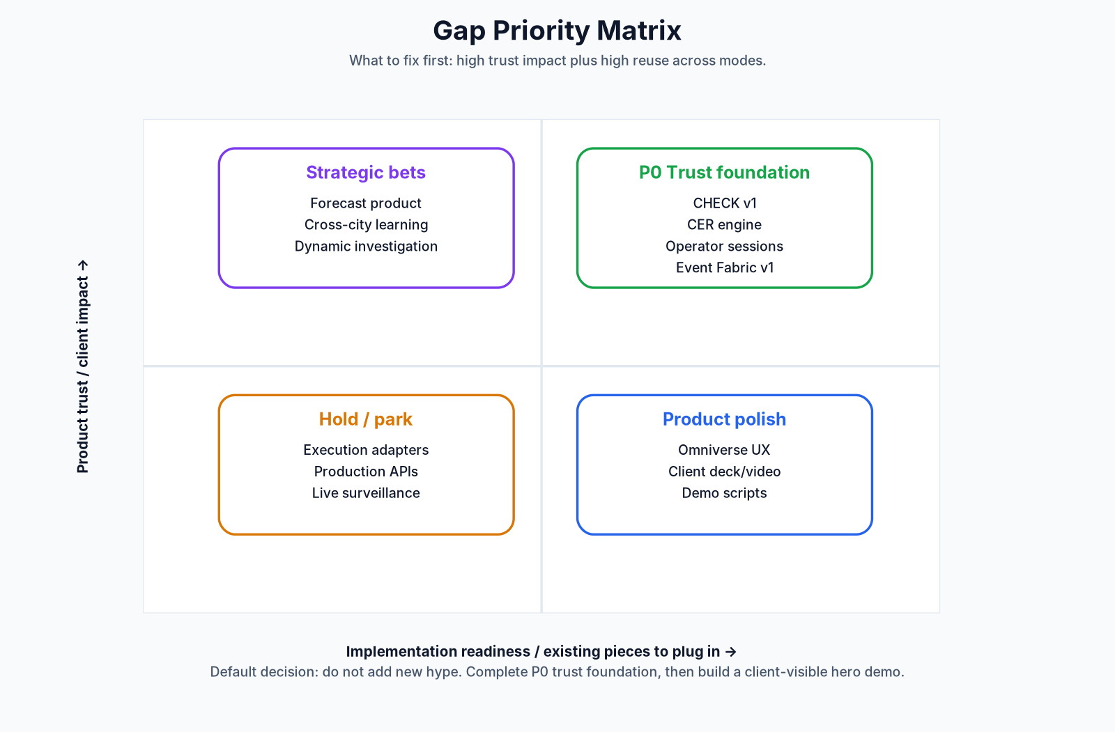

Top gap register
Priority | Gap | Why it matters | Parked / built | Next action
P0 | CHECK v1 contradiction/source-depth/freshness engine | Claimability is the product trust layer; every mode depends on it. | CHECK v0 exists but deeper rules remain open. | Build CHECK v1 with claim-to-evidence mapping, stale-source checks, contradiction rules and cannot-claim downgrade.
P0 | CER engine depth and conflict resolution | Graph, spatial selection and recall are unsafe if identity is unstable. | Contracts and examples exist; full engine is incomplete. | Build CER R1 and bridge all domain packs to canonical IDs.
P0 | Real human operator sessions | The product surface is not truly validated without user behavior. | Several gates record human review/session capture pending. | Run 5-10 recorded review sessions, capture confusion, task success, dismissed WATCH items and export feedback.
P0 | Event Fabric v1/v2 production depth | Without event fabric the cockpit is mostly static/replay. | Local/replay materialization exists; production live fabric is not done. | Local v1 first: append/replay/resolve/quarantine/materialize/query/trace; only later live onboarding.
P1 | Execution authority / official workflow adapters | Clients will ask how review becomes action; today it must stay human-only. | HITL and proposal contracts exist, execution adapters are not built. | Define sandbox adapter only; no production execution until authority policy exists.
P1 | Open ASK router and real operator corpus | ASK is the natural entry point to the product. | Staged router design exists; training/real operator validation not claimed. | Build router eval corpus with refusals, selected-item questions, queue questions and source-profile questions.
P1 | Simulation stack beyond one review problem | PLAN/SCHEDULE/SIMULATE needs calibrated models to become more than option copy. | SUMO/cuOpt proof exists; pandapower/EPANET/closed-loop missing. | Pick one simulator end-to-end, starting with SUMO, then utilities.
P1 | Synthetic Data Factory, not just packs | Spark testing and demos need reproducible worlds with known truth and deliberate messiness. | Gold/dirty/challenge/scenario strategy exists; factory not formalized. | Generate gold, dirty, challenge and scenario tiers with seeded reproducibility.
P1 | Data quality / maturity cockpit | This is a strong commercial consulting wedge for departments. | Concepts exist; dashboards underbuilt. | Build maturity scorecards: identity fragmentation, source freshness, relationship coverage.
P2 | Forecast productization | Offline experiment is promising but not usable by operators yet. | One frozen-replay forecast exists; no product surface or Watch consumption. | Keep offline until operator label depth and calibration gates pass.
P2 | Cross-city learned transfer / dynamic investigation | Strategic differentiator but unsafe before labels and federation mature. | Explicitly future-track / not armed. | Hold until Federation R1 and enough reviewed cases exist.
P2 | Omniverse product UX and hero-neighbourhood twin | Spatial proof exists; clients need a legible demo body. | WebRTC/Kit proofs exist but UX polish remains separate. | Build one hero-neighbourhood twin, not a citywide twin first.

6. Component plug-in map
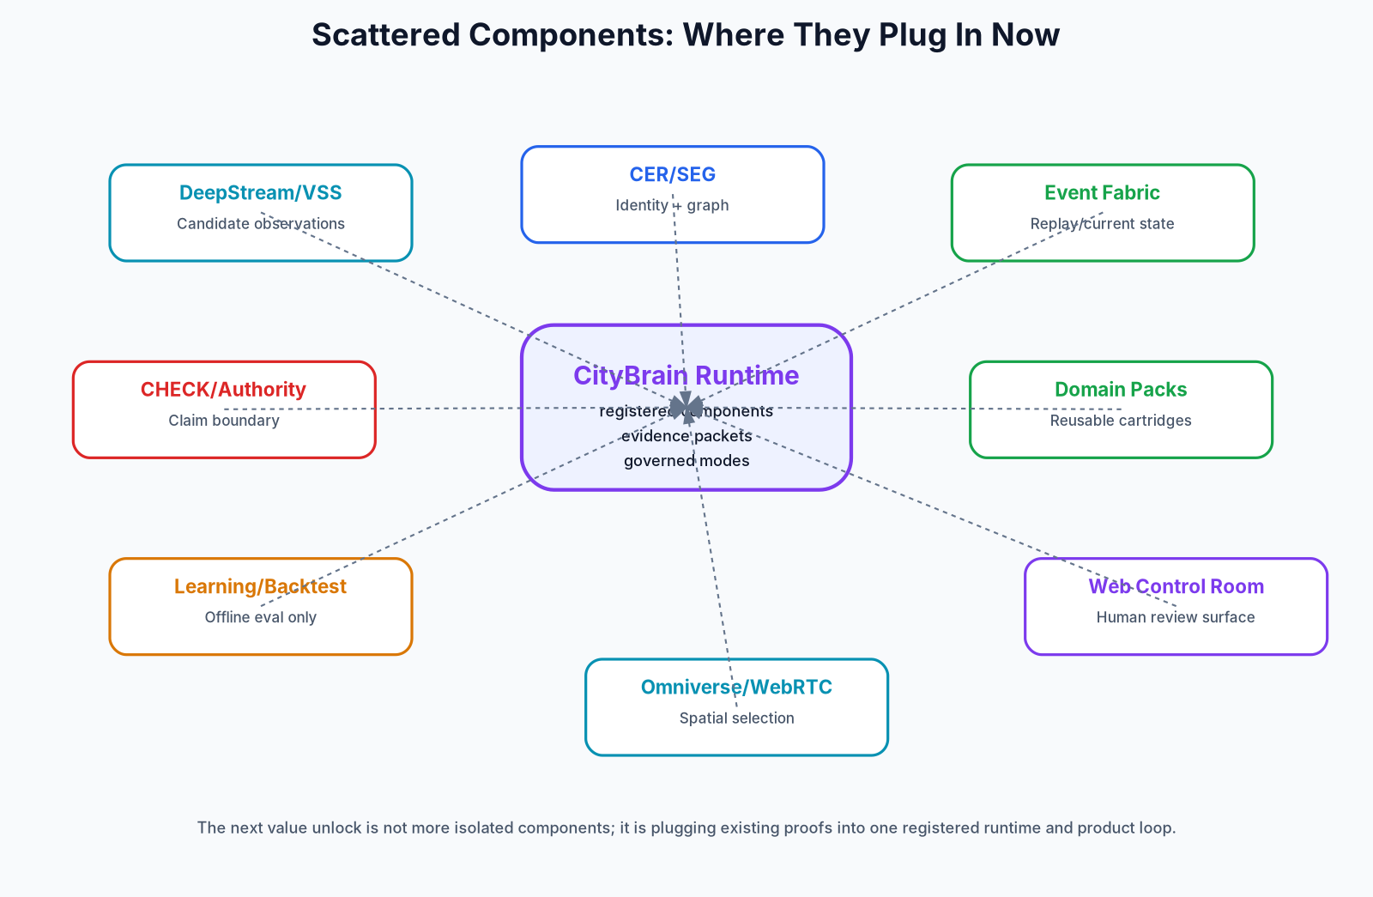
The next value unlock is not more isolated components. It is registering existing proofs into one runtime and product loop. Every component should have a component ID, version, owner, tool permissions, source classes, budget, consumer surfaces, replay fixture and release status.

Immediate plug-in opportunities
- DeepStream/VSS -> Event Fabric -> CHECK -> Review UI.
- CER/SEG -> Spatial binding so Omniverse selection is trustworthy.
- CHECK -> all modes, not just warning copy.
- Outcome ledger -> WATCH relevance learning before trained rankers.
- Data maturity -> client diagnostic product.
- Domain packs -> flows/cartridges instead of bespoke agents.

7. Data and synthetic strategy
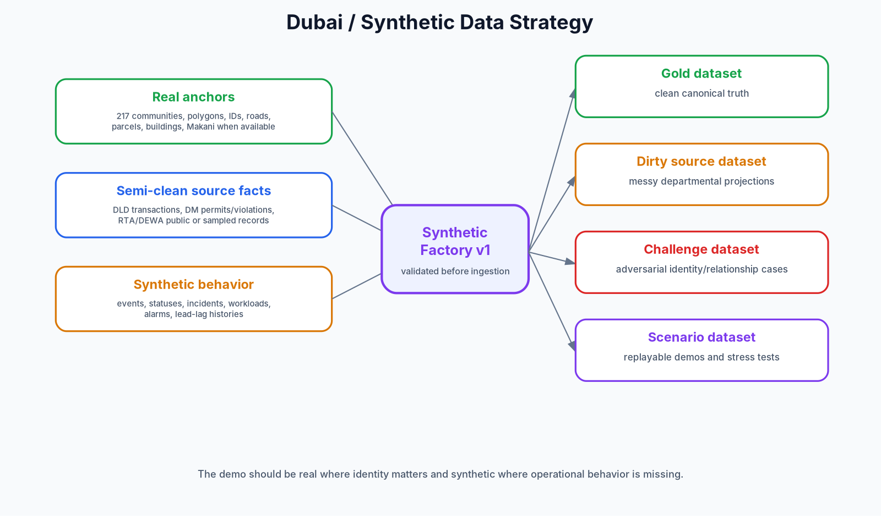
The strongest Dubai strategy is real where identity matters, synthetic where behavior is missing. Real community IDs/polygons, Makani, roads/buildings and true counts should anchor the world; statuses, scenarios, events, workloads and stress histories can be synthetic and clearly labeled.

Four synthetic tiers
- Gold dataset: clean canonical truth.
- Dirty source dataset: messy departmental projections.
- Challenge dataset: adversarial identity and relationship cases.
- Scenario dataset: replayable demos and stress tests.

8. Governance boundary
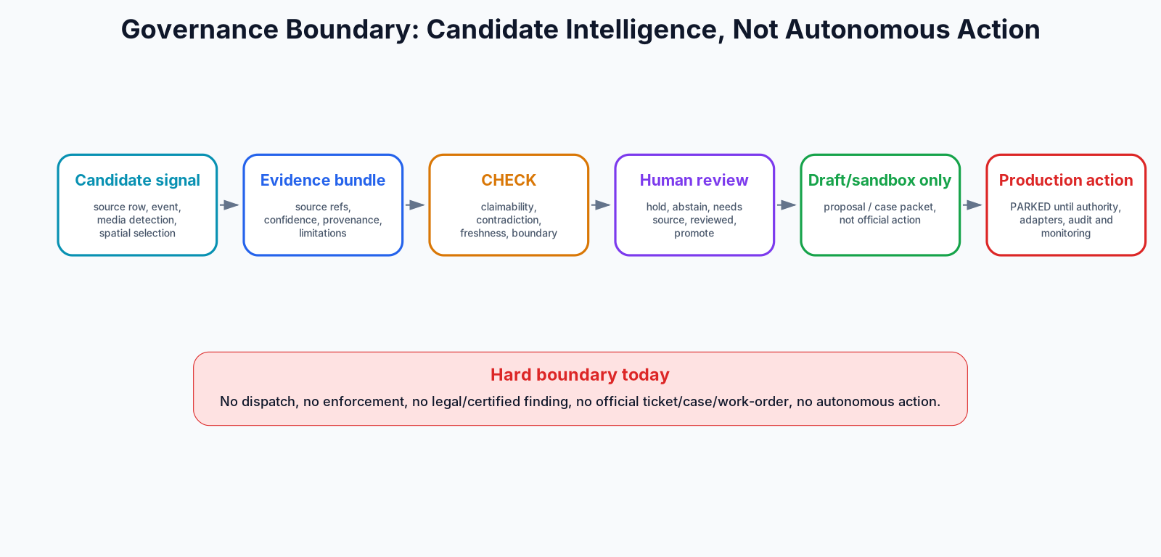
The current product boundary is clear: candidate signals become evidence and review packets. They do not become dispatch, enforcement, legal findings, official cases or autonomous action.

9. Roadmap and next moves
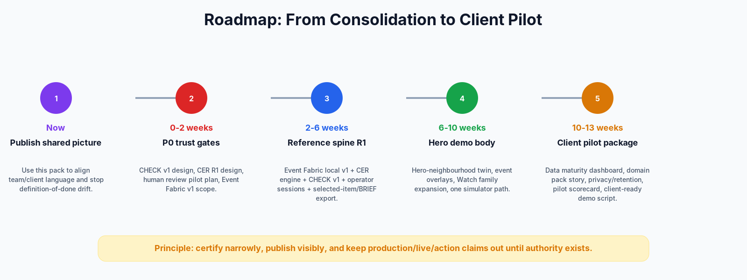
Horizon | Goal | Deliverables
Now | Publish shared picture | Use this pack to align team/client language and stop definition-of-done drift.
0-2 weeks | P0 trust gates | CHECK v1 design, CER R1 design, human review pilot plan, Event Fabric v1 scope.
2-6 weeks | Reference spine R1 | Event Fabric local v1 + CER engine + CHECK v1 + operator sessions + selected-item/BRIEF export.
6-10 weeks | Hero demo body | Hero-neighbourhood twin, event overlays, Watch family expansion, one simulator path.
10-13 weeks | Client pilot package | Data maturity dashboard, domain pack story, privacy/retention, pilot scorecard, client-ready demo script.

P0 decisions
- Publish this pack as the team/client product room.
- Build CHECK v1 and CER R1 before new intelligence.
- Run real operator sessions.
- Finish local Event Fabric v1.
- Build one hero-neighbourhood spatial demo with event overlays.

10. Scenario portfolio and demo script
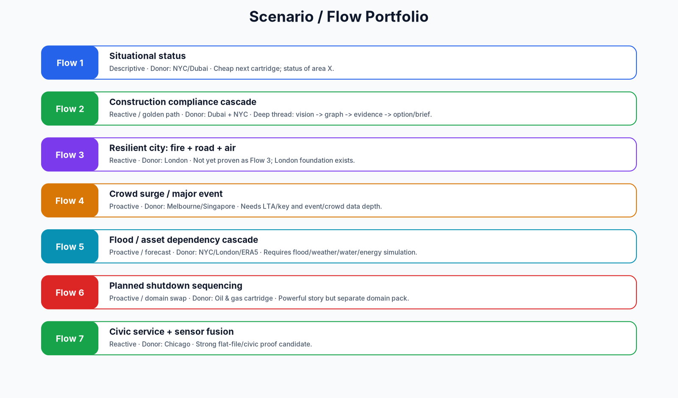

Client demo arc
- The city boots: records, entities, graph and map/twin connect.
- A WATCH item appears: review prompt, not alert.
- The operator asks: bounded ASK answer from packet truth.
- CHECK validates: support, uncertainty, stale sources, cannot-claim.
- BRIEF packages: operator/executive/analyst view.
- SPATIAL grounds: same packet in map/Omniverse/WebRTC.
- Human boundary: hold, abstain, mark reviewed or draft/sandbox only.

11. Source crosswalk and evidence basis
This pack consolidates uploaded Codex exports, conversation summaries, CityBrain Evolution Digest, RTX Vision/Roadmap/SyntheticData docs, north-star product loop notes, VSS/Metropolis closeout, Barcelona and task-update files, and the previous consolidation master. It is a synthesis layer, not a forensic repo audit.

Recommended source-of-truth publishing layer
- Product Truth page.
- Architecture Spine page.
- Gap/Parked Register.
- ComponentRegistry export.
- Demo/Client Story pack.
- Monthly source crosswalk.

