**IMPROVING THE PERFORMANCE OF MOBILE DATA GATHERING BY THE LOCALIZATION OF RELAY TERMINAL IN THREE LAYER APPROACH**

By

Priya Narayana Subramanian

Reg. No: 96210104075

A PROJECT REPORT

Submitted to the Faculty of

INFORMATION AND COMMUNICATION ENGINEERING

*in the partial fulfilment for the*

*award of the degree*

*of*

**BACHELORS OF ENGINEERING**

**in**

**Computer Science and Engineering**

**ANNA UNIVERSITY, CHENNAI**

**NATIONAL ENGINEERING COLLEGE, K.R.NAGAR, KOVILPATTI-628 503**

**(An Autonomous Institution)**



**CHAPTER 1**

**INTRODUCTION**

A wireless sensor network (WSN) are spatially distributed [autonomous](https://en.wikipedia.org/wiki/Autonomous) [sensors](https://en.wikipedia.org/wiki/Sensor) to monitor physical or environmental conditions, such as [temperature](https://en.wikipedia.org/wiki/Temperature), [sound](https://en.wikipedia.org/wiki/Sound), [pressure](https://en.wikipedia.org/wiki/Pressure), etc. and to cooperatively pass their data through the network to a main location. A Wireless sensor networks in Figure 1.1 is composed of a large number of tiny sensor nodes, which are randomly or manually deployed in a given coverage area. The sensor node consists of sensing, data processing and communicating components along with a power unit.WSN collects local information, process them and send it to a remote base station.

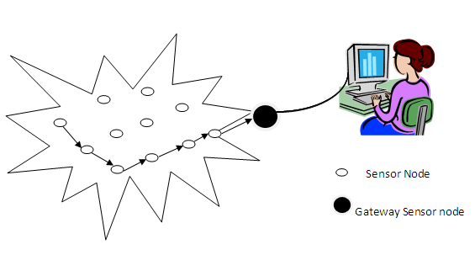

**Figure 1.1 Wireless Sensor Network**

Depending on the communication range between sensor nodes and gateways there are two kinds of sensor nodes. They are restricted nodes and open nodes. Restricted nodes are those sensor nodes, which can communicate only with one and only one gateway. Open nodes are those sensor nodes, which can communicate with more than one gateway.

**1.1 BASICS OF WIRELESS SENSOR NETWORK**

WSN is composed of large number of sensor nodes. The event is sensed by the low power sensor node deployed in neighborhood and the sensed information is transmitted to a remote processing unit or Base Station. To deliver crucial information from the environment in real time it is impossible with wired sensor networks whereas WSN are used for data collection and processing in real time from environment.

Depending on the different applications of WSN they are either deployed manually or randomly. After being deployed either in a manual or random fashion, the sensor nodes self-organize themselves and start communication by sending the sensed data. These sensor networks are deployed at a great pace in the current world. There is an interesting unlimited potential in this wireless technology with various application areas along with crisis management, transportation, military, medical, natural disaster, seismic sensing and environmental. There are two main applications of WSNs which can be categorized as: monitoring and tracking.

WSN consisting of nodes with limited power are deployed to gather useful information from the field. In WSNs it is critical to collect the information in an efficient manner. It is applied in routing and difficult power supply area that cannot be reached and some temporary situations, which do not need fixed network supporting and it can fast deploy with strong anti-damage. Figure 1.2 shows the basic components of WSN.

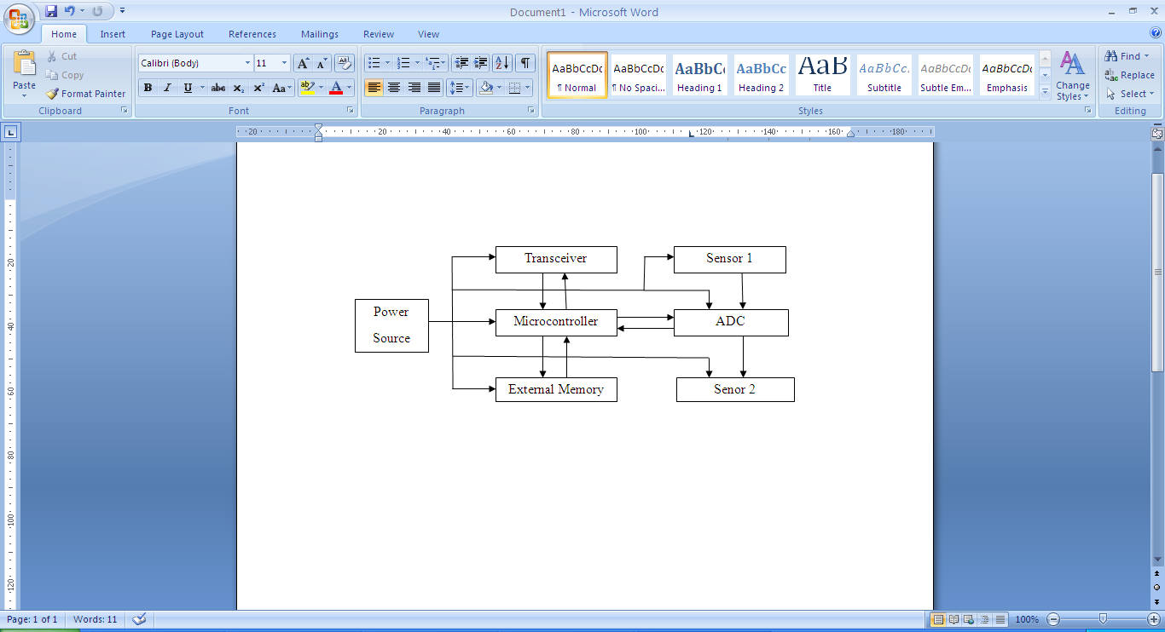

**Figure 1.2 Basic Components of WSN**

In addition to one or more sensors, each node in a sensor network is typically equipped with a radio transceiver or other wireless communications device, a small microcontroller, and an energy source, usually a battery.

**1.2 WIRELESS SENSOR COMPONENTS**

* Microcontroller.
* Radio transceiver.
* Energy source (battery).

**1.2.1 Embedded Processor**

The functionality of an embedded processor in a sensor node is to schedule tasks, process data and control the functionality of other hardware components. There are several types of embedded processors available that can be used in a sensor node include Microcontroller, Digital Signal Processor (DSP), Field Programmable Gate Array (FPGA) and Application Specific Integrated Circuit (ASIC) been the most used embedded processor for sensor nodes is the Microcontroller because of its flexibility to connect to other devices and its cheap price[2]. For example, the most recent CC2531 development board provided by Chipcon (acquired by Texas Instruments) uses 8051 microcontroller, and the Mica2 Mote platform provided by Crossbow uses ATMega128L microcontroller.

**1.2.2 Power Source**

In deployment of the WSN device is likely to be battery powered. Power is consumed by sensing, communication and data processing by a sensor node. . Batteries are the main source of power supply for sensor nodes. For example, Mica2 Mote runs on 2 AA batteries. While some of the nodes may be wired to a continuous power source in some applications, and energy harvesting techniques may provide a degree of energy renewal in some cases, the finite battery energy is probable to be the most critical resource bottleneck in most applications.

**1.2.3 Transceiver**

The responsibility of a transceiver is for the wireless communication of a sensor node. There are different types of wireless transmission media, which includes Radio Frequency (RF), Laser and Infrared. The most used transmission media to fits to most of WSN applications is the RF based communication. The different operational states of a transceiver are Transmit, Receive, Idle and Sleep. Mica2 Mote uses two kinds of RF radios one is RFM TR1000 and other one is Chipcon CC1000. The Mica2 Mote’s outdoor transmission range of is about 150 meters.

WSN composed of independent sensor nodes deployed in an area working collectively in order to monitor different environmental and physical conditions such as motion, temperature, pressure, vibration sound or pollutants. The main reason in the advancement of WSN was military applications in battlefields in the beginning but now the application area is extended to other fields including industrial monitoring, controlling of traffic and health monitoring. Different constraints are provided such as size and cost, results in constraints of energy, bandwidth, memory and computational speed of sensor nodes.

**1.3 CHARACTERISTICS OF WSN**

The WSNs are scalable; the only limitation is the bandwidth of gateway node. WSNs have the ability to deal with node failures. Another unique feature is the mobility of nodes. They have the ability to survive in different environmental surroundings. They have dynamic network topology. Further developments in this technology have led to integration of sensors, digital electronics and radio communications into a single integrated circuit (IC) package. Generally WSN have a BS that communicates through radio connection to other sensor nodes. The required data collected at sensor node is processed, compressed and sent to gateway directly or through other sensor nodes.

**1.4 SENSOR NODE**

A sensor is otherwise called as transducer which converts physical phenomenon e.g. heat, light, motion, vibration, and sound into electrical signals. A sensor node, also known as a mote is the basic unit in sensor network. It is a node in a WSN that is capable of performing some processing, gathering sensory information and communicating with other connected nodes in the network. It contains on-board sensors, processor, memory, transceiver, and power supply. A mote is a node but a node is not always a mote. WSNs are first divided into different clusters. Each cluster comprises a set of wireless sensor nodes. A sensor network consists of large number of sensor nodes. The nodes are deployed either inside or very close to the sensed phenomenon.

**1.5 SENSOR NODE ARCHITECTURE**

A wireless sensor node is capable of gathering information from surroundings, processing and transmitting required data to other nodes in network. The sensed signal from the environment is analog which is then digitized by analog-to-digital converter which is then sent to microcontroller for further processing. Figure 1.3 shows the architecture of sensor network. While designing the hardware of any sensor node the main feature in consideration is the reduction of power consumption by the node. Most of the power consumption is radio subsystem of the sensing node. So the sending of required data over radio network is advantageous. Another important factor is the reduction of power consumption by the sensor which should be in consideration as well.

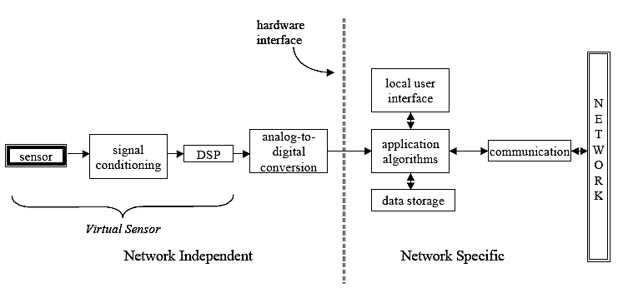

**Figure 1.3 Architecture of Sensor Network**

**1.6 SENSOR NODE COMPONENTS**

Figure 1.4 shows the sensor node components. The various sensor nodes have the capabilities regarding power of microcontroller, radio and capacity of memory. Despite of the variances it can be said that there are four basic sub- systems of sensor nodes; computing subsystem, sensing subsystem, power subsystem and communication subsystem.

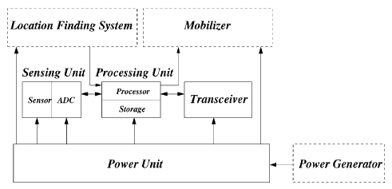  
**Figure 1.4 Sensor Node Components**

**1.6.1 Controlling Component**

In order to control the components of the sensor nodes and perform the required computations this subsystem is responsible for it. There are two sub-units, storage unit and processor unit. There are different operational modes of processors in sensor nodes. They are either Idle, Active or in Sleep modes.

**1.6.2 Communication Component**

The sensor nodes due to this component interact with the BS and to the other nodes. Usually this subsystem is a radio of short range but other fields has also been explored like ultrasound, infrared communication and inductive fields. The advantage of radio frequency communication for sensor nodes is that it is not limited by line of sight and low power radio transceivers with data-rates and ranges depending on the applications are easily implemented with the help of current technology.

**1.6.3 Power Component**

Power is supplied to sensor nodes by this sub-system in which a battery is contained. Every aspect of the network regarding communication algorithms, sensing devices, localization algorithms should be efficient in terms of energy usage because replacement or recharging of battery is unfeasible in case where large numbers of sensor nodes are deployed. For recharging of battery onsite a power generator should be included.

**1.6.4 Sensing Component**

In this sub-system the physical phenomena is converted to electrical signals by sensor transducers. So the outside world is linked to this subsystem. Sensors may have analog or digital output. There should be an analog to digital converter (ADC) incase if output is analog.

Sensor node consumes mostly its energy in transmitting and receiving packets. Clustering is one of the promising techniques for reducing the energy consumption. In a clustered WSN, sensor nodes are partitioned into a certain number of clusters, each of which has a cluster head (CH) and some non-CH members. CH collects information from all the cluster members and then forwards to other CHs or BS, while non-CHs are responsible for sensing environmental conditions and transmitting information to the corresponding CH. There are two types of nodes in each cluster: cluster member nodes and cluster head node. Member nodes collect data from the environment and send it to the cluster head node. Then, the head node sends the received data to the sink after fusion.

**1.7 APPLICATIONS OF WSN**

Sensor networks may consist of many different types of sensors such as magnetic, thermal, visual, seismic, and infrared and radar, which are able to monitor a wide variety of conditions. These sensor nodes can be put for continuous sensing, location sensing, and motion sensing and event detection. The idea of micro-sensing and wireless connection of these sensor nodes promises many new application areas. A few examples of their applications are as follows

**Area monitoring applications**

Area monitoring is a very common application of WSNs. In area monitoring, the WSN is deployed over a region where some physical activity or phenomenon is to be monitored. When the sensors detect the event being monitored (sound, vibration), the event is reported to the base station, which then takes appropriate action (e.g., send a message on the internet or to a satellite). Similarly, wireless sensor networks can be deployed in security systems to detect motion of the unwanted, traffic control system to detect the presence of high-speed vehicles. Also WSNs finds huge application in military area for battlefield surveillance, monitoring friendly forces, equipment and ammunition, reconnaissance of opposing forces and terrain, targeting and battle damage assessment.

**Environmental applications**

A few environmental applications of sensor networks include forest fire detection, green house monitoring, landslide detection, air pollution detection and flood detection. They can also be used for tracking the movement of insects, birds and small animals, planetary exploration, monitoring conditions that affect crops and livestock and facilitating irrigation.

**Health applications**

Some of the health applications for sensor networks are providing interfaces for the disabled, integrated patient monitoring, diagnostics, drug administration in hospitals, monitoring the movements and internal processes of insects or other small animals, telemonitoring of human physiological data, and tracking and monitoring doctors and patients inside a hospital

**Industrial applications**

WSNs are now widely used in industries, for example in machinery condition based maintenance. Previously inaccessible locations, rotating machinery, hazardous or restricted areas, and mobile assets can now be reached with wireless sensors. They can also be used to measure and monitor the water levels within all ground wells and monitor leach ate accumulation and removal.

**Vehicle Detection**

Wireless sensor networks can use a range of sensors to detect the presence of vehicle ranging from motorcycles to train cars.

**Agriculture:**

Using wireless sensor networks within the agricultural industry is increasingly common. Gravity fed water systems can be monitored using pressure transmitters to monitor water tank levels, pumps can be controlled using wireless I/O devices, and water use can be measured and wirelessly transmitted back to a central control center for billing. Irrigation automation enables more efficient water use and reduces waste.

**Other applications**

Sensor networks now find huge application in our day-to-day appliances like vacuum cleaners, micro-wave ovens, VCRs and refrigerators. Other commercial applications include constructing smart once spaces, monitoring product quality, managing inventory, factory instrumentation and many more.

**1.8 CHALLENGES IN WSN**

* 1. Energy Efficiency
  2. Limited storage and computation
  3. Low bandwidth and high error rates
  4. Errors are common
  5. Scalability to a large number of sensor nodes
  6. Survivability in harsh environments
  7. Experiments are time sensitive and space-intensive

**1.9 CLUSTERING IN WSN**

In energy-constrained sensor networks of large size, it is inefficient for sensors to transmit the data directly to the sink .In such scenarios, Cluster based approach is hierarchical approach. The whole network is divided into several clusters. Each cluster has a cluster-head which is selected among cluster members. Cluster-heads do the role of aggregator which aggregate data received from cluster members locally and then transmit the result to base station (sink).



**Figure 1.5 Clustering in WSN**

Figure 1.5 shows the clustering in WSN. Clustering is one of the important methods for prolonging the network lifetime in wireless sensor networks (WSNs). It involves grouping of sensor nodes into clusters and electing cluster heads (CHs) for all the clusters. CHs collect the data from respective cluster’s nodes and forward the aggregated data to base station. A major challenge in WSNs is to select appropriate cluster heads.

**1.10 TYPES OF CLUSTERS**

There are two different types of clusters namely homogeneous clustered network and Heterogeneous clustered network. Nodes which are having similar characteristics mainly based on energy level and distance are grouped in to a separate homogeneous cluster. Nodes which are having different characteristics are grouped to form heterogeneous clusters.

Clustering formation procedure involves the selection of a cluster head node, in order to control the member nodes. There are two ways for selecting Cluster Head for each cluster. One way is CH can be selected as per the probability value after conducting an election among the cluster members. Second way is for selecting CH two processes are used the BS collects the information of the position and energy level from all sensor nodes in the networks. The non-cluster head nodes send data to cluster head node during their allocated transmission time. When all the data have been received, the cluster head node performs signal processing to compress the data into a single signal. Then, this signal is sent to the Base Station.

**1.11 DATA AGGREGATION IN WSN**

Data aggregation is the process of collecting and aggregating the useful data. Data The data aggregation is a technique used to solve the implosion and overlap problems in data centric routing. Data coming from multiple sensor nodes is aggregated as if they are about the same attribute of the phenomenon when they reach the same routing node on the way back to the sink aggregation is considered as one of the fundamental processing procedures for saving the energy.

In WSN, data aggregation is an effective way to save the limited resources. The main goal of data aggregation in Figure 1.6 is to gather and aggregate data in an energy efficient manner so that network lifetime is enhanced. Wireless sensor networks have limited computational power, limited memory and battery power, hence increased complexity for application developers which results in applications that are closely coupled with network protocols.



**Figure 1.6 Data Aggregation**

Wireless sensor nodes are very small in size and have limited processing capability and very low battery power. This restriction of low battery power makes the sensor network prone to failure. Data aggregation is a very crucial technique in WSNs. Data aggregation helps in reducing the energy consumption by eliminating redundancy.

Recently, there is many increasing interest on data collection in wireless sensor network. Sink node is used to collect data in wireless sensor network .Data collection may be in one hop or multi- hop. All sensors collect data and is send to the base station called sink node. Large or thousand numbers of Sensor nodes deployed in collaborate to form a network capable of reporting to data collection and deployment can be random deployment or self organization. In some cases mobile sink node move or travel in sensing area and directly collects data from the sensors and send to the base station for further processing. Taxi, Airplane, bus is used for the data collection. This may be reducing communication traffic by using mobile sink node data collection.

**1.12 METHODS OF DATA COLLECTION IN WSN**

**1.12.1 Sink node**

All collected sensor data are forwarded to sink node. It is used for data collection purpose it can be a base station or access point.

**1.12.2 Multiple Sink**

In Multiple Sink Node Data Collection Problem data from sensor nodes needs to be transmitted to one of multiple sinks in wireless sensor networks. To minimize the latency of data collection, Schedule designs an approximation algorithm.

**1.12.3 Approximate Data Collection (ADC)**

ADC is to divide a sensor network into clusters, discover local data correlations on each cluster head, and perform global approximate data collection on the sink node according to model parameters uploaded by cluster heads. Wireless sensor networks must be designed to meet a number of challenging requirements including extended lifetime in the face of energy constraints, robustness, scalability, and autonomous operation. Wireless sensor networks are getting smaller and faster, increasing their potential applications in commercial, industrial, and residential environments.

**1.12.4 Using Routing Protocol**

There are various routing protocols are available for data collection in wireless sensor network in 1) Location based protocol 2) Data Centric Protocols 4) Hierarchical Protocols 5)

Mobility-based Protocols 6) Multipath-based Protocols 7) Heterogeneity-based Protocols 8)

QoS-based Protocols.

**1.12.5 Comparison of sink node**

Static sink node was used for data collection in wireless sensor network by using multi hop forwarding so there is more energy consumption nearby node around Base station and relaying in data from other one. Mobile sink node was used to collect data from sensors node and stored it to the base station. But due to failure of a node whole process fail as only one mobile sink node is using. Multiple sink nodes were used in data collection process from the sensors and stored collected data on the base station in the database. Here when one of the node mobile sink node fail other is available as the backup one.

**1.13 MOBILE DATA GATHERING WITH CLUSTERING**

Wireless Sensor Networks (WSNs) consist of sensor nodes that are deployed into a large scale sensing field without a preconfigured infrastructure. The goal of the sensor node is to collect the data at regular intervals, then transform the data into digital signal and finally send the signal to the sink or the base node. The sensors near the data sink in the wireless sensor network lose its battery power because of acting as relay. Sensors are generally densely deployed and randomly scattered over a sensing field and left unattended after being deployed, which makes it difficult to recharge or replace their batteries.

After sensors form into autonomous organizations, those sensors near the data sink typically deplete their batteries much faster than others due to more relaying traffic. When sensors around the data sink deplete their energy, network connectivity and coverage may not be guaranteed. Due to these constraints, it is crucial to design an energy-efficient data collection scheme that consumes energy uniformly across the sensing field to achieve long network lifetime. Furthermore, as sensing data in some applications are time-sensitive, data collection may be required to be performed within a specified time frame. Therefore, an efficient, large-scale data collection scheme should aim at good scalability, long network lifetime and low data latency.

The first category is the enhanced relay routing in which data are relayed among sensors. Besides relaying, some other factors, such as load balance, schedule pattern and data redundancy, are also considered. The second category organizes sensors into clusters and allows cluster heads to take the responsibility for forwarding data to the data sink. Clustering is particularly useful for applications with scalability requirement and is very effective in local data aggregation since it can reduce the collisions and balance load among sensors. The third category is to make use of mobile collectors to take the burden of data routing from sensors.

Then mobile collector is introduced to take the burden of data routing to reduce energy cost at sensor side. In that, the data collection time of mobile collector may be high because from each cluster head the data is to be gathered individually.

In relay routing schemes, minimizing energy consumption on the forwarding path does not necessarily prolong network lifetime, since some critical sensors on the path may run out of energy faster than others. In cluster-based schemes, cluster heads will inevitably consume much more energy than other sensors due to handling intra-cluster aggregation and inter-cluster data forwarding. Though using mobile collectors may alleviate non-uniform energy consumption, it may result in unsatisfactory data collection latency.

Based on these observations, the proposed method is based on energy efficient data collection using mentor node. Here a distributed algorithm is proposed to organize sensors into clusters, where each cluster has multiple cluster heads. Then multiple cluster heads within a cluster can collaborate with each other to perform energy efficient inter-cluster transmissions. Also it reduces the waiting state of Mentar and hence decreases the packet loss ratio and provides efficient data collection from Cluster Head to the sink node.

**1.14 MOBILE COLLECTOR**

The proposed system contains clustering with load balancing and mobile collecting concept with dual data uploading technique. The mentor node is introduced which is a mobile data collector serves as a mobile data transporter that moves through every community and links all separated sub networks together. The moving path of the mobile data collector acts as virtual links between separated sub networks. Mobile data collector could be a mobile robot or a vehicle equipped with a powerful transceiver, battery, and large memory. The mobile data collector starts a tour from the data sink, traverses the network, collects sensing data from nearby nodes while moving, and then returns and uploads data to the data sink.

Since the data collector is mobile, it can move close to sensor nodes, such that if the moving path is well planned, the network lifetime can be greatly prolonged. Here, network lifetimeis defined as the duration from the time sensors start sending data to the data sink to the time when a certain percentage of sensors either run out of battery or cannot send data to the data sink due to the failure of relaying nodes. If a wireless sensor network is considered that consists of a large number of sensors and a limited number of mobile data collectors. In such a network, mobile collectors take over the burden of routing from sensors, roaming over the sensing area and collecting data from nearby sensors via short-range wireless communications.

A sensor node consumes energy for monitoring the environmental conditions and it transfers the information to all other nodes using processing unit. Energy consumption is made least by using cluster head and packet forwarding. When a cluster head is consuming a very meager amount of power, all that it does is just passes on the control to the very next node and it is made as cluster head. The cluster head for the next iteration is being chosen based on the distance and residual energy. Time acts as the main criteria over here. The cluster head should be chosen within the specified distance and energy within a pre-defined time. This leads to efficient power consumption, thereby letting the next qualified node to act as the cluster head and this process keeps repeating itself to minimize the power consumption in each node. Thus the cluster head is changed within the node itself, keeping time as the limit. And if a node is in failure, that particular node will be rejected as cluster head.

The next process in making the power consumption less is by packet forwarding. This is all about selecting the route for the node selection. A specified path for one node to another is chosen by means of distance. The route is selected when the distance between the two nodes is least. If any one of the nodes fails due to the energy consumption criteria, an alternate path is chosen so that the path of the cluster head flow should be to the node which is of least distance to the current cluster head. Choosing the path in qualifying the cluster head is called route discovery. Maintaining the path whenever there is a change in the cluster head in a routing table is called route maintenance. Though many routes exist, the path should be made by selecting the closest distance. This is called route selection. The path flow is made and the cluster head is selected based on the time limits and energy consumption. If there exists a barrier to the path i.e., a cluster head is failed out of power consumption, an alternate path is found. This is called failure checking. Efficient energy consumption is made possible by cluster head and packet forwarding. Thus energy consumption is reduced to a greater extent, thereby letting a network system more efficient.

**CHAPTER 2**

**LITERATURE SURVEY**

Energy consumption is the major issue in WSNs. Each sensor nodes can utilize only limited amount of power supply for performing transmission of packets in a wireless environment. Sensors are generally densely deployed and randomly scattered over a sensing field and left unattended after being deployed, which makes it difficult to recharge or replace their batteries. Due to these constraints, it is crucial to design an energy-efficient data collection scheme that consumes energy uniformly across the sensing field to achieve long network lifetime. Therefore, an efficient, large-scale data collection scheme should aim at good scalability, long network lifetime and low data latency.

**Kenan Xu et al** proposed that in a heterogeneous wireless sensor network (WSN), relay nodes (RNs) are adopted to relay data packets from sensor nodes (SNs) to the base station (BS). The deployment of the RNs can have a significant impact on connectivity and lifetime of a WSN system. Here the author proposed a phenomenon called biased energy consumption rate problem associated with uniform random deployment. This problem leads to insufficient energy utilization and shortened network lifetime. To overcome this problem, the authors proposed two new random deployment strategies, namely, the lifetime-oriented deployment and hybrid deployment [6]. The former solely aims at balancing the energy consumption rates of RNs across the network and the latter reconciles the concerns of connectivity and lifetime extension. Both single-hop and multi-hop communication models are considered. When the number of RNs is relatively small, the hybrid deployment is the preferred solution as it reconciles the concerns of lifetime with connectivity. When the number of RNs is large, the hybrid deployment is the same as the lifetime deployment, and they both significantly outperform the connectivity-oriented deployment.

**Miao Zhao** **et al** addressed the issue of data gathering, mobility and space-division multiple access (SDMA) technique. Specifically, mobile collectors, called SenCar in this paper, work like mobile base stations and collect data from associated sensors via single-hop transmissions so as to achieve uniform energy consumption. The authors also apply SDMA technique [9] for data gathering by equipping each SenCar with multiple antennas such that distinct compatible sensors may successfully make concurrent data uploading to a SenCar. They consider two cases, where a single SenCar and multiple SenCar are deployed in a WSN, respectively. For the single SenCar case, we aim to minimize the total data gathering time, which consists of the moving time of the SenCar and the data uploading time of sensors, by exploring the trade-off between the shortest moving tour and the full utilization of SDMA. In the multi-SenCar case, the sensing field is divided into several regions, each having a SenCar. They focus on minimizing the maximum data gathering time among different regions and refer to it as mobile data gathering with multiple SenCar and SDMA (MDG-MS) problem. Accordingly, a region-division and tour-planning (RDTP) algorithm was proposed in which data gathering time is balanced among different regions.

**Euisin Lee et al** proposed that the data generated from the sources in the region are often redundant and highly correlated. Accordingly, gathering and aggregating data from the region in the sensor networks is important and necessary to save the energy and wireless resources of sensor nodes. In order to address this issue, the author introduced a phenomenon called local sink. The local sink is a sensor node in the region, in which the sensor node is temporarily selected by a global sink [4] for gathering and aggregating data from sources in the region and delivering the aggregated data to the global sink. Then a Single Local Sink Model is designed because the buffer size of a local sink is limited and the deadline of data is constrained, single local sink is capable of carrying out many sources in a large-scale local and adjacent region. Hence, they also extend the Single Local Sink Model to a Multiple Local Sinks Model. A data gathering mechanism is proposed that gathers data in the region through the local sink and delivers the aggregated data to the global sink. The proposed mechanism is more efficient in terms of the energy consumption, the data delivery ratio, and the deadline miss ratio than the existing mechanisms.

**Dawei Gong et al** proposed a novel data gathering method using Compressive Sensing (CS) and random projection to improve the lifetime of large Wireless Sensor Networks. By using compressive sensing in data aggregation, referred to as Compressive Data Gathering (CDG), one can dramatically improve the energy efficiency, and this is particularly attributed to the benefits obtained from data compression. Random projection together with compressive data gathering helps in balancing the energy consumption load throughout the network. A new compressive data gathering method called Minimum Spanning Tree Projection (MSTP) [3] was proposed in order to create a number of Minimum-Spanning-Trees (MSTs), each rooted at a randomly selected projection node, which in turn aggregates sensed data from sensors using compressive sensing. The authors further extend to introduce eMSTP, which joins the sink node to each MST and makes the sink node as the root for each tree.

**Pengfei Zhang et al** proposed an optimization algorithm for maximizing the lifetime of a single-cluster network, followed by an extension to handle multi-cluster networks. Then the study of the joint problem of prolonging network lifetime by introducing energy-harvesting (EH) nodes [14] was introduced. An algorithm is proposed for maximizing the network lifetime where EH nodes serve as dedicated relay nodes for cluster heads (CHs). Based on the assumption that the locations of the EH nodes can be adjusted in order to maximize network lifetime, the author extend the proposed algorithms to handle the case where EH sensors serve as relay nodes for CHs. By communicating with EH nodes over a shorter distance rather than sending data to BS directly, CHs can have lowered energy consumptions for at least a certain fraction of time. Each cluster contains a single CH and a certain number of NCHs (Non Cluster Head).Each CH is responsible for aggregating data from NCHs and forwarding the information to BS, either directly or via a dedicated EH relay node. The proposed algorithms can achieve optimal or suboptimal solutions efficiently, and therefore help provide useful benchmarks for various centralized and distributed clustering scheme designs and may help prolong the network lifetime.

**Zhenghao Zhang et al** proposeda two-layered heterogeneous sensor networks was where two types of nodes are deployed in the network: basic sensor nodes and cluster head nodes. A cluster head node organizes the basic sensor nodes around it into a cluster. A basic sensor node does data collections and sends the data packets when polled by the cluster head. By introducing hierarchy, such a two-layered heterogeneous sensor network has better scalability than homogeneous sensor networks. It also has a smaller overall cost since networking functionalities [17] are shifted from sensors to the cluster head. It also has a longer life time, as sensors send packets only when polled by the cluster head and less energy is consumed in collisions and idle listening. This type of network will be ideally suited for applications such as environmental monitoring. Here the authors focus on finding energy efficient and collision-free polling schedules in the multi-hop cluster.

**Xueyan Tang et al** proposed data collection strategies in lifetime-constrained wireless sensor networks. The objective is to maximize the accuracy of data collected by the base station over the network lifetime. Instead of sending sensor readings periodically, the relative importance of the readings is considered in data collection: the sensor nodes send data updates to the base station when the new readings differ more substantially from the previous ones. The optimal update strategy [15] was analyzed and adaptive update strategies for both individual and aggregate data collections were developed. The two methods to cope with message losses in wireless transmission were presented. To make full use of the energy budgets, an algorithm is designed to allocate the number of updates allowed to be sent by the sensor nodes based on their topological relations.

**S.Fahmy et al** proposed a new energy-efficient approach for clustering nodes in ad-hoc sensor networks. Based on this approach, protocol called HEED (hybrid energy-efficient distributed clustering) [11] was presented that periodically selects cluster heads according to a hybrid of their residual energy and a secondary parameter, such as node proximity to its neighbors or node degree. HEED does not make any assumptions about the distribution or density of nodes, or about node capabilities, e.g., location-awareness. The clustering process terminates in O(1) iterations, and does not depend on the network topology or size. The protocol incurs low overhead in terms of processing cycles and messages exchanged. It also achieves fairly uniform cluster head distribution across the network. A careful selection of the secondary clustering parameter can balance load among cluster heads. The simulation results demonstrate that HEED outperforms weight-based clustering protocols in terms of several cluster characteristics.

**Ming Ma et al** proposed a new data gathering mechanism for large-scale multi hop sensor network. A mobile data observer, called SenCar, which could be a mobile robot or a vehicle equipped with a powerful transceiver and battery, works like a mobile base station in the network. SenCar [10] starts the data gathering tour periodically from the static data processing center, traverses the entire sensor network, gathers the data from sensors while moving, returns to the starting point, and, finally, uploads data to the data processing center. Unlike SenCar, sensors in the network are static and can be made very simple and inexpensive. They upload sensed data to SenCar when SenCar moves close to them. Since sensors can only communicate with others within a very limited range, packets from some sensors may need multi hop relays to reach SenCar. The moving path of SenCar can greatly affect network lifetime. So a heuristic algorithm for planning the moving path/circle of SenCar and balancing traffic load in the network was proposed. By driving SenCar along a better path and balancing the traffic load from sensors to SenCar, network lifetime can be prolonged significantly. The moving planning algorithm can be used in both connected networks and disconnected networks. In addition, SenCar can avoid obstacles while moving.

**Dariush Ebrahimi et al** proposed a novel data gathering method using Compressive Sensing (CS) and random projection was proposed to improve the lifetime of large Wireless Sensor Networks (WSNs). By using compressive sensing in data aggregation, referred to as Compressive Data Gathering (CDG) [2] one can dramatically improve the energy efficiency, and this is particularly attributed to the benefits obtained from data compression. Random projection together with compressive data gathering helps in balancing the energy consumption load throughout the network. A new compressive data gathering method called Minimum Spanning Tree Projection (MSTP) was proposed. MSTP creates a number of Minimum-Spanning-Trees (MSTs), each rooted at a randomly selected projection node, which in turn aggregates sensed data from sensors using compressive sensing.

**Y.Wu** **et al** designed a data-gathering process to conserve energy and extend network lifetime. In this work, the construction of a data-gathering tree [16] is done when there is a single base station in the network. The sensor continuously monitors the environment and periodically reports to a base station, a tree-based topology is often used to collect data from sensor nodes. The objective is to maximize the network lifetime which is defined as the time until the first node depletes its energy. The problem is shown to be NP-complete. An algorithm is designed that starts from an arbitrary tree and iteratively reduces the load on bottleneck nodes where nodes likely to soon deplete their energy due to high degree or low remaining energy. The results show that both the tree and forest construction algorithms terminate in polynomial time and are provably near optimal.

**Ionut Cardei et al** addressed the target coverage problem in Wireless Sensor Network. Communication and sensing consume energy, therefore, efficient power management can extend network lifetime. Here the author considers a large number of sensors randomly deployed to monitor a number of targets. Each target redundantly covered by multiple sensors. To conserve energy they organize sensors in sets activated successively. In this paper, an algorithm named Connected Set Covers (CSC) [5] problem is introduced that has as objective finding a maximum number of set covers such that each sensor node to be activated is connected to the Base Station (BS). A sensor can participate in multiple sensor sets, but the total energy spent in all sets is constrained by the initial energy reserves. The results show that the CSC problem is NP-complete and propose three solutions namely an Integer Programming (IP)-based solution, a greedy approach and a distributed and localized heuristic.

**Athanasios Kinalis et al** proposed a biased, adaptive sink mobility scheme, that adjusts to local network conditions, such as the surrounding density, remaining energy and the number of past visits in each network region to improve energy-latency trade-offs [1]. The sink moves probabilistically favoring less visited areas in order to cover the network area faster, while adaptively stopping more time in network regions that tend to produce more data. The simulation results achieve significantly reduced latency, especially in networks with non uniform sensor distribution, without compromising the energy efficiency and delivery success when compared with blind random, non-adaptive schemes.

**M. Ma et al** proposed a new data-gathering mechanism for large-scale wireless sensor networks by introducing mobility into the network. A mobile data collector, for convenience called an M-collector could be a mobile robot or a vehicle equipped with a powerful transceiver and battery, working like a mobile base station and gathering data while moving through the field. An M-collector starts the data-gathering tour periodically from the static data sink, polls each sensor while traversing its transmission range, then directly collects data from the sensor in single-hop communications, and finally transports the data to the static sink. Since data packets are directly gathered without relays and collisions, the lifetime of sensors is expected to be prolonged. In this paper, the authors mainly focus on the problem of minimizing the length of each data-gathering tour and refer to this as the single-hop data-gathering problem (SHDGP) [7]. Simulation results demonstrate that the proposed data-gathering algorithm can greatly shorten the moving distance of the collectors compared with the covering line approximation algorithm and is close to the optimal algorithm for small networks. In addition, the proposed data-gathering scheme can significantly prolong the network lifetime compared with a network with static data sink or a network in which the mobile collector can only move along straight lines

**M. Zhao et al** proposed a polling-based mobile collection approach and formulate it into an optimization problem, named bounded relay hop mobile data collection (BRH-MDC). [8] To pursue maximum energy saving at sensor nodes, intuitively, a mobile collector should traverse the transmission range of each sensor in the field such that the transmission of each packet can be constrained to a single hop. However, this approach may lead to significantly increased data collection latency due to the low moving velocity of the mobile collector. On the other hand, data collection latency can be effectively shortened by performing local aggregation via multi-hop transmissions and then uploading the packets from relay sensors to the mobile collector. In this paper, the tradeoff between energy saving and data collection latency in mobile data gathering is studied by exploring a balance between the relay hop count of local data aggregation and the moving tour length of the mobile collector. In the meanwhile, when sensors are affiliated with these polling points, it is guaranteed that any packet relay is bounded within a given number of hops.

**Songtao Guo et al** proposed a framework of joint wireless energy replenishment and anchor-point based mobile data gathering (WerMDG) [13] in WSNs by considering various sources of energy consumption and time-varying nature of energy replenishment. Mobile data gathering has been considered as an efficient alternative to data relaying in WSNs. However, time variation of recharging rates in wireless rechargeable sensor networks imposes a great challenge in obtaining an optimal data gathering strategy. To that end, first they determine the anchor point selection strategy and the sequence to visit the anchor points. Then they formulate the WerMDG problem into a network utility maximization problem which is constrained by flow, energy balance, link and battery capacity and the bounded sojourn time of the mobile collector. Furthermore, they present a distributed algorithm composed of cross-layer data control, scheduling and routing sub algorithms for each sensor node, and sojourn time allocation sub algorithm for the mobile collector at different anchor points. They also provide the convergence analysis of these sub algorithms.

**Shuai GAO et al** proposed a novel data collection scheme, called the Maximum Amount Shortest Path (MASP) [12] that increases network throughput as well as conserves energy by optimizing the assignment of sensor nodes. MASP is formulated as an integer linear programming problem and then solved with the help of a genetic algorithm. A two-phase communication protocol based on zone partition is designed to implement the MASP scheme. Due to the path constraint, a mobile sink with constant speed has limited communication time to collect data from the sensor nodes deployed randomly. This poses significant challenges in jointly improving the amount of data collected and reducing the energy consumption. This problem is solved using the proposed technique.

Based on the focus of these works, we can roughly divide them into three categories. The first category is the enhanced relay routing in which data are relayed among sensors. The second category organizes sensors into clusters and allows cluster heads to take the responsibility for forwarding data to the data sink. Clustering is particularly useful for applications with scalability requirement and is very effective in local data aggregation since it can reduce the collisions and balance load among sensors. The third category is to make use of mobile collectors to take the burden of data routing from sensors.

**CHAPTER 3**

**IMPROVING THE PERFORMANCE OF MOBILE DATA GATHERING BY THE LOCALIZATION OF RELAY TERMINAL IN THREE LAYER APPROACH**

**3.1 PROBLEM DEFINITION**

Wireless Sensor Networks (WSNs) consist of sensor nodes that are deployed into a large scale sensing field without a preconfigured infrastructure. The goal of the sensor node is to collect the data at regular intervals, then transform the data into digital signal and finally send the signal to the sink or the base node. The sensors near the data sink in the wireless sensor network lose its battery power because of acting as relay. Then mobile collector is introduced to take the burden of data routing to reduce energy cost at sensor side. In that, the data collection time of mobile collector may be high because from each cluster head the data is to be gathered individually.

**3.2 PROPOSED METHOD**

The proposed system contains clustering with load balancing and mobile collecting concept with dual data uploading technique. The mentor node is introduced which is a mobile data collector serves as a mobile data transporter that moves through every community and links all separated sub networks together. The moving path of the mobile data collector acts as virtual links between separated sub networks. Mobile data collector could be a mobile robot or a vehicle equipped with a powerful transceiver, battery, and large memory. The mobile data collector starts a tour from the data sink, traverses the network, collects sensing data from nearby nodes while moving, and then returns and uploads data to the data sink.

Since the data collector is mobile, it can move close to sensor nodes, such that if the moving path is well planned, the network lifetime can be greatly prolonged. Here, network lifetimeis defined as the duration from the time sensors start sending data to the data sink to the time when a certain percentage of sensors either run out of battery or cannot send data to the data sink due to the failure of relaying nodes. If a wireless sensor network is considered that consists of a large number of sensors and a limited number of mobile data collectors. In such a network, mobile collectors take over the burden of routing from sensors, roaming over the sensing area and collecting data from nearby sensors via short-range wireless communications.

**3.3 SELECTION OF CLUSTER HEAD**

A sensor node consumes energy for monitoring the environmental conditions and it transfers the information to all other nodes using processing unit. Energy consumption is made least by using cluster head and packet forwarding. When a cluster head is consuming a very meager amount of power, all that it does is just passes on the control to the very next node and it is made as cluster head. The cluster head for the next iteration is being chosen based on the distance and residual energy. Time acts as the main criteria over here. The cluster head should be chosen within the specified distance and energy within a pre- defined time. This leads to efficient power consumption, thereby letting the next qualified node to act as the cluster head and this process keeps repeating itself to minimize the power consumption in each node. Thus the cluster head is changed within the node itself, keeping time as the limit. And if a node is in failure, that particular node will be rejected as cluster head.

The next process in making the power consumption less is by packet forwarding. This is all about selecting the route for the node selection. A specified path for one node to another is chosen by means of distance. The route is selected when the distance between the two nodes is least. If any one of the nodes fails due to the energy consumption criteria, an alternate path is chosen so that the path of the cluster head flow should be to the node which is of least distance to the current cluster head. Choosing the path in qualifying the cluster head is called route discovery. Maintaining the path whenever there is a change in the cluster head in a routing table is called route maintenance. Though many routes exist, the path should be made by selecting the closest distance. This is called route selection. The path flow is made and the cluster head is selected based on the time limits and energy consumption. If there exists a barrier to the path i.e., a cluster head is failed out of power consumption, an alternate path is found. This is called failure checking. Efficient energy consumption is made possible by cluster head and packet forwarding. Thus energy consumption is reduced to a greater extent, thereby letting a network system more efficient.

**3.4 SYSTEM ARCHITECTURE**

In Figure 3.1 the proposed architecture is given. The network formation is designed to collect the required amount of data and the total number of sensor nodes which are used to 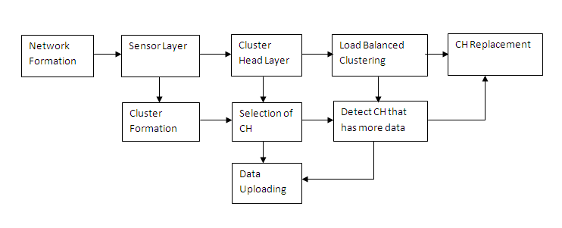**Figure 3.1 System Architecture**

transmit the input data from one sensor node to another sensor node. In sensor layer, cluster formation is done where all the nodes are grouped together and finally one Cluster Head is elected. CH is elected based on the energy. Every data transmission is done using CH and then the CH finally sends all the data to the sink. Using Load Balanced clustering algorithm it detects the Cluster Head that has large amount of data. Finally the Cluster Head checks its energy with other cluster nodes. If the particular energy of node is more in the cluster then it will act as a Cluster Head.

**3.5 FLOW DIAGRAM**

In Figure 3.2 the flow diagram is given. A new node called Mentar is introduced where it is a vehicle equipped with powerful transceiver and battery which collects all the data from the Clustering Head.

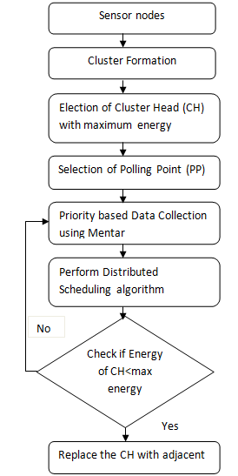

**Figure 3.2 Flow diagram**

Cluster Head is monitored that it has maximum energy compared with other nodes in the cluster and hence the Mentar is placed in the CH. If the energy of the CH is less than the maximum energy then CH is replaced else the transmission is done to Mentar.

**3.6 SELECTION OF POLLING POINTS (PP)**

A Mentar can visit the transmission range of every static sensor, such that sensing data can be gathered by single hop communication without any relays and collisions. The sensors are selected as polling point (PP) that are very near to the data sink and are also distributed efficiently. Considering the factors an algorithm is developed called Smallest Route Tree based data gathering algorithm (SRT-DGA).This algorithm is iteratively used for choosing the PP among the sensors on a smallest route tree based upon the sensor that is near to the root that can connect to other the remote sensors on the tree. SRT-DGA has the capability to build a SRT which has the ability to cover all the sensors in the network.

**Algorithm 1: SRT-DGA**

|  |
| --- |
| Consider SRT denoted by S’= (V’, E’)  **Input**: A sensor network G (V, E), the relay hop bound b, and the static data sink α.  **Output**: A set of PPs Q  Construct SRTs for G that covers every vertex in V  **Step 1**: For every SRT, when S’ is not empty then find the farthest leaf vertex v on S’.  **Step 2:** If v is not a PP then assign parent (v) to u and assign u to v.  **Step 3:** If u is not the root of S’ then update S’ by removing all the child vertices of u and the pertinent edges.  **Step 4:** If u is the root of S’ then all the sensors on are affiliated with S u and S’ is set to be empty.  **Step 5:** If v is a PP then  Remove v from current S’ if b = 1  Assign parent (v) to x and x to v if b ≠ 1  **Step 6:** If x is not the root of S’ then remove the sub tree rooted at x from S’. Corresponding sensors on the removed sub tree are affiliated with v on the geometric tree tv. If x is the root of S’ then sensors on that are not selected as PPs are affiliated with v on the geometric tree tv.  Find an approximate shortest tour U visiting α and all the PPs in Q. |

**3.7 MODULE DESCRIPTION**

The four modules of the project are

1. Cluster Formation and Election of CH

2. CH Replacement

3. Priority based Data Collection

4. Distributed Scheduling Algorithm

**3.7.1 CLUSTER FORMATION AND ELECTION OF CH**

The sensor nodes are formed as clusters by self-organizing mechanism. Clustering is completely distributed. Each node independently makes its decisions based only on local information. These nodes are grouped together to form a cluster and for every cluster a Cluster Head (CH) is elected. LEACH (Low-Energy Adaptive Clustering Hierarchy) is used which is a cluster-based energy efficient routing protocol, which reduce the number of transmissions towards to the BS. LEACH is a hierarchical protocol in which most nodes transmit to cluster heads, and the cluster heads aggregate and compress the data and forward it to the base station (sink). Nodes that have been cluster heads cannot become cluster heads again for *P* rounds, where *P* is the desired percentage of cluster heads.

Thereafter, each node has a 1/*P* probability of becoming a cluster head again. At the end of each round, each node that is not a cluster head selects the closest cluster head and joins that cluster. The cluster head then creates a schedule for each node in its cluster to transmit its data. All nodes that are not cluster heads only communicate with the cluster head in a TDMA fashion, according to the schedule created by the cluster head. They do so using the minimum energy needed to reach the cluster head, and only need to keep their radios on during their time slot. LEACH also uses [CDMA](https://en.wikipedia.org/wiki/Code_division_multiple_access) so that each cluster uses a different set of CDMA codes, to minimize interference between clusters.

* + 1. **CH REPLACEMENT**

CH Replacement is done using Primary Replacement algorithm where it is used in order to prolong the network lifetime by distributing energy consumption. Cluster head replacement is primarily based on the residual energy of each node. Since the energy consumed per bit for sensing, processing, and communication is typically known and hence residual energy can be estimated. It terminates the clustering process with the constant number of iterations and minimizes the control overhead. The algorithm guarantees that every sensor is part of just one cluster, and the cluster heads are well-distributed.

**3.7.3 PRIORITY BASED DATA COLLECTION**

All data packets need to be assigned a priority by the source node, depending on how important is it for the packet to reach the destination node. The data is classified as high and low priority based on the deadline and urgency. The high priority data is buffered near the polling points. When there is overload of data at the mobile data collector, the lower priority of data will be dropped. The sensors that hold large number of data are collected first by the Mentar node and finally to the next priority based sensor node. The goal of PBDS is that the packets that are dropped from SRT should be minimized. If the packet drop is unavoidable then the low priority data is allowed to drop. The higher priority data are allowed to store in the PP that is closer to the data sink.

**3.7.4 DISTRIBUTED SCHEDULING ALGORITHM**

The Distributed Scheduling Algorithm is designed here in order to schedule the time slots according to which the Mentar collects the maximum data from each sensor within the limited period. When the proxy node gathers the sensed data from the neighboring nodes, these data should be collected by the Mentar when they are in contact. When more than one proxy node is available then the Mentar has to decide the order so that it could collect the maximum amount of data within the limited period. The scheduling can be done by Proxy node Time Slot Allocation (PTSA) problem. The expected amount of data gathered is estimated using the following equation

=

Where, is Expected amount of data stored at proxy node

is the number of distinct contacts of yi

B(s) is amount of data a node might have in data gathering

**CHAPTER 4**

**PERFORMANCE ANALYSIS**

**4.1 SIMULATION RESULTS**

**4.1.1 Node Deployment**

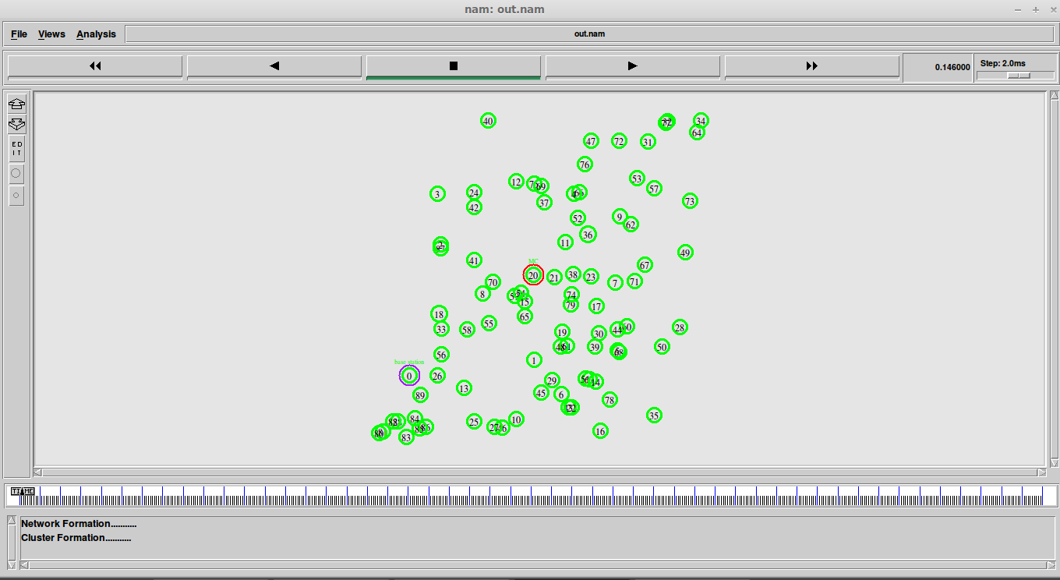

**Figure 4.1 Node Deployment**

Figure 4.1 represents the 100 nodes are randomly deployed in 90 * 90 areas for WSNs. The simulation environment is composed of a BS and some sensor nodes. The BS is fixed and located far from the sensor nodes. The location of each sensor node is randomly distributed in the sensing area. The non cluster head node can monitor the environment and send data to the cluster head node. The cluster head node can gather data, compress it and forward to the AP. And the AP sends the sensing information to the BS. All sensor nodes are stationary and the initial energy is the same for all the common nodes. The total network energy is defined as the sum of residual energy at all sensor nodes.

**4.1.2** **Selection of Base Station Mentar node and CH**

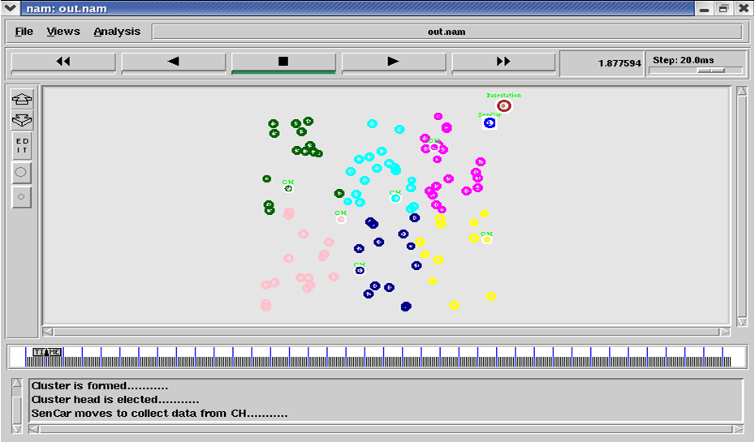

**Figure 4.2 Selection of Base Station Mentar node and CH**

Figure 4.2 shows the Selection of Base Station Mentar node and CH. The Mentar node gathers all the data from the Cluster Head and finally it sends it to the Base Station. Mentar has the capability to move anywhere within the particular region, collects the data and it reaches the Base Station. The Selection of Cluster Head is done where it would be easy for transmission of data to the sink. Cluster Head is elected where every data from the other nodes are send to the nearby Cluster Head. The Cluster Head collects the all the data from the sensor nodes and it sends the data to the base station.

**4.1.3** **Data Collection from CH 2**

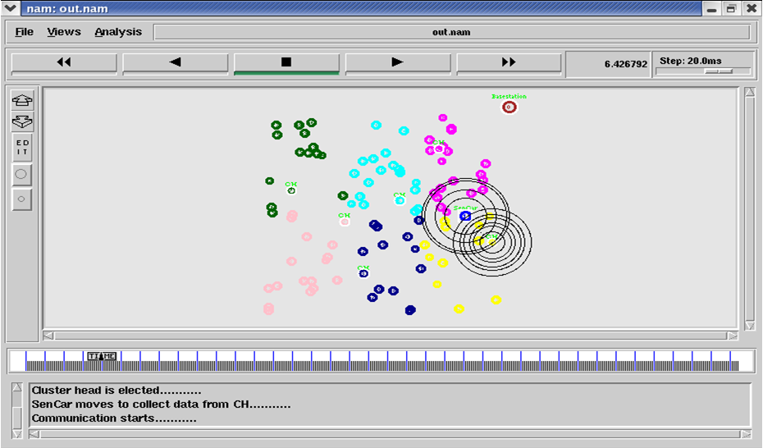

**Figure 4.3 Data Collection from CH 2**

Figure 4.3 shows that the data is moved from one of the Cluster Head 2 to the Mentar node. Here based on the Priority data first Mentar moves near to the CH 2 where large number of data. This may lead to save the data from dropping and no data is missed. All the nearby nodes of Cluster Head 2 send the information to the Cluster Head. It collects all the required data using Distributed Scheduling algorithm schedule the time slots according to which the Mentar collects the maximum data from each sensor within the limited period and save them. When the Mentar node reaches the Cluster Head it transfers all the data present in the CH. Mentar collects the data from CH for some amount of time till all the data is sent completely.

**4.1.4** **Data Collection from CH 1**

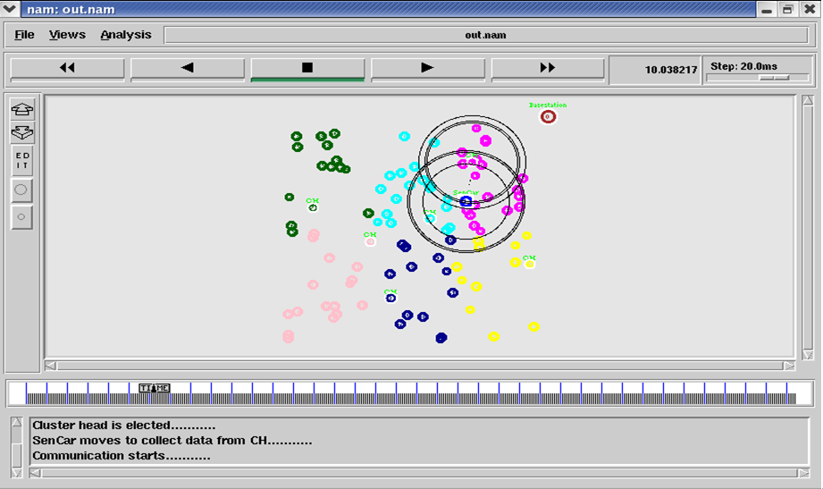

**Figure 4.4 Data Collection from CH 1**

Figure 4.4 shows that the data is moved from one of the Cluster Head 1 to the Mentar node. Here based on the Priority data first Mentar moves near to the CH 1 where large number of data. This may lead to save the data from dropping and no data is missed. All the nearby nodes of Cluster Head 1 send the information to the Cluster Head. It collects all the required data using Distributed Scheduling algorithm schedule the time slots according to which the Mentar collects the maximum data from each sensor within the limited period and save them. When the Mentar node reaches the Cluster Head it transfers all the data present in the CH. Mentar collects the data from CH for some amount of time till all the data is sent completely.

**4.1.5** **Data Collection from CH 3**

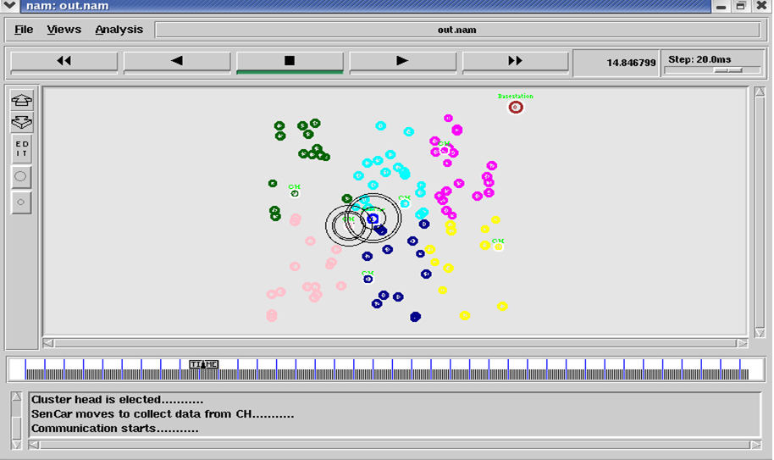

**Figure 4.5 Data Collection from CH 3**

Figure 4.5 shows that the data is moved from one of the Cluster Head 3 to the Mentar node. Here based on the Priority data first Mentar moves near to the CH 3 where large number of data. This may lead to save the data from dropping and no data is missed. All the nearby nodes of Cluster Head 3 send the information to the Cluster Head. It collects all the required data using Distributed Scheduling algorithm schedule the time slots according to which the Mentar collects the maximum data from each sensor within the limited period and save them. When the Mentar node reaches the Cluster Head it transfers all the data present in the CH. Mentar collects the data from CH for some amount of time till all the data is sent completely.

**4.1.6** **Replacement of CH**

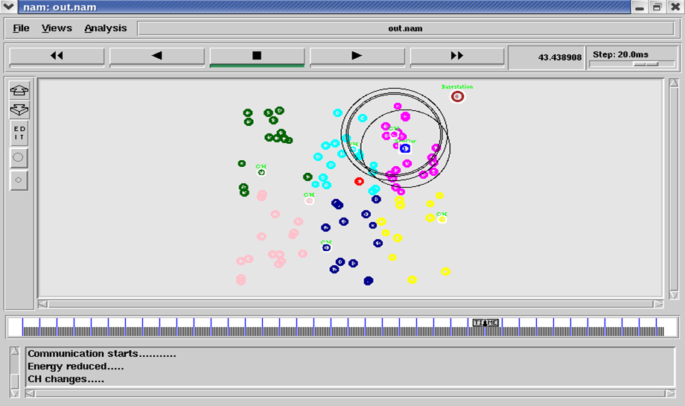

**Figure 4.6 Replacement of CH**

Fig 4.6 shows the replacement of Cluster Head where new Cluster Head is elected based on the energy. When the Mentar continuously collects the data from the particular Cluster Head, the energy of that Cluster Head get decreased. For that purpose in order to increase the packet delivery ratio there should occur sufficient energy in the Cluster Head. When the energy of the particular Cluster Head is decreased then the next Cluster Head is chosen where it contains sufficient energy compared with that Cluster Head. Then the newly chosen Cluster Head forwards the information to the Mentar.

**4.1.7** **Data sending to Base Station**

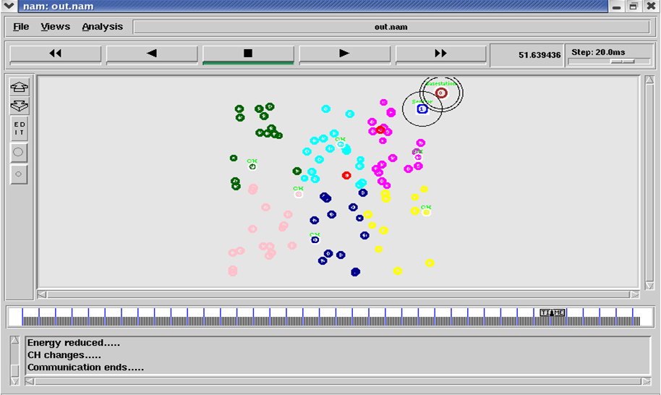

**Figure 4.7 Data Collection from CH 2**

Fig 6 shows that the data is moved from the next Cluster Head 18 to Base Station. The Mentar node collects all the data from each Cluster Head and finally it sends the data to the Base Station. The Base Station collects all the data from the Mentar node. Thus the network is formed with 100 nodes. Nodes are organized in a cluster and also cluster Head is elected. Mentar node is created where it traverses near every Cluster Head and then collects the information from each and finally sends them to the Base Station.

**4.2 RESULT ANALYSIS**

The formation of the network, and the CH selection was done using the parameters specified in the Table 4.1

For the implementation of the proposed work simulator NS-2.26 is used. Number of nodes 100 is randomly deployed in 700*700m area. Initial energy of each node is set to 250J/node.

**Table 4.1 Simulation Parameters**

|  |  |
| --- | --- |
| **Parameter** | **Value** |
| Simulator | NS-2.34 |
| Simulation Time | 160 Sec |
| Number of Nodes | 100 |
| Initial Energy | 100 J/node |
| Sensing Area | 700 * 700 m |

The simulation environment is composed of BS and some other sensor nodes.BS location is fixed and locations of other nodes are randomly distributed and they are used for the environment monitoring purpose. Initial energy level is fixed for all sensor nodes which are stationary.

**Table 4.2 Rate Vs Delay**

|  |  |  |  |
| --- | --- | --- | --- |
| **Rate(Kb)** | **Delay (Sec)** | | |
| **ADG** | **P MDG PDS** | **SRT DGA** |
| 100 | 3 | 2.5 | 1.5 |
| 200 | 5 | 4 | 3 |
| 300 | 6 | 5 | 4 |
| 400 | 10 | 6 | 5 |
| 500 | 8 | 4 | 3 |

100 200 300 400 500

**Figure 4.8 Rate Vs Delay**

Figure 4.8 represents the simulation results of Delay with respect to the Rate. Shortest Route Tree Data Gathering algorithm (SRT DGA) algorithm is implemented in the network. Table 4.2 compares the Delay in existing algorithm namely ADG (Adaptive Data Gathering) and PMDG PDS(Polling-based Mobile Data Gathering and Priority Based Data Storage) algorithm with the proposed algorithm SRT DGA. When compared the proposed algorithm SRT DGA achieves less amount of delay than the existing one. The delay level of SRT DGA is decreased when the rate is increased. Thus when compared with existing algorithm proposed algorithm is more efficient one.

**Table 4.3 Rate Vs Packet drop**

|  |  |  |  |
| --- | --- | --- | --- |
| **Rate(Kb)** | **Packet Drop** | | |
| **ADG** | **P MDG PDS** | **SRT DGA** |
| 100 | 200 | 100 | 50 |
| 200 | 600 | 300 | 200 |
| 300 | 700 | 400 | 300 |
| 400 | 900 | 500 | 400 |
| 500 | 2100 | 1100 | 1000 |

100 200 300 400 500

**Figure 4.9 Rate Vs Packet Drop**

Figure 4.9 represents the simulation results of Delay with respect to the Packet drop. Shortest Route Tree Data Gathering algorithm (SRT DGA) algorithm is implemented in the network. Table 4.3 compares the Packet Drop in existing algorithm namely ADG (Adaptive Data Gathering) and PMDG PDS (Polling-based Mobile Data Gathering and Priority Based Data Storage) algorithm with the proposed algorithm SRT DGA. When compared the proposed algorithm SRT DGA achieves less amount of Packet Drop than the existing one. As a result there would be no loss of packet and it is sent to the base station without any failure. Thus when compared with existing algorithm proposed algorithm is more efficient one.

**Table 4.4 Rate Vs Energy**

|  |  |  |  |
| --- | --- | --- | --- |
| **Rate(Kb)** | **Energy (J)** | | |
| **ADG** | **P MDG PDS** | **SRT DGA** |
| 100 | 23 | 22 | 20 |
| 200 | 22.5 | 19 | 18 |
| 300 | 21 | 18 | 16 |
| 400 | 20 | 17 | 15 |
| 500 | 19 | 18 | 14 |

100 200 300 400 500

**Figure 4.10 Rate Vs Energy**

Figure 4.10 represents the simulation results of Energy with respect to the Packet drop. Shortest Route Tree Data Gathering algorithm (SRT DGA) algorithm is implemented in the network. Table 4.4 compares the Energy in existing algorithm namely ADG (Adaptive Data Gathering) and PMDG PDS(Polling-based Mobile Data Gathering and Priority Based Data Storage) algorithm with the proposed algorithm SRT DGA. When compared the proposed algorithm SRT DGA spends less amount of energy than the existing one. As a result it would be sufficient for every sensor to collect the data and send them to the base station. The energy loss is limited when compared to the existing algorithm.

**Table 4.5 Rate Vs Packet delivery ratio**

|  |  |  |  |
| --- | --- | --- | --- |
| **Rate(Kb)** | **Packet** | | |
| **ADG** | **P MDG PDS** | **SRT DGA** |
| 100 | 100 | 120 | 140 |
| 200 | 300 | 200 | 220 |
| 300 | 400 | 250 | 300 |
| 400 | 500 | 300 | 200 |
| 500 | 700 | 350 | 300 |

100 200 300 400 500

**Figure 4.11 Rate Vs Packet Delivery Ratio**

Figure 4.11 represents the simulation results of Energy with respect to the Packet drop. Shortest Route Tree Data Gathering algorithm (SRT DGA) algorithm is implemented in the network. Table 4.5 compares the Energy in existing algorithm namely ADG (Adaptive Data Gathering) and PMDG PDS(Polling-based Mobile Data Gathering and Priority Based Data Storage) algorithm with the proposed algorithm SRT DGA. When compared the proposed algorithm SRT DGA achieves more Packet Delivery ratio compared to existing one. As a result it would be sufficient for every sensor to collect the data and send them to the base station without any loss. Also there would not be any loss of data since all the data are collected based on the priority.

**CHAPTER 4**

**CONCLUSION**

The energy-efficient data collection approach in wireless sensor networks is a basic issue. Each sensor node has the capability to collect data and forward it to the sink through the multi hop communication. In addition, it is equipped with a battery which is difficult to replace. Here SRT DGA framework is proposed for mobile data collection in a WSN which employs distributed load balanced clustering for sensor self-organization adopts collaborative inter-cluster communication for energy-efficient transmissions among CHGs and optimizes SenCar’s mobility. Thus we have to balance energy consumption of sensor nodes by efficient data gathering mechanism. Also the priority based data storage module is processed where the data is categorized as high and low priority based on the deadline and urgency. Moreover, when there is overload of data at the mobile data collector, the lower priority of data will be dropped. At last distributed scheduling algorithm is used to schedule the time slots according to which the data collector could gather the maximal amount of data within a limited period. The results show that SRT DGA can greatly reduces energy consumptions by alleviating routing burdens on nodes and balancing workload among cluster heads, which achieves 20 percent less data collection time compared to ADG and PMDG PDS mobile data gathering and over 60 percent energy saving on cluster heads.