Setup trên F407 như sau:

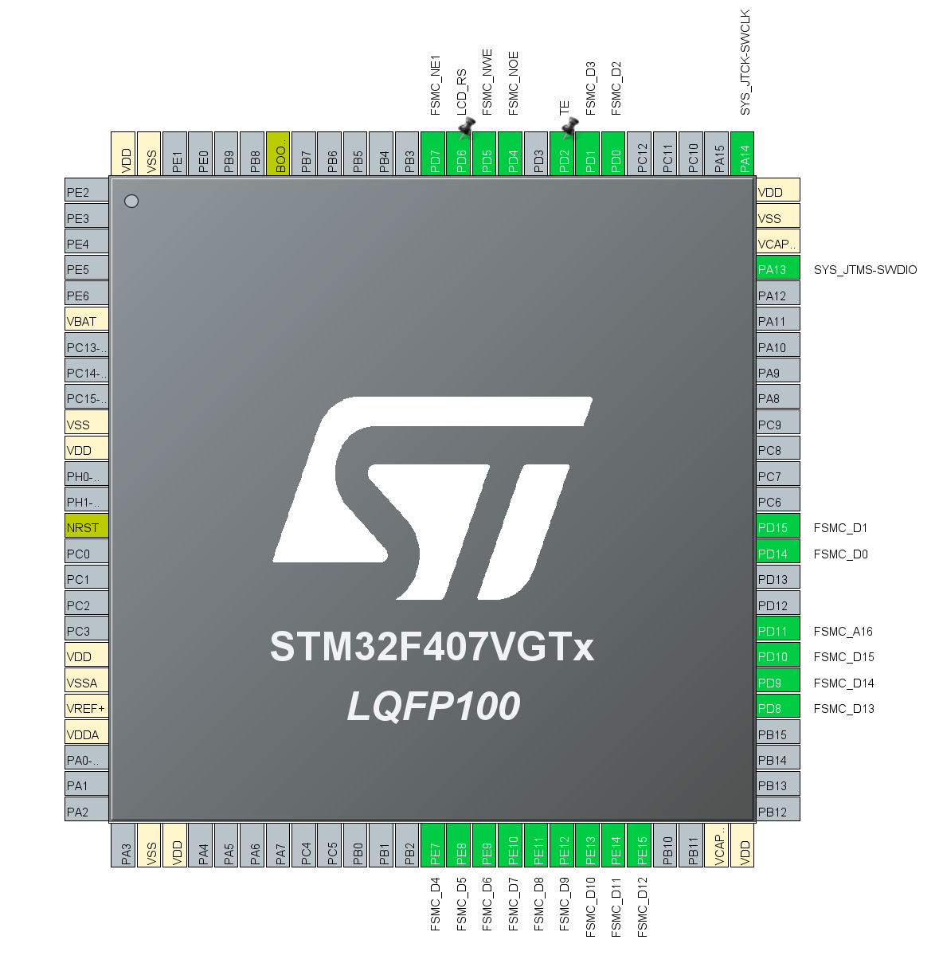

Ta cần tính toán **Address** và **Data Setup Time**

Đọc datasheet của LCD để lấy $t_{wp}$**, $t_{wc}$, $t_{rc}$**

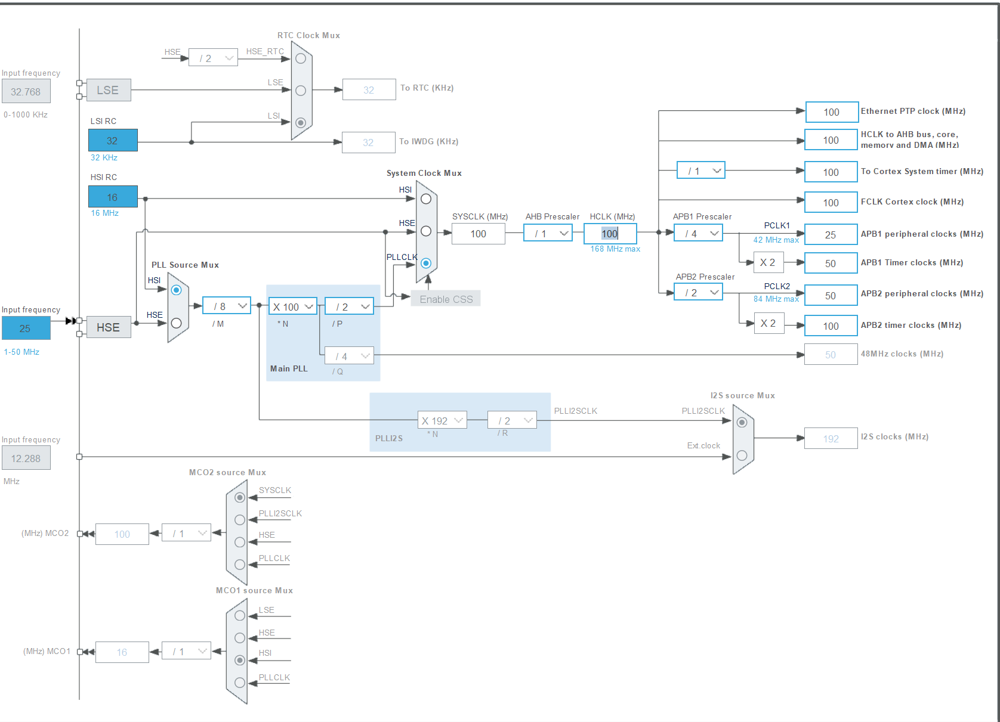

1. **Address Setup Time (T0):** This is when you write a command to the FSMC and it propagates to the external device's address space. For NOR/PSRAM, this usually involves writing a byte to an address.
2. **Data Setup Time (T1):** After enabling the external memory bus, you need to send data before reading it back or waiting for acknowledgment. This is similar to setup time in other peripheral setups.
3. **Bus Turn Around Time (TP):** This includes both T0 and T1 but also any additional delays between writing to one address and writing to another on the same bus.