****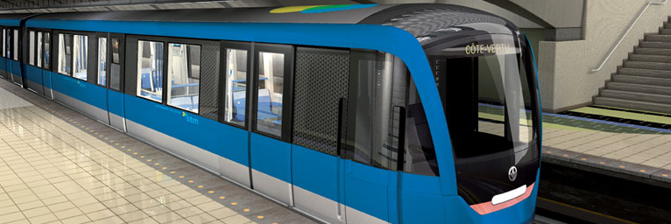

Activity Planning

Transit Droid Team

Austin Takam

Daniel Magni

Paul Smelser

Razvan-Lada Moldovan

Yasser Al-Hasan

Revision History

|  |  |  |
| --- | --- | --- |
| **Date** | **Rev.** | **Description** |
|  | 1.0 | Initial version |
|  |  |  |
|  |  |  |
|  |  |  |

Contents

1 Introduction 3

2.1 Purpose 3

2.2 Definitions, Acronyms and Abbreviations 3

2 Activities 4

2.1 Roles and Responsibilities 4

2.2 Resources 4

2.3 Activity List 4

3 Activity Networks 5

3.1 Activity-On-Node Network 5

4 Glossary 5

Activity Planning

# Introduction

## Purpose

The purpose of Activity planning is to enable us to allocate resources and tasks more accurately based on initial estimates.

## Definitions, Acronyms and Abbreviations

Please refer to the Project Glossary for definitions, acronyms and abbreviations needed to properly interpret this document.

# Activities

## Roles and Responsibilities

* Developers
  + For this project, we have only five people and they are all developers. Since we don’t have other dedicated professionals such as project managers we will have to share responsibilities. Activities such as analysis, design, testing, documentation and deployment are all going to be done by developers.

## Resources

* The hourly rate for a developer is 31$/hr. We have used this rate to calculate the costs for each activity.

## Activity List

The figure below illustrates the list of activities.

[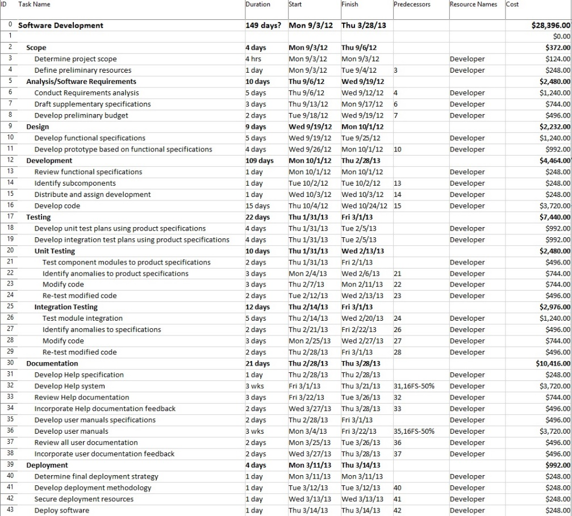](http://transitdroid.net/documents/images/Management/pdf/Transitdroid-Activities.pdf)

# Activity Networks

## Activity-On-Node Network

In order to get a better picture of the plan of the problem and to estimate more accurately when the project will be completed given the resources we have, we’ve created an Activity-on-node network in the figure below.

[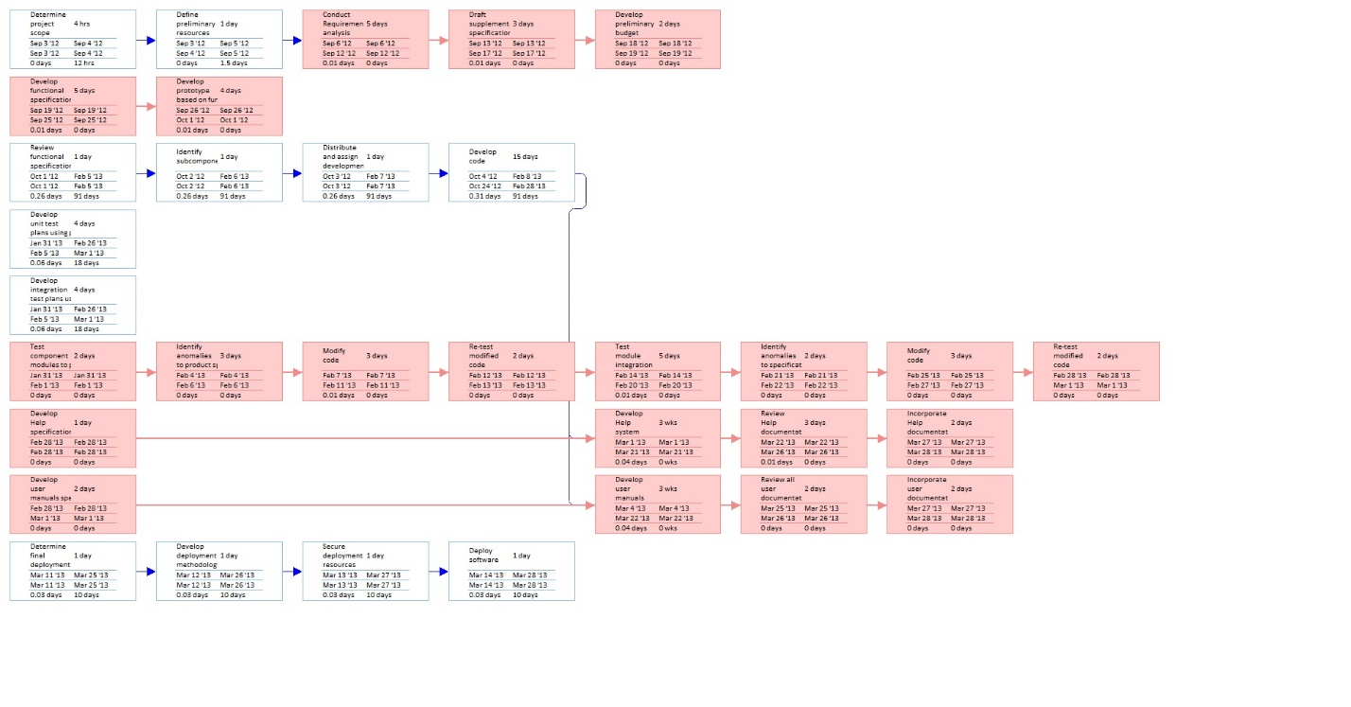](http://transitdroid.net/documents/images/Management/pdf/Transitdroid-Activityonnode.pdf)

# Glossary

**N/A**