
TRANSITION TRAILS
Brand Book & Design System
Our Living Blueprint
Version 2.0 · June 2026
Empowering individuals by bridging the experience gap

Introduction: A Guide for Our Journey
Welcome to the Transition Trails Brand Book & Design System. This consolidated document is the single source of truth for our brand — meticulously crafted to ensure consistency, clarity, and confidence across every touchpoint.
It is designed to empower our internal teams, volunteers, and strategic partners to communicate who we are, what we do, and why it matters with one unified voice.

A Living Blueprint
This is not a rigid set of rules designed to restrict creativity, but rather a collection of foundational principles, strategic insights, and practical tools. These guidelines are here to help all of us effectively communicate our mission, support our learners, and guide our entire community forward on a clear and consistent path.

How to Use This Document
This document is organized into four major sections:
- Our North Star — Strategy, mission, vision, and design philosophy
- Our Voice — Messaging, content strategy, and tone of voice
- Our Visual Identity — Logos, colors, typography, and imagery
- Brand in Action — Application guidelines, Salesforce mapping, governance

Section 1: Our North Star — Strategy & Philosophy
This section outlines the foundational 'why' behind the Transition Trails brand. Before applying any specific visual style or verbal tone, it is essential to understand the core strategic principles that guide our organization.

1.1 Our Mission: Bridging the Experience Gap
"Empowering individuals and organizations by bridging the experience gap through education, mentorship, and hands-on work."
This statement directly addresses a systemic problem in the technology workforce: the 'experience gap.' Many talented individuals earn professional certifications but struggle to secure their first role because they lack the verifiable, on-the-job experience employers demand.
Our mission is to solve this specific challenge by focusing exclusively on post-certification, experience-based development — creating a reliable pathway from theoretical knowledge to career-readiness.

1.2 Our 2028 Vision: An Enduring Institution
By the end of 2028, Transition Trails will operate as a mature, evidence-driven workforce development institution. Our success will be defined by three key outcomes:

Stakeholder | Outcome by 2028
Learners | Graduate as experience-validated Salesforce professionals with trusted proof of applied judgment that employers recognize as a credible signal of workforce readiness.
Nonprofit Partners | Receive consistent, low-risk value through supervised project engagements, allowing them to build capacity while our learners gain critical experience.
Organization | A durable and financially stable institution, with systems and processes so well-designed that high-quality program delivery is no longer dependent on founder heroics.

1.3 Our Five Strategic Pillars
Our five strategic pillars are the guiding principles that shape every organizational decision. They are the rules of the road that ensure we grow with integrity, credibility, and resilience.

Pillar | Core Principle
Evidence Before Scale | We only expand programs and initiatives governed by defensible evidence, not by volume or aspiration.
Founder-Independent Delivery | Our program must function with excellence through system-led, documented processes, independent of founder involvement.
Governed Technology & AI | We use technology and AI as consent-based, auditable tools to amplify human judgment, not to replace it.
Measurable Nonprofit Impact | The value we deliver to our nonprofit partners must be real, supervised, documented, and repeatable.
Financial Sustainability | We are committed to building a durable institution through diversified revenue, fair compensation, and active governance.

1.4 Our Design Philosophy
Our design philosophy translates our strategic principles into the tangible experience we create for our community. These four beliefs shape every digital and programmatic touchpoint:

- Guidance over heroics — Our brand and systems exist to support the learner, not to compete for attention.
- Progress over perfection — We value and celebrate forward motion and iterative learning.
- Human before digital — Technology is a powerful tool, but our story is always centered on people.
- Calm confidence — We provide a reassuring, grounded, and purposeful environment for growth.

This North Star strategy informs not just what we do, but how we present ourselves. The following sections detail the specific verbal and visual systems that bring this philosophy to life.

Section 2: Our Voice — Messaging & Content
A consistent brand voice is a strategic imperative. It ensures that how we communicate is as meaningful as what we communicate. This section defines the persona, tone, and language of Transition Trails.

2.1 Our Persona: The Strategic Advisor
When we communicate, we embody the persona of a strategic advisor — knowledgeable and forward-thinking, yet grounded, accessible, and focused on helping others navigate their journey successfully.

Trait | What It Means
Professional & Forward-Thinking | We are credible, informed, and focused on the future of work.
Supportive & Guiding | We are mentors and facilitators, offering clarity and encouragement.
Clear & Action-Oriented | We use precise language and provide actionable next steps.
Calm & Confident | We communicate with a sense of purpose and reassurance, avoiding urgency and hype.

2.2 Our Lexicon: Trail-Inspired Language
Our brand naturally uses concise, trail-inspired metaphors to make complex concepts relatable and reinforce our mission. These terms should feel authentic, not forced:

pathway | milestone | horizon | guide | navigator | compass

2.3 Protecting Our Identity: Prohibited Terms
To maintain our distinct brand identity and avoid confusion within the broader Salesforce ecosystem, we must be disciplined in our language. Transition Trails is an independent institution.

Avoid This Term | Use This Alternative
Trailhead | Learning Path / Curriculum
Trailblazer | Learner / Navigator / Transitioner
Ohana | TTDS Community / Network
Ranger/Expedition | Milestone / Stage

2.4 Content Strategy: The 70/20/10 Rule
Our content strategy balances our messaging and reinforces our role as a 'Guide' rather than a 'hard seller.'

Share | Pillar | Content Types | The Vibe
70% | The Guide | Salesforce tips, career advice, how-to snippets, mindset shifts | "Here is a tool for your journey."
20% | The Navigator | Learner spotlights, volunteer why stories, partnership highlights | "Others are on this path with you."
10% | The Compass | Donation drives, volunteer recruitment, program enrollment | "The next step on your trail is here."

2.5 Channel Engagement Strategy

LinkedIn: Professional Authority
- Cadence: Minimum 1 post per week
- The 15-Minute Rule: Spend 15 minutes engaging with comments and relevant posts immediately after content goes live to boost visibility
- Tagging: Tag relevant partners or featured volunteers (with permission) to expand reach

Substack: The Narrative Journey
- Cadence: Weekly ('Notes from the Trail') and monthly ('Digital Compass Newsletter')
- Use polls to let the community vote on future topics
- End every post with a reflective question to encourage comments

YouTube: The Visual Teacher
- Cadence: 2 videos per month
- Use YouTube Chapters to help learners quickly find specific solutions
- Feature a 'Question of the Month' from comments in a future video to build community

Section 3: Our Visual Identity — Logos, Color, Type & Imagery
The Transition Trails Design System (TTDS) is the visual translation of our core philosophy. This section provides every element needed to apply the brand consistently across all channels and platforms.

3.1 Logo System
Our logo system consists of four variants, each built from the same core badge mark. Each variant serves a distinct purpose. Always use the appropriate variant for the context — never stretch, recolor, or recreate the logo.

3.1.1 The Badge Mark (Primary Icon)
The badge mark is our core brand symbol. It features the mountain, winding trail, and sun — representing guidance, journey, and forward progress.


Badge Mark (Primary) Circle Seal w/ Tagline Circle Seal — No Tagline

3.1.2 Stacked Wordmark
The stacked wordmark is the primary logo for all marketing materials where the brand name must appear alongside the mark. Use this for website headers, presentations, and print materials.



3.1.3 Logo Usage Rules

Variant | Use For | File to Use
Badge Mark | Social profiles, favicons, app icons, email signatures, overlays on any background | TT_Badge_1024px_transparent.png
Stacked — No Tagline | Website header, presentations, slides, email header, documents | TT_Stacked_White_NoTag.png
Stacked — With Tagline | Grant proposals, pitch decks, official print, program brochures | TT_Stacked_White_WithTag.png
Circle Seal — With Tagline | Merchandise, event programs, certificates, donor thank-you materials | TT_Circle_WithTagline_1024px.png
Circle Seal — No Tagline | Profile badges, stickers, circular profile photo formats | TT_Circle_NoTagline_1024px.png
App Icon (Square) | App Store, Google Play, Salesforce app icon, Slack workspace, browser favicon | TT_AppIcon_1024px.png

Logo Don'ts
Never stretch, skew, recolor, or add drop shadows to the logo. Never place the full-color logo on a busy or low-contrast background. Never recreate the logo from scratch. Always use the provided files.

3.1.4 Complete Logo Asset Reference
The full logo asset reference sheet below shows all variants, sizes, and recommended use cases at a glance:

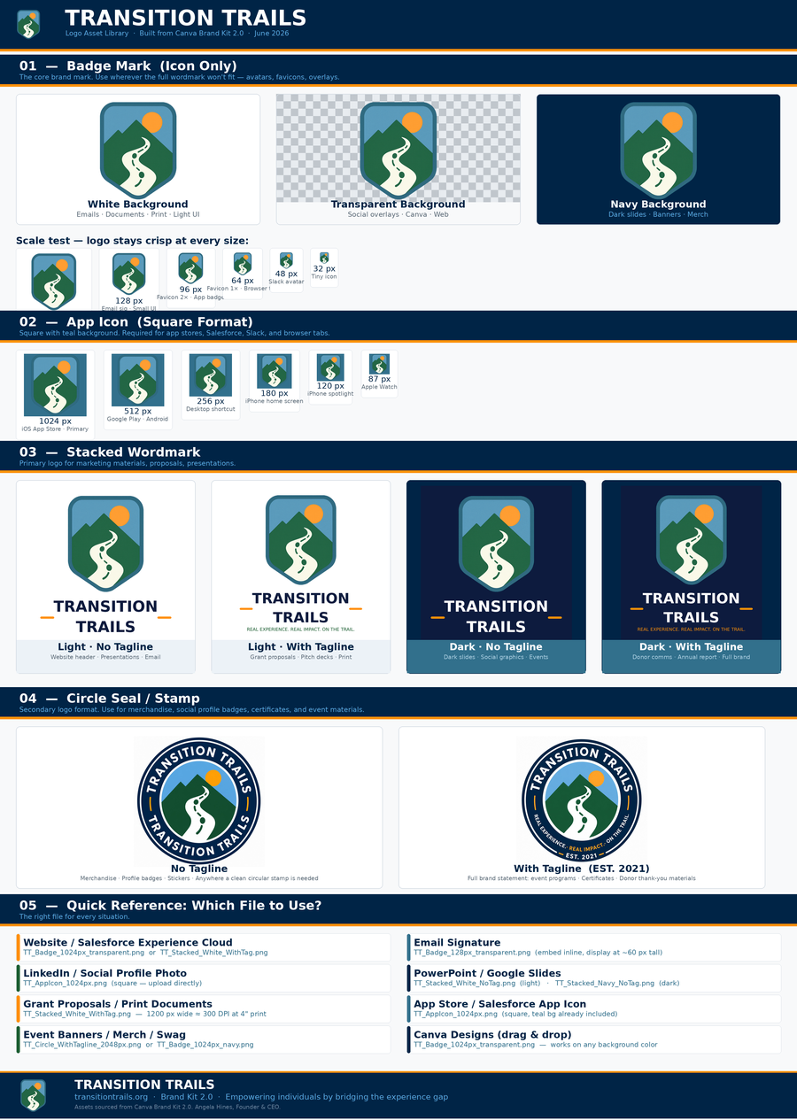

3.2 Color System
Our color system is derived from nature-inspired visuals that reinforce the metaphor of trails and guided progress. Each color is used with clear intent to signal action, provide structure, and support readability.

3.2.1 Core Brand Palette

Color | Name & Hex | Role | Usage
#2F6B3F | Trail Green#2F6B3F | Primary | Action buttons, headings, growth themes
#2F6F7E | Deep Teal#2F6F7E | Secondary | Background containers, footer areas, depth
#7FAFC6 | Sky Blue#7FAFC6 | Surface | Main backgrounds, cards, white-space equivalent
#F5A623 | Sun Amber#F5A623 | Accent | Next Step buttons, progress markers, highlights

3.2.2 Neutral & Supporting Colors

Color | Name & Hex | Role | Usage
#FAFAF7 | Trail Light#FAFAF7 | Light Neutral | Main backgrounds
#E2E4E1 | Warm Gray#E2E4E1 | Neutral | Dividers, borders
#4A4F4D | Slate#4A4F4D | Dark Neutral | Body text
#2A2E2C | Charcoal#2A2E2C | Deep Neutral | Headings, icons

3.2.3 Color Ramps (100–900)
TTDS uses simplified tint and shade ramps for hierarchy, states, and accessibility:

Trail Green | 100 · #E6F0EA | 300 · #9FC3AE | 500 · #2F6B3F | 700 · #245531

Sun Amber | 100 · #FFF3E0 | 300 · #FFD08A | 500 · #F5A623 | 700 · #CC8400

3.2.4 Accessibility & Contrast Rules
- Body text: minimum AA contrast (4.5:1)
- Large text (18pt+ or 14pt bold): minimum AA contrast (3:1)
- Primary CTAs: target AAA contrast where possible (7:1)
- Trail Green 700+ on Trail Light ✓ — Charcoal on Sky Blue 100–300 ✓ — White on Trail Green 700+ ✓

Sun Amber Usage Rule
Sun Amber is used sparingly and intentionally. No more than ONE Sun Amber CTA should appear per screen/page. It signals a moment of commitment — never use it decoratively.

3.3 Typography
TTDS typography is designed to be clear, approachable, and flexible across platforms. Font choices prioritize readability, accessibility, and a modern nonprofit tone.

3.3.1 Core Font Families

Font | Role | Characteristics | Use For
Poppins (Primary) | Headings | Geometric, modern, confident. Optimistic, forward-looking. | H1–H4, feature callouts, key statements
Open Sans / Roboto (Secondary) | Body | Highly readable, neutral, accessible. Calm, supportive, trustworthy. | Body paragraphs, UI labels, forms, navigation
Caveat (Accent — Limited) | Expressive | Human, warm, handwritten feel. Never for body or UI text. | Program/trail names, short pull quotes, gentle callouts (max 1 per page)

3.3.2 Typographic Hierarchy

Element | Font | Weight | Size Range | Notes
H1 – Page Title | Poppins | 600–700 | 36–48px | Primary anchor
H2 – Section | Poppins | 600 | 28–36px | Section headings
H3 – Subsection | Poppins | 500–600 | 22–28px | Subsections
H4 – Card Title | Poppins | 500 | 18–22px | UI groupings
Body Primary | Open Sans / Roboto | 400 | 16–18px | Default reading
Body Secondary | Open Sans / Roboto | 400–500 | 14–16px | Supporting text
UI Labels | Open Sans / Roboto | 500 | 14–16px | Forms, nav
Accent / Callout | Caveat | 400–600 | 22–32px | Short phrases only

3.4 Imagery & Illustration
Our imagery style is a direct reflection of our human-centered approach to learning and development. All imagery must communicate our core principles: Guidance over heroics, Progress over perfection, Human-centered learning, and Calm confidence.

3.4.1 Photography (Primary Style)
- Diverse people in collaborative settings
- Candid and documentary-style compositions
- Natural or soft lighting
- Focus on learning in motion: discussion, mentoring, problem-solving
- What to Avoid: Posed corporate headshots, generic tech imagery, exaggerated or staged scenarios

3.4.2 Illustration (Secondary Style)
- Hand-drawn or watercolor style with soft, earthy color palette aligned with TTDS colors
- Recurring motifs: trails, pathways, bridges, maps, and compasses
- Use to explain journeys, systems, and abstract concepts where photography would be too literal

3.4.3 AI Generation Guidelines (Gemini)

Photography Prompt Template
Use this prompt:
A candid, documentary-style photograph of diverse adults collaborating on a learning activity. The setting is warm, professional, and human-centered. People are engaged in discussion, problem-solving, or mentoring. Natural lighting, realistic expressions, no exaggerated posing. The mood is calm, focused, and supportive. Style: modern nonprofit education, authentic, inclusive.

Illustration Prompt Template
Use this prompt:
A hand-drawn watercolor illustration in a calm, natural style. A person stands as a guide or navigator, pointing toward a path or destination. The landscape includes trails, bridges, and layered terrain representing learning and progress. Soft earth tones, muted greens and blues, with warm highlights. Style is illustrative, thoughtful, and human-centered, not cartoonish.

Negative Prompts — Always Include
- Avoid: Futuristic, High-tech, Glowing circuits, Neon, Holograms
- Avoid: Suits and ties, Luxury boardrooms, Aggressive handshakes
- Avoid: Superheroes, Mountain climbers on peaks, Winning a race
- Avoid: Cartoons, 3D Render style, Disney-style characters

3.4.4 Image Standards & Sizing

Image Type | Use Case | Recommended Size | Aspect Ratio
Hero Image | Page headers, homepage hero | 1920 × 1080 px | 16:9
Banner / Section Hero | Section dividers | 1600 × 900 px | 16:9
Medium Image | Program pages, feature blocks | 1200 × 800 px | 3:2
Small Image | Cards, previews | 800 × 600 px | 4:3
Thumbnail | Lists, dashboards | 400 × 400 px | 1:1
Icon / Illustration | UI accents, steps | 256 × 256 px | 1:1

File Naming Convention
TTDS_[page-type]_[image-type]_[descriptor]_[size]Example: TTDS_program_hero_guided-learning_1920x1080.jpg

Section 4: Brand in Action — Application & Governance
This section provides practical guidelines for applying the Transition Trails brand consistently across our key channels, platforms, and technology stack.

4.1 UI Components (TTDS)

Buttons
- Primary: Trail Green background, white text — used for forward action
- Secondary: Neutral outline, Trail Green text — used for forms or alternatives
- Accent/CTA: Sun Amber background, dark text — used for commitment moments only

Cards & Containers
- Background: Trail Light (#FAFAF7) or Sky Blue 100 (#EDF5F8)
- Border: Warm Gray (#E2E4E1)
- Title: Poppins H4
- Body: Open Sans / Roboto

Navigation
- Header background: Deep Teal (#2F6F7E)
- Active link: Trail Green (#2F6B3F)
- Hover states: Trail Green 700 (#245531)

4.2 Salesforce Experience Cloud Mapping
This mapping ensures TTDS is implemented consistently within our core technology platform. Use these settings when configuring Salesforce Experience Cloud themes.

Color Token Mapping

TTDS Token | Salesforce Theme Setting | Notes
Trail Green 500 · #2F6B3F | Brand Color | Primary buttons, active links
Trail Green 700 · #245531 | Brand Color Dark | Hover and active states
Sun Amber 500 · #F5A623 | Action Color | Primary CTAs only
Deep Teal 500 · #2F6F7E | Header Background | Global navigation background
Sky Blue 100–300 | Page Background | Main content surfaces
Charcoal · #2A2E2C | Text Color | Default body text
Trail Light · #FAFAF7 | Page Background Alt | Cards and sections

Typography Mapping

TTDS Role | Salesforce Setting | Font
Headings | Heading Font | Poppins
Body Text | Body Font | Open Sans / Roboto
UI Labels | Body Font | Open Sans / Roboto

Accent Font Note
Caveat is not applied globally in Salesforce. Use only in custom components or rich text blocks.

4.3 Page-Type Standards (Experience Cloud)

Homepage — Purpose: Orientation and Invitation
✓ Do | ✗ Don't
Use photography featuring real people in collaborative learning | Overload with multiple CTAs
Lead with a clear H1 in Poppins | Use dense text blocks
Highlight one primary CTA (Sun Amber) | Introduce decorative animation
Use generous spacing and simple content blocks | Place CTAs above meaningful context

Program Pages — Purpose: Explanation and Commitment
✓ Do | ✗ Don't
Combine photography and illustration intentionally | Mix visual styles randomly
Use cards to break content into clear sections | Hide key actions below long text
Use Trail Green for primary actions | Use accent colors excessively

4.4 Layout, Grid & Spacing
- Base spacing unit: 12px
- Consistent margins and padding throughout
- Clear vertical flow — content hierarchy drives layout
- Predictable spacing rhythm reduces cognitive load for learners

4.5 Motion & Interaction
- Scroll fade-ins for orientation and context
- Hover states to reinforce interactivity
- Progress indicators to signal advancement through content
Motion Rule
Avoid decorative animation without meaning. Every motion element must serve a navigational or communicative purpose.

4.6 Governance: Volunteer Content Checklist
This checklist serves as a final quality gate for all volunteer-created content, ensuring it is fully aligned with our brand before publication.

1 | Pillar Check: Which content pillar is this? Does it maintain our 70/20/10 balance?
2 | Prohibited Terms: Does it use any Salesforce-specific trademarks? (No "Trailblazer," "Trailhead," etc.)
3 | Engagement Loop: Is there a question or call-to-action to spark a conversation?
4 | Image Check: Does the image match Volunteer Guardrails? (No robots, neon, or corporate clichés)

4.7 Canva Brand Kit — Setup Instructions
The following steps will keep your Canva Brand Kit aligned with this document. Updating the kit cannot be done programmatically — it must be done manually in Canva.

1. | Open Canva → Brand Hub → Brand Kits → Transition Trails 2.0 (or create a new kit if this is the first time)
2. | Under Logos, upload the following files from the Logo Asset Library:  - TT_Badge_1024px_transparent.png (primary icon — transparent)  - TT_Stacked_White_WithTag.png (light wordmark with tagline)  - TT_Stacked_Navy_WithTag.png (dark wordmark with tagline)  - TT_Circle_WithTagline_1024px.png (circle seal)
3. | Under Colors, verify these brand colors are set: Trail Green #2F6B3F · Deep Teal #2F6F7E · Sky Blue #7FAFC6 · Sun Amber #F5A623 · Charcoal #2A2E2C · Trail Light #FAFAF7
4. | Under Fonts, set: Heading = Poppins (Bold), Body = Open Sans, Accent = Caveat. Click "Save Brand Kit."

Appendix: Quick-Reference Summary

Do / Don't Visual Reference

Color Usage
✓ Do | ✗ Don't
Use Trail Green for primary actions | Use accent colors decoratively
Reserve Sun Amber for moments of decision | Introduce new colors without documentation
Use neutrals to support readability | Rely on color alone to convey meaning

Typography
✓ Do | ✗ Don't
Use Poppins for headings | Mix multiple heading styles on one page
Use Open Sans or Roboto for body text | Use Caveat for body or UI text
Maintain size and weight hierarchy | Reduce font sizes below accessibility guidance

Imagery
✓ Do | ✗ Don't
Choose visuals that show learning in motion | Mix illustration and photography without intent
Use illustration for journeys and concepts | Use generic corporate stock imagery
Maintain consistent visual style per page | Add visuals that do not support understanding

Transition Trails Brand Book & Design System — Version 2.0
This is a living document. Updates should be reflected here first.
transitiontrails.org · Angela Hines, Founder & CEO · June 2026

