# CS 340 README Template

## About the Project/Project Title

This project is a simple project that takes in a list of shelter animals, dogs and cats, and pulls dog data to make selective options for rescue dogs. It displays the data as a table, geolocation map, and a pie chart.

## Motivation

The motivation behind this project was for Grazioso Salvare to use it to help identify dogs that are capable for search and rescue training. This software will help the company make decisions easier by giving them a user interface to interact with the data.

## Getting Started

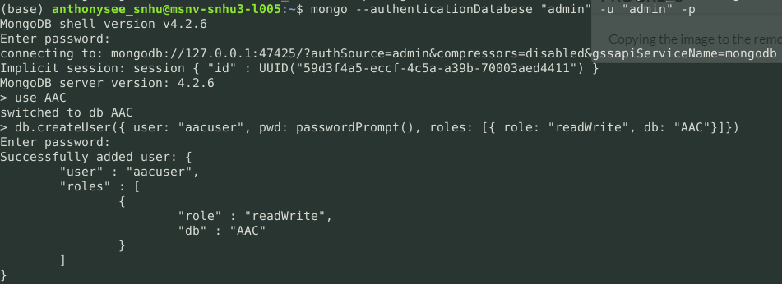To get started, the user must first have a MongoDB database set up. Said database does not need anything in it, it just needs to be installed and exist. Python is, also, needed for this module to work. The latest python from <https://www.python.org/downloads/> will work. Once you have MongoDB and Python set up, a new user, with a username and password must be added. This will give this python module access to the database. The commands below are an example of what to look for if done correctly.

## Installation

As said in **Getting Started,** you will need Python and MongoDB for this to work. You can download and install Python from the link above. For MongoDB, you need to download the installer from Mongo’s website, or you can go to [link](https://www.mongodb.com/try/download/community), and download the community server for local databases. You can follow this [link](https://docs.mongodb.com/manual/tutorial/install-mongodb-on-windows/) to install Mongo and to create a database. Once both are installed, you will need to create a txt file and save it with extension **.py** at the end. This will turn the txt file into a python file. You can edit the file with any text editor, as long as it allows you. Notepad, or Python IDE’s work. Lastly, you will to import any needed files, in CVS format, with mongo. Just select the directly, and the file to import, mongo will do the rest.

## Usage

Currently, this application has three main uses, aside from the uses of the python module. It shows collective data for dogs that are in range for Water rescue, Wilderness and Mountain rescue, and Disaster rescue.

### Code Example

This code is the main code used from the Python Module for the application to run. It’s the main communication between the data and the user interface. Below is a sample of what the output would look like for this data.

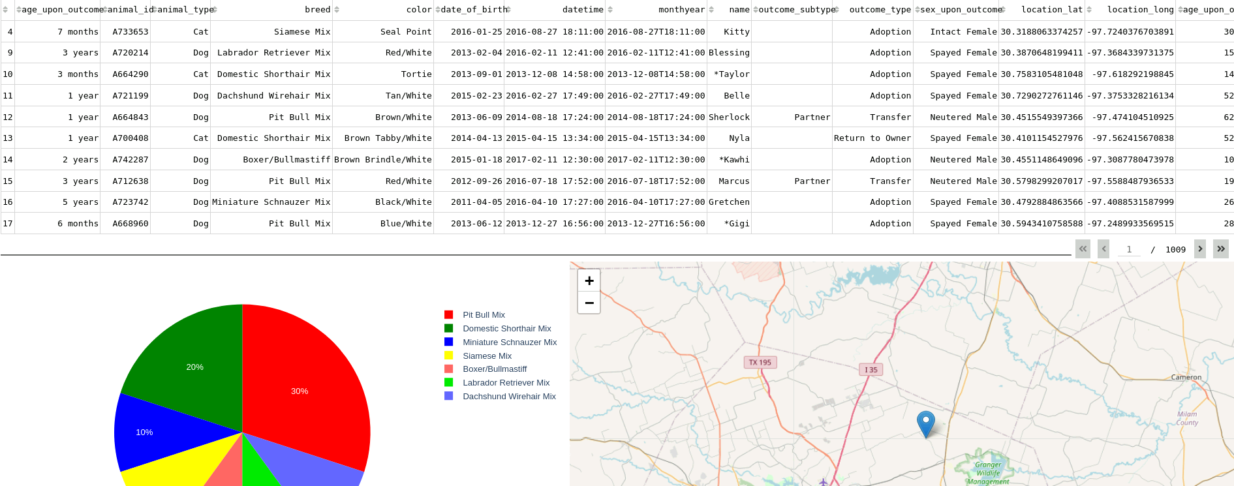

### Screenshots

Aside from above, the rest will show all the features this application has to offer. There are quite a few shots, so get ready for scrolling.

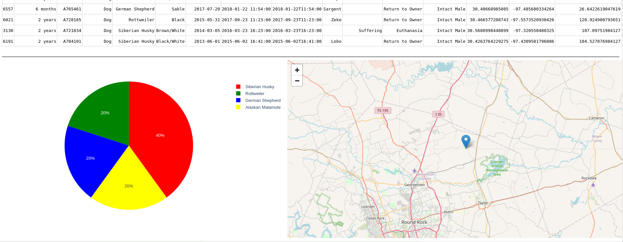

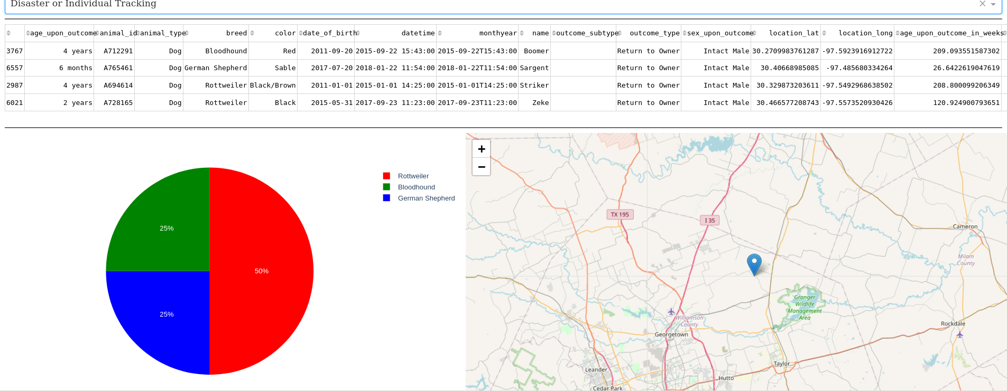

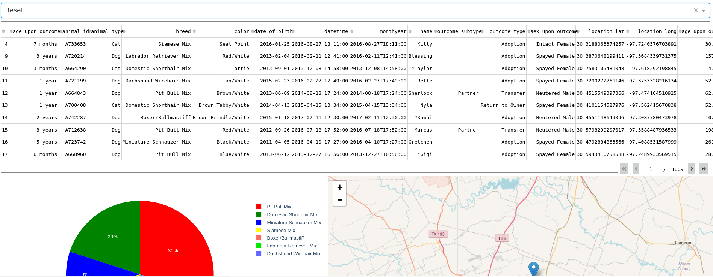

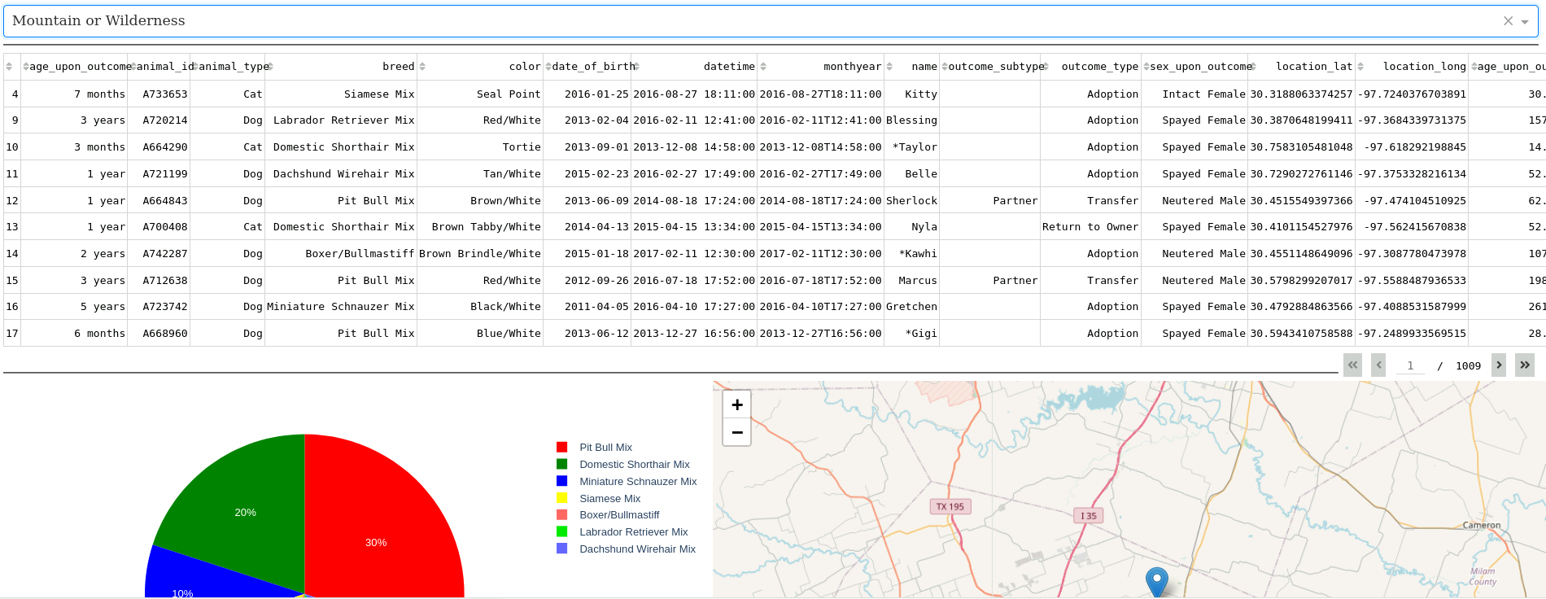

## Contact

Your name: Anthony See