# CS 255 System Design Document Template

## UML Diagrams

### UML Use Case Diagram

### UML Activity Diagrams

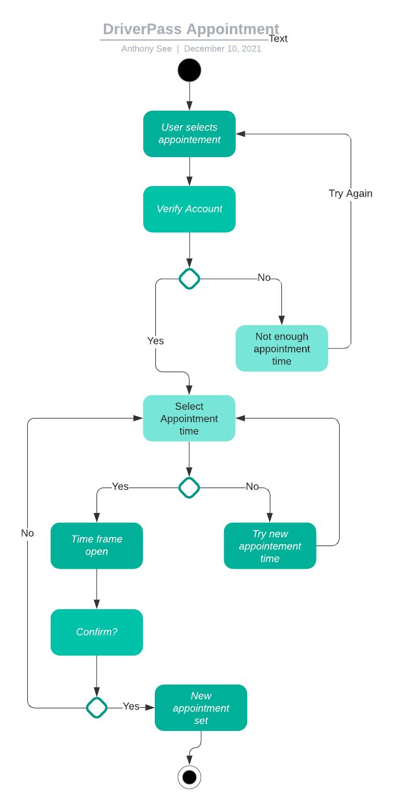

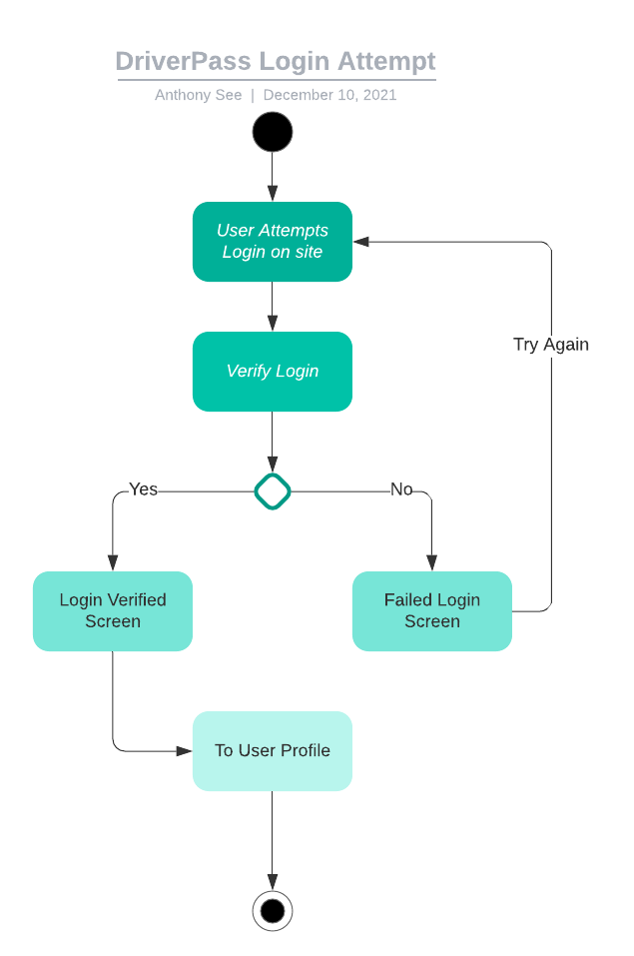

### UML Sequence Diagram

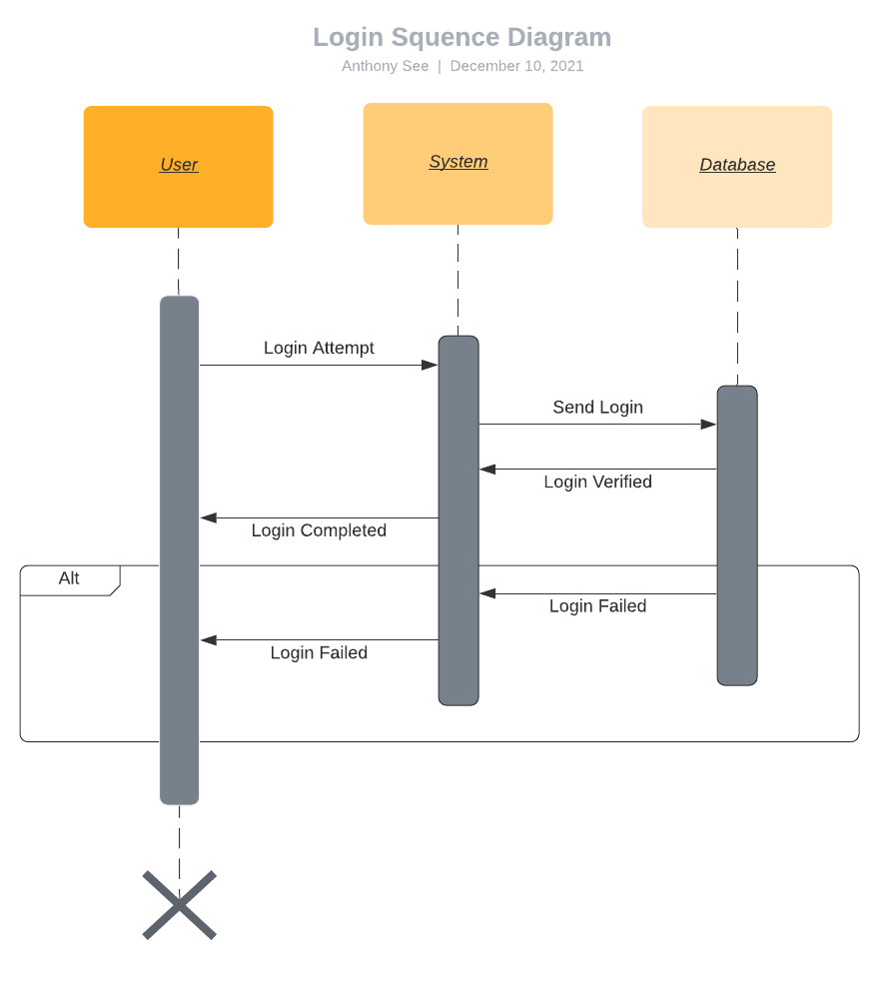

### UML Class Diagram

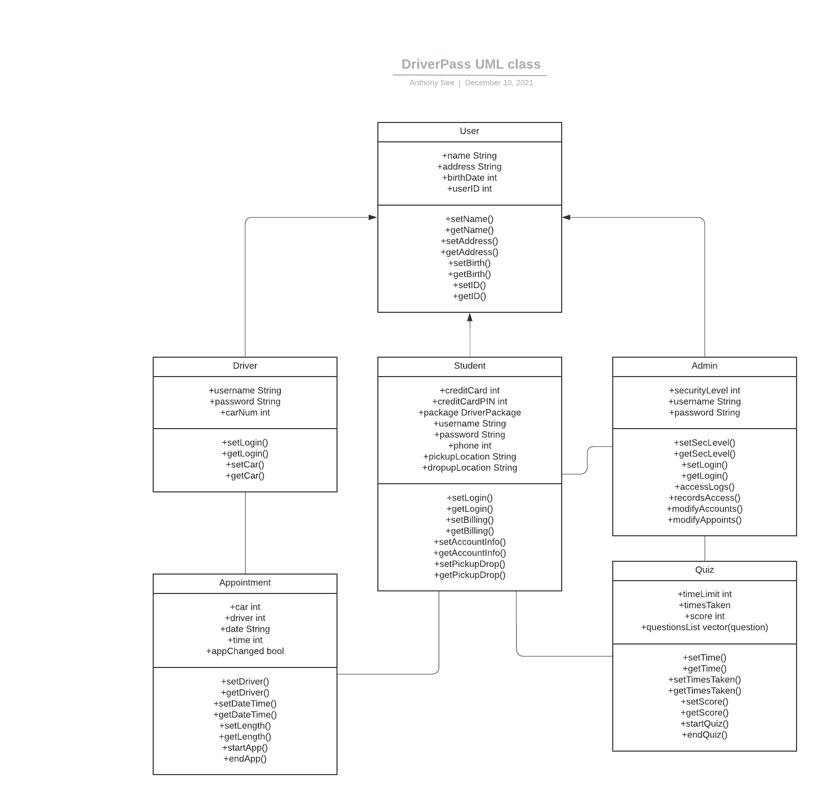

## Technical Requirements

*[Based on the diagrams you have created, describe the technical requirements of your system. These requirements should address the required hardware, software, tools, and infrastructure necessary for your system design.]*

**Hardware:**

We wouldn’t have to rely on hardware too much as the whole system would be cloud based. The physical hardware would be provided by the cloud hosting service that we and/or DriverPass would choose. The only actual hardware in the system would be any computers that DriverPass themselves would use to login while working.

**Software:**

Not much software would be needed either. Aside from using an IDE that the team is comfortable with, a database tool that the cloud provider uses, and the software that the cloud provider uses, nothing else would be needed. A cloud provider example would be Amazon’s Web Services, or AWS. One other third party resource DriverPass would need would be billing validation, since DriverPass elected to not deal with security.

**Tools:**

Any IDE the team is comfortable with in creating the environment. Any software that the cloud provider uses that would help the team, like a database tool the provider may use.

**Infrastructure:**

The infrastructure needed for this system would be a reliable connection to the internet. The internet is needed for this whole system to operate as without it, students wouldn’t be able to access their resources, drivers would not be able to book appointments, and employees would not be able to log in. More types of infrastructure would be reliable cars/drivers, as they would be the sole basis for driving appointments. Employees would be another type as they would help run the system. Getting students registered, maintaining the system, and managing accounts are all done by them, among other things. Lastly, students are required as they are the sole source of income for DriverPass. Plus, without them, there is no need for any part of the system.