Applicant details:
Name:
Contact number:
Email address:
Person responsible for signage:
Date of application:

Signage details:
[Insert image of proposed sign]

Proposed locations:
Location and structure | Map view
[INCLUDE LOCATION AND SUBURB]  [INCLUDE DETAILS OF STRUCTURE] | [INCLUDE AERIAL VIEW AND STREET IMAGE WITH LOCATION CLEARLY MARKED]  [INCLUDE DISTANCE FROM ROAD THAT THE SIGN IS PROPOSED TO BE PLACED]
EXAMPLE:  Address: Corner of Bridge Inn Road & Cookes Road  Suburb: Doreen VIC 3754  Structure: 900mm x 600m corflute, cable tied to wooden stake. | 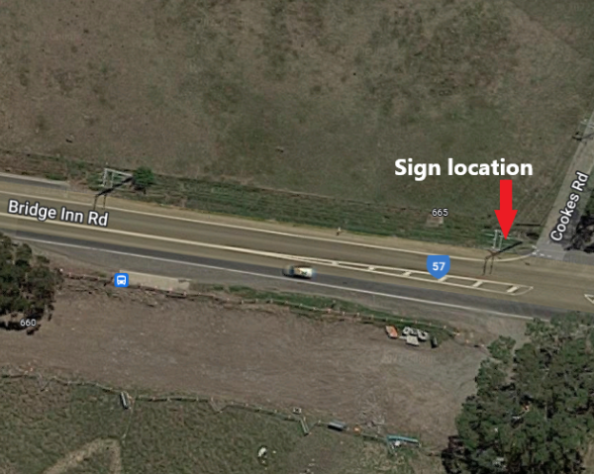  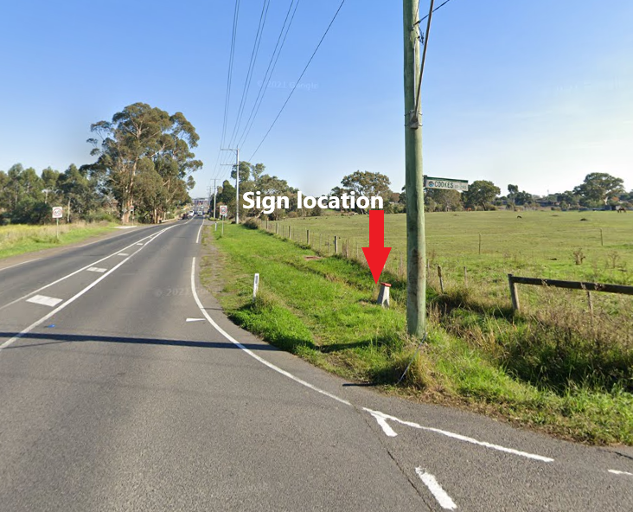

Next steps
- Please send completed application to: electionsignage@transport.vic.gov.au
- Please title the subject of your email: “Request for Election Signage approval - [INSERT CANDIDATE NAME] - [INSERT NAME OF ELECTORATE]”
- Applications will take approximately 10 business days to process, and you will be notified if approved, rejected or if further information is required.

Please note that in assessing your application, and in accordance with regulation 23(4) of the Road Management (General) Regulations 2026, the Department of Transport and Planning considers whether the signage would, or would be likely to:
- Obscure the field of view of a user of the road.
- Cause a hazard by distracting the attention of a user of the road.
- Distract attention of a user of the road from a traffic control device.
- Wholly or partly obscure a road user’s view of a traffic control device.
- In any other way be detrimental to the safe or efficient use of the road.

