Human Machine Interface - Documentation

Presentation
This human machine interface has been developed in Python for the summer project Autonomous Driving with F1/10 in June and July 2017. A vehicle will be run outside and the interface is a tool to display data and communicate with the car. Data is sent and received in real time through WIFI and ROS nodes.

Maps
The user can choose between two maps when the interface is launched and whenever after. One map corresponds to Grönlandsparken in Kista and the other one corresponds to Maskinparken in KTH's campus, Stockholm city.

The maps are downloaded from Open Street Map and saved in the format .png. The latitude and longitude of the maps' borders have to be known to convert the GPS position into the pixel coordinate system.
For each map, two zooms are available, corresponding to the north or the south part of each map. These zooms are pictures taken from the original pictures of the maps. Therefore the resolution of the four pictures for the zooms are variable. It is necessary to know the resolution of these pictures and their position in the original map in order to convert the coordinate system (see the paragraph “Conversion, zooms”).

The window
The Python's library Pygame has been chosen to code the interface. The window is divided into two vertical parts, the one on the left displays data received from the car :
- velocity (m/s)
- status ( “Running” if data is received, “No Subscriber”)
- GPS Quality (green, red or orange according to ROS messages received)
- Obstacle detection

There are seven buttons, two for the maps and five for the communication with the car, called “Scenario x”, one to reset the screen and one to quit.
The buttons “Kista” and “KTH” display the maps. The button “Scenario 1” sends way points to the car through a ROS Publisher called “...” and display this way points on the map. The button “Customized Scenario” offer the possibility to the user to choose the way points to send to the car. A maximum limit of ten way points has been fixed.
The reset button erases the way points displayed on the map and cancels any zooms.

The right part of the window is for the map.

The coordinate system
The origin of the coordinates system is set at the top left corner of the window. The window's size is (1542, 872).
(0,0) | (500,0) |  | (1542, 0)
DATA RECEIVED |  | MAP
(0, 872) | (500, 872) |  | (1542, 872)

Positioning the car
The data received from the car is its GPS coordinates. The car is represented in the screen by a picture of a car which can be oriented. The orientation received from the car is relative to the abscissa axis as well as the orientation used by Pygame.

Conversion, zooms
The coordinates are affected to the points according to the map currently displayed. Conditions are set on x and y : they correspond to the borders of the zooms' picture in the map. Outside of these boundaries, the conversion would give coordinates out of the window and the point no be displayed.

Latitude/Longitude - pixels
The position given by latitude and longitude coordinates have to be converted in pixel to be put on the right place on the screen. The conversion happens only for the starting point since the position is calculated relatively to it with data in meters.

L,M and N are storage lists for the coordinates. They are linked through a fonction of conversion.

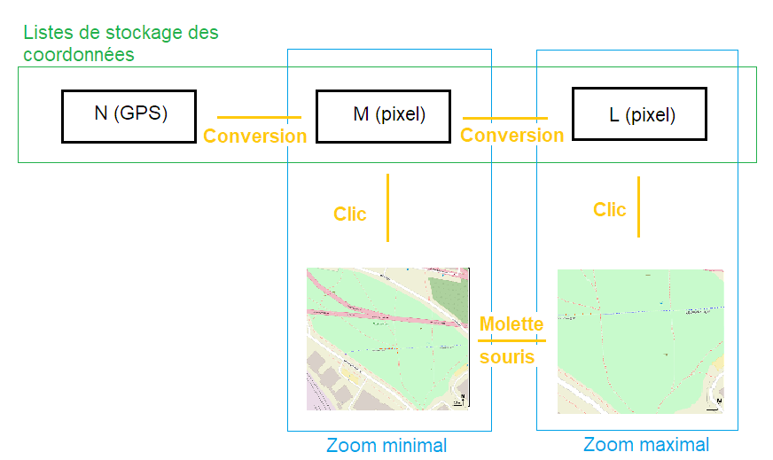

Equations :
xpixels = int( (L – LongitMin) / EchelleLongit + 500 )
ypixels = int( (LatitMax – l) / EchelleLatit )

Where (L, l) are the longitude and the latitude of the point
LongitMin is the minimal longitude covered by the map,
LatitMax is the maximal latitude covered by the map
EchelleLongit, the scale in longitude-pixel
EchelleLatit, the scale in latitude-pixel

Zooms
The zooms have been faked because this function is not available with Pygame. It is possible to zoom in by scrolling with the mouse. When zooming, the position of the point in the screen has to be calculated again. The conversion uses affine transformation for each picture because it depends on its characteristics and its position in the original picture.

x_{zoom} = x*a+b (idem for Y)

 | x |  | y
Zooms | a | b | a | d
Kista N | 1042/341 | -1862 | 872/283 | -502
Kista S | 1042/341 | -2179 | 872/283 | -1038
KTH E | 1042/550 | -1296 | 872/450 | -687
KTH W | 1042/486 | -604 | 872/283 | -28

Where a = 1042 / alpha, alpha is the width of the zooms' picture extracted from the original map.
Where a = 872 / beta, beta is the weight of the zooms' picture extracted from the original map.

The zooms' picture has coordinates in the original map from where it is extracted. For instance, the top left corner coordinates are (s,t) and the bottom right corner coordinates are (u,v). When s, t, u and v are multiplied by a, the interval for x and y are outside the window ( > 1542 for x and > 872 for y). The constant b is used to set the left boundary abscissa to 500 and and d to set the top boundary ordinate to 0.

Scale meters-pixels
187.7 m = 1042 pixels approximatively without zooming.
For the zoom, the pictures are resized, so there are two scales for each operation, one for the vertical and the other for the horizontal.

Data received from the car
The data received from the car is its GPS coordinates. It is converted to pixels.

!! MAXIMUM 10 WAYPOINTS CAN BE CHOOSEN !!

Screen refreshing
Pygame's philosophy is based on surfaces : a picture such as a map is a surface. The picture representing the car is also a surface which is pasted on the map. Here comes the issue of the screen('s) refreshing. After this conversion part, the displaying commands of the map are called again, outside of the for loop this time.
The call in the for loop is useful to give a new reference of map (KTH, Kista, zoom in or zoom out). Once this reference is defined, the picture of the car is pasted on the map each time a new position is received from ROS nodes. Therefore, the map is quickly full of pictures corresponding to the former positions of the car.
To avoid this phenomenon, the screen has to be refreshed by pasting the map at each loop so that one picture is displayed at a time.

Then, texts and buttons are updated.

Script
Two classes are defined in the following script : one for buttons and one for the interface, named 'Game'.

How does the interface work
The window can be shut only with the button QUIT.

The interface runs thanks to a while loop where some variables are defined as well as some arbitrary starting points for Kista and KTH. Then, a for loop detects users interaction with the interface by collecting mouse buttons or keyboard actions and refreshing buttons and texts. Finally, the data received by the subscribers defined in the beginning of the script (talk about global variables) is treated.

