**INDUS TECH SERVICES**

**Proposal for**

**Developing a Drowsiness Detection System on Virtual Lab**

**on AWS**

**Date: May 06, 2020**

**Submitted By:**

Mr Rohan Gupta

B. Tech. III year, Mechanical Engineering

**Submitted To:**

Mr Gagandeep Singh Sekhon

CEO, Indus Tech Services

**CONTENTS**

|  |  |  |
| --- | --- | --- |
| **S. No.** | **Title** | **Page No.** |
| 1. | About Us | 3 |
| 2. | Drowsiness Detection System | 3 |
| 3. | Team Members Involved | 3 |
| 4. | Algorithm | 4 |
| 5. | Execution | 7 |
| 6. | Applications | 7 |

**About us:**

Indus Tech Services, a premier IT services start-up, committed to nurturing world-class tech talent by creating an enabling environment. With an experience of a year, our dedicated team of experts is focused on implementing a well-researched plan to augment and elevate the tech competence in India and showcase this expertise to the world. We provide avenues for continuous learning and skill testing in various aspects of IT, especially futuristic technologies like AI and ML, mentoring, networking, hackathons, and other knowledge-building engagements. We have developed dedicated spaces for tech professionals and graduates to conduct research and build and test prototypes of cutting-edge AI-ML innovations. We connect businesses with top-notch tech talent in India to help them solve complex, strategic challenges speedily and create extraordinary value at scale.

**Drowsiness Detection System:**

If you have driven before, you’ve been drowsy at the wheel at some point. It’s not something we like to admit but it’s an important problem with serious consequences that needs to be addressed. 1 in 4 vehicle accidents are caused by drowsy driving and 1 in 25 adult drivers report that they have fallen asleep at the wheel in the past 30 days. The scariest part is that drowsy driving isn’t just falling asleep while driving. Drowsy driving can be as small as a brief state of unconsciousness when the driver is not paying full attention to the road. Drowsy driving results in over 71,000 injuries, 1,500 deaths, and $12.5 billion in monetary losses per year. Due to the relevance of this problem, we believe it is important to develop a solution for drowsiness detection, especially in the early stages to prevent accidents.

Additionally, we believe that drowsiness can negatively impact people in working and classroom environments as well. Although sleep deprivation and college go hand in hand, drowsiness in the workplace especially while working with heavy machinery may result in serious injuries similar to those that occur while driving drowsily.

Our solution to this problem is to build a detection system that identifies key attributes of drowsiness and triggers an alert when someone is drowsy before it is too late.

**Team Members Involved:**

* Rohan Gupta (Intern, B. Tech. III yr. Mechanical Engineering at IIT Roorkee)
* Gaurav Chatterjee (Mentor, Data Scientist at Lumiq.ai)

**The drowsiness detector algorithm**

Our drowsiness detector hinged on two important computer vision techniques:

* Facial landmark detection
* Eye aspect ratio

[Facial landmark prediction](https://pyimagesearch.com/2017/04/03/facial-landmarks-dlib-opencv-python/) is the process of localizing key facial structures on a face, including the eyes, eyebrows, nose, mouth, and jawline.

Specifically, in the context of drowsiness detection, we only needed the eye regions (I provide more detail on [how to extract each facial structure from a face here](https://pyimagesearch.com/2017/04/10/detect-eyes-nose-lips-jaw-dlib-opencv-python/)).

Once we have our eye regions, we can apply the eye aspect ratio to determine if the eyes are closed. If the eyes have been closed for a sufficiently long enough period of time, we can assume the user is at risk of falling asleep and sound an alarm to grab their attention.

The facial landmarks produced by dlib are an indexable list, as I describe here:

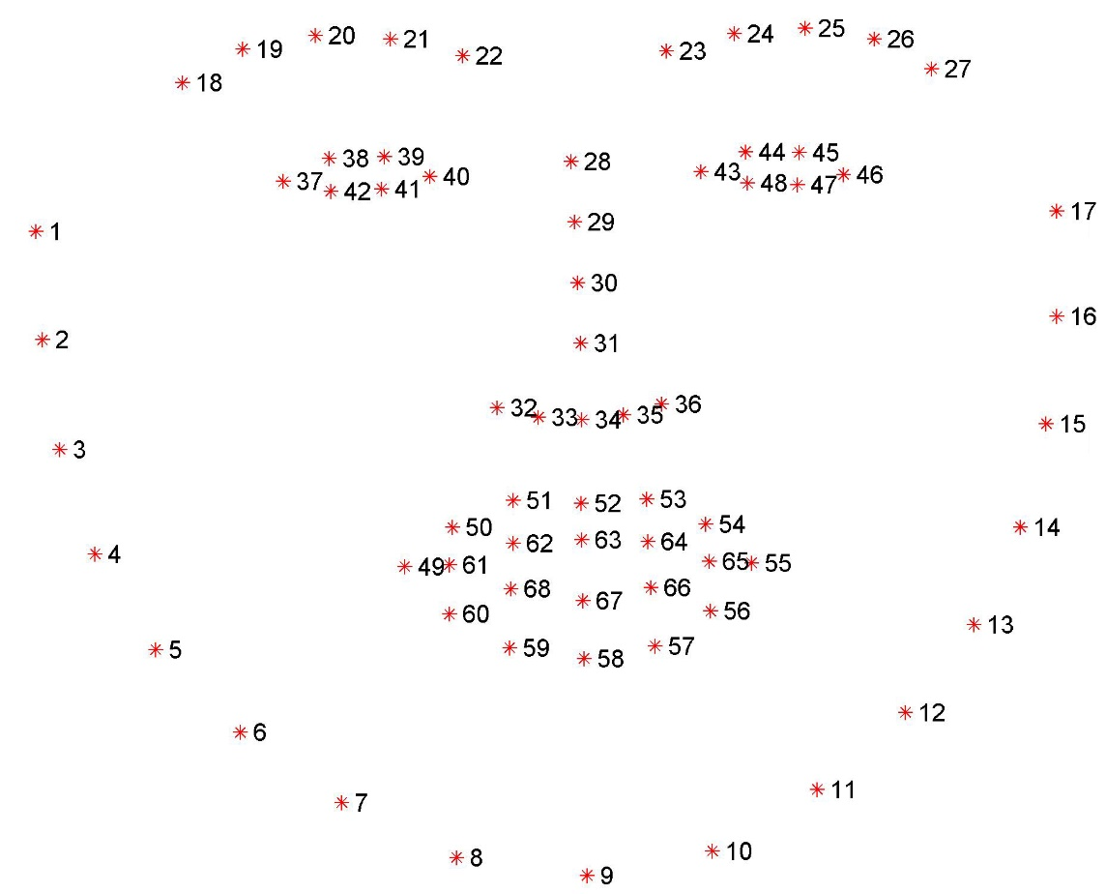

**Figure 5:** Visualizing the 68 facial landmark coordinates from the iBUG 300-W dataset.

**Eye Aspect Ratio (EAR):** EAR, as the name suggests, is the ratio of the length of the eyes to the width of the eyes. The length of the eyes is calculated by averaging over two distinct vertical lines across the eyes as illustrated in the figure below.

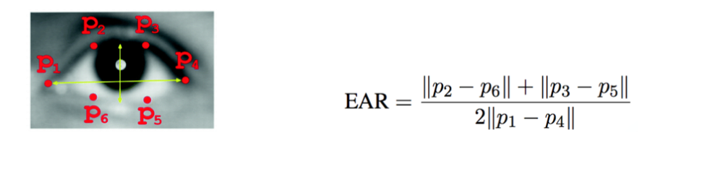

Eye Aspect Ratio (EAR)

The general flow of our drowsiness detection algorithm is fairly straightforward.

First, we’ll setup a camera that monitors a stream for faces:

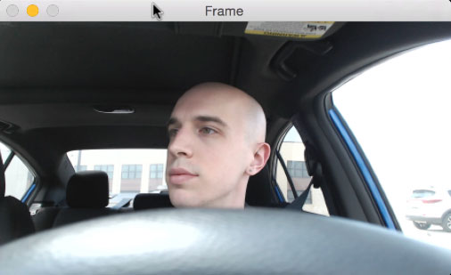

**Figure 1: Step #1 — Look for faces in the input video stream.**

If a face is found, we apply facial landmark detection and extract the eye regions:

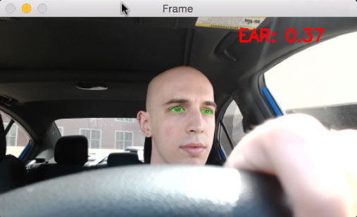

**Figure 2: Step #2 — Apply facial landmark localization to extract the eye regions from the face.**

Now that we have the eye regions, we can compute the eye aspect ratio (detailed [here](https://pyimagesearch.com/2017/04/24/eye-blink-detection-opencv-python-dlib/)) to determine if the eyes are closed:

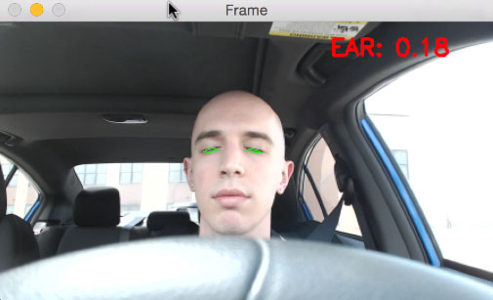

**Figure 3: Step #3 — Compute the eye aspect ratio to determine if the eyes are closed.**

If the eye aspect ratio indicates that the eyes have been closed for a sufficiently long enough amount of time, we’ll sound an alarm to wake up the driver:

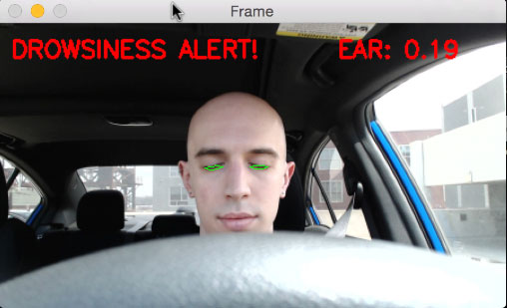

**Figure 4: Step #4 — Sound an alarm if the eyes have been closed for a sufficiently long enough time.**

Our drowsiness detector requires one command line argument followed by two optional ones, each of which is detailed below:

* *--shape-predictor:* This is the path to dlib’s pre-trained facial landmark detector. You can download the detector along with the source code to this tutorial by using the “Downloads” section at the bottom of this blog post.
* *--alarm:* Here you can optionally specify the path to an input audio file to be used as an alarm.
* *--webcam:* This integer controls the index of your built-in webcam/USB camera.

**Executing the code on system:**

Executed the following command:

**Drowsiness detection with OpenCV**

$ python detect_drowsiness.py \

--shape-predictor shape_predictor_68_face_landmarks.dat \

--alarm alarm.wav

**Applications:**

* **Deployment in Cars and Trucks:** Our solution to this problem is to build a detection system that identifies key attributes of drowsiness and triggers an alert when someone is drowsy before it is too late.