Tucker Lebor

Artificial Neural Network Model of Sales Anomalies in a Butcher Shop

Neural networks can be very useful for modeling expansive data with poorly known relevancies of the input data. This is because the network is able to sort through inputs and ignore them if they are irrelevant, or apply whatever minor effect they may have upon the result. They are also able to take a very large amount of input data, allowing for a wide variety of factors to be taken into account. Thus it will be used to model the various factors that contribute to the common anomalies in the sales of a business.

The business in question, Olde Towne Butcher, is a butcher shop in Fredericksburg, Virginia, that sells various grocery items. Due to the higher end nature of the products, many customers only come on occasions. Thus, the sales are not as regular as that of a grocery store or supermarket, which is most people’s everyday source of food.

A neural network has been used to create a model for grocery stores. This network has past gross profit, marketing cost, and gross profit of competitors as inputs (Penpece & Elma, 2014). While this model is sufficient for a reliable prediction in that case, it is not sufficient when the crucial earnings and losses are made in distinct anomalies, as is the case with the butcher shop. Using a wide variety of inputs, including time based measurements as well as previous sales of certain categories of products, these anomalies may become predictable.

First, a preliminary model will be made that utilizes basic data and POS data sorted into general groups. It will predict sales by these simple groups as well. These groups will be meat, dairy, deli, and dry foods. This should create a model that can predict sales data similarly to weekly averages, but not to most anomalies. This will not include many extraneous factors, though it may be necessary to include days of the week and weather to get any type of predictable outcome. This will probably also be a smaller network, and will help create a platform to be expanded upon for greater sophistication and accuracy.

Another major component is the actual design of the network. Previous research (Sano, Machino, Yada, & Suzuki, 2015) has compared various types of networks for grocery store recommendation systems. This is based on point of sale data, the same type of data available from the butcher shop. The recommendation system predicted what a customer would buy based on other products already selected. This would be useful, since it would be comparable to predicting the amount of one product sold based on sales of another. This will allow the network to interpret sales by product type, further increasing the usefulness of its output. Inputs of various types may need to be used, so multiple neuron types, possibly within the same layer, may be necessary to interpret the information properly.

Most of the time will probably be taken by the design of the network. This is because of the unique nature of its inputs. Running and modifying the network will certainly be necessary, and either manual or automatic removal of irrelevant inputs may be implemented. 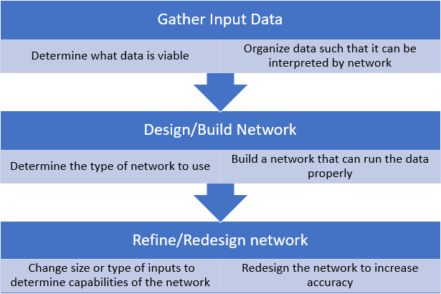

References:

Penpece, D., Elma, O. E. (2014). Predicting sales revenue by using artificial neural network in

grocery retailing industry: a case study in Turkey. *International Journal of Trade,*

*Economics and Finance,* 5, 435-439.

Sano, N., Machino, N., Yada, K., & Suzuki, T. (2015). Recommendation system for grocery store

considering data sparsity. *Procedia Computer Science,* 60, 1406-1413.