A* Search Algorithm
A* search is the most commonly known form of best-first search. It uses heuristic function h(n), and cost to reach the node n from the start state g(n). It has combined features of UCS(Uniform Cost Search) and greedy best-first search, by which it solve the problem efficiently. A* search algorithm finds the shortest path through the search space using the heuristic function. This search algorithm expands less search tree and provides optimal result faster. A* algorithm is similar to UCS except that it uses g(n)+h(n) instead of g(n).
In A* search algorithm, we use search heuristic as well as the cost to reach the node. Hence we can combine both costs as following, and this sum is called as a fitness number.
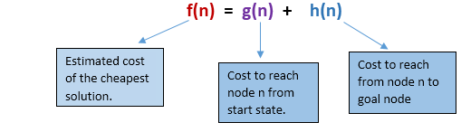

Algorithm of A* search:
Step1: Place the starting node in the OPEN list.
Step 2: Check if the OPEN list is empty or not, if the list is empty then return failure and stops.
Step 3: Select the node from the OPEN list which has the smallest value of evaluation function (g+h), if node n is goal node then return success and stop, otherwise
Step 4: Expand node n and generate all of its successors, and put n into the closed list. For each successor n', check whether n' is already in the OPEN or CLOSED list, if not then compute evaluation function for n' and place into Open list.
Step 5: Else if node n' is already in OPEN and CLOSED, then it should be attached to the back pointer which reflects the lowest g(n') value.
Step 6: Return to Step 2.

Advantages:
- A* search algorithm is the best algorithm than other search algorithms.
- A* search algorithm is optimal and complete.
- This algorithm can solve very complex problems.

Disadvantages:
- It does not always produce the shortest path as it mostly based on heuristics and approximation.
- A* search algorithm has some complexity issues.
- The main drawback of A* is memory requirement as it keeps all generated nodes in the memory, so it is not practical for various large-scale problems.

