PART 2

SELECT a.cust_name AS "Customer Name",

a.city, b.name AS "Salesman", b.commission

FROM customer a

INNER JOIN salesman b

ON a.salesman_id=b.salesman_id

WHERE b.commission>.12;

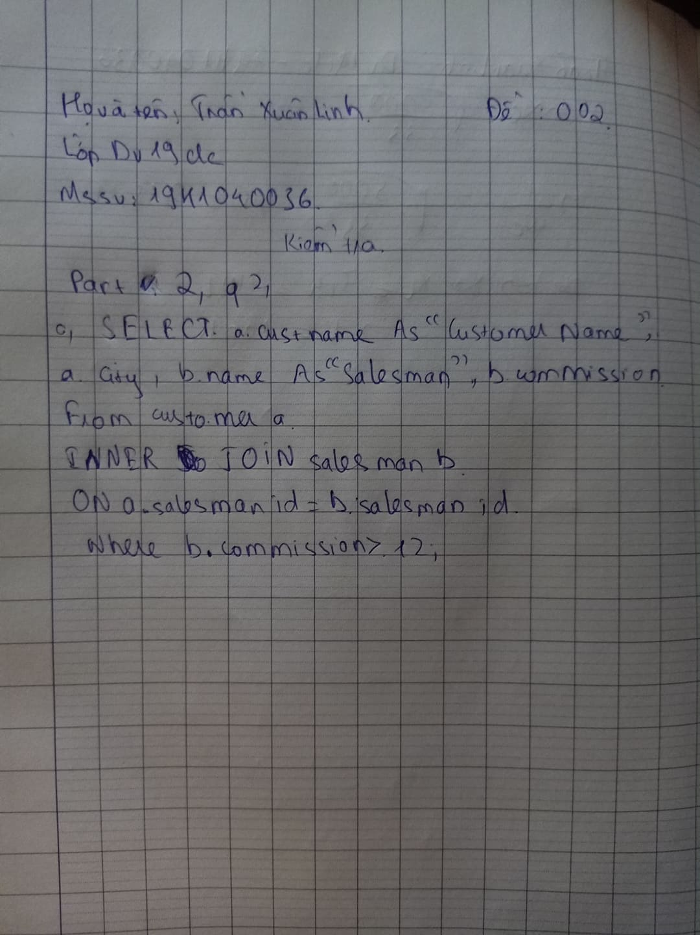

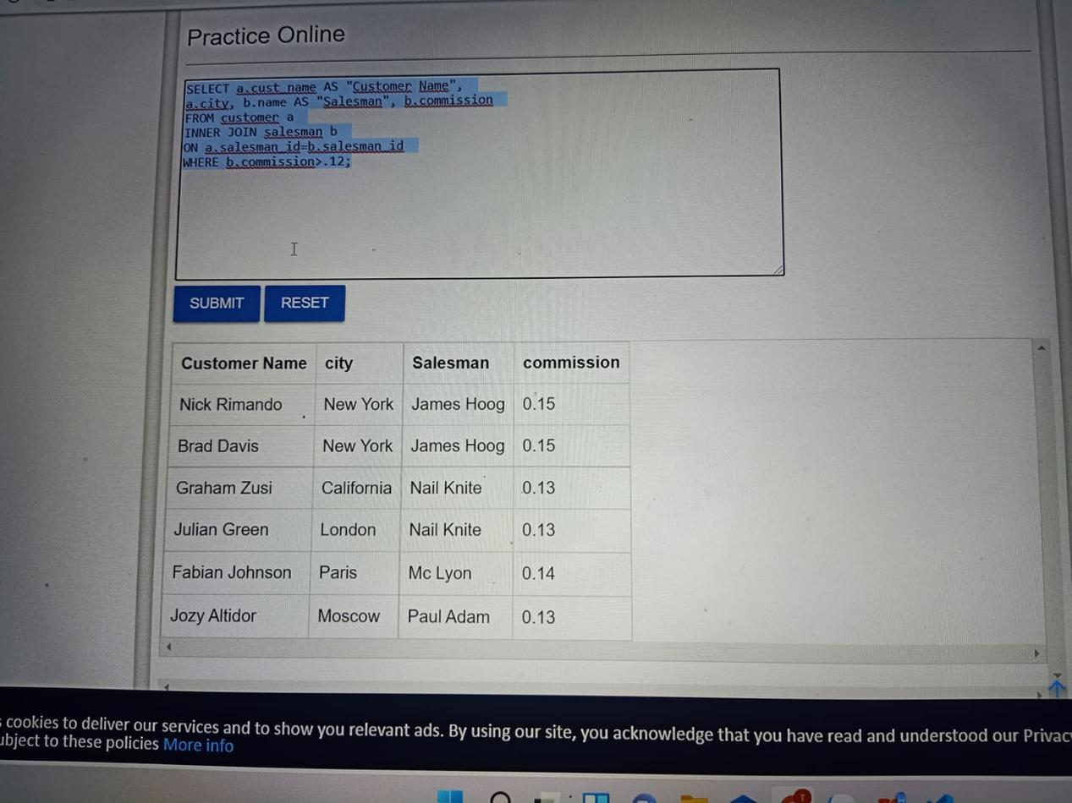

https://github.com/Tranxuanlinh/PUBLIC.git