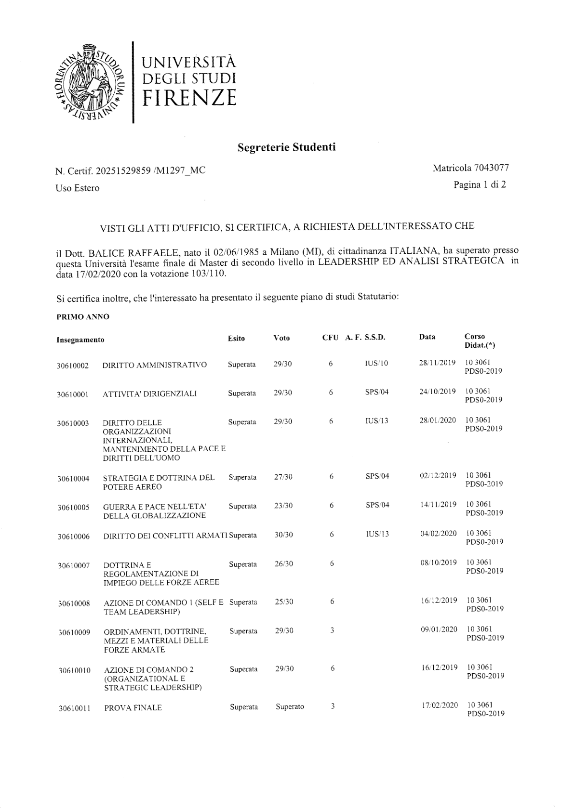
Student Registrar's Office
Certificate No. 20251529859 /M1297_MC Student ID No. 7043077
For Foreign Use Page 1 of 2
HAVING EXAMINED THE OFFICIAL RECORDS, IT IS HEREBY CERTIFIED, AT THE REQUEST OF THE INTERESTED PARTY, THAT
Dr. BALICE RAFFAELE, born on 02/06/1985 in Milano (MI), of ITALIAN citizenship, passed at this University the final examination of the Second-Level Master's Degree in LEADERSHIP AND STRATEGIC ANALYSIS on 17/02/2020 with a grade of 103/110.
It is further certified that the interested party submitted the following Statutory study plan:
FIRST YEAR
Code | Course | Outcome | Grade | CFU | S.S.D. | Date | Teaching  Course (*)
30610002 | ADMINISTRATIVE LAW | Passed | 29/30 | 6 | IUS/10 | 28/11/2019 | 10 3061  PDS0-2019
30610001 | MANAGERIAL ACTIVITIES | Passed | 29/30 | 6 | SPS/04 | 24/10/2019 | 10 3061  PDS0-2019
30610003 | LAW OF INTERNATIONAL ORGANISATIONS, PEACEKEEPING AND HUMAN RIGHTS | Passed | 29/30 | 6 | IUS/13 | 28/01/2020 | 10 3061  PDS0-2019
30610004 | STRATEGY AND DOCTRINE OF AIR POWER | Passed | 27/30 | 6 | SPS/04 | 02/12/2019 | 10 3061  PDS0-2019
30610005 | WAR AND PEACE IN THE AGE OF GLOBALISATION | Passed | 23/30 | 6 | SPS/04 | 14/11/2019 | 10 3061  PDS0-2019
30610006 | LAW OF ARMED CONFLICTS | Passed | 30/30 | 6 | IUS/13 | 04/02/2020 | 10 3061  PDS0-2019
30610007 | DOCTRINE AND REGULATION OF AIR FORCE EMPLOYMENT | Passed | 26/30 | 6 |  | 08/10/2019 | 10 3061  PDS0-2019
30610008 | COMMAND ACTION 1 (SELF AND TEAM LEADERSHIP) | Passed | 25/30 | 6 |  | 16/12/2019 | 10 3061  PDS0-2019
30610009 | REGULATIONS, DOCTRINES, MEANS AND MATERIEL OF THE ARMED FORCES | Passed | 29/30 | 3 |  | 09/01/2020 | 10 3061  PDS0-2019
30610010 | COMMAND ACTION 2 (ORGANIZATIONAL AND STRATEGIC LEADERSHIP) | Passed | 29/30 | 6 |  | 16/12/2019 | 10 3061  PDS0-2019
30610011 | FINAL EXAMINATION | Passed | Passed | 3 |  | 17/02/2020 | 10 3061  PDS0-2019

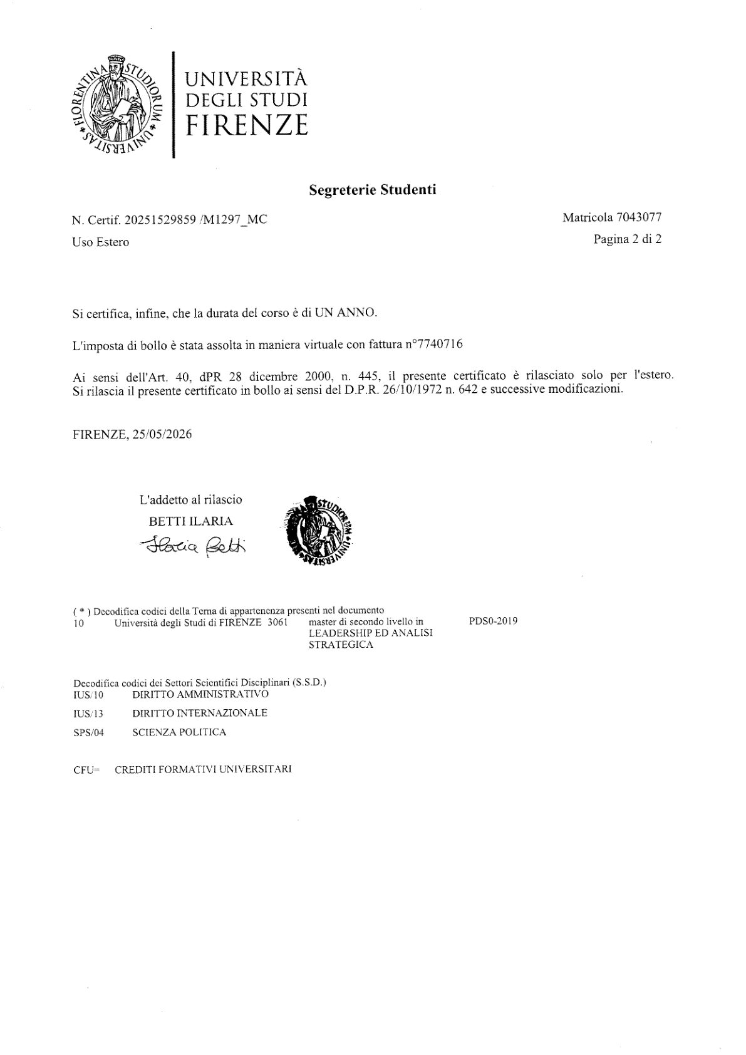
Student Registrar's Office
Certificate No. 20251529859 /M1297_MC Student ID No. 7043077
For Foreign Use Page 2 of 2
It is further certified that the duration of the course is ONE YEAR.
The stamp duty has been paid electronically under invoice no. 7740716.
Pursuant to Article 40 of Presidential Decree No. 445 of 28 December 2000, this certificate is issued for use abroad only. This certificate is issued with stamp duty in accordance with Presidential Decree No. 642 of 26/10/1972 and subsequent amendments.
FLORENCE, 25/05/2026
(*) Decoding of the institution-triad codes appearing in the document:
10 | Università degli Studi di FIRENZE 3061 | Second-Level Master's Degree in LEADERSHIP AND STRATEGIC ANALYSIS  PDS0-2019
Decoding of Scientific Disciplinary Sector codes (S.S.D.):
IUS/10 | ADMINISTRATIVE LAW
IUS/13 | INTERNATIONAL LAW
SPS/04 | POLITICAL SCIENCE
CFU = UNIVERSITY TRAINING CREDITS
Note: This is an English translation of the original Italian certificate issued by the Università degli Studi di Firenze (University of Florence). The crest, seal and signature are reproduced from the original scan. Course codes, sector codes (S.S.D.), credit values (CFU), grades and reference numbers are reproduced unchanged.

