**TITLE OF THESIS OR DISSERTATION: SIMPLE FORMAT WITH ENDNOTES AND TYPED BIBLIOGRAPHY IN WORD 2016**

A Dissertation Presented

by

SAMANTHA S. STUDENT

Submitted to the Graduate School of the

University of Massachusetts Amherst in partial fulfillment

of the requirements for the degree of

DOCTOR OF PHILOSOPHY

(or DOCTOR OF EDUCATION)

Month Year

Official Graduate Program Name

© Copyright by Samantha S. Student 2016

All Rights Reserved

**TITLE OF THESIS OR DISSERTATION: SIMPLE FORMAT WITH ENDNOTES AND TYPED BIBLIOGRAPHY IN WORD 2016**

A Dissertation Presented

by

SAMANTHA S. STUDENT

Approved as to style and content by:

Name O. Chairr, Chair

First O. Member, Member

Second M. Name, Member

Name, Department Head or Dean as appropriate

Department Name

DEDICATION

[optional]

# ACKNOWLEDGMENTS

[optional]

# ABSTRACT

**TITLE OF DISSERTATION**

DEGREE DATE

NAME OF STUDENT, B.A., COLLEGE OR UNIVERSITY

M.A., COLLEGE OR UNIVERSITY

Ph.D., UNIVERSITY OF MASSACHUSETTS AMHERST

Directed by: Professor Xxxx Y. Zzzz

TABLE OF CONTENTS

Page

ACKNOWLEDGMENTS v

ABSTRACT vi

LIST OF TABLES viii

LIST OF FIGURES ix

CHAPTER

1. NEW SCIENTIFIC DARWINISTS 1

Introduction 1

Thomas Henry Huxley 1

Discoveries of Organic Chemists and Evolutionists  
 Complementary 2

Applicability of Darwin's Argument to Human Beings 2

An Example of a Heading 4 Subdivision Head 3

An Example of a Heading 5 Subdivision Head 3

2. SECOND CHAPTER TITLE 5

Ernst Heinrich Haeckel 5

Haeckel’s Anti-Anthropocentrism 5

APPENDICES

A. THE DARWINIAN REVOLUTION 9

B. THE TABLES 10

BIBLIOGRAPHY 11

# LIST OF TABLES

Table Page

1. Caption for First Table 9

2. Caption for Second Table 9

# LIST OF FIGURES

Figure Page

1. Caption for My First Figure 3

2. Caption for My Second Figure 5

**CHAPTER 1**

# NEW SCIENTIFIC DARWINISTS

## Introduction

This chapter shows how Darwin's theory of evolution was applied to the study of human evolution by two of the most enthusiastic of the new scientific Darwinists, T. H. Huxley and Ernst Haeckel. Both Huxley and Haeckel adopted the anti-creationist aspects of Darwin's theory and used them to attack many traditional beliefs and social institutions, as well as to advance the claims of science to be an authority within society. The chapter also shows how Darwin's theory provided a basis for the foundation of comparative psychology by G. J. Romanes.

## Thomas Henry Huxley

Huxley argued against primary anthropocentrism and the two forms of evolutionary anthropocentrism--"yes, but" and "Crown of Creation"--which are attempts to resurrect supernatural control of evolution or to portray humans as the goal of creation. However, he is himself an example of the "engineering mentality" form of anthropocentrism. According to Huxley, "naught endures save the flow of energy and the rational order which pervades it."[1] In using the adjective "rational," Huxley did not suggest that he believed in a rational Mind or Lawgiver rather he meant that he believed the order of the universe to be comprehensible by a rational mind. The principle of the universe is order, and scientists are gradually discovering that order. The most fundamental principles of that order, as they are observed by humans, are described as "laws of nature."[2]

Huxley made a point of reminding his readers that the chemicals making up living beings are breaking down and being reformed into new individuals all the time and that people belong to that system of life-and-death:

Under whatever disguise it takes refuge, whether fungus or oak, worm or man, the living protoplasm not only ultimately dies and is resolved into its mineral and lifeless constituents, but is always dying, and, strange as the paradox may sound, could not live unless it died.[3]

### Discoveries of Organic Chemists and Evolutionists Complementary

Since the basic elements in living and non-living things are the same, Huxley had no doubt that life had evolved from non-living matter.[4] Thus, the discoveries of organic chemists and evolutionists were complementary to each other. If life is made of the same materials as non- life, the evolution of life becomes more plausible.

### Applicability of Darwin's Argument to Human Beings

Huxley accepted Darwin's argument for evolution by natural selection and set out to demonstrate the applicability of the argument to human beings. Man's Place in Nature was published in 1863. Although Huxley had given lectures on the subject of the human relationship to apes in 1860 and 1862, Man's Place was the first book to present the anthropological evidence supporting the theory that humans had evolved from or with other primates. The book is a precise and exhaustive examination of anatomical archaeological, and geological evidence for the evolution of Homo sapiens. It contains three essays, "On the Natural History of the Man-Like Apes," "On the Relation of Man to the Lower Animals," and "On Some Fossil Remains of Man."

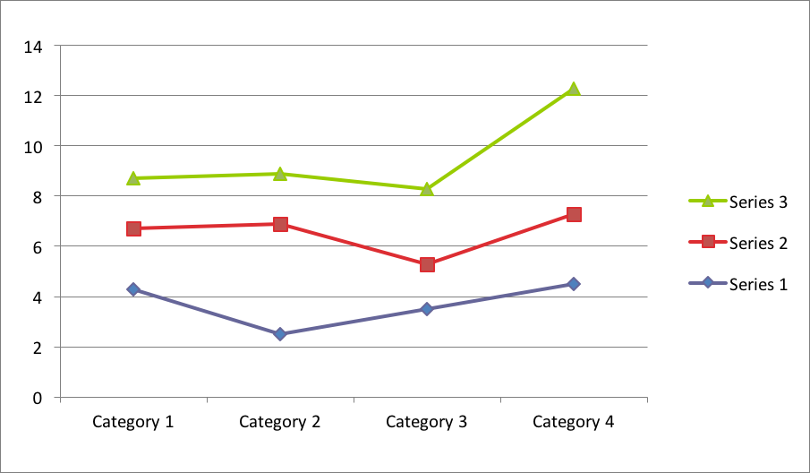

Figure : Caption for My First Figure

#### An Example of a Heading 4 Subdivision Head

One of the major controversies of Darwin scholarship is whether or not there is a "Darwinian revolution." I agree with those who consider that Darwin's insights, arguments and impact are significant enough to warrant the title "revolution."

##### An Example of a Heading 5 Subdivision Head

Nevertheless, most educated people still believed in special creation and the Argument from Design; naturalists expected and hoped that the study of nature would "reveal some meaning in it, something about man's place in nature, man's relation with God." Darwin's study did just that--but hardly what had been expected or hoped for.

CHAPTER 2

# SECOND CHAPTER TITLE

## Ernst Heinrich Haeckel

Ernst Haeckel, like Huxley, used science as a weapon against some of the prevalent assumptions and institutions of his day. For Haeckel natural selection was both a description of the origin of species and (because it is a mechanical non-teleological explanation of morphology, which paralleled the mechanical explanations of physics and astronomy) the final proof of the "unity of organic and inorganic nature."[5] Haeckel wrote a number of books in an attempt to convert non-scientists to his ideas.

### Haeckel’s Anti-Anthropocentrism

Many of these were quickly translated into English and sold very well. The most important of his books for an examination of his anti-anthropocentrism are: The History of Creation (translated in 1873); The Evolution of Man (translated 1879); The Last Link (translated 1898); The Riddle of the Universe (1900); and The Wonders of Life (1905).

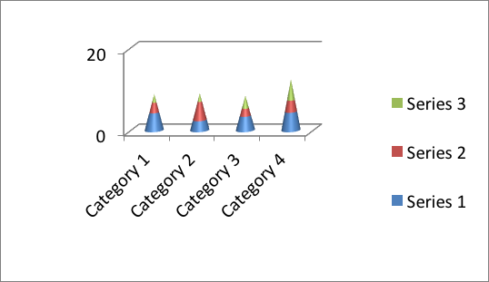

Figure : Caption for My Second Figure

APPENDICES

**APPENDIX A**

# THE DARWINIAN REVOLUTION

One of the major controversies of Darwin scholarship is whether or not there is a "Darwinian revolution." I agree with those who consider that Darwin's insights, arguments and impact are significant enough to warrant the title "revolution." Of course, no intellectual revolution occurs without a context.

Darwin did not invent the idea of evolution; there were major forces for intellectual change in science in general as well as social change. Nevertheless, most educated people still believed in special creation and the Argument from Design; naturalists expected and hoped that the study of nature would "reveal some meaning in it, something about man's place in nature, man's relation with God."

Darwin's study did just that--but hardly what had been expected or hoped for.

Modern scientists and historians of science who argue that there is a "Darwinian revolution" include Michael T. Ghiselin (The Triumph of the Darwinian Method, 1969); Ernst Mayr ("The Nature of the Darwinian Revolution," Science, 1971), David Hull (Darwin and his Critics: the Reception of Darwin's Theory of Evolution by the Scientific Community, 1973); and Howard Gruber, (Darwin on Man: A Psychological Study of Scientific Creativity, 1974). Lewontin, Passmore and Coleman also have interesting comments about Darwin's most important contributions.

**APPENDIX B**

# THE TABLES

Unfortunately, a short caption looks dumb left-justified and a long caption looks dumb center-justified, but you have to choose one style and be consistent.

Table 1: Caption for First Table

|  |  |  |  |
| --- | --- | --- | --- |
| column1 | column2 | column3 | column4 |
| one | two | three | four |
| one again | two again | three again | four again |
| final one | final two | final three | final four |

Table 2: Caption for Second Table

In order to avoid having a long caption, I have put an explanation in a paragraph under the caption but above the table.

|  |  |  |  |
| --- | --- | --- | --- |
| Identifying colors | original placements | 1 month later | end of year |
| red | 4 | 3 | 3 |
| orange | 5 | 4 | 3 |
| blue | 3 | 2 | 0 |

# BIBLIOGRAPHY

Branford, Victor.  *Interpretations and Forecasts: A Study of Survivals and Tendencies in Contemporary Society*. London: Duckworth & Co., 1914.

Branford, Victor and Geddes, Patrick. *The Coming Polity. The Making of the Future*. London: Williams & Norgate, 1919.

Darwin, Charles Robert. *The Descent of Man, and Selection in Relation to Sex*. 2 vols. New York: D. Appleton & Co., 1871.

________. *The Expression of the Emotions in Man and Animals*. Preface by Konrad Lorenz. London: D. Appleton, 1872; reprint ed., Chicago: University of Chicago Press, 1965.

________. *On the Origin of Species by Means of Natural Selection, or Preservation of Favoured Races in the Struggle for Life*. Introduction by Ernst Mayr. London: Murray. 1859; facsimile ed., Cambridge: Harvard University Press, 1964.

Geddes, Patrick. *Cities in Evolution: An Introduction to the Town Planning Movement and to the Study of Civics*. London: Williams & Norgate, 1915; reprint ed., London: Ernest Benn, 1968.

________. *Cities in Evolution*. Edited by The Outlook Tower Association, Edinburgh, and The Association for Planning and Regional Reconstruction, London. Jaqueline Tyrwhitt, General Editor. London: Williams & Norgate, Ltd., 1949.

________. *City Development: A Report to the Carnegie Dunfermline Trust*. Introduction by Peter Green. Edinburgh, 1904; reprint ed., New Brunswick, N.J.: Rutgers University Press, 1973.

________. "Morphology." *Encyclopaedia Britannica*. 9th ed. (1883) XVI:836-47.

________. *Patrick Geddes: Spokesman for Man and the Environment*. Edited and Introduction by Marshall Stalley. New Brunswick, N.J.: Rutgers University Press, 1972.

________. "Variation and Selection." *Encyclopaedia Britannica*. 9th ed. (1888) XXIV:76-85.

Geddes, Patrick and Slater, Gilbert. *Ideas at War. The Making of the Future*. London: Williams & Norgate, 1917.

Geddes, Patrick and Thomson, John Arthur. *Evolution*. Home University Library. New York: Henry Holt & Co., 1911.

1. Thomas Henry Huxley, Collected Essays, vol. V: Science and Christian Tradition (London: Macmillan & co., 1894; reprint ed., Hildesheim: Georg Olms Verlag, 1970), p. 76.
2. Thomas Henry Huxley, Collected Essays, vol. II: Darwiniana (London: Macmillan & co., 1894; reprint ed., Hildesheim: Georg Olms Verlag, 1970), p. 316.
3. Thomas Henry Huxley, Collected Essays, vol. II,, p. 316.
4. Thomas Henry Huxley, Lay Sermons, pp. 131-31
5. Ernest Heinrich Haeckel, The History of Creation or the Development of the Earth and Its Inhabitants by the Action of Natural Causes: A Popular Exposition of the Doctrine of Evolution in General, and of that of Darwin, Goethe, and Lamarck in Particular, 2 vols., trans. and revised by E. Ray Lankester (London: Henry S. King & Co. 1876), I:22.