A dissertation

Jessica L. Burnett

2019

caTools (1.17.1.1 -> 1.17.1.2) [CRAN]  
openssl (1.2.1 -> 1.2.2 ) [CRAN]  
purrr (0.3.0 -> 0.3.1 ) [CRAN]  
sys (2.1 -> 3.0 ) [CRAN]  
  
The downloaded binary packages are in  
 /var/folders/49/kjbx1jwd3wzc2mlvsk1p5hq00000gn/T//RtmpeBY7eu/downloaded_packages  
   
 checking for file <U+2018>/private/var/folders/49/kjbx1jwd3wzc2mlvsk1p5hq00000gn/T/RtmpeBY7eu/remotesab4d7021a671/TrashBirdEcology-bbsRDM-984f7d9/DESCRIPTION<U+2019> ...  
   
<U+2714> checking for file <U+2018>/private/var/folders/49/kjbx1jwd3wzc2mlvsk1p5hq00000gn/T/RtmpeBY7eu/remotesab4d7021a671/TrashBirdEcology-bbsRDM-984f7d9/DESCRIPTION<U+2019>  
  
   
<U+2500> preparing <U+2018>bbsRDM<U+2019>: (878ms)  
  
   
<U+2714> checking DESCRIPTION meta-information  
  
   
<U+2500> checking for LF line-endings in source and make files and shell scripts  
  
   
<U+2500> checking for empty or unneeded directories  
  
   
<U+2500> looking to see if a <U+2018>data/datalist<U+2019> file should be added  
  
   
<U+2500> building <U+2018>bbsRDM_0.1.0.tar.gz<U+2019>

[[1]]  
[1] "ggplot2" "stats" "graphics" "grDevices" "utils" "datasets"   
[7] "methods" "base"   
  
[[2]]  
[1] "ggthemes" "ggplot2" "stats" "graphics" "grDevices" "utils"   
[7] "datasets" "methods" "base"   
  
[[3]]  
 [1] "gapminder" "ggthemes" "ggplot2" "stats" "graphics"   
 [6] "grDevices" "utils" "datasets" "methods" "base"   
  
[[4]]  
 [1] "here" "gapminder" "ggthemes" "ggplot2" "stats"   
 [6] "graphics" "grDevices" "utils" "datasets" "methods"   
[11] "base"   
  
[[5]]  
 [1] "dplyr" "here" "gapminder" "ggthemes" "ggplot2"   
 [6] "stats" "graphics" "grDevices" "utils" "datasets"   
[11] "methods" "base"   
  
[[6]]  
 [1] "forcats" "stringr" "purrr" "readr" "tidyr"   
 [6] "tibble" "tidyverse" "dplyr" "here" "gapminder"  
[11] "ggthemes" "ggplot2" "stats" "graphics" "grDevices"  
[16] "utils" "datasets" "methods" "base"   
  
[[7]]  
 [1] "kableExtra" "forcats" "stringr" "purrr" "readr"   
 [6] "tidyr" "tibble" "tidyverse" "dplyr" "here"   
[11] "gapminder" "ggthemes" "ggplot2" "stats" "graphics"   
[16] "grDevices" "utils" "datasets" "methods" "base"   
  
[[8]]  
 [1] "gganimate" "kableExtra" "forcats" "stringr" "purrr"   
 [6] "readr" "tidyr" "tibble" "tidyverse" "dplyr"   
[11] "here" "gapminder" "ggthemes" "ggplot2" "stats"   
[16] "graphics" "grDevices" "utils" "datasets" "methods"   
[21] "base"   
  
[[9]]  
 [1] "sp" "gganimate" "kableExtra" "forcats" "stringr"   
 [6] "purrr" "readr" "tidyr" "tibble" "tidyverse"   
[11] "dplyr" "here" "gapminder" "ggthemes" "ggplot2"   
[16] "stats" "graphics" "grDevices" "utils" "datasets"   
[21] "methods" "base"   
  
[[10]]  
 [1] "raster" "sp" "gganimate" "kableExtra" "forcats"   
 [6] "stringr" "purrr" "readr" "tidyr" "tibble"   
[11] "tidyverse" "dplyr" "here" "gapminder" "ggthemes"   
[16] "ggplot2" "stats" "graphics" "grDevices" "utils"   
[21] "datasets" "methods" "base"   
  
[[11]]  
 [1] "feather" "raster" "sp" "gganimate" "kableExtra"  
 [6] "forcats" "stringr" "purrr" "readr" "tidyr"   
[11] "tibble" "tidyverse" "dplyr" "here" "gapminder"   
[16] "ggthemes" "ggplot2" "stats" "graphics" "grDevices"   
[21] "utils" "datasets" "methods" "base"   
  
[[12]]  
 [1] "maps" "feather" "raster" "sp" "gganimate"   
 [6] "kableExtra" "forcats" "stringr" "purrr" "readr"   
[11] "tidyr" "tibble" "tidyverse" "dplyr" "here"   
[16] "gapminder" "ggthemes" "ggplot2" "stats" "graphics"   
[21] "grDevices" "utils" "datasets" "methods" "base"   
  
[[13]]  
 [1] "inlabru" "maps" "feather" "raster" "sp"   
 [6] "gganimate" "kableExtra" "forcats" "stringr" "purrr"   
[11] "readr" "tidyr" "tibble" "tidyverse" "dplyr"   
[16] "here" "gapminder" "ggthemes" "ggplot2" "stats"   
[21] "graphics" "grDevices" "utils" "datasets" "methods"   
[26] "base"   
  
[[14]]  
 [1] "gridExtra" "inlabru" "maps" "feather" "raster"   
 [6] "sp" "gganimate" "kableExtra" "forcats" "stringr"   
[11] "purrr" "readr" "tidyr" "tibble" "tidyverse"   
[16] "dplyr" "here" "gapminder" "ggthemes" "ggplot2"   
[21] "stats" "graphics" "grDevices" "utils" "datasets"   
[26] "methods" "base"   
  
[[15]]  
 [1] "kedd" "gridExtra" "inlabru" "maps" "feather"   
 [6] "raster" "sp" "gganimate" "kableExtra" "forcats"   
[11] "stringr" "purrr" "readr" "tidyr" "tibble"   
[16] "tidyverse" "dplyr" "here" "gapminder" "ggthemes"   
[21] "ggplot2" "stats" "graphics" "grDevices" "utils"   
[26] "datasets" "methods" "base"   
  
[[16]]  
 [1] "caTools" "kedd" "gridExtra" "inlabru" "maps"   
 [6] "feather" "raster" "sp" "gganimate" "kableExtra"  
[11] "forcats" "stringr" "purrr" "readr" "tidyr"   
[16] "tibble" "tidyverse" "dplyr" "here" "gapminder"   
[21] "ggthemes" "ggplot2" "stats" "graphics" "grDevices"   
[26] "utils" "datasets" "methods" "base"   
  
[[17]]  
 [1] "deSolve" "caTools" "kedd" "gridExtra" "inlabru"   
 [6] "maps" "feather" "raster" "sp" "gganimate"   
[11] "kableExtra" "forcats" "stringr" "purrr" "readr"   
[16] "tidyr" "tibble" "tidyverse" "dplyr" "here"   
[21] "gapminder" "ggthemes" "ggplot2" "stats" "graphics"   
[26] "grDevices" "utils" "datasets" "methods" "base"   
  
[[18]]  
 [1] "segmented" "deSolve" "caTools" "kedd" "gridExtra"   
 [6] "inlabru" "maps" "feather" "raster" "sp"   
[11] "gganimate" "kableExtra" "forcats" "stringr" "purrr"   
[16] "readr" "tidyr" "tibble" "tidyverse" "dplyr"   
[21] "here" "gapminder" "ggthemes" "ggplot2" "stats"   
[26] "graphics" "grDevices" "utils" "datasets" "methods"   
[31] "base"   
  
[[19]]  
 [1] "DiagrammeR" "segmented" "deSolve" "caTools" "kedd"   
 [6] "gridExtra" "inlabru" "maps" "feather" "raster"   
[11] "sp" "gganimate" "kableExtra" "forcats" "stringr"   
[16] "purrr" "readr" "tidyr" "tibble" "tidyverse"   
[21] "dplyr" "here" "gapminder" "ggthemes" "ggplot2"   
[26] "stats" "graphics" "grDevices" "utils" "datasets"   
[31] "methods" "base"   
  
[[20]]  
 [1] "webshot" "DiagrammeR" "segmented" "deSolve" "caTools"   
 [6] "kedd" "gridExtra" "inlabru" "maps" "feather"   
[11] "raster" "sp" "gganimate" "kableExtra" "forcats"   
[16] "stringr" "purrr" "readr" "tidyr" "tibble"   
[21] "tidyverse" "dplyr" "here" "gapminder" "ggthemes"   
[26] "ggplot2" "stats" "graphics" "grDevices" "utils"   
[31] "datasets" "methods" "base"   
  
[[21]]  
 [1] "revtools" "webshot" "DiagrammeR" "segmented" "deSolve"   
 [6] "caTools" "kedd" "gridExtra" "inlabru" "maps"   
[11] "feather" "raster" "sp" "gganimate" "kableExtra"  
[16] "forcats" "stringr" "purrr" "readr" "tidyr"   
[21] "tibble" "tidyverse" "dplyr" "here" "gapminder"   
[26] "ggthemes" "ggplot2" "stats" "graphics" "grDevices"   
[31] "utils" "datasets" "methods" "base"

# Abstract

Sed ut perspiciatis unde omnis iste natus error sit voluptatem accusantium doloremque laudantium, totam rem aperiam, eaque ipsa quae ab illo inventore veritatis et quasi architecto beatae vitae dicta sunt explicabo. Nemo enim ipsam voluptatem quia voluptas sit aspernatur aut odit aut fugit, sed quia consequuntur magni dolores eos qui ratione voluptatem sequi nesciunt. Neque porro quisquam est, qui dolorem ipsum quia dolor sit amet, consectetur, adipisci velit, sed quia non numquam eius modi tempora incidunt ut labore et dolore magnam aliquam quaerat voluptatem. Ut enim ad minima veniam, quis nostrum exercitationem ullam corporis suscipit laboriosam, nisi ut aliquid ex ea commodi consequatur? Quis autem vel eum iure reprehenderit qui in ea voluptate velit esse quam nihil molestiae consequatur, vel illum qui dolorem eum fugiat quo voluptas nulla pariatur?

# Introduction

*If a regime shift occurs and no one detects it–is it a regime shift at all?*

Anthropogenic activity in the last few decades will continue to influence the interations within and among ecological systems worldwide. The complexity of and drivers of changes in coupled human-natural systems is consequently altered, further limiting our ability to detect and predict change and impacts of change (Liu et al., 2007; Scheffer, 2009). Early warning systems are developed to detect, and in some cases predict, abrupt changes in disparate systems [e.g. cyber security [@], infrastructure [@], banking crises (Davis & Karim, 2008), and agricultural systems]. The need to develop and improve early warning systems for natural and coupled human-natural systems is exacerbated by the consequences of climate change and globalization, especially when the human-related stakes are high.

Forecasting change is, arguably, the holy grail of ecology. Paired with an understanding of system interactions, forecasting change is ideal if it provides information with sufficient time to prevent or mitigate unwanted systemic change.

Despite the quantitative methods proposed as early warning systems for ecological data, they are currently of limited practical utility. This paradox may be a consequence of existing ecological early warning systems (or quantitative methods for identifying systemic change) having one or more of the quailities below. Research focusing on these areas will contribute to the advancement and improvement of existing early warning systems, and ideally rule out or highlight those that are or are not useful to practitioners and decision makers.

1. not generalizable across systems or system types (especially when it requires a model or a determinsitic function to describe the system)
2. require a large number of observations
3. difficult to implement
4. difficult or to interpret
5. requires an understanding of the drivers of change
6. performs poorly under uncertainty
7. give no uncertaintiy around estimates (tying into interpretation issues)
8. cannot handle noisy data
9. ignores or does not sufficiently account for observation error
10. no baseline with which to compare results
11. no application/testing on empirical systems data

The overarching aim of this work is to advance our understanding of the utility and limitations of select early warning systems (a.k.a. regime detection metrics; RDMs). Specifically, herein I focus on RDMs which are designed for or capable of analyzing multi-varaible data, including temporally- and spatially-explicit. Although the most widely-applied RDMs proposed in the ecological literature are those deveoped for and tested on single-variable time series (e.g., temperature or fisheries stock time series), the utility of these methods in multi-variable systems (data) is limited. Regime detection metrics for tracking and identifying changes in multivariable systems data are of greater use than single-variable RDMs in systems within which a change manifests dynamically and across multiple variables (e.g., species). Multivariable RDMs may also prove advantageous when the drivers of systemic change are unknown. Further, ecological systems are noisy, and ecological systems data are messy.

### Dissertation structure

The chapters hereain are written as separate, publishable manuscripts. Where applicable, co-authors are listed in the front matter of the chapter. The dissertation comprises an introduction to the dissertation (Chapter 1}), a brief overview of early warning systems (or regime detection measures) for ecological systems data (Chapter 2), a detailed guide to Fisher Information as a RDM written for ecologists (Chapter 3), an application of Fisher Information to spatially-explicit data (Chapter 4), introduction of ‘new’ RDM, Distance Travelled (Chapter ??), a study of data quality and data loss on select RDMs including Distance Travelled and Fisher Information (Chapter ??), and conclusions (Chapter ??).

## Glossary

Research surrounding regime shifts, threshold identification, change-point detection, bifurcation theory, etc. is muddled with jargon. Here, I provide a glossary (Table 1.1) for terms and concepts that may either be unfamiliar to the practical ecologist, or may have multiple meanings among and within ecological researchers and practitioners.

# A brief overview of ecological regime detection methods methods

## Introduction

Long-lasting changes in the underlying structure or functioning of natural systems due to exogeneous forcings (also called regime shifts) is of interest to ecologists. The ability to identify and predict these shifts is particularly useful for systems which are actively managed, provide ecosystem services, or provide benefit to societiy. There exists a disparity among the number of methods proposed for detecting abrupt changes in ecological, oceanographic, and climatological systems and the studies evaluating these methods using empircal data. Despite the already large number of existing methods and models, new methods continue to permeate the literature. Although reviews of regime shift detection methods exist (Scheffer, Carpenter, Dakos, & Nes, 2015, S. N. Rodionov (2005), Andersen, Carstensen, Hern??ndez-Garc??a, & Duarte (2009), Roberts et al. (2018), Dakos, Carpenter, Nes, & Scheffer (2015), (**???**)), the most comprehensive presentation of available methods is outdated (S. N. Rodionov, 2005). See also Kefi et al. (2014) for a review and applications of some spatial indicators.

There is currently not a single and current resource to which the practical ecologist can refer for identifying potential RDMs. Previous reviews of this literature vary in both the number and detail of the methods presented. This chapter is meant to serve as an addendum, of sorts, to previous reviews. I follow the style of S. N. Rodionov (2005) in that I present a brief overview of RDMs and point the reader to original sources for detailed descriptions of the methods.

## Methods

Methods proposed as RSDMs are not easily identified using systematic literature review techniques for a few reasons. First, the terminology associated with regime shift detection methodologies is highly variable within and among fields. For example, the terms, *regime shifts, regime changes and tipping points* are variably used in studies of ecological systems, whereas *inhomogeneities* is common in meterology and climatology and *structural change* is largely confined to econometrics. Although the definition of, e.g., a regime shift and a structural change vary across and within fields of study, some methods are shared.

Second, papers introducing a new method or approach to identifying regime shifts are not often proposed in publications that focus primarily on quantitative methodologies (e.g., *Ecological Modelling*, *Methods in Ecology and Evolution*) or in general ecology journals (e.g., *Ecology*). Instead, they are often published in journals with audiences that may not necessarily overlap with typical searches of the ecological litearture (e.g., *Entropy*, *Progress in Oceanography*).

I conducted a systematic literature review to identify original papers introducing quantiative regime detection metrics (RDMs). Although the literature review boolean (see below) was designed to detect as many methodological papers as possible, many methods were not found using this method. Therefore, I filled the gaps using prior knowledge. Finally, I gathered additional methods using the snowball method from previous reiews of RDMs (Scheffer et al., 2015, S. N. Rodionov (2005), Andersen et al. (2009), Roberts et al. (2018), Dakos et al. (2015)).

### Identifying candidate articles

#### Web of Science

I used the Thomson-ISI Web of Science (WoS) database to identify papers published prior to March 2019 that introduced new RDMs. The complete boolean was:

(TS=(“regime shift*" OR “regime change” OR “abrupt shift*" OR “abrupt change” OR “break point” OR “change point” OR “change-point” OR “tipping point” OR “structural change” OR “observational inhomogeneity” OR “abrupt” OR “alter* state” OR “sudden” OR “stark” OR “threshold”) AND TS=(“new method” OR “new approach” OR “novel method” OR “novel approach” OR “we introduce” OR “I introduce”) AND WC=(Fisheries OR Ecology OR “Biodiversity Conservation” OR “Environmental Sciences” OR Biology)) AND DOCUMENT TYPES: (Article) Indexes=SCI-EXPANDED, CPCI-S, BKCI-S, ESCI Timespan=All years

where ’*‘indicates a wildcard. Next, I read the titles abstracts to retain only articles positing a ’new’ RDM. If it was not clear whether a new method was being introduced, I further read the article to determine whether it should be included.

#### Prior knowledge and snowball method

Next, I gathered methodological papers not identified using the WoS review criteria based both on prior knowledge previous RDM review articles (Scheffer et al., 2015, S. N. Rodionov (2005), Andersen et al. (2009), Roberts et al. (2018), Dakos et al. (2015)).

#### Google Scholar

There was a high disparity among the number of methods of which I was previously aware and those identified in an initial Web of Science review. In an attempt to collect as many new methods as possible, I conducted an informal search of the Google Scholar database, which is notoriously broader in scope. The length of boolean for the Google Scholar database is limited by the number of characters. Unfortunately, this, coupled with the wide breadth of Google Scholar’s search boundaries, limits the capacity to which Google Scholar can be used to refine the literature to a manageable number of articles. For these reasons I arbitrarily skimmed the titles of the first 25 pages of the Google Scholar results (25 pages = 250 articles). It should be noted that the order of terms appearing in the boolean are regarded as the order of desired relevancy. I used the following boolean:

(“regime shift” OR “regime change” OR “tipping point”) AND (“new method” OR “new approach” OR “novel method” OR “novel approach”)

### Filtering criteria

In addition to using the abovementioned search booleans, I also excluded the following types of articles: those which proposed a combination of previously-used methods (e.g., PCA combined with other techniques, see Kong et al. (2017), Seddon, Froyd, Witkowski, & Willis (2014), Vasilakopoulos, Raitsos, Tzanatos, & Maravelias (2017)) as a ‘novel’ method; those making relatively minor methodological updates/additions to existing methods (but see Nicholls, Hoyle, Johannsson, & Dermott, 2011 for an addition of variable optimization to the method in (**???**) that was not included in the results; Zhou & Shumway, 2008); and articles proposing new methodologies in mathematical journals (J. Byrski & Byrski, 2016, Salehpour, Gustafsson, & Johansson (2011)) that have yet to be associated with or tested using ecological or relevant data.

## Results

The Web of Science search yielded 80 unique articles, of which 3 were retained after filtering (Fig. 1). Of the 250 articles scanned in Google Scholar, 3 were retained. Using my prior knowledge of the relevant litearture and referring to methods presented in prior reviews (e.g., S. N. Rodionov, 2005), I added an additional 41 methods. Using these processes, I identified 47 unique RDMs proposed and/or applied to ecological data (Figs. 1, 2, 3).

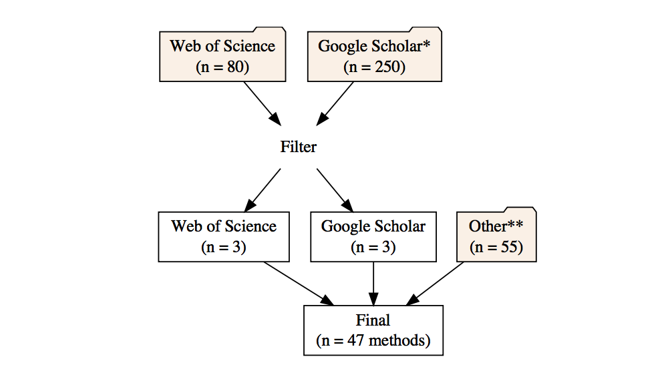

Figure 1 Flowchart of the litearture review process for identifying new regime detection methods. *Only the first ten pages (250 articles) of Google Scholar results were examined. **Other papers include prior knowledge and methods found in previous reviews that were not identified using Google Scholar or Web of Science.

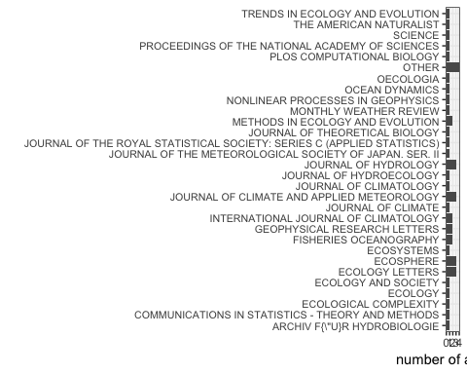

Figure 2 Distribution of identified methods across publications. Note: books, reports, and articles without original reference coded as ‘Other’

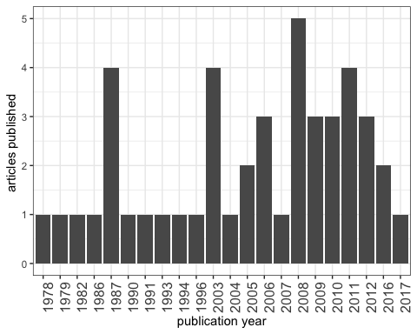

Figure 3 Number of methods publisheed over time.

## Discussion

In this chapter I highlighted the plethora of regime detection metrics (RDMs) proposed in the literature for analyzing ecological data. Although multiple reviews of RDMs exist, they are not comprehensive in their survey of the possible methods. Most reviews have summarized various aspects of RDMs. For example, Roberts et al. (2018) summarizes methods capable of handling multiple (c.f. a single) variable, and Dakos et al. (2015) review only methods designed to detect the phenomenon of critical slowing down. Here, I did not discriminate, but rather highlight, the diversity of methods proposed to ecological detect regime shifts, *sensu lato*. This chapter provides a much-needed update to collection provided by S. N. Rodionov (2005).

A survey of applications of these methods to empirical data may prove useful in highlighting the needs of future research and methodological improvements. Many of the methods presented in Table ?? have either not been applied to empirical data at all, or were tested only once (in the article introducing the method). Although the more mainstream early-warning indicators (e.g., variance, autoregressive model coefficients) and other mainstream methods have been applied to numerous datasets, they have not been rigorously tested on noisy, high dimensional, empirical data. Further, the methods which are not mainstream but have been applied to one of these data types have not any statistical indicators associated with confirming the existence and location of the regime shift.

As shown this chapter, identifying RDMs using traditional literature review techniques may prove difficult. Many of the methods identified in my review were not identified using Web of Science or Google Scholar–rather, I was either previously aware of most of the methods, and many others were highlighted in previous RDM reviews (Scheffer et al., 2015, S. N. Rodionov (2005), Andersen et al. (2009), Roberts et al. (2018), Dakos et al. (2015), (**???**)). To facilitate this process, an online, comprehensive database may prove useful to the practical ecologist.

### Next steps

Change-point detection is a huge field, especially in information and control theory (Aminikhanghahi & Cook, 2017). I purposefully did not survey this, the climatological, and the econometric literatures, which are replete with additional change-point analyses. I suspect most of the methods in Table ?? were used to analyze climate and economy time series prior to application to ecological data. A database or online resource comprising a comprehensive survey of these and other methods in the relevant literatures may prove useful to the practical ecologist. Further, disemminating various criteria and characteristics relevant ecological data analysis by way of interactive toosl, e.g. issue trees, may better the utility of this database and the methods themselves. I pose a series of questions that may prove useful to the practical ecologist should a database like this be created in Table ??.

# A guide to Fisher Information for Ecologists

*This chapter is intended for submission to the publication Methods in Ecology and Evolution.*[1]

## Abstract

Ecological regime shifts are increasingly prevalent in the Anthropocene. The number of methods proposed to detect these shifts are on the rise yet few are capable detecting regime shifts without a priori knowledge of the shift or are capable of handling high-dimensional and noisy data. A variation of Fisher Information (FI) in a dataset was proposed as a method for detecting changes in the orderliness of ecological systems. Although FI has been described in multiple research articles, previous presentations do not highlight a key component of FI that may make the metric easier to understand by practitioners. We use a two-species predator prey model to describe the concepts required to calculate FI. We hope this work will serve as a useful explanation of the FI metric for those seeking to understand it in the ecological systems and regime shifts.

## Introduction

Changes in the feedback(s) governing ecosystem processes can trigger unexpected and sometimes undesirable responses in environmental conditions (Scheffer, Carpenter, Foley, Folke, & Walker, 2001; Walther et al., 2002). Ecologists often refer to such changes as regime shifts<80><94>but this term is used interchangeably in the literature with state change, state transition, or alternative state (Andersen et al., 2009). Climate change and globalization are triggering novel and unexpected changes in ecosystems, and the rapidity with which these changes occur make predictive modeling difficult. Although detecting regime shifts becomes more difficult as we increase the extent and complexity of the system in question , advances in the collection and analysis of ecological data may improve our ability to detect impending regime shifts in time for intervention (Jorgensen & Svirezhev, 2004).

Although multiple quantitative approaches are proposed as regime shift detection methods ,few are consistently applied to terrestrial ecological data. We classify a regime shift detection methods (DMs) broadly as either model-based or model-free (Boettiger & Hastings, 2012; Dakos et al., 2012; Hastings & Wysham, 2010). Model-based methods incorporate mathematical (mechanistic) representations of the system (Hefley, Tyre, & Blankenship, 2013) and carry strict assumptions, which are often violated by real systems (Abadi, Gimenez, Arlettaz, & Schaub, 2010). In addition to assumption violations nullifying parts of the model, model misspecification may yield spurious results [Charles T. Perretti, Munch, & Sugihara (2013).

Model-free (or metric-based detectin ethods (e.g., descriptive statistics, cross-correlation mapping) require fewer assumptions to implement than do model-based DMs (Dakos et al., 2012). The most widely used model-free methods for detecting ecological regime shifts include descriptive statistics of one or a few components of a system, such as variance, skewness, and mean value (Andersen et al., 2009; Mantua, 2004; S. Rodionov & Overland, 2005) and composite measures which handle multivariable data, including principal components analysis (Petersen et al., 2008), clustering algorithms (Beaugrand, 2004), exergy (B. D. Fath & Cabezas, 2004), and Fisher Information (Cabezas & Fath, 2002; Karunanithi, Cabezas, Frieden, & Pawlowski, 2008).

Fisher Information, hereafter FI is a model-free composite measure of any number of variables (Fisher, 1922), and is proposed as an early warning signal for ecological regime shift detection system sustainability (D. A. L. Mayer, Pawlowski, Fath, & Cabezas, 2007, Karunanithi et al. (2008), Eason and Cabezas 2012, Eason et al. 2014a). Three definitions of FI exist: I. A measure of the ability of the data to estimate a parameter.  
II. The amount of information extracted from a set of measurements [Roy Frieden (1998); frieden_fisher_1990[].  
III. A measure representing the dynamic order/organization of a system (Cabezas & Fath, 2002).

The application of FI to complex ecological systems was posed as part of the <80><98>Sustainable Regimes Hypothesis,<80><99> stating a system is sustainable, or is in a stable dynamic state, if over some period of time the average value of FI does not drastically change (Cabezas & Fath, 2002). This concept can be described using an ecological example. Consider the simple diffusion of a population released from a point source at $t=0$. This process can be described by a bivariate normal distribution, $p(x,y|t)$. As the time since release (as $t$ increases) increases the spread of the distribution, $p(x,y|t)$, becomes larger (less concentrated about the mean) because the animals have moved further from the release location. FI will decrease in value as t increases, because $p(x,y|t)$ contains less information (higher uncertainty) about where the animals will be located. As $t<e2><86><92>∞$, the animals will be relatively uniformly distributed across the environment and $p(x,y|t)$ will carry no information about the location of the animals. Consequently, as $t<e2><86><92>∞$, FI will approach zero. This system is not in a stable dynamic state because FI is decreasing with time.

In contrast, imagine a population varying around a carrying capacity following a simple logistic growth model. As long as the average system parameters (r and K and their variances) are stationary (not changing with time), then the logarithm of population size will have a normal distribution (check this <80><93> might need some different model). The FI measured over any selected window of time will be constant, indicating that the system is in a stable dynamic state. A perturbation to the population size due to disturbance will also not affect FI, as long as the disturbance does not change the distributions of r and K, and the perturbations themselves occur with some stationary probability distribution.

Although the concept of FI is firmly grounded in physics (B. R. Frieden, 1998), the concepts behind its application to ecological systems remain elusive to the average ecologist. We aim to elucidate the statistical concept of FI and the steps required to calculate it as a measure of <80><98>ecosystem order<80><99> and as a regime shift detection method (Cabezas & Fath, 2002; B. D. Fath, Cabezas, & Pawlowski, 2003). We believe a concise and accessible synthesis of the topic, along with reproducible code, will aid the ecologists<80><99> understanding of this metric and will advance our understanding of its usefulness as an indicator of ecological regime shifts. We reproduce the analyses presented in (B. D. Fath et al., 2003) and D. A. L. Mayer et al. (2007) to fully explain these concept of and steps for calculating this form of Fisher Information. We hope this work will serve as a useful explanation of the FI metric for those seeking to understand it in the ecological regime shift context and will stimulate research using this and other multivariate, model-free, and composite measures to understand ecological regime shifts.

### On Fisher Information

Two methods exist for calculating Fisher Information (FI) as applied to ecological systems data, which we refer to as the <80><98>derivatives-based<80><99> method, first appearing in Cabezas & Fath (2002), and the <80><98>binning<80><99> method, first appearing in Karunanithi et al. (2008). The binning method was proposed as an alternative to the derivatives-based method for handling noisy and sparse data, and requires additional calculations and system-specific decisions, and for these reasons we focus solely on the derivatives-based method. The general form of FI can be found in (B. D. Fath et al., 2003) and (D. A. L. Mayer et al., 2007), and although others can be found, we refer the reader to Cabezas & Fath (2002) for a complete derivation of FI, and to @ref(#fiBiblio) for applications of Fisher Information in other fields.

### Notation

A capital letter (e.g., $A$) denotes a random variable; an asterisk superscript (${}^{*}$) indicate a particular realization; *bold notation* indicates that the state of the system is defined in more than one dimension.

### Steps for calculating Fisher Information (FI)

To calculate FI for a system with more than one state variable, we first estimate the probability of observing the system $p(x)$ in a given state, $x$, over time period $T$. The probability density function, $p(x)$, is then directly used to calculate the derivatives-based FI. We use bold notation to indicate that the state of the system is defined in more than one dimension (e.g., the state of a predator prey system is defined in two dimensions by the number of predators and number of prey). Here, we describe these steps and present the numerical calculation of FI using a two-species predator-prey model [B. D. Fath et al. (2003); mayer_applications_2007], hereafter referred to as the <80><98>model system<80><99>:

$$

The specified parameters for the model system are $g_{1}=m_{2}=1$, $l_{12}=g_{12}=0.01$, $k=625$,and $β=0.005$ (see B. D. Fath et al., 2003; B. R. Frieden & Gatenby, 2007; D. A. L. Mayer et al., 2007). The initial conditions (predator and prey abundances) for the model system were not provided in the original references. Using package *deSolve* in Program R (v 3.3.2) to solve the model system (1) we found $x_{1}=277.7815$ and $x_{1}=174.551$ provided reasonable results. We found that a complete cycle of the system corresponds to approximately 11.145 time units.

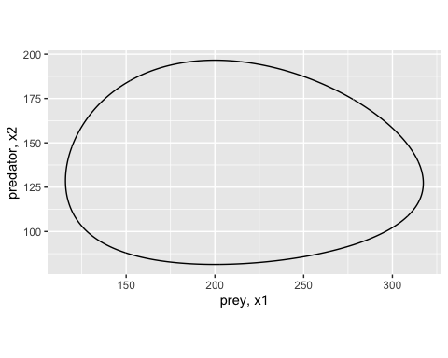

Figure 4 Phase space plot of two-species Lotka-Volterra predator-prey system over a single period (~11.145 time units.

### Concepts behind the calculations

Although the numerical steps for calculating the derivatives-based FI are relatively straightforward, the concepts required to interpret the measure in the context of multiple variables is more complex. Here, we thoroughly discuss the concepts and assumptions behind FI calculation. Below, steps do not represent steps within the calculation, they represent the major concepts required

#### **Step 1. Probability of observing the system in a particular state, $p(x)$**

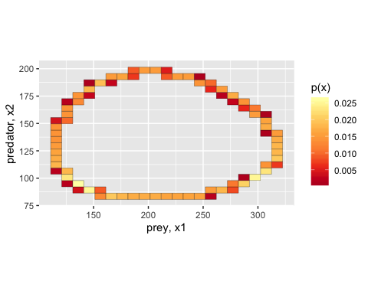

Figure 5 A 2-dimensional histogram of the probability of observing a system in a particular state, $p(x)$, of the 2-species Lotka-Volterra predator prey system over a single period (~11.145 time units).

Fisher Information (FI) is defined with respect to a probability distribution. In the derivatives-based method, FI is calculated for a probability of observing a system (as defined by one or more state variables) in a particular state, $p(x)$, over some period of time, ($0tot_{end}$). In other words $p(x)$ is the probability that, at a specific point in time ($t_{obs}^{*}$) we will observe the system in a particular state, $x^{*}$. The time at which we observe the system is a random variable, $t_{obs} Uniform(0,t_{end})$. To be clear, the study system is assumed to be deterministic and we assume no observation error, however, the observed state of the system, $x(T_{obs})$, is a random variable because it is a function of the random observation time, $x^{*}=x(t_{obs}^{*})$. The state of the model system, x, is defined in two dimensions by the number of predators and the number of prey (1) and is easily visualized 4.Therefore, the probability of observing a particular state is a two-dimensional joint distribution ??.

A single state of the model system is defined by the number of predators and prey at a given point in time such that for any given point in time $x(t)=[x_{1}(t),x_{2}(t)]$. At some random time between 0 and $t_{end}$ [$T_{obs} Uniform(0,t_{end})$] we can count the number of predators and the number of prey to determine the state of the model system. We must assume the system is deterministic and there is no observation error. We can then calculate the probability of observing a particular predator and prey abundance combination, $p(x)$. Under these assumptions, the only possible states of the system are defined by the system<80><99>s observed trajectory, the model parameters, and the initial conditions. Therefore, the support of the probability distribution 5 is the trajectory of the system.

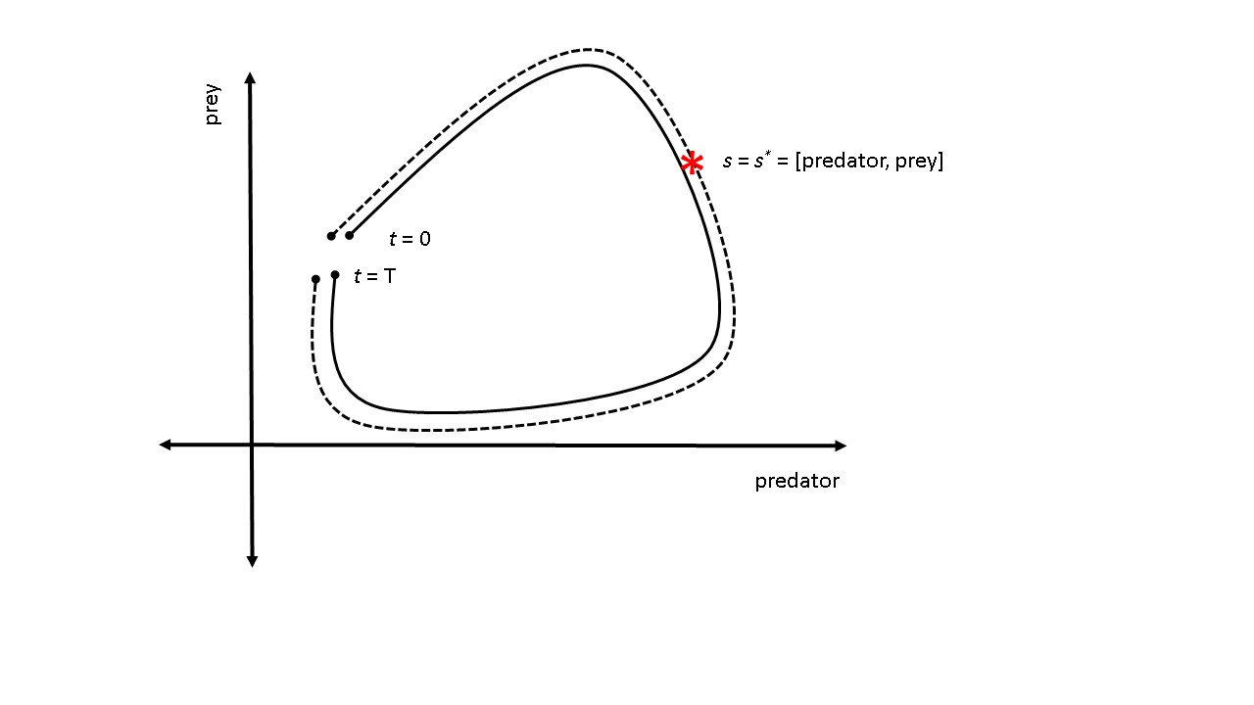

Figure 6 A single cycle of a hypothetical two-species system over time period $t=0$ to $t=T$. $s^{*}$ is the state of the system at some point in time. The dotted line represents the distance travelled by the system in phase space over its trajectory during time $(0,T)$.

#### **Step 2.** Distance traveled by the system, $s$

Distance traveled by the system, s. We can now move from an n-dimensional representation of the probability distribution to a one-dimensional representation. To better understand this, imagine placing a string over the path of the entire trajectory from $0tot_{end}$ 6. If we know the number of predators and prey at a particular point in time $(t_{obs}^{*})$ then we can mark that location on the string (see asterisk in 6. Next, imagine picking up the string and laying the string flat along a ruler. The length, s, of the entire string measures the total distance traveled by the system in phase space. The mark we made on the string (denoted $*$) lies at a distance $s^{*}$ between 0 and $s$. We call this length the distance traveled by the system, $s^{*}$. In this context, $s^{*}$ in phase space represents a measure of cumulative change in state. We note that the distance traveled in phase space increases monotonically with time. If the system never revisits the same state (i.e., the trajectory never overlaps or intersects itself), then every unique system state (i.e., point on the trajectory) is mapped to a unique value of distance traveled. Therefore, $p(x)$ (n-dimensional) is equivalent to the probability that the system is at distance s, i.e., $p(x)=p(s)$, (where $p(s)$ is one dimensional; Cabezas, Pawlowski, Mayer, & Hoagland (2005)). However, if the system revisits previous states, then a unique system state may be mapped to different values of distance traveled and the relationship between $p(x)$ and $p(s)$ is not one-to-one. We calculated the distance traveled s of the model system over a single cycle (11.145 time units; 7.

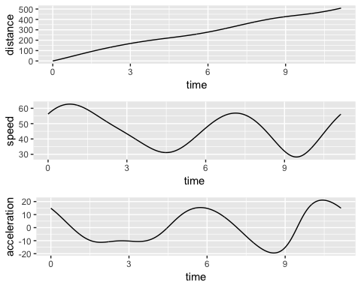

Figure 7 From top to bottom, distance traveled in phase space, speed tangential to system trajectory, acceleration tangential to system trajectory.

#### **Step 3. $p(s)$** as a function of the rate of change of $s$

In previous presentations of FI, the relationship between the state of the system (n-dimensional) and the distance traveled (1-dimensional) was not always emphasized (Cabezas & Fath, 2002). Here we use x to denote the state of the system and s to denote the distance traveled to emphasize this distinction. If a system travels at a constant speed over the entire time period, then the system is equally likely to be in any state along the trajectory ( $s$ is linear and $p(s)$ is uniform). Referring to our model system, if the number of predators and prey are linearly related, then the speed of the system is constant. For non-linear systems, the distribution above the string will not be uniform 6. Rather, it will change depending on the amount of time the system spends in each state. It follows that $p(s)$ is proportional to the inverse of the rate of change of distance traveled (i.e., the speed along the path in phase space).

We will now demonstrate this using our model system as an example. Suppose the abundances of the predator and their prey in our model system predictably operate at carrying capacity. Over a relatively short period of time the prey abundance quickly declines after a severe weather event (a pulse disturbance; (Bender et al. 1984), but quickly recovers. Intuitively, the absolute rate of change at time points near the disturbance will be larger than during time periods long before or long after the disturbance. It is therefore more likely that the system will be (observed) in a state where prey and predators are operating approximately at carrying capacity than in a state with relatively low prey abundance. Mathematically, the time, $t*$, at which we calculate the abundances of prey and predators is a uniform random variable, and the distance traveled by the system, $s^{*}$, is a function of time, is differentiable, and monotonically increases. Therefore, the probability density function of the distance traveled $p(s)=\frac{1}{T}\frac{1}{s′}$, where $s′=\frac{ds}{dt}$ is the speed of the system (the speed tangential to the trajectory; the first derivative of the distance traveled; instantaneous rate of change of $s$). We calculated the speed (the first derivative; 7 and acceleration (the second derivative; 7 of the distance traveled s by the model system over a single cycle using function ode in package deSolve (Soetaert et al. 2010) in Program R (R Core Team 2016).

#### **Step 4.** Calculate the derivatives-based Fisher Information

Now that we understand how to calculate both the distance traveled, $s$, and its probability density, $p(s)$, calculating the derivatives-based FI is straightforward and computationally inexpensive (2). There are several comparable equations for calculating the shift-invariant FI, and some may offer numerical advantages over others. Equation (3) is the general form and Equation (4) is the amplitude form for FI (in D. A. L. Mayer et al. (2007), respectively). Although these formulations are equivalent, (4) is most readily calculated when the differential equations for the system are known, obviating any advantage of a model-free metric.

This article is interested in the Fisher Information calculated for a distribution of distance traveled, $s$, by the entire system. We calculated the Fisher Information value using Equation (2) over a single period of the model system (??). We calculated Fisher Information to be $5.3$ x ${10}^{−5}$ which is consistent with the results of Mayer et al. (2007).

## Case Study

Mayer et al. (2007) calculated FI for a predator-prey system for several discrete values of carrying capacity of prey. The results of this study showed that FI was different for systems with different carrying capacities. However, this study did not address the central question of how FI changes during a regime shift. As an extension of the original study, we simulate a regime shift by modeling a situation where carrying capacity is abruptly decreased. To simulate an abrupt change in carrying capacity, we assume carrying capacity is described by Eq. 6 where $k1$ is the initial carrying capacity, $k2$ is the final carrying capacity, $t*$ is the time of the regime shift, and alpha is a parameter that controls how quickly the regime shift occurs. The hyperbolic tangent function simulates a smooth, continuous change in carrying capacity while still allowing for the change to occur suddenly. To incorporate the change in carrying capacity into the system differential equations we define the rate of change of carrying capacity as given by (5).

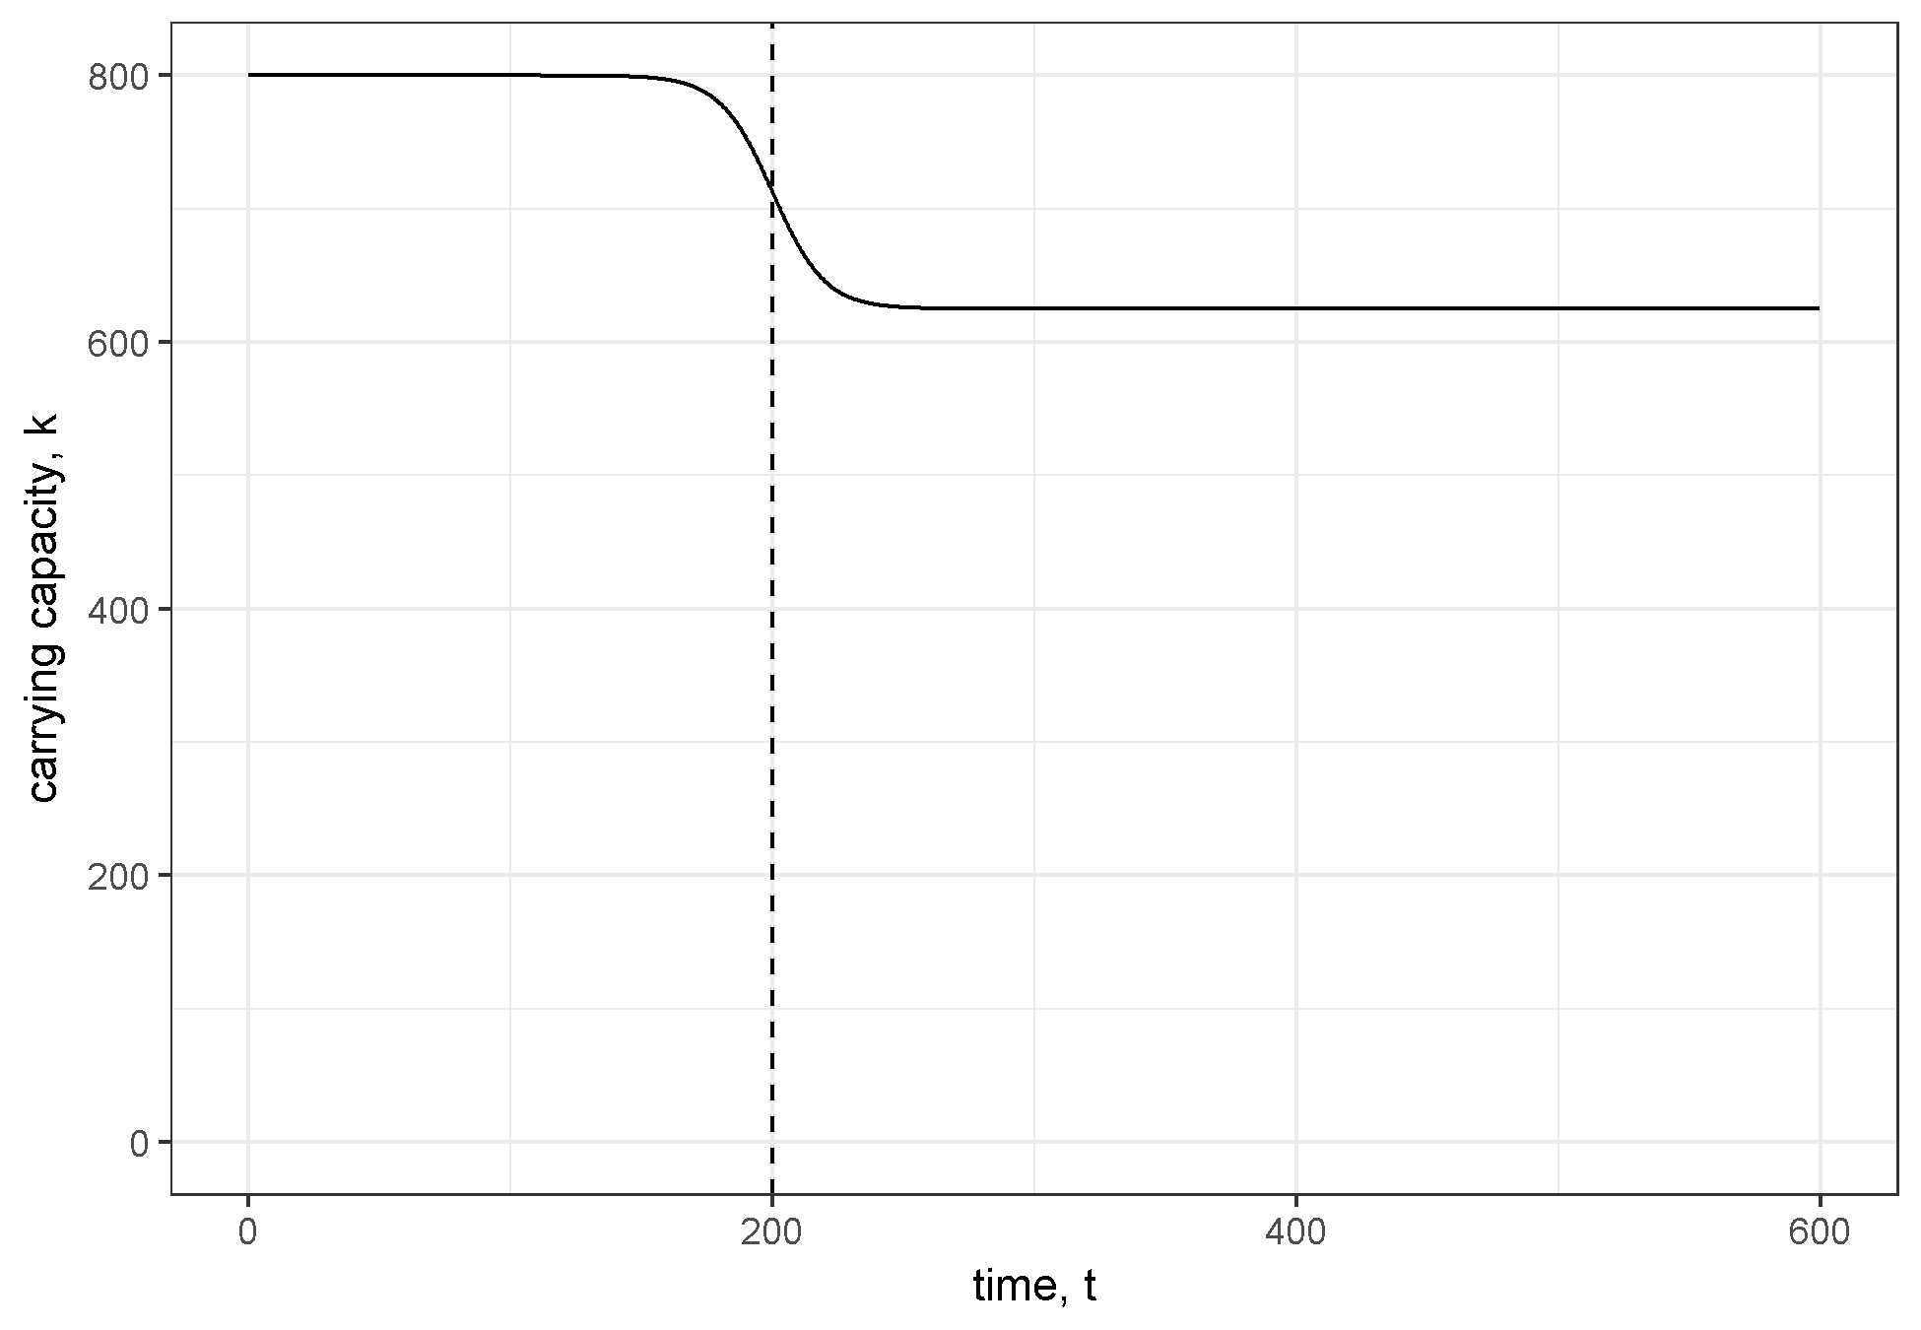

Figure 8 Carrying capacity over time with a regime shift occuring around time 200.

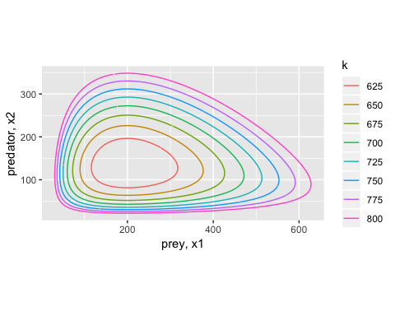

Figure 9 Phase space plot of system trajectories for different values of k

We assumed an initial carrying capacity of 800 and a final carrying capacity of 625 which corresponds to the range of carrying capacities explored by Mayer et al. (2007). We simulated a time series of 600 time units with a regime change after 200 time units. We used an alpha value of 0.05. The time series for carrying capacity is shown in 8 and the system trajectory in phase space is shown in 9. The distance travelled in phase space (i.e., cumulative change in state) is shown in ?? and the speed of the system (i.e., rate of change) is shown in 10.

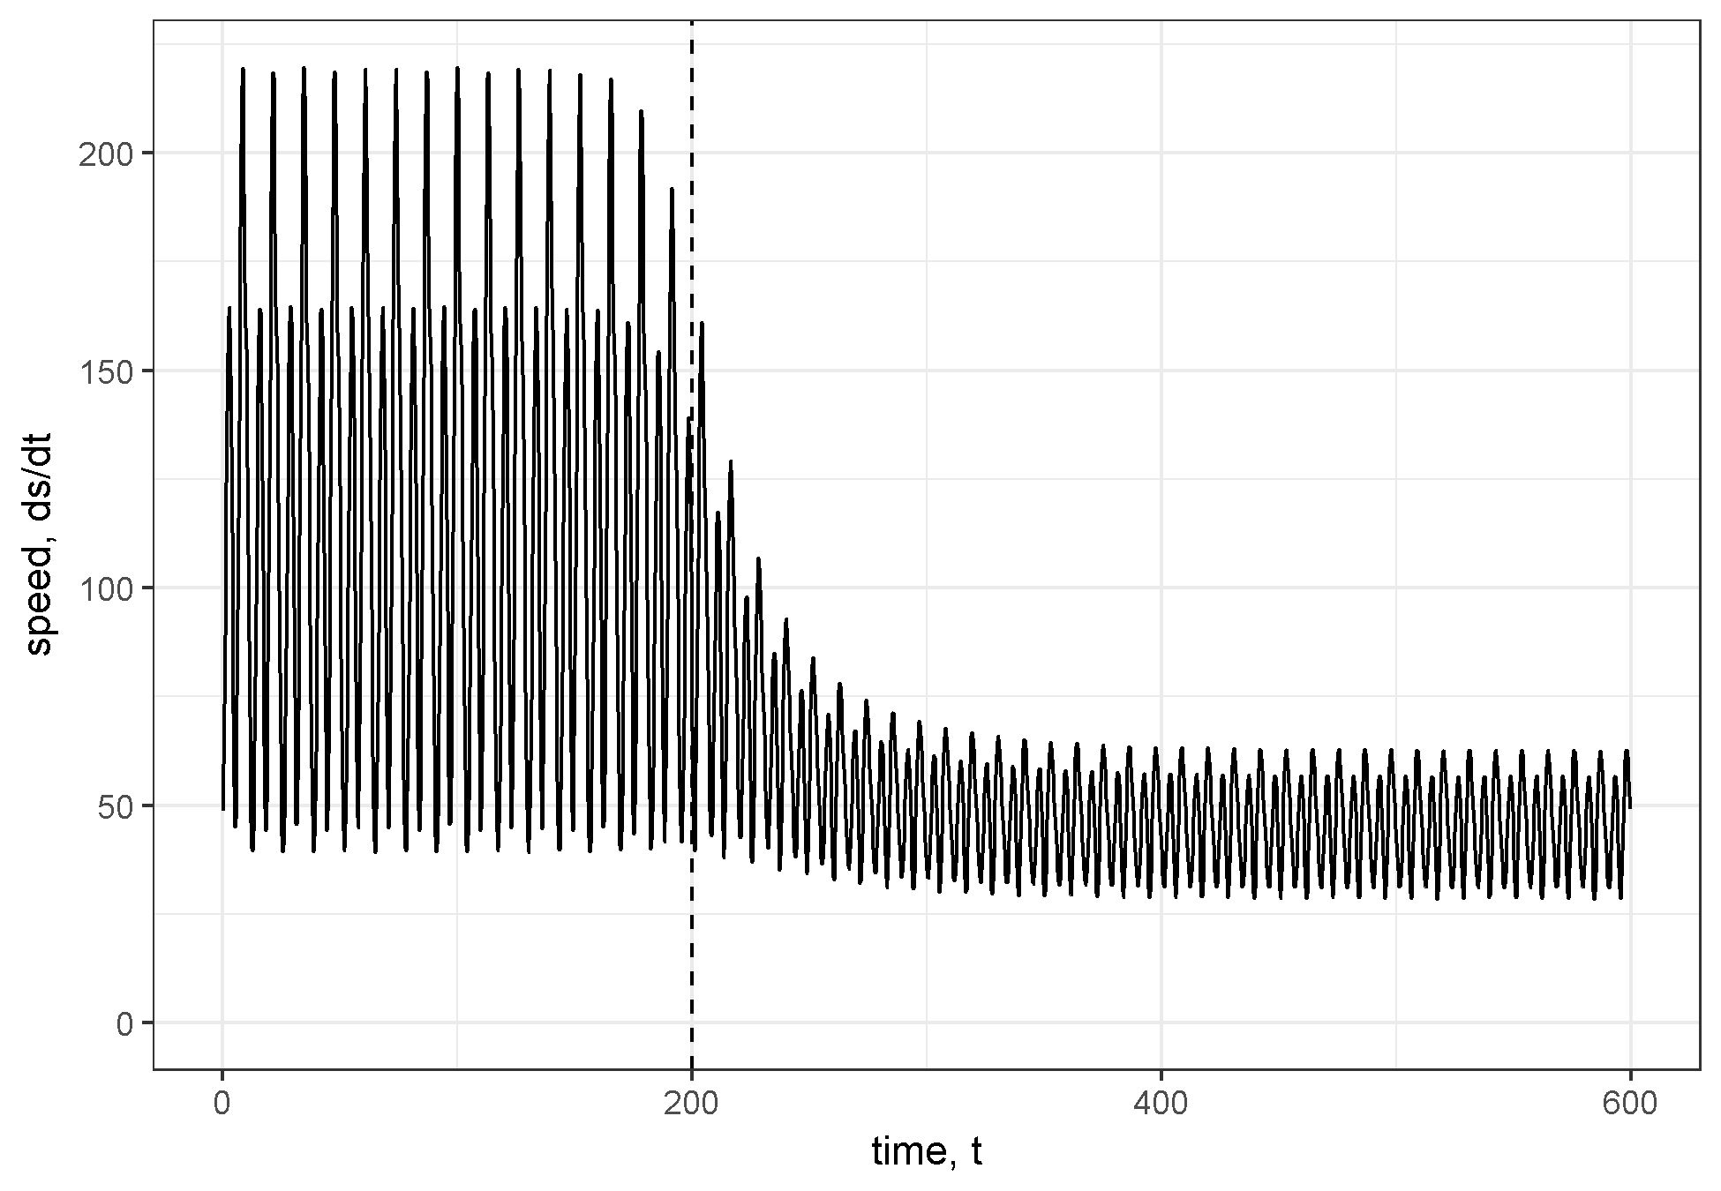

Figure 10 Speed of the system (rate of change) in phase space. Dashed vertical line at time 200 indicates location of regime shift.

We calculated FI for the distribution of distance travelled over a series of non-overlapping time windows. Multiple sources suggest the length of the time window should be equal to one system period such that FI is constant for a periodic system (Cabezas & Fath, 2002; D. A. L. Mayer et al., 2007). However, the system period is different before, during, and after the regime shift. Therefore, we performed two separate calculations of FI using window sizes corresponding to the initial and final period of the system ( $13.061$ and $11.135$, respectively). The change in FI over time is shown in ??.

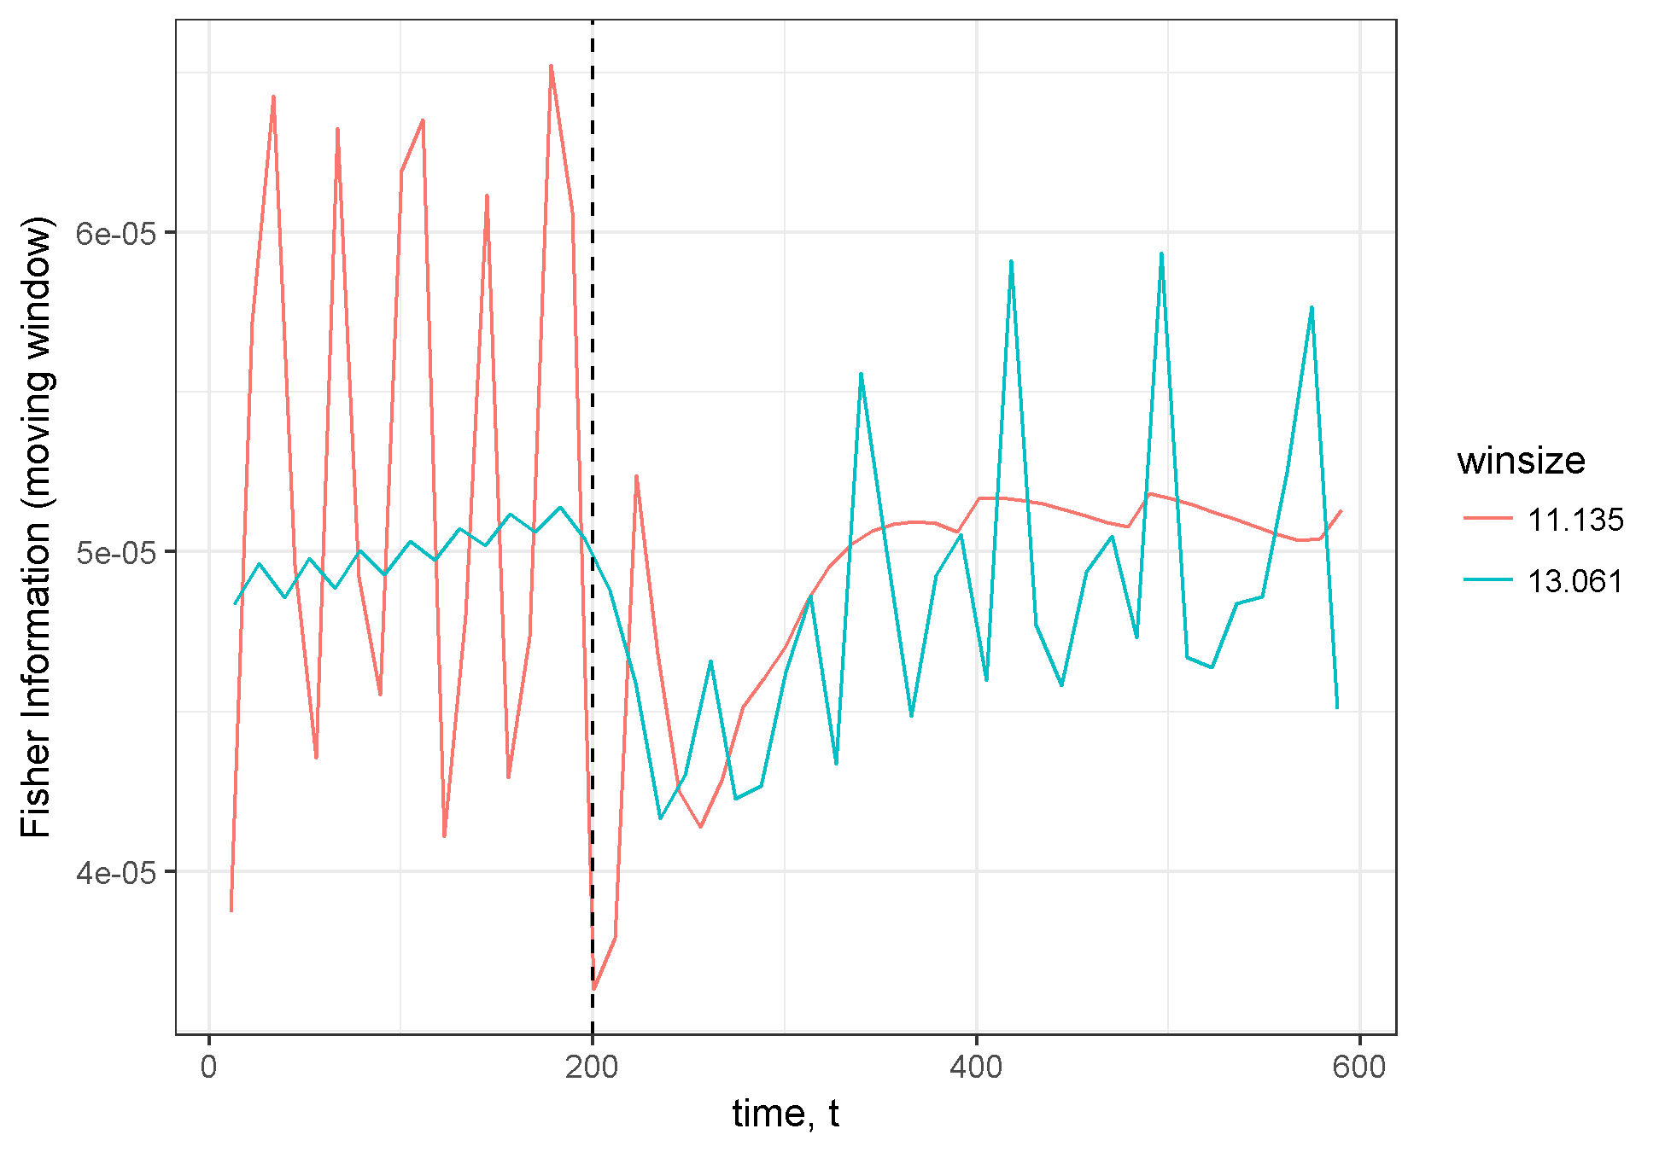

Figure 11 Fisher Information calculated for non-overlapping time windows. Two different window sizes were used as indicated by color. Dashed vertical line at time 200 indicates approximate location of regime shift.

## Conclusions

We simulated a regime shift caused by a change in carrying capacity ($K$) within a simulated, two-species Lotka-Volterra system. We applied the Fisher Information (FI) method for regime shift detection to the simulated time series data. The predator-prey system was modeled as deterministic and the time series data was free from measurement and observation error. Despite this, the estimated FI had high variation over time, and results were dependent on the size of the time window used (winsize) in the calculation ??. The FI method for regime shift detection is based on the cumulative change in the state of the system (i.e., distance traveled in phase space) and the rate of change of the system (i.e., speed tangential to trajectory in phase space). The distance travelled metric, $s$, and its speed, $dsdt$, appear better visual indicators of the regime shift than FI [??; ??].

In our explanation of the FI concept and calculation, we emphasize the distinction between the *state of the system* and the *distance traveled in phase space*. There are several reasons worth emphasizing this. First, there may not always be a one-to-one relationship between the probability of observing a system in a particular state and the probability of observing a system at a particular distance along the trajectory. In these situations the interpretation of FI may be less clear than if a one-to-one relationship existed. Second, this distinction facilitates the separation of the dimensionality reduction step (calculating distance traveled in phase space, $s$) from the subsequent steps related specifically to FI. Third, the distinction suggests that the **value of FI as a regime shift detection method is related to the rate of change of the system** (i.e., velocity and acceleration tangential to system trajectory in phase space). In particular, the distribution for which FI is calculated is simply the distribution of the distance traveled in phase space, when time is assumed to be uniformly distributed over a given interval.

Our results suggest that insights can be gained directly from the calculation of distance traveled and associated rates of change. Consequently, these insights preclude the need to calculate beyond Step 3 (described above). This result also supports the use of the distance travelled metric, or the derivatives-based Fisher Information (#eq:fiDerivs).

One remaining issue that is prevalent across ecological field studies is the assumption that the system is observed without error. Although ecological data rarely fulfill this assumption, this does not suggest that FI is useless as a metric of system stability. The primary difficulty with noisy data, especially with observations in integer form (e.g. count data), is that the denominator in can easily be zero for some pair of observations, making FI an infinite value within windows which contain two or more adjacent zero observations. One possible solution is to smooth the multidimensional vector of observations prior to calculating the derivatives, or to treat any sequential identical value as missing, and simply use a larger time step for that portion of the window calculation.

The utility of Fisher Information in ecological studies is also stunted by its interpretability. This metric is unitless, making its values relative only within-sample (e.g., within a single time series). Further, interpreting the results within-sample is currently a qualitative effort (B. D. Fath et al., 2003; Mantua, 2004). When the FI of a system is increasing, the system is said to be moving toward a more orderly state, and most presentations of FI posit sharp changes in FI, regardless of the directionality of the change, may indicate a regime shift (Cabezas & Fath, 2002; Karunanithi et al., 2008; Spanbauer et al., 2014). Due to the qualitative nature of these interpretations of Fisher Information, intimate knowledge of the system in question and the potential driver(s) of the observed regime shift are required to confirm presence of a shift.

## Acknowledgements

I thank T. Eason, H. Cabezas and B. Roy Frieden for early discussions regarding Fisher Information.

# An application of Fisher Information to spatially-explicit avian community data

## Introduction

Objective of this chapter: Calculate FI for spatial transects. Idnetify whether it can be a leading indicator. Why or why not? Objectives of this chapter include: 1. Calculate Fisher Information across space 1. Identify the utility of Fisher Information for spatial data 1. Identify ecological regime changes using Fisher Information

To achieve these aims, I wrote software to calculate Fisher Information using Equation (2), as it is simple to calculate, and requires fewer parameters to be chosen *a priori* by the analyst.

Perhaps the easiest case is a situation where the population density shows a clear disappearance of periodic cycles of voles, lemmings, and grouse in Europe (59) (Fig. 1A), or the slow steady population decline in extinction debt phenomena (60).

Few studies have rigorously tested the quantitative regime shift detection methods using observational data from real, ecological systems (Bestelmeyer et al. (2011)). Many of the advances in ecological regime shift detection theory have been made in the aquatic sciences (freshwater and marine, but especially freshwater lakes; see Carpenter et al. 2011, Batt et al. 2013). However, many of the methods (e.g., critical slowing down, variance, autoregression) which appear to be useful in aquatic systems do not readily translate to higher dimensional data. Fisher Information was introduced as a method for

Applications of these quantitative methods to real systems data, coupled with expert knowledge, are required to advance regime change theory.

Leading indicators of regime shifts using univariate data are well-tested on both theoretical and empirical data (e.g. Burthe et al., 2015). Commonly used indicators applied to time-series data include an index of variance, moments around the grand mean (skewness and kurtosis), and critical slowing down (Brock and Carpenter 2006). Although univariate indicators may provide insight into relatively simple systems, like small lakes and isolated wetlands (carpenter references), their reliability as indicators for complex systems is less certain. Leading indicators can be a reliable warning of impending shift (@carpenterBrock2006), however, may prove most useful in systems of which we have mapped the suspected drivers and response mechanisms (Scheffer et al. 2009). Some methods have beeen adapted for spatially explicit data (Butitta et al 2017; Kefi et al. 2014). Some methods have been applied to early-warning indicators in whole systems (Carpenter et al. 2011), however, it is uncommon to have enough information to build reliable networks or food webs. Consequently, reliably measuring the ecological system at hand is often realistically (and financially) not possible.

Contrary to univariate indicators of regime change, the Fisher Information measure is proposed as a method for identifying changes in a multivariate data set (Fisher 1922, Cabezas and Fath 2002, Karunanithi et al. 2008, Eason and Cabezas 2012, Eason et al. 2014, Ahmad et al. 2016). See Chapter @ref(#derivatives) for a detailed explanation of the concept of Fisher Information. It is suggested that Fisher Information captures the ecological complexity of a system if given a set of observations which encompass the ecological drivers which dictate the state of the system. A relatively rapid change in the amount of Fisher Information is interpreted as a change in system configuration or orderliness (e.g., see Karunanithi et al. 2008). Fisher Information is rooted in statistics and in the physical sciences-it has only recently been applied to complex ecological and social-ecological systems (Frieden 1998; Fath et al.; Palowski et al). Despite its established use in identifying the degree of predictability of closed systems in physics, Fisher Information’s utility in rigorously and universally assessing the state of complex ecological systems is not known.

In this chapter I present an application of the Fisher Information measure using what I call the ‘binning’ Fisher Information method (first proposed in {Karunanithi et al. (2008)}; hereafter, binning method) to a broad-scale and long-running abundance time series in North America. I present both spatial and temporal applications of the Fisher Information measure to community data to provide an applied and baseline understanding of how the Fisher Information binning measure appears on these data. This chapter also serves as an exploratory study of the Fisher Information binning measure for identifying regime boundaries and change in both space and time.

## Methods

### Data: North American Breeding Bird Survey

I use community abundance data from long-term monitoring programs to identify spatial and temporal regimes using the Fisher Information binning method. Although Fisher Information can be calculated using any number of variables, the binning method (see ??) requires many data points and a large number of observations at each sampling site or period of time. I therefore chose to using breeding bird abundances from a long-standing avian community survey, the North American Breeding Bird Survey (NABBS).

The NABBS trains citizen scientist volunteers to annually collect data using a standardized roadside, single observer point count protocol and has been collecting data regularly across North America (12) since 1966. The roadside surveys consist of 50 point counts (by sight and sound) along an approximately 24.5 mile stretch of road. Due to strict reliane on volunteers, some routes are not covered every year. Additionally, some routes are moved or discontinued, and some routes are not sampled in a given year. Route-year combinations which are missing years but are not discontinued are treated as missing data.

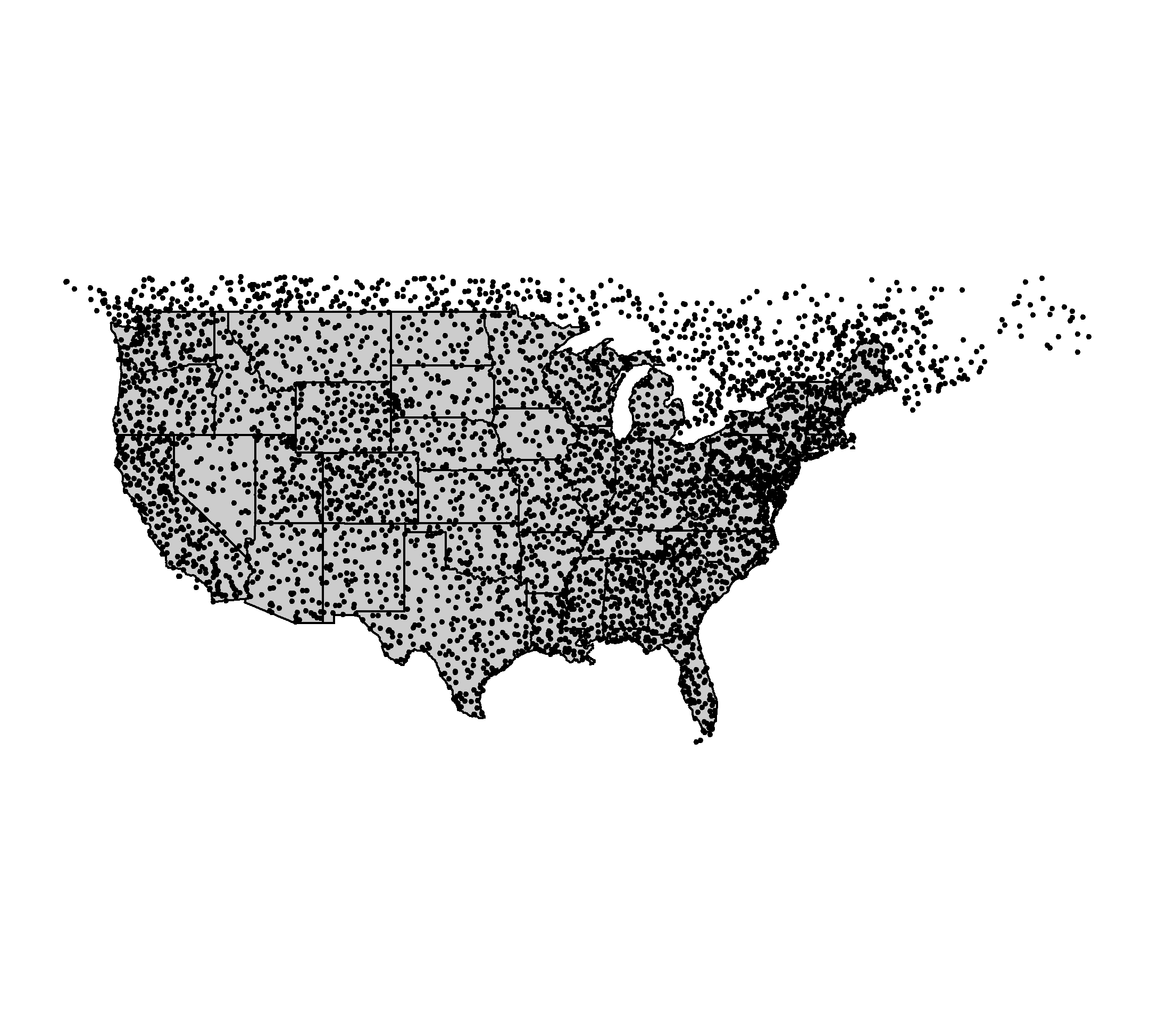

Figure 12 Locations of Breeding Bird Survey routes sampled between 1966 and 2017.

Although NABBS volunteers identify all species as possible, persistent biases exist in this protocol. To reduce the influence of potential sampling bias, I removed waterfowl, waders, and shore species (AOU species codes 0000 through 2880).

### Study areas

Although the NABBS conducts surveys throughout much of North America, I limited analyses to the continental United States and parts of southern Canada. NABBS coverage of the boreal forests of Canada are sparse in space, and many routes in Mexico have fewer than 25 years of observations. I identified two strip-transects across large swaths of the continental United States-one running in a South-North direction, the other running East-West-and two individual NABBS sites (routes) to conduct spatial and temporal regime shift analyses, respectively. The South-North and East-West transects are hereafter referred to as spatial transects, and the NABBS sampling sites are referred to as routes (see section ‘Building spatial transects’, below).

#### Military bases as study sites

The Mission of the US Department of Defense is to provide military forces to deter war and protect the security of the country, and a primary objective of individual military bases is to maintain military readiness. To maintain readiness, military bases strictly monitor and manage their natural resources. Military bases vary in size and nature, and are heterogeneously distributed across the continental United States (See 14). The spread of these bases, coupled with the top-down management of base-level natural resources presumably influences the inherent difficulties associated with collaborative management within and across military bases and other natural resource management groups (e.g., state management agencies, non-profit environmental groups.

Much like other actively managed landscapes, miltiary bases are typically surrounded by non- or improperly-managed lands. Natural resource managers of military bases face environmental pressures within and surrounding their properties, yet their primary objectives are very different. Natural resource managers of military bases, whose primary objective is to maintain military readiness, are especially concerned with if and how broad-scale external forcings might influence their lands. Prominent concerns include invasive species, wildlife disease, and federally protected species (personal communication with Department of Defense natural resource managers at Eglin Air Force and Fort Riley military bases). For these reasons, natural resource managers attempt to create buffers along their perimeters (e.g., live fire/ammunitions suppression, wide fire breaks). Identifying the proximity of military bases to historic and modern ecological shifts may provide insight into the effectiveness of their natural resource management efforts.

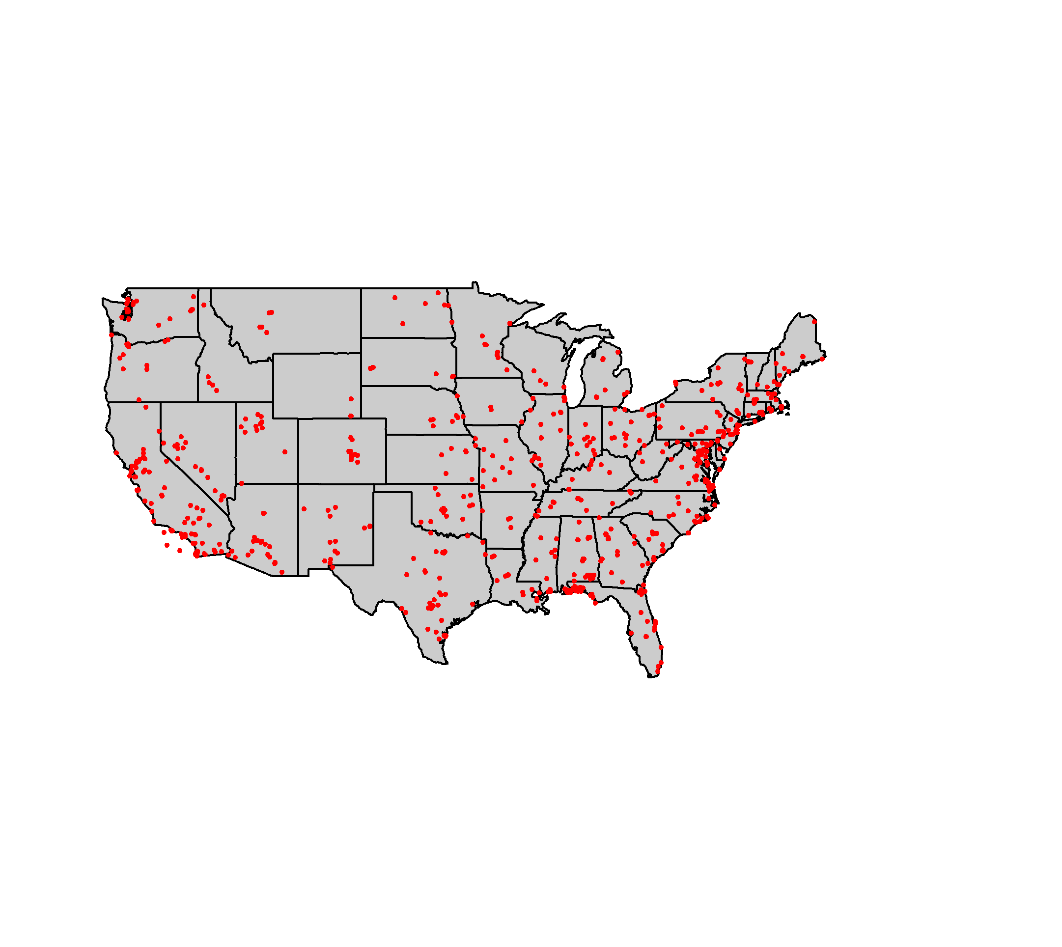

Figure 13 Locations of U.S. military bases in our study area.

#### Focal military bases

The NABBS routes chosen for analyses in this Chapter lie within or near two two US Department of Defense properties: Fort Riley military base (located at approximately 39.110474 ??, -96.809677 ??; Kansas, USA) and Eglin Air Force base (located at approximately 30.459588 ??, -86.548459 ??; Florida USA). These military bases were used for research conducted under the a grant funded by the Department of Defense’s Strategic Environmental Research and Development Program (SERDP; RSCON-15-01:RC 3150).

Eglin Air Force and Fort Riley military bases (??) serve as ideal reference sites for this study. The natural resource management teams are active on each base and have been for at least two decades and each uses wildfire as a management technique. Fort Riley military base is especially relevant to regime shift detection method exploratory analysis. Woody encroachment of the Central Great Plains over the last century has triggered shifts in dominant vegetative cover and diversity (Ratajczak et al. 2012) in the area surrounding Fort Riley military base (e.g., Van Auken 2009). This phenomena should present itself as a regime boundary should Fisher Information be a robust regime shift detection method. Eglin Air Force base is embedded within a heavily developed matrix, and consequently has experienced less pronounced effects at broad spatial extent and over longer periods. Therefore, the ecological communities (and the data) surrounding Eglin Air Force base may exhibit a greater amount of noise, making the effect size of a regime shift and consequently the effect size smaller and more difficult to detect. For these reasons, Eglin Air Force and Fort Riley military bases are ideal locations for an exploratory analysis of the Fisher Information binning method as a regime shift detection method.

#### Spatial sampling grid

To our knowledge, Sundstrom et al. (2017) is the only study to use the Fisher Information binning method on spatially-referenced data. The authors of this study hand-picked NABBS routes to be included in their samples such that their metrics should detect ‘regime changes’ when adjacent sampling points represented different ecoregions. The authors also suggest each ecoregion is similarly represented, having a similar number of NABBS routes within each ecoregion in the analysis. Their method of handpicking routes resulted in a transect which was neither North-South nor East-West running (see Sundstrom et al. (2017)), but rather zigzagged across a midwestern region.

I constructed a gridded system across much of the continental United States and Canada to ameliorate potential effects of site selection bias. This method allows one to overlay regime detection metric results over various vegetation characteristic maps (e.g., ecoregions), rather than fit the sampling scheme to an ecoregion. The former also allows for comparison of results across time, and is especially useful when vegetation zones, or ecoregions, shift over time.

The gridded system comprises North-South and East-West running transects transects running in either North-South or East-West directions. Here, I examine in detail only a single North-South and a single East-West transect, such that they contain the Eglin Air force and Fort Riley military bases, respectively. 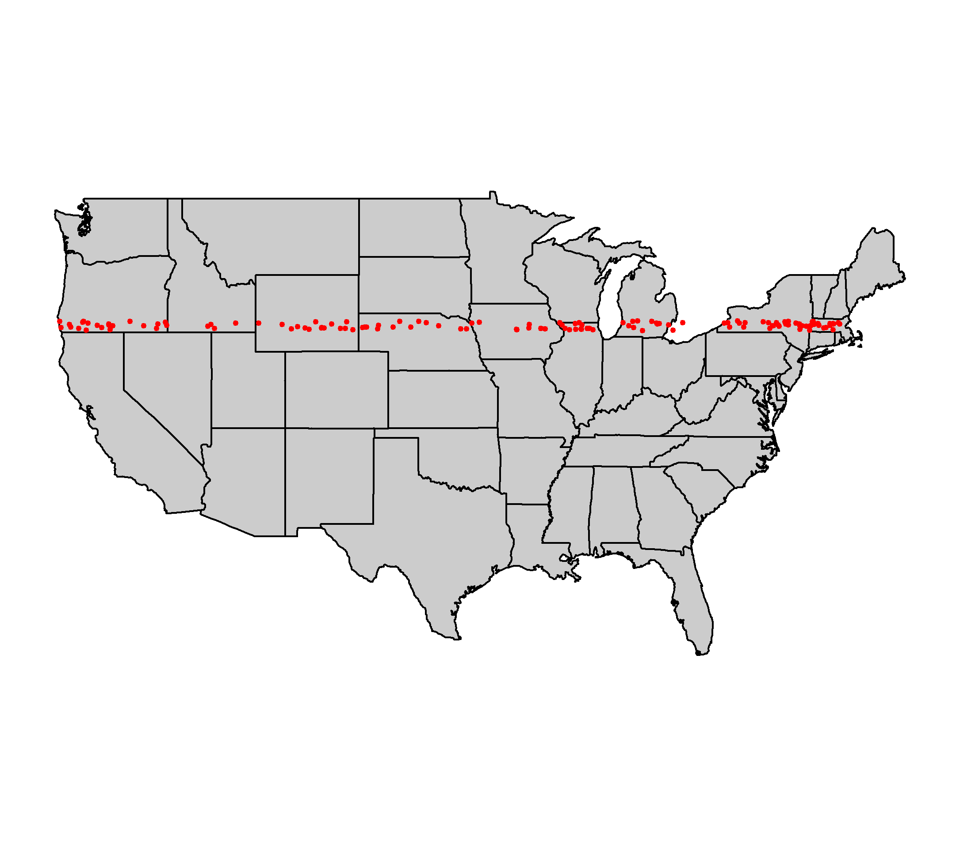

#### Selecting routes for temporal analysis

Temporal analysis consisted of time series of annually collected data at the level of an individual NABBS route. I analyzed two NABBS routes near the Eglin Air Force base-one to the East and one to the West.

### Calculating the Fisher Information binning measure

Fisher Information, $I(θ)$, was developed in 1922 by Ronald Fisher as a measure of the amount of information that an observable variable, X, reveals about an unknown parameter, $θ$. Fisher Information is a measure of indeterminacy (Fisher 1922) and is defined as,

$$ where $p(y|θ)$ is the probability density of obtaining the data in presence of ??. The Fisher Information measure (FIM) is used to calculate the covariance matrix associated with the likelihood, $p(y|θ)$. Fisher Information is described as Extreme Physical Information (EPI; Frieden and Soffer 1995, Kibble 1999, Frieden et al. 2002), a measure that has been used to track the complexity of systems in many scientific disciplines including, physics, cancer research, electrical engineering, and, recently, complex systems theory and ecology

Fisher Information as gathered from observational data provides insight as to the dynamic order of a system, where an orderly system is one with constant (i.e., unchanging) observation points, and one whose nature is highly predictable. A disorderly system is just the opposite, where each next data point is statistically unpredictable. In ecological systems, patterns are assumed to be a realization of ecosystem order; therefore, we should expect orderliness in a system with relatively stable processes and feedbacks. Orderliness, however, does not necessarily infer long-term predictability. (6) is next adapted to estimate the dynamic order of an entire system, $s$, as

$$

where $p(s)$ is the probability density for $s$. Here, a relatively high Fisher Information value ($I$) infers higher dynamic order, whereas a lower value (approaching zero) infers less orderliness. To limit the potential values of I in real data, we can calculate the amount of Fisher Information by re-expressing it in terms of a probability amplitude function $q(s)$ (Fath et al. 2003, Mayer et al. 2007, eq. 7.3):

$$I=4∫ds{\left[\frac{dq(s)}{ds}\right]}^{2} (7)$$

A form specific to the pdf of distance travelled is derived as (D. A. L. Mayer et al., 2007, eq. 7.12)(see @derivatives for more information on (8)):

, where T is the number of equally spaced time points over which we integrate.

These two variants of Fisher Information, (7) and (8), have been used to estimate the dynamic order of complex systems (Cabezas and Fath 2002, Karunanithi et al. 2008). Numerical calculation of I using the binning method ((7) and (8)) incorporates a binning procedure for the probability of the system, $p(s)$, as being in one of an unidentified number of states ($s$).

I carefully considered prior to analyzing data using the Fisher Infomration binning method (7)). The binning procedure allows for a single point in time or space to be categorized into more than one state, which violating the properties of alternative stable states theory. The size of states (see Eason and Cabezas 2012) measure is required to construct p(s). In the case of high dimensional data, a univariate binning procedure of p(s) is not intuitive (i.e., reducing a multivariable system to a single probability distribution rather than constructing a multivariate probability distribution). Importantly, when using community or abundance data, rare or highly abundant species can influence the size of states criterion, thus influencing the assignment of each point into states. Finally, (7) assumes equal spacing (in space or time) between sampling points. Each of these violations can be avoided by using (8); Cabezas and Fath 2002, Fath et al. 2003) to calculate the Fisher Information measure (see @derivatives for discussion on this topic). The derivatives method ((8)) estimates the trajectory of the system’s state by calculating the integral of the ratio of the system’s acceleration and speed in state space (Fath et al. 2003).

## Results

### Temporal data

### Spatial data

### Interpreting the Fisher Information binning measure

Here I define a potential regime change as a point in time or space that exhibits a relatively large change in the Fisher Information value and which has a non-zero first derivative. Regime shifts are identified as data changing from one state to another, thus, rapid shifts in the value of I should indicate the points, in time or space, at which the system undergoes reorganization. Spatial and temporal Fisher Information calculation does not vary, but interpretation of either differ in that a spatial analysis will identify a spatial regime boundary (Sundstrom et al. 2017) in space within a single year (or a single aggregation of years). Analysis of temporal data will identify a point(s) in time at which a system in a specific location undergoes a regime shift. I follow the methods outlined in the relevant literature for interpreting the Fisher Information binning measure (e.g., Karunanithi et al. 2008, Eason and Cabezas 2012, Sundstrom et al. 2017).

Interpreting the Fisher Information binning measure is currently a qualitative effort. I interpret an increase in I as increasing system order (Mantua 2004), and periods of relatively high values of I as the system occurring in a single state, or fluctuating around a single attractor. A rapid change in I indicates the system is no longer orderly and may be undergoing a reorganization phase (Holling 1992). Whether Fisher Information can identify a switch among basins of attraction within a single, stable state (or around a single attractor) remains unknown, as does the number of states which a system can occupy.

When a system occurs within any number of states equally, i.e., p(s) is equal for each state, both the derivative, ($\frac{dq(s)}{ds}$, and $I$ are zero. As ( $\frac{dq(s)}{ds}$ approaches ???, we infer the system is approaching a stable state, and as (dq(s))???ds approaches zero the system is showing no preference for a single stable state and is on an unpredictable trajectory. (7) bounds the potential values of Fisher Information at $[0,8]$, whereas (6), (3), and (8) have are positively unbounded $[0,∞)$. If the Fisher Information is assumed to represent the probability of the system being observed in some state, s, then the absolute value of the Fisher Information binning measure is relative within a single datum (system). Thus, trends in Fisher Information should be interpreted relatively, but not absolutely.

## Discussion

Current methods for identifying ecological regime changes in noisy, complex data are imperfect and require strict assumptions and detailed knowledge of the system. The Fisher Information binning measure was introduced to avoid some analytical issues related to complex and noisy data in the analaysis of ecological data (Karunanithi et al. 2008). This study found that the Fisher Information binning measure and other analytical techniques have a long way to go prior to being ready for ubiquitous application. It is vital for the user to understand the assumptions of estimating dynamic order and identifying regime changes in ecological systems using Fisher Information as the feasibility of calculating I using noisy data is still being explored (Sundstrom et al. 2017). There are three primary assumptions required when using Fisher Information to estimate relative orderliness within ecological data (Mayer et al. 2007):  
1. the order or state(s) ($s$) of the system is observable, 1. any observable change in the information observed in the data represents reality and the variables used in the analyses will not produce false negatives, and 1. changes in $I$ presumed to be regime shifts do not represent the peaks of cyclic (periodic) patterns.

The first assumption is one of philosophical debate and is thus not controllable. To attempt to control for false negatives, the user should take caution in her choice of input variables. In the the case of a very large, multivariate dataset, relativization and/or variable reduction measures may be useful (Rodionov 2005). To account for cyclic behavior in the data, we can take measures to ensure our integration periods capture at one full cycle of the system (Mayer et al. 2007). Increasing the integration period may also alleviate some issues of noisiness.

Although the current calculation of Fisher Information for complex systems is a relatively straightforward process and is mathematically grounded, care should be taken when applying to ecological data due to its often sparse and noisy nature. Further, the boundaries of interpretation of $I$ for identifying ecological regime shifts are still under exploration.

Is it possible to identify regiem changes with as many as 25 points across space, for large regions? The lack of patterns identified using Fisher Information may also be duet o the fact that (1) tehse data were designed to identify species trends, not cahnges in communities across space, (2) even wiht !~30 poiunts across space, is this sufficeint # of observations to identify regime changes in space? If this were time, would 30 years, e.g., be enough to observe cahgnes induced by slow drivers? No.

Using these methods, e.g., Fisher Ifnormation, to identify rapid shfits in bird communities is not sufficient to suggest a regime shift. In accordance with (**???**), sufficient evidence of a regiem shift must also include statistical evidence of pressure-changes that influenced the observed “regime change”.

Even if statistical methods/RDMs suggest that regime shifts have occurredc across large spatial extents, such as our East-West transect of avian communities, there is no way to test using a BACI, since the environmental conditions presumably driving observed changes at large spatial scales are NOT limited only to our transect.

I think that, due to the short time period of our study (~30 years), we can not suggest regime shifts have occurred, since anthropogenic influences on environmental conditions have yet to or have only recently begun. This study can help to provide baseline measures for what RDM measures look like across space, for our community, but cannot make inference beyond this.

While the birds in our communities may be self-sustaining, if the habitat or charactersitics providing opportunity adn resources to these birds are relics, then the birds will appear as non-self-sustaining.

# (APPENDIX) Appendix

# Appendix A

This appendix contains the vignette associated with the R Package, rRDM. Development source code for this package is available on GitHub as a compressed file, <https://github.com/TrashBirdEcology/rRDM/archive/master.zip> or <https://github.com/TrashBirdEcology/rRDM>.

# References

# Catch-all, unused, to be removed from pdf

## On the complexity of nature

Natural systems are far too complex and chaotic to model wholly, therefore, synthetic models and qantiattive analyses for tracking ecisystems are required to gain further understanding and forecasting (Hastings, Hom, Ellner, Turchin, & Godfray (1993)). Improving the tractibility of models of ecological systems requires an understanding that ecological phenomena are non-linear, and that incorporating or accounting for chaotic (stochastic) dynamics is required.

Creating tractible models or representations of ecological systems requires methods which incorporate both dynamial nonlinearities and noise.

## On analysing ecol time series data

Hastings et al. (1993) suggest we ask the following questions of ourselves before analysing ecological tiem series data: - What questions are being asked? - What alternative hypotheses are credible, given what is already known about the system? - What assumptions can safely be made about the data? For the questions, hypotheses, and data in hand, what methods are acceptably reliable?

## on improving RDMs

We need the rdms to be able to tell us (1) binary, is there a change point, (2) precision of location of change point, and (3) forecasting next change points

for most ecological systems, there is not sufficient data to use supervised methods (i.e,. we don’t usually have enough data for a treaining and testing dataset split), so unsupervised methods are currently ideal – efforts focused here will be useful in coming years. Additiaonlly, **unsuprvised** methods do not require us to label the data (i.e., no a priori).

## on fisher info

eason2014managing – “characterziews the behavior of dynamical systems” .This paper compares traditional EWis with FI, sugesting that > “Although thresholds and regime shifts appear to be quite closely related concepts, these phenomena are quite distinct. In particular, thresholds are defined as a point where small changes in underlying system variables produce large scale system wide responses and result in sudden and dramatic changes in key properties and system quality (Groffman et al. 2006). On the contrary, regime shifts do not require abrupt tipping points but can be the result of long periods of system reorganization. However, while thresholds do not automatically imply regime shifts, threshold approaches may provide insight into pertinent trends in key variables that coincide with a regime shift.”

## On the evidence for ecol regime shifts

(**???**) found evidence for regime shifts in nature are limited mostly to freshwater shallow lakes. (**???**) Authors conducted lit review to search for papers that suggest there was a regime shift, but found that few papers actually found evidence for a *stark* change. Suggest that identifying stark changes is hindered by a few things: 1) terminology, 2) calims based on two obvservations (B and A), 3) what is the frequency of the change, 4) are the changes actually linked to variation in drivers?

In agreemen wiht (**???**), I suggest that stability does not

## On alternative stable staets

“Inconsistent terminology and vague links…to theory” ((**???**)…) are hindering advancement of regime shift detection mehtods and theory

(**???**) suggest that a good test of showing whether a system has alternative state sis > “good test of the theory would simply require showing that a given habitat would support two or more different assemblages of species and that these assemblages were stable”

also from (**???**) “proof of an alternative community required showing by experiment that the same site could be occupied by different self-replacing communities (this is by peterson1984 in response to connell and sousa)

lotka1956elements on eof hte first to suggest multipel states of a natural system

“Both Lotka and Lewontin note that constancy does not imply stability and that stability is a dynamical property” - from (**???**)

## On critical slowing down

**Critical slowing down** is the most solid theoretical concept in the study of **ecological regime shifts** and is a more precise variant of **Pimm’s resilience** (c.f. **Hollings resilience**). The theory is such that the **recovery rate**, or the time it takes to return to a **stable** point, decreases as it nears its **tipping point**.

“the recovery rate should decrease. It occurs because a system???s internal stabilizing forces become weaker near the point where they break and the system moves into a new regime. Thus critical slowing down is posited to exist at phase transitions, such as ecosystem collapse. A system is stable when it is in a deep basin of attraction corresponding to many strong negative feedback loops acting on it. In such a case small perturbations do not have long-term consequences. As a system degrades these negative feedback loops become broken and thus the steepness of the basin of attraction becomes lower. Its resilience becomes decreased bring the system close to a critical transition. This means that the same perturbation that may not flip the system will though likely take longer to dissipate. Thus it will take longer for the system to return to its point of equilibrium when close to a tipping point. The simplest way to measure the approach to a potential tipping point then would be to directly measure the recovery rate at which the system returns back to its initial equilibrium state following a perturbation. In cases where the system is close to a tipping point, the recovery rate should decrease ??? slow down. As such critical slowing down offers some potential to probe the dynamics of a system in order to assess its resilience and the risk of an upcoming regime shift. ???We have all these complex systems like the brain, the climate, ecosystems, the financial market, that are really difficult to understand, and we will probably never fully understand them. So it???s really kind of a small miracle that across these very different systems, we could find these universal indicators of how close they are to a threshold??? ??? Marten Scheffer”"

For multispecies data you will typically need to reduce dimensionality before you can proceed, for example by some sort of ordination. The vegan package for R is typically the starting point for this. I can help you a bit further on the way if you are not familiar with this if you want to, but then I would need to know a bit more about your data.

## Types fo regime shifts

There are different types fo regime shifts, and **why those differences matter**

* only ???regime shifts??? that are also ???critical transitions??? should show ???critical slowing down???
  + so that???s an important *technical distinction* if you???re trying to use *???early warning signals???*.
* There are mutiple types og **critical transitions**
  + these results in very different changes in time series
  + in some contexts, this doesn’t really matter

## Brandolini’s principle

* Current state of regime shift theory
* Why it is important to diagnose/detect abrupt changes at the system level
* Current methods are not being employed by ecological management.
  + Why are applications largely restricted to theoretical research?
  + Why are the applications to empirical data largely restricted to the research community?
  + Is this an artefact of how long it takes for applied ecologists and ecological management to adopt new data anlysis techniques?

## Importance of this thesis

* Identifying methods for multiple species data
* Highlighting the methods that may or may not be useful to the causal quantitative ecologist

## Other shit unclassfied

## Some notes on RSDMs not yet in text.

Ecosystems are complex and we will never fully understand them… “So it???s really kind of a small miracle that across these very different systems, we could find these universal indicators of how close they are to a threshold” - Scheffer

As the scale of the system increases, so does the ability to cahracterise a system in a relevant manner, and also the ability to detect meaningful change int eh ssytem becomes muddier. It is not surprising, therefore, that RSDMs have been relatively well-developed and tested in climatic and marine systems. It is with these data that parametric and non-parametric tests which detect changes in the mean of a system have been most commonly applied.

If we know or suspect a shift exists, then it is advantageous to know to what disturbances or interventions the system responds/shifts, and at what rate it will cahnge (rapid, slow) (Contamin & Ellison (2009a)).

how to handle systems that are non-stationary how to handle systems taht are not ergodic? how do we determine ergodicity of ecosystems? especially when baseline or comparable sites are unavailble. If these RSDMs cannot even reliabily and consistently detect RSs, then how are we goign to detect them in time for mangaement/intervention? All of these methods are assuming that a system is ergodic – this si especiall yimportnt when examinig systems at scales that are smaller thatn teh underlying process - the system may not look ergodic. Critical transitions are more concrete than a regime shift – so it is no surprise that these methods are more explored than for “regime shifts”.

Tipping points are points at which a system responds in a big way to a small chagne, adn much of the theoryand methods are well-developed in this space (e.g. coral reefs Hughes, Linares, Dakos, Van De Leemput, & Van Nes (2013), forests Scheffer, Holmgren, Brovkin, & Claussen (2005), insect outbreaks Ludwig, Jones, Holling, & others (1978), and society Scheffer, Westley, & Brock (2003)). While these RSDMs are useful for manipulable systems, they are less so for systems of larger scale or extent (e.g. bird communities) and especially for regime shifts occuring due to some uncontrollable circumstance (e.g., climate).

Changes in hte underlying structure or functioning of natural systems due to exogeneous forcings is of interest to climatologists, and terrestrial and aquatic ecologists alike. BEing able to identify and predict these shifts is particularly useful for systems which are actively managed, or are systems that are used by or are beneficial to humans. Being able to predict these shifts in time for management action, or response, is key.

Papers that are critical of RSDMs and RSD include Charles T Perretti & Munch (2012), Andersen et al. (2009), Contamin & Ellison (2009b), Charles T Perretti & Munch (2012) and Contamin & Ellison (2009b) concluded that some early-warning indicators (skewness, kurtosis, AR1, spectral ratio) perform poorly in the presence noise, but are unaffected by autocorrelation of the noise. Although most tests of variance as an indicator have fared well (S. R. Carpenter & Brock (2011), Brock & Carpenter (2006)), the amount of noise significantly reduces its ability to detect regime shifts (Charles T Perretti & Munch (2012)).

A goal in ecological RSDM is to move from objective to subjective identification of regime shifts. Probabilistic approaches to RSD are desireable, however, the inherent subjective nature of a regime shift will always make the approach subjective (since the user has to define the system boundaries and what variables can be used to indicate the shift…).

Many papers (e.g. Sundstrom 2017, EasonXX, WAng et al) suggest using multiple indicators when attempting to detect regime shifts, such that inference amogng each is similar.

## This section contains notes on model-based and metric-based methods for detecting regime shifts

## Types of regime dtection methods

There are two types: model-based and metric-based. Most methods (model- and metric based) try to identifyi regime chagnes by identifying points int eh TS where memory and variability change, and try to fit to a model of critical transitions (e.g., saddle-node, …).

### Model-based

These methods (see Table XXX) fit the observed time series to a model.

### Metric-based

These methods do not fit the data to a model, but rather observe changes in various statistical properties of the time series. Model-free metrics are free from highly-parameterized models, allowing for idetifying RS in less-understood systems, or in systems in which reliable mathematical models do not exist. - Critical slowing down (CSD) is among the most well-developed theories in natural systems regime shifts, borrowed from dynamical systems theory. It states that, as a system nears a phase transition (or tipping point) it’s return or recoery rate should decreased. CSD, however, is difficult to detect in ecosytems which do not exhibit stationary behavior prior to the shift, and/or about which we have little baseline knowledge (with which to compare the system in question).

Autocorrelation and spectral properties: critical slowing down (return rate): change in the correlation structuer of the TS, which results in an increase in short-term memory of a system before the transition. ways to measure AC:

Methods for distinguishing noise form signal were borrowed from information theories, and are well-developed for climatological and oceanographic data. However, there is still debate about white vs red noise. Further, methods in these fields are well-developed for *periodic* or cyclic systems*, or systems with a single, known state attractor. WHen the system does not oscillate around some grand mean system state, the definition and conseuqently the methods for detecting regime changes of the entire system are muddied.

Numerous quantitative methods are proposed for identifying abrupt changes, or regime shifts, in ecological systems (Andersen et al. (2009), Roberts et al. (2018)). Despite the rapid rate at which these new methods enter the relevant literature, methods for detecting regime shifts remain largely in the theoretical domain. However, significant work has been done on systems exhibiting saddle-node bifurcations (or systems which have some ‘tipping point’), where numerous methods for detecting “early-warning signals” (e.g., flickering, rising variance) have been tested in theoretical and empirical data (see Dakos et al. (2012) for an overview of these methods).

Although early-warning signals have proven useful in some systems (Carpenter et al. (2011)), most methods are applicable so sytems First, sudden shifts in dynamics may occur in the absence of underlying parameter changes (i.e., in the absence of the tipping point).

cases where systems lose their periodicity Hastings et al. (2018)

## Some text from the review chapter -

Potential text: 1. Climate change is expected to induce an increase in both the intensity and frequency of rapid ecological change or disturbance, impacting social systems, potentially to the detriment of human communities most vulnerable. Identifying and forecasting these changes is critical for community and ecological planning, management, and disaster mitigation.

1. Because ecological and social systems are tightly coupled, we have used indicators in the environment and in wildlife communities to identify change and potential changes that may impact our social communities.
2. Many regime shift analytical papers suggest that, using multiple quantitative methods to provide for evidence for a regime shift in a specific data set is necessary (Lindegren et al., 2012). Although this proposition is valid, comparing results within a single system using multiple methods has often yielded varying results. Managing systems using quantitative methods that yield different results may yield improper management techniques and objectives.

Identifying historic ecolgoical regime changes has been achieved using post-hoc analyitcal approaches Methods for reliably forecasting and predicting these changes are less common. Although numerous quantitative methods exist for detecting ecological regime shifts, new methods are proposed for achieving this aim ata XXX rate (*insert figure of number of papers per year with new methods*). These methods have proven useful in detecting shifts in atmospheric and fisheries catch data, and in systems that are well-described by a few state variables, or can be modelled reliably with matheamtical equations. Because ecological comunities are more complex than, say, a simple Lotka-Volterra predator prey system, the set of reliable regime shift detection methods narrows.

Ecological and social-ecolgical systems have many unpredictable and variably interacting components. Quantitative models and methods are available for analyzing complex systems, but often require more data than is typically available in ecological reserach and management. Hence, tracking the changes in ecological systems is rarely done so using multiple variables.

A survey of the methods available for detecting ecological regime shifts in high dimensional data is timely. Although multiple reviews of regime shift indicators exist, Recent reviews of regime shift indicators (Andersen et al, the others) are outdated, are not comprehensive (include only a subset of the available RSDMs), and do not provide recommendations for which events, systems, or data characterstics are appropriate for these methods.

Some RSDMs are proposed for and are subsequently applied to data having specific characteristics, while others are proposed to be useful in multiple systems and on data of varying characterstics (e.g., Karunithi et al; Mayer 2007; Eason). This review provides a summary of the available methods and evaluates the appropriateness of these methods to data of varying character, quality, and quantity.

In this chapter I presented a comprehensive overview of quantitative methods proposed as regime detection methods for ecological data. I discuss the relevant characteristics of the data/information that are required for each method, and how these characterstics may help or hinder the ecologists’ interpretation of the analytical results. We pay special attention to the RSDMs that are most appropriate for analysis of high dimensional and noisy ecological data.

Abadi, F., Gimenez, O., Arlettaz, R., & Schaub, M. (2010). An assessment of integrated population models: Bias, accuracy, and violation of the assumption of independence. *Ecology*, *91*(1), 7–14.

Aminikhanghahi, S., & Cook, D. J. (2017). A survey of methods for time series change point detection. *Knowledge and Information Systems*, *51*(2), 339–367.

Andersen, T., Carstensen, J., Hern??ndez-Garc??a, E., & Duarte, C. M. (2009). Ecological thresholds and regime shifts: Approaches to identification. *Trends in Ecology & Evolution*, *24*(1), 49–57. <http://doi.org/10.1016/j.tree.2008.07.014>

Angel, E. (2000). *Interactive computer graphics : A top-down approach with opengl*. Boston, MA: Addison Wesley Longman.

Angel, E. (2001a). *Batch-file computer graphics : A bottom-up approach with quicktime*. Boston, MA: Wesley Addison Longman.

Angel, E. (2001b). *Test second book by angel*. Boston, MA: Wesley Addison Longman.

Beaugrand, G. (2004). The north sea regime shift: Evidence, causes, mechanisms and consequences. *Progress in Oceanography*, *60*(2-4), 245–262.

Bestelmeyer, B. T., Ellison, A. M., Fraser, W. R., Gorman, K. B., Holbrook, S. J., Laney, C. M., … others. (2011). Analysis of abrupt transitions in ecological systems. *Ecosphere*, *2*(12), 1–26.

Boettiger, C., & Hastings, A. (2012). Quantifying limits to detection of early warning for critical transitions. *Journal of the Royal Society Interface*, *9*, 2527–39.

Brock, W., & Carpenter, S. (2006). Variance as a Leading Indicator of Regime Shift in Ecosystem Services. *Ecology and Society*, *11*(2). <http://doi.org/10.5751/ES-01777-110209>

Byrski, J., & Byrski, W. (2016). A double window state observer for detection and isolation of abrupt changes in parameters. *International Journal of Applied Mathematics and Computer Science*, *26*(3), 585–602.

Cabezas, H., & Fath, B. D. (2002). Towards a theory of sustainable systems. *Fluid Phase Equilibria*, *194*(Supplement C), 3–14. <http://doi.org/10.1016/S0378-3812(01)00677-X>

Cabezas, H., Pawlowski, C. W., Mayer, A. L., & Hoagland, N. T. (2005). Simulated experiments with complex sustainable systems: Ecology and technology. *Resources, Conservation and Recycling*, *44*(3), 279–291. Retrieved from <http://www.sciencedirect.com/science/article/pii/S092134490500025X>

Carpenter, S. R., & Brock, W. A. (2011). Early warnings of unknown nonlinear shifts: A nonparametric approach. *Ecology*, *92*(12), 2196–2201. <http://doi.org/10.1890/11-0716.1>

Carpenter, S. R., Cole, J. J., Pace, M. L., Batt, R., Brock, W., Cline, T., … others. (2011). Early warnings of regime shifts: A whole-ecosystem experiment. *Science*, *332*(6033), 1079–1082.

Contamin, R., & Ellison, A. M. (2009a). Indicators of regime shifts in ecological systems: What do we need to know and when do we need to know it. *Ecological Applications*, *19*(3), 799–816. <http://doi.org/10.1890/08-0109.1>

Contamin, R., & Ellison, A. M. (2009b). Indicators of regime shifts in ecological systems: What do we need to know and when do we need to know it. *Ecological Applications*, *19*(3), 799–816.

Dakos, V., Carpenter, S. R., Brock, W. A., Ellison, A. M., Guttal, V., Ives, A. R., … Nes, E. H. van. (2012). Methods for detecting early warnings of critical transitions in time series illustrated using simulated ecological data. *PloS One*, *7*(7), e41010.

Dakos, V., Carpenter, S. R., Nes, E. H. van, & Scheffer, M. (2015). Resilience indicators: Prospects and limitations for early warnings of regime shifts. *Philosophical Transactions of the Royal Society B: Biological Sciences*, *370*(1659), 20130263.

Davis, E. P., & Karim, D. (2008). Comparing early warning systems for banking crises. *Journal of Financial Stability*, *4*(2), 89–120.

Fath, B. D., & Cabezas, H. (2004). Exergy and Fisher Information as ecological indices. *Ecological Modelling*, *174*(1), 25–35. <http://doi.org/10.1016/j.ecolmodel.2003.12.045>

Fath, B. D., Cabezas, H., & Pawlowski, C. W. (2003). Regime changes in ecological systems: An information theory approach. *Journal of Theoretical Biology*, *222*(4), 517–530. <http://doi.org/10.1016/S0022-5193(03)00067-5>

Fisher, R. A. (1922). On the Mathematical Foundations of Theoretical Statistics. *Philosophical Transactions of the Royal Society of London. Series A, Containing Papers of a Mathematical or Physical Character*, *222*, 309–368. Retrieved from <http://www.jstor.org/stable/91208>

Frieden, B. R. (1998). *Physics from Fisher information: A unification.* New York, NY: Cambridge University Press.

Frieden, B. R., & Gatenby, R. (Eds.). (2007). *Exploratory Data Analysis Using Fisher Information*. Springer. Retrieved from <http://www.springer.com/us/book/9781846285066>

Hastings, A., & Wysham, D. B. (2010). Regime shifts in ecological systems can occur with no warning. *Ecology Letters*, *13*(4), 464–472. <http://doi.org/10.1111/j.1461-0248.2010.01439.x>

Hastings, A., Abbott, K. C., Cuddington, K., Francis, T., Gellner, G., Lai, Y.-C., … Zeeman, M. L. (2018). Transient phenomena in ecology. *Science*, *361*(6406), eaat6412.

Hastings, A., Hom, C. L., Ellner, S., Turchin, P., & Godfray, H. C. J. (1993). Chaos in ecology: Is mother nature a strange attractor? *Annual Review of Ecology and Systematics*, *24*(1), 1–33.

Hefley, T. J., Tyre, A. J., & Blankenship, E. E. (2013). Statistical indicators and state–space population models predict extinction in a population of bobwhite quail. *Theoretical Ecology*, *6*(3), 319–331.

Hughes, T. P., Linares, C., Dakos, V., Van De Leemput, I. A., & Van Nes, E. H. (2013). Living dangerously on borrowed time during slow, unrecognized regime shifts. *Trends in Ecology & Evolution*, *28*(3), 149–155.

Jorgensen, S. E., & Svirezhev, Y. M. (2004). *Towards a Thermodynamic Theory for Ecological Systems*. Elsevier.

Karunanithi, A. T., Cabezas, H., Frieden, B. R., & Pawlowski, C. W. (2008). Detection and assessment of ecosystem regime shifts from fisher information. *Ecology and Society*, *13*(1).

Kefi, S., Guttal, V., Brock, W. A., Carpenter, S. R., Ellison, A. M., Livina, V. N., … Dakos, V. (2014). Early warning signals of ecological transitions: Methods for spatial patterns. *PloS One*, *9*(3), e92097.

Kong, X., He, Q., Yang, B., He, W., Xu, F., Janssen, A. B., … others. (2017). Hydrological regulation drives regime shifts: Evidence from paleolimnology and ecosystem modeling of a large shallow chinese lake. *Global Change Biology*, *23*(2), 737–754.

Lindegren, M., Dakos, V., Gr??ger, J. P., G??rdmark, A., Kornilovs, G., Otto, S. A., & M??llmann, C. (2012). Early Detection of Ecosystem Regime Shifts: A Multiple Method Evaluation for Management Application. *PLoS ONE*, *7*(7), e38410. <http://doi.org/10.1371/journal.pone.0038410>

Liu, J., Dietz, T., Carpenter, S. R., Alberti, M., Folke, C., Moran, E., … others. (2007). Complexity of coupled human and natural systems. *Science*, *317*(5844), 1513–1516.

Ludwig, D., Jones, D. D., Holling, C. S., & others. (1978). Qualitative analysis of insect outbreak systems: The spruce budworm and forest. *Journal of Animal Ecology*, *47*(1), 315–332.

Mantua, N. (2004). Methods for detecting regime shifts in large marine ecosystems: A review with approaches applied to North Pacific data. *Progress in Oceanography*, *60*(2), 165–182. <http://doi.org/10.1016/j.pocean.2004.02.016>

Mayer, D. A. L., Pawlowski, D. C., Fath, P. B. D., & Cabezas, D. H. (2007). Applications of Fisher Information to the Management of Sustainable Environmental Systems. In B. R. F. B. MS & R. A. G. B. MD (Eds.), *Exploratory Data Analysis Using Fisher Information* (pp. 217–244). Springer London. <http://doi.org/10.1007/978-1-84628-777-0_7>

Nicholls, K., Hoyle, J., Johannsson, O., & Dermott, R. (2011). A biological regime shift in the bay of quinte ecosystem (lake ontario) associated with the establishment of invasive dreissenid mussels. *Journal of Great Lakes Research*, *37*(2), 310–317.

Perretti, C. T., & Munch, S. B. (2012). Regime shift indicators fail under noise levels commonly observed in ecological systems. *Ecological Applications*, *22*(6), 1772–1779.

Perretti, C. T., Munch, S. B., & Sugihara, G. (2013). Model-free forecasting outperforms the correct mechanistic model for simulated and experimental data. *Proceedings of the National Academy of Sciences*, *110*(13), 5253–5257.

Petersen, J. K., Hansen, J. W., Laursen, M. B., Clausen, P., Carstensen, J., & Conley, D. J. (2008). Regime shift in a coastal marine ecosystem. *Ecological Applications*, *18*(2), 497–510.

Roberts, C. P., Twidwell, D., Burnett, J. L., Donovan, V. M., Wonkka, C. L., Bielski, C. L., … others. (2018). Early warnings for state transitions. *Rangeland Ecology & Management*, *71*(6), 659–670.

Rodionov, S. N. (2005). A brief overview of the regime shift detection methods. *Large-Scale Disturbances (Regime Shifts) and Recovery in Aquatic Ecosystems: Challenges for Management Toward Sustainability*, 17–24. Retrieved from <http://www.beringclimate.noaa.gov/regimes/rodionov_overview.pdf>

Rodionov, S., & Overland, J. E. (2005). Application of a sequential regime shift detection method to the Bering Sea ecosystem. *ICES Journal of Marine Science*, *62*(3), 328–332. <http://doi.org/10.1016/j.icesjms.2005.01.013>

Roy Frieden, B. (1998). *Physics from Fisher information*. Cambridge: Cambridge University Press.

Salehpour, S., Gustafsson, T., & Johansson, A. (2011). An on-line method for estimation of piecewise constant parameters in linear regression models. *IFAC Proceedings Volumes*, *44*(1), 3171–3176.

Scheffer, M. (2009). *Critical transitions in nature and society*. Princeton University Press.

Scheffer, M., Carpenter, S. R., Dakos, V., & Nes, E. H. van. (2015). Generic indicators of ecological resilience: Inferring the chance of a critical transition. *Annual Review of Ecology, Evolution, and Systematics*, *46*, 145–167.

Scheffer, M., Carpenter, S., Foley, J. A., Folke, C., & Walker, B. (2001). Catastrophic shifts in ecosystems. *Nature*, *413*(6856), 591–596.

Scheffer, M., Holmgren, M., Brovkin, V., & Claussen, M. (2005). Synergy between small-and large-scale feedbacks of vegetation on the water cycle. *Global Change Biology*, *11*(7), 1003–1012.

Scheffer, M., Westley, F., & Brock, W. (2003). Slow response of societies to new problems: Causes and costs. *Ecosystems*, *6*(5), 493–502.

Seddon, A. W., Froyd, C. A., Witkowski, A., & Willis, K. J. (2014). A quantitative framework for analysis of regime shifts in a galápagos coastal lagoon. *Ecology*, *95*(11), 3046–3055.

Spanbauer, T. L., Allen, C. R., Angeler, D. G., Eason, T., Fritz, S. C., Garmestani, A. S., … Stone, J. R. (2014). Prolonged instability prior to a regime shift. *PLoS One*, *9*(10), e108936.

Sundstrom, S. M., Eason, T., Nelson, R. J., Angeler, D. G., Barichievy, C., Garmestani, A. S., … Knutson, M. (2017). Detecting spatial regimes in ecosystems. *Ecology Letters*, *20*(1), 19–32.

Vasilakopoulos, P., Raitsos, D. E., Tzanatos, E., & Maravelias, C. D. (2017). Resilience and regime shifts in a marine biodiversity hotspot. *Scientific Reports*, *7*(1), 13647.

Walther, G.-R., Post, E., Convey, P., Menzel, A., Parmesan, C., Beebee, T. J., … Bairlein, F. (2002). Ecological responses to recent climate change. *Nature*, *416*(6879), 389.

Zhou, T., & Shumway, R. (2008). One-step approximations for detecting regime changes in the state space model with application to the influenza data. *Computational Statistics & Data Analysis*, *52*(5), 2277–2291.

1. Co-authors include: N.B. Price, A.J. Tyre, C.R. Allen, T. Eason, D.G. Angeler, and D. Twidwell