Table of Contents

Abstract iii

About the authors iv

Introduction 1

Methods 2

Study system and data 2

Distance traveled metrics 2

Comparing distance traveled to other DMs 3

Effect of prior knowledge on regime shift identification 4

Results 4

Study system and data 4

Distance traveled metric 5

Comparing distance traveled to other DMs 5

Discussion 5

Future work 6

Acknowledgements 7

References 8

Tables 13

Figures 15

## Abstract

A growing concern with effects of climate change and globalization include rapid and undesirable shifts in the structure and functioning of ecological systems. Identifying and predicting these changes (or ‘regime shifts’, ‘state changes’ or ‘abrupt changes’) would be of great utility to ecological systems management. Numerous quantitative methods are proposed for detecting these changes, however, most have yet to be implemented by practitioners. We present a regime shift detection metric which tracks the trajectory of systems data that is simple to calculate, intuitive, and appears insensitive to variable selection and data availability. The metric, distance travelled, is simply calculated as a cumulative summation of changes in state variables over time. We compare our results to that of regime shift detection metrics to demonstrate the relative ease with which this metric can be calculated and interpreted. We also use resampling techniques to explore the sensitivity of our metric to issues which are common in ecological data collection and analysis.

## Introduction

Ecological systems have many unpredictable and variably interacting components (Jørgensen et al. 2011). Methods for analyzing these complex systems, e.g. Dynamic Bayesian Networks, network models, and food webs are designed to handle these complexities, yet require data and knowledge-intensive models. Although ecological data collection and data management techniques are improving (La Sorte et al. 2018), the aforementioned approaches to model and understand complex system are often infeasible in ecosystem research and management (Clements et al. 2015).

A growing concern with anthropogenic impacts on the environment has increased the demand for mathematical and statistical techniques that capture these dynamics. These often undesirable changes in the structure or functioning of ecological systems are often referred to as “regime shifts”, “regime changes”, “state change”, “abrupt change”, etc. (Andersen et al. 2009)[1]. A yet-unattained goal of ecological research and management is to reach a point where these methods can predict impending regime shifts in real-time and with high confidence. Ideally, ecological regime shift detection methods (hereafter, DMs) would require little knowledge of the intrinsic drivers of the system, and the users of the method would not be required to know if and where a regime shift occurred in the data.

Despite the suite of DMs in the environmental and ecological research literatures, they are not used in ecological management. We can describe the current state of DMs as being either system–specific (i.e., the method is not widely applicable or generalizable across systems) or not. Methods of the latter type are convenient in that they can be applied across various system and data types, but the results of these analyses require some degree of subjective interpretation (Clements and Ozgul 2018; c.f. Batt et al. 2013). Efforts to develop and/or improve DMs that can handle these biases will aid the advance of DMs research and application.

Current efforts to improve DMs are, we argue, stunted by the lack of application beyond simple and/or theoretical systems data. Like most statistical and mathematical approaches, the evolution of many DMs begins with application to theoretical data, followed by application to empirical data. Current applications of DMs to empirical, ecological data are largely limited to data describing populations (e.g., Anderson and Piatt 1999, Alheit et al. 2005, deYoung et al. 2008), climatic, marine (e.g., Lipizer et al. n.d., Nicholls 2011), and Paleolithic regime shifts (Spanbauer et al. 2014, Yang et al. 2017, Kong et al. 2017), with few applications terrestrial data (c.f. Bahlai et al. 2015, Sundstrom et al. 2017). Although testing the performance and inference boundaries of theoretical and simple systems is important, they are of little use to ecosystem managers if they are not proven to be easily and reliably applicable to their system. Additionally, DMs should be capable of handling diverse and often noisy field data.

Ecological systems data are not only expensive and difficult to capture, but are also notoriously imperfect—that is, process and observation error are common in these data. The resulting variability in data quality and quantity limits the numerical tools available for detecting ecological regime shifts (Thrush et al. 2009). Some methods, new and old, are proposed in the literature as DMs which are capable of handling data limitation and quality issues inherent in ecological data and require few subjective decisions for choosing state variables and interpreting results. Several variable reduction techniques, e.g., principal components analysis (Rodionov 2005, Andersen et al. 2009, Reid et al. 2016) and clustering algorithms (Weijerman et al. 2005, Weissmann and Shnerb 2016), an index of variance (Brock and Carpenter 2006) and Fisher Information (Cabezas and Fath 2002, Fath and Cabezas 2004, Karunanithi et al. 2008), were introduced as methods which collapse the system into a single indicator of ecological regime shifts.

The transferability of DMs to practitioners can only be facilitated by identifying intuitive metrics (including DMs and their outputs) and repeatedly testing the capacity of DMs to handle high dimensional, empirical data. Here, we present a method for tracking the trajectory of an *n*-dimensional system using a single metric and its derivative. Here, we provide a description of the metric and apply the method to empirical data. We compare the results of our metric to other, model-free metrics [Variance Index (Brock and Carpenter 2006) and Fisher Information (Cabezas and Fath 2002)]. Finally, we explore how decisions made during the data collection and data analysis phases impact these metrics.

## Methods

### Study system and data

We use paleodiatom time series from a freshwater system in North America (Spanbauer et al. 2014). Data are collected using sediment coring methods. Community profiles at various depths within sediment cores are analyzed to obtain relative abundances. Relative abundances at various depths within the sediment core are then related to time (years before present) using carbon dating techniques. We last retrieved these data (Spanbauer et al. 2014) from the publisher’s website on 15 August 2018.

### Distance traveled metrics

We propose a metric, referred to here as ‘distance traveled’, as dimension reduction technique and potential ecological regime shift detection method (DM). Although this metric was first introduced into the relevant literature by Cabezas and Fath (2002) as a step required for calculating their variant of Fisher Information. We refer the reader to Cabezas and Fath (2002) and Fath and Cabezas (2004) as primary references for the distance metric. The distance traveled is simply calculated as the cumulative sum of the sum of squares of variable values over time. We describe this calculation in a few steps below.

**Distance traveled.** First, the distance traveled is calculated for each state variable, $x_{i}$, as the squared first difference in values between two adjacent points in time (Table 1, Step 1). Next, these differences are first squared for each variable and time, ${{dx}_{i}(t)}^{2}$ (Table 2, Step 2). Next, we use linearly approximate the distance traveled by all state variables, $x_{i}$, using the Pythagorean theorem,

$$p=\sqrt{\sum{{{dx}_{i}(t)}^{2}}}$$

This step (Table 1, Step 3) provides a single measure for an *n-*dimensional system. Finally, the distance traveled at a given point in time, $s(t)$ is calculated as the cumulative sum of $d$ from time $t=0$ (or first time point) to $t=T$ (Table 1, Step 4).

**Velocity and acceleration.** Further, we can calculate the speed or velocity, $v(t)$, of the system as it travels through phase space as the first derivative of $s(t)$, such that $v\left(t\right)= s(t)'=\frac{ds}{dt}$. Similarly, the acceleration, $a\left(t\right),$ is calculated as $a\left(t\right)=v^{'\left(t\right)}=s^{''}\left(t\right)$. If the time elapsed between time points is equal, as is the case in our example in Table 2, $v\left(t\right)=s(t)$.

### Comparing distance traveled to other DMs

Perhaps due to the high observation frequency of many paleodiatom community samples, diatom time series are featured in studies of and case studies using regime shift detection methods (Table 2). In the studies of diatom community time series we encountered (Table 2), it is common to subset or transform the data in some manner. Dimension reduction is typically performed in studies of diatom community assemblages, based on either mathematical technique for dimension reduction (e.g., PCA) or by removing non-dominant species according to a predefined dominance threshold.

Examining single-species indicators (e.g., variance) are important when there is sufficient knowledge of the characteristics of the regime shift and of the driver(s). However, examining univariate indicators of regime shifts using much more than a few species, interpretation is difficult (Spanbauer et al. 2014). The Variance Index (Brock and Carpenter 2006) and Fisher Information (Cabezas and Fath 2002, Karunanithi et al. 2008) were introduced to identify regime shifts in high-dimensional data. Although many DMs are capable of handling multivariable data (Roberts et al. 2018), the Variance Index, which describes variable distribution, and Fisher Information, which describes the movement of a system through phase space, are calculated using more straight-forward calculations than other methods (e.g., ordination techniques). Additionally, these DMs require no *a priori* knowledge of a regime shift occurrence or location (Brock and Carpenter 2006), like e.g., algorithms for cluster analyses (Spanbauer et al. 2014, Bunting et al. 2016, Beck et al. 2018, Zhang et al. 2018).

To demonstrate the potential benefits of using the distance traveled metric in lieu of or in addition to other DMs (see Table 2), we calculated the Fisher Information (Cabezas and Fath 2002, Fath et al. 2003, Fath and Cabezas 2004) and the Variance Index (Brock and Carpenter 2006).

We used a moving window analysis to calculate the alternative metrics (Fisher Information, Variance Index, variance, coefficient of variation and kurtosis). The size of the moving window (number of observations, or time points, to be included in the window) for each analysis was set such that each window contained 25% of the data. Windows were moved by a single time step defined as the minimum of the maximum of the difference in time steps. Because samples are not evenly spaced across the time period, the number of years by which the window moves varied.

**Fisher Information.** Although two variations of Fisher Information as a DM exist, we use the calculation first proposed by Cabezas and Fath (2002). This value of Fisher Information, *FI*, is simply a function of the velocity and the acceleration of the distance traveled,

$$FI=\frac{1}{T}\int_{0}^{T}{d}t{\left[\frac{s″^{2}}{s'^{4}}\right]}^{2}$$

where *T* is time and *s* is the cumulative distance travelled.

Another variation of Fisher Information (Karunanithi et al. 2008) uses a moving-window analysis and requires the user to make multiple decisions prior to conducting the analysis. Therefore, we do not use this variation. We instead refer readers to published applications of this method to various systems (Eason and Cabezas 2012a, 2012b, Gonzalez-Mejia et al. 2012, Spanbauer et al. 2014). Fisher Information is expected to change rapidly prior to a reorganization of a system. This method has been applied to theoretical and empirical data (Fath et al. 2003).

**Variance Index.** The Variance Index was introduced as a composite measure of the variance of a multivariate system (Brock and Carpenter 2006). The Variance Index is simply the maximum eigenvalue of the variance-covariance matrix of a time series. The Variance Index is computed using a moving-window analysis, where a predefined subset of the data is used to capture change over time. Based on previous works, which posit ecosystems become more variable as they approach reorganization, the variance within a system is expected to increase prior to a regime shift. As such, the Variance Index is expected to increase relatively abruptly prior to a regime shift (Brock and Carpenter 2006).

### Effect of prior knowledge on regime shift identification

Although technological advancements are facilitating censuses of whole communities as opposed to subsets of communities (e.g. one or a few species instead of all species), the limited resources of many ecological monitoring programs require censuses of a limited number of, e.g. species within a community. As such, the practitioner is required to identify one or a few state variables to monitor based on prior knowledge, theory, and site conditions. The choice of state variables is suggested to be very important for some DMs, however, we are unaware of sensitivity analyses of these metrics to state variable selection. We seek to determine if and how the distance metric is sensitive to various forms of prior knowledge of the system in question.

To determine the influence of data availability and variable selection on the DMs used in this study, we randomly sampled our data using bootstrapping (50 resampling iterations). In addition to using the entire raw dataset, we subset the original data using three methods (species dominance, species richness, and sampling frequency), each of which were individually bootstrapped for a vector of proportions,***X*** = [0.25, 0.50, 075, 100]*[2].

1. **Dominance**. We retained species that comprised at least ***X***%of the relative abundance species at one or more observation (time) point. Retaining species based on relative dominance is a commonly-used technique in paleodiatom time series analyses. *Note: because species dominance does not change, data were not bootstrapped for this method.
2. **Species**. We randomly retained ***X*** % of the species present in the entire data. This method allows us to identify the sensitivity, if any, of the DMs to state variable quantity and selection.
3. **Observations**. We randomly retained ***X*** % of the observations (here, time points). Randomly sampling time points provides insight into the sensitivity of our DMs to data sampling frequency.

To obtain prediction intervals for the metric estimates across our bootstrapped samples, we linearly interpolated (*approx* function in package *stats*) each result across 500, regularly-spaced observations. Bootstrapped metric estimates are presented as the mean metric value, and prediction intervals for estimates within the 2.5% to 95% percentile range. Sample subsets (i.e., species) with less than five observations were removed from the analysis prior to linear approximation. Unless otherwise noted we conducted all data quality assessment and control, visualizations, and analyses in Program R (R Core Team 2016).

## Results

### Study system and data

The Foy Lake paleodiatom community data (retrieved from in Spanbauer et al. 2014) are comprised of 109 time series of species’ relative abundance estimates at 763 points in time (Figure 1). The data collected cover a period of ~7,000 years before present (1942). Species observations are provided as relative abundances, such that the sum of observations at each time point equals 1.00. A total of 109 unique species were observed over the entire sampling period, however, species richness was much lower at individual sampling points (Figure 2).

Time (years) elapsed between samples is not consistent (min = 3, max = 74, mean = 9, SD = 6). Time elapsed between samples sharply declines at approximately year 2,200 before present (Figure 3) and is strongly correlated with species richness over time (R7602=0.39, *p ­*= 2.2 x 10-6). Age models used to estimate relative abundances in paleodiatom sediment samples create irregularly-spaced estimates, and produce potentially false signals (Wang et al. 2012). Although community profiles are estimated at regular intervals (~2-4cm) across the entire sediment core, sediment deposition is not a linear process. Consequently, the relative abundance estimates are sampled at irregular points in time. In these data, the sampling frequency drops around approximately 2,200 years before present (Figure 3). Changes in sampling frequency (as identified by age models) is strongly correlated with sedimentation rates in these systems (pers. comm. T. Spanbauer). The models used to estimate sediment age are not examined in this study and issues with these age models have been documented.

[PUT THE FIGURES IN HERE]

### Distance traveled metric

We calculated the distance traveled and the velocity and acceleration of distance traveled of the system for the original data for each data subsetting method and proportion combination. The distance traveled metric identified three sharp changes in the trajectory of the entire community (Figure 4). This pattern was preserved across all subsetting method (decision criterion for subsetting the data; dominance, observations and species) and level (proportions used to subset data) combinations (Figure 5). Unsurprisingly, velocity (s’) and acceleration (s’’) provide signals of change at location similar to that of the distance measure, and major patterns of change are preserved across subsetting techniques and proportions (Figure 6).

[PUT THE FIGURES IN HERE] – I suggest a little more detail in the text describing the different regime periods (and the labels) that were found. Something more direct about the results – “This many regimes were found…”

### Comparing distance traveled to other DMs

Visual representation of single-variable, early warning indicators (e.g., variance) are difficult to interpret when the number of variables is >>> 3 (Figure 7). The Variance Index and Fisher Information reduce the dimensions of the data to a single metric. The Variance Index suggests a slow as opposed to a rapid shift in the system ~2,200 and ~1,300 years before present (Figure 8). The shift at ~2,200 is not pronounced in the Fisher Information (log scaled) metric, instead it highlights the latter shift, ~1,300 years before present (Figure 8). Although changes in the VI and FI correspond with changes in the species composition, the signals vary across subsetting methods and across subsetting proportions (Figure 8).

## Discussion

The preservation of ecosystem dynamics within sediment core samples provides a unique opportunity to test methods for identifying ecological regime shifts. We used diatom community profiles of a freshwater lake in North America using a sediment core dating approximately 8,000 years before present to introduce a potential method for identifying ecological regime shifts: distance traveled. The distance traveled metric requires simple calculations and appears to be robust to biases inherent in ecological data collection and analysis.

For this study system, visualizing the change in sedimentation rate (using age models) may yield similar results to the distance traveled metric. Dimension reduction techniques, including Principal Components Analysis, may yield trends similar to the distance measure. However, visualizing the trajectory in phase space proves difficult when the first one or two components (principal coordinates) do not explain a large proportion of the noise in the data. The cumulative distance traveled, the Fisher Information, and the Variance Index each provide a single metric for estimating the trajectory, regardless of dimensionality, and were not computationally expensive. Unlike Fisher Information and Variance Index, however, the distance traveled may be less sensitive to nuisance variables and observation errors. Visual examination of the distance traveled results yielded results similar to those of Spanbauer et al. (2014), but signals appear as sharp changes in *s* rather than less fluctuations or curves (Figures 9-10). The inference from the distance traveled metric coincides with both the abrupt changes we observed in the community data (Figure 1) and the local and regional published, hydrological and climatological records (Booth et al. 2005, Stevens et al. 2006, Stone and Fritz 2006, Bracht-Flyr and Fritz 2012, Spanbauer et al. 2014).

It is not surprising that the distance traveled metric coincides with abrupt changes in species composition (Figure 1) and richness (Figure 2). We scaled the Foy Lake paleodiatom to relative abundances, such that if an extinction in one species coincides with a rapid increase in another, the absolute distance travelled by the two species would be higher than if they both changed gradually. Changes in the Foy Lake Rapid shifts in many species versus rapid shifts in a few species should also yield a relatively higher distance traveled. How the results of such differences within a single community time series remains to be explored.

## Future work

The sharp changes in the distance traveled metric may be better indicators of impending change than the Fisher Information, Variance Index, or other DMs, because it appears demonstrate only major changes in the community composition. Next steps for this project include exploring methods for statistically identifying breaks in the distance traveled metric, using, for example, broken-stick (segmented), or change-point methods. Planned works by the authors include determining whether measurements of relative abundances (proportional) yield results similar to absolute abundance data. Transferability of this method to flora may require testing this method with biomass data. We suspect the inference gathered from the distance traveled metric will change as the breadth of taxa included in the computation of the metric increases.

## References

Alheit, J., C. Möllmann, J. Dutz, G. Kornilovs, P. Loewe, V. Mohrholz, and N. Wasmund. 2005. Synchronous ecological regime shifts in the central Baltic and the North Sea in the late 1980s. ICES Journal of Marine Science: Journal du Conseil 62:1205–1215.

Andersen, T., J. Carstensen, E. Hernández-García, and C. M. Duarte. 2009. Ecological thresholds and regime shifts: approaches to identification. Trends in Ecology & Evolution 24:49–57.

Anderson, P. J., and J. F. Piatt. 1999. Community reorganization in the Gulf of Alaska following ocean climate regime shift. Marine Ecology Progress Series:117–123.

Bahlai, C. A., W. vander Werf, M. O’Neal, L. Hemerik, and D. A. Landis. 2015. Shifts in dynamic regime of an invasive lady beetle are linked to the invasion and insecticidal management of its prey. Ecological Applications 25:1807–1818.

Batt, R. D., S. R. Carpenter, J. J. Cole, M. L. Pace, and R. A. Johnson. 2013. Changes in ecosystem resilience detected in automated measures of ecosystem metabolism during a whole-lake manipulation. Proceedings of the National Academy of Sciences 110:17398–17403.

Beck, K. K., M.-S. Fletcher, P. S. Gadd, H. Heijnis, K. M. Saunders, G. L. Simpson, and A. Zawadzki. 2018. Variance and rate-of-change as early warning signals for a critical transition in an aquatic ecosystem state: a test case from Tasmania, Australia. Journal of Geophysical Research: Biogeosciences.

Booth, R. K., S. T. Jackson, S. L. Forman, J. E. Kutzbach, E. A. Bettis Iii, J. Kreigs, and D. K. Wright. 2005. A severe centennial-scale drought in midcontinental North America 4200 years ago and apparent global linkages. The Holocene 15:321–328.

Bracht-Flyr, B., and S. C. Fritz. 2012. Synchronous climatic change inferred from diatom records in four western Montana lakes in the U.S. Rocky Mountains. Quarternary Research 77:456–467.

Brock, W., and S. Carpenter. 2006. Variance as a Leading Indicator of Regime Shift in Ecosystem Services. Ecology and Society 11.

Bunting, L., P. R. Leavitt, G. L. Simpson, B. Wissel, K. R. Laird, B. F. Cumming, A. St Amand, and D. R. Engstrom. 2016. Increased variability and sudden ecosystem state change in Lake Winnipeg, Canada, caused by 20th century agriculture. Limnology and Oceanography 61:2090–2107.

Burthe, S. J., P. A. Henrys, E. B. Mackay, B. M. Spears, R. Campbell, L. Carvalho, B. Dudley, I. D. Gunn, D. G. Johns, and S. C. Maberly. 2016. Do early warning indicators consistently predict nonlinear change in long-term ecological data? Journal of Applied Ecology 53:666–676.

Cabezas, H., and B. D. Fath. 2002. Towards a theory of sustainable systems. Fluid Phase Equilibria 194:3–14.

Carstensen, J., R. J. Telford, and H. J. B. Birks. 2013. Diatom flickering prior to regime shift. Nature 498:E11–E12.

Clements, C. F., J. M. Drake, J. I. Griffiths, and A. Ozgul. 2015. Factors influencing the detectability of early warning signals of population collapse. The American Naturalist 186:50–58.

Clements, C. F., and A. Ozgul. 2018. Indicators of transitions in biological systems. Ecology Letters 21:905–919.

deYoung, B., M. Barange, G. Beaugrand, R. Harris, R. I. Perry, M. Scheffer, and F. Werner. 2008. Regime shifts in marine ecosystems: detection, prediction and management. Trends in Ecology & Evolution 23:402–409.

Eason, T., and H. Cabezas. 2012a. Evaluating the sustainability of a regional system using Fisher information in the San Luis Basin, Colorado. Journal of Environmental Management 94:41–49.

Eason, T., and H. Cabezas. 2012b. Evaluating the sustainability of a regional system using Fisher information in the San Luis Basin, Colorado. Journal of Environmental Management 94:41–49.

Fath, B. D., and H. Cabezas. 2004. Exergy and Fisher Information as ecological indices. Ecological Modelling 174:25–35.

Fath, B. D., H. Cabezas, and C. W. Pawlowski. 2003. Regime changes in ecological systems: an information theory approach. Journal of Theoretical Biology 222:517–530.

Gonzalez-Mejia, A. M., T. Eason, H. Cabezas, and M. T. Suidan. 2012. Computing and interpreting Fisher Information as a metric of sustainability: regime changes in the United States air quality. Clean Technologies and Environmental Policy 14:775–788.

Hobbs, W. O., J. M. R. Hobbs, T. LaFrançois, K. D. Zimmer, K. M. Theissen, M. B. Edlund, N. Michelutti, M. G. Butler, M. A. Hanson, and T. J. Carlson. 2012. A 200-year perspective on alternative stable state theory and lake management from a biomanipulated shallow lake. Ecological Applications 22:1483–1496.

Jassby, A. D., and T. M. Powell. 1990. Detecting Changes in Ecological Time Series. Ecology 71:2044–2052.

Jørgensen, S. E., B. Fath, S. Bastianoni, J. C. Marques, F. Muller, S. N. Nielsen, B. D. Patten, E. Tiezzi, and R. E. Ulanowicz. 2011. A new ecology: systems perspective. Elsevier.

Karunanithi, A. T., H. Cabezas, B. R. Frieden, and C. W. Pawlowski. 2008. Detection and assessment of ecosystem regime shifts from Fisher information. Ecology and Society 13:22.

Kattel, G., P. Gell, A. Zawadzki, and L. Barry. 2017. Palaeoecological evidence for sustained change in a shallow Murray River (Australia) floodplain lake: regime shift or press response? HYDROBIOLOGIA 787:269–290.

Kong, X., Q. He, B. Yang, W. He, F. Xu, A. B. G. Janssen, J. J. Kuiper, L. P. A. van Gerven, N. Qin, Y. Jiang, W. Liu, C. Yang, Z. Bai, M. Zhang, F. Kong, J. H. Janse, and W. M. Mooij. 2017. Hydrological regulation drives regime shifts: evidence from paleolimnology and ecosystem modeling of a large shallow Chinese lake. GLOBAL CHANGE BIOLOGY 23:737–754.

La Sorte, F. A., C. A. Lepczyk, J. L. Burnett, A. H. Hurlbert, M. W. Tingley, and B. Zuckerberg. 2018. Opportunities and challenges for big data ornithology. The Condor 120:414–426.

Lipizer, M., M. Cabrini, B. Cataletto, F. Cerino, P. Del Negro, S. Fonda Umani, D. Fornasaro, M. Giani, M. Kralj, and M. Monti. (n.d.). Plankton response in post regime shift conditions: the Gulf of Trieste, North Adriatic Sea case study.

Nicholls, K. H. 2011. Detection of regime shifts in multi-species communities: the Bay of Quinte phytoplankton example. Methods in Ecology and Evolution 2:416–426.

R Core Team. 2016. R: A language and environment for statistical computing. Vienna, Austria. R Foundation for Statistical Computing, Vienna, Austria.

Reid, P. C., R. E. Hari, G. Beaugrand, D. M. Livingstone, C. Marty, D. Straile, J. Barichivich, E. Goberville, R. Adrian, Y. Aono, R. Brown, J. Foster, P. Groisman, P. Hélaouët, H.-H. Hsu, R. Kirby, J. Knight, A. Kraberg, J. Li, T.-T. Lo, R. B. Myneni, R. P. North, J. A. Pounds, T. Sparks, R. Stübi, Y. Tian, K. H. Wiltshire, D. Xiao, and Z. Zhu. 2016. Global impacts of the 1980s regime shift. Global Change Biology 22:682–703.

Roberts, C. P., D. Twidwell, J. L. Burnett, V. M. Donovan, C. L. Wonkka, C. L. Bielski, A. S. Garmestani, D. G. Angeler, T. Eason, B. W. Allred, M. O. Jones, D. E. Naugle, S. M. Sundstrom, and C. R. Allen. 2018. Early Warnings for State Transitions. Rangeland Ecology & Management.

Rodionov, S. N. 2005. A brief overview of the regime shift detection methods. Large-Scale Disturbances (Regime Shifts) and Recovery in Aquatic Ecosystems: Challenges for Management Toward Sustainability:17–24.

Seddon, A. W. R., C. A. Froyd, A. Witkowski, and K. J. Willis. 2014. A quantitative framework for analysis of regime shifts in a Galápagos coastal lagoon. Ecology 95:3046–3055.

Spanbauer, T. L., C. R. Allen, D. G. Angeler, T. Eason, S. C. Fritz, A. S. Garmestani, K. L. Nash, and J. R. Stone. 2014. Prolonged Instability Prior to a Regime Shift. PLoS ONE 9:e108936.

Stevens, L. R., J. R. Stone, J. Campbell, and S. C. Fritz. 2006. A 2200-yr record of hydrologic variability from Foy Lake, Montana, USA, inferred from diatom and geochemical data. Quaternary Research 65:264–274.

Stone, J. R., and S. C. Fritz. 2006. Multidecadal drought and Holocene climate instability in the Rocky Mountains. Geology 34:409–412.

Sundstrom, S. M., T. Eason, R. J. Nelson, D. G. Angeler, C. Barichievy, A. S. Garmestani, N. A. J. Graham, D. Granholm, L. Gunderson, M. Knutson, K. L. Nash, T. Spanbauer, C. A. Stow, and C. R. Allen. 2017. Detecting spatial regimes in ecosystems. Ecology Letters 20:19–32.

Thrush, S. F., J. E. Hewitt, P. K. Dayton, G. Coco, A. M. Lohrer, A. Norkko, J. Norkko, and M. Chiantore. 2009. Forecasting the limits of resilience: integrating empirical research with theory. Proceedings of the Royal Society of London B: Biological Sciences:rspb20090661.

Wang, R., J. A. Dearing, P. G. Langdon, E. Zhang, X. Yang, V. Dakos, and M. Scheffer. 2012. Flickering gives early warning signals of a critical transition to a eutrophic lake state. Nature 492:419–422.

Weijerman, M., H. Lindeboom, and A. F. Zuur. 2005. Regime shifts in marine ecosystems of the North Sea and Wadden Sea. Marine Ecology Progress Series 298:21–39.

Weissmann, H., and N. M. Shnerb. 2016. Predicting catastrophic shifts. Journal of Theoretical Biology 397:128–134.

Yang, Y., X. Yin, Z. Yang, T. Sun, and C. Xu. 2017. Detection of regime shifts in a shallow lake ecosystem based on multi-proxy paleolimnological indicators. Ecological Indicators.

Zhang, K., X. Dong, X. Yang, G. Kattel, Y. Zhao, and R. Wang. 2018. Ecological shift and resilience in China’s lake systems during the last two centuries. Global and Planetary Change 165:147–159.

## Tables

Table 1. Steps for calculating the distance traveled of a multi-variable system with a 2-variable, four time-step hypothetical example.

|  |  |  |  |  |  |  |  |  |
| --- | --- | --- | --- | --- | --- | --- | --- | --- |
|  | Observe State Variables | | Step 1: Change in x, ignoring time | | Step 2 | | Step 3 | Step 4 |
| Time, $t$ | $$x_{1}$$ | $$x_{2}$$ | $${dx}_{1}$$ | $${dx}_{1}$$ | $${{dx}_{1}}^{2}$$ | $${{dx}_{2}}^{2}$$ | $$\sum_{i}{{{\sqrt{{{dx}_{i}(t)}^{2}}}_{}}^{}}$$ | $$\sum_{t=0}^{t=T}{\sum{\sqrt{{{dx}_{i}(t)}^{2}}}}$$ |
| 0 | 1 | 15 | NA | NA | NA | NA | NA | 0 |
| 1 | 1 | 10 | 0 | 5 | 0 | 25 | 5 | 5 |
| 2 | 10 | 5 | 9 | -5 | 81 | 25 | 10.3 | 15.3 |
| 3 | 25 | 25 | 15 | 20 | 225 | 400 | 25 | 40.3 |

Table 2. Diversity of methods used to detect ecological regime shifts on empirical diatom community time series data.

|  |  |
| --- | --- |
| Method | Case stud(ies) |
| Principal components analysis (PCA) and sequential t-test analysis of regime shifts (STARS) | (Wang et al. 2012, Seddon et al. 2014, Kattel et al. 2017, Zhang et al. 2018) |
| Redundancy analysis (RDA) | (Spanbauer et al. 2014) |
| Fisher Information | (Spanbauer et al. 2014) |
| Distribution moments (variance, skewness, kurtosis, Variance Index) | (Carstensen et al. 2013, Spanbauer et al. 2014) |
| Cluster analyses | (Spanbauer et al. 2014, Bunting et al. 2016, Beck et al. 2018, Zhang et al. 2018) |
| Detrended correspondence analysis (DCA) | (Hobbs et al. 2012, Wang et al. 2012, Kattel et al. 2017) |
| Autocorrelation at lag-1 | (Burthe et al. 2016) |
| Rate of change on chord distances | (Beck et al. 2018) |
| Generalized additive models (GAMs) | (Bunting et al. 2016, Beck et al. 2018) |

## Figures

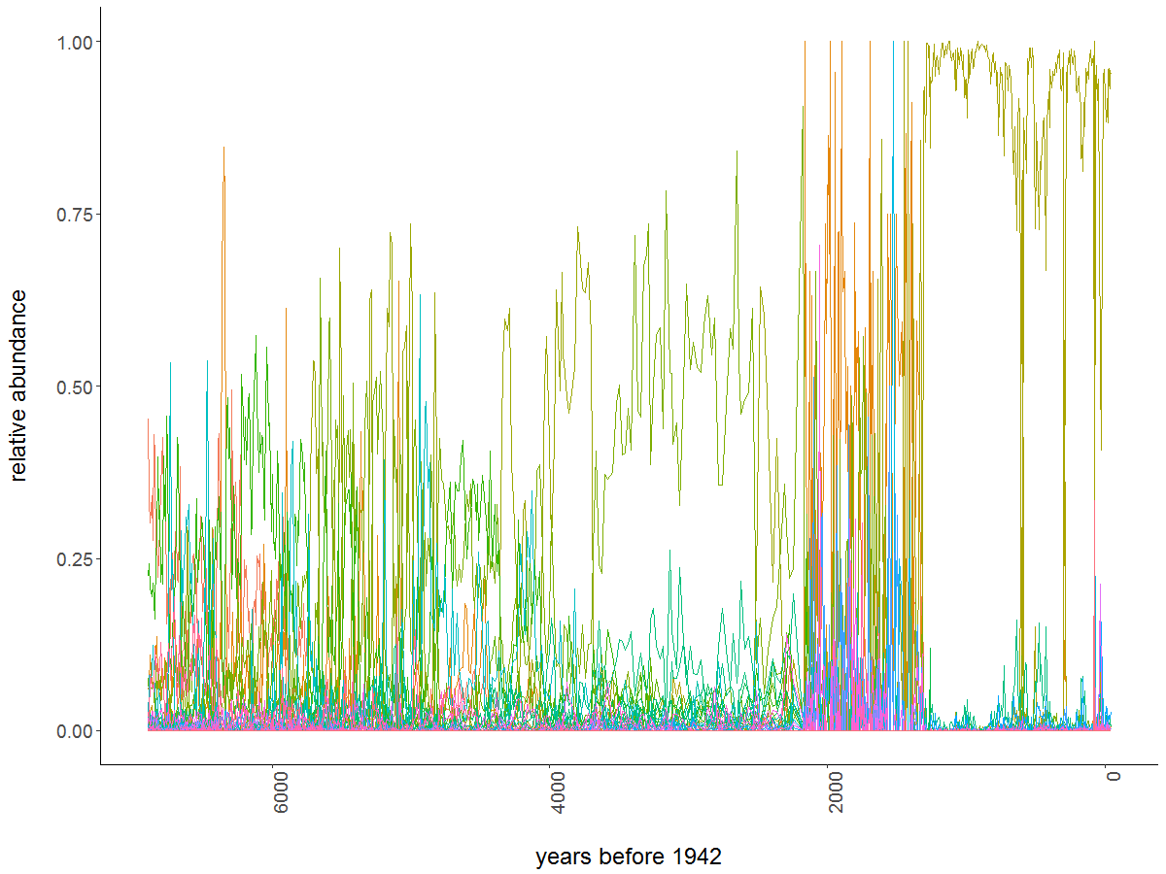

Figure 1. Foy Lake relative abundances for 109 species over ~7,000 year time period. Sampling occurred at 763 time points, with irregular time elapsing between sampling (mean 9 years, variance 37 years). Species with low relative abundances are collapsed into a single variable for visualization purposes only.

Figure 2. Figure 1. Foy Lake relative abundances for 109 species over ~7,000 year time period. Sampling occurred at 763 time points, with irregular time elapsing between sampling (mean 9 years, variance 37 years). Species with low relative abundances are collapsed into a single variable for visualization purposes only.

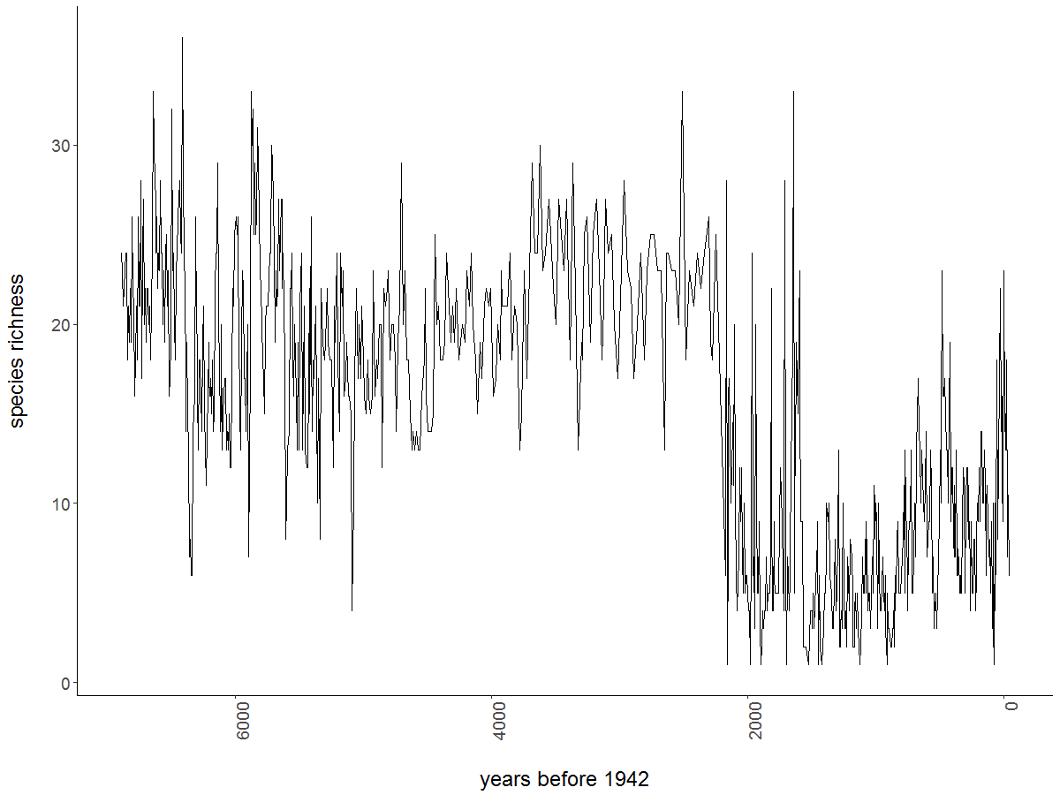

Figure 2. Number of species observed at each sampling point. Species richness sharply declines at ~ 2,200 years before 1942.

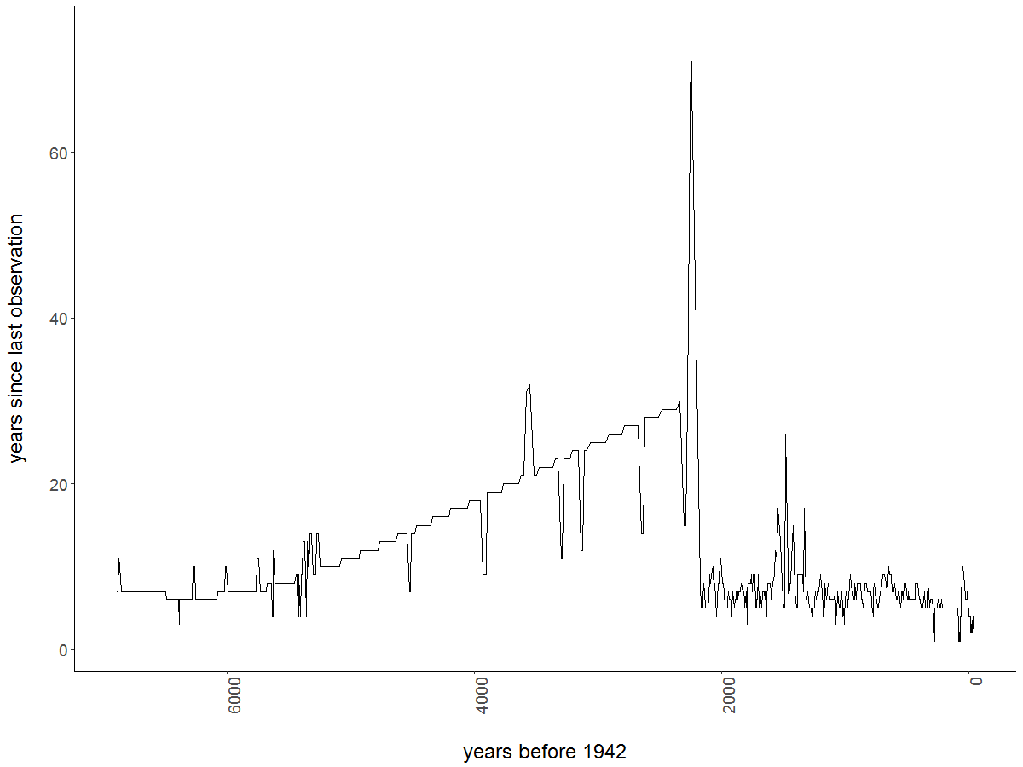

Figure 3. Years elapsed between samples increases until ~2200 when sampling frequency increases.



Figure 4. Cumulative distance traveled, s, by the entire paleodiatom community over the entire time period for each subsetting method and proportion combination. Bootstrapped estimates provided as the mean (solid lines) and 95% prediction intervals (shaded areas).



Figure 5. The distance metric, s, appears robust to both the method (line colors) and proportion (panels) used to subset the original data.



Figure 6. Velocity of the distance traveled metric preserves the major signals of abrupt changes in species composition (see Figure 1). These data are presented for the ‘species’ subsetting method as an example. Trends are similarly preserved across subsetting methods. Data are truncated to include up to 1,000 years before present for demonstration purposes.



Figure 7. In high-dimensional systems, single-species metrics produce results that are difficult to interpret. Here, we present an example of such a result. The interpolated (over 500 time points) values of the coefficient of variation (CV) for each species (N = 109) in the Foy Lake dataset.



Figure 8. Predicted means of the interpolated Fisher Information (log scale; logFI) and Variance Index metrics for a single subsetting method, ‘species’. The Fisher Information and Variance Index similarly give signals of the shift in community composition that occurs around ~1,300 years before present. Otherwise, the Variance index indicates an additional potential regime shift around ~2,100 years before present. Signals in the predicted means of the Fisher Information are impacted by the proportion of species used to calculate the metric. The signal for the shift around ~2,100 years before present is not lost when removing species, however, the relatively “smaller” shift around ~3,600 years before present is. Signals in the predicted means of the Variance Index are impacted by the proportion of species used to calculate the metric. The Variance Index appears more sensitive as we increase the proportion of species included. The signal for the shift around ~2,100 years before present is mostly lost when only 25% of the species are retained.



Figure 11. Percent species turnover of the species in the Foy Lake community. We define turnover as the sum of the species entering and leaving the system between two time points.

1. Herein we refer to these changes as “regime shifts” as an overarching term for changes in ecosystem structure or functioning. We recognize that the characteristics of a regime shift is user-defined and is inherently unique to any system in question. We refer readers to Andersen et al. (2009) for discussion on the semantics of “regime shifts”.
2. For the species and observations subletting methods, a subsetting proportion of *X* 