**Calculating Fisher Information**

Spatial and temporal Fisher Information calculation does not vary, but interpretation of either differ in that a spatial analysis will identify a spatial regime boundary (Sundstrom et al. 2017) in space within a single year while a temporal analysis identifies the point(s) in time at which a system experiences a regime shift. We identify potential areas of regime change following the methods outlined in Sundstrom et al. (2017). Current interpretation of Fisher Information is qualitative. We define a potential regime change as a point in time or space that exhibits a relatively large change in the Fisher Information value and which has a non-zero first derivative.

### Results

### Spatial results

We identified potential regime boundaries within select areas of the continental United States using Fisher Information using multiple methods of data aggregation (or lack thereof) and visualization. Comparing trends in Fisher Information across broad spatial extents among years allows for (1) the identification of areas undergoing a change in ecosystem order, (2) estimation of the relative vulnerability (via euclidean proximity) of military bases to changes in ecosystem order and (3) the changes in ecosystem order and base vulnerability over time (Figure 7). As expected, investigation of the third and fourth moments (skewness and kurtosis, respectively) of species abundances (N = 154) and the variance index (the eigenvalue of the covariance matrix of the community abundance matrix) using the moving window analysis yield indiscernible results (Figure 8). As such, we omit additional presentation of these metrics in this report.

Fisher Information was useful in our analysis of an East-West route running from Florida to Texas (see Figure 5) over a longer time period (2006 to 2014) displays the significance of time series data in identifying the points at which these changes may have occurred (Figure 9). Here, we notice high variability in estimated ecosystem order (Fisher Information) between Fort Hood and Fort Polk, and a potential westward shift in a regime boundary in the Southeastern United States (Figure 10).

### Temporal results

As evidenced in Figure 10 Fisher Information identified high variability of trends in a spatial transect. While Fisher Information allows for inference regarding changes in ecological processes operating at larger spatial and, likely, temporal scales, time series data at smaller spatial scales (e.g., within a single BBS route or military base) provides insight to changes within a single ecosystem. Depending on the data, a temporal analysis using Fisher Information has the potential to point to ecological processes operating at varying spatial and temporal extents.

We calculated Fisher Information using individual Breeding Bird Survey routes in and near military bases and other areas of interest to identify regime shifts in time. Following up on the estimated westward shift of regime boundaries in the Southeastern United States (Figure 10) we ran Fisher Information on Breeding Bird Survey routes across time in and around Eglin Air Force base to determine whether these changes in ecosystem order were echoed at the route-level (Figure 11). Fisher information allowed us to compare and contrast the trends in Fisher Information among bird communities within and near Eglin Air Force base (Figure 11). Applying a loess smooth to the Fisher Information trends provides a more pronounced visual interpretation of Fisher Information trend over time (Figure 12).

We are currently exploring the use of binning Fisher Information estimates from multiple years within a single BBS route in examining routes for regime shifts (Figure 13). This binning approach is useful in identifying trends in a single area (or military base) over a long time period, and may alleviate the negative effects of missing data and assess outliers on the potential performance of Fisher Information in regime shift interpretation. A Loess smooth can be applied to these binned values. Plotting these smoothed lines on top of the confidence intervals of the averaged (binned) Fisher Information allows for identification of an underfit smooth (Figure 14).

We calculated Fisher Information across both broad spatial extents and at the base-level. Contrary to the findings of Sundstrom et al. (2017), we did not detect clear ecoregion boundaries along our transects. A Nonmetric Multidimensional Scaling (NMDS) using k-means clustering did not reveal distinct and non-overlapping clusters. Sundstrom et al. (2017) designed their study based on BBS route location within and across ecoregions such that each ecoregion was approximately equally represented in the data, and the transect analyzed crossed known, spatial regime boundaries (well-defined and distinct ecoregions). We took a less subjective approach to detecting spatial regime shifts by using (see Figure 3) stratified random sampling techniques. As a consequence, ecoregions were unequally sampled within a transect and Fisher Information in some locations is a byproduct of the data sampling technique. The differences between the Sundstrom study and ours highlight that Fisher Information is sensitive to sampling design, highlighting its usefulness in terms of accuracy and performance as a function of input data, which provides opportunities for further explorations. These current results allowed us to plan an investigation of the spatial trends of Fisher Information that is calculated on time series data, when available. In other words, we recommend the user to calculate Fisher Information over time series data, and visualize the changes in Fisher Information across space.

### Discussion

One of the primary objectives of this study to date is to use Fisher Information in identifying broad-scale regime shifts in complex ecological systems. Our results indicate that although the Breeding Bird Survey and base-level data sets are amenable to identifying regime boundaries using Fisher Information coupled with discontinuity analysis, further testing of the sensitivity of data aggregation and taxon-specific data qualities in detecting regime shifts may refine our current results.

We are examining the efficacy of the application (Sundstrom et al. 2017) of size of states in calculating Fisher Information in ecological systems. Specifically, we will explore alternative methods to the data binning techniques that are used to create the probability mass function, which is used to determine the state membership of a window of data (e.g., a local bird community).

In addition to Fisher Information, the ability of discontinuity analysis to detect directional changes in spatial regimes represents an enormous benefit both to land managers at individual military installations and to managers across installations. Using these methods, managers across and within installations could track trajectories of ecological change, essentially forecasting broad-scale regime shifts. Managers can use these methods to communicate necessary management mitigation or prioritization measures to bases before a directional regime shift reaches a given installation. The proximity of directional regime shifts to an installation could also serve as an estimate of that installation’s ecological vulnerability. Currently, we are developing methods to characterize and compare spatial regimes across time (i.e., in order to determine if the southernmost regime from 1970 is the same as the southernmost regime in 1990; Figure 15), which will further enable land managers to identify approaching regimes and compare approaching regimes to the regime their installations currently reside in.

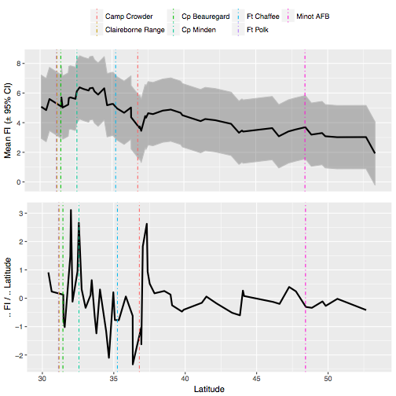

Figure a. The average Fisher Information binning measure (± 95 % confidence intervals) (top) and the rate of change of the average Fisher Information binning measure (bottom) over a single, North-South transect in Central North America in year 2010. Vertical lines indicate the approximate location of select US military bases that fall within or near the transect (see Figure 4).

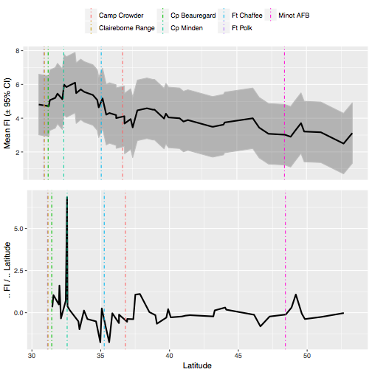

Figure b. The average Fisher Information binning measure (± 95 % confidence intervals) (top) and the rate of change of the average Fisher Information binning measure (bottom) over a single, North-South transect in Central North America in year 2014. Vertical lines indicate the approximate location of select US military bases that fall within or near the transect (see Figure 4).

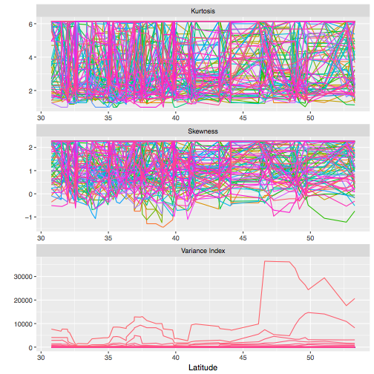

Figure . Traditional leading indicators (see ) (skewness, kurtosis, variance index) of species abundances of a North-South transect of North American Breeding Bird Survey routes sampled in year 2010. Skewness and kurtosis are the third and fourth moments of the mean (species abundance), and the Variance Index is the eigenvalue of the covariance matrix (of species’ abundances). Traditional leading indicators are difficult to visually interpret when analyzing a large number of variables.

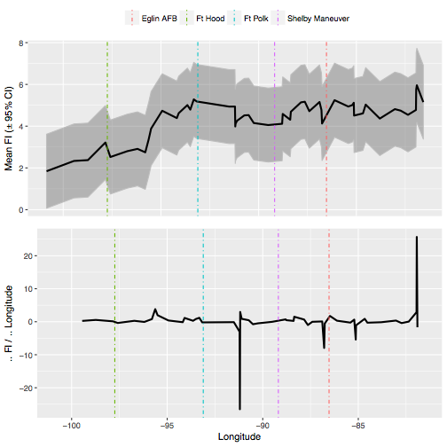

Figure a. The average Fisher Information binning measure (± 95 % confidence intervals) (top) and the rate of change of the average Fisher Information binning measure (bottom) over a single, East-West transect in Central North America in year 2006. Vertical lines indicate the approximate location of select US military bases that fall within or near the transect (see Figure 6).

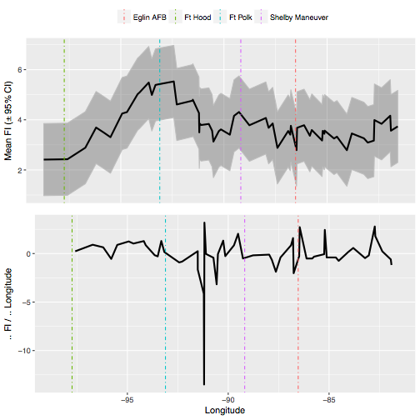

Figure b. The average Fisher Information binning measure (± 95 % confidence intervals) (top) and the rate of change of the average Fisher Information binning measure (bottom) over a single, East-West transect in Central North America in year 2010. Vertical lines indicate the approximate location of select US military bases that fall within or near the transect (see Figure 6).

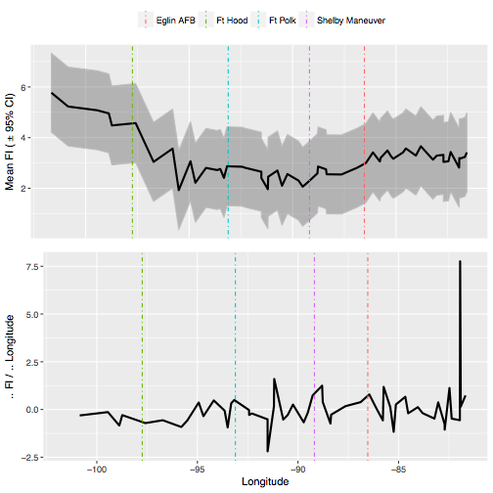

Figure c. The average Fisher Information binning measure (± 95 % confidence intervals) (top) and the rate of change of the average Fisher Information binning measure (bottom) over a single, East-West transect in Central North America in year 2014. Vertical lines indicate the approximate location of select US military bases that fall within or near the transect (see Figure 6).

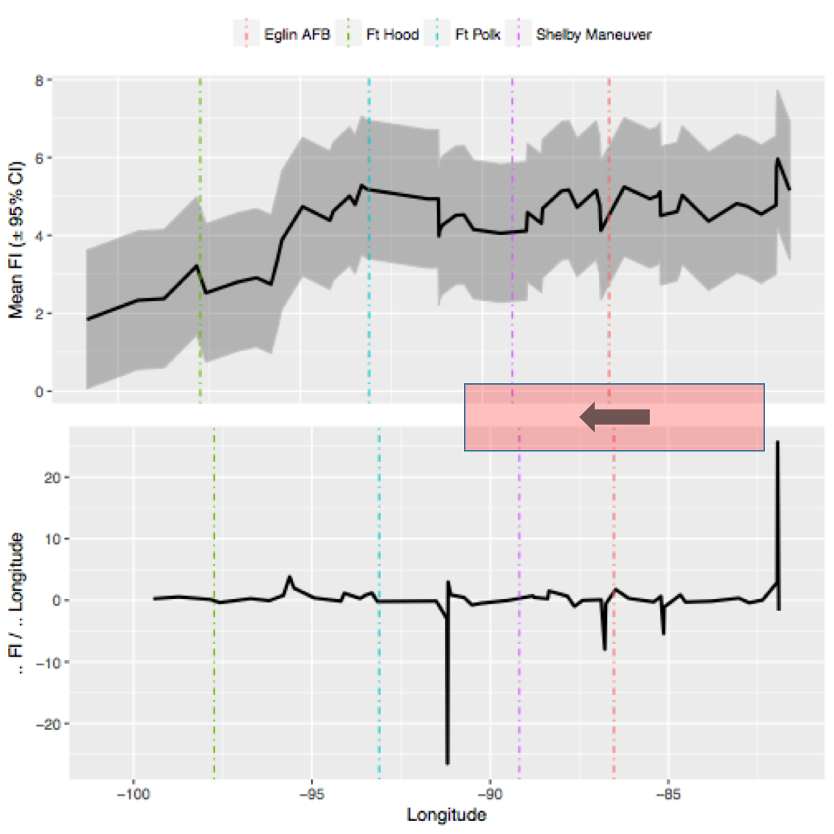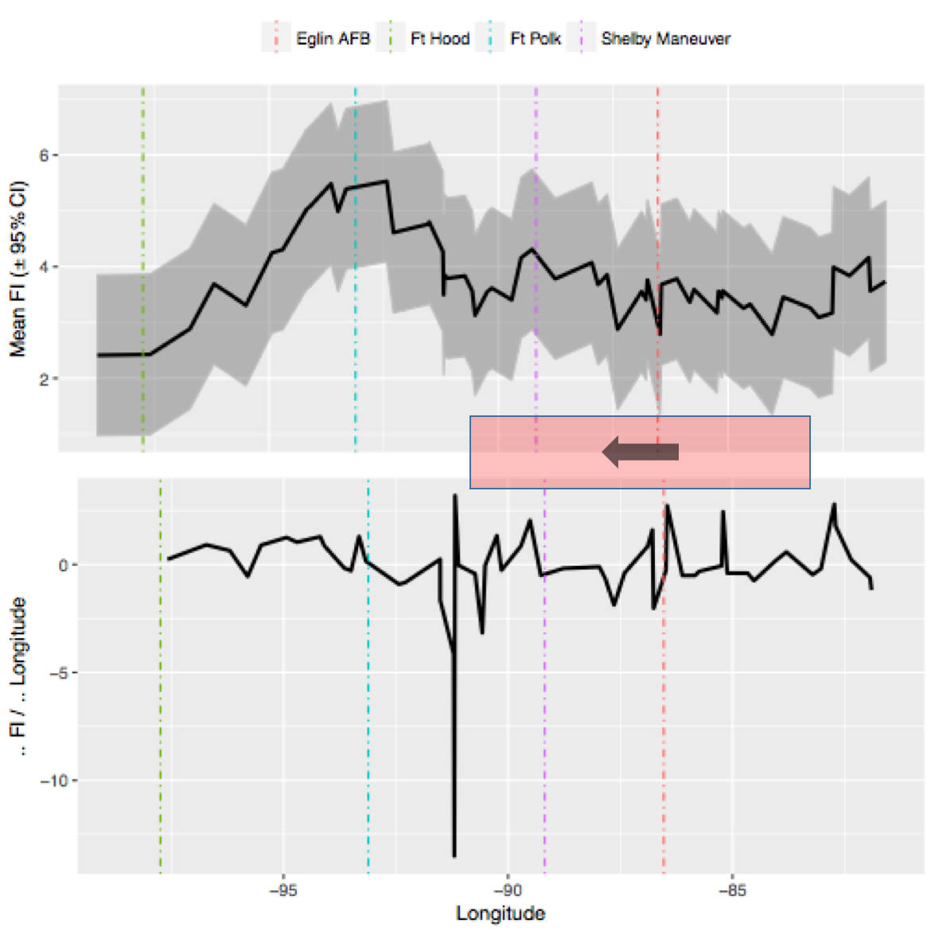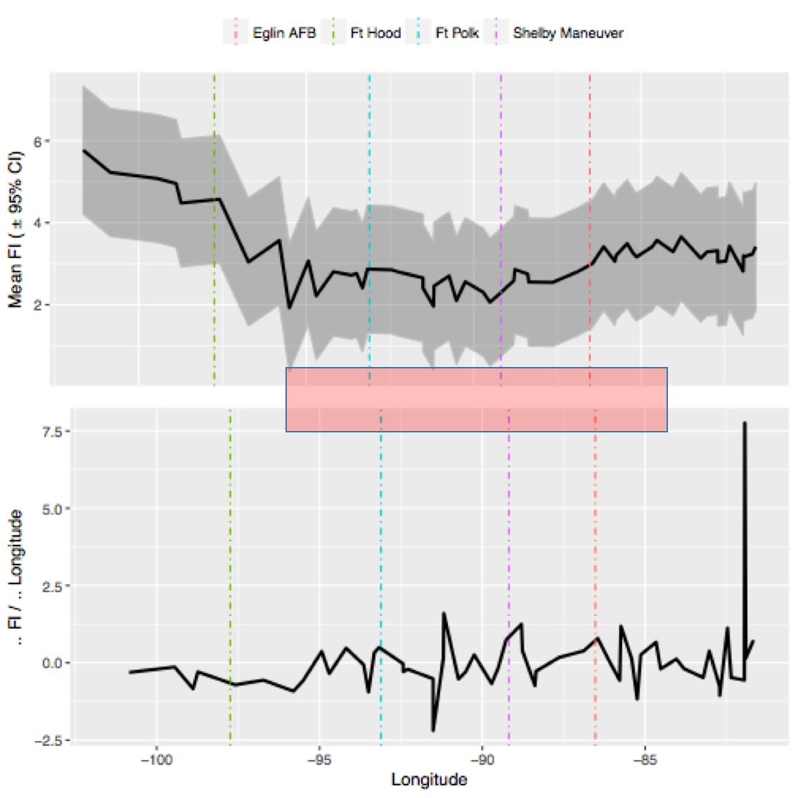

Figure . Qualitative interpretation of the average Fisher Information binning measure (top trend in each panel) and the first derivative of the average Fisher Information binning measure (bottom trend in each panel) indicates a potential, west-moving regime boundary along this East-West transect of the Southeastern US. Trends were calculated along the East-West transect (see Figure 6) in years 2006 (top left), 2010 (top right) and 2014 (bottom left).

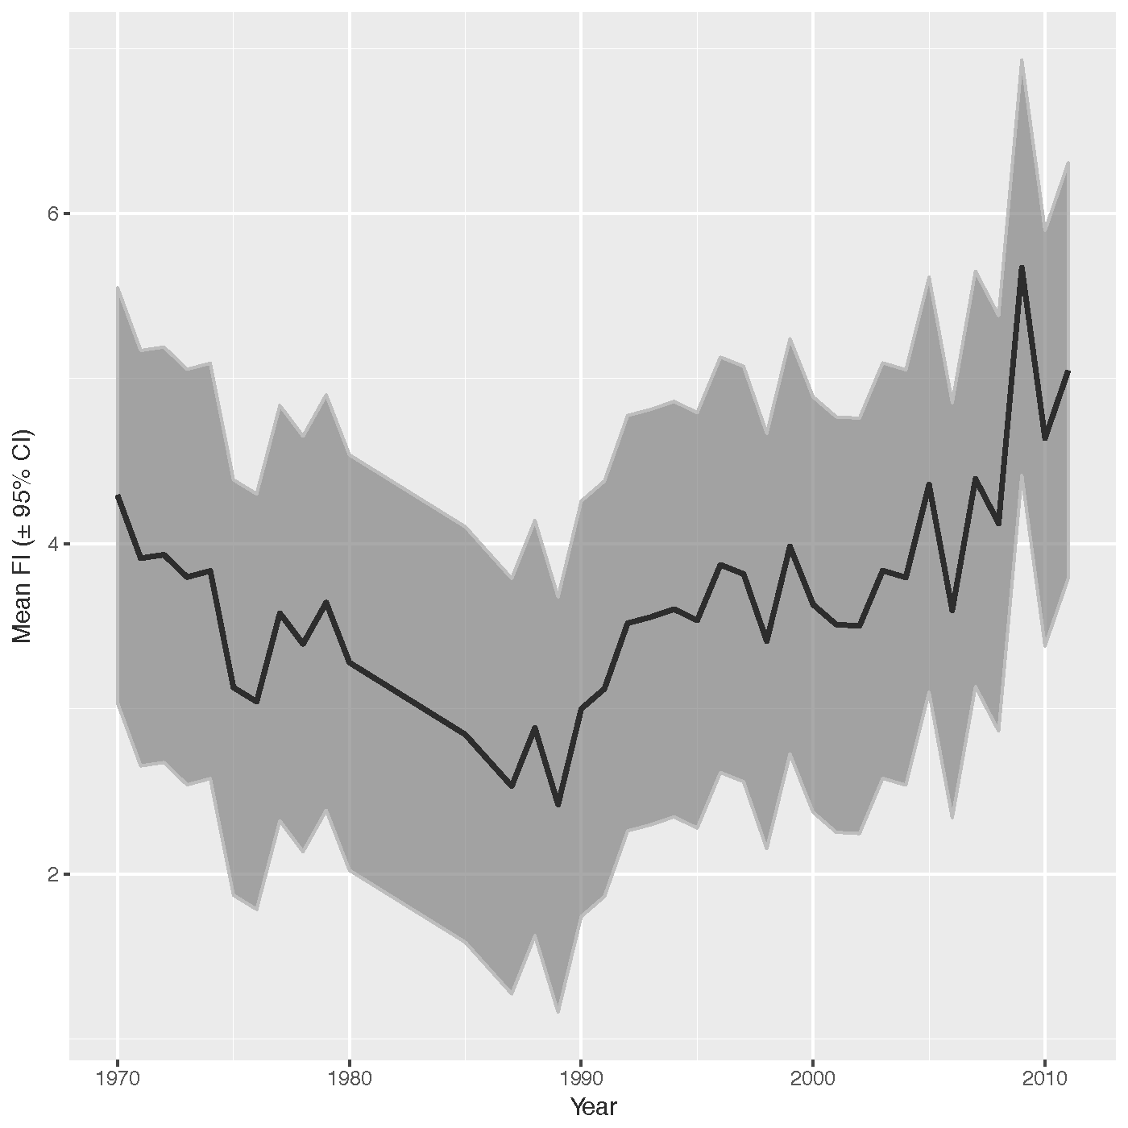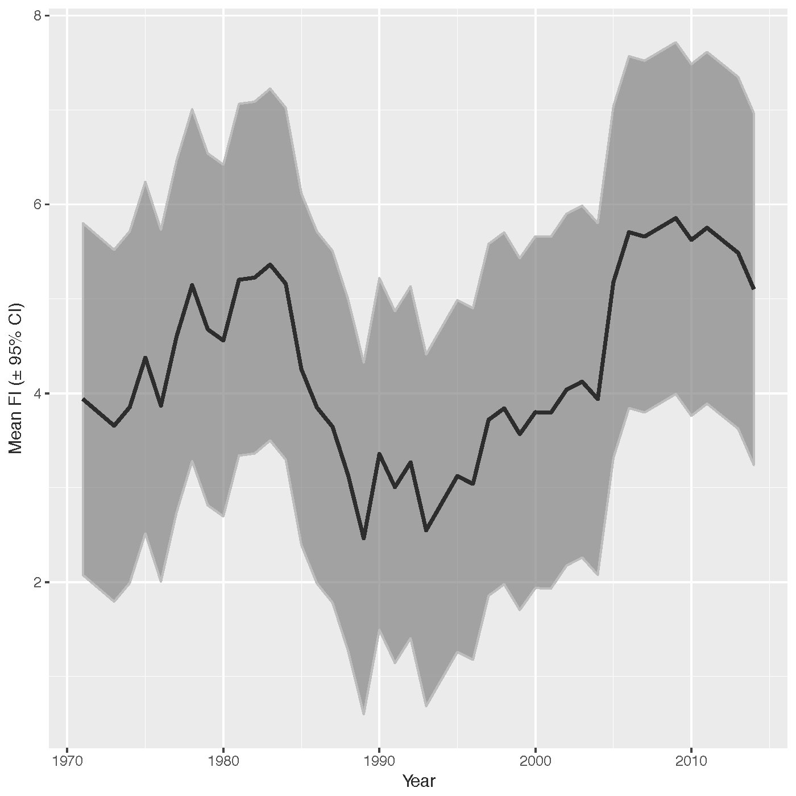

Figure . The average Fisher Information binning measure from 1970-2015 for two North American Breeding Bird Survey routes to the immediate east (left panel) and west (right panel) of a US military base, Eglin Air Force base (Destin, Florida, USA). Trends in the average Fisher Information binning measure suggests the east and west sides of this military base may have experienced “edge effects” from potential regime changes at different points in time. A rapid change in the Fisher Information on the east (left panel) and west (right panel) suggest potential regime changes in the bird communities around 1990 and 1987, respectively.

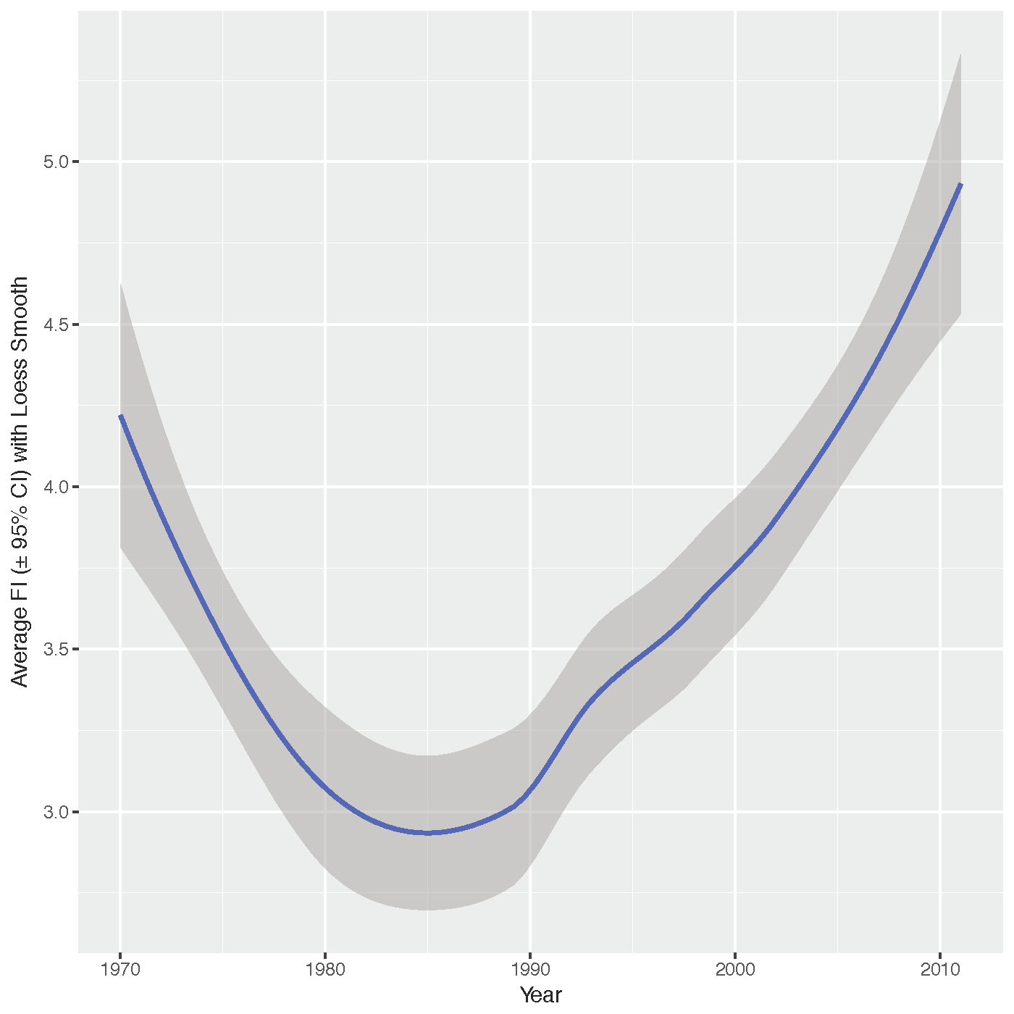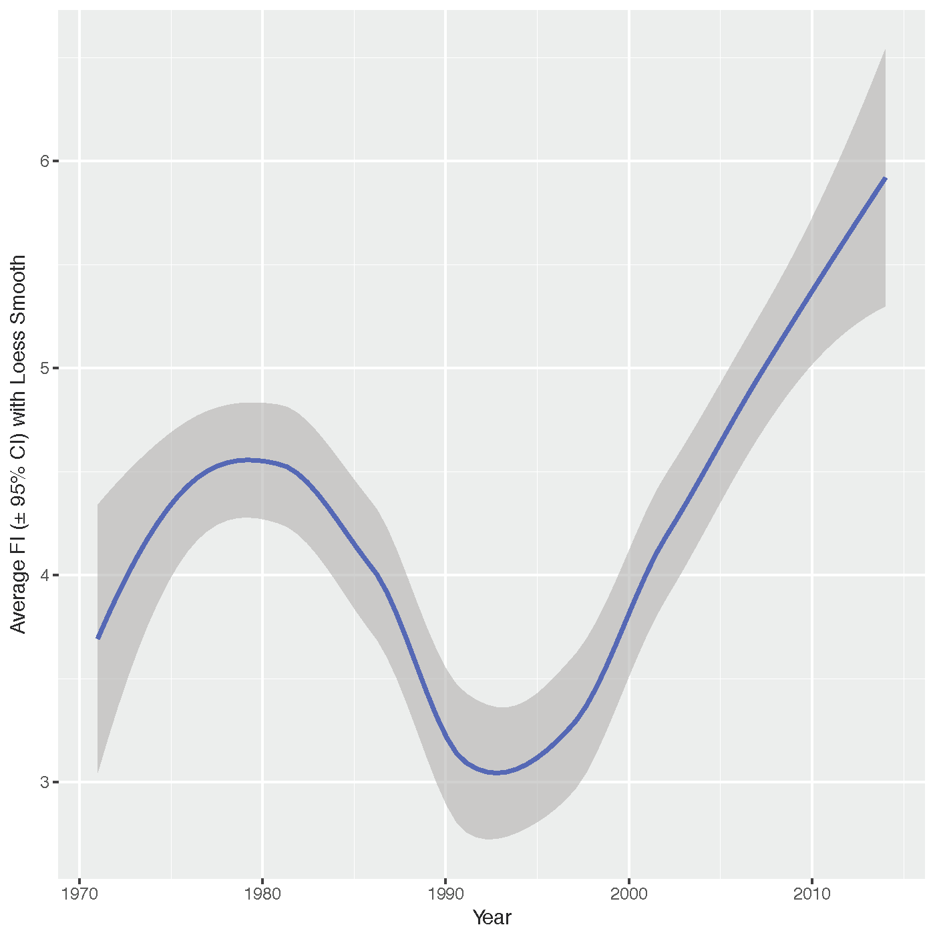

Figure . The average Fisher Information binning measure (± 95 % confidence intervals) for the east-west route (see Figure 11) is fitted using a Loess smoothing function in an attempt to filter noise for ease of interpretation. A smoothing function does not aid the author’s interpretation of these time series.

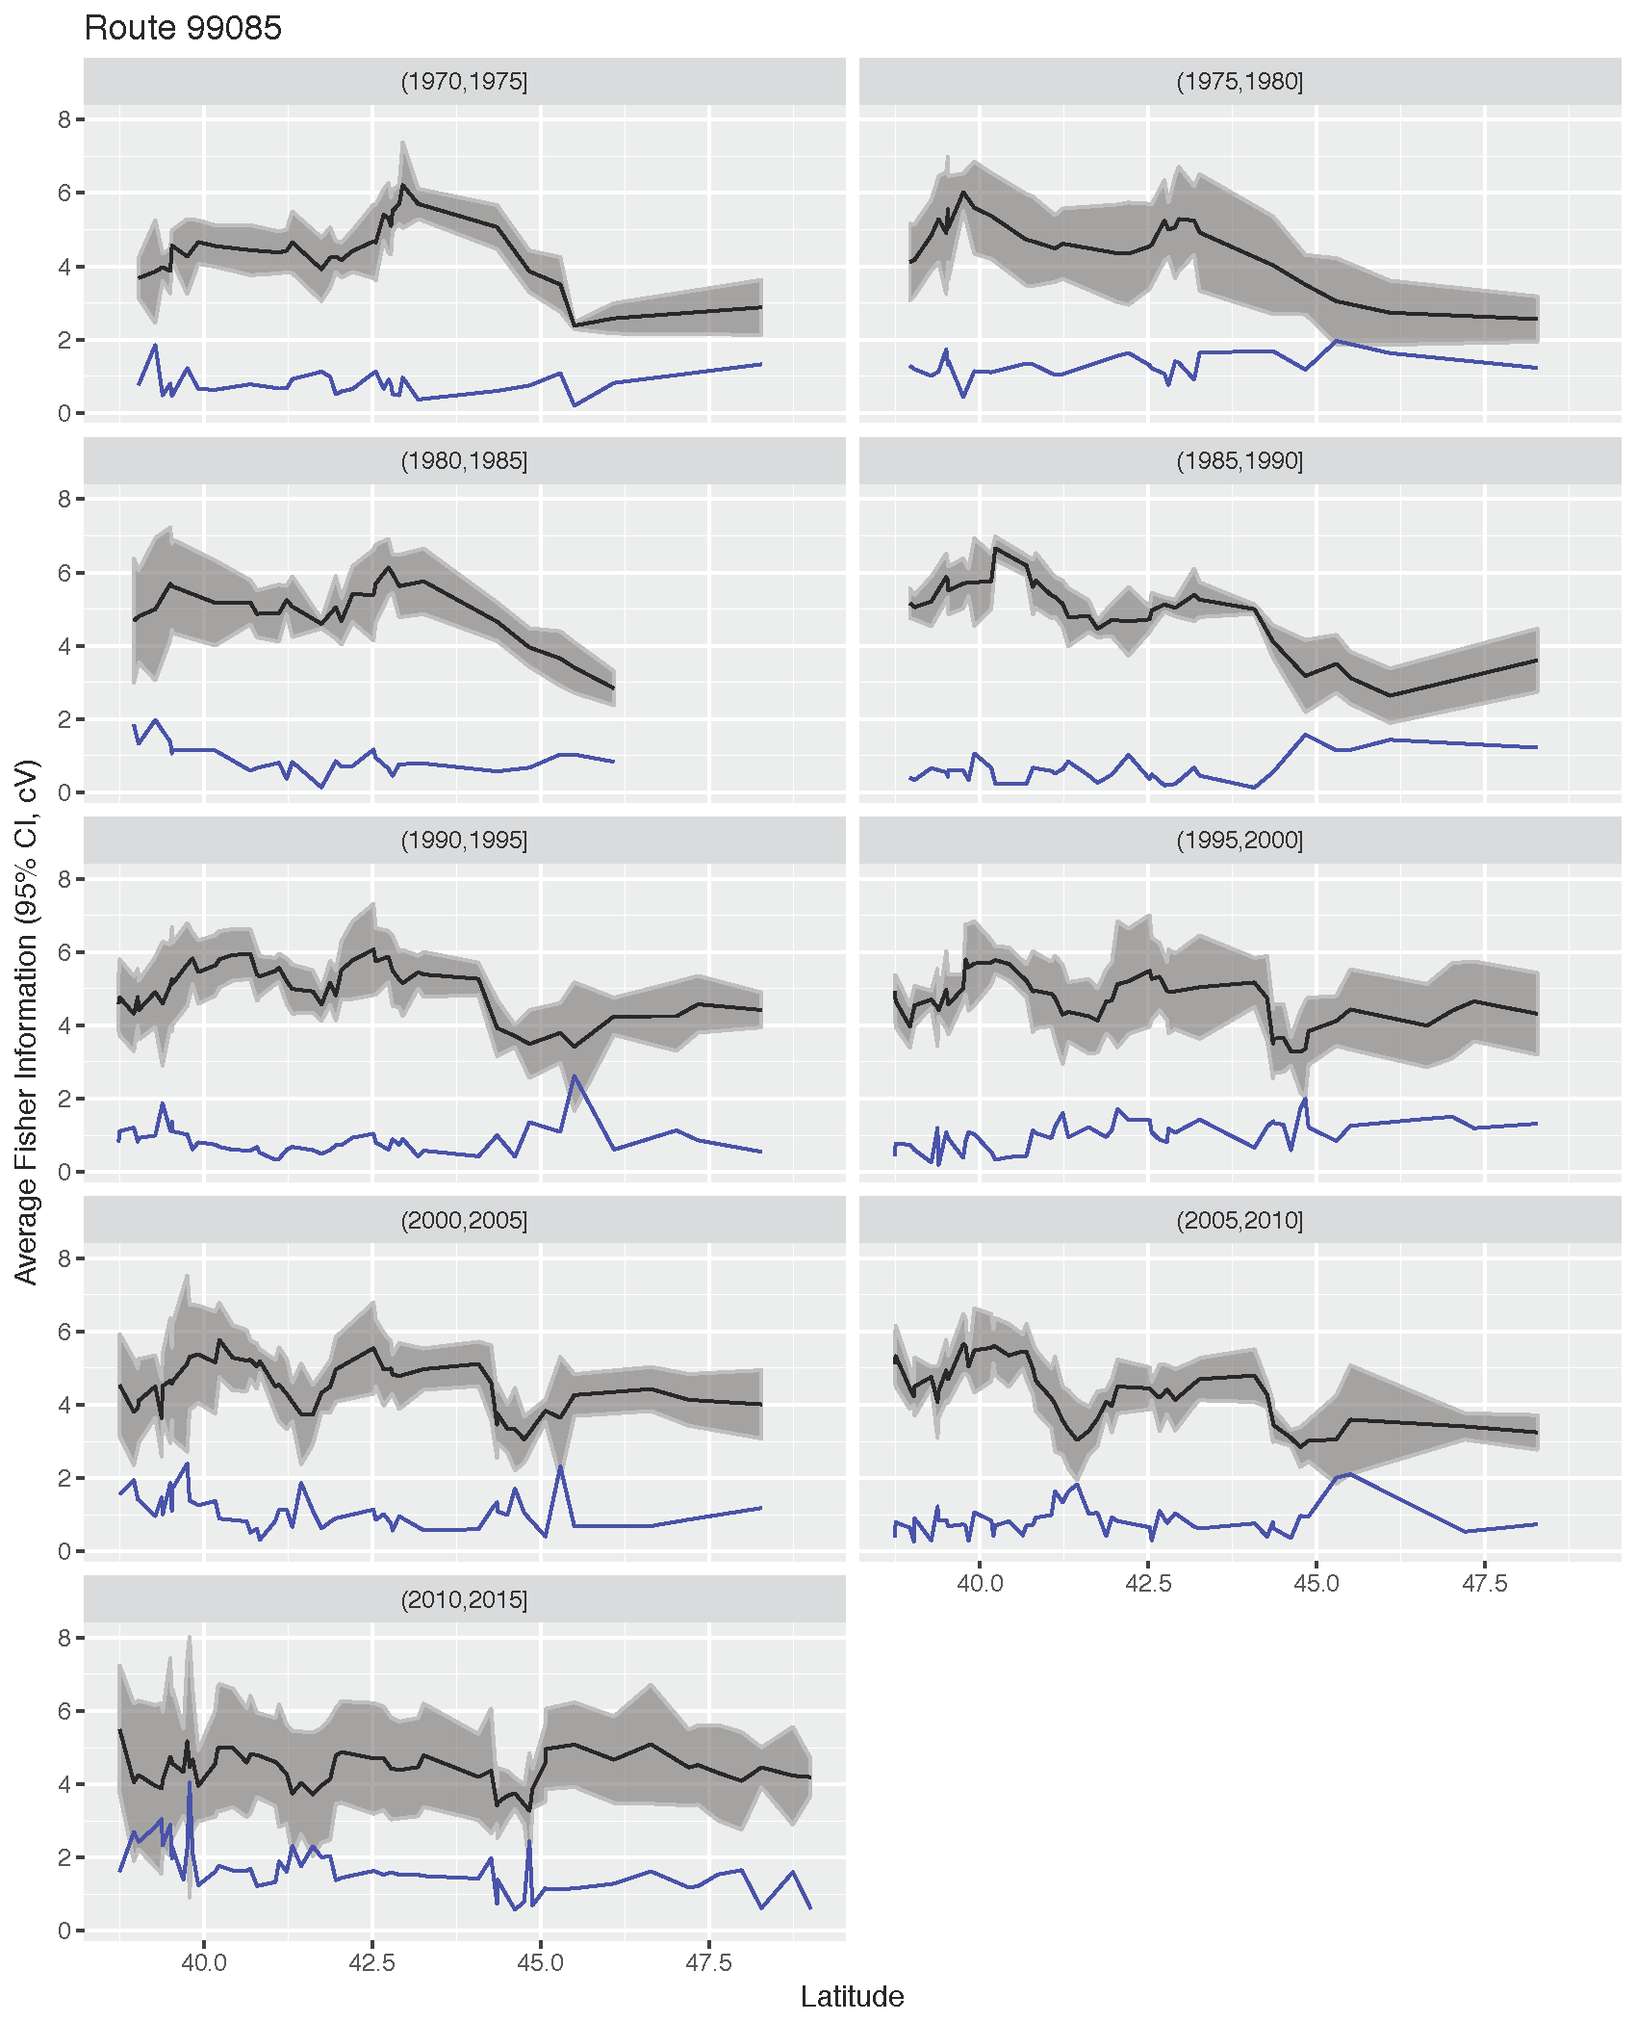

Figure . The averaged Fisher Information binning measure (black; ± 95 % confidence intervals) for a single North American Breeding Bird Survey route is binned and averaged over a five-year period. The coefficient of variation of the species abundances (blue) can be used simultaneously to help identify periods of high variance.

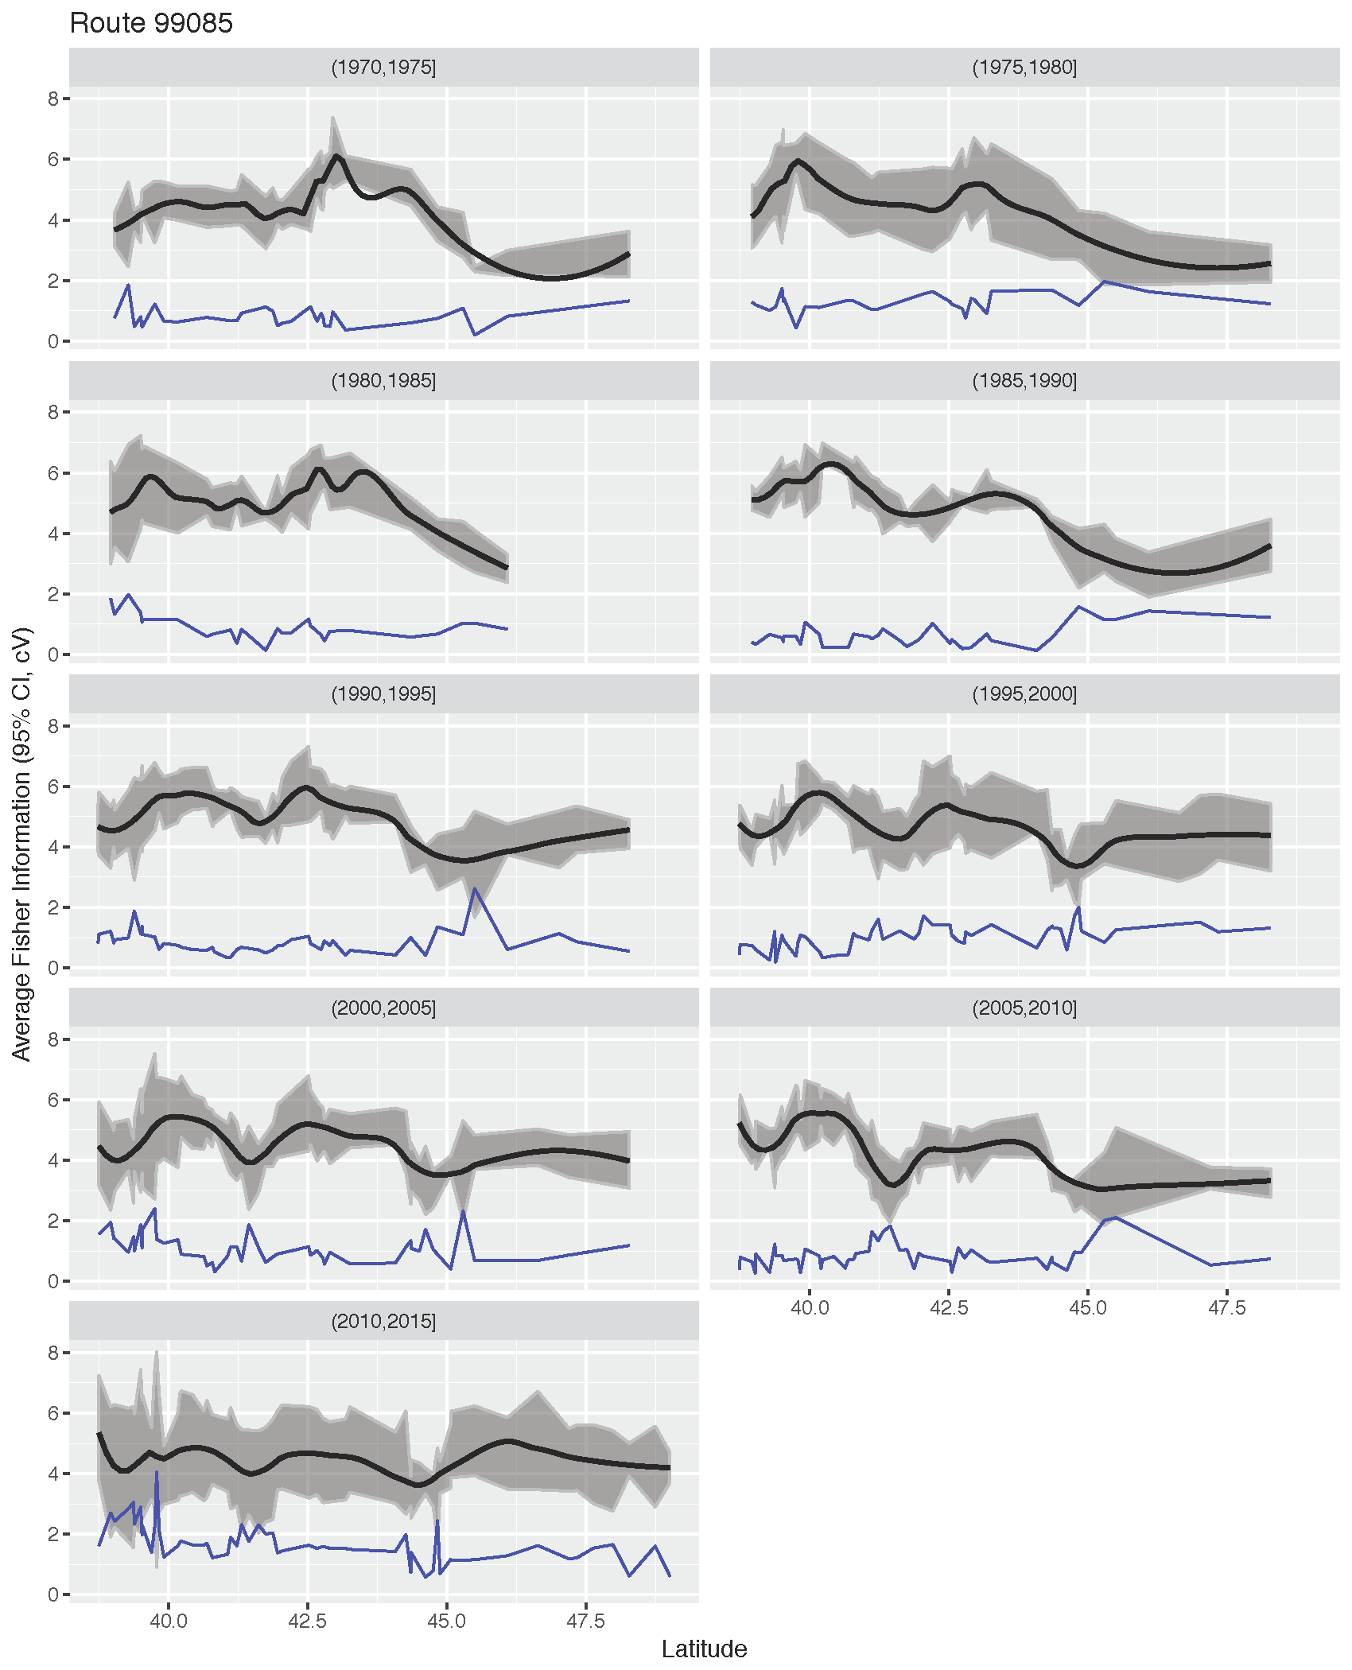

Figure . A Loess smoothing function (± 95 % confidence intervals) is applied to the average Fisher Information binning measure over a five-year period (see Figure 13). The coefficient of variation of the species abundances (blue trend).