**Title:** Scale mismatches in ecological research and management: consequences and solutions through data management

**Short title:** Scale mismatch in ecology

**PI Contact Information:**

Jessica L. Burnett

[jburnett8@unl.edu](mailto:jburnett8@unl.edu)

+1 (352) 792-5425

3310 Holdrege Street

Lincoln, NE 68510

Hao Ye

[hao.ye@weecology.org](mailto:hao.ye@weecology.org)

+1 (619) 201-2699

110 Newins-Zeigler Hall

Gainesville, FL 32611

Craig Allen

[callen3@unl.edu](mailto:callen3@unl.edu)

+1 (402) 472-0229

3310 Holdrege Street

Lincoln, NE 68583

George Sugihara

gsugihara@ucsd.edu

+1 (858) 534-5582

9500 Gilman Drive

La Jolla, CA 92093-0202

**Project Summary**

Numerous, long-term ecological monitoring programs exist yet the data are not always collected at the scales(s) necessary to identify and understand the relevant processes driving observed patterns. Moreover, the lack of a unifying standard makes it difficult to aggregate and integrate multiple datasets *post hoc*. These “mismatches” between observation and process as well as between independent datasets make it challenging to develop effective management policy or predict future transitions in a changing global climate. This project aims to identify the scope of these issues and develop solutions that bridge the gap between monitoring programs and research efforts. We propose a series of workshops with these specific goals:

1. identify how research questions about global ecological change are affected by mismatches with the sscale of extant datasets
2. develop a standardized framework for data integration to enable interoperability among multiple datasets and guidelines for model development
3. create recommendations for prioritizing current and future monitoring programs and for establishing adaptive management/monitoring practices

**Proposed Start and End Dates:** January 2019—August 2020 with 1 five-day and 2 four-day workshops at the Powell Center.

**Proposed Data Release Date (or before):**  May 2020

**Total Requested Budget:** $172,121.50 (Year 1: $85,984.38; Year 2 $84,337.13)

**Is this a resubmission?** No

**Conflicts of Interest with Reviewers:** Craig R. Allen serves on the Powell Center SAB.

**Keywords:** ecosystems

# 1 Problem Statement

The scales at which we monitor and manage ecological systems do not always align with the scales at which ecological feedbacks and processes (hereafter processes) operate. Mismatches between our observations and the processes we aim to understand can lead to ineffective or counterproductive management and policy decisions (Lee 1993, Folke et al. 1998, Cumming et al. 2006), unexpected responses of faunal populations to intervention (e.g., Chundawat et al. 2016), and overexploitation or harvest of natural resources (e.g., Lee 1993). We refer to the misalignment between ecological (or physical) scale and social (or management) scales as ‘scale mismatch’ (Levin 1992, Cumming et al. 2006). Such mismatches can occur along one or several axes simultaneously, including spatial (wrong physical size and/or extent), temporal (wrong sampling frequency and/or extent), or even taxonomic (wrong taxonomic rank) dimensions. For example, ecosystem dynamics often operate on larger spatial (or longer temporal) scales than any single monitoring program or management area can capture, and management decisions often occur at spatial (temporal) scales that are smaller (quicker) than assessments or models provide, requiring strict assumptions of constancy or problematic downscaling methods. As we navigate the ‘Big Data’ revolution (Kitchin 2014, LaDeau et al. 2017), capturing and analyzing ecological observations will become increasingly efficient; however, scale mismatches can undermine these advances. Furthermore, efforts to understand multi-scale processes can be hindered by artificial hierarchies that result from sampling schemes or analysis frameworks. For example, it is common to process irregularly-spaced observations to conform to a uniform grid of latitude and longitude. These “false hierarchies” may mask true ecological dynamics that occur or interact at multiple scales (Levin 2000), and even introduce statistical artifacts because the different “levels” are actually determined by choices made when designing the monitoring program or analysis pipeline.

Scale mismatches can have substantial consequences for understanding the ecological mechanisms that produce our observations. Consequently, scale mismatch may limit our ability to identify early warning signs of community or ecosystem collapse (Holling 1992, Scheffer 2009). Ecological ‘regime shifts’ can have a number of underlying mechanisms and may result in drastic and unwanted changes to ecosystem goods and services. Recovery from these disturbances is difficult without knowledge of the true scale of the problem and the underlying processes. With predicted increases in the intensity and frequency of disturbances as a result of global climate change, it is critically important to know both the potential impacts of and alternatives for scale mismatches in ecological research and management. We propose to investigate the scope of scale mismatch among ecological processes and observations (i.e., data) and to develop solutions for integrating and utilizing multiple sources, qualities, and types of data to identify ecological patterns and processes across multiple spatial and temporal scales. For example, is it possible to construct criteria for creating proxy variables that allow upscaling or down scaling in time, space or taxon?

### *Impacts of Scale Mismatches*

Our first objective is to identify the extent to which the spatial, temporal, and taxonomic scale of datasets affect the ability to detect or predict patterns of ecological change. Although long-term monitoring programs are highly valuable for identifying trends and distributions, they may not have been designed with modern research questions in mind. Moreover, because many monitoring programs were the first to begin sampling their system of interest, they may not have collected data at the appropriate scale for investing the ecological processes that interest researchers today.

### *Data Integration Practices*

Although the collection and analysis of fine-grained data in climatology and hydrology is increasingly efficient, large-scale ecosystem monitoring efforts are stunted by both the expenses related to collecting these data and the misalignment of science and bureaucracy (Field et al. 2007). Data integration is a practical solution to this problem - it unifies data from separate sources to address a research question(Sutter et al. 2015). In this way, out-of-sample prediction and out-of-scale inference can be supported using existing datasets. Because data needs are often unique to different models and do not always overlap, we will develop a set of guidelines for both datasets and models to lower the barrier of entry. This will help ensure that datasets can be more widely used, and that researchers/modelers spend less time wrangling data into consistent formats.

# Research questions

We will examine the effects of and solutions for scale mismatch in ecological monitoring protocols and consequential information (data). Many monitoring programs protocols are designed such that the information collected maximizes monetary resources, statistical power, and are sustainable over the lifetime of the program. Monitoring program protocols, however, often implicitly assume stationarity of ecological processes, and often fail to adapt to changing environmental and sociological conditions. This occurs when the spatial and/or temporal scales at which ecological processes operate are not captured within the maximum scale of the data.

A spatial (temporal) mismatch can be defined as an incongruence between the physical (temporal) location of a process(es) and the location at which information are collected. Mismatches in ecological data can be defined broadly when one of two conditions, or a combination of each, are met with respect to spatial extent and resolution, and temporal extent and resolution. Under these conditions, either the area (or time period) sampled does not overlap with the ecological process(es) of interest, or the area (or time period) sampled does not encompass sufficient information to capture the process of interest (Figures 1 and 2). 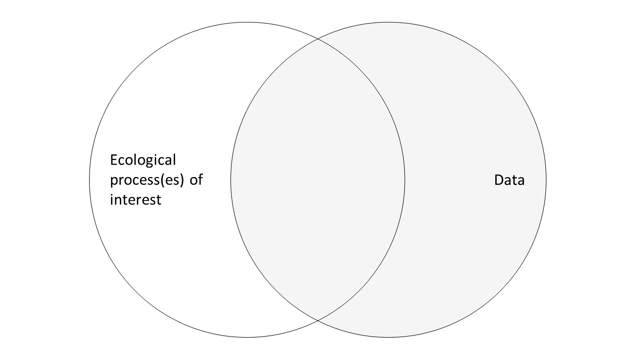

Figure 1. Scale mismatch between data and the ecological process(es) of interest. This scale mismatch occurs when the ecological process occurs outside the spatial or temporal scale or resolution at which the data is collected. Any inference gained from the data may not reveal the ecological process driving the observations.

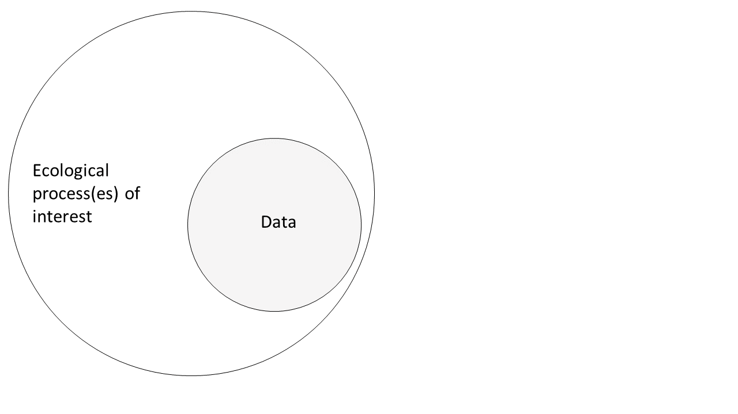

Figure 2. Scale mismatch between data and ecological process(es) of interest. This mismatch occurs when the data are captured at a spatial or temporal resolution or extent that is smaller than required.

Spatial and temporal mismatches, alone, are often relatively simple to resolve. Increasing the spatial or temporal extent or resolution at which the data are collected may alleviate these mismatches. It is often not the case, however, that simply increasing the spatial or temporal extent or resolution will solve problems associated with scale mismatch. Increasing the spatial extent of a monitoring program, for example, may muddle inference from the processes captured in the data if the temporal extent of the program is not subsequently increased. This working group will explore questions surrounding the issues of (i) spatial, (ii) temporal, (iii) and spatiotemporal scale mismatches in ecological monitoring data, inference, and management. We ask the following questions with respect to the aforementioned scale mismatches:

* + - 1. How can we identify scale mismatches in ecological monitoring programs?
      2. What issues are inherent in spatial, temporal, and spatiotemporal scale mismatches?
      3. What are solutions for handling these scale mismatches?
      4. What are solutions for preventing scale mismatches?

# 2 Proposed Activities

## *Data*

We have identified a diverse group of datasets which differ in variety (types of data), velocity (sampling frequency and/or the rate at which the data is available for analysis; e.g., retrieving mass quantities of data at one time vs. real-time data from sensors), veracity (uncertainty in the observation; e.g., remotely-sensed data)(see LaDeau et al. 2017).

*Analytical Approach*

We propose to investigate the potential impacts of these scale mismatches on research into long-term change and regime shifts in the following way. First, we will examine publicly-funded and/or publicly-available data (see Table 1) and assemble standardized metadata to enable cross-dataset comparison. Next, we will impose artificial hierarchies (e.g., through down-sampling, aggregation, and extent restrictions) on these data to understanding how scale mismatches affect analyses. Finally, we will test different methods of analysis to see how the spatial, temporal, or taxonomic scale of the data impact ability to detect patterns of change or regime shifts.

We will identify the effects of scale mismatches on the quantitative and qualitative results of from multiple regime shift detection methods including changes in point estimates (e.g., first through fourth moments, variance), multivariate time series analysis, and clustering techniques. Analytical details will be hashed out in the first meeting, and will be contingent upon the final research questions and associated data. Many of our team members have considerable experience in a variety of quantitative methodologies for detecting ecological regime shifts and nonlinear dynamics (e.g., Sugihara and May 1990, 1998, Gill et al. 2009, Batt et al. 2013).

# 3 Participants

We have identified a diverse team of researchers (Table 2) whose expertise, together, will advance the objectives proposed herein. All but one team member (Dr. Ryan Batt) are confirmed participants at the time of submission. Our team members represent two countries (U.S. and Australia), work in ecological and research and management and represent both academic and federal institutions.

# 3.1 Diversity statement

Our team comprises 5 women (1 African American) and 10 men. The age and career stages of our confirmed participants are well distributed (3 doctoral students, 3 postdoctoral researchers, 5 early- to mid-career researchers, and 4 mid- to late-career scientists). Additionally, some of our team members are especially active in local and national efforts to promote and retain diversity in the natural resource sciences. As a first-generation college student, the Powell Center fellow (Jessica Burnett) is particularly interested in generating awareness among and creating opportunities for natural resource research and management in the first-generation community.

# 4 Timetable of Activities

This project will be aided most by the in-person meetings and discussions. Although some participants are familiar with each other most have yet to work together. It is therefore important we meet as a group for longer, rather than shorter, periods of time. We propose one, five-day workshop and two, four-day workshops.

January—April 2019

* Initial email correspondence
* Circulate scale mismatch and other pertinent literature
* Video conference with entire group to
  + establish rapport
  + discuss literature (see above)
  + refine agenda for January workshop
* During and after video conference we will, as a group, draft a code of ethics and expectation
* The Powell Center fellow will gather and summarize, at a minimum, the data presented in Table 1

April or May 2019

* First in-person meeting (4 days)
  + refine group objectives and methods
  + define preferred study systems/taxa
  + finalize data to be included in analyses
  + define a common metadata (this will likely be updated before or at next meeting)
  + define specific methodologies and data combinations for analytical approaches
  + define potential products and project point-persons

May—July 2019

* Powell Center fellow will gather additional data accordingly
* Fellow will work with Powell Center to identify data storage options, if necessary
* Data munging
* Data will be published such that all team members can access
* Introduce artificial hierarchies into data
* Run regime shift/change point detection analyses on data (as identified in April/May meeting)

August 2019

* Disseminate results to team prior to meeting
* Video conference with entire team

August or September 2019

* Second in-person meeting (5 days)
  + Day 1:
    - review and discuss results
    - expert interpretation for system-specific analyses
    - run additional analyses as necessary
    - define manuscript audiences
  + Day 2:
    - breakout groups
    - writing
  + Day 3:
    - regroup, updates
    - writing
    - regroup and assign tasks as necessary

October 2019—August 2020

* Email correspondence and video conferencing as necessary
* Work on manuscript drafts

June 2020

* Third in-person meeting (4 days)
  + Finalize manuscripts and submit for internal reviews
  + Discuss future directions
  + Draft management recommendations / final report

July—August 2020

* Publish data and metadata as applicable with Powell Center and ScienceBase
* Submit manuscripts

# 5 Anticipated Results and Benefits

Ecological monitoring programs can provide valuable information about species distributions and population trends, ideally informing relevant policy and management actions. However, some long-term and/or large-scale monitoring programs consume large amounts of resources (*i.e.*, manpower, non-renewable resources, money) and their protocols are often not adaptive (Lindenmayer *et al.*, 2009). Non-adaptive data collection may fail to capture processes operating across multiple functional scales (Holling 1992). In fact, some ecological studies and monitoring programs gather information at a single level of interest yet extrapolate results beyond the spatial and temporal resolution and extent of the data (e.g., species distribution modeling). Furthermore, some programs may fail to capture processes operating across broad temporal and spatial extents (Brown 1995) if the spatial resolution of the data is smaller than that of the processes. In many cases, this occurs because the true scale of relevant processes was unknown before designing the monitoring program, or because conditions have changed that necessitate collecting additional data streams.

We propose that adaptive monitoring and management protocols provide a way to effectively use and reuse scientific resources. This approach is not intended to replace current fixed monitoring programs, but rather to supplement existing efforts in a way that addresses scale mismatches. Notably, effective use of resources for adaptive monitoring requires clear definitions of both the research questions and models to guide decisions on what additional observations will be most helpful. Ultimately, these adaptive schemes can aid adaptive policy to enable flexible management under changing climate conditions and no-analogue scenarios. Again, this requires standardized protocols for defining datasets and models. Thus, our objective is to create a set of recommendations based on current research needs and data availability.

Our team strategically comprises ecologists with strong mathematical backgrounds (Batt, Deyle, Sugihara), applied ecologists with a firm management background (Allen, Gross, Twidwell), and experts in ecological statistics and data management (Bahlai, Burnett, Roberts, Ye), social-ecological systems and feedbacks (Bailey, Cumming), macroecology (Ernest, Gill), and environmental management and policy (Garmestani). As such, we expect the first meeting of this diverse group to generate novel and interesting ideas focused around the theme of scale mismatch in ecological research, management, and monitoring (data). At a minimum, we expect to produce two high-impact manuscripts (effects of scale mismatch on detecting ecological regime shifts and management recommendations for data integration best practices) and a practitioner’s guide for addressing and preventing scale mismatch in an adaptive monitoring framework.

**Table 1**. Examples of the publicly-available datasets to be used by this working group.

|  |  |  |
| --- | --- | --- |
| Monitoring program/data source | System(s) | Data curator/funding |
| North American Breeding Bird Survey (NABBS) | Avifaunal community | US Geological Survey |
| Amphibian and Reptile Monitoring Initiative (ARMI) | Herpetofauna (abundance estimates) | US Geological Survey |
| Eglin Air Force Base | Various | Department of Defense |
| California Current Ecosystem (CCE) | Coastal upwelling biome (planktonic communities; fish abundance; climatic and oceanic sensors) | National Science Foundation |
| Forest Inventory Analysis (FIA) | Private land forest conditions and harvest | US Forest Service |
| Paleoclimatology Data | Paleoocean; ice cores; lake; plant macros | NOAA |
| Neptune Sandbox | Microfossil occurrence data | Neptune Sandbox Berlin |
| Continuous Plankton Recorder Survey (CPR) | Northern Atlantic Ocean plankton chlorophyll index | Sir Allister Hardy Foundation for Ocean Science (SAHFOS) |

# 

**Table 2.** List of participants (in alphabetical order; 1 unconfirmed).

|  |  |  |  |
| --- | --- | --- | --- |
| Participant | Position | Affiliation(s) | Expertise |
| CraigAllenϴ | Unit leader, Professor | U.S. Geological Survey, Nebraska Cooperative Fish and Wildlife Research Unit, University of Nebraska-Lincoln | Adaptive management, resilience, invasion ecology |
| Christie Bahlai | Assistant Professor | Kent State University | Break-point analysis, data science |
| Karen Bailey | Ph.D. Candidate (graduating May 2018) | University of Florida | Social-ecological feedbacks, livelihood decision making |
| Ryan Batt* | Postdoctoral Fellow | U.S. Environmental Protection Agency, National Academy of Sciences | Limnology, time series analysis, critical transitions |
| Jessica Burnettϴ § ¥ | Ph.D. Candidate | University of Nebraska-Lincoln | Quantitative ecology, regime shifts, applied ecology |
| Graeme Cumming | Research Professor | James Cook University | Scale mismatch, social-ecological systems |
| Ethan Deyle | Postdoctoral Research Associate | University of California San Diego | Ecological mathematics, complex systems |
| Morgan Ernest | Associate Professor | University of Florida | Community ecology, macroecology, LTER, NEON |

*  Unconfirmed participant

§ Technical liaison to Powell Center computing staff & party responsible for adherence to Powell Center Data and Information Policy

¥  Powell Fellow

|  |  |  |  |
| --- | --- | --- | --- |
| **Table 2 continued.** List of participants (in alphabetical order). | | | |
| Participant | Professional title(s) | Affiliation(s) | Expertise |
| Ahjond Garmestani | Research Scientist | U.S. Environmental Protection Agency | Environmental law and policy, environmental governance, social-ecological systems, ecology |
| Jacquelyn Gill | Assistant Professor | University of Maine | Paleoecology, biodiversity |
| John E. Gross | Ecologist | National Park Service | Climate science, land use change, ecosystems |
| Caleb Roberts | Ph.D. Student | University of Nebraska-Lincoln | Applied ecology, landscape ecology |
| George Sugiharaϴ | McQuown Chair, Professor | Scripps Institution of Oceanography, University of California San Diego | Time series modeling, theoretical ecology |
| Dirac Twidwell | Assistant Professor | University of Nebraska-Lincoln | Rangeland ecology, fire ecology, resilience |
| Hao Ye ϴ | Postdoctoral Research Associate | University of Florida | Complex systems, nonlinear forecasting |

ϴ Principal Investigator

* Unconfirmed participant

§ Liaison to Powell Center computing staff and party responsible for adherence to Powell Center Data and Information Policy

¥ Powell Fellow

# 6 References

Batt, R. D., S. R. Carpenter, J. J. Cole, M. L. Pace, and R. A. Johnson. 2013. Changes in ecosystem resilience detected in automated measures of ecosystem metabolism during a whole-lake manipulation. Proceedings of the National Academy of Sciences 110:17398–17403.

Chundawat, R. S., K. Sharma, N. Gogate, P. K. Malik, and A. T. Vanak. 2016. Size matters: Scale mismatch between space use patterns of tigers and protected area size in a Tropical Dry Forest. Biological Conservation 197:146–153.

Cumming, G., D. H. Cumming, and C. Redman. 2006. Scale mismatches in social-ecological systems: causes, consequences, and solutions. Ecology and society 11.

Field, S. A., P. J. O’connor, A. J. Tyre, and H. P. Possingham. 2007. Making monitoring meaningful. Austral Ecology 32:485–491.

Folke, C., L. Pritchard, F. Berkes, J. Colding, and U. Svedin. 1998. The problem of fit between ecosystems and institutions.

Gill, J. L., J. W. Williams, S. T. Jackson, K. B. Lininger, and G. S. Robinson. 2009. Pleistocene megafaunal collapse, novel plant communities, and enhanced fire regimes in North America. Science 326:1100–1103.

Holling, C. S. 1992. Cross-scale morphology, geometry, and dynamics of ecosystems. Ecological monographs 62:447–502.

Kitchin, R. 2014. Big Data, new epistemologies and paradigm shifts. Big Data & Society 1:2053951714528481.

LaDeau, S. L., B. A. Han, E. J. Rosi-Marshall, and K. C. Weathers. 2017. The Next Decade of Big Data in Ecosystem Science. Ecosystems 20:274–283.

Lee, K. N. 1993. Greed, Scale Mismatch, and Learning. Ecological Applications 3:560–564.

Levin, S. A. 1992. The Problem of Pattern and Scale in Ecology: The Robert H. MacArthur Award Lecture. Ecology 73:1943–1967.

Levin, S. A. 2000. Multiple scales and the maintenance of biodiversity. Ecosystems 3:498–506.

Scheffer, M. 2009. Critical transitions in nature and society. Princeton University Press.

Sugihara, G., and R. M. May. 1990. Nonlinear forecasting as a way of distinguishing chaos from. Nature 344:6268.

Sugihara, G., and R. M. May. 1998. Nonlinear forecasting as a way of distinguishing chaos from. Nonlinear Physics for Beginners: Fractals, Chaos, Solitons, Pattern Formation, Cellular Automata and Complex Systems:118.

Sutter, R. D., S. B. Wainscott, J. R. Boetsch, C. J. Palmer, and D. J. Rugg. 2015. Practical guidance for integrating data management into long-term ecological monitoring projects. Wildlife Society Bulletin 39:451–463.