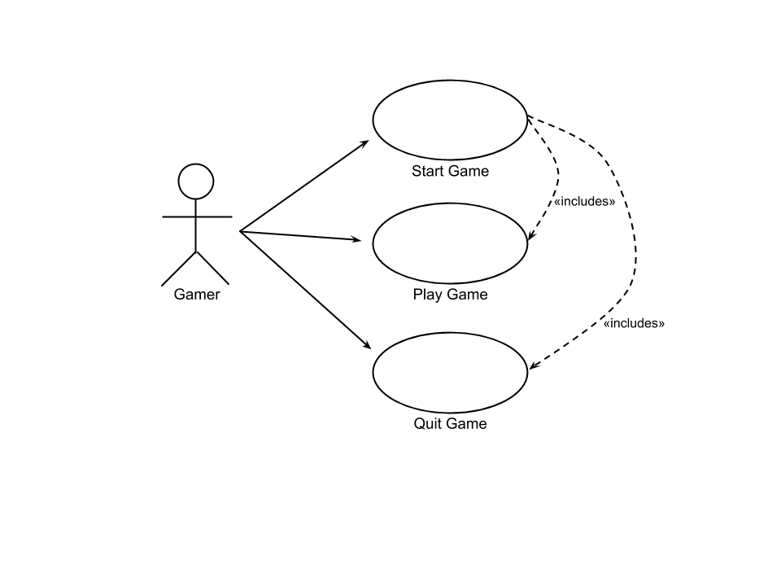UC 1 Start Game

Precondition: none.

Postcondition: the game menu is shown.

# Main scenario

1. Starts when the user wants to begin a session of the hangman game.
2. The system presents the main menu with a title, the option to play and quit the game.
3. The Gamer makes the choice to start the game.
4. The system starts the game (see Use Case 2).

Repeat from step 2

# Alternative scenarios

3.1 The Gamer makes the choice to quit the game.

The system quits the game (see Use Case 2)

4.1 Invalid menu choice

The system presents an error message.

Goto 2

UC 2 Play game

Precondition: The user has pressed the key corresponding to “Start Game”

Postcondition: the game is finished, asks to play again.

# Main scenario

1. Starts when the user has started the game from the menu.
2. The system has chosen a word and prompts the user for input.
3. The user inputs a letter.
4. The system checks if the word contains the letter.
5. The system displays the result and number of guesses left.
6. The user is prompted for input.

*Repeat from step 3*

# Correct guess scenario

* 1. The word is displayed, and the user is prompted to play again or quit.

# Wrong guess scenario

* 1. The user is prompted to play again or quit

UC 3 Quit Game

Precondition: The game is running.

Postcondition: The game is terminated.

# Main scenario

1. Starts when the user wants to quit the game.
2. The system prompts for confirmation.
3. The user confirms.
4. The system terminates.

# Alternative scenarios

3.1. The user does not confirm

The system returns to its previous state

State Machine Diagram



Class Diagram



Time log

|  |  |  |  |
| --- | --- | --- | --- |
| **Activity** | **Est. Time** | **Date** | **Actual time** |
| Reading of Chapter 4,5,6,7,15 and 20 | 20 hrs | 19-02-12/13/15/16/19 | 16 hrs |
| Viewing of online lectures | 4 hrs | 19-02-13/15 | 7 hrs |
| Course lectures on campus | 8 hrs | 19-02-06/13/20 | 6hrs |
| Design features to hangman | 2 hrs | 19-02-19/20 | 1 hr |
| Implement features to hangman | 10 hrs | 19-02-19/20/21/22 | 9 hrs |
| Developing project plan | 4 hrs | 19-02-19 | 1 hr |
| Working on diagrams | 4 hrs | 19-02-19/20/21 | 4 hrs |
| Studying for test | 3 hrs | 19-02-21 | 3 hrs |
| **total** | 55 hrs |  | 47 hrs |