BALANGKAS: A GAMIFIED E-LEARNING AND ASSESSMENT SYSTEM FOR DATA STRUCTURES AND ALGORITHMS

A Capstone Proposal
Presented to the Faculty of
College of Information and Communications Technology
STI West Negros University

In Partial Fulfilment
of the Requirements for the Degree
Bachelor of Science in Information Technology

Vicente E. Pioneta
Lee Ruben H. Valero
Benedict P. Piñon
Dave Venge S. Malunes

March 2026

ENDORSEMENT FORM FOR PROPOSAL DEFENSE

TITLE OF RESEARCH: Balangkas: A Gamified E-Learning and AssessmentSystem For Data Structures and Algorithms

NAME OF PROPONENTS: Vicente E. Pioneta Jr.
Lee Ruben H. Valero
Benedict P. Piñon
Dave Venge S. Malunes

In Partial Fulfilment of the Requirements
for the degree Bachelor of Science in Information Technology
has been examined and is recommended for Proposal Defense.

ENDORSED BY:

RHYAN C. DE LOYOLA
Capstone Adviser

APPROVED FOR PROPOSAL DEFENSE:

DANICA S. DUAZO
Capstone Coordinator

NOTED BY:

MAE B. LODANA, PhD TM
CICT Dean

May 2026
APPROVAL SHEET

This thesis titled Balangkas: A Gamified E-Learning and Assessment System For Data Structures And Algorithms , prepared and submitted by Vicente E. Pioneta Jr.; Lee Ruben H. Valero; Benedict P. Piñon ; and Dave Venge S. Malunes, in partial fulfillment of the requirements for the degree of Bachelor of Science in Information Technology, has been examined and is recommended for acceptance and approval.

RHYAN C. DE LOYOLA
Capstone Adviser

Accepted and approved by the Capstone Review Panel
in partial fulfillment of the requirements for the degree of
Bachelor of Science in Information Technology

MYCA PACIBO | KURT N. BONCALON
Panel Member | Panel Member

ORVILLA V. BALANGUE, MSCS
Lead Panelist

APPROVED:

DANICA S. DUAZO | MAE B. LODANA, PhD TM
Capstone Coordinator | CICT Dean

May 2026

ACKNOWLEDGEMENTS

We would like to express their sincere gratitude to all individuals who contributed to the completion of this study.
First and foremost, we extend our deepest appreciation to our capstone adviser Mr.Rhyan De Loyola for the continuous guidance, support, and valuable insights provided throughout the development of this study. His expertise and encouragement greatly contributed not only in the development of the study but also in our well-being.
We would also like to thank our validators Ms.Cherry Ann Angus, Mr.Jhunrhick Tarre, and Mr.Raymart Abella for their time, effort, and constructive feedback in evaluating the survey for data collection. Their suggestions and professional insights helped improve the quality and reliability of the study.
Special thanks to our capstone review panel, our head panelist, Engr. Orvilla Balangue, our panel members, Ms. Kurt Boncalon and Ms. Myca Pacibo for their valuable recommendations, comments, and guidance, which helped refine and strengthen the study.
Also to our parents and guardians we are always grateful for their unwavering financial support, understanding, and encouragement throughout the development of the study.
To our friends for their moral support, motivation, and inspiration that helped us persevere in developing this study.
Above all, we offer our deepest gratitude to God Almighty for the strength, wisdom, and guidance in overcoming challenges and making this study possible.

ABSTRACT

Title of research: <Research Title>

Researchers: < Researcher’s Given Name MI. Family Name>
< Researcher’s Given Name MI. Family Name>
< Researcher’s Given Name MI. Family Name>
< Researcher’s Given Name MI. Family Name>

Degree: Bachelor of Science in <Program>

Date of Completion: <Month year of graduation>

Keywords: <keywords of your research>

The abstract is an important component of your thesis. Presented at the beginning of the thesis, it is likely the first substantive description of your work read by an external examiner. You should view it as an opportunity to set accurate expectations. The abstract is a summary of the whole thesis. It presents all the major elements of your work in a highly condensed form. An abstract is not merely an introduction in the sense of a preface, preamble, or advance organizer that prepares the reader for the thesis. In addition to that function, it must be capable of substituting for the whole thesis when there is insufficient time and space for the full text. Currently, the maximum sizes for abstracts submitted are 150 words to 350 words. Usually a one-pager abstract is the most ideal. To preserve visual coherence, you may wish to limit the abstract for your research to one 1.5-spaced page, about 280 words. The structure of the abstract should mirror the structure of the whole thesis and should represent all its major elements. There should be one or more sentences assigned to summarize each chapter.
In the succeeding paragraphs, there should be no indentations, paragraphs are justified with left alignment. Delete this highlighted section and replace it with your Abstract.

TABLE OF CONTENTS
 |  | Page
Title Page |  | i
Endorsement Form for Oral Defense |  | ii
Approval Sheet |  | iii
Acknowledgments |  | iv
Abstract |  | v
Table of Contents |  | vi
List of Tables |  | vii
List of Figures |  | viii
List of Appendices |  | ix
CHAPTER I – INTRODUCTION
 | Background of the Problem | 1
 | Overview of the Current State of the Technology
 | Objectives of the Study
 | Significance of the Study
 | Scope and Limitations of the Study
 | Definition of Terms
CHAPTER II - REVIEW OF RELATED LITERATURE AND STUDIES
Foreign Related Literature
Local Related Literature
Foreign Related Studies
Local Related Studies
Synthesis
CHAPTER III – METHODOLOGY
Overview of the Project
System Methodology
System Functionalities
System Requirements
System Technicalities
Calendar of Activities
Budgetary Estimate
APPENDICES
CURRICULUM VITAE

LIST OF TABLES

Table |  | Page
1 | <Title of the table>
2 | <Title of the table>
3 | <Title of the table>
4 | <Title of the table>

LIST OF FIGURES

Figure |  | Page
1 | <Title of the figure>
2 | <Title of the figure>
3 | <Title of the figure>
4 | <Title of the figure>

LIST OF APPENDICES

Appendix |  |  |  |  | Page
 | A Data Sources
 | B Report Layouts/Forms
 | C Written Communications
 | D Interview Guide/Survey Questionnaire
 | E Benefactor’s Location Map
 | F Pictures (Data Gathering)
 | G Actual Thesis Expenses
 | H Adviser’s Acceptance Form
 | I Advisee and Adviser Agreement

CHAPTER I

Background of the Problem
Data Structures and Algorithms are core subjects in computing programs because they strengthen problem-solving, logic building, and efficient program design. However, many students find these topics difficult because the concepts are abstract and the processes happen behind the scenes. We observed that learning DSA at STI West Negros University presents similar challenges. Understanding key concepts was difficult when relying solely on provided learning materials and classroom instruction. Students often lacked sufficient guidance in breaking down complex topics, which affected their ability to fully grasp lessons. Additionally, the use of multiple programming languages, such as Java and Python, in teaching DSA may contribute to confusion among learners, as they are required to adjust to different syntaxes while simultaneously learning algorithmic concepts. This situation may divide students focus and further complicate the learning process.

Moreover, while the institution provides a Learning Management System (LMS), its primary use is limited to distributing course materials and submitting assignments. Based on observation, students tend to access the LMS only when necessary, such as for completing tasks or retrieving files. This indicates that the current system lacks interactive and engaging features that encourage continuous learning and active participation. Studies support that LMS platforms that do not incorporate interactive elements and feedback mechanisms may fail to sustain student engagement and motivation (Kaya & Ercag, 2023).
These challenges highlight a significant need for a more effective learning support system that goes beyond traditional teaching methods and static LMS platforms. There is a need for a system that can provide structured guidance, interactive learning experiences, and opportunities for students to actively engage with DSA concepts. In particular, integrating features such as pre-assessment and post-assessment can help measure student learning progress, while simulation-based activities can support visualization and deeper understanding of algorithmic processes.

In response to these needs, this study proposes the development of “Balangkas: A Gamified E-Learning and Assessment System for Data Structures and Algorithms” for CICT students at STI West Negros University. The system aims to address the identified problems by providing an interactive learning environment that integrates instructor-managed content, pre-test and post-test assessments, and simulation-based activities. Through the use of gamification and structured learning design, the system is expected to improve student engagement, enhance conceptual understanding, and support learners in mastering DSA concepts more effectively. The findings of this study may contribute to the improvement of teaching strategies and the development of more effective digital learning tools for complex computing subjects.

Overview of the Current State of the Technology
The teaching and learning of Data Structures and Algorithms (DSA) have evolved significantly with the advancement of educational technologies. Traditionally, DSA instruction has been delivered through classroom lectures and programming exercises, where instructors explain concepts while students apply them through coding tasks. While this approach provides foundational knowledge, studies have shown that it is often insufficient for helping students fully understand abstract algorithmic processes, as learners are required to mentally visualize operations without interactive support (Del Mundo & Caballes, 2022). As a result, students frequently experience difficulty in grasping complex topics such as recursion, sorting algorithms, and data structure manipulation.
To address these limitations, Learning Management Systems (LMS) were introduced as platforms for organizing course materials, distributing resources, and managing student assessments. Systems such as Moodle and similar platforms have been widely adopted in higher education institutions to support online and blended learning environments. However, research indicates that LMS platforms are often used primarily for content delivery and administrative purposes rather than as interactive learning tools. In many cases, students engage with the system only when required to submit assignments or access files, limiting its effectiveness in promoting continuous learning and engagement (Kaya & Ercag, 2023).
In recent years, more advanced educational technologies have emerged, including visualization tools and gamified learning systems designed to enhance student interaction and understanding. Visualization platforms allow learners to observe how algorithms operate step-by-step, making abstract concepts more concrete and easier to comprehend. Meanwhile, gamified systems incorporate elements such as points, levels, challenges, and feedback mechanisms to increase motivation and engagement. Studies have shown that these approaches can significantly improve student participation and learning outcomes when properly integrated into the instructional process (Dichev & Dicheva, 2017; Koivisto & Hamari, 2020).
Despite these advancements, existing systems still present several limitations. Many visualization tools focus solely on demonstrating algorithm behavior without integrating structured assessments or instructor-guided learning. On the other hand, gamified platforms often emphasize engagement but lack alignment with course content and formal assessment strategies. Additionally, most systems do not provide a unified environment where instructors can manage lesson content, monitor student progress, and integrate both assessment and interactive learning activities. This fragmentation limits the effectiveness of current technologies in fully addressing the challenges associated with learning DSA.
Furthermore, while these technologies have been available for several years, their implementation in actual classroom settings remains inconsistent. Some institutions continue to rely on traditional teaching methods, while others use LMS platforms that do not fully utilize interactive features. As a result, the core problem of helping students effectively understand and apply DSA concepts persists despite the availability of various technological solutions.
Given the current state of technology, there is a clear need for a more integrated and structured learning system that combines the strengths of existing approaches while addressing their limitations. This study aims to develop “Balangkas: A Gamified E-Learning and Assessment System for Data Structures and Algorithms,” which integrates instructor-managed content, structured pre-test and post-test assessments, and simulation-based learning activities within a single platform. By addressing the gaps in existing technologies, the proposed system seeks to provide a more effective solution for improving student engagement, understanding, and performance in DSA.

Figure 1
Existing Workflow

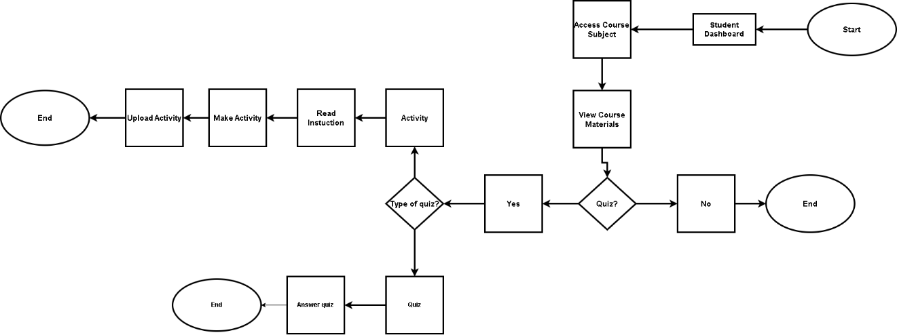

We have identified problems encountered by the beneficiary in the existing workflow. These are the following:
1. Students experience difficulty in understanding abstract concepts in Data Structures and Algorithms, especially when lessons are presented in a purely theoretical manner.
2. Traditional teaching methods rely heavily on lectures and static materials, which often result in low student engagement.
3. Many students struggle to visualize how algorithms work step-by-step, leading to confusion in implementation.
4. There is a lack of interactive learning tools that allow students to practice Data Structures and Algorithms concepts in a hands-on manner.
5. Instructors have limited platforms where they can easily upload and manage structured learning materials.
6. Students often lack immediate feedback when answering exercises, slowing down their learning progress.
7. Existing systems do not effectively measure students’ learning progress before and after instruction.
8. Monitoring student performance across different activities is difficult using manual or traditional methods.
Objectives of the Study
The main objective of the study is to develop BALANGKAS, a gamified e-learning and assessment system that makes Data Structures and Algorithms easier to understand while improving student engagement and academic performance among CICT students.
Specifically, the study aims to:
1. To enhance students’ understanding of abstract Data Structures and Algorithms concepts through simulation-based lessons and interactive visualizations.
2. To increase student engagement in learning by integrating gamification elements such as points, levels, rewards, and feedback mechanisms.
3. To provide step-by-step visualization of algorithm processes to help students better understand their execution and implementation.

4. To develop an interactive platform that allows hands-on practice of Data Structures and Algorithms concepts.
5. To provide instructors with a web-based platform for organizing and managing structured learning materials.
6. To deliver immediate feedback on student activities and exercises to support continuous learning improvement.
7. To implement assessment tools such as pre-tests and post-tests to measure students’ learning progress and knowledge gains.
8. To track and monitor student performance across various activities and assessments within the system.
Scope and Limitations of the Study
The study focuses on the development of a web-based gamified e-learning and assessment system for Data Structures and Algorithms. The primary users of the system are CICT students at STI West Negros University who have already taken DSA, with second-year students as the main target users given their proximity to the subject. Third-year and fourth-year CICT students were also included as survey respondents to supplement the sample and ensure the minimum required count was met. Instructors will manage the learning materials and assessments through the system. The system will include modules for lesson viewing, simulation-based activities, quizzes, pre-test and post-test assessments, performance tracking, and gamified feedback.

The scope of the study is limited to the selected DSA topics that will be included in the proposed system. It will not replace the full classroom teaching process, and it will not cover all advanced programming or software engineering topics. The system will also depend on internet access and user participation, which may affect performance in actual deployment. Because the study is focused on a specific academic context, its results may not automatically apply to all institutions or all computer science courses.

Significance of the Study
This study bring significance to:

Students. This study will help students better understand abstract DSA concepts through visual, interactive, and game-based learning activities. It may also improve motivation, confidence, and independent study habits.

Instructors. This study will provide instructors with a platform for organizing lessons, uploading learning materials, and monitoring student progress in a more efficient way.

The Institution. This study may support the institution in improving the quality of instruction for core computing subjects and in promoting the use of innovative educational technology.

Future Researchers. This study may serve as a reference for future developers and re-searchers who want to create similar systems for other difficult subjects or for broader learning environments

Definition of Terms
To ensure clarity and better understanding of the key concepts used in this study, the following terms are defined operationally and conceptually as applied within the context of the study.

Gamification. This refers to the use of game design elements in non-game contexts to enhance user engagement, motivation, and participation (Dichev & Dicheva, 2017).

E-Learning. This is a mode of education that utilizes digital platforms and electronic technologies to deliver instructional content and facilitate learning (Caporarello, Magni, & Pennarola, 2017).

Data Structures and Algorithms (DSA). This refers to the methods used to organize, store, and process data efficiently, as well as the step-by-step procedures for solving computational problems (Goodrich, Tamassia, & Goldwasser, 2014).

Interactive Visualization. This refers to graphical representations of data or processes that allow users to manipulate and explore information dynamically to enhance understanding (Ware, 2013).

Simulation-Based Learning. This refers to an instructional approach that uses modeled environments or systems to replicate real-world or conceptual processes for educational purposes (Lateef, 2010).

Learning Management System (LMS). This refers to a software platform used to deliver, manage, and track educational courses, instructional materials, and learner performance (Turnbull, Chugh, & Luck, 2021).

Assessment. This refers to the systematic process of evaluating students’ knowledge, skills, and learning progress using various tools such as tests, quizzes, and activities (Black & Wiliam, 2009).

Pre-test and Post-test. This are assessment methods used to measure learners’ knowledge before and after instruction in order to determine learning gains (Dimitrov & Rumrill, 2003).

Student Engagement. This refers to the level of students’ active participation, involvement, and emotional investment in the learning process (Fredricks, Blumenfeld, & Paris, 2004).

Feedback Mechanism. This refers to a process that provides learners with information about their performance to guide improvement and enhance learning outcomes (Hattie & Timperley, 2007).

CHAPTER II

REVIEW OF RELATED LITERATURE AND STUDIES

This chapter presents a comprehensive review of both foreign and local literature and studies that are relevant to the development of the proposed system. It explores existing concepts, theories, and prior research related to gamification, e-learning systems, visualization techniques, simulation-based learning, and learning analytics. These topics are essential in understanding how modern educational technologies enhance student engagement, motivation, and learning outcomes, particularly in technical subjects such as Data Structures and Algorithms (DSA).

Foreign Related Literature
Gamification in Education
Gamification has become a widely explored strategy in education due to its ability to increase motivation, engagement, and participation among learners. Kurt (2023) explains that gamification involves the application of game mechanics such as point-scoring, rewards, and competition into educational contexts, tapping into students' natural desire for achievement to create more meaningful learning experiences. The primary goal of gamification is to boost motivation, improve material retention, and encourage active participation through immediate feedback. Supporting this view, Hamari, Koivisto, and Sarsa (2014) emphasized that game elements such as points, badges, rewards, and leaderboards positively influence students' learning experiences and increase active participation. The researchers explained that gamification encourages learners to remain engaged in activities by creating a sense of achievement and progression, which is directly relevant to the design of Balangkas, which integrates these elements to support DSA learning.
The effectiveness of gamification has also been demonstrated in online and blended learning environments. Domínguez-Díaz et al. (2013) found that students exposed to gamified learning systems showed higher motivation, participation, and engagement compared to those in traditional settings, concluding that gamification positively affects practical learning performance and learner participation. Similarly, Abu-Hammad and Hamtini (2023) investigated the use of gamification in online programming education, finding that students who used gamified systems demonstrated improved engagement, motivation, and participation. The researchers concluded that gamification significantly enhances online learning experiences and learner satisfaction. These findings underscore the appropriateness of incorporating gamification into a platform designed to support the learning of complex subjects such as Data Structures and Algorithms.
Lamrani and Abdelwahed (2020) further reinforced this perspective by demonstrating that simulation-based and game-based learning enhances learner participation and improves conceptual understanding through interactive activities. Their literature highlighted that interactive simulations help learners actively engage with educational content rather than passively consuming information and that these environments improve problem-solving and analytical thinking skills. This is consistent with the design goals of Balangkas, which integrates simulation-based activities for learners to interact with DSA concepts in a structured and engaging way.
Challenges in Learning Data Structures and Algorithms
Data Structures and Algorithms (DSA) is widely recognized as one of the most challenging courses in computing programs. Mtaho and Mselle (2024) conducted a comprehensive literature review of the main causes of student difficulties in learning DSA, using the Cognitive Load Theory (CLT) as an analytical lens. Their review found that DSA content is highly interconnected and imposes a very high cognitive load, resulting in higher failure and dropout rates. Specifically, difficulties were traced to the abstract and dynamic nature of DSA concepts, poor instructional methods, curricula organization, inadequate instructional materials, lack of conceptual understanding, poor problem-solving skills, faulty mental models, and low student motivation. The study recommended that instructors adopt new instructional approaches and tools that stimulate student motivation and minimize learning overheads, particularly for beginners.
Musina (2024) similarly addressed the problems in teaching algorithms and data structures, emphasizing the importance of personalized learning and adaptive algorithms in the modern educational process. The study found that the development of high-quality educational materials and tools, including interactive simulators and visualizers, contributes to a better understanding of complex concepts and the practical application of knowledge. Musina recommended that these tools be integrated into the learning environment to provide deep understanding and skills that meet modern requirements. This perspective directly supports the development of Balangkas, which incorporates step-by-step algorithm visualization and simulation-based activities to address the conceptual difficulties identified in the literature.

Visualization and Interactive Learning in Computer Science Education
The role of visualization in reducing the cognitive difficulty of learning complex computational concepts has been well-established in the literature. Theoharis, Papaioannou, Platis, and Patrikalakis (2008) explained that graphical and visual representations improve comprehension and reduce cognitive difficulty when dealing with abstract processes and structures. Their work emphasized that visualization allows learners to better understand relationships, movements, and transformations within systems, which is particularly valuable in DSA where operations such as sorting, searching, and traversal are not visually apparent through text-based instruction alone.
Osman and Elmusharaf (2014) investigated the effectiveness of combining algorithm and program animation in teaching data structure courses, presenting a visualized learning environment using an embedded visualizer to produce animation. Their experimental study involving two groups found that combining Algorithm and Program Animation is an effective way to enhance students' performance, with students exposed to animation performing significantly better in understanding the course material. This supports the inclusion of animated, step-by-step algorithm visualizations in the Balangkas system as a key instructional feature.
Lepouras, Katifori, Vassilakis, Antoniou, and Platis (2014) further highlighted the importance of learning analytics platforms in supporting educational processes. Their study emphasized that monitoring learner performance helps instructors identify weaknesses, measure progress, and provide appropriate interventions, while learning analytics also assist in evaluating the effectiveness of educational systems and learning materials. This literature supports the performance tracking and progress monitoring features integrated into Balangkas, which allow instructors to manage student outcomes and provide timely feedback.
Local Related Literature
Gamification in Philippine Education
In the Philippine context, gamification has gained increasing recognition as an effective strategy in higher education and various learning settings. Duterte (2024) conducted a mixed-methods study using a quasi-experimental pretest-posttest design with 133 undergraduate students from three private universities in Manila. Gamification elements including points, badges, leaderboards, and collaborative challenges were integrated into an online learning environment. The study revealed statistically significant improvements in academic performance and motivation following the gamification intervention, with thematic analysis of qualitative data highlighting students' positive perceptions of the gamified learning environment and increased engagement and enjoyment. However, the study noted that individual differences, such as prior gaming experience, influenced responses to gamification, suggesting the need for tailored approaches in system design.

Domingo, Bautista, and Fajardo (2025) likewise explored the impact of gamified e-learning platforms on student engagement and academic performance in higher education institutions in the Philippines. Their mixed-methods study with 150 undergraduate students across three universities found that 82% of participants reported increased motivation and engagement when using gamified learning platforms, and 67% demonstrated improved academic performance compared to those using traditional e-learning methods. Students particularly responded positively to badges, leaderboards, and point-based systems, which enhanced their sense of competition and achievement. The study concluded that gamification holds significant potential to improve the effectiveness of e-learning in the Philippine educational context, despite some challenges related to internet accessibility and culturally relevant design.
Gabatin et al. (2025) examined the effectiveness of gamification on student satisfaction and learning outcomes at Mapua Malayan Colleges Laguna using the Technology Acceptance Model (TAM) and PLS-SEM methodology with 413 respondents. The findings showed that gamification has a favorable impact on student satisfaction and learning, with perceived usefulness mediating the association between gamification features and learning effectiveness. Similarly, Cajilla and Bug-os (2022) found that the use of a gamified learning management system increased students' academic achievement in Physical Science and that students had a positively perceived satisfaction with using the gamified LMS. These findings reinforce the rationale for incorporating gamification features into Balangkas and suggest that such features can meaningfully improve both performance and learner satisfaction.
A systematic review by Guisadio et al. (2025) examined gamified elements in Philippine education and found that points, badges, leaderboards, quests, and levels positively affect learner motivation, engagement, and academic performance in Philippine educational settings. Their review emphasized that gamified educational systems encourage active learner participation and improve the learning experience among Filipino students, directly supporting the gamified features incorporated into the proposed Balangkas system for DSA learning. This is further corroborated by Nob, Roble, and Lomibao (2024), who revealed through a literature review in the Philippine context that gamification improves learner engagement, motivation, academic performance, and higher-order thinking skills among Filipino learners.
Pelegro (2022) discussed how gamification improves student motivation and engagement in online educational environments in the Philippines, emphasizing that integrating game mechanics into online learning creates more interactive and enjoyable experiences. Landicho et al. (2017) similarly demonstrated through their Hortari application that gamification improves student engagement and motivation in higher education, with game mechanics positively affecting student productivity and learning participation. These local works collectively affirm that gamified learning environments are both contextually relevant and educationally beneficial in the Philippine higher education setting.

2.2 Related Studies and/or Systems
2.2.1 Comparative Analysis of Related System
This section presents a review of existing systems and studies relevant to the development of the study. The review covers works on gamification in education, the challenges associated with learning Data Structures and Algorithms (DSA), visualization and simulation-based learning, as well as existing systems both locally and internationally. These prior works are examined to establish the theoretical and empirical foundations of the proposed system, identify gaps in existing approaches, and highlight the significance of developing an integrated and interactive learning platform for DSA learners.
Table 1
Comparison of Related Systems/Applications
System Name & Criteria | VisuAlgo | AGBL | Stack GBL | Active Learning Game (Dicheva & Hodge | Code It! | Hortari | CSS Quest | LogIO | Balangkas (Proposed)
Platform | Web | Web | Web | Web | Web | Web | Web | Web and Mobile | Web
Target Subject | Data Structures & Algorithms | Data Structures | Data Structures (Stack) | Data Structures (Stack) | Iterative Programming | General | Computer System Servicing | Digital Logic Gates | Data Structures & Algorithms
Gamification Elements | No | Partial | Partial | Yes | Yes | Yes | Yes | Yes | Yes
Points, Badges & Leaderboards | No | No | No | Partial | Yes | Yes | Yes | Yes | Yes
Algorithm Visualization | Yes | Yes | Yes | Partial | No | No | No | Partial | Yes
Simulation-Based Activities | Partial | Yes | Yes | Yes | Yes | No | No | No | Yes
Pre-test & Post-test Assessment | No | No | Yes | Yes | No | No | No | No | Yes
Instructor Content Management | No | No | No | No | No | No | No | No | Yes
Performance Tracking & Analytics | Partial | No | No | No | No | No | Partial | Partial | Yes
Immediate Feedback Mechanism | Partial | Partial | Yes | Yes | Yes | Yes | Yes | Yes | Yes
Methodology | Iterative Development | Quasi-Experimental | Pre-Experimental | Quasi-Experimental | Experimental | Developmental | Iterative & Incremental | Developmental-Evaluative | DevOps CI/CD

Based on the comparative analysis presented above, it is evident that while several systems address aspects of DSA learning through visualization or gamification, no existing system fully integrates instructor-managed content, step-by-step algorithm visualization, pre-test and post-test assessments, simulation-based activities, performance tracking, and gamified feedback within a single unified platform. Balangkas addresses all of these dimensions in one cohesive system, making it a more comprehensive and contextually adapted solution for CICT students at STI West Negros University.

2.3 Synthesis/Research Gap
The reviewed literature and studies consistently demonstrate that gamification, interactive visualization, and simulation-based learning are effective strategies for improving student engagement, motivation, and academic performance, particularly in technically demanding subjects such as Data Structures and Algorithms. Internationally, studies confirm that gamified elements such as points, badges, leaderboards, and rewards positively influence learning outcomes (Hamari et al., 2014; Domínguez-Díaz et al., 2013; Abu-Hammad & Hamtini, 2023). In the Philippine context, local research likewise affirms that gamification improves motivation and engagement among Filipino learners at various educational levels (Duterte, 2024; Guisadio et al., 2025; Domingo et al., 2025). Visualization tools have further been shown to reduce cognitive load and improve conceptual understanding of abstract algorithmic processes (Osman & Elmusharaf, 2014; Theoharis et al., 2008; Halim, 2015).
However, the synthesis of existing works reveals a significant research and development gap. Most reviewed systems address only one or two dimensions of effective DSA instruction. Visualization platforms such as VisuAlgo improve conceptual understanding but lack gamification and structured assessment features. Gamified systems such as Code It! and CSS Quest improve engagement but were not developed for DSA and do not integrate step-by-step algorithm visualization. Other systems such as AGBL and the Stack game-based learning tools provide gamified DSA experiences but do not include instructor-managed content delivery or performance analytics. Furthermore, no existing local system has been developed to address the specific needs of DSA learners in the CICT program at STI West Negros University.
Balangkas directly addresses this gap by proposing a unified, gamified e-learning and assessment system that integrates all of the following components within a single platform: instructor-managed lesson delivery, step-by-step algorithm visualization, simulation-based learning activities, pre-test and post-test assessments, gamification elements, and performance tracking. By bridging the identified gap between engagement-focused and content-focused systems, Balangkas seeks to provide a more effective, complete, and contextually relevant solution for improving student understanding and performance in Data Structures and Algorithms

2.4 Conceptual Framework
Figure2.
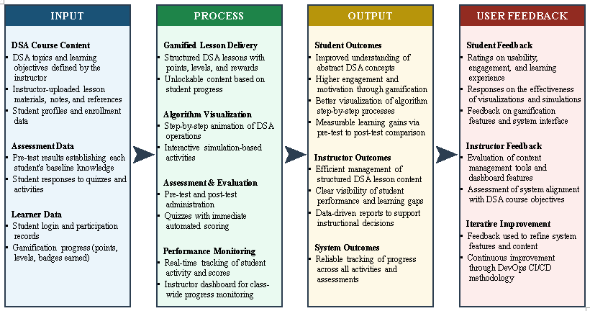

CHAPTER III

METHODOLOGY

This chapter presents the methodology used in the development of the proposed system, BALANGKAS. It discusses the methods, procedures, and techniques employed to address the identified learning difficulties encountered by students in Data Structures and Algorithms (DSA). The chapter also explains how the researchers gathered and analyzed the necessary data to support the development of the system.
Based on the survey conducted, students commonly experience difficulties in understanding DSA concepts, implementing logic, remembering algorithmic processes, and visualizing complex structures such as recursion, trees, and graphs. The findings also revealed that many students rely on external learning resources and expressed positive perceptions toward gamified learning approaches. In response to these challenges, the proposed system aims to provide a more interactive, engaging, and learner-centered platform through the integration of gamification features, visual learning tools, and assessment mechanisms.
Furthermore, this chapter describes the research design, respondents of the study, data gathering procedures, instruments used, system development methodology, software and hardware requirements, database design, system architecture, and testing procedures. These sections are interconnected and collectively demonstrate how the proposed system was carefully planned, developed, and evaluated to ensure that it effectively addresses the objectives of the study and improves students’ learning experience in DSA.

Research Design
The study employs a developmental research design, which is appropriate for studies that involve the systematic design, development, and evaluation of a product or system intended to solve an identified problem. Since the primary output of this study is a gamified learning system for Data Structures and Algorithms (DSA), the developmental design serves as the overarching framework that guides the entire research process—from identifying learning difficulties to designing, building, and evaluating the proposed system.
To support the developmental process, the study also incorporates a mixed method data-gathering approach, combining quantitative and qualitative techniques. The quantitative component consists of survey responses from students enrolled in the College of Information and Communications Technology (CICT), which will help identify the common difficulties, perceptions, and learning needs related to DSA. The qualitative component consists of interviews with DSA instructors, which will provide contextual insights into the problems observed during classroom instruction. Together, these two data sources establish an evidence-based foundation for the design and development of the gamified system.
By adopting a developmental design supported by mixed method data gathering, the study ensures that the proposed solution is not only technically grounded but also responsive to the actual experiences of both students and instructors. This approach allows the researchers to systematically develop a system that is informed by empirical evidence and validated through appropriate evaluation methods.

System Development Methodology
The study adopts the DevOps methodology in developing the proposed system, Balangkas. DevOps is a software development approach that integrates development and operations practices into a continuous, iterative cycle — covering planning, coding, building, testing, releasing, deploying, operating, and monitoring. It is well-suited for this project because the gamified learning system requires ongoing refinement of its interactive features, quick response to testing feedback, and consistent coordination among team members throughout the development process.
The DevOps workflow is divided into two sides: the Dev Side, which covers the activities directly involved in building the system, and the Ops Side, which handles everything from releasing the finished build to keeping the live system running and monitored.

Dev Side
Plan. The team used MS Teams for communication, meeting coordination, and adviser consultations throughout the project. GitHub Issues served as the task tracker, where features, bugs, and development tasks were logged and assigned to team members on a per-sprint basis.
Code. Visual Studio Code (VS Code) was the team's primary development environment, chosen for its lightweight build and strong extension support for JavaScript, React, and Tailwind CSS. Git handled local version control, allowing developers to track changes and manage branches independently. GitHub served as the remote repository where all code was stored, reviewed through pull requests, and merged — supporting parallel development across the team.
Build. Node.js provided the runtime environment for executing JavaScript outside the browser and running local development servers. npm managed project dependencies and executed build scripts, including npm run build, to compile the application into a production-ready bundle. React was chosen for its component-based architecture and efficient state management, both of which are well-suited for the platform's dynamic and interactive pages. PhaserJS was selected as the game framework for rendering DSA simulations and algorithm visualizations directly in the browser, requiring no additional installation from the user. Tailwind CSS handled responsive styling through utility-based classes applied directly within components, eliminating the need for large separate stylesheet files.
Test. Manual testing was conducted using the web browser to verify the functionality, layout, and behavior of all system features. Chrome DevTools was used to inspect UI elements, debug JavaScript errors, monitor network requests, and test responsiveness across different screen sizes.
Ops Side
Release. The release phase is triggered automatically when a developer pushes finalized code to the main branch on GitHub. This push integrates directly with Netlify, initiating an automatic deployment without any manual release step — reducing human error and speeding up delivery.
Deploy. Netlify hosts the production build of Balangkas. Every push to the main branch on GitHub prompts Netlify to pull the latest build and deploy it to a live URL. This continuous deployment setup ensures users always have access to the most recent version of the system without requiring manual server management.
Operate. Supabase serves as the backend-as-a-service layer of the system, providing a PostgreSQL database, user authentication, and a RESTful API that handles all data transactions — including student accounts, progress tracking, scores, and instructor-managed content. Node.js supports server-side scripting and manages API communication between the frontend and Supabase.
Monitor. System monitoring is carried out by reviewing Supabase dashboard logs to track database activity, API calls, and authentication events. The browser console is used to catch and inspect runtime errors in the live production environment, allowing the team to identify and address issues reported during actual use.
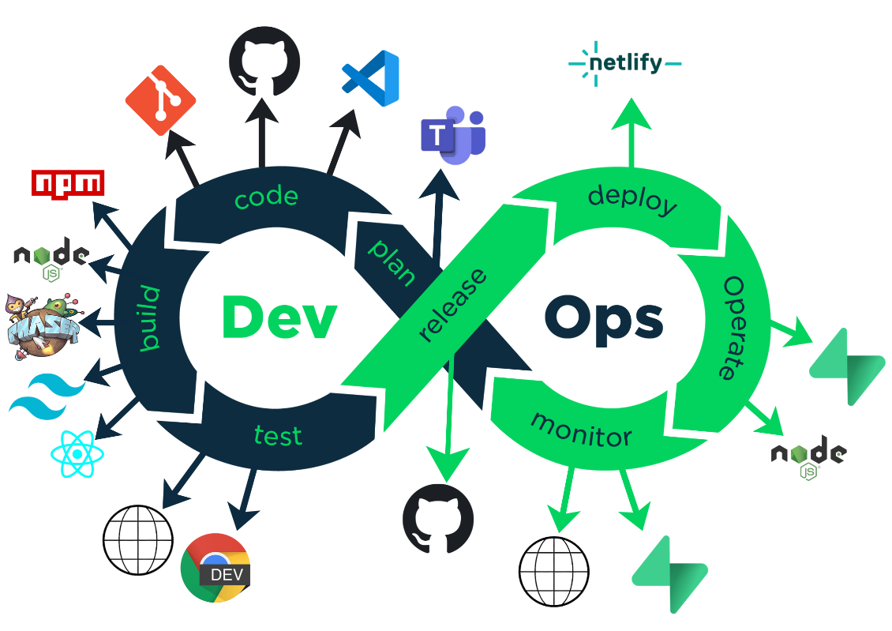

Data Gathering
Data gathering is necessary in order to determine whether existing problems are present in the teaching and learning of Data Structures and Algorithms. The responses collected from both instructors and students will serve as the primary basis for identifying the difficulties that the proposed system must address. The researchers will gather data from the instructors through interviews and from the students through survey questionnaires. These instruments are suitable because they allow the researchers to collect both descriptive and numerical information relevant to the study.
The interview guide for the DSA instructors will be used to obtain qualitative information regarding classroom challenges, student difficulties, and instructional concerns. The survey questionnaire for the students will be used to collect quantitative data on their experiences, understanding, engagement, and perceived difficulties in the subject. After the responses are collected, the researchers will count the responses, tabulate the results, and compute the mean in order to identify the most common issues and tendencies reflected in the data.
The collected information will support the study because it will provide evidence of the actual needs of the students and the observations of the instructors. These findings will guide the researchers in identifying the features and improvements that should be included in the gamified learning system. In this way, the data gathering procedure directly contributes to the development of a solution that is aligned with the real learning problems experienced in DSA.

Respondents/System Users
The primary respondents of the study are second-year students of the College of Information and Communications Technology (CICT) at STI West Negros University who have already taken Data Structures and Algorithms. These students will also serve as the main users and testers of the proposed gamified e-learning and assessment system. They are considered appropriate respondents because they have recently encountered the subject and can provide relevant insights regarding the level of difficulty, learning challenges, and overall experience in studying DSA.
Third-year and fourth-year CICT students were also included to widen the range of responses and support data reliability. While second-year students formed the primary group, higher-year students who had previously taken DSA were able to contribute relevant responses drawn from their own experience with the subject.
The estimated total population of second-year Information Technology students is 400. To determine the required sample size, the researchers applied Slovin's formula:
n = N / (1 + Ne²)
Where:
- n = sample size
- N = total population (400)
- e = margin of error (0.05 or 5%)
Solving for n:
n = 400 / (1 + 400 × 0.05²) n = 400 / (1 + 400 × 0.0025) n = 400 / (1 + 1) n = 400 / 2 n = 200
The computed minimum sample size is 200 respondents. The study collected a total of 210 responses, distributed as follows: 163 second-year students, 41 third-year students, and 6 fourth-year students. This exceeded the minimum required sample, which strengthens the reliability of the gathered data.
Among the 163 second-year respondents, thematic saturation was observed at approximately 20 to 30 responses, where recurring patterns and similar perceptions regarding DSA difficulties, learning obstacles, and gamified learning preferences became repetitive and no substantially new themes emerged. The continued collection beyond that point served to confirm the consistency of findings rather than uncover new ones.
The selected respondents are suitable for the study because they are CICT students of STI West Negros University who have already studied Data Structures and Algorithms and can provide meaningful feedback on the effectiveness of the proposed system in improving understanding, engagement, and learning experience.

Hardware and Software Requirements
VSCODE - We used this as our main IDE as this provides and supports extension for development.

Github - We used this for version control and group collaboration

Browser - Since we are developing a web based game browser is a necessary tool for testing.

DEVELOPMENT TOOLS

React Native - We chose to use React for the dynamic characteristic of React when it comes to UI updates rendering things like SPA(Single Page Application) behaviour through client-side routing and state management.

PhaserJS - Since our platform is web, we decided to use the framework PhaserJS. It's lightweight and is browser-based it also doesn't require any installations like every other game engines making its setup easier.

Tailwind - We use Tailwind on some pages that might need responsiveness across different screen resolutions. Its utility-based styling also speeds up development by allowing styles to be applied directly within components without creating large separate CSS files.

PROGRAMMING LANGUAGES

We used JavaScript as the main programming language for both the frontend interface and game logic of the platform as it is usually used to handle interactive features, user input, content rendering, and communication between different components of the system. JavaScript also works well with React and Phaser which is very suitable to web-based application and games

HARDWARE SPECIFICATIONS

The minimum hardware requirements for the system include a dual-core processor running at 1.8 GHz, 4 GB of RAM, and at least 200 MB of free storage space for browser cache and assets. The system also requires integrated graphics with WebGL 1 support, a display resolution of 1366×768, and a stable broadband internet connection with a minimum speed of 5 Mbps. For better performance and a smoother user experience, the recommended hardware specifications include a quad-core processor running at 2.5 GHz or higher, 8 GB of RAM or more, and at least 1 GB of free storage space. In addition, a modern integrated or dedicated GPU with WebGL 2 support, a display resolution of 1920×1080 or higher, and a high-speed broadband connection of 10 Mbps or higher are recommended.

APPENDICES

APPENDIX A

DATA SOURCES

<Forms/brochure/sample data from the beneficiary>

APPENDIX B

REPORT LAYOUT/FORMS

<Sample Report produced by the proposed system>

APPENDIX C

WRITTEN COMMUNICATION



APPENDIX D

INTERVIEW GUIDE

Capstone Title: BALANGKAS : A GAMIFIED E-LEARNING AND ASSESSMENT SYSTEM FOR DATA STRUCTURES AND ALGORITHMS
Thank you for participating in this survey. This study aims to identify the specific academic and technical roadblocks students face when learning Data Structures and Algorithms (DSA). Your honest feedback will help in developing more effective learning strategies and support systems for IT professionals and students alike.
All responses are anonymous and will be used strictly for research purposes. Please rate the following statements based on your personal experience.

Name (Optional) Year Level: ◻ 1st Year 2nd Year 3rd Year 4th Year
Status: ◻ Regular Student Irregular Student
Program: ◻ BSIT BSCS

Self-Assessment of Proficiency

  - What is your level of awareness with the concepts of Data Structure and Algorithm?

1. 2. 3. 4.
Novice / No Basic Awareness Working Knowledge Proficient Experience Basic awareness of DSA Understands common DSA Strong understanding of No
prior knowledge or concepts, but limited concepts and can apply DSA concepts and can exposure to Data understanding or them with some guidance. confidently apply them to
Structures and Algorithms experience. solve problems (DSA). independently.

  - How long have you been studying Data Structures and Algorithms (DSA)?
    - Less than a year
    - 1 year
    - More than 1 year
    - Haven’t studied at all

  - How difficult is it for you to understand DSA?
1. Very Easy 2. Easy 3. Moderate 4. Difficult 5. Very Difficult

  - On average, how much time do you spend mastering a specific concept of DSA until you can implement it independently?
Less than 1 hour 1 – 3 hours A Full Day Multiple days / Ongoing study

Perceived Difficulty and Learning Obstacles

  - Provide the difficulty level of each DSA concepts using the scales:
- Very Easy 2. Easy 3. Moderate 4. Difficult 5. Very Difficult
DSA Concept | Scale | DSA Concept | Scale
1. Arrays |  | 9. Graphs
2. Linked List |  | 10. Iteration
3. Stacks |  | 11. Recursion
4. Queues |  | 12. Algorithms
5. Trees
6. Heaps
7. Sets
8. Maps
- What primary roadblock/s do you face when working and understanding Data Structures and Algorithms? Select All that applies.
  - Understanding Concepts
  - Applying Concepts
  - Visualizing Data Structures
  - Remembering Processes
  - Implementing the Logic
  - Others:

- Please read each statement carefully and select the response that best reflects your personal experience. There are no right or wrong answers; your honest feedback is the most valuable asset to this study.
Scale: [1] Never | [2] Rarely | [3] Sometimes | [4] Often | [5] Always
 |  | 1 | 2 | 3 | 4 | 5
A. | Study Habits & Engagement
1. | I dedicate time to review or practice DSA concepts outside of my required class hours.
2. | I use external resources (e.g., YouTube, AI tools, or textbooks) to supplement my understanding of DSA.
3. | I perform "dry-runs" or manual traces of data structures on paper to understand their behavior.
B. | Technical & Conceptual Roadblocks

4. | I find it difficult to mentally visualize how data moves within a structure (e.g., pointers, recursion, or tree branching).
5. | I understand the theoretical logic of a structure but struggle to implement it in actual code.
6. | I struggle to remember the specific steps or patterns of an algorithm shortly after learning them.
7. | I find it challenging to calculate and solve problems in DSA.
8. | I experience "total blockage" where I cannot proceed with a problem even with the help of hints or notes.
C. | Problem-Solving & Application
9. I am confident in my ability to choose the most efficient data structure for a new, unseen problem.
10. I find myself relying on external solutions (e.g., Google or AI) rather than solving the logic independently.
11. I struggle to identify which specific algorithm (e.g., sorting vs. searching) is appropriate for a given task.
12. I find the mathematical foundations of DSA more challenging than the actual coding implementation.

- Do you have other platforms used when learning DSA?
No Yes, Specify

- Would gamification (points, badges, levels) motivate you to learn DSA?
Yes No Maybe
- Which gamification features would you prefer? Select all that applies
  - Points System
  - Badges/achievements
  - Leaderboards
  - Mini games
  - Progress Tracking
  - Reward System
  - Others:

- If given a chance, what will be your perception of a gamified DSA learning platform? Check all the applies.
  - I believe game elements (points, badges, leaderboards) would make me want to practice more consistently.
  - I think the interactive nature would help me "see" and understand complex structures (like Trees and Graphs) better than a textbook.
  - I feel that a game-like environment would make the difficult concepts of DSA feel less intimidating and more approachable.

  - I believe seeing my progress compared to my peers would push me to master topics faster.
  - I think a platform that lets me "level up" through coding challenges would better prepare me for technical interviews.
  - I am concerned that the game elements might distract me from actually learning the deep logic and math required.
  - I believe my learning style is better suited for traditional methods (lectures and labs) rather than games.

APPENDIX E

BENEFFACTOR’S LOCATION MAP

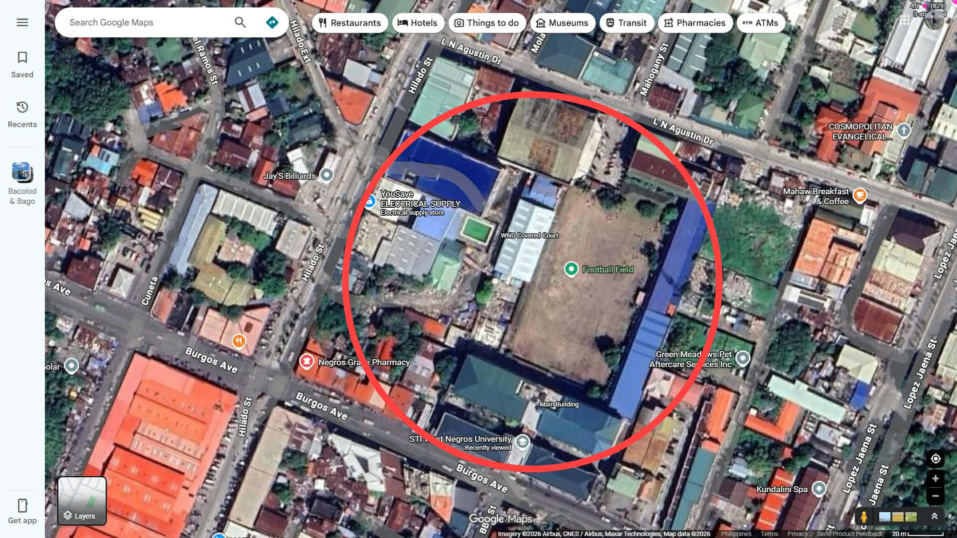

APPENDIX F

PICTURES (DATA GATHERING)

