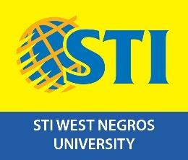
College of Information and Communications Technology
Burgos Street, Bacolod City, Negros Occidental, Philippines 6100 Tel. (034) 434 4561

May 05, 2026

Mae B. Lodana, Phd TM
CICT Dean
STI West Negros University Burgos Street, Bacolod City

THRU: Ariel T. Sumagaysay, MaEd, MSCS
Bachelor of Science in Information Technology
Program Head

Orvilla V. Balangue, MSCS
Bachelor of Science in Computer Science
Program Head

Dear Dr. Lodana

The undersigned are currently working on a capstone project entitled "BALANGKAS: A Gamified E-Learning and Assessment System for Data Structures and Algorithms for STIWNU 2nd year CICT Students" as part of our academic requirements for the Bachelor of Science in Information Technology. As part of our research process, we intend to conduct a survey among 2nd Year CICT students who have successfully completed the Data Structures and Algorithms (DSA) course during their first semester.
In this regard, we respectfully request your approval to administer this survey to the students. The purpose of this activity is to gather valuable data and insights regarding their past experiences with DSA, which will contribute significantly to the development and evaluation of our gamified system. Rest assured that any information provided by the respondents will be treated with strict confidentiality and used solely for academic purposes.
The survey will be conducted using printed questionnaires and will take approximately 10 to 15 minutes for the students to complete. We will ensure that the distribution and collection of these questionnaires will be properly coordinated so as not to disrupt any of their ongoing scheduled classes.
We would be highly grateful for your favorable response to this request. For any additional questions or concerns, please contact us at 09513622874 or vincepioneta@gmail.com.Thank you.

Vicente Pioneta Jr. BSIT 3rd Year Project Manager

Reviewed by:

Ms. Danica S. Duazo
Capstone Coordinator Approved by:

Dr. Mae B. Lodana
CICT Dean

