Touchstone 3: Visual Design and Responsive Layout
Name: Travis Erwin
Course: Introduction to Web Development
Date: 10/21/26
Selected Client: Riverbend Yoga Studio

Section 1: Preview Link and GitHub Link
Paste the GitHub Repository Link: Travasauras/RiverbendYogaStudio: Sophia intro to web development projects
Working Project/Preview Link: https://travasauras.github.io/RiverbendYogaStudio/

Section 2: Design Explanation

Respond to each prompt below. Focus on explaining your design decisions.

Your responses should reference specific elements from your website. General descriptions without examples may receive reduced credit.

Note: Your design should use 2 to 4 colors and no more than 2 font families, applied consistently across all pages.

Client Alignment
I thought of a yoga studio and considered the colors I may see in it. I thought of off-white or white walls, and different shades of green yoga mats and thought that would be a nice approach in the design for the Riverbend Yoga Studio. Clear headings and basic descriptions give the site an accessible feel for beginner and veteran yoga students. The navigation switches from horizontal on large screens to vertical on smaller/mobile screens to make the site accessible by a wider range of users.

Color Palette
In the rubric we were not given the colors to use, and I did not see these suggestions until I started this template. I used 4 different colors as described in my previous paragraph, an off white color that was (#F7F4EC), dark bluish green (#233F35), a light sea green color (#B8CBBB), and white (#FFFFFF). I manipulated the color palette in CSS Color Codes to find the hex suitable for the color I wanted. The headers use the light sea green color, with darker green text throughout each page. The main content in each page uses the off-white color

Typography
Georgia was used for the heading and Arial for the body text. Arial is a very readable font that I personally use in all of my own word assignments and thought it would be a good font to use for the longer passages in the site. After scrolling through sample fonts for the heading, I thought Georgia gave a nice readable font while keeping it somewhat different from the body arial font. 18 pixels in the body text with 1.6 line spacing keep everything readable without creating too much whitespace in the descriptions or class lists. Bold navigation links and larger headings give a visual hierarchy that helps users find the information they are looking for.

Responsive Design
The layout adapts to different screen sizes through flexible media sizing and a CSS media query. Smaller browsers and mobile devices make the navigation links to stack vertically, keeping them easy to read and eliminating the need for horizontal scrolling. At 768 pixels and above, the navigation links are horizontal and the main content padding increases from 20 to 40 pixels. Images and videos scale within their containers.

Design Challenge

The biggest challenge I encountered was deciding what content to include in the class descriptions and instructor biographies. I wanted the information to be useful to visitors and fit the yoga studio’s welcoming tone. A layout challenge was making the navigation work across different screen sizes. I used Flexbox to stack the links vertically on smaller screens and added a media query to arrange them horizontally on larger screens.

Section 3: Submission Checklist
☐x Updated HTML files
☐x External CSS file
☐x Working preview link
☐x Consistent color palette (2–4 colors)
☐x Consistent typography (1–2 fonts)
☐x Styles applied across all pages
☐x Flexbox used in layout
☐x At least one media query
☐x Readable text with sufficient contrast
☐x Completed design explanation

Section 4: Screenshot
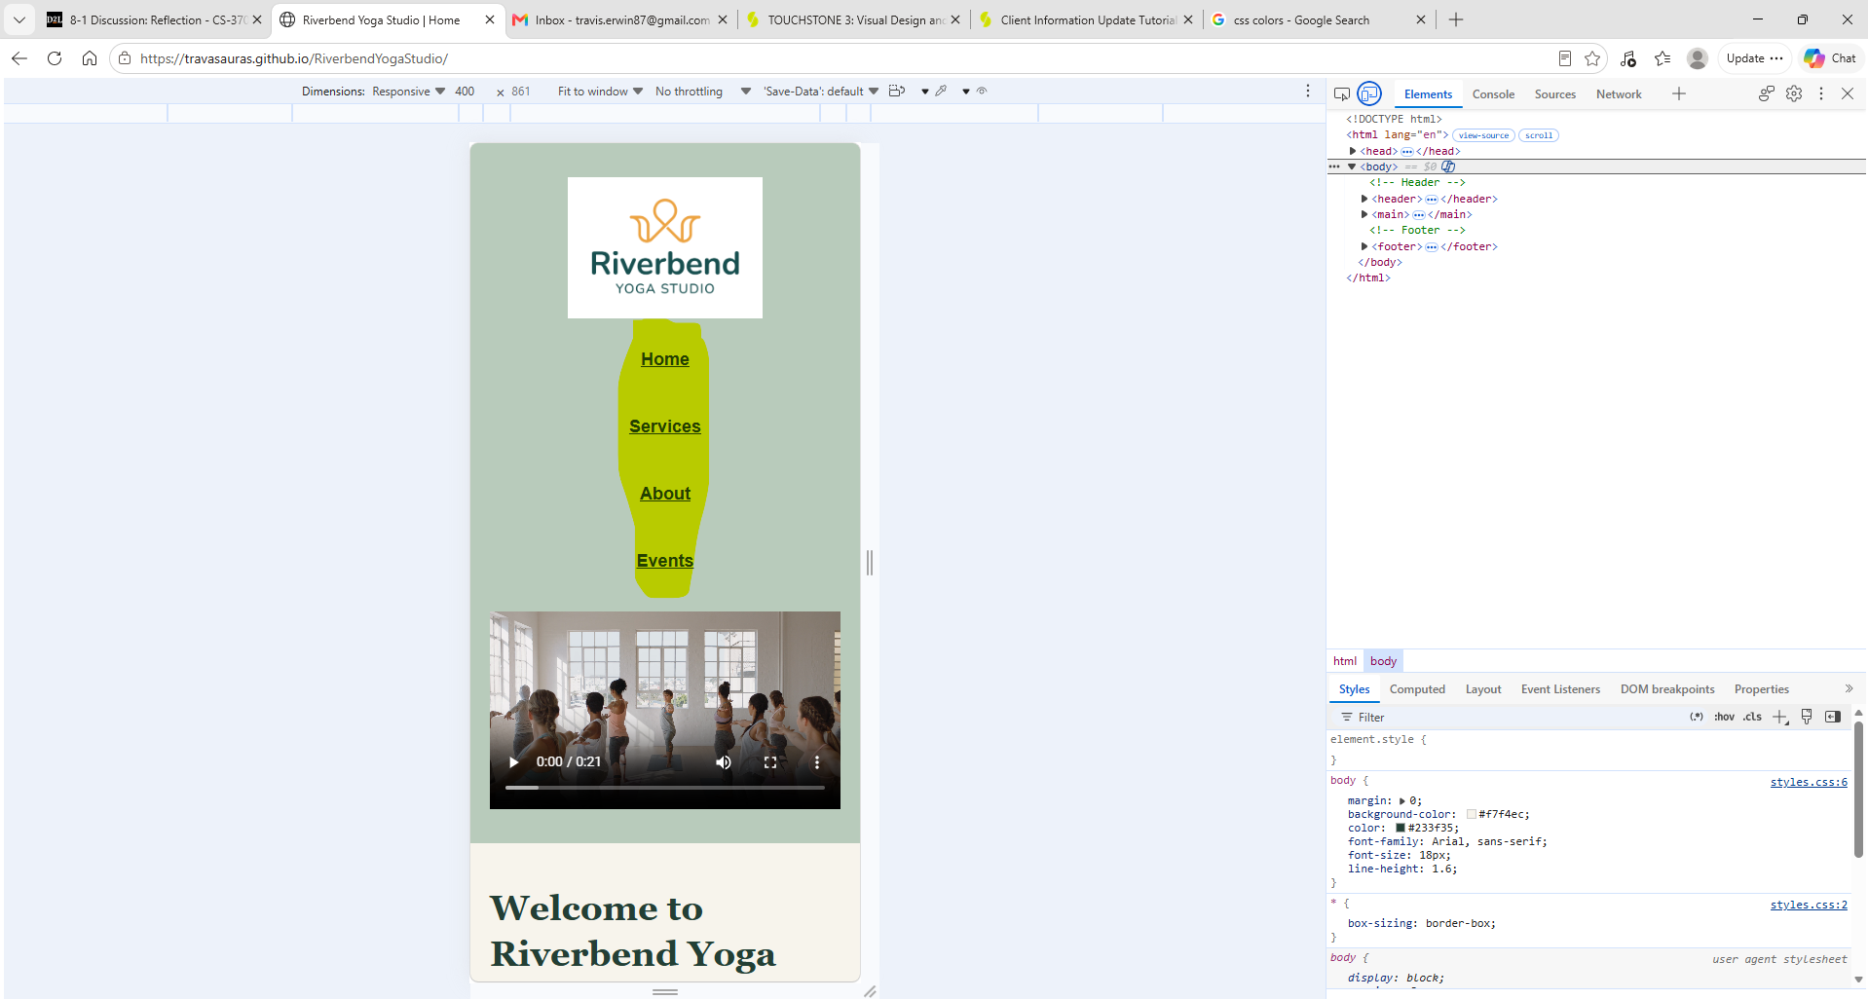Here we can see the navigation links are now vertical on a simulated mobile screen. I highlighted it in the screenshot, that yellow does not exist in the page.

Section 5: Final Review
☐x All pages display correctly
☐x Navigation works across all pages
☐x Layout adjusts across screen sizes
☐x Design is consistent and readable

