Touchstone 4 Template
Interactivity and Client-Side Data
Name: | Travis Erwin
Course: | Introduction to Web Development
Date: | 10/23/2026
Selected Client: | Riverbend Yoga Studios

Important: Continue using the same client and website from Touchstone Task 2 and Touchstone 3. Submit this completed template as your single Touchstone file. Your linked project must contain the updated HTML, CSS, and JavaScript files.

Section 1: Project Link
Paste the URL to your public GitHub repository for this project. The repository should include all updated HTML, CSS, and JavaScript files required for this Touchstone.
Working Project Link: Travasauras/RiverbendYogaStudio: Sophia intro to web development projects
Repository Link (if different):

Section 2: Implementation Explanation
Respond to every prompt below. Each response should be 2–4 sentences, refer to a specific element or behavior from your project, and explain how the implementation works. Reference your screenshots where requested.
Feature Purpose
Explain what your interactive feature helps users do and how it supports your client’s goals or audience. Identify the page where the feature appears and describe the user need it addresses.
Reference Screenshot 1 in your response.
Response:
In the services.html page, I created a drop down menu that users can select information about a type of yoga class offered by riverbend studio. Visitors can choose gentle, vinyasa, or restorative yoga and it displays a custom description below without leaving the page. It can help the user identify the classes provided and compare them with each other to find the class that fits their needs. The feature also remembers their selection if they leave and return.

User Interaction
Describe how a user interacts with the feature step by step. Explain what JavaScript changes on the page after the user clicks, selects, or enters information.
Include the key action and the visible result.
Response:
When a user opens the services page and selects a yoga class in the dropdown menu, JavaScript finds the matching class in the array and updates with a paragraph below the menu showing a description of the class. Selecting another class changes the page without reloading. The selection is saved in localStorage and restored when the user returns to the site after navigating away from it.
Form Validation
Identify at least two JavaScript validation checks you added to your form. Explain how invalid submission is prevented and how feedback appears near the relevant fields so users can correct their entries.
Reference Screenshot 2 and quote or summarize at least one error message.
Response:
On the events page, users can fill out a form to show interest in the monthly workshops. Before, the form used HTML’s built-in validation to check required fields. In this current version, I added novalidate to the HTML and used validation.js to check all the required fields and make sure the email address has a valid format. If a check fails, JavaScript displays a message under the field and prevents the form from submitting.
Data Storage
State whether you used localStorage or sessionStorage. Explain what data is stored, when it is saved, and when it is loaded again. Describe how this improves the user experience.
Reference Screenshot 3 and identify the restored or remembered data.
Response:
To save the class selected in the dropdown list on the services page, I used localStorage. The choice is saved whenever the user changes their selection. When they open the page again, JavaScript loads the saved choice and displays the matching class description. The screenshot below was taken after navigating away from the events page and then back to it.

Technical Design
Explain how functions organize your JavaScript and how arrays or objects manage data. Name at least one function and one array or object, then describe what each does in your implementation.
For Advanced performance, the rubric expects at least two arrays or at least two objects.
Response:
Functions organize my JavaScript by grouping related steps into a named task. updateClassDescription() in script.js groups the steps for finding a selected class, changing the description, and saving the selection. validateField(fieldId) in validation.js groups the steps for checking a field and showing or clearing its error message.

In script.js the classes array holds class objects, containing “id” and “description”. In validation.js requiredFields hold “name, email, interest, experience, contact, and message” in an array that is used for the validateField(fieldId)
Challenges Encountered
Describe one specific problem you encountered while building or testing the feature, validation, or storage. Explain what was not working, how you identified the cause, and what change fixed it.
Focus on a real implementation decision rather than a general statement.
Response:
I didn’t run into a major bug but adding validation to all six required fields in the events form without repeating the same code was a bit of a challenge, planning the solution was the hard part but after coming up with a plan it was fairly straight forward. Instead of writing a separate check for each field, I listed their IDs in the requiredFields array. Each ID is then passed into validateField(fieldId) which finds the input and its matching error message.

Section 3: Technical and Submission Checklist
Check each item after testing your project.
☐ One meaningful JavaScript feature responds to a click, selection, or user input.
☐ The feature updates the page dynamically and clearly supports the client’s goals.
☐ JavaScript is organized into multiple functions rather than one large block.
☐ At least one array or object is used to manage data.
☐ For Advanced performance, at least two arrays or at least two objects are used.
☐ At least two JavaScript validation checks are implemented.
☐ Invalid form submission is prevented.
☐ Clear validation feedback appears near the relevant fields.
☐ Users can correct errors without losing the information they already entered.
☐ localStorage or sessionStorage saves at least one meaningful piece of data.
☐ Stored data is loaded when the relevant page opens or reloads.
☐ All previous HTML, CSS, navigation, media, and form functionality still works.
☐ The working project link is included and opens without requiring sign-in.
☐ All six explanation sections are complete and use project-specific examples.
☐ At least three screenshots and captions are included below.

Section 4: Screenshots
Insert at least three clear screenshots. Crop each image so the relevant feature is easy to see, and add a short caption that explains what the screenshot proves.
Screenshot 1: Interactive Feature in Use
Show the feature after a user action and the resulting dynamic update on the page.

Caption: ____________________________________________________________
Screenshot 2: Form Validation Feedback
Show at least two validation messages displayed near the relevant fields while submission is prevented.
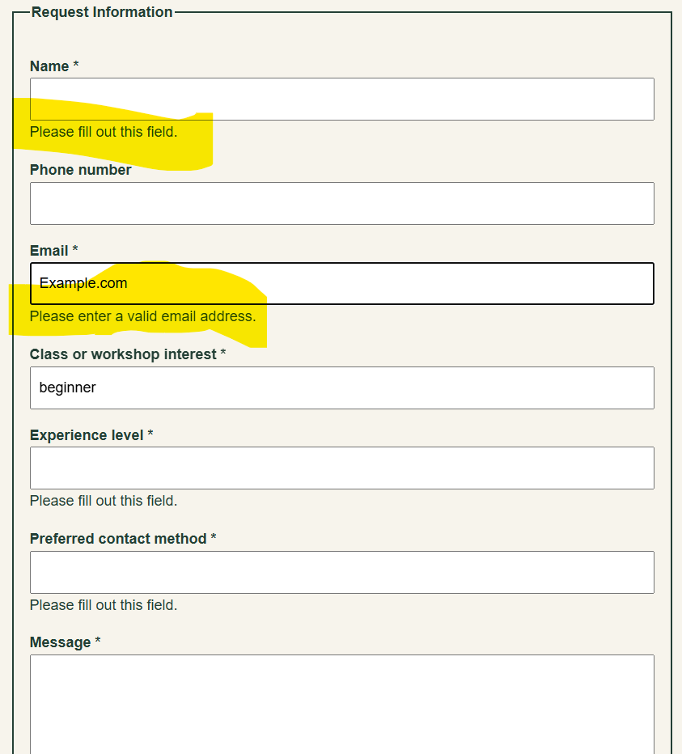
Caption: ____________________________________________________________
Screenshot 3: Browser Storage Working
Show data restored after a refresh or return visit, such as a remembered selection, saved favorite, or pre-filled field.

Caption: ____________________________________________________________

Section 5: Final Review
☐ The interactive feature works as expected after repeated testing.
☐ The page updates dynamically when the user takes the intended action.
☐ Validation prevents invalid submission and messages appear near fields.
☐ Valid form entries can proceed without unnecessary errors.
☐ Stored data saves and reloads correctly after refreshing or reopening the page.
☐ No JavaScript errors appear in the browser console during normal use.
☐ Navigation and relative file paths work across all pages.
☐ The project remains readable and usable at mobile and desktop widths.
☐ The submitted link and all screenshots match the final version of the project.

Section 1: GitHub Repository
Paste the URL to your public GitHub repository for this project. The repository should include all updated HTML, CSS, and JavaScript files required for this Touchstone.
Repository URL:
______________________________________

Updated Final Review Items
- ☐ Public GitHub repository link included
- ☐ Repository opens without requiring login
- ☐ Repository contains all updated HTML, CSS, and JavaScript files
- ☐ Interactive feature works as expected
- ☐ Form validation prevents invalid submission
- ☐ Feedback appears near the relevant fields
- ☐ Stored data persists correctly
- ☐ Previous HTML and CSS functionality remains intact

