**Project name:**

Absence Checker for Online Meeting

**Introduction:**

For teachers and managers, it is complex to check absenteeism in some online meeting software like zoom and tencent meeting, which not have function for signing in. Here is a program which takes good use of the chat bar can help them get the list of absent people in a quick and easy way.

**Direction for use:**

First part: Record the all students name in the notepad named “total” and separate each name with comma. Like this: Steven, Mike, Carl, John, Mark

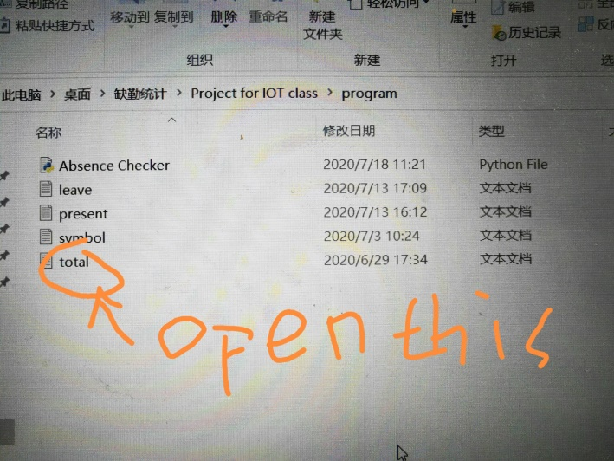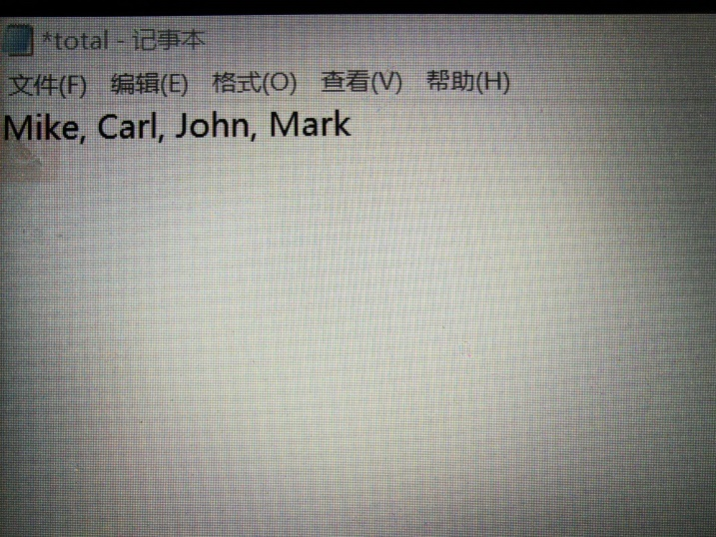

You can add as much name as you want

Then, record the students/staffs who ask for leave in the notepad named “leave” and separate each name with comma in the same way. Like this: john, Carl

Second part: Let attender type symbol for signing in the chat bar like this:

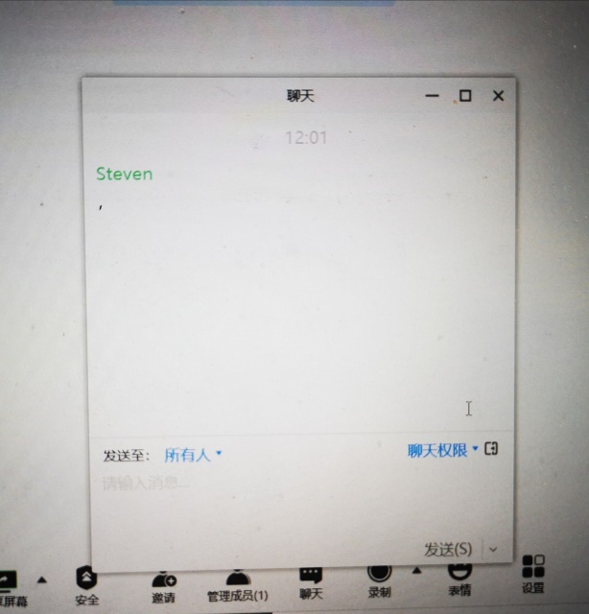

After the time for signing in, copy the content in chat bar into notepad named “present”

Like this:

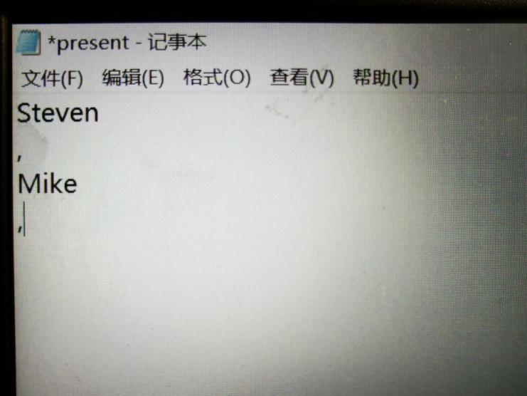

Finally click the program named “Absence Checker” you can get the absent list!

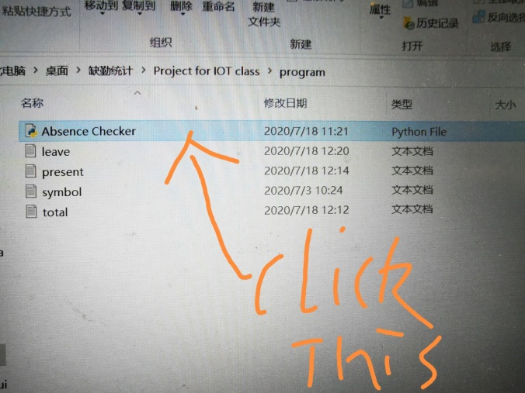

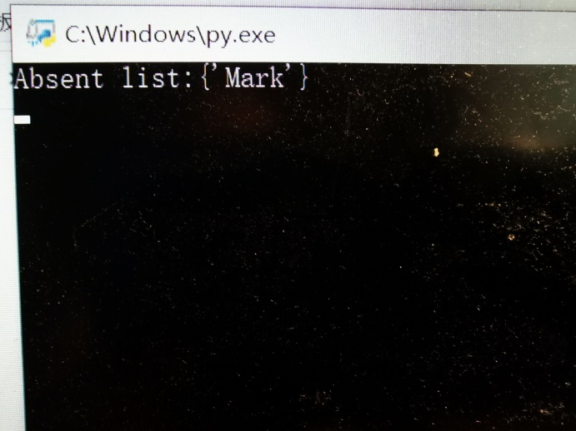

The preference for symbol to sign in: You can set up the symbol for signing in at notepad named “symbol”, you can set up several symbols but remember to separate them with “|”.

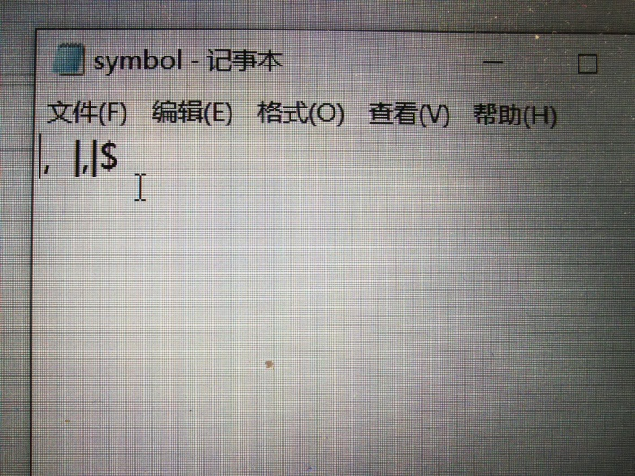

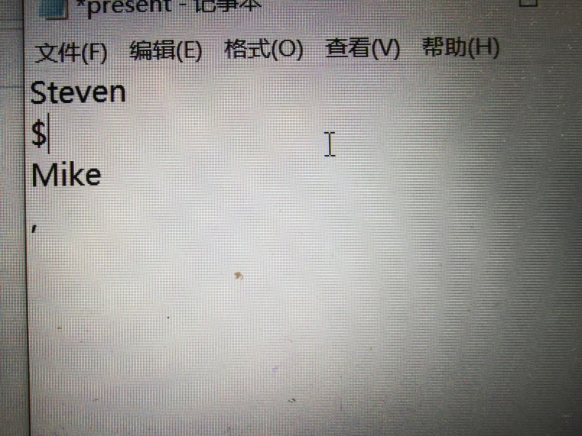 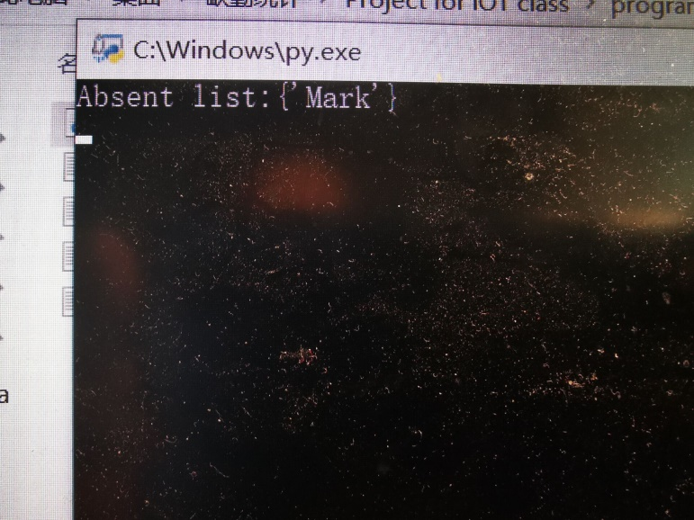

You can still get the same result