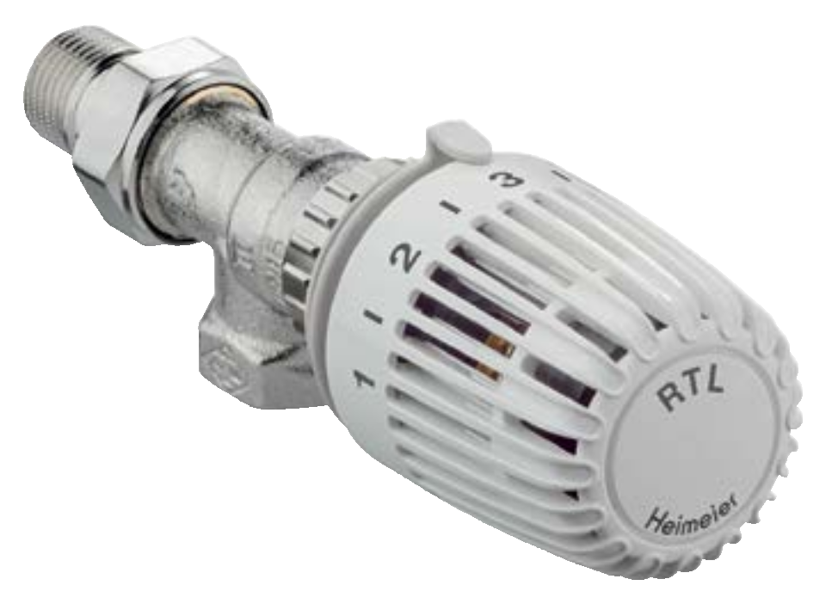

RTL

**Floor Heating Controller**

Return temperature limiter



RTL

Among other things, the return temperature limiter RTL is used to limit the return temperatures of radiators or combined floor/radiator systems to equalize the temperature of smaller floor surfaces

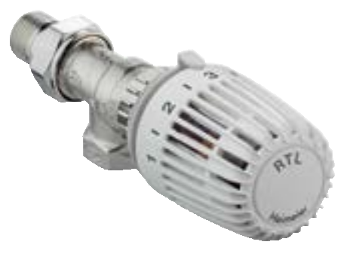

(up to ca. 15 m2).

**Key features**

> **Body made of corrosion-resistant gunmetal**

> **Stainless spindle with double**

**O-ring seal**

> **Outer O-ring can be replaced while under pressure**

> **Concealed limiting or blocking using stop clips**

**Technical description**

|  |  |  |  |  |
| --- | --- | --- | --- | --- |
| **Applications area:**  Heating systems |  | **Maximum sensor temperature:**  60° C |  | **Colour:**  White RAL 9016 |
| **Functions:** |  | **Specific extension:** |  | **Surface treatment:** |
| Maximum limitation of the return |  | 0.10 mm/K, |  | Valve body and fittings are nickel-plated. |
| temperature. |  | Valve stroke limiter |  |  |
| Shut-off. |  | **Marking:** |  | **Connection:**  **Attention:** The RTL return temperature |
| Temperature range is limited on both |  | THE, flow direction arrow, |  | limiter is constructed from a special valve |
| ends and can be blocked using covered  stop clips. |  | DN -Designation. II -Designation. |  | body and sensor element. Thermostatic  valve bodies cannot be used. |
|  |  | **Material:** |  |  |
| **Control behavior:** |  | RTL thermostatic head: |  | **Pipe connection:** |
| Proportional controller without auxilliary |  | ABS, PA6.6GF30, brass, steel, |  | The female-threaded version is designed |
| energy. |  | Thermostat filled with an expansible  medium. |  | for connection to threaded pipe, or in  conjunction with compression fittings, to |
| **Dimensions:** |  |  |  | copper precision steel or multi-layer pipe |
| DN 15 |  | Valve body: corrosion resistant Gunmetal  O-rings: EPDM rubber |  | (only DN 15). The male-threaded version,  in conjunction with the appropriate |
| **Pressure class:** |  | Valve disc: EPDM rubber |  | compression fittings, permits connection |
| PN 10 |  | Return spring: Stainless steel  Valve insert: Brass |  | to plastic pipe. |
| **Temperature:** |  | Spindle: Niro-steel spindle with double |  |  |
| Max. working temperature: 120°C |  | O-ring sealing. The outer O-ring can be |  |  |
| Min. working temperature: 2°C |  | replaced under pressure. |  |  |

**Construction**

**RTL – return temperature limiter**

1. Valve body

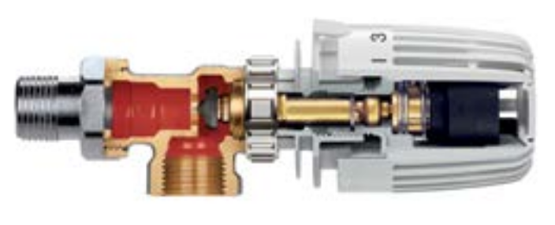

2. Sensor

3. Overstroke safety

**Function**

The return temperature limiter RTL is an automatic thermostatic controller. The temperature of the flowing medium is transferred to the sensor via conductivity. This keeps the specified value

constant within a proportional band necessary for control.

The valve only opens when the set limiting value has not been reached.

**Application**

Among other things, the return temperature limiter RTL is used to limit the return temperatures of radiators or combined floor/ radiator systems to equalize the temperature of smaller floor surfaces (up to ca. 15 m2). The return temperature is constantly controlled.

With floor heating systems, it is important to note that the flow temperature controlled by the system is approp riate for the particular system installed.

Please make sure the setting value is not below the ambient temperature of the return temperature limiter, as this would then no longer open (carefully choose location of installation). This may also be the case if the return temperature limiter is

influenced by transferred heat, e.g. by mounting a floor heating circuit distributor directly on the return collector.

**Sample application**

**Return temperature limiting on radiators Floor heating**

*RTL*

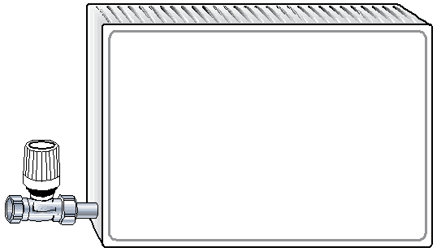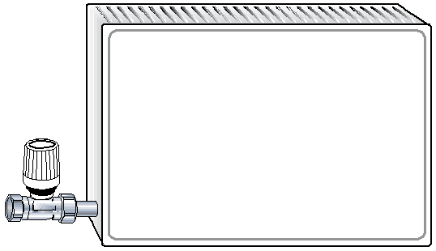

*RTL*

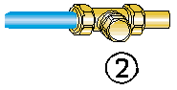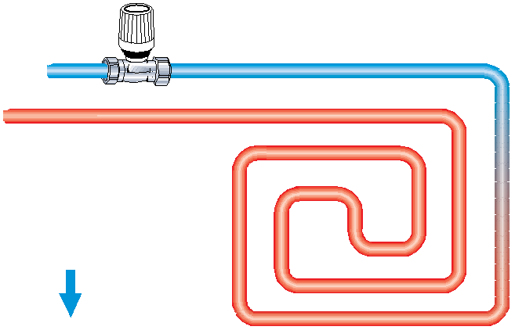

*RTL*

1. Thermostatic valve

2. Regulux lockshield

**Note**

The composition of the heat transfer medium should be one which avoids damage or the accumulation of stones in hot water heating systems, in accordance with VDI guide line 2035. For industrial and long-distance energy systems, see applicable codes VdTÜV and 1466/AGFW FW 510.

Heat transfer media containing mineral oils or lubricants

containing mineral oil can have seriously negative effects on the

source apparatus and usually lead to the disintigration of EPDM

seals.

When using nitrite-free frost and corrosion resistance solutions with an ethylene glycol base, pay close attention to the details outlined in the manufacturers’ documentation, particularly details concerning concentration and specific additives.

**Functional heating**

Carry out functional heating of heating screed conforming to standards in keeping with EN 1264-4.

**Earliest start for functional heating:**

– Cement screed: 21 days after laying

– Anhydrite screed 7 days after laying

Begin 20 °C - 25 °C flow temperature and maintain for 3 days. Then set maximum design temperature and maintain for 4

days. Flow temperature can be regulated by controlling the heat generator. Turn the protective cap anticlockwise to open valve or turn RTL head to Position 5.

Refer to the screed manufacturer’s information!

**Do not exceed maximum floor temperature at the heating pipes:**

– Cement and anhydrite screed: 55 °C

– Poured asphalt screed: 45 °C

– according to screed manufacturer’s technical advice!

**Settings**

|  |  |  |  |  |  |  |
| --- | --- | --- | --- | --- | --- | --- |
| **Number on dial** | **0** | **1** | **2** | **3** | **4** | **5** |
| Return temperature t [°C]  R | 0 | 10 | 20 | 30 | 40 | 50 |
| Return temperature t [°F]  R | 32 | 50 | 68 | 86 | 104 | 122 |

**Technical data**

30

20

10

5

3

2

1

0,5

0,3

0,2

2 K 4 K

8 K

6 K 10 K

kvs

300

200

100

50

30

20

10

5

3

2

Δp [mbar]

0,1

Δp [kPa]

5 10

ª [kg/h]

20 30 50

100

1

200 300 500 1000

**Controller with valve body (angle, straight)**

|  |  |  |  |  |  |  |  |
| --- | --- | --- | --- | --- | --- | --- | --- |
| DN 15 (1/2”) | **Kv**  **P-band xp [K]** | | | | | **Kvs** | **Permitted differential pressure at which the return temperature limiter still closes**  **∆p [bar]** |
| **2** | **4** | **6** | **8** | **10** | 2,00 | 4 |
| 0,32 | 0,66 | 1,00 | 1,34 | 1,60 |

**Articles**

107 59

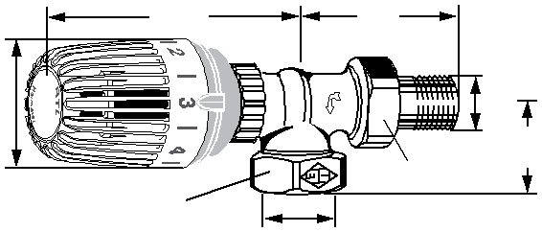

Ø 53

**Angle**

SW1*)

Rp1/2

SW2*)

R1/2

28

**Connection Kvs EAN Article No**

R1/2 2,00 4024052285716 9173-02.800

107 29

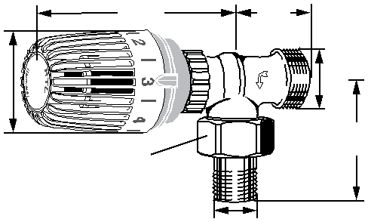

Ø 53

G3/4

**Angle**

SW2*)

58

**Connection Kvs EAN Article No**

G3/4 2,00 4024052285013 9153-02.800

R1/2

SW2*)

Ø 53

95

R1/2

**Straight**

**Connection Kvs EAN Article No**

R1/2 2,00 4024052285914 9174-02.800

SW1*)

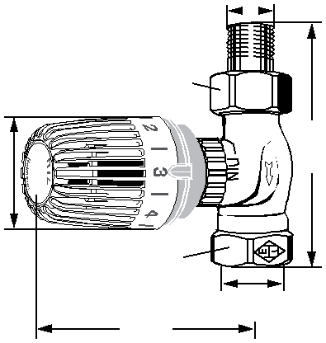

107

Rp1/2

Ø 53

**Straight**

SW2*)

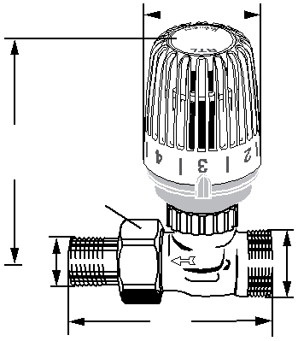

107

R1/2

91

G3/4

*) SW1: 27 mm; SW2: 30 mm

|  |  |  |  |
| --- | --- | --- | --- |
| **Connection** | **Kvs** | **EAN** | **Article No** |
| G3/4 | 2,00 | 4024052285112 | 9154-02.800 |

Kvs = m3/h at a pressure drop of 1 bar and fully open valve.

**Accessories**

|  |  |  |  |
| --- | --- | --- | --- |
| **Spindle extension for RTL** |  | | |
| Brass, nickel-plated. | **L** | **EAN** | **Article No** |
|  | 20 | 4024052500215 | 9153-20.700 |

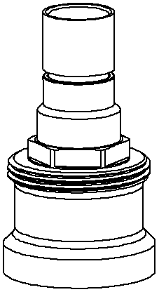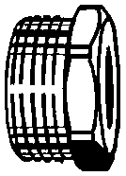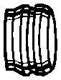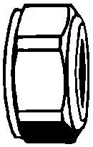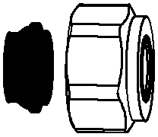

|  |  |  |  |  |
| --- | --- | --- | --- | --- |
| **Compression fitting**  for copper or precision steel pipe | **Ø Pipe** |  | **EAN** | **Article No** |
| according to DIN EN 1057/10305-1/2. | 15 |  | 4024052175017 | 2201-15.351 |
| Female thread connection Rp1/2. | 16 |  | 4024052175116 | 2201-16.351 |
| Metal-to-metal joint. Brass nickel-plated. |  |  |  |  |
| Support sleeves should be used for a pipe |  |  |  |  |
| wall thickness of 0.8 – 1 mm. Follow the |  |  |  |  |
| specifications of the pipe manufacturer. |  |  |  |  |
| **Compression fitting** |  |  |  |  |
| for copper or precision steel pipe | **Ø Pipe** |  | **EAN** | **Article No** |
| according to DIN EN 1057/10305-1/2. | 12 |  | 4024052214211 | 3831-12.351 |
| Connection male thread G 3/4 according | 15 |  | 4024052214617 | 3831-15.351 |
| to DIN EN 16313 (Eurocone). | 16 |  | 4024052214914 | 3831-16.351 |
| Metal-to-metal joint. Brass nickel-plated. | 18 |  | 4024052215218 | 3831-18.351 |
| With a pipe wall thickness of 0.8-1 mm |  |  |  |  |
| insert supporting sleeves. Heed pipe |  |  |  |  |
| manufacturer’s technical advice. |  |  |  |  |
| **Support sleeve** |  |  |  |  |
| for copper or precision steel pipe with a | **Ø Pipe** | **L** | **EAN** | **Article No** |
| 1 mm wall thickness. | 12 | 25,0 | 4024052127016 | 1300-12.170 |
| Brass. | 15 | 26,0 | 4024052127917 | 1300-15.170 |
|  | 16 | 26,3 | 4024052128419 | 1300-16.170 |
|  | 18 | 26,8 | 4024052128815 | 1300-18.170 |
| **Compression fitting** |  |  |  |  |
| for copper or precision steel pipe | **Ø Pipe** |  | **EAN** | **Article No** |
| according to DIN EN 1057/10305-1/2. | 15 |  | 4024052515851 | 1313-15.351 |
| Connection male thread G 3/4 according | 18 |  | 4024052516056 | 1313-18.351 |
| to DIN EN 16313 (Eurocone). |  |  |  |  |
| Soft sealed, max. 95°C. |  |  |  |  |
| Nickel-plated brass. |  |  |  |  |
| **Compression fitting** |  |  |  |  |
| for plastic pipe according to DIN 4726, | **Ø Pipe** |  | **EAN** | **Article No** |
| ISO 10508. PE-X: DIN 16892/16893, | 14x2 |  | 4024052134618 | 1311-14.351 |
| EN ISO 15875; PB: DIN 16968/16969. | 16x2 |  | 4024052134816 | 1311-16.351 |
| Connection male thread G 3/4 according | 17x2 |  | 4024052134915 | 1311-17.351 |
| to DIN EN 16313 (Eurocone). | 18x2 |  | 4024052135110 | 1311-18.351 |
| Nickel plated brass. | 20x2 |  | 4024052135318 | 1311-20.351 |

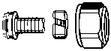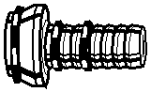

**Compression fitting**

|  |  |  |  |
| --- | --- | --- | --- |
| **Compression fitting**  for Alu/PEX multi-layer pipe according to | **Ø Pipe** | **EAN** | **Article No** |
| DIN 16836. Connection male thread G 3/4 | 16x2 | 4024052137312 | 1331-16.351 |
| according to DIN EN 16313 (Eurocone). Nickel-plated brass. |  |  |  |

for Alu/PEX multi-layer pipe according to

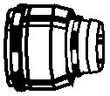

DIN 16836. Female thread connection

Rp 1/2. Nickel-plated brass.

**Ø Pipe EAN Article No**

16x2 4024052138616 1335-16.351

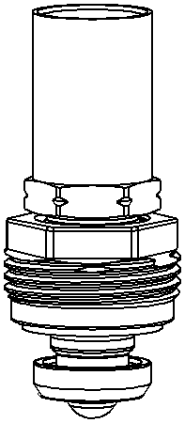

|  |  |  |  |
| --- | --- | --- | --- |
| **RTL thermostatic head** |  | | |
| As spare part for return temperature | **Colour** | **EAN** | **Article No** |
| limiter RTL. | white RAL 9016 | 4024052275311 | 6500-00.500 |
|  | chrome | 4024052478521 | 6500-00.501 |

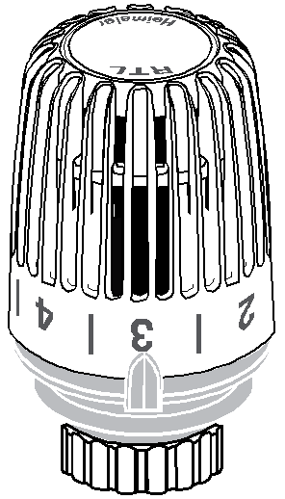

**Insert for RTL**

Since 2012 (II marking on the valve body). With 25 mm brass sleeve.

**Insert for RTL**

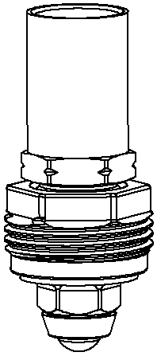

Since 1996 to end of 2011 (Boss marking on the valve body).

With 25 mm brass sleeve.

**Special insert for RTL**

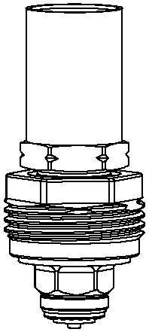

Since 1996 to end of 2011 (Boss marking on the valve body). With 25 mm brass sleeve. For reversed flow direction.

**EAN Article No**

4024052909711 1305-02.300

**EAN Article No**

4024052529216 2004-02.300

**EAN Article No**

4024052529117 2004-24.300

*The products, texts, photographs, graphics and diagrams in this document may be subject to alteration by IMI Hydronic Engineering without prior notice or reasons being given. For the most up to date information about our products and specifications, please visit* [*www.imi-hydronic.com.*](http://www.imi-hydronic.com)



*3400-18.483 EN RTL 02.2016*