El Escobal de Tulú, Coclé, Panamá

Travis Bumgarner

WaterSTAR Analysis

Environmental Health - Group 73

Peace Corps Panama

October 27, 2014

Contents

Introduction 3

Original Infrastructure (Prior to Volunteer Arrival) 3

Capture Point 3

Tank 4

System Tubing 5

Houses 8

Current Infrastructure and Project Progress 9

Community Information Collection 9

Data Collection Work Days 9

Data Collection Analysis 9

Water Meetings 9

Water Seminar 10

Construction Work Days 10

Installation of Shutoff Valves 10

Future Infrastructure 11

Planned Events 11

Capture Point 11

Tank 11

System Tubing 12

Houses 13

Appendices 13

Appendix A: Community Interviews 13

Appendix B: Materials List 13

Document Notes

* Houses are listed by number, to see head of house names, please see appendix A. Column 1 lists head of house and column 2 lists house number.

# Introduction

The community of El Escobal is located in the province of Coclé. It is situated forty minutes by bus and then 20 minutes walking outside of the regional capital, Penonomé. It is located in the mountains and has a rather cool climate that experiences the rainy season from May to January and the dry season from January to May.

With regards to the water, the community is split in to two different systems, Escobal Arriba and Escobal Abajo. The focus of this document is on the Arriba water system. The system was constructed about 15 years ago by the organization CCC of Panama. There are 22 houses, 57 residents, and a church in the area of the water system. Eight of the houses and the church are currently not connected to the water system. The houses that are connected do not receive sufficient water throughout the year. The proposed project calls for the complete overhaul of the spring box, installation of new equipment to prevent water leakage, and pressure equalization throughout the system.

The document is split into three sections: original, current, and future infrastructure. Original infrastructure documents the water situation prior to the arrival of the volunteer within the community. Current infrastructure covers all activities completed by the volunteer up to this point including interviews, data collection, and completion of some improvements to the water system. Future infrastructure lays out the plan envisioned by the volunteer for the time period from December 2014 until August 2015 when the volunteer finishes his time within the community.

# Original Infrastructure

The description of the system’s infrastructure is split into four parts. Water enters the system at the **capture point** and is stored in the **tank** for distribution using the **system tubing**, where it eventually arrives at individual **houses.**

## Capture Point

|  |  |
| --- | --- |
| C:\Users\travis\Google Drive\Peace Corps\Water\Pictures\output\Pictures001.jpg  Figure : Water Capture Point | C:\Users\travis\Google Drive\Peace Corps\Water\Pictures\output\Pictures003.jpg  Figure : Cleanout Point |

Figure 1 shows the current spring box. It was originally designed so that the spring was covered and water was forced to flow into the PVC tube. The rocks along the bottom of the picture form a dam which trapped additional water bypassing the tube and collecting it as well. Over time the water found routes around the tube and presently, no water is collected within the tube. All water is now exposed to a section of earth that runs about fifteen feet horizontally and allows for contamination to easily enter the system. During the rainy season, the area fills up with mud, leaves, and other debris which restricts the flow into the system.

Figure 2 shows the cleanout point for the spring box. It functions by using gravity to force sedimentation in the tube to fall to the bottom of the tank before continuing on to the rest of the system. However, the pressure from the entrance is great enough that a large portion of the water flowing in can shoot across to the exit point, allowing most of the sedimentation into the rest of the system.

## Tank

|  |  |
| --- | --- |
| C:\Users\travis\Google Drive\Peace Corps\Water\Pictures\output\Pictures007.jpg  Figure : Water Tank | C:\Users\travis\Google Drive\Peace Corps\Water\Pictures\output\Pictures006.jpg  Figure : Water Tank Lid |

Figures 3 and 4 show the current water tank. The tank itself is in good condition and properly covered. The concern is about the tubing leaving the tank which can be seen in the following figures.

|  |  |
| --- | --- |
| C:\Users\travis\Google Drive\Peace Corps\Water\Pictures\output\Pictures001.jpg  Figure : Overflow Tube in Foreground | C:\Users\travis\Google Drive\Peace Corps\Water\Pictures\output\Pictures011.jpg  Figure : Air Release Valve |
| C:\Users\travis\Google Drive\Peace Corps\Water\Pictures\output\Pictures003.jpg  Figure : Cleanout Tube | |
| C:\Users\travis\Google Drive\Peace Corps\Water\Pictures\output\Pictures005.jpg  Figure : Tubing to the Community | |

Figure 5 shows the overflow tube. It is a problem because if the tank overflows, the water that leaves the tube will cause erosion near the base of the tank which could eventually lead to the failure of the tank.

Figure 6 shows the air release valve which has lost the screen that covered it which allows insects and other animals to easily enter and contaminate the system.

Figure 7 shows the cleanout tube. Currently there is some leakage between the tube and the concrete wall and placement of the tube outlet isn’t good because it causes erosion near the tank base.

Figure 8 shows the tubing to the community. There are several visible leaks and both valves, one which has already been removed, do not function correctly anymore.

## System Tubing

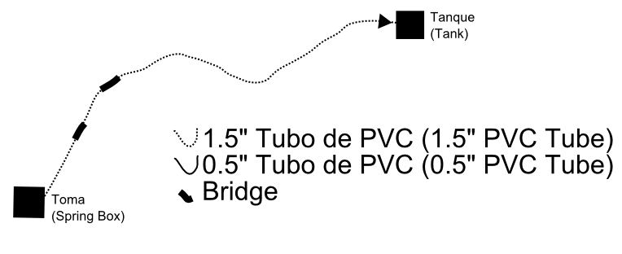

Figure : Spring Box to Tank

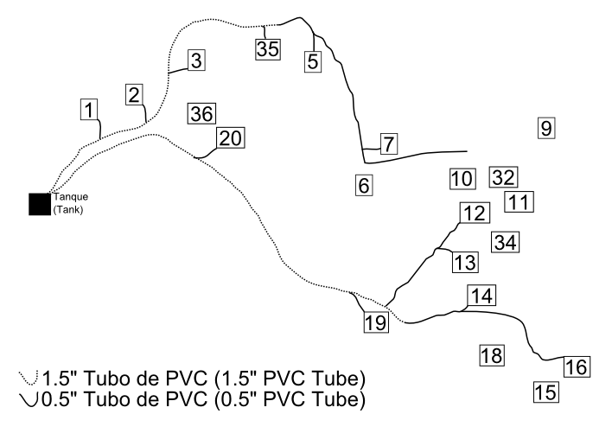

Figure : Tank to Community

Figure 9 shows the tubing running from the spring box to the tank. The tubing is generally in good condition. However, there are several areas that are in need of either a bridge or tubing to be buried since they cross near streams or hang across small elevation drops.

Figure 10 shows the distribution system. The lines show existing tubing. Currently, houses 6, 9, 10, 11, 18, 32, 34, 36, and 37 are not connected to the system.

## Houses

Faucets in the houses are in generally good condition with minimal leakage. The responsibility of maintaining the line and faucets from the main line to the house are the responsibility of the owner of the house. Figure 11 shows some typical examples of water in the house.

|  |
| --- |
| C:\Users\travis\Google Drive\Peace Corps\Water\Pictures\out\CAM00214.jpg C:\Users\travis\Google Drive\Peace Corps\Water\Pictures\out\CAM00210.jpg C:\Users\travis\Google Drive\Peace Corps\Water\Pictures\out\CAM00228.jpg  Figure : Examples of Water in the House |

# Current Infrastructure and Project Progress

## Work Days for Community Data

The focus for the first several months was to complete a community analysis. Information was collected about community population and needs, potential work, etc. Appendix A shows the methods of data collection and results.

## Work Days for Water System Data

Table : Work Days

|  |  |  |
| --- | --- | --- |
| Date | Attendance | *Objective/Goal* |
| May 4th, 2014 | 13 | Look for new water sources and check flow of current water source. |
| May 15th, 2014 | 8 | Take altitude and distance measurements of water system. |
| May 16th, 2014 | 8 |
| June 23rd, 2014 | 6 |
| July 9th, 2014 | 9 |
| August 15th, 2014 | 13 |

Note: For following sections, community members typically send one member of their household to a meeting or work day, depending on the amount of people required for that day’s meeting or work. There are currently 19 houses with community members living in them.

The first step in data collection was to make measurements of tube sizes, system altitude and distance, condition and quantity of faucets in each house, and system flows. Table 1 shows the information about each work day.

Tube sizes can be seen in the previous figures 9 and 10, faucets in the house in figure 11, system flows in table 2. System altitude and distance data collection is still being analyzed in NeatWork.

## System Data

Table : Water Flow Measured at the Source

|  |  |  |
| --- | --- | --- |
| Date | Water Flow | People Receiving Water1 |
| April 5th, 2014 | 2,400 Gallons/Day | 80 |
| August 22nd, 2014 | 3,809 Gallons/Day | 127 |
| October 23rd, 2014 | 3,000 Gallons/Day | 100 |

1This calculation is based on a standard by the Ministry of Health of 30 gallons of water per person per day.

## 

## Sustainability

### Water Meetings

|  |  |
| --- | --- |
| Date | Attendance |
| March 3rd, 2014 | 10 |
| June 20th, 2014 | 11 |
| July 20th, 2014 | 9 |
| August 24th, 2014 | 13 |
| October 12th, 2014 | 16 |
| October 26th, 2014 | 14 |

In an effort to encourage sustainability after the departure of the volunteer, monthly water meetings were started at the end of March 2014. The original purpose was to organize work days and discuss system issues. Since their implementation, the water committee, consisting of a president, treasurer, secretary, spokesman, and sergeant-at-arms, was re-elected. Monthly fees of $1 per house began at the same time as the re-election of the committee. Currently meetings are held monthly to discuss system maintenance, workdays, fundraising, unforeseen issues, and future construction.

### Water Seminar

|  |  |
| --- | --- |
| C:\Users\travis\Google Drive\Peace Corps\Water\Pictures\out\DSC05596.JPG  Figure : Learning to use the fake aqueduct | C:\Users\travis\Google Drive\Peace Corps\Water\Pictures\out\DSC05529.JPG  Figure : Presentations in the church. |

On September 5th and 6th, a water seminar was held within the community. Five volunteers assisted in giving presentations to a representative from each household. In total, twenty-five community members attended and the topics of health, system construction and maintenance, holding successful meetings, and an intro to the physics of aqueducts were given.

### Construction Work Days

Table : Construction Work Days

|  |  |  |
| --- | --- | --- |
| Date | Attendance | Objective/Goal |
| October 23rd, 2014 | 3 | Install Shutoff Valves |

To date, we’ve had one construction work day.

### Installation of Shutoff Valves

|  |  |
| --- | --- |
| C:\Users\travis\Google Drive\Peace Corps\Water\Pictures\out\CAM00159.jpg  Figure : Installation of shutoff valves | C:\Users\travis\Google Drive\Peace Corps\Water\Pictures\out\CAM00161.jpg  Figure : Installation of Tube for Cleanout |

During a meeting in July, we began collecting monthly funds for the water system. Since the shutoff valves after the tank weren’t functioning, cleaning and maintenance of the tank were impossible.

In October, a workday was proposed to use some of the funds collected, about $40, to install shutoff valves after the tank. With materials leftover, the cleanout valve was improved as well. See figures 14 and 15 for pictures.

# Future Infrastructure

|  |  |
| --- | --- |
| **Date** | **Goal** |
| **Phase 1** | |
| 1/2014 | Flow Reducers and Shutoff Valves |
| 1/2014 | Tank Improvements |
| 2/2014 | System Cleanout Points and Air Release Valves |
|  |  |
| **Phase 2** | |
| 11/2014 | Materials Preparation |
| 12/2014 | Funding |
| 3/2014 | Spring box Overhaul |
| **Phase 3** | |
| 5/2014 | Leadership Seminar |

## Planned Events

Construction will be split between two phases. Phase 1 will be completed with funds from the representative Maribel Ibarra. Phase 2 will be completed with funds from a PCPP grant solicited by the volunteer. Phase 3 will continue with project sustainability.

## Flow Reducers and Shutoff Valves

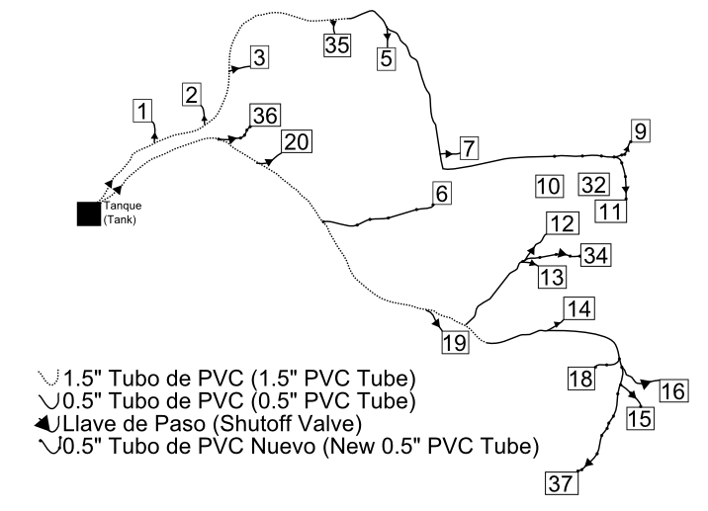

Figure : Improvements of tubing from the tank to the houses.

Figure 16 shows improvements to the tubing from the tank to the house. Shutoff valves will be installed between the main line and the houses so that if there is an issue in a single house, the entire system doesn’t need to be turned off. Additionally, tubing will be run to houses that do not currently receive water.

## Tank Improvements

There are several small improvements and repairs that need to be made to the tank that can all be achieved in one work day. The first is to repair the leaky tubes. This will be achieved by sealing the space between the tube and the concrete wall.

For the issue with the overflow tube, extra tubes will be installed so that the overflow will exit the tank several feet further away.

Fencing will be installed to protect the tank and tubing from animals and children.

The tank currently lacks a shutoff valve before the entrance. For tank cleaning, this requires someone to go up to the spring box and shutoff the water there. Once the shutoff valve is installed regular maintenance of the tank can begin.

## System Cleanout Points and Air Release Valves

These two items together will help to reduce sedimentation buildup and air buildup in the tubing. These will be installed strategically throughout the system at their most ideal locations. If the first round of installation doesn’t reduce all problems, additional components will be installed along the line.

## Spring Box Overhaul

The overhaul of the spring box will be the most complicated and final construction.

The area will first be cleaned and prepped for the installation of the new spring box. Several feet around the spring source will be cleared of dirt, roots, trees, etc. up to the impermeable layer.

The second step will be to begin placing large rocks along the floor of the outlet to create a path for the water to flow and a support structure for the concrete cap. Once the first layer has been placed, additional smaller rocks will be placed on top until there is a sizeable layer of rocks. Additionally, a dam will be installed at the end of the collection point to trap the water and force it into a tube.

Finally the rocks will be capped with a layer of concrete.

Design of the spring box is still in progress; however an estimation of materials has been made and is included in appendix b.

# Appendices

## Appendix A: Data Collection Methods and Results

|  |  |  |
| --- | --- | --- |
| **Date** | **Who** | **What** |
| 27-9-13 | Bladimir Quirós | Community Leader Interview |
| 30-9-13 | Fermin del Rosario | Community Leader Interview |
| 1-10-13 | Gustavo Ibarra | Community Leader Interview |
| 2-10-13 | Alone | GPS Community Mapping |
| 4-10-13 | Alone | GPS Community Mapping |
| 8-10-13 | Alone | GPS Community Mapping |
| 14-10-13 | Fermin del Rosario | Community Leader Interview |
| 21-10-13 | Bladimir Quirós | GPS Community Mapping |
| 23-10-13 | Gustavo Ibarra | Limiar Tanque, Caminar Sistema |
| 2-11-13 | Gustavo Ibarra | Community Leader Interview |
| 5-11-13 | Gustavo Ibarra | Community Interviews. House numbers 15, 16, 14, 13, 12, 34, 7 |
| 9-11-13 | Familia Anfitriona | Looked over map and community member information |
| 15-11-13 | Fermin del Rosario | Community Leader Interview |
| 20-11-13 | Alone | Community Interviews. House numbers 26, 27, 28, 29, 30 |
| 21-11-13 | Alone | Community Interviews. House numbers 1, 9, 13, 14, 15, 16, 34 |
| 8-1-14 | Gustavo Ibarra | Community Leader Interview |
| 8-1-14 | Anabel | Centro de Salud Interview |



## Appendix B: Materials List