INTRODUCTION

Time represent a fundamental axis that shapes ecological systems. In regards to animal behavior, time and space are linked in that the spatial characteristics of an animal’s local environment can influence an animal’s temporal behavior (Kronfeld-Schor and Dayan 2003). For example, some species make seasonal changes in diel activity to be most active during optimal temperatures in their local environment (e.g., Maloney et al. 2005), and other species are known to temporally partition themselves from competition or aggression by other species (e.g., Kronfeld-Schor and Dayan 2003, van der Vinne et al. 2019). While temporal behavior have never been a strong focus in animal ecology (Kronfeld-Schor and Dayan 2003), how animals use time as an ecological resource has inspired the study of now well-known ecological phenomenon like niche partitioning, species co-existence, and predator-prey dynamics (Wolkovich et al. 2014, Gaston 2019). However, from an applied perspective, understanding if an animal can make temporal adjustments to mitigate or adapt to local environmental change, such as human disturbance, has largely gone unstudied (Levy et al. 2019).

Species that persist in urban ecosystems – an extreme of human disturbance – require some degree of human avoidance to safely navigate through these complex landscapes and use available habitat (Riley et al. 2003, Gehrt et al. 2009). However, in urban ecosystems, few habitat patches exist for animals to seek spatial refuge when confronted with human disturbance. An alternative strategy to reduce risk in these environments could be to temporally partition from human activity. Behavioral and life-history strategies that allow species to persist in urban environments has been a central focus of urban wildlife research (Magle et al. 2012, 2019). However, urban wildlife research has been inherently spatial in nature; invoking traditional ecological principles like island biogeography, metapopulations, and connectivity to study species-habitat relationships (e.g., Gallo et al. 2018, Moll et al. 2020), spatial overlap of interacting species (e.g., Mueller et al. 2018, Moll et al. 2018, Fidino et al. 2019), or population and community dynamics (e.g., Rodewald and Gehrt 2014, Gallo et al. 2017). Such research demonstrates dramatic changes in species’ responses along spatial gradients of urbanization, but ignore the fact that animals also use time as an ecological resource (Kronfeld-Schor and Dayan 2003).

A recent global analysis of mammal activity patterns confirmed that animals do adjust their diel activity patterns in areas of high human disturbance (Gaynor et al. 2018). While the Gaynor et al. (2018) review focused on several forms of human disturbance, 11 studies did specifically assess changes in diel activity due to urbanization. Yet, these 11 urban studies explored differences in diel patterns only between urban and non-urban areas, indicating that variation in diel activity within cities and across gradients of urbanization have gone relatively unexplored. Gaynor et al. (2018) also revealed that there has been a strong focus on carnivore activity patterns. All but one of the 11 urban studies focused on carnivore species (Gaynor et al. 2018), further indicating that little is known about temporal behavioral changes among urban mammal communities. Taxa within a community will vary in their baseline temporal activity. For example, coyotes and racoons are generally nocturnal (CITATIONS), while deer and rabbits tend to be crepuscular or diurnal (CITATION). Taking a more comprehensive look at a larger suite of the urban mammal community will allow us to more fully understand the variability of activity patterns and assess temporal adjustments in response to local environmental change.

Here, we link spatial landscape characteristics with the diel activity patterns of 8 terrestrial meso-mammals across 10 U.S. cities. Our objectives were to assess whether species change their diel patterns as a function of urbanization within a city and to explain what characteristics of the urban environment have the strongest effect on diel activity patterns. We hypothesized that species will become more nocturnal in areas of greater urbanization (Gaynor et al. 2018). In urban environments, humans are likely the greatest threat to carnivores (Gehrt et al. 2009, Clinchy et al. 2016). Therefore, we hypothesized that the diel activity of medium to large carnivores will be most affected by anthropogenic characteristics of the urban environment (e.g., human population or impervious cover). However, in human-dominated ecosystems, prey species must contend with both humans and their natural predators (Berger 2007, Magle et al. 2014, Blecha et al. 2018). Therefore, we hypothesized that prey species and subordinate carnivore species will have less flexibility to adjust temporally and their diel activity will be affected by both anthropogenic characteristics and natural features (e.g., available habitat or vegetation cover). Animals need spatial and temporal habitats to persist. Yet, the use of time as a resource to adapt to environmental change has largely been ignored in wildlife management and conservation. Our study explores how urbanization influences the diel patterns of common urban wildlife species, offering insight to how some species adapt to urbanization.

METHODS

**Study Design**

To quantify temporal shifts of wildlife in response to urbanization we used data from remotely-triggered trail cameras that are a part of the Urban Wildlife Information Network (Magle et al. 2019). Data was obtained from cameras placed in a systematic fashion across 10 U.S. cities – Austin, TX, Chicago, IL, Denver and Fort Collins, CO, Indianapolis, IN, Iowa City, IA, Long Beach, CA, Madison, WI, Manhattan, KS, and Wilmington, DE (see Magle et al. 2019 for details). The number of sampling sites per city ranged from 24-110. At each sampling site (*n =* 453) we placed one Bushnell motion-triggered infrared Trophy Cam (Bushnell Corp., Overland Park, KS, USA; see supporting information for camera models and settings). To increase the detection probability of each species we placed one synthetic fatty acid scent lure in the camera line of sight (Gerber et al. 2012). Lures were replaced on two-week intervals if missing to remain consistent throughout the study. We used observation data collected between June 2016 and December 2018. However, not all cities sampled continuously throughout the study period (see Supporting Information - table of cities, number of sites, number of trap nights, date range).

**Data processing**

We used camera detection data for 8 commonly detected species to assess diel activity: bobcat (*Lynx rufus*), coyote (*Canis latrans*), eastern cottontail (*Sylvilagus floridanus*), raccoon (*Procyon lotor*), red fox (*Vulpus vulpus*), striped skunk (*Mephitis mephitis*), Virginia opossum (*Didelphis virginiana*), white-tailed deer (*Odocoileus virginianus*). For each species, we defined a single detection event as all photos taken within a 15-minute period at each camera station (Ridout and Linkie 2009, Farris et al. 2015). We categorized each detection event as either ‘dawn’, ‘dusk’, ‘day’, ‘night’, and ‘darkest night’ using the *suncalc* package (Thieurmel and Elmarhraoui 2019) in R ver 4.2.0 (R Core Team 2019). We defined ‘dawn’ as starting when morning twilight begins and ending when the bottom edge of the sun touches the horizon ( h). ‘Dusk’ was defined as the beginning of evening twilight to the point when it became dark enough for astronomical observations ( h). ‘Day’ was defined as the period between dawn and dusk ( h). We defined ‘night’ as the periods between the end of dusk and 1 h before the darkest moment of the night (when the sun is at the lowest point), and from 1 hour after the darkest moment to dawn ( h). The ‘darkest hours’ of the night were categorized as 1 hour before and after the darkest moment in the night ( h). We accounted for the date and the geographical location when categorizing detection events.

**Predictor Variables**

To assess how characteristics of urban environments influenced diel patterns of urban wildlife species we calculated site-level predictor variables within a fixed-radius buffer around each study site. Fixed-radius buffers varied in size for each species and were based on the typical home range of each species (500 m fixed-radius buffer for eastern cottontail (Hunt et al. 2014), Virginia opossum (Wright et al. 2012, Fidino et al. 2016), and white-tailed deer (Etter et al. 2002); 1 km fixed-radius buffer for striped skunk (Rosatte 2000) and raccoon, and 1.5 km fixed radius buffer for coyote (Riley et al. 2003, Gehrt et al. 2009), red fox (Mueller et al. 2018), and bobcat (Riley et al. 2003)). In our analysis we included variables that described the two opposing characteristics of urban environments: the built environment and the more natural characteristics of urban ecosystems. We also included a seasonal covariate to control for any seasonal changes in diel activity.

*Urban features* – To characterize urbanization around each sampling site we calculated human population density (units/km2) and mean impervious cover (%) around all 453 sites. Population density was extracted from Block Level Housing Density data (Radeloff et al. 2018) created from 2010 U.S. Census data (U.S. Census Bureau 2010), and mean impervious cover was calculated from the National Land Cover Database (NLCD) 2011 Percent Developed Imperviousness data (Homer et al. 2015).

*Natural features* – We calculated the proportion of vegetation cover and the proportion of available habitat around each site to characterize the natural features around each sampling site. To calculate the proportion of vegetation cover around each sampling site, we first calculated the Normalized Difference Vegetation Index (NDVI) from a LandSat 8 image courtesy of the U.S. Geological Survey that 1) covered the entire study area of each city, 2) was taken during a summer month that coincided with the respective city’s sampling period, and 3) contained less than 15% cloud cover. We downloaded LandSat 8 imagery using the *getSpatialData* package (Schwalb-Willmann 2019) in R. We then calculated the proportion of vegetation cover as the proportion of cells within each buffer that had an NDVI value representing substantial vegetation cover (> 0.2; <https://climatedataguide.ucar.edu/climate-data/ndvi-normalized-difference-vegetation-index-noaa-avhrr>). To calculate the proportion of available habitat around each site we extracted the proportion of NLCD 2011 Land Cover raster cells within each buffer that were classified as forest, shrubland, herbaceous, wetland, and developed open space (urban green spaces).

*Seasonality* – Because the weather that defines each calendar season varies across our sampled longitudinal gradient, we used daily average temperature as a continuous covariate to describe seasonality. For each day and location of a detection event, we recorded the daily average temperature from the National Climatic Data Center using the R package *rnoaa* (Chamberlain 2020). We used data from the nearest weather station to each city that recorded daily weather during our study period (Supplemental Materials).

**Calculating changes in diel patterns due to urbanization**

For each species and in each city we calculated a log risk ratio (RR = ln(Xhigh/Xlow) as a measure of changes in diel activity patterns (Gaynor et al. 2018). Xhigh is the proportion of nighttime photos (categories night and darkest hours combined) at high levels of urbanization (> mean) and Xlow is the proportion of nighttime photos at sites with low urbanization (< mean). A positive risk ratio indicates a relative shift to nocturnality in response to urbanization, whereas a negative value indicates a relative reduction in nocturnality in response to urbanization. To summarize urbanization into a single metric, we calculated an urbanization index for each site using a principle component analysis of housing density, mean impervious cover, and the proportion of vegetation cover. We calculated the index for all three spatial scales. We used the first principle component from each site as an index of urbanization. The first principle component accounted for 63%, 67%, and 70% of the variation in the data for the 500 m, 1 km, and 1.5 km buffer, respectively. For all three scales, larger index values indicated higher impervious cover and housing density (i.e. more urban), whereas lower index values indicated higher proportion of vegetation cover (i.e. less urban).

**Quantifying the influence of urban characteristics on diel patterns**

To further understand the mechanistic changes in diel activity patterns and assess the influence that each predictor variable had on the temporal activity of each species, we modeled the probability that a detection event *i* occurred during each time category *k* (*k* in 1,…,K) using softmax regression (Kruschke 2011). Softmax regression represents the probability of an event happening in each category as the log odds of each outcome λk relative to a reference outcome – in our case ‘day’ or category 1. For example,

|  |  |  |
| --- | --- | --- |
|  |  | (1) |

In our model the linear predictor of each outcome was

|  |  |  |
| --- | --- | --- |
|  |  | (2) |

*******j* coefficients correspond to the effect of habitat availability, impervious cover, vegetation cover, human population density, and daily average temperature. As detection events within each city may not be wholly independent, we included a random intercept for city, *c[i]*, that allowed for partial pooling across cities (Gelman and Hill 2006) . We also included an offset term, log(α*k,i*), equal to the log number of hours available in category *k* at the time of detection event *i*. Similar to a traditional resource selection function, this offset allowed us to model the probability of selecting a time category *k* given the availability of category *k*. [1-2 SENTENCES HERE FROM BRIAN TO JUSTIFIY OFFSET IN MULTINOMIAL.]

Because we considered ‘day’ (category 1) as our reference outcome, we set the first category for each parameter to zero: β*c[i]*,1 = 0 and β*j*,1 = 0. The remaining β*j,k*parameters were giving Laplace(0,π) priors as a form of LASSO regularization. The tuning parameter  was given a uniform(0.001,10) prior distribution. βc[i],k was given a N(μ*k*,τ*k*) prior for each city where μ*k* ~ N(0,10) and τ*k* ~ Gamma(1,1).

The probability (φ*i,k*) of outcome *k* is then given by the softmax function:

|  |  |  |
| --- | --- | --- |
|  |  | (3) |

Where *S* is the set of all possible outcomes. Our data then arises as a categorical random variable

|  |  |  |
| --- | --- | --- |
|  |  | (4) |

Where *****i,k*is a vector of 1,…,K probabilities that the *i*th data point is in category *k* and these probabilities sum to 1.

Models were fit using an MCMC algorithmic implemented in JAGS ver 4.2.0 (Plummer 2003) using the *runjags* package (Denwood 2016) in R. Fourteen parallel chains were each run from random starting values. The first 20,000 iterations from each chain were discarded and every 7th iteration was kept to reduce autocorrelation among the samples. A total of 75,000 iterations were obtained. Model convergence was assessed by checking that the Gelman-Rubin diagnostic statistic for each parameter was <1.1 (Gelman and Rubin 1992) and by visually inspecting the trace plots of MCMC samples.

**Estimating population-level diel patterns in response to human population**

Using the posterior distribution from our model above, we calculated population-level log risk ratios for each species in relation to human population density. Here, Xhigh was the probability of nighttime activity (categories night and darkest hours combined) at high population density (> 1 sd). Xlow is the probability of nighttime activity at sites with low population density (< 1 sd). Again, a positive risk ratio indicates a relative shift to nocturnality in response to human population density, whereas a negative value indicates a relative reduction in nocturnality in response to population density.

**Results**

Across 551 trap nights we captured 79,659 total unique detection events. Total detections per species ranged from 102-34,931 and the number of cities each species was detected in ranged from 5-10 (Table X). The average proportion of sites that each species was detected in per city ranged from 0.16 – 0.77, with bobcat being found at the least number of cities and the lowest proportion of sites and racoon being found in all 10 cities and at the greatest proportion of sites (Table X).

Table X. The total number of detections for each species, the number of cities each species was detected in, and the mean proportion of sites each species was detected at per city for 8 urban mammal species

|  |  |  |  |
| --- | --- | --- | --- |
| Species | Total detections | No. of cities species detected | Mean proportion of sites species detected per city |
| Bobcat | 102 | 5 | 0.16 |
| Coyote | 2732 | 9 | 0.63 |
| Eastern cottontail | 16102 | 10 | 0.61 |
| Racoon | 34931 | 10 | 0.77 |
| Red fox | 1570 | 8 | 0.51 |
| Striped skunk | 990 | 10 | 0.24 |
| Virginia opossum | 8357 | 8 | 0.7 |
| White-tailed deer | 14875 | 10 | 0.56 |

**Risk Ratios**

Our risk ratios analysis demonstrated mixed results depending on the species, but species-specific trends did emerge (Fig. X). Bobcats showed a relative shift away from nocturnal activity as urbanization increased in smaller cities, but in the only large city where they were detected (Long Beach, CA) we saw a shift towards nocturnal activity as sites became more urban (Fig. X). Eastern cottontail showed a strong shift towards nocturnality at more urban sites in Austin, TX, but generally shifted towards diurnal activity across most cities as urbanization increased (Fig. X). Striped skunk had a relative shift towards nocturnality in response to urbanization in smaller cities, but shifted away from nocturnal activity as urbanization increased in larger cities (Fig. X). [DEER ARE ALL OVER THE PLACE AND AGAIN IN THE MULTINOMIAL RESULTS. PERHAPS SOMETHING HERE…CAN’T WRAP MY HEAD AROUND IT THOUGH]

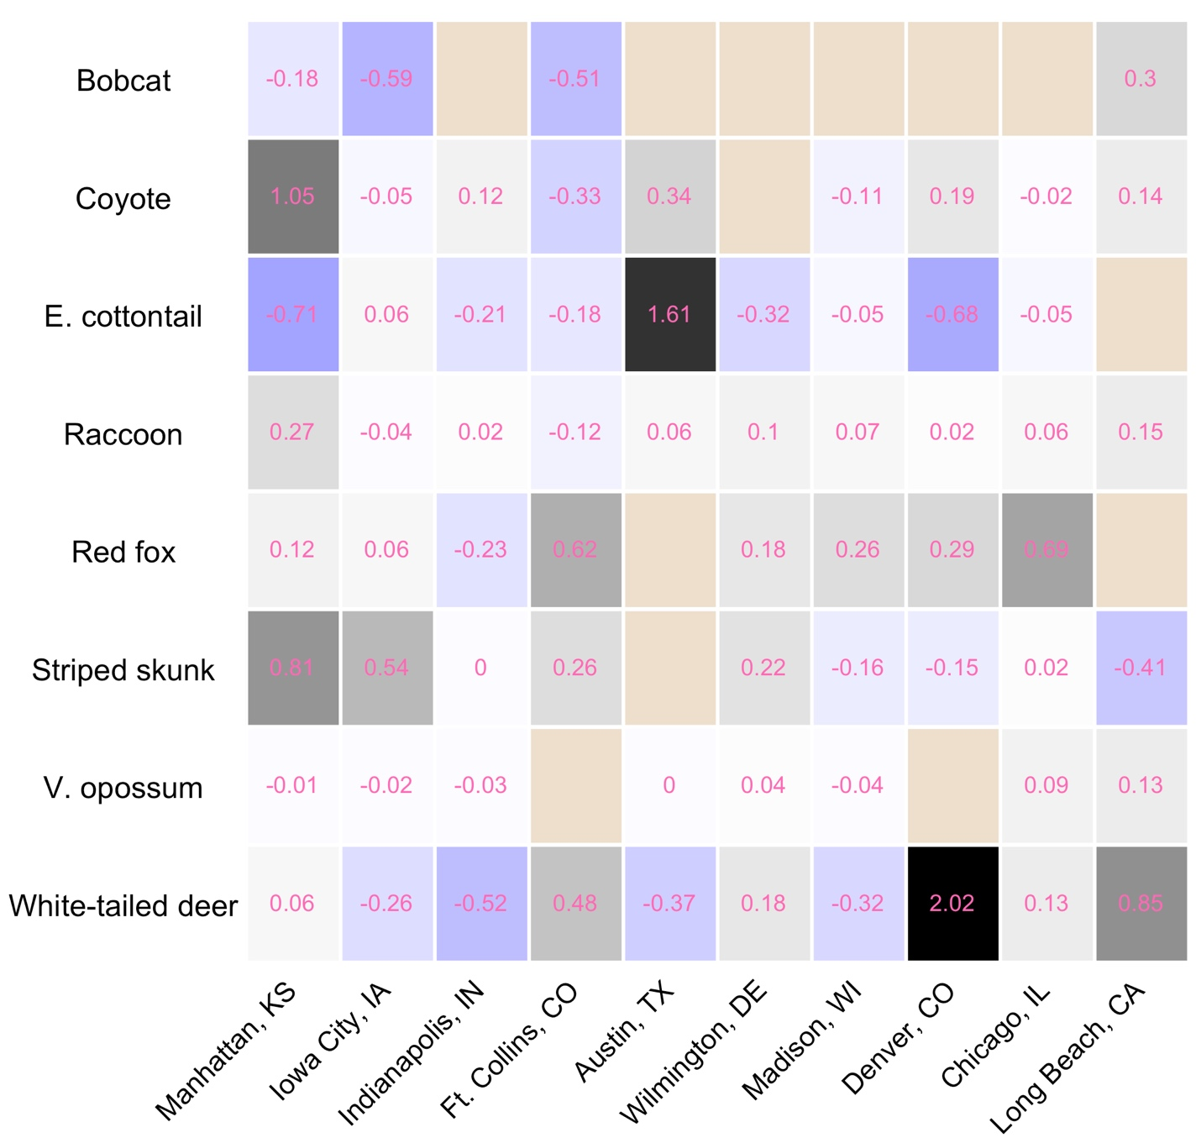

Figure X. Risk ratios for each species and each city. Cities are listed left to right from least urban to most urban based off the mean urbanization index of sampled sites within each city.

**Daily activity**

I got this one comment from a reviewer and really started taking it to heart. Think about how you could incorporate this thought into the results here:

The authors fail to claim one of the strengths of Bayesian analysis – the ability to make inference using probability statements derived from the posterior probability distribution (Ellison 2004, Kery 2010 [section 1.1.5], Hobbs and Hooten 2015 [page 206], or your favorite Bayesian textbook). The authors instead approach inference using a traditional approach akin to null hypothesis testing. For example, on Line 263-266, the authors state that “There was some evidence that the presence of lure increased opossum daily detection probability by roughly 5%, but the 95% credible interval for [the coefficient] overlapped zero…”. In Figure 2 (right panel), you can see that almost all of the posterior probability (here trimmed to the central 95% credible interval) supports that the lure increased the detection probability. I don’t suggest removing the text already in the results (posterior mean or median and 95% credible interval), but consider adding a probability statement. Here’s an example of how that opossum result might be framed (adapted from Hobbs and Hooten 2015; page 206): “Based on the posterior for [the coefficient], we can be 97% certain that the value of [the coefficient] does not include 0 and that the presence of a lure has a positive effect on the daily detection probability of opossum.”

This could be especially useful for your results (if you have a lot of stuff on the cusp of ‘significance’).

We found that most species, on average, were nocturnal with the exception of bobcat and white-tailed deer (Fig. 2a). We also found that coyotes had a higher probability of being diurnal at lower levels of human population, but switched to a higher probability of being nocturnal as human population levels increased. On the contrary we found that white-tailed deer had a higher probability of being active at night when human population was low but became more likely to be active during the day when human population increased. Both eastern cottontail and white-tailed deer increased their probability of diurnal activity as daily average temperature increased, indicating a strong herbivore effect (CITATION). Red fox switched from nocturnal activity at lower proportions of available habitat to diurnal activity when potential habitat was more available and white-tailed deer switched from diurnal to nocturnal activity as impervious cover increased. Both raccoon and striped skunk had a consistent probability of being active at night across all tested covariates.

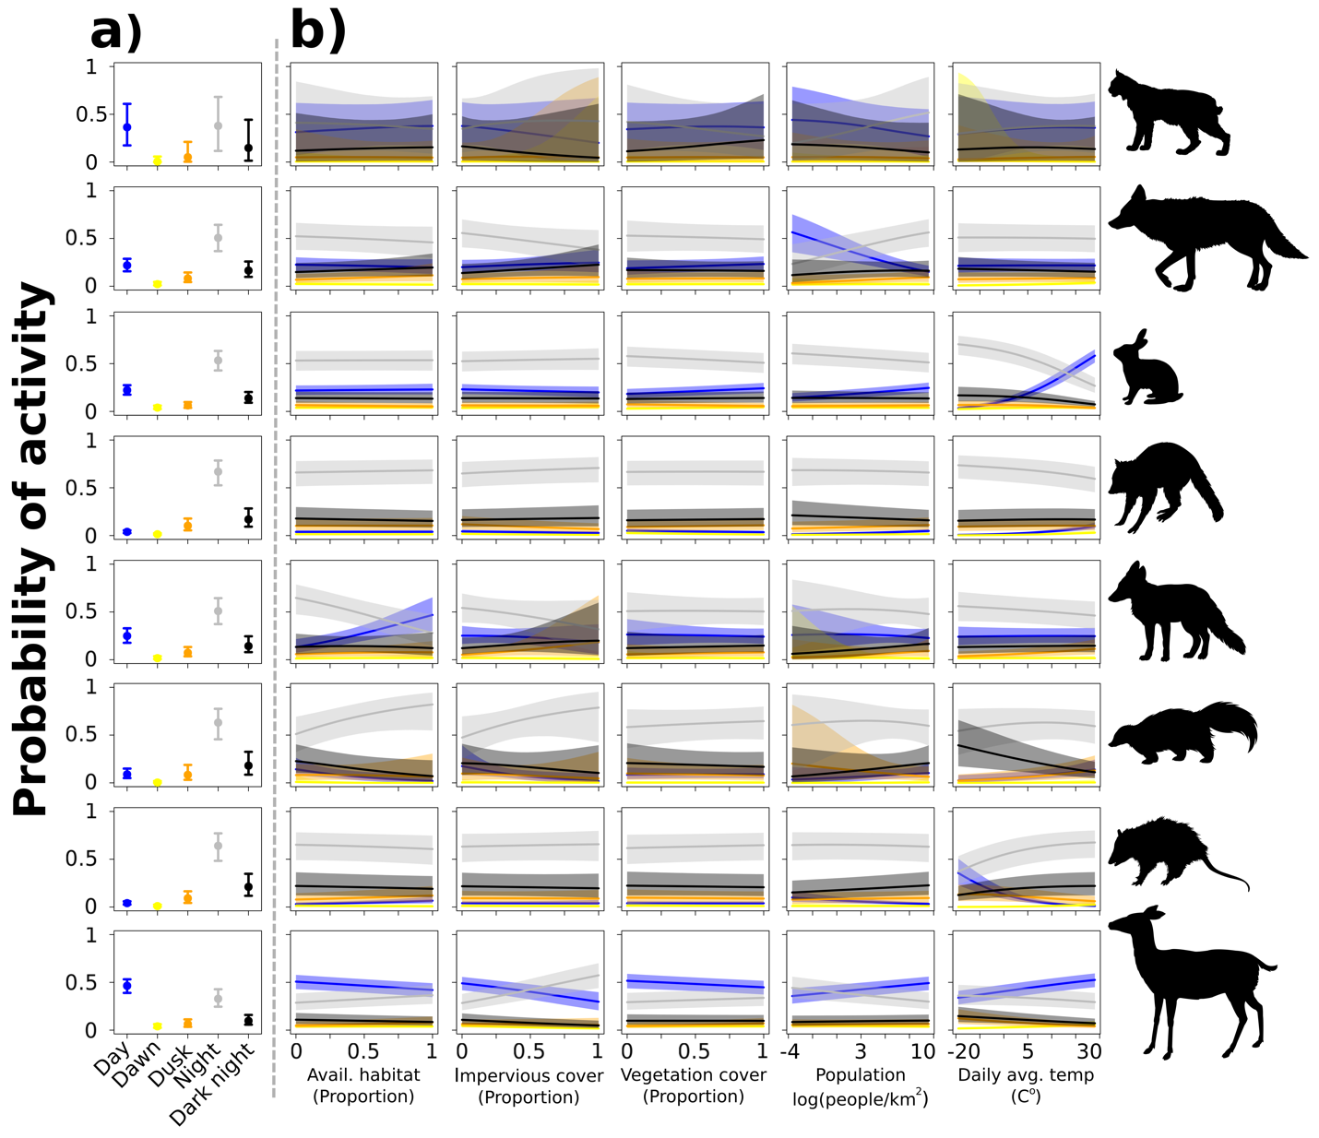

Figure 2. Probability of activity during each category. a) average probability of activity for each time category. b) Probability of activity for each time period as a function of predictor variables. Colors in b) match the categories in a).

Selection Plot:

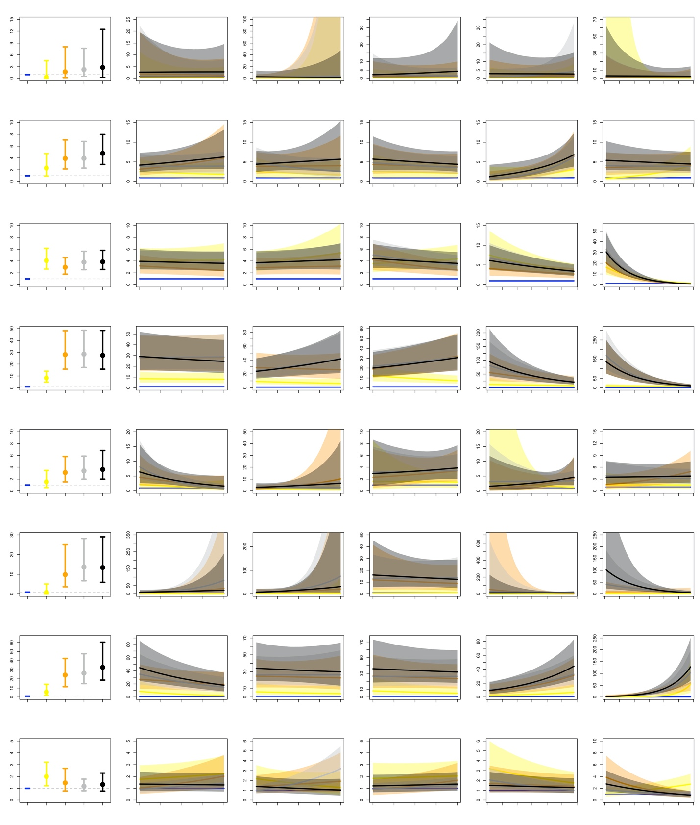

**Discussion**

Ecologists have long known that ecological processes act across space and time. Yet, only recently have we began to think about how animals use time as an ecological resource. Gaynor et. al’s (2018) global meta-analysis found that animals become more nocturnal in human dominated systems, and we found similar results looking specifically at urban ecosystems. We found that most species had a tendency to become more nocturnal as sites became more urban (Fig. X). Digging deeper into the mechanism for this change we found that human characteristics of urban ecosystems (human population density and impervious cover) had the greatest effect on the diel behavior of larger urban species (ie. deer and coyote). In other cases (i.e. red fox) we found that available habitat played a bigger role in diel their behavior. These results provide evidence of behavioral plasticity that allow urban species to adapt and persist in highly dynamic and human dominated urban ecosystems.

1. Foxes

* While cities are often characterized by the built environment, Urban green spaces provide habitat (aronson and gallo citation).
* habitat is important for behavioral processes (Cite) Why?
* We found that red fox became more diurnal when camera locations were surrounded by more green spaces (presumably available habitat)
* Give an explanation

1. Studies have shown coyotes respond to humans
   1. we found that coyotes became more nocturnal as human population increased. This is similar to other findings
   2. In fact human population was the only covariate we tested that showed
   3. Our findings add to the growing list of studies that show humans likely have the greatest influence on the distribution and behavior of urban coyotes.
2. Interestingly we found that deer had the opposite behavior to population density
   1. Define human shield effect
   2. Our results may show evidence of this taking place in urban areas
   3. However we saw a the opposite behavior in areas of high impervious cover which is often correlated with human population
   4. perhaps there is a threshold where an area can be too developed
3. One limitation to our study is that we studied the physical characteristics of cities. Yet, cities are dynamic and non-tangible characteristics of a city like sound, lights, odors could influence animal behaviors. Additionally, other ecological processes like predator or prey distributions and behaviors or food resources may influence behaviors. Cities are dynamic and many things take place in them. Therefore we should consider the interactions between many factors that may influence the behavior of urban wildlife species.
4. We also found evidence that expected wildlife behaviors still existed with cities. For example, both white-tailed deer and eastern cottontail showed a strong ‘herbivore effect’ (CITATION) in regards to daily average temperature. Both species became more diurnal as temperatures increased, presumably foraging more during the day as resources were higher.
5. Future research and additional limitations
6. Conclusion

**References**

Denwood, M. J. 2016. runjags: An R Package Providing Interface Utilities, Model Templates, Parallel Computing Methods and Additional Distributions for MCMC Models in JAGS. Journal of Statistical Software 71:25.

Etter, D. R., K. M. Hollis, T. R. Van Deelen, D. R. Ludwig, J. E. Chelsvig, C. L. Anchor, and R. E. Warner. 2002. Survival and Movements of White-Tailed Deer in Suburban Chicago, Illinois. The Journal of Wildlife Management 66:500–510.

Fidino, M. A., E. W. Lehrer, and S. B. Magle. 2016. Habitat Dynamics of the Virginia Opossum in a Highly Urban Landscape. The American Midland Naturalist 175:155–167.

Gaynor, K. M., C. E. Hojnowski, N. H. Carter, and J. S. Brashares. 2018. The influence of human disturbance on wildlife nocturnality. Science 360:1232–1235.

Gehrt, S. D., C. Anchor, and L. A. White. 2009. Home Range and Landscape Use of Coyotes in a Metropolitan Landscape: Conflict or Coexistence? Journal of Mammalogy 90:1045–1057.

Gelman, A., and D. B. Rubin. 1992. Inference from iterative simulation using multiple sequences. Statistical Science 7:457–472.

Gerber, B. D., S. M. Karpanty, and M. J. Kelly. 2012. Evaluating the potential biases in carnivore capture–recapture studies associated with the use of lure and varying density estimation techniques using photographic-sampling data of the Malagasy civet. Population Ecology 54:43–54.

Hensley, C. B., C. H. Trisos, P. S. Warren, J. MacFarland, S. Blumenshine, J. Reece, and M. Katti. 2019. Effects of Urbanization on Native Bird Species in Three Southwestern US Cities. Frontiers in Ecology and Evolution 7.

Homer, C. G., J. Dewitz, L. Yang, S. Jin, P. Danielson, Xian, J. Coulston, N. Herold, J. Wickham, and J. Megown. 2015. Completion of the 2011 National Land Cover Database for the conterminous United States – representing a decade of land cover change information. Photogrammetric Engineering and Remote Sensing 81:345–353.

Hunt, V. M., S. B. Magle, C. Vargas, A. W. Brown, E. V. Lonsdorf, A. B. Sacerdote, E. J. Sorley, and R. M. Santymire. 2014. Survival, abundance, and capture rate of eastern cottontail rabbits in an urban park. Urban Ecosystems 17:547–560.

Kronfeld-Schor, N., and T. Dayan. 2003. Partitioning of Time as an Ecological Resource. Annual Review of Ecology, Evolution, and Systematics 34:153–181.

Kruschke, J. K. 2011. Doing Bayesian Data Analysis. Second edition. Academic Press, London, UK.

Magle, S. B., M. Fidino, E. W. Lehrer, T. Gallo, M. P. Mulligan, M. J. Ríos, A. A. Ahlers, J. Angstmann, A. Belaire, B. Dugelby, A. Gramza, L. Hartley, B. MacDougall, T. Ryan, C. Salsbury, H. Sander, C. Schell, K. Simon, S. S. Onge, and D. Drake. 2019. Advancing urban wildlife research through a multi-city collaboration. Frontiers in Ecology and the Environment 17:232–239.

Mckinney, M. 2006. Urbanization as a major cause of biotic homogenization. Biological Conservation 127:247–260.

Mueller, M. A., D. Drake, and M. L. Allen. 2018. Coexistence of coyotes (Canis latrans) and red foxes (Vulpes vulpes) in an urban landscape. PLOS ONE 13:e0190971.

Murray, M. H., and C. C. St. Clair. 2015. Individual flexibility in nocturnal activity reduces risk of road mortality for an urban carnivore. Behavioral Ecology 26:1520–1527.

Plummer, M. 2003. A program for analysis of Bayesian graphical models using Gibbs sampling. Pages 125–133 Proceedings of the Third International Workshop on Distributed Statistical Computing. R Foundations for Statistical Computing, Vienna, Austria.

R Core Team. 2016. R: A language and environment for statistical computing. R Foundation for Statistical Computing, Vienna, Austria.

Radeloff, V. C., D. P. Helmers, H. A. Kramer, M. H. Mockrin, P. M. Alexandre, A. Bar-Massada, V. Butsic, T. J. Hawbaker, S. Martinuzzi, A. D. Syphard, and S. I. Stewart. 2018. Rapid growth of the US wildland-urban interface raises wildfire risk. Proceedings of the National Academy of Sciences 115:3314–3319.

Riley, S. P. D., R. M. Sauvajot, T. K. Fuller, E. C. York, D. A. Kamradt, C. Bromley, and R. K. Wayne. 2003. Effects of Urbanization and Habitat Fragmentation on Bobcats and Coyotes in Southern California. Conservation Biology 17:566–576.

Rosatte, R. C. 2000. Management of raccoons (Procyon lotor) in Ontario, Canada: Do human intervention and disease have significant impact on raccoon populations? Mammalia 64:369–390.

Wright, J. D., M. S. Burt, and V. L. Jackson. 2012. Influences of an Urban Environment on Home Range and Body Mass of Virginia Opossums (Didelphis virginiana). Northeastern Naturalist 19:77–86.