PasswordChecker1_Testing_TravisGriggs

Screenshot 1

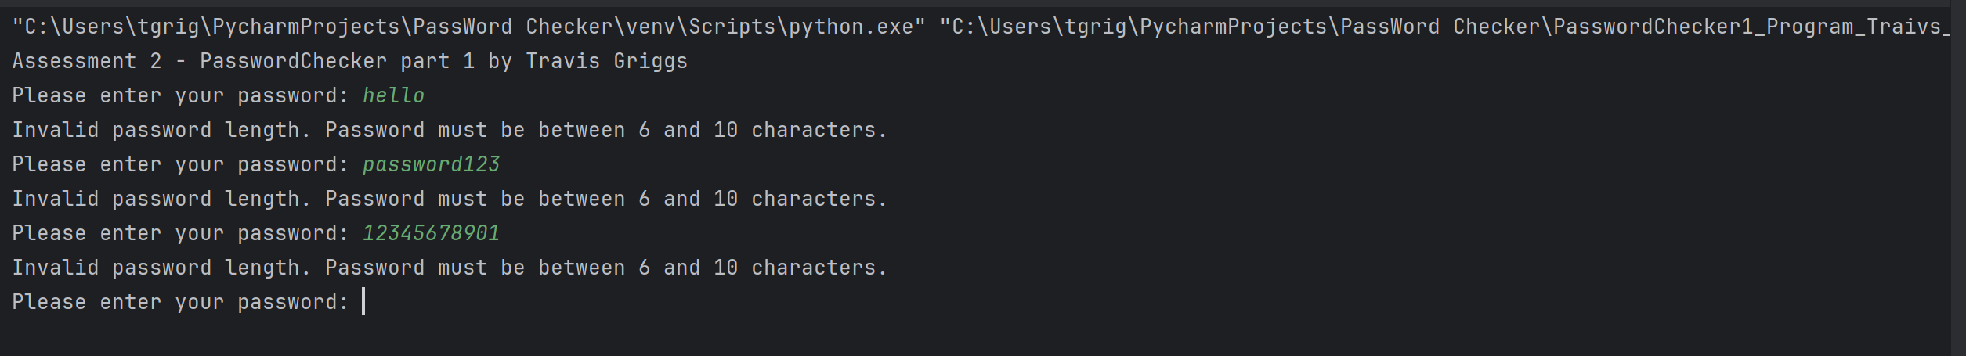

Screenshot 2

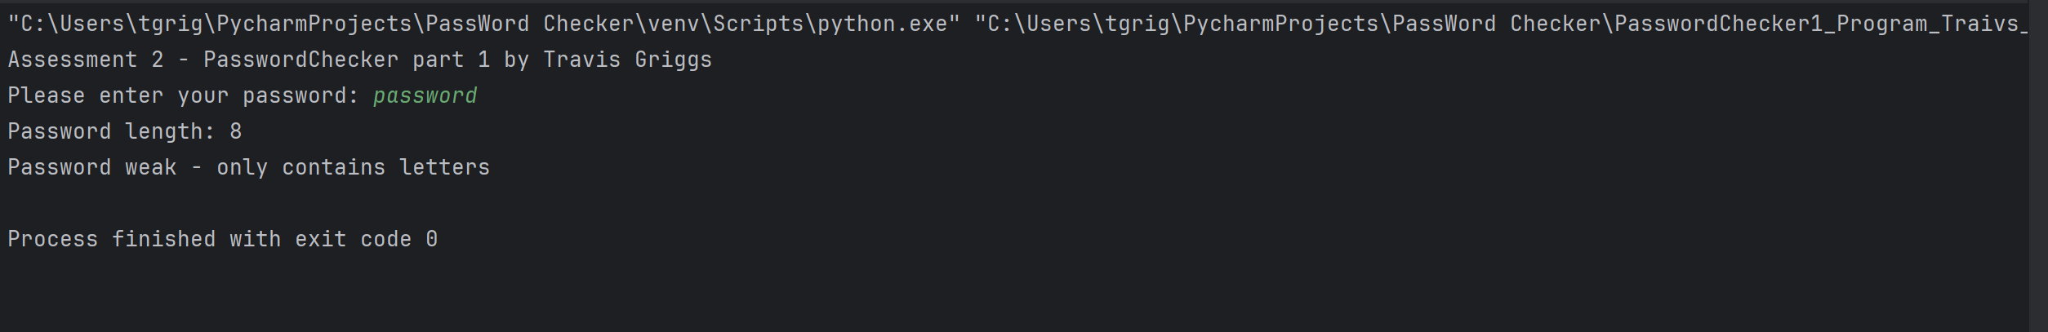

Screenshot 3

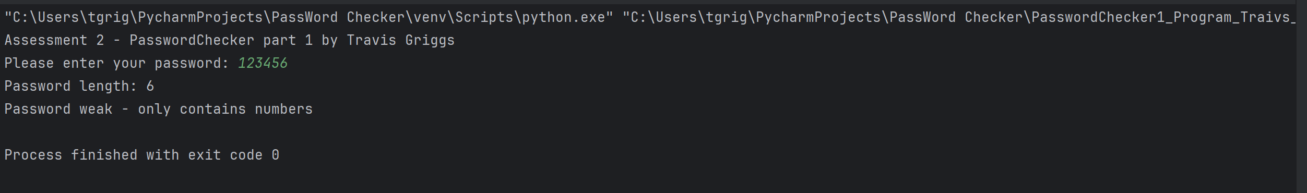

Screenshot 4

