**Sample Test Data - Debug**

Screenshot 1:

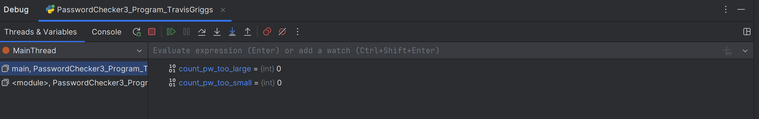

Screenshot 2:

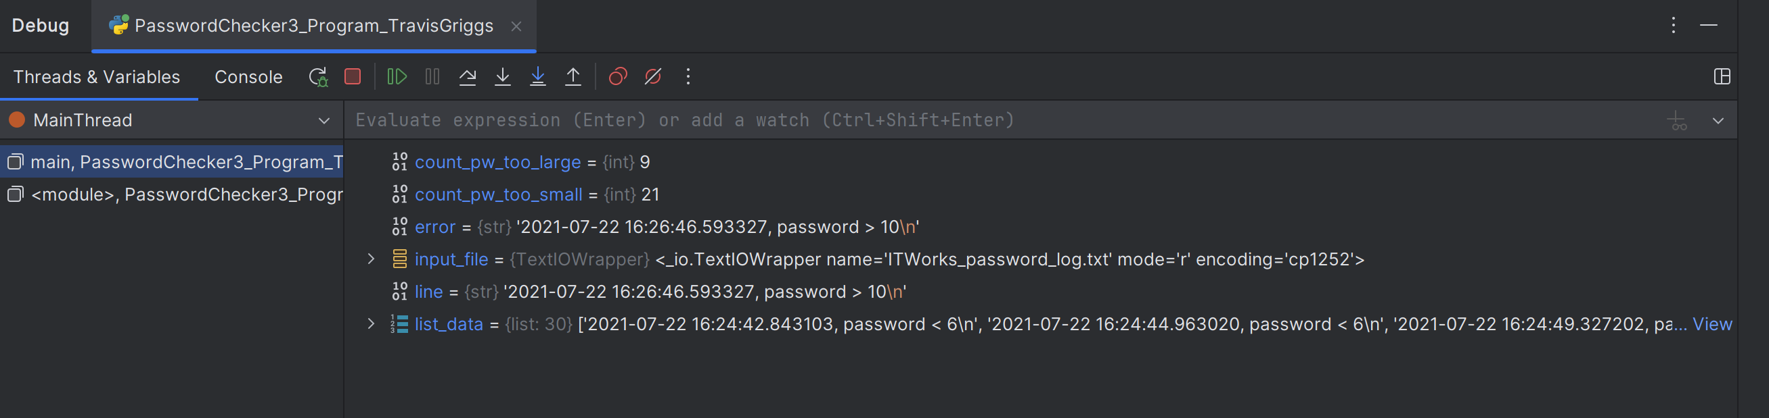

Screenshot 3:

