**Name: Travis Griggs**

Object, Method, Action/Pseudocode (MAP) Plan

|  |  |  |
| --- | --- | --- |
| **Object** | **Method** | **Actions - Pseudocode** |
| Save Button | saveButtonClick | Input customerPhone, customerName, & vehiclePrice  Disable customerPhoneTextBox & customerName TextBox  Focus vehiclePriceTextBox |
| Calculate Button | calclateButtonClick | gst_rate = 10% = 0.1  Input vehiclePrice & lessTradeIn  subAmount = vehiclePrice – lessTradeIn  gstAmount = subAmount * gst_rate  finalAmount = subAmount + gstAmount  Output subAmount, gstAmount, & finalAmount |
| Reset Button | resetButtonClick | Clear customerPhoneTextBox, customerNameTextBox, vehiclePriceTextBox, lessTradeInTextBox, subAmountTextBox, gstAmountTextBox, & finalAmountTextBox  Enable customerPhoneTextBox & customerNameTextBox  Focus customerNameTextBox |

**Test Data 1:**

Customer Name: David Smith

Customer Phone: 0123456789

Vehicle price: 40000

Less Trade In: 15000

**Test Data 2:**

Customer Name: Paul Williams

Customer Phone: 0987654321

Vehicle price: 200000

Less Trade In: 60000

**Testing Screen shots:**

**Using Test Data1**

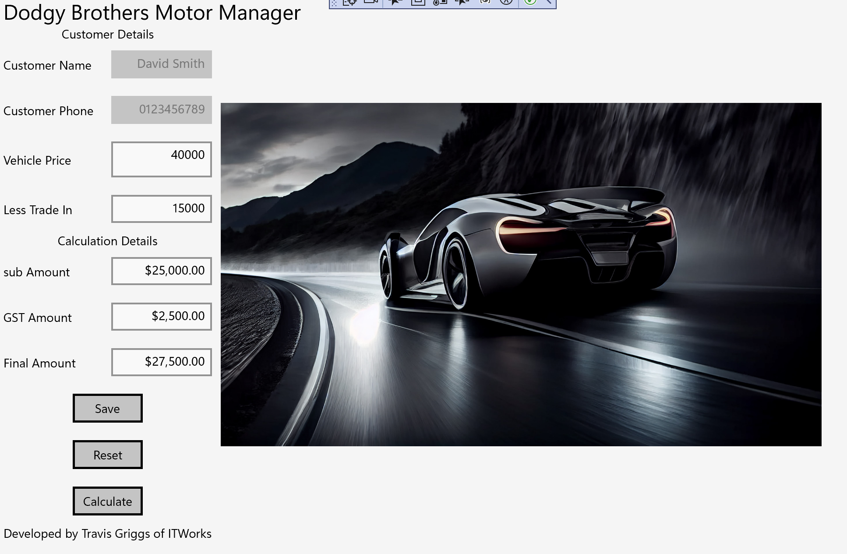

**Using Test Data2**

