**Name:** Travis Griggs

Object, Method, Action/Pseudocode (MAP) Plan

|  |  |  |
| --- | --- | --- |
| **Object** | **Method** | **Actions - Pseudocode** |
| Save Button | saveButtonClick | Input customerPhone & customerName  If customer name is blank (null)  output error message, and focus customer name textbox.  Else disable customerNameTextBox  If customer phone number is blank (null)  output error message, and focus customer name textbox.  Else disable customerPhoneNumberTextBox  Focus vehiclePriceTextBox |
| Summary Button | summaryButtonClick | Input vehiclePrice & lessTradeIn  gst_rate = 10% = 0.1  Try  vehiclePrice is double  Catch  Output error  Return  If vehicle price is less than or equal to 0  Output error message, and focus vehiclePrice textbox.  If less trade in is empty (null)  Output error message, and focus lessTradeIn textbox  Try  lessTradeIn is double  Catch  Output error  Return  If less trade in is less than 0  Output error message, and focus lessTradeIn textbox.  If less trade in is greater than vehicle price  Output error message, and focus lessTradeIn textbox.  subAmount = vehiclePrice – lessTradeIn  gstAmount = subAmount * gst_rate  finalAmount = subAmount + gstAmount  Output subAmount, gstAmount, & finalAmount |
| Reset Button | resetButtonClick | Clear customerPhoneTextBox, customerNameTextBox, vehiclePriceTextBox, lessTradeInTextBox, subAmountTextBox, gstAmountTextBox, & finalAmountTextBox  Enable customerPhoneTextBox & customerNameTextBox  Focus customerNameTextBox |

**Test Data 1:**

**Input**: Vehicle cost 1000, tradeIn 100

**Calculations**: sub Amount = 900 GST Amount = 90 Final Amount = 990

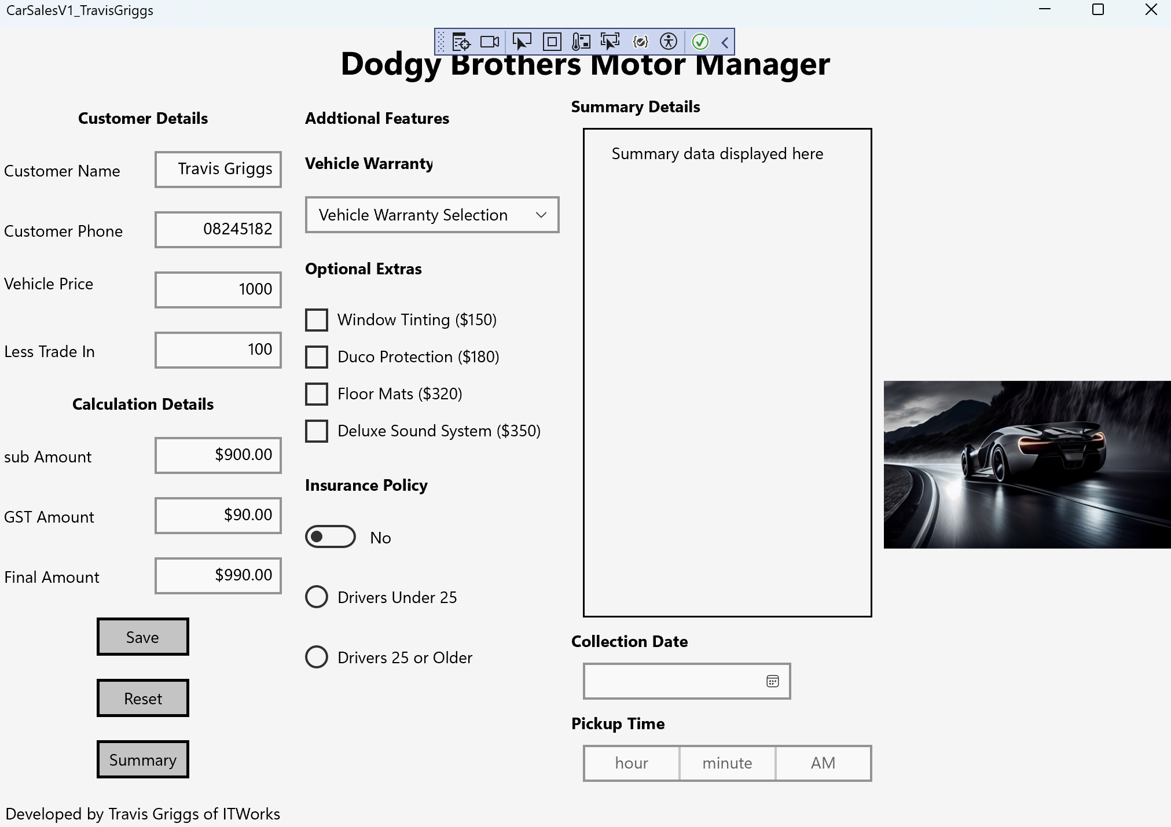

**Test Data 2:** Vehicle cost 15000, tradeIn 3000

**Calculations**: sub Amount = 12000 GST Amount = 1200 Final Amount = 13200

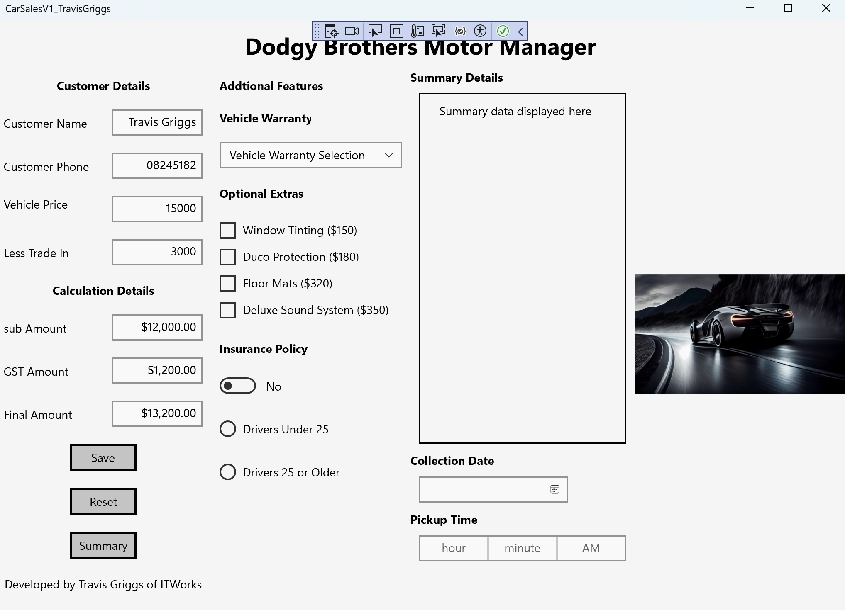

**Testing Screen shots:**

1. **incorrect data entry for customer name**

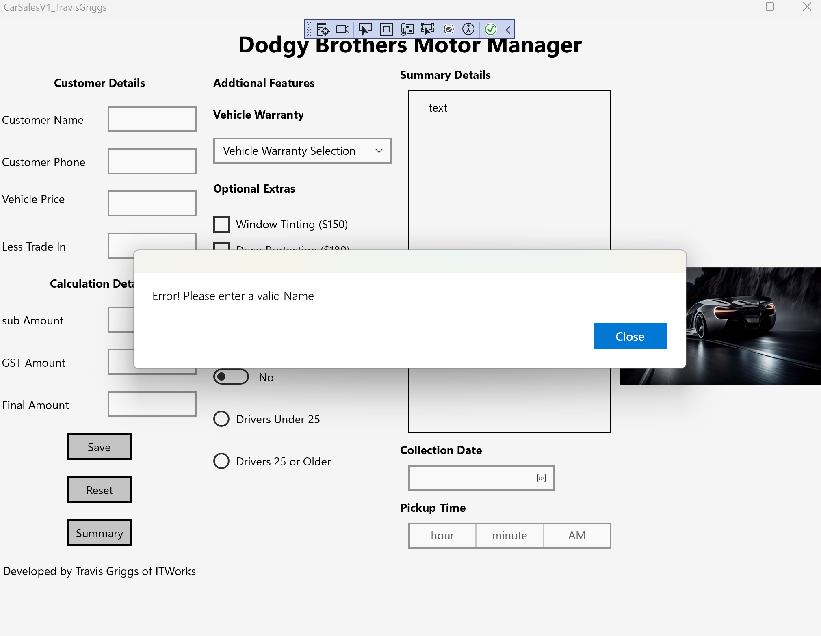

1. **incorrect data entry for customer phone**

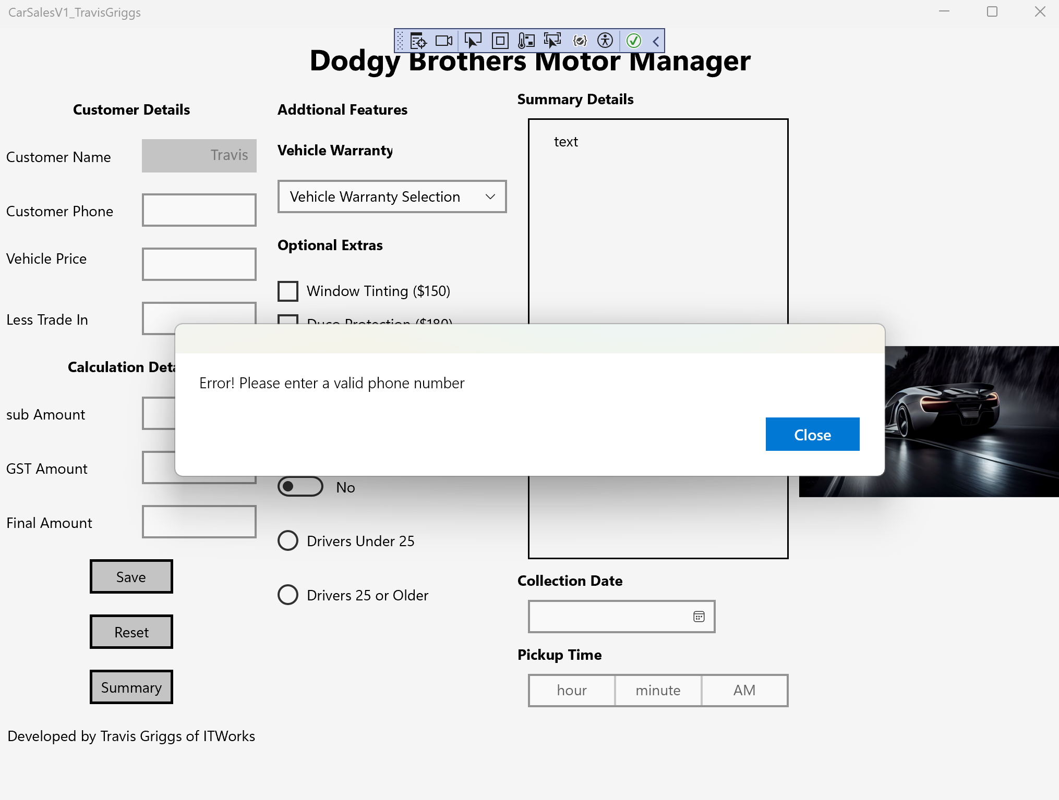

1. **incorrect data entry for vehiclePrice to test the try/catch**

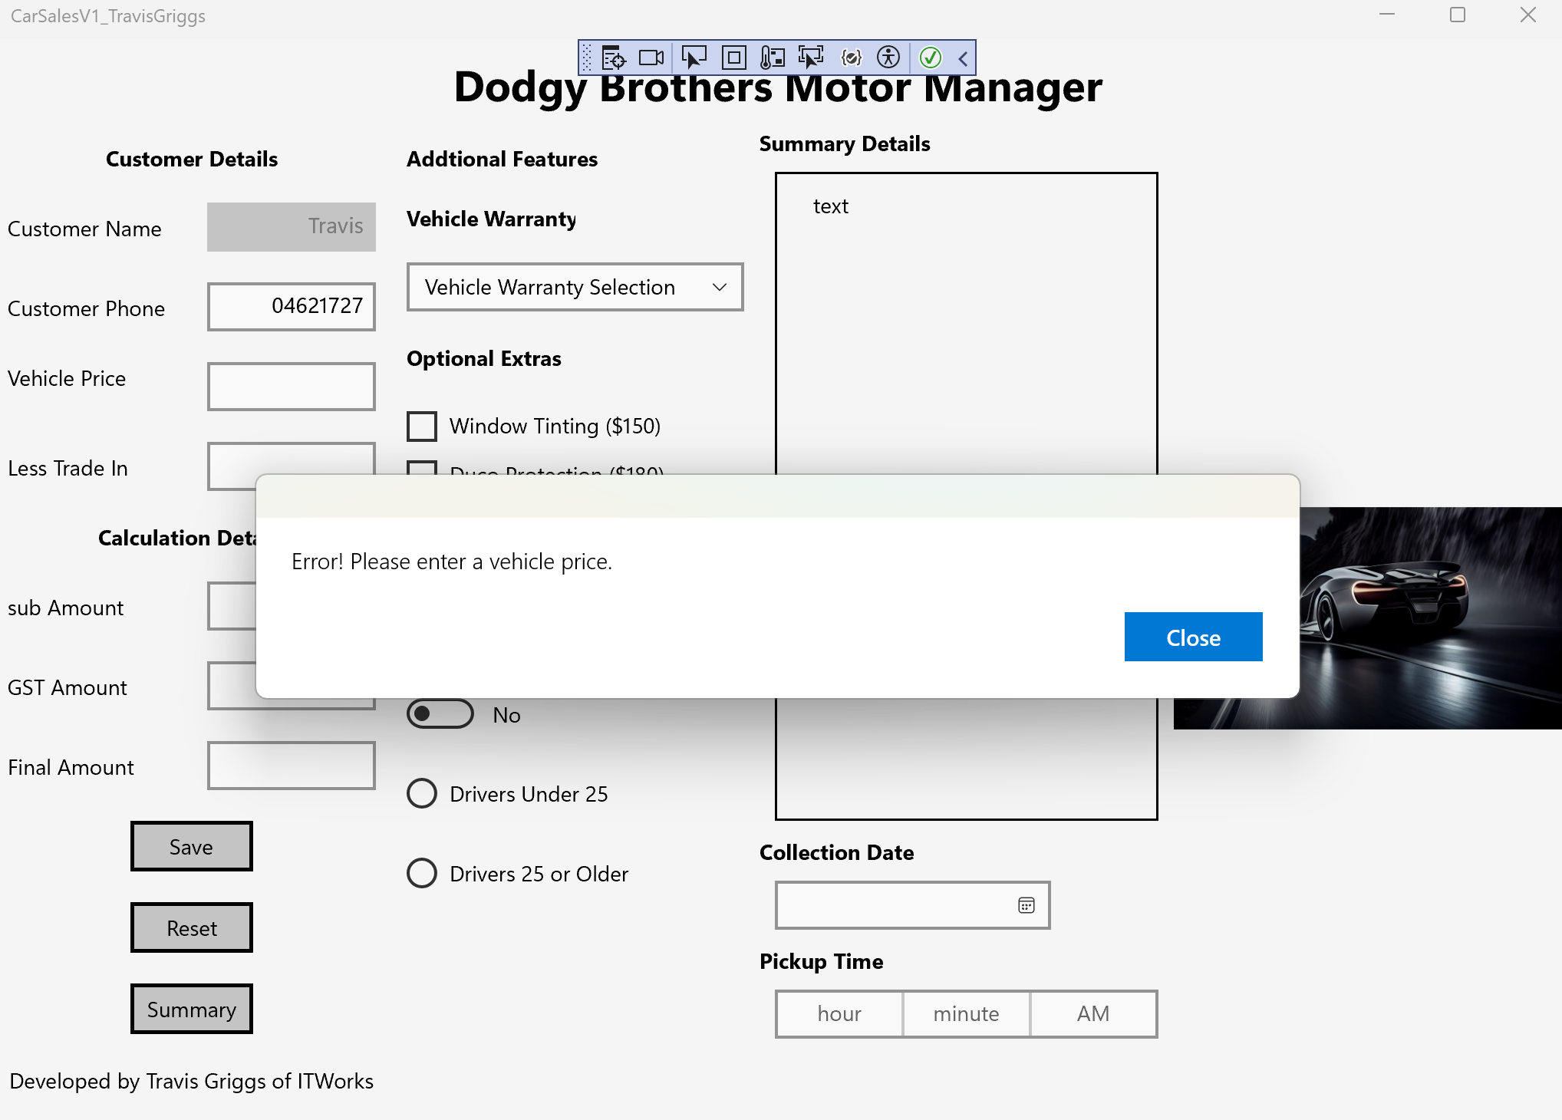

1. **incorrect data entry for tradeIn to test the try/catch**

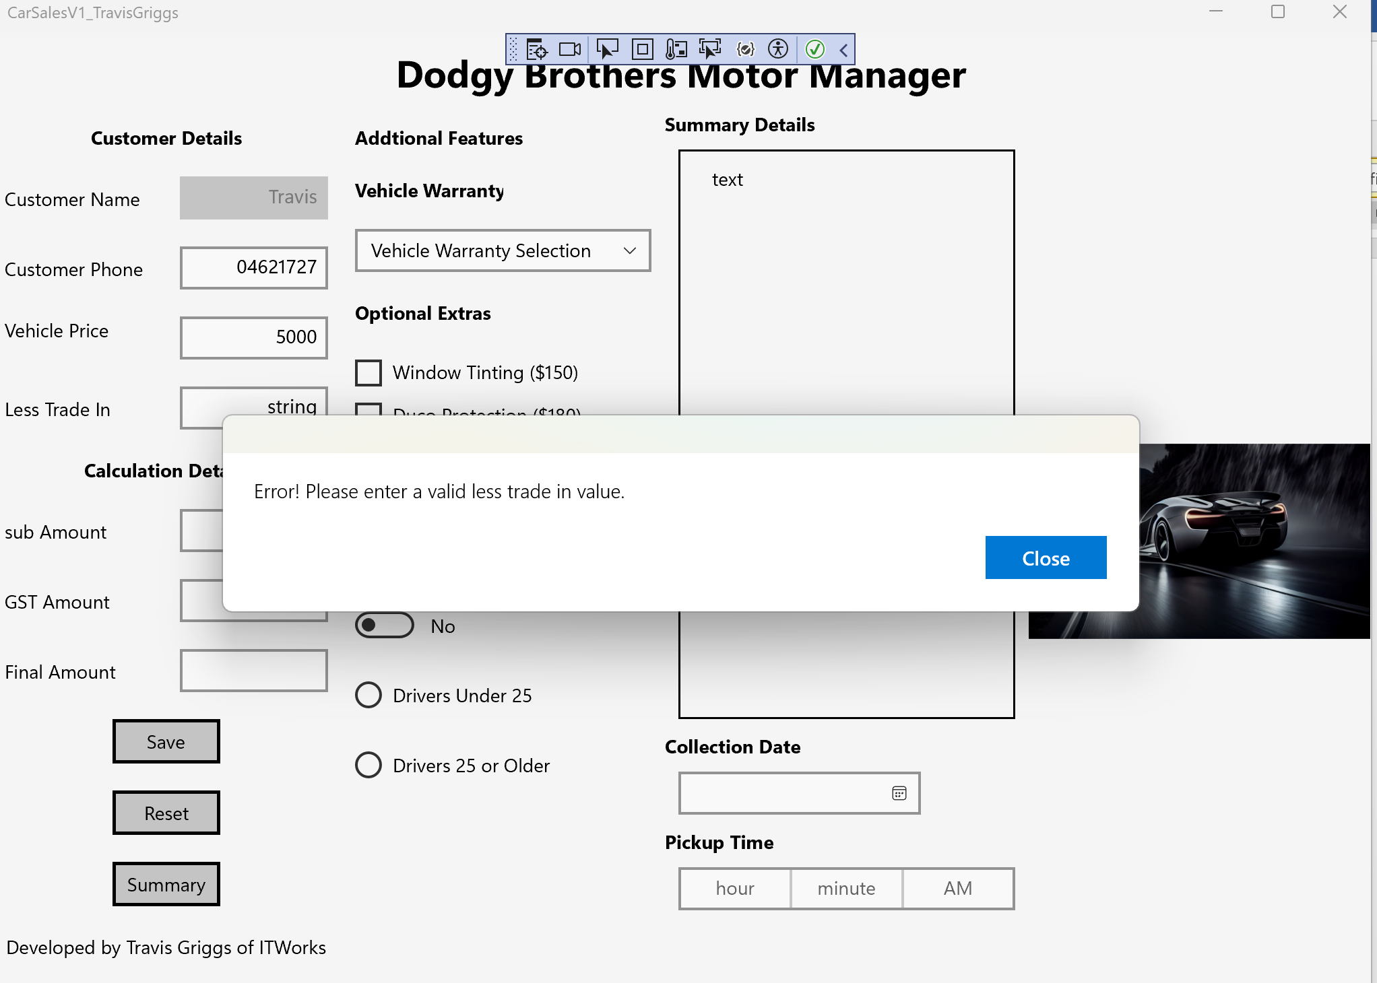

1. **incorrect data entry for vehiclePrice to test <=0**

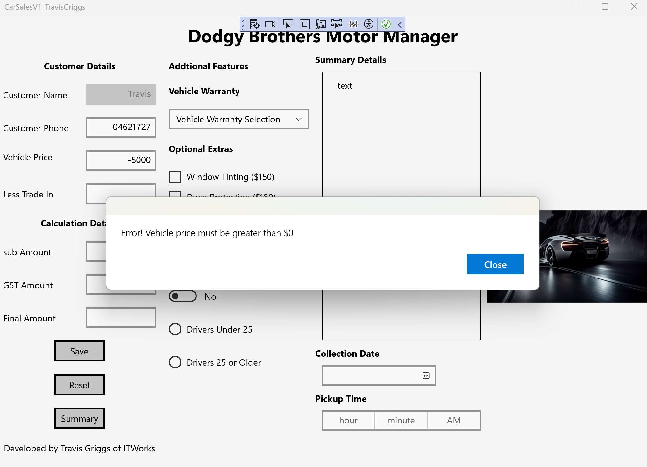

1. **incorrect data entry for tradeIn to test <0**

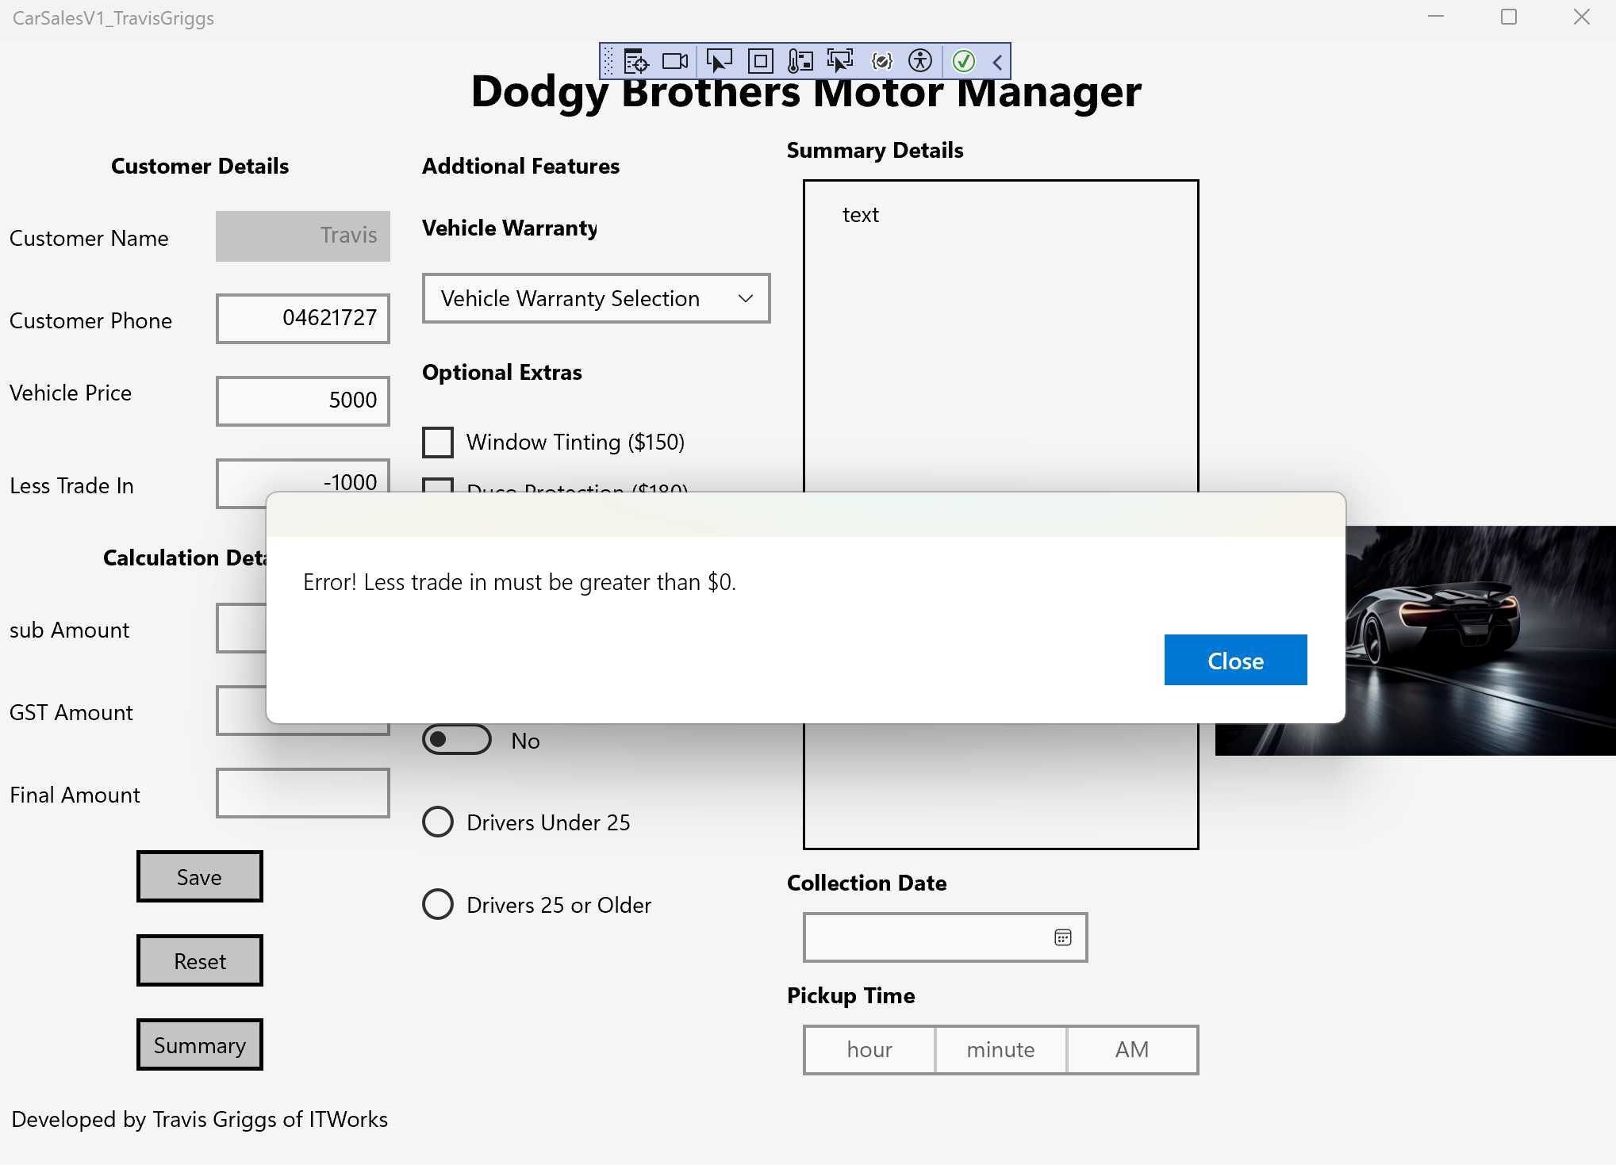

1. **incorrect data entry to test vehiclePrice > tradeIn**

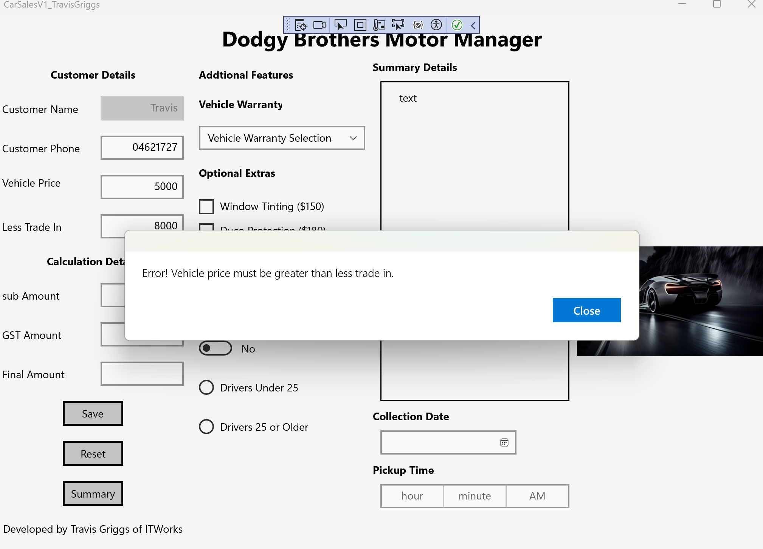

**Debugging Screen shots:**

1. **Initial values of variables**

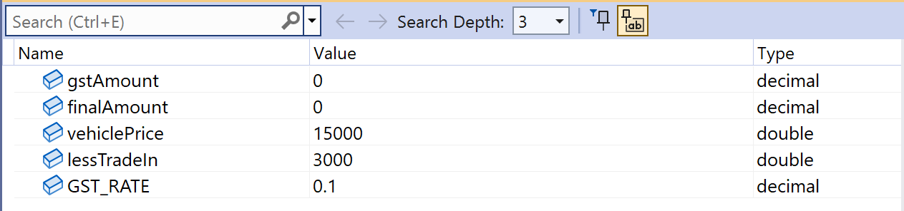

1. **Final calculations of the variables**

