**Name:** Travis Griggs

Object, Method, Action/Pseudocode (MAP) Plan

|  |  |  |
| --- | --- | --- |
| **Object** | **Method** | **Actions - Pseudocode** |
| Save Button | saveButtonClick | Input customerPhone & customerName  If customer name is blank (null)  output error message, and focus customer name textbox.  Else disable customerNameTextBox  If customer phone number is blank (null)  output error message, and focus customer name textbox.  Else disable customerPhoneNumberTextBox  Focus vehiclePriceTextBox |
| Summary Button | summaryButtonClick | Input vehiclePrice & lessTradeIn  gst_rate = 10% = 0.1  Try  vehiclePrice is double  Catch  Output error  Return  If vehicle price is less than or equal to 0  Output error message, and focus vehiclePrice textbox.  If less trade in is empty (null)  Output error message, and focus lessTradeIn textbox  Try  lessTradeIn is double  Catch  Output error  Return  If less trade in is less than 0  Output error message, and focus lessTradeIn textbox.  If less trade in is greater than vehicle price  Output error message, and focus lessTradeIn textbox.  Define warrantyCost, extrasCost, and insuranceCost  subAmount = vehiclePrice + warrantyCost + optionalExtrasCost + insuranceCost - lessTradeIn  gstAmount = subAmount * gst_rate  finalAmount = subAmount + gstAmount  Output customerName, customerPhone, vehicleCost, tradeIn, warrantyCost, optionalExtrasCost, insuranceCost subAmount, gstAmount, & finalAmount |
| Reset Button | resetButtonClick | Clear customerPhoneTextBox, customerNameTextBox, vehiclePriceTextBox, lessTradeInTextBox, subAmountTextBox, gstAmountTextBox, & finalAmountTextBox  Enable customerPhoneTextBox & customerNameTextBox  Focus customerNameTextBox  Uncheck windowTintingCheckBox, ducoProtectionCheckBox, floorMatsCheckBox,  deluxeSoundSystemCheckBox  Return vehicleWarrantyComboBox to default 1 year warranty  Turn off insurancePolicyToggleSwitch    Uncheck driversUnderAgeRadioButton and olderDriversRadioButton |
| N/A | calcVehicleWarranty | double warrantyCost = 0;  calculate warrantyCost for each case  case 1:  warrantyCost = vehiclePrice * 0.05;  break;  case 2:  warrantyCost = vehiclePrice * 0.10;  break;  case 3:  warrantyCost = vehiclePrice * 0.20;  break;  default:  warrantyCost = 0;  break;  return warrantyCost |
| N/A | calcOptionalExtras | double extrasCost = 0;  if windowTinting is Checked add $150 to extra cost  if ducoProtection is Checked add $180 to extra cost  if floorMats is Checked add $320 to extra cost  if deluxeSoundSystem is Checked add $350 to extra cost  return extrasCost; |
| N/A | calcAccidentInsurance | if insurancePolicyToggleSwitch is on then    if driversUnderAgeRadioButton is checked  return (vehiclePrice + optionalExtras) * 0.20;    else if (olderDriversRadioButton is checked  return (vehiclePrice + optionalExtras) * 0.10;    if insurancePolicyToggleSwitch is off then  return 0 |
| Insurance Policy Toggle Switch | insurancePolicyToggleSwitch | if insurancePolicyToggleSwitch is on then    enable driversUnderAgeRadioButton  enable olderDriversRadioButton  enable olderDriversRadioButton    else    disable and uncheck driversUnderAgeRadioButton  disable and uncheck olderDriversRadioButton |

**Test Data 1:**

**Input**: Vehicle cost 1000, tradeIn 100, 3yr warranty selected, all extras selected, insurance with age >=25

**Calculations**: sub Amount = 2200 GST Amount = 220 Final Amount = 2420

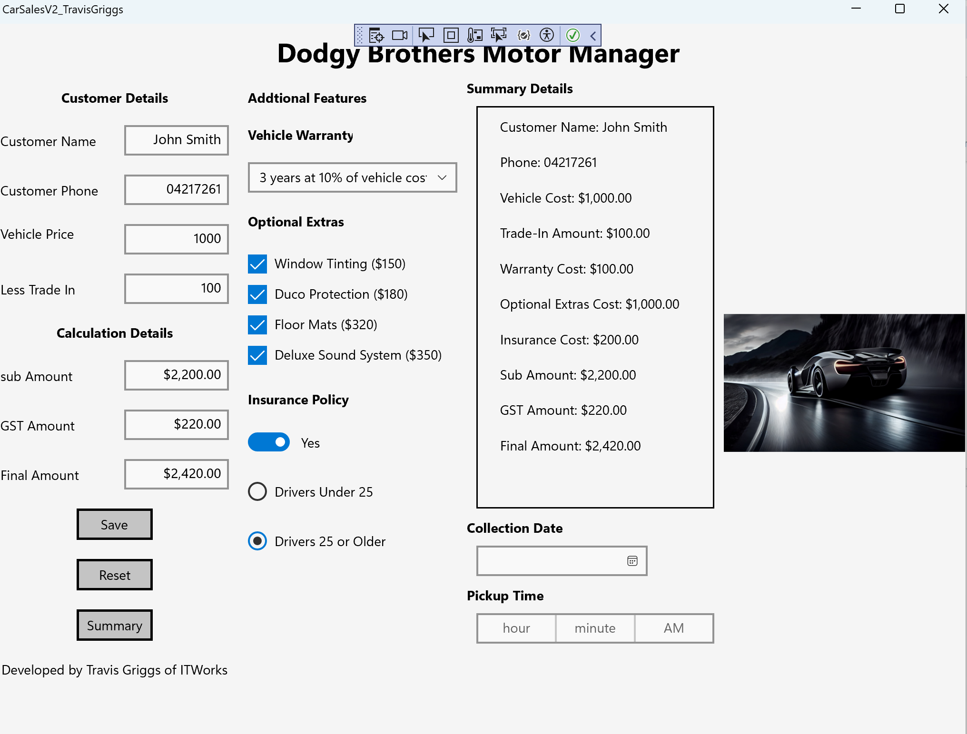

**Test Data 2:** Vehicle cost 15000, tradeIn 3000, 5yr warranty selected, no extras selected, insurance with age <25

**Calculations**: sub Amount = 20700 GST Amount = 2070 Final Amount = 22770

