|  |  |  |  |  |  |  |  |  |  |
| --- | --- | --- | --- | --- | --- | --- | --- | --- | --- |
| **Statement** | **logical** | **Fullname** | **Address** | **Postcode** | **Email** | **Card Number** | **CCV** | **Expiry Date** | **Output** |
| INPUT fullname, address, postcode, email, cardNumber, ccv, expiryDate |  |  |  |  |  |  |  |  |  |
| IF (fullname =="") | T |  |  |  |  |  |  |  | Name Required |
| OUTPUT Please fill in all required fields |  |  |  |  |  |  |  |  |  |
| RETURN false |  |  |  |  |  |  |  |  |  |
| INPUT fullname, address, postcode, email, cardNumber, ccv, expiryDate |  | Travis Griggs |  |  |  |  |  |  |  |
| IF (fullname =="") | F |  |  |  |  |  |  |  |  |
| IF (address =="") | T |  |  |  |  |  |  |  | Address Required |
| OUTPUT Please fill in all required fields |  |  |  |  |  |  |  |  |  |
| RETURN false |  |  |  |  |  |  |  |  |  |
| INPUT fullname, address, postcode, email, cardNumber, ccv, expiryDate |  | Travis Griggs | 3 Shell Road |  |  |  |  |  |  |
| IF (fullname =="") | F |  |  |  |  |  |  |  |  |
| IF (address =="") | F |  |  |  |  |  |  |  |  |
| IF (postcode =="") | T |  |  |  |  |  |  |  | Postcode Required |
| OUTPUT Please fill in all required fields |  |  |  |  |  |  |  |  |  |
| RETURN false |  |  |  |  |  |  |  |  |  |
| INPUT fullname, address, postcode, email, cardNumber, ccv, expiryDate |  | Travis Griggs | 3 Shell Road | 121 |  |  |  |  |  |
| IF (fullname =="") | F |  |  |  |  |  |  |  |  |
| IF (address =="") | F |  |  |  |  |  |  |  |  |
| IF (postcode =="") | F |  |  |  |  |  |  |  |  |
| IF (email == "") | T |  |  |  |  |  |  |  | Email Required |
| OUTPUT Please fill in all required fields |  |  |  |  |  |  |  |  |  |
| RETURN false |  |  |  |  |  |  |  |  |  |
| INPUT fullname, address, postcode, email, cardNumber, ccv, expiryDate |  | Travis Griggs | 3 Shell Road | 121 | Travis.Griggs@ |  |  |  |  |
| IF (fullname =="") | F |  |  |  |  |  |  |  |  |
| IF (address =="") | F |  |  |  |  |  |  |  |  |
| IF (postcode =="") | F |  |  |  |  |  |  |  |  |
| IF (email =="") | F |  |  |  |  |  |  |  |  |
| IF (cardNumber =="") | T |  |  |  |  |  |  |  |  |
| OUTPUT Please fill in all required fields |  |  |  |  |  |  |  |  | Card Number Required |
| RETURN false |  |  |  |  |  |  |  |  |  |
| INPUT fullname, address, postcode, email, cardNumber, ccv, expiryDate |  | Travis Griggs | 3 Shell Road | 121 | Travis.Griggs@ | 1234 |  |  |  |
| IF (fullname =="") | F |  |  |  |  |  |  |  |  |
| IF (address =="") | F |  |  |  |  |  |  |  |  |
| IF (postcode =="") | F |  |  |  |  |  |  |  |  |
| IF (email =="") | F |  |  |  |  |  |  |  |  |
| IF (cardNumber =="") | F |  |  |  |  |  |  |  |  |
| IF (ccv =="") | T |  |  |  |  |  |  |  |  |
| OUTPUT Please fill in all required fields |  |  |  |  |  |  |  |  | cvv Required |
| RETURN false |  |  |  |  |  |  |  |  |  |
| INPUT fullname, address, postcode, email, cardNumber, ccv, expiryDate |  | Travis Griggs | 3 Shell Road | 121 | Travis.Griggs@ | 1234 | 12 | January 2024 |  |
| IF (fullname =="") | F |  |  |  |  |  |  |  |  |
| IF (address =="") | F |  |  |  |  |  |  |  |  |
| IF (postcode =="") | F |  |  |  |  |  |  |  |  |
| IF (email =="") | F |  |  |  |  |  |  |  |  |
| IF (cardNumber =="") | F |  |  |  |  |  |  |  |  |
| IF (ccv =="") | F |  |  |  |  |  |  |  |  |
| IF (postcode.length < 4 or isNaN ) | T |  |  |  |  |  |  |  |  |
| OUTPUT Please enter a valid postcode (4 digits) |  |  |  |  |  |  |  |  | Please enter a valid postcode (4 digits) |
| RETURN false |  |  |  |  |  |  |  |  |  |
| INPUT fullname, address, postcode, email, cardNumber, ccv, expiryDate |  | Travis Griggs | 3 Shell Road | 1214 | Travis.Griggs@ | 1234 | 12 | January 2024 |  |
| IF (fullname =="") | F |  |  |  |  |  |  |  |  |
| IF (address =="") | F |  |  |  |  |  |  |  |  |
| IF (postcode =="") | F |  |  |  |  |  |  |  |  |
| IF (email =="") | F |  |  |  |  |  |  |  |  |
| IF (cardNumber =="") | F |  |  |  |  |  |  |  |  |
| IF (ccv =="") | F |  |  |  |  |  |  |  |  |
| IF (postcode.length < 4 or isNaN ) | F |  |  |  |  |  |  |  |  |
| IF (email.length < 8 or email.indexOf("@")== -1 or email.indexOf(".")== -1) | T |  |  |  |  |  |  |  |  |
| OUTPUT Please enter a valid email address i.e. contains at least 8 chracters, inclduing @ and . |  |  |  |  |  |  |  |  | Please enter a valid email address i.e. contains at least 8 chracters, inclduing @ and . |
| RETURN false |  |  |  |  |  |  |  |  |  |
| INPUT fullname, address, postcode, email, cardNumber, ccv, expiryDate |  | Travis Griggs | 3 Shell Road | 1214 | Travis.Griggs@gmail.com | 1234 | 12 | January 2024 |  |
| IF (fullname =="") | F |  |  |  |  |  |  |  |  |
| IF (address =="") | F |  |  |  |  |  |  |  |  |
| IF (postcode =="") | F |  |  |  |  |  |  |  |  |
| IF (email =="") | F |  |  |  |  |  |  |  |  |
| IF (cardNumber =="") | F |  |  |  |  |  |  |  |  |
| IF (ccv =="") | F |  |  |  |  |  |  |  |  |
| IF (postcode.length < 4 or isNaN ) | F |  |  |  |  |  |  |  |  |
| IF (email.length < 8 or email.indexOf("@")== -1 or email.indexOf(".")== -1) | F |  |  |  |  |  |  |  |  |
| IF (cardNumber.length < 16 or isNaN) | T |  |  |  |  |  |  |  |  |
| OUTPUT Please enter a valid credit card number (16 digits). |  |  |  |  |  |  |  |  | Please enter a valid credit card number (16 digits). |
| RETURN false |  |  |  |  |  |  |  |  |  |
| INPUT fullname, address, postcode, email, cardNumber, ccv, expiryDate |  | Travis Griggs | 3 Shell Road | 1214 | Travis.Griggs@gmail.com | 1111-2222-3333-4444 | 12 | January 2024 |  |
| IF (fullname =="") | F |  |  |  |  |  |  |  |  |
| IF (address =="") | F |  |  |  |  |  |  |  |  |
| IF (postcode =="") | F |  |  |  |  |  |  |  |  |
| IF (email =="") | F |  |  |  |  |  |  |  |  |
| IF (cardNumber =="") | F |  |  |  |  |  |  |  |  |
| IF (ccv =="") | F |  |  |  |  |  |  |  |  |
| IF (postcode.length < 4 or isNaN ) | F |  |  |  |  |  |  |  |  |
| IF (email.length < 8 or email.indexOf("@")== -1 or email.indexOf(".")== -1) | F |  |  |  |  |  |  |  |  |
| IF (cardNumber.length < 16 or isNaN) | F |  |  |  |  |  |  |  |  |
| IF (ccv.length < 16 or isNaN) | T |  |  |  |  |  |  |  |  |
| OUTPUT Please enter a valid CCV (3 digits) |  |  |  |  |  |  |  |  | Please enter a valid CCV (3 digits) |
| RETURN false |  |  |  |  |  |  |  |  |  |
| INPUT fullname, address, postcode, email, cardNumber, ccv, expiryDate |  | Travis Griggs | 3 Shell Road | 1214 | Travis.Griggs@gmail.com | 1111-2222-3333-4444 | 121 | January 2024 |  |
| IF (fullname =="") | F |  |  |  |  |  |  |  |  |
| IF (address =="") | F |  |  |  |  |  |  |  |  |
| IF (postcode =="") | F |  |  |  |  |  |  |  |  |
| IF (email =="") | F |  |  |  |  |  |  |  |  |
| IF (cardNumber =="") | F |  |  |  |  |  |  |  |  |
| IF (ccv =="") | F |  |  |  |  |  |  |  |  |
| IF (postcode.length < 4 or isNaN ) | F |  |  |  |  |  |  |  |  |
| IF (email.length < 8 or email.indexOf("@")== -1 or email.indexOf(".")== -1) | F |  |  |  |  |  |  |  |  |
| IF (cardNumber.length < 16 or isNaN) | F |  |  |  |  |  |  |  |  |
| IF (ccv.length < 16 or isNaN) | F |  |  |  |  |  |  |  |  |
| Define variables: currentYear and currentMonth |  |  |  |  |  |  |  |  |  |
| IF ((expiryYear < currentYear or (expiryYear == currentYear && expiryMonth < currentMonth)) | T |  |  |  |  |  |  |  |  |
| OUTPUT Your credit card has expired. Please enter a valid expiry date |  |  |  |  |  |  |  |  | Your credit card has expired. Please enter a valid expiry date |
| RETURN false |  |  |  |  |  |  |  |  |  |
| INPUT fullname, address, postcode, email, cardNumber, ccv, expiryDate |  | Travis Griggs | 3 Shell Road | 1214 | Travis.Griggs@gmail.com | 1111-2222-3333-4444 | 121 | October 2028 |  |
| IF (fullname =="") | F |  |  |  |  |  |  |  |  |
| IF (address =="") | F |  |  |  |  |  |  |  |  |
| IF (postcode =="") | F |  |  |  |  |  |  |  |  |
| IF (email =="") | F |  |  |  |  |  |  |  |  |
| IF (cardNumber =="") | F |  |  |  |  |  |  |  |  |
| IF (ccv =="") | F |  |  |  |  |  |  |  |  |
| IF (postcode.length < 4 or isNaN ) | F |  |  |  |  |  |  |  |  |
| IF (email.length < 8 or email.indexOf("@")== -1 or email.indexOf(".")== -1) | F |  |  |  |  |  |  |  |  |
| IF (cardNumber.length < 16 or isNaN) | F |  |  |  |  |  |  |  |  |
| IF (ccv.length < 16 or isNaN) | F |  |  |  |  |  |  |  |  |
| Define variables: currentYear and currentMonth |  |  |  |  |  |  |  |  |  |
| IF ((expiryYear < currentYear or (expiryYear == currentYear && expiryMonth < currentMonth)) | F |  |  |  |  |  |  |  |  |
| RETURN true |  |  |  |  |  |  |  |  |  |

Testing Screenshots:

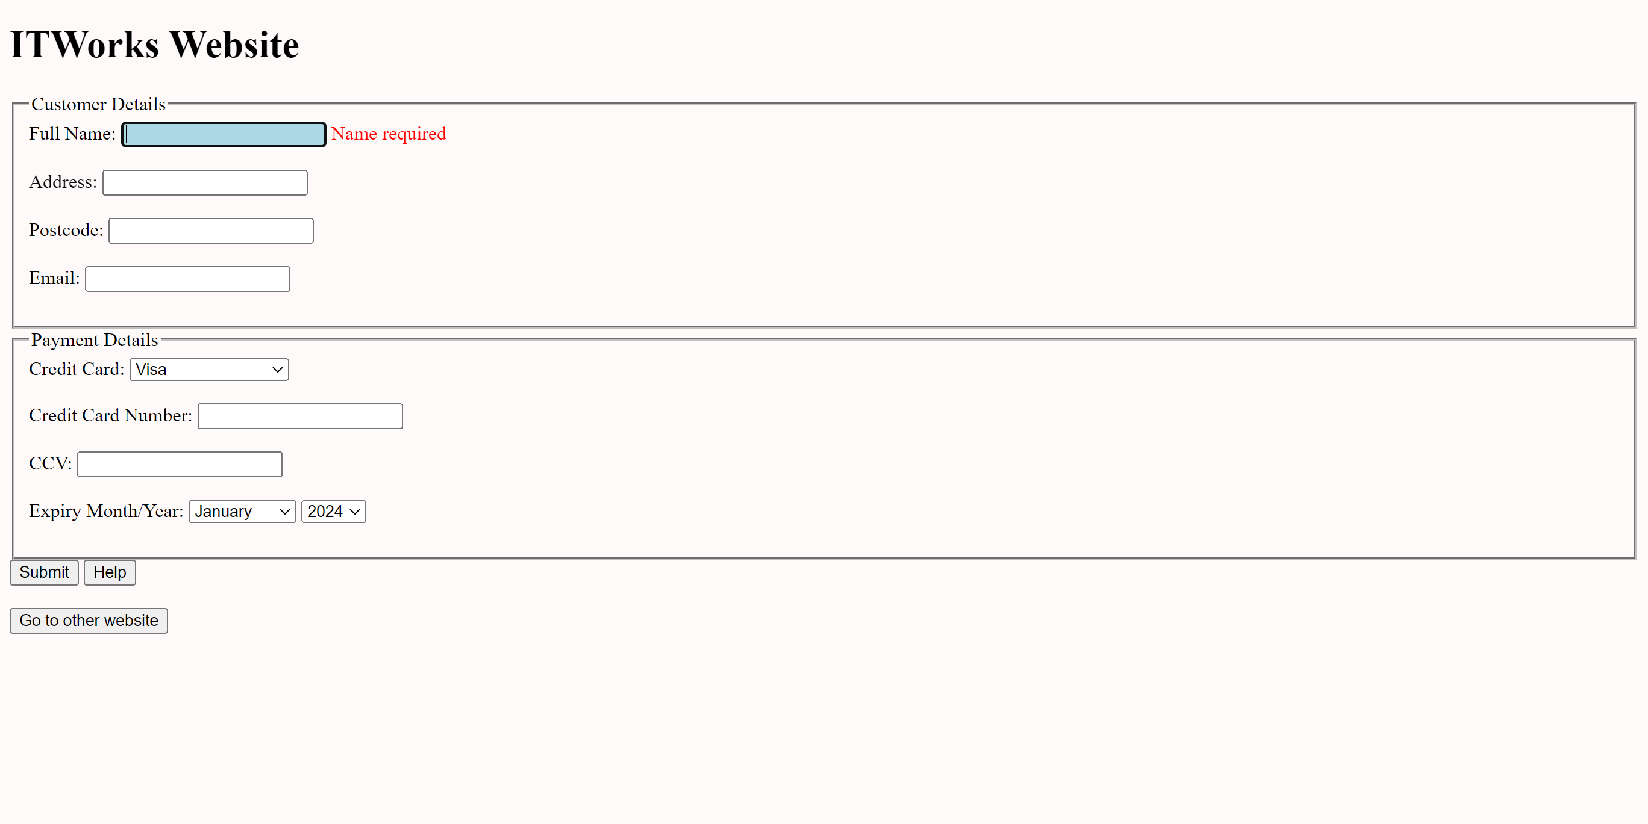

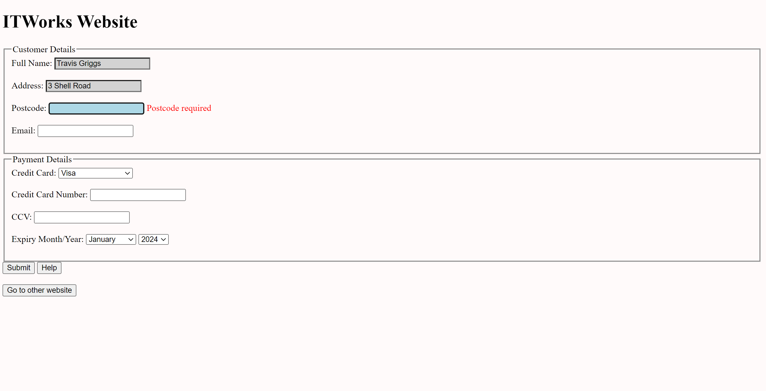

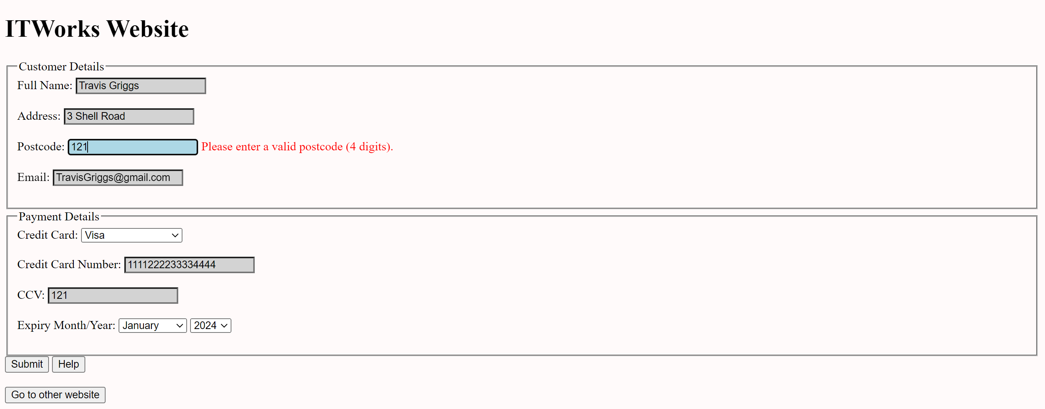

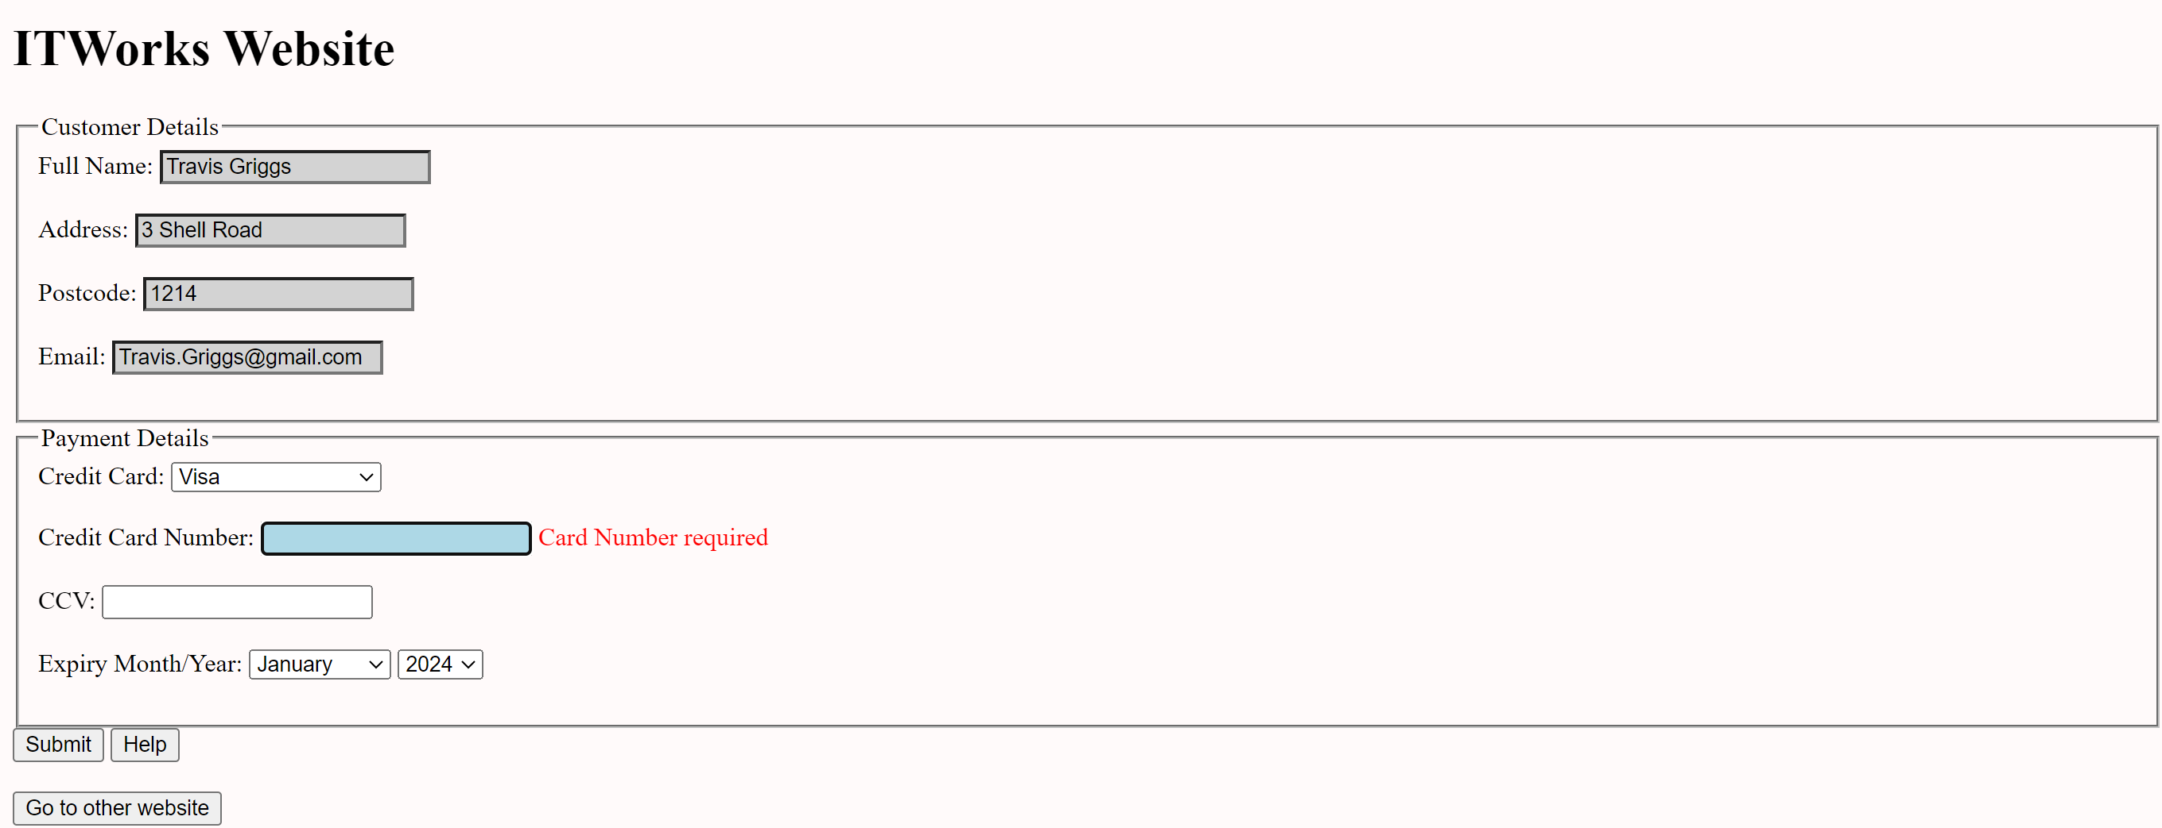

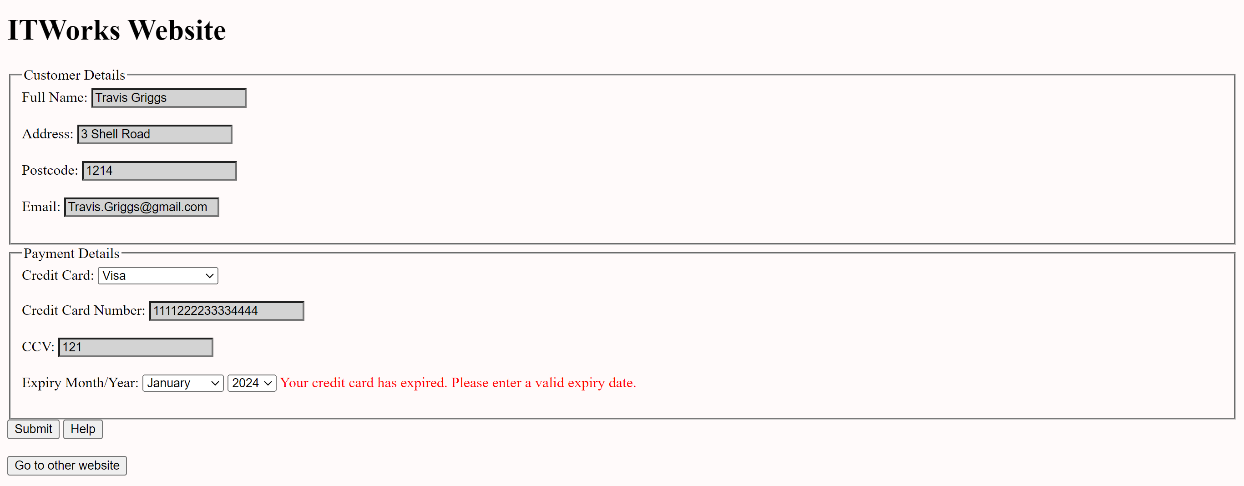

Debugging Screen Shots:

