## ERD Design Approval Form

Student Name

Travis Griggs

Student ID

001216363

File Name for the Submitted ERD

Travis_Griggs_TASK1.mwb

Provide a screenshot of the ERD

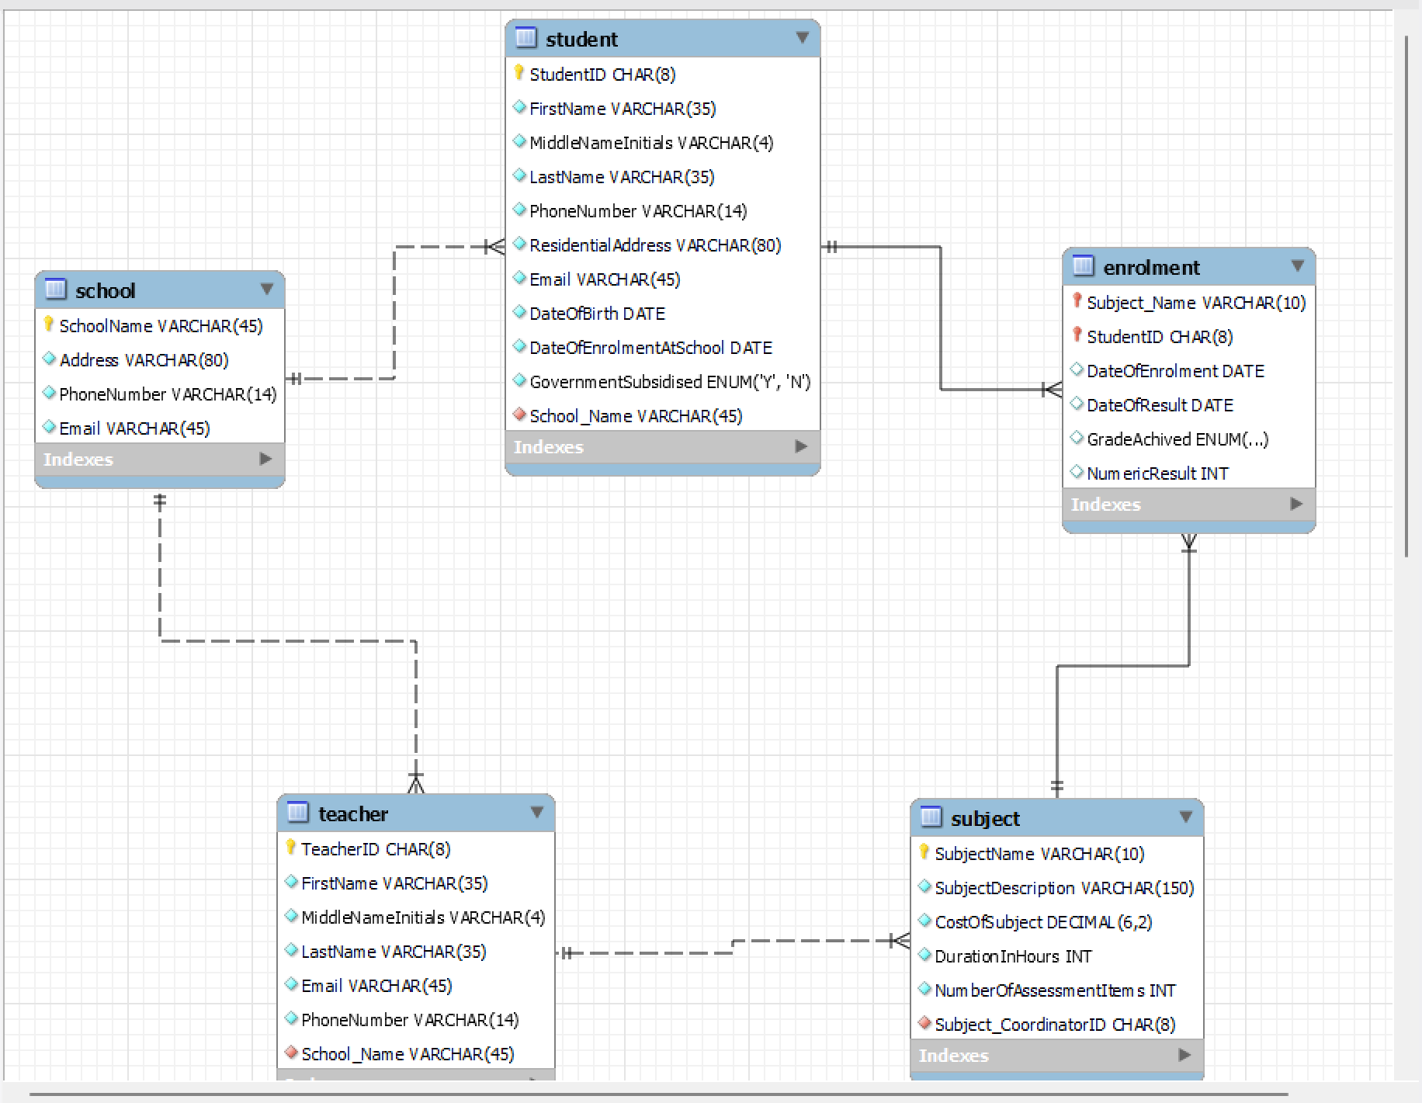

Provide the following information

Tables and relationships

|  |  |  |  |
| --- | --- | --- | --- |
| Table Name | Primary Key | Foreign key(s) & Table | Relationships statement to other tables |
| student | StudentID | School_Name from school | A student has one school  A student has many subjects in which they enrol |
| subject | SubjectName | Subject_CoordinatorID form teacher | A subject has one coordinator  A subject has many students enrolled in the subject |
| school | SchoolName | None | A school has many students  A school has many teachers |
| teacher | TeacherID | School_Name from school | A teacher has one school  A teacher coordinates many subjects |
| enrolment | StudentID & SubjectName | StudentID from student  &  Subject_Name from subject | A subject has many students - but each student is enrolled in that subject only once  A student enrolment has many subjects - but each student only enrols in each subject once |

Tables and data

Provide information on all tables

|  |  |  |  |
| --- | --- | --- | --- |
| student |  | | |
| Column Name | **Datatype** | **Data Character Capacity** | **Reason for the chosen Datatype and Data Capacity** |
| StudentID | CHAR(8) | Must be 8 | All student IDs have 8 digits |
| FirstName | VARCHAR(35) | Max 35 | Student names vary in length - 35 characters should be sufficient |
| MiddleNameInitials | VARCHAR(4) | Max 4 | The number of middle names students hold vary in quantity - 4 characters should be sufficient |
| LastName | VARCHAR(35) | Max 35 | Student names vary in length - 35 characters should be sufficient |
| PhoneNumber | VARCHAR(14) | Max 14 | Enables phone numbers with special characters or leading “0” for mobile |
| ResidentialAddress | VARCHAR(80) | Max 80 | Includes street address, suburb, state and postcode - 80 characters will be sufficient |
| Email | VARCHAR(45) | Max 45 | Emails may vary in length – 45 characters should be sufficient |
| DateOfBirth | DATE |  | Dates take the format DD/MM/YYYY |
| DateOfEnrolmentAtSchool | DATE |  | Dates take the format DD/MM/YYYY |
| GovernmentSubsidised | ENUM(‘Y’,’N’) | Must be 1 | Must be specified as 1 character (Y or N) |
| School_Name | VARCHAR(45) | Max 45 | School names vary in length - 45 character should be sufficient |

|  |  |  |  |
| --- | --- | --- | --- |
| subject |  | | |
| Column Name | **Datatype** | **Data Character Capacity** | **Reason for the chosen Datatype and Data Capacity** |
| SubjectName | VARCHAR(10) | Max 10 | Subject names will vary in length, up to a maximum of 10 characters |
| SubjectDescription | VARCHAR(150) | Max 150 | Subject description can have up to a maximum of 150 characters |
| CostOfSubject | Decimal(6,2) | Total character 6 with 2 decimals | Subject prices may range in the 1000.00s of $, thus 6 digits with 2 decimals places will be sufficient |
| DurationInHours | INT | Max 10 digits | Hours are measured/reported as integer numbers |
| NumberOfAssessmentItems | INT | Max 10 digits | The number of assessment items is reported as an integer number |
| Subject_CoordinatorID | CHAR(8) | Must be 8 | All teacher IDs have 8 digits |

|  |  |  |  |
| --- | --- | --- | --- |
| school |  | | |
| Column Name | **Datatype** | **Data Character Capacity** | **Reason for the chosen Datatype and Data Capacity** |
| SchoolName | VARCHAR(45) | Max 45 | Subject names will vary in length, up to a maximum of 10 characters |
| Address | VARCHAR(45) | Max 45 | Includes street address, suburb, state and postcode - 80 characters will be sufficient |
| PhoneNumber | VARCHAR(14) | Max 14 | Enables phone numbers with special characters or leading “0” for mobile |
| Email | VARCHAR(45) | Max 45 | Emails may vary in length – 45 characters should be sufficient |

|  |  |  |  |
| --- | --- | --- | --- |
| teacher |  | | |
| Column Name | **Datatype** | **Data Character Capacity** | **Reason for the chosen Datatype and Data Capacity** |
| TeacherID | CHAR(8) | Must be 8 | All teacher IDs have 8 digits |
| FirstName | VARCHAR(35) | Max 35 | First names vary in length - 35 characters should be sufficient |
| MiddleNameInitials | VARCHAR(4) | Max 4 | The number of middle names one holds may vary in quantity - 4 characters should be sufficient |
| LastName | VARCHAR(35) | Max 35 | Last names vary in length - 35 characters should be sufficient |
| Email | VARCHAR(45) | Max 45 | Emails may vary in length – 45 characters should be sufficient |
| PhoneNumber | VARCHAR(14) | Max 14 | Enables phone numbers with special characters or leading “0” for mobile |
| School_Name | VARCHAR(45) | Max 45 | Subject names will vary in length, up to a maximum of 10 characters |

|  |  |  |  |
| --- | --- | --- | --- |
| enrolment |  | | |
| Column Name | **Datatype** | **Data Character Capacity** | **Reason for the chosen Datatype and Data Capacity** |
| Subject_Name | VARCHAR(10) | Max 10 | Subject names will vary in length, up to a maximum of 10 characters |
| StudentID | CHAR(8) | Must be 8 | All student IDs have 8 digits |
| DateOfEnrolment | DATE |  | Dates take the format DD/MM/YYYY, which |
| DateOfResult | DATE |  | Dates take the format DD/MM/YYYY, which |
| GradeAchived | ENUM(‘P’,’C’,’D’,’F’) | Must be 1 | Grades must be reported as 1 character i.e. P- Pass, C-Credit, D-Distinction, F-Fail |
| NumericResult | INT | Max 10 digits | The numeric result reported as an integer number |