**SQL Database Testing**

### Test 1 Name & Phone

Insert into student statement

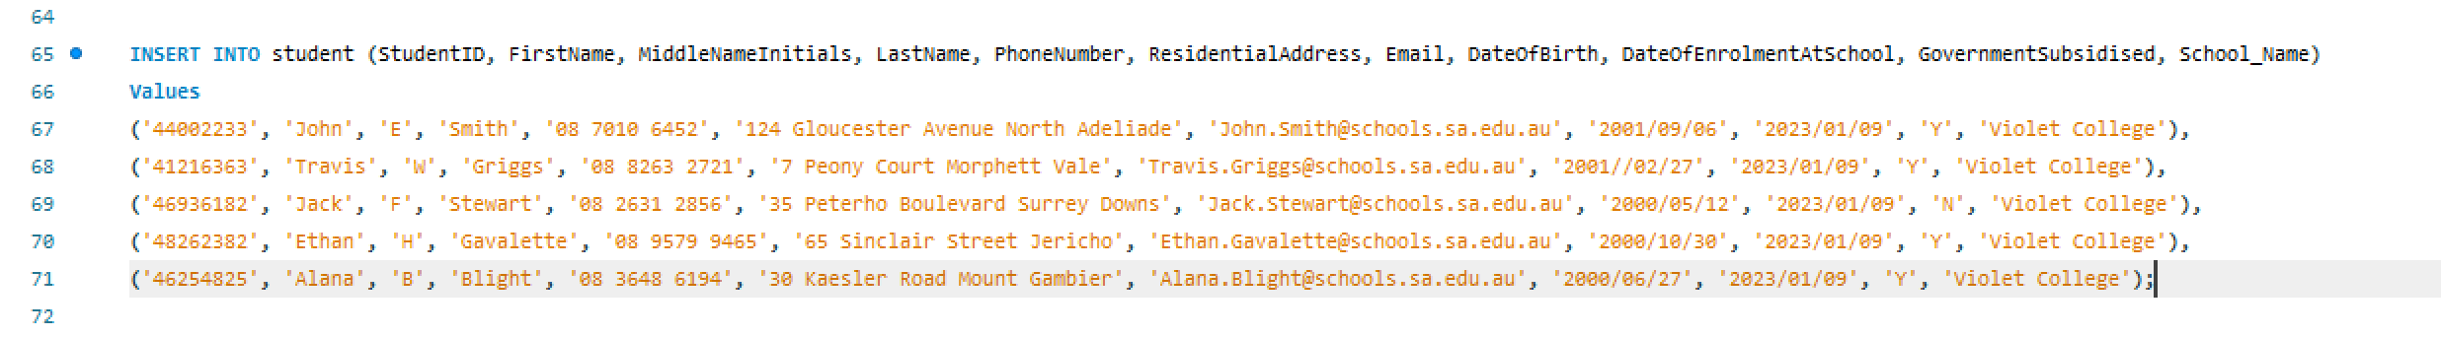

SQL code



SQL code output

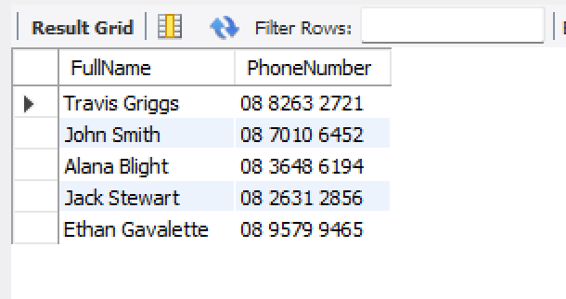

### Test 2 Aggregate Functions

SQL code and comments

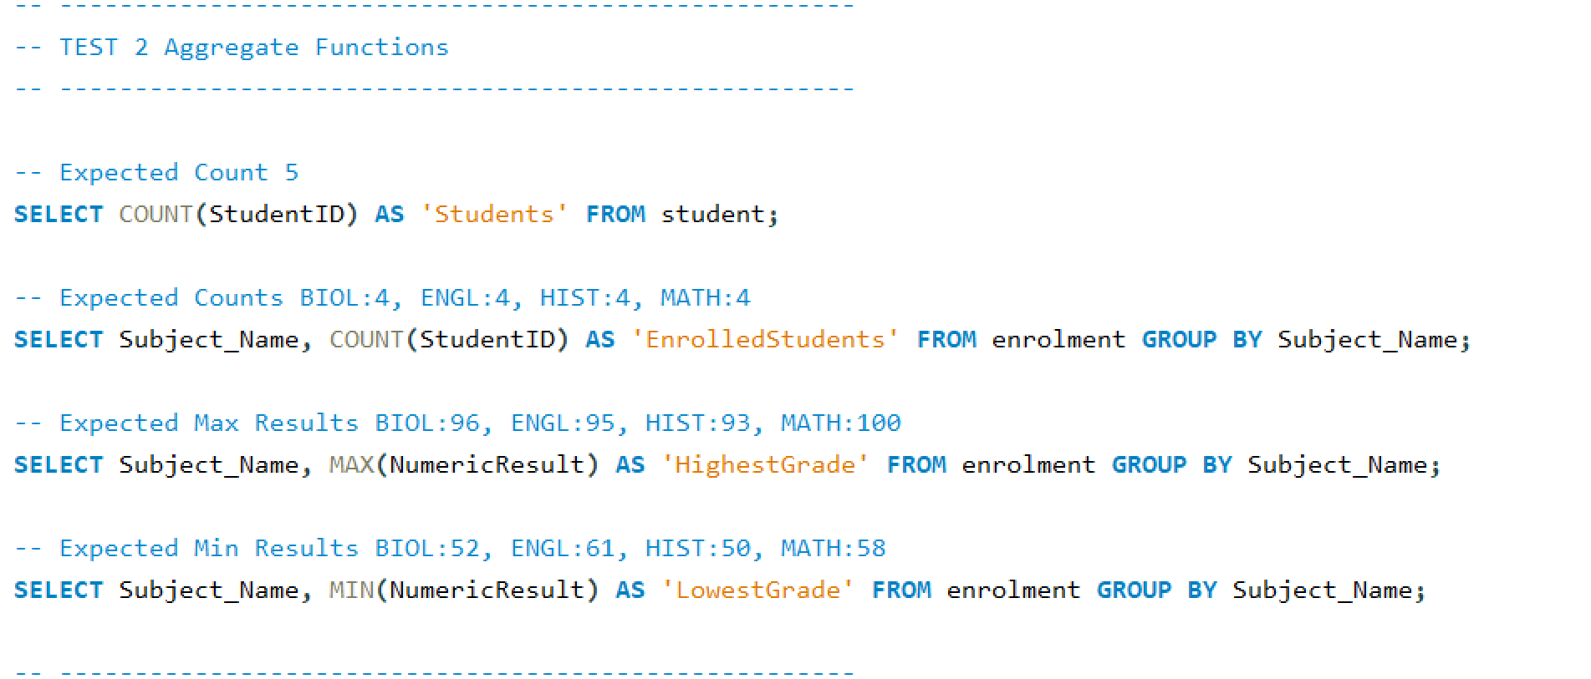

SQL code output

Student count

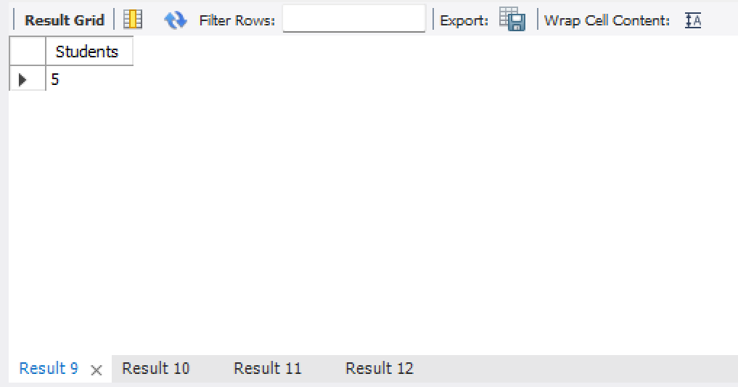

Enrolled students count (grouped by subject)

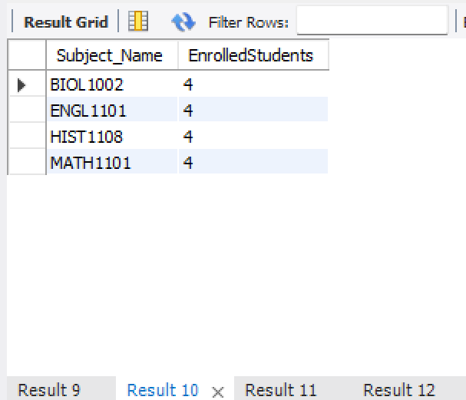

Max results in each subject

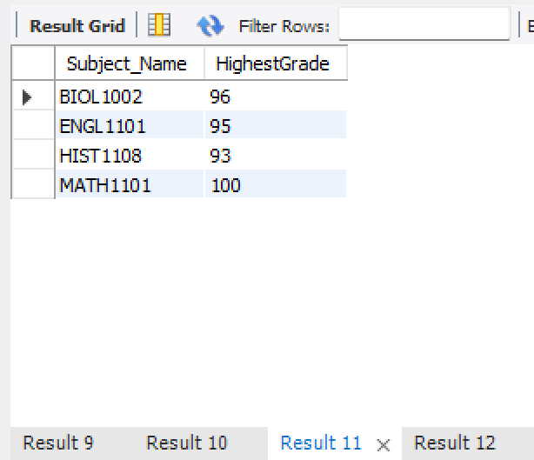

Min results in each subject

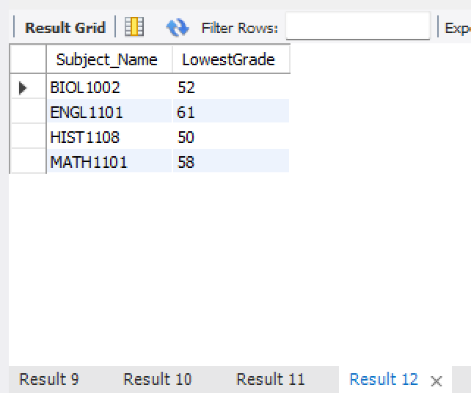

### Test 3 Results of a Student

SQL code and comment

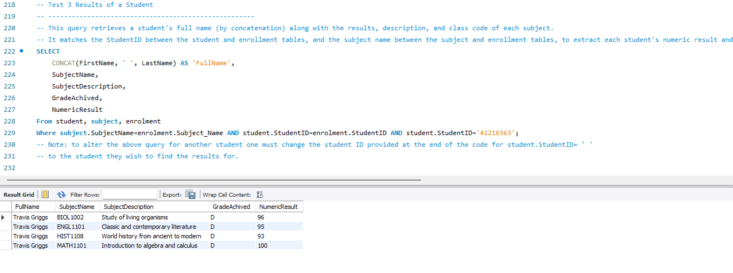

Results of Travis (me)

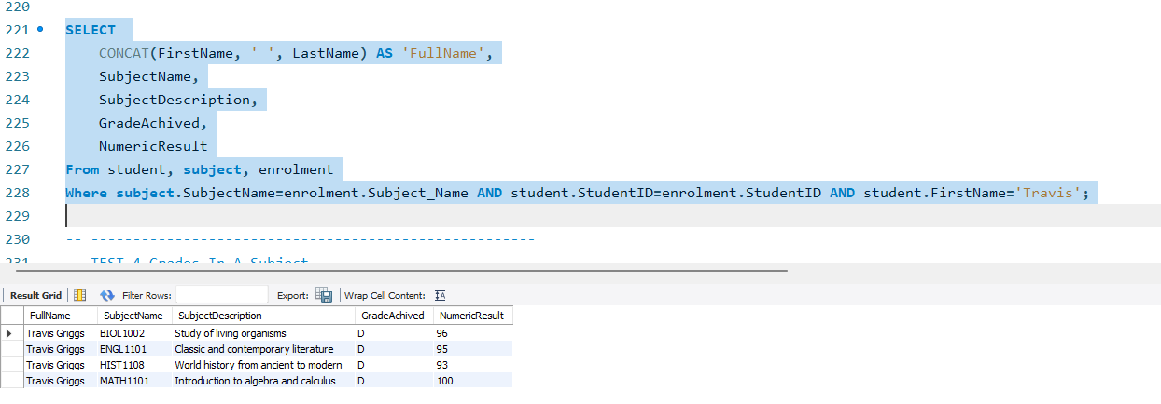

Results of Jack

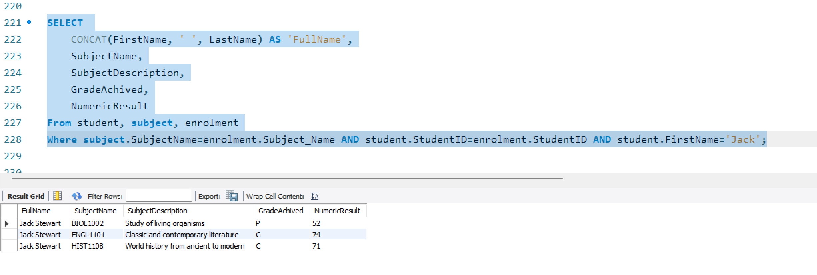

### Test 4 Grades in a Subject

SQL code and comment 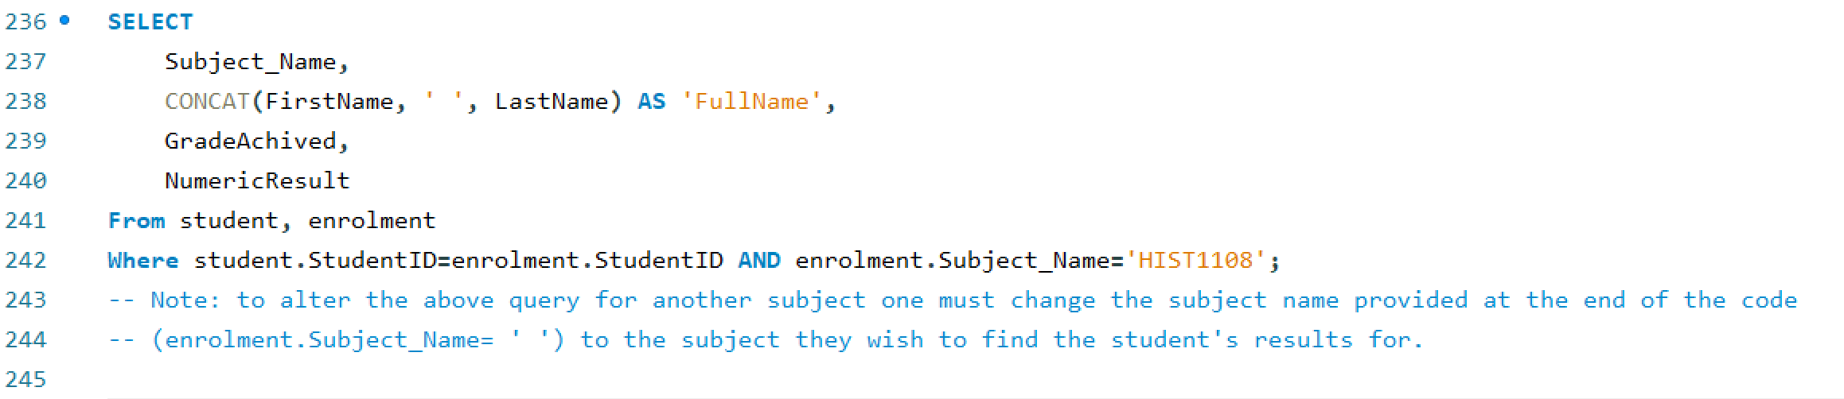

HIST1108 results 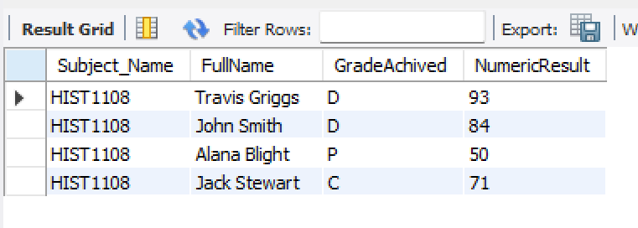

MATH1101 results

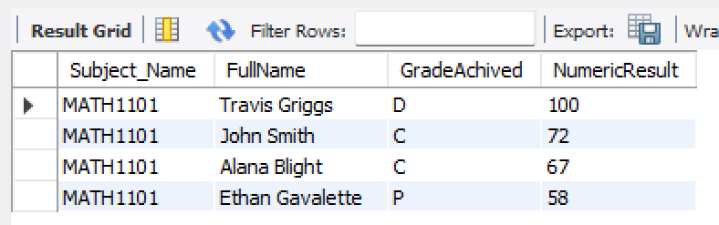

### Test 5 Alter the table structure – for Student’s language spoken at home

Code for alter table and update 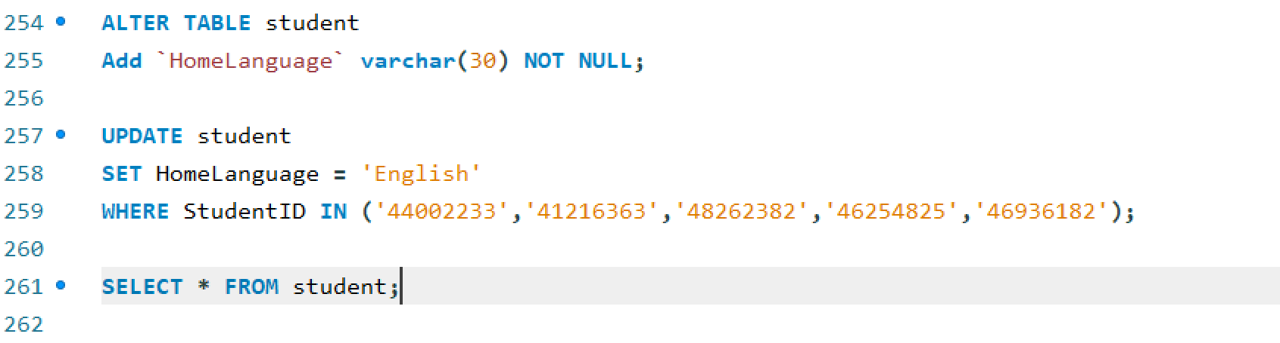

Output from the select * from student query

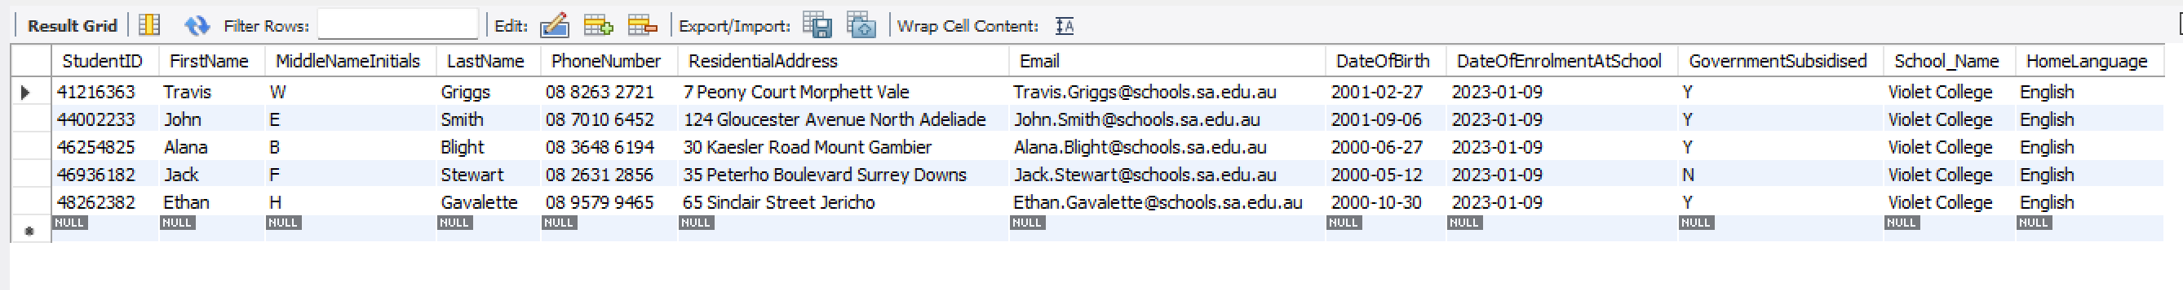

### Test 6 Change A Subject Coordinator

Subject table before change

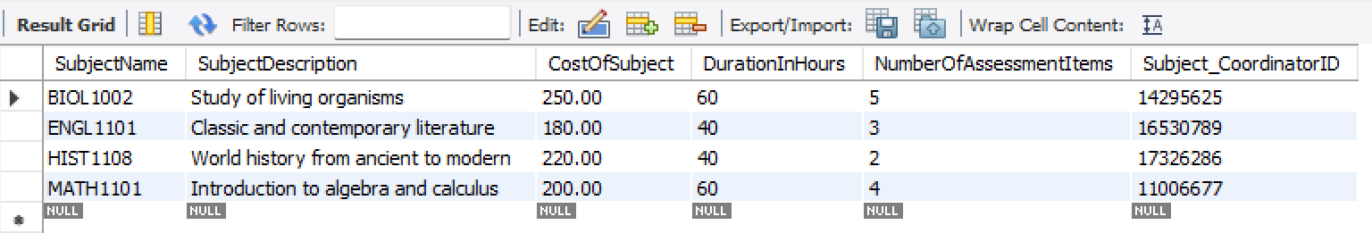

SQL code and comments for change a subject coordinator

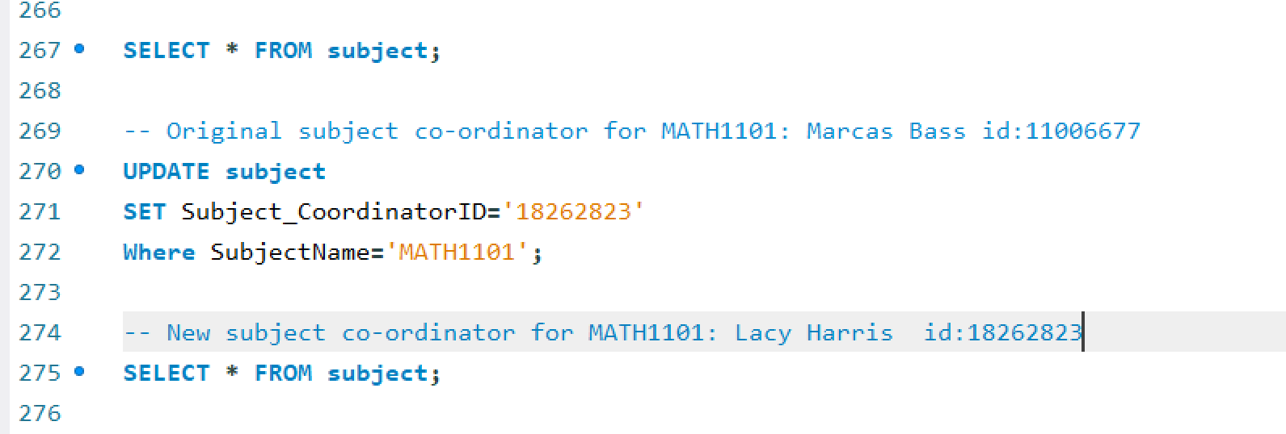

Subject table after change

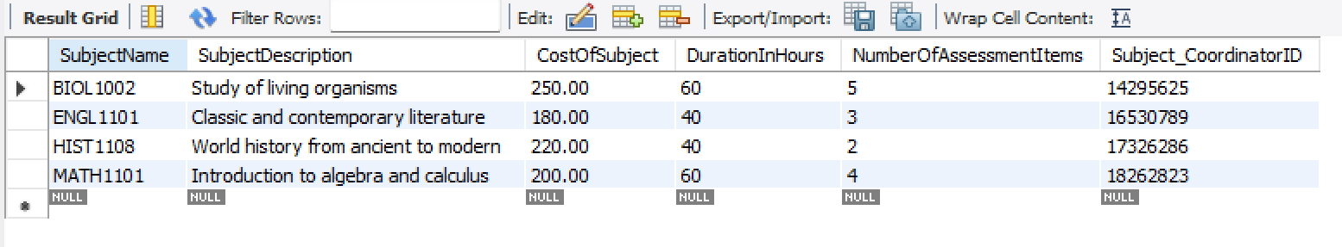

### Test 7 Delete a teacher

teacher table before change

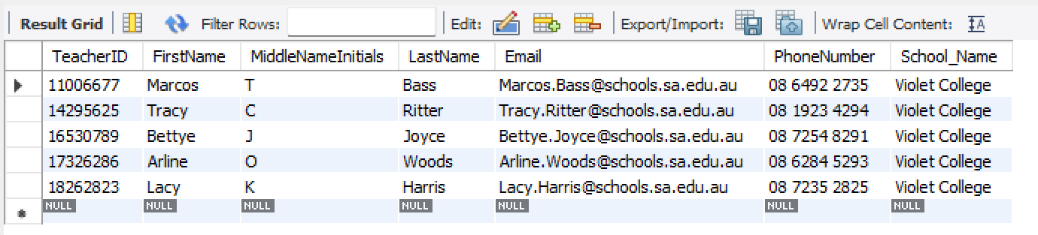

SQL code and comments for delete a teacher

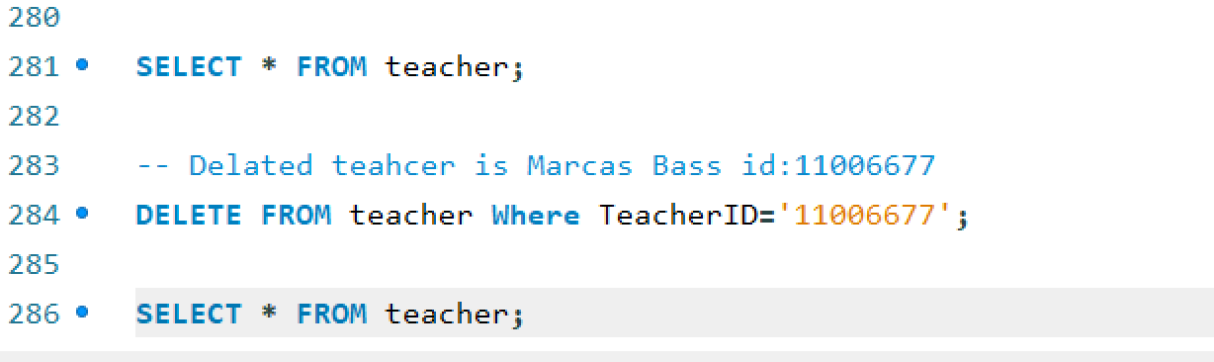

teacher table after change

