1

Sketch uses 177,504 bytes (173.34 KB, 0.169 MB) of program storage space (18% of 983,040 bytes).

Global variables use 111,144 bytes (108.56 KB, 0.106 MB) of dynamic memory (42% of 262,144 bytes).

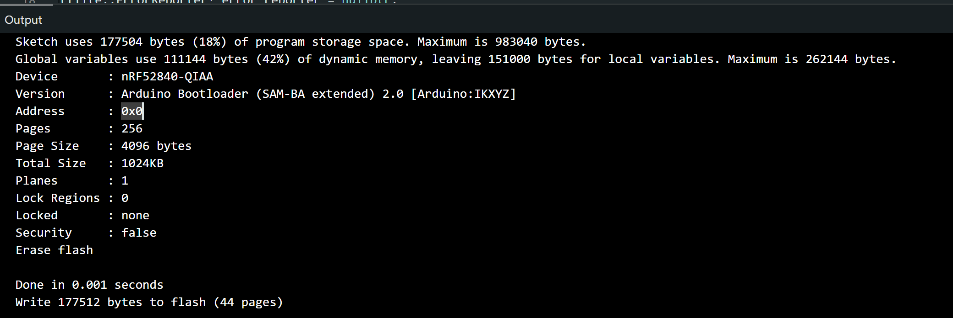

2

Arduino IDE version
- 2.3.8
Arduino Nano 33 BLE board package version
- Arduino Mbed OS Nano Boards: 4.5.0
Arduino_LSM9DS1 version
- 1.1.1
TensorFlowLite / TFLite Micro Arduino library version
- Harvard_TinyMLx: 1.2.4-Alpha

3

model_bytes=10288
tensor_arena_bytes=61440
kChannelCount=6
kWindowSize=128
kStride=64
normalization_source=UCI-HAR train + Arduino V2 train + capped V2.1 long adaptation
input_scale=0.136206716
input_zero_point=8
output_scale=0.003906250
output_zero_point=-128

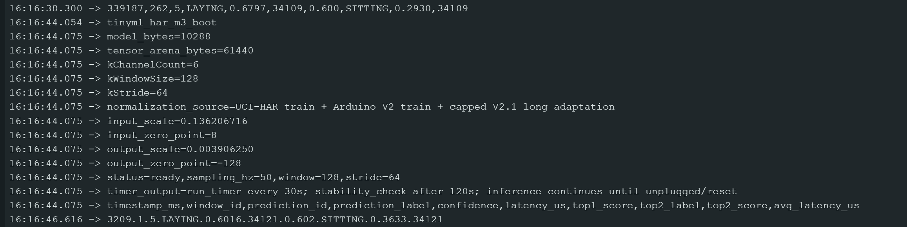

4

latency_summary,window_count=50,avg_invoke_latency_us=34113

5

Self screen 2 min – saved to “2_30_stability_video”

6
Saved 3 classes proof vids to “sitting_proof”, “standing_proof”, “walking_proof”
7
Done – saved to control folder
8
Done – saved to robust folder

